University of Vocational Technology

Restaurant Table Booking System
IT304082 - Database Implementation Final Assignment

Team Information
Team Name: | Group - 06
Member 1 (Database): | SIS/24/B2/23 Chalana Anantha
Member 2 (Frontend): | SIS/24/B2/20 J.M.S.L.B Jayasekara
Member 3 (Backend): | SIS/24/B2/26 M.K.M Sareek
Member 4 (Project Manager): | SIS/24/B2/14 W.B.D.M Bandara

Introduction

The Restaurant Table Booking System (RTBS) is a web-based application designed to streamline the reservation process for customers and the management of those reservations for restaurant staff. The system operates on a 3-Tier Architecture, utilizing HTML/CSS/JavaScript for the presentation layer, pure PHP for the application layer, and a MySQL/MariaDB database for the data layer.
Customers can view available tables, select booking dates, and check the status of their reservations. Administrators have access to a secure backend dashboard where they can manage table inventory, accept or reject incoming bookings, manage sub-admin accounts, and generate detailed booking reports within specific date ranges.

Entity-Relationship (ER) Diagram

The following diagram illustrates the relationships between the core entities in our database: Administrators, Tables, and Bookings. It highlights the primary keys, foreign keys, and cardinality mapping.
[Insert ER Diagram Image Here]

Normalization Process

To ensure data integrity and reduce redundancy, the database schema underwent normalization from Unnormalized Form (UNF) to Third Normal Form (3NF).

First Normal Form (1NF)

Rule: Eliminate repeating groups and ensure all attributes are atomic.

Action: Initial designs often include multiple table names or booking dates in a single row. We restructured the data so that each booking record contains only atomic values (e.g., separating the customer's full name into first and last names if necessary, and ensuring only one booking per row).

Second Normal Form (2NF)

Rule: Must be in 1NF and have no partial dependencies (non-key attributes must depend on the entire primary key).
Action: In a composite key scenario (e.g., BookingID + TableID), attributes like Table Capacity only
depend on the TableID. We separated tblrestables (Table details) from tblbookings. The bookings table now only references the TableID as a foreign key.

Third Normal Form (3NF)

Rule: Must be in 2NF and have no transitive dependencies (non-key attributes must not depend on other non-key attributes).
Action: If we stored 'Admin Name' inside the Bookings table based on who approved it, that would be a transitive dependency (Booking -> AdminID -> Admin Name). Instead, tblbookings only stores the AdminID/Status, and the application joins with tbladmin to retrieve the admin's details
when needed.

Implemented MySQL Features

Beyond basic CRUD operations, the database utilizes advanced MySQL features to maintain data integrity and optimize queries.

Stored Procedures

Feature: sp_accept_booking

Explanation: This stored procedure encapsulates the logic for accepting a booking. It takes the
Booking ID as an input parameter, updates the status to 'Accepted' in tblbookings, and logs the timestamp of the approval. This reduces the number of queries sent from the PHP application layer to the database.

Triggers

Feature: trg_prevent_double_booking

Explanation: A BEFORE INSERT trigger on tblbookings. Before a new reservation is saved, this trigger checks if the requested table is already booked and accepted for the specific date and time. If a conflict exists, it raises a signal state to abort the insert, ensuring the restaurant is never double-booked.

Views

Feature: vw_pending_dashboard

Explanation: A virtual table that pre-joins tblbookings and tblrestables, filtering only for bookings where the status is 'Pending'. This view is queried by the admin dashboard to quickly display incoming requests without writing complex JOIN statements in the PHP code.

System Screenshots

The following screenshots demonstrate the functionality of the Tier 1 Presentation Layer and its integration with the backend systems.

Frontend: User Booking Interface


Backend: Admin Dashboard
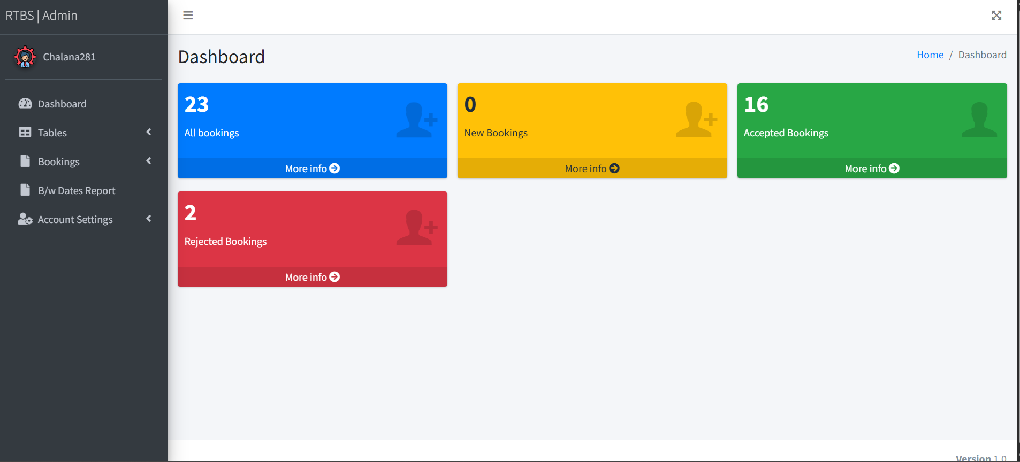

Backend: Manage Bookings
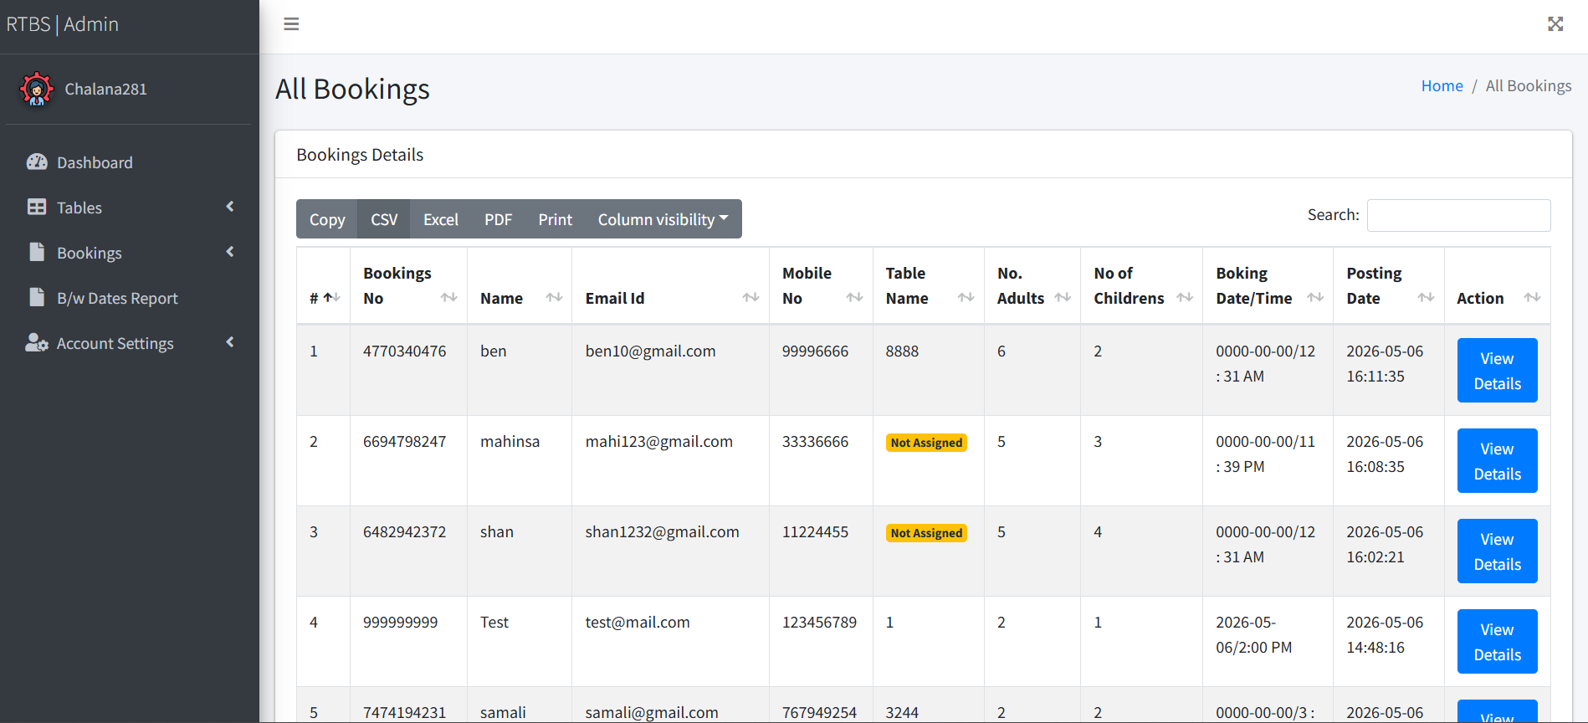

Team Contribution

The project development was divided into distinct roles using Git branching to ensure seamless collaboration and version control.

Member Role | GitHub Branch | Contributions & Responsibilities
Member 1 (Database Admin) | database-tier | Designed the ER diagram and normalized the schema.  Created the rtbsdb.sql file, including all tables, constraints, stored procedures, views, and triggers.
Member 2 (Frontend Dev) | frontend-tier | Developed the user-facing website (index.php, check- status.php, table.php). Integrated UI plugins and ensured form submissions communicated correctly with the database.
Member 3 (Backend Admin) | backend-tier | Developed the admin/ dashboard. Handled PHP session management, authentication logic, and the CRUD operations for managing tables and booking statuses.
Member 4 (Project Manager) | documentation | Configured database connections (config.php). Managed GitHub repository setup, branch merging, resolved merge conflicts, and compiled the final PDF and README documentation.

Challenges Faced and Solutions

Database Port Conflicts (WampServer)

Challenge: During deployment, we encountered (HY000/1045): Access denied and Unknown database errors. We discovered that WampServer was running two separate database services simultaneously: MySQL on port 3306 (which was locked behind an old password) and MariaDB on port 3307.
Solution: We identified the active DBMS containing our tables. By modifying the PHP
mysqli_connect function to explicitly state the IP address (127.0.0.1 instead of localhost to prevent IPv6 routing issues) and explicitly passing the correct port number as the 5th parameter, we successfully bypassed the conflict and established a stable connection.

Database Naming Typographical Errors

Challenge: The PHP application was requesting the database rtbsdb, but the actual database created in phpMyAdmin was accidentally named rbstdb, causing fatal connection failures.
Solution: We utilized PHP's mysqli_connect_error() within a call stack trace to identify the exact line of failure. We aligned the spelling in the config.php file with the phpMyAdmin schema to resolve the error.

Collaborative Version Control

Challenge: We needed to combine four distinct parts of a 3-tier architecture without overwriting each other's code or breaking the folder structure.

Solution: We implemented Git version control using GitHub. We initialized a main branch with a README, then created isolated branches (database-tier, frontend-tier, backend-tier, documentation). Each member uploaded their specific directories to their respective branches. Finally, we used Pull Requests to merge everything back into main, preserving the directory structure and generating a clean commit history.

