1. **Create account in Zoom marketplace**

https://marketplace.zoom.us/

1. **Then select JWT app**

https://marketplace.zoom.us/develop/create?source=devdocs

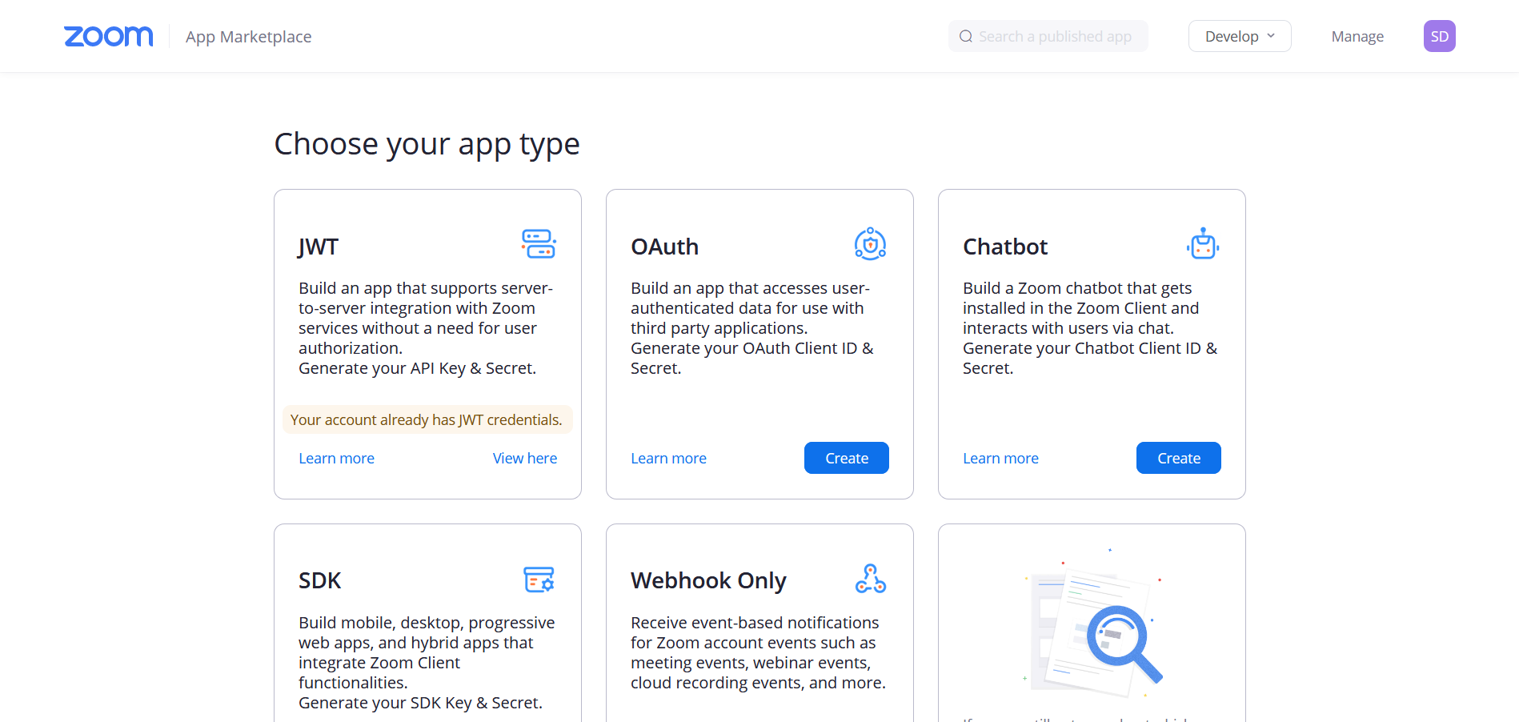

1. **Then fill in the form and create your app**

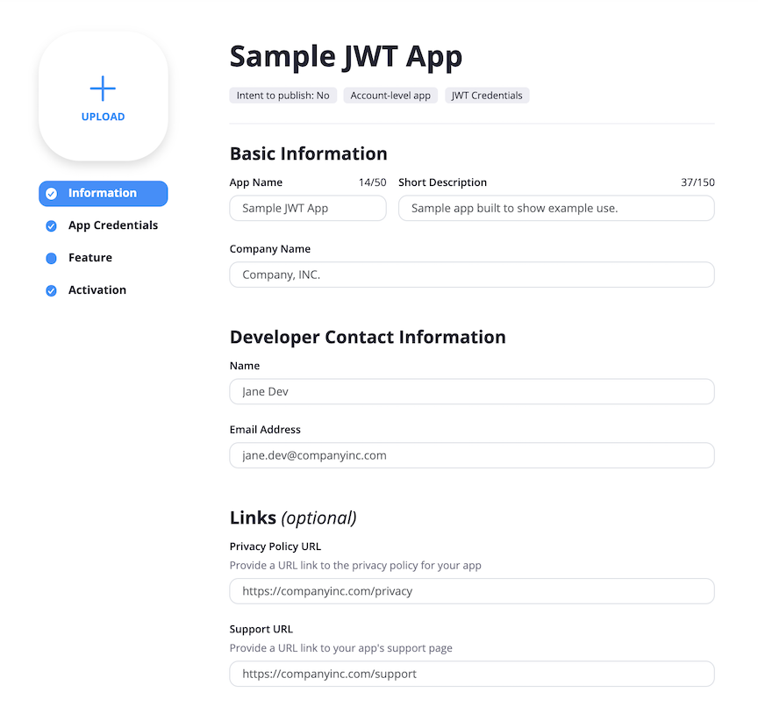

1. **Genarate App credentials and use this in Code**

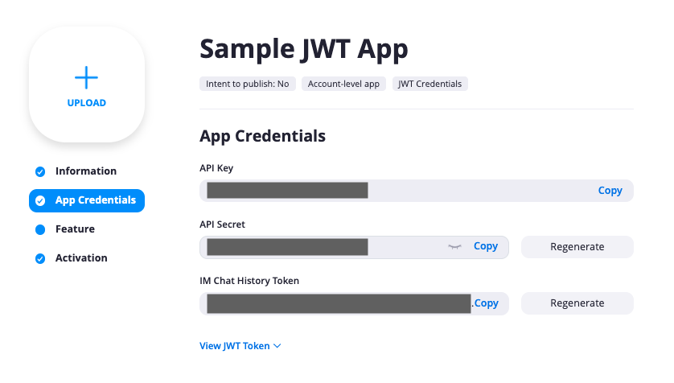

1. **Then Crete subscription if you want. Finally Activate your app.**

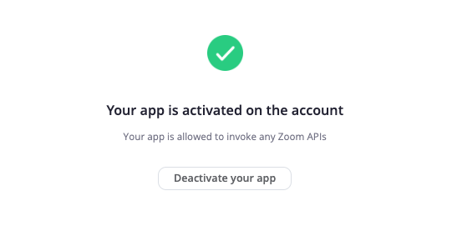

1. **Then add the app credentials for the code segment**

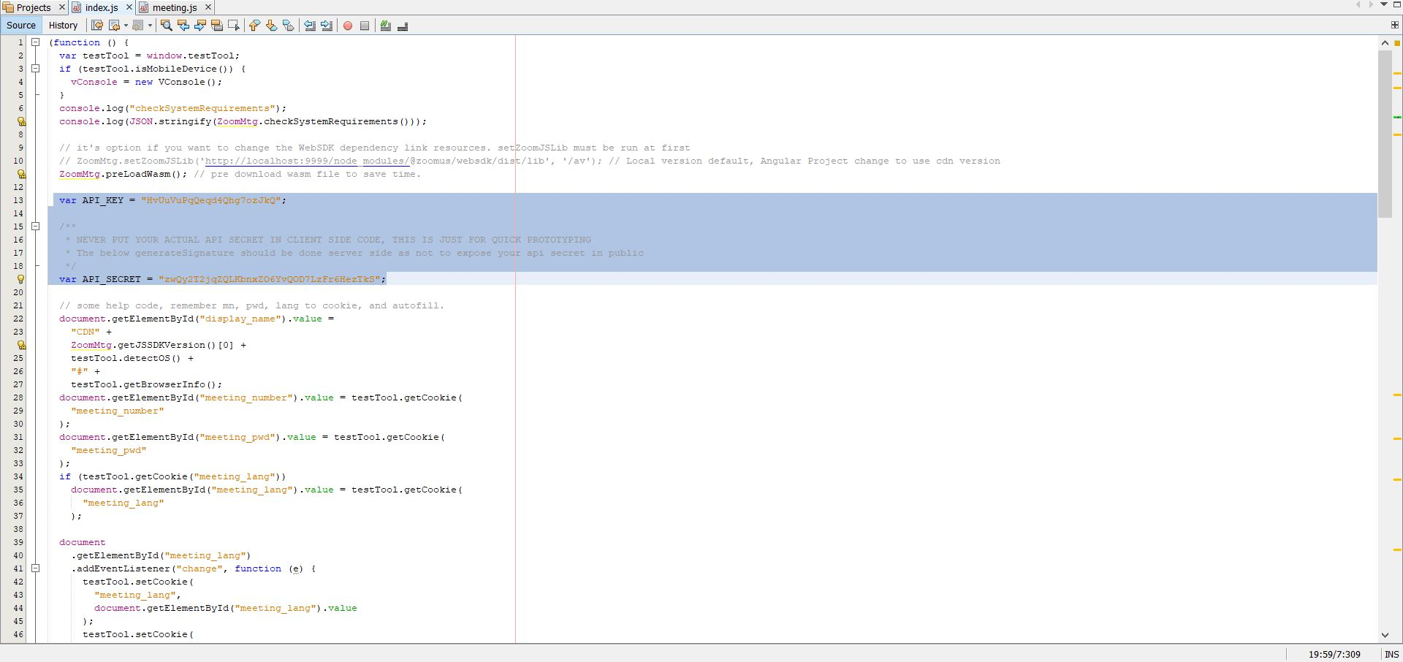

1. **Echo your system parameters**

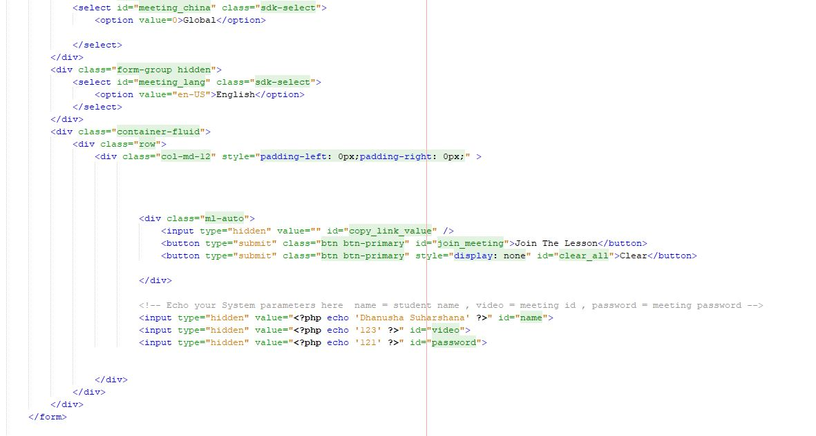

**\*add auth and session to header section. So no one can login using the URL**

1. **Change URL for your project**

Index.js : line 105 , 130

Meeting.js : 26

*Real Server will take its directory path

**9. Dissable right click and Ctrl+U in above pages.**