1. N Refers to all the positive integers. (Called as Natural Numbers)

f : N N f(n) = x4 – 2x + 1

1. N Refers to all the positive integers. (Called as Natural Numbers)

f : N N f(n) = x3 – 2x2 + 5

1. Consider the function f : R->R f(x) = x

1. N Refers to all the positive integers. (Called as Natural Numbers)

n3 +3

3. N Refers to all the positive integers. (Called as Natural Numbers)

f : N N f(n) = x3 -3

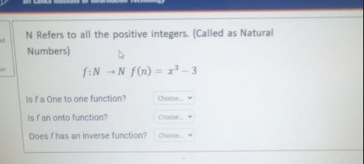

1. Consider the following function. Find g-1(-3)

g:R R g(x)=(12 - 3x)

4

1. Consider the function f : R->R f(x) = x2-1

