

**SRI LANKA INSTITUTE OF INFORMATION TECHNOLOGY**

SOFTWARE ARCHITECTURE

Assignment 1

**Group Members**

**Group ID – MTIT-050**

IT18121452 – Kooragama K.G.C.M.

IT18121902 – Jayashanka L.R.W.D.

IT18126884 – Munasinghe J.A.

IT18117738 – Jayawardhana K.W.

**Scenario Introduction**

This Publisher - Subscriber Scenario is designed using the OSGI framework. In this scenario there are 2 publishers and 2 Subscribers. In order to achieve this, we created 4 bundles. They are,

**Publisher Bundles:**

1. Publisher_AutoVehicles

2. Publisher_ManualVehicles

**Subscriber Bundles:**

1. Normal_Subscriber

2. Permanent_Subscriber (rewarded customer)

**Publishers**

Both publishers contain three classes. First one is the interface to define the services. Then there is the Impl class to implement the service methods. Service methods in Publisher_AutoVehicles are displayAutoVehicles: to display all the auto vehicles, getName: to return a auto vehicle name, getPrice: to return a auto vehicle price. In Publisher_ManualVehicle there are displayManualVehicles: this will display all the manual vehicles, getName: will return the name of a manual vehicle, getPrice: will return the price of a manual vehicle. And there is an Activator class to register the services.

**Subscribers**

Each subscriber bundle has an Activator class. With the use of service reference object, we can access the server Objects. After that subscribers can select auto or manual vehicles and get the total price of it. If the subscriber is a normal subscriber, they won’t get a discount. Only the permanent subscribers will get a 10% discount from the total amount.

**Scenario Using Diagrams**

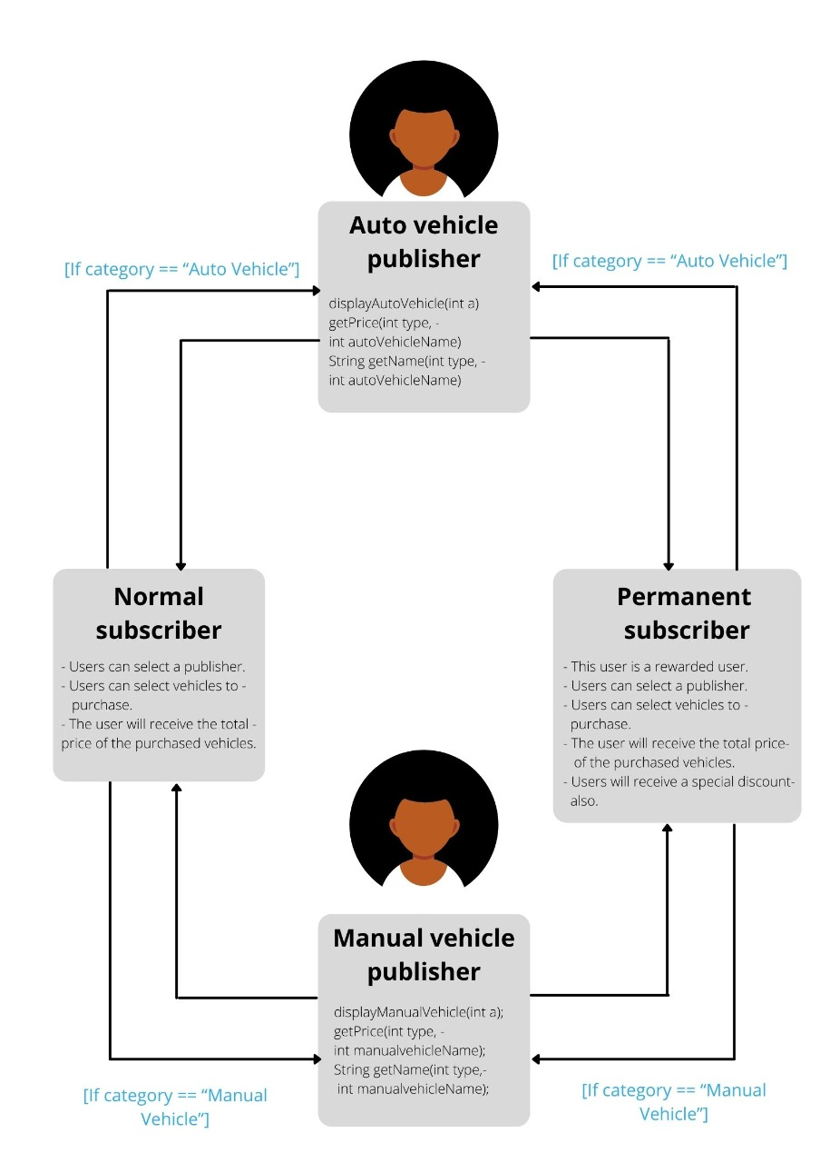

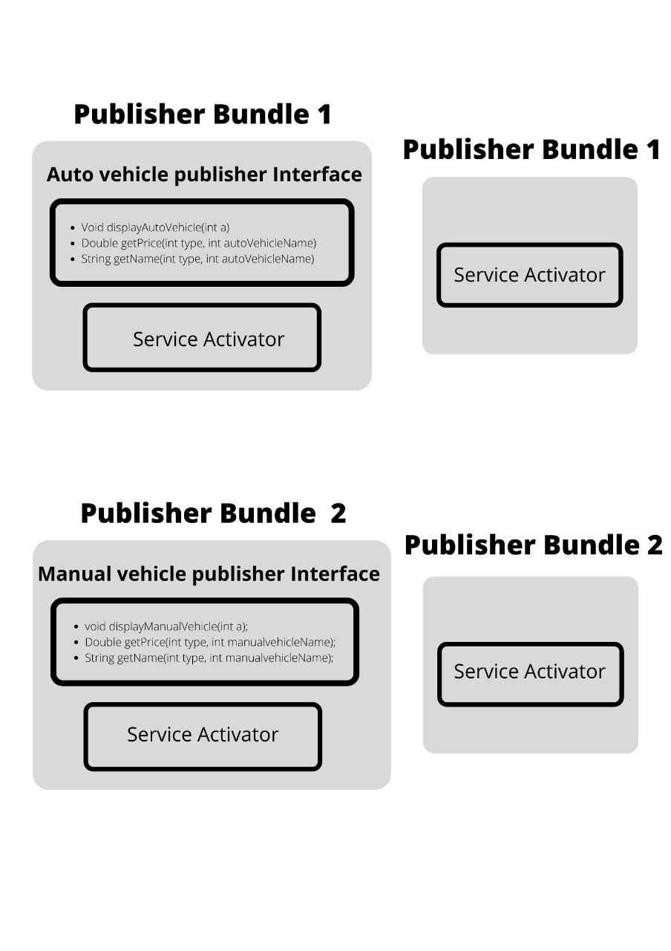

**Manifest Implementation (Exported Services / Imported Services)**

1. **Publisher Manifest Files**
2. Publisher_AutoVehicle

* Export Package – particular publisher package (publisher_autoVehicle)
* Import Package – org.osgi.framework package

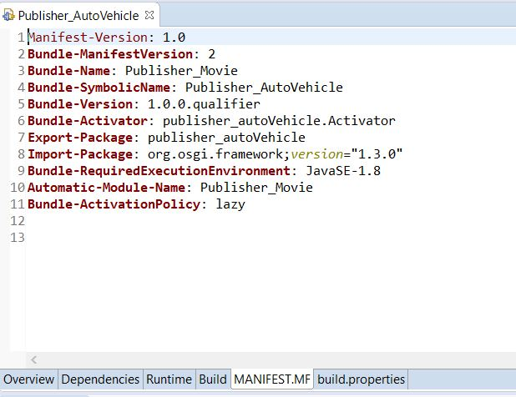

Figure 1: Manifest implementation of Auto Vehicle Publisher

1. Publisher_ManualVehicle

* Export Package – particular publisher package (publisher_manualVehicle)
* Import Package – org.osgi.framework package

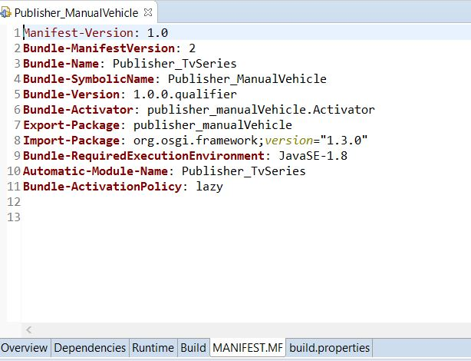

Figure 2: Manifest implementation of Manual Vehicle Publisher

1. **Subscriber Manifest Files**
2. Normal_Subscriber

* Export Package – No Export Packages
* Import Package –
* org.osgi.framework
* Publisher Packages
* publisher_autoVehicle
* publisher_manualVehicle

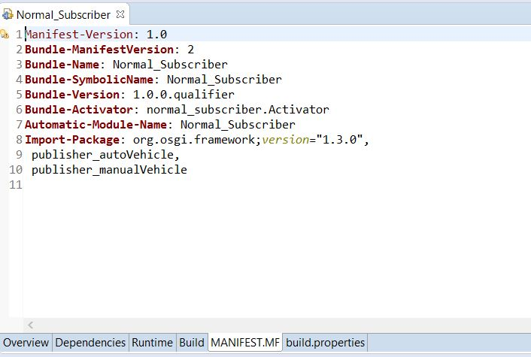

Figure 3: Manifest implementation of Normal Subscriber

1. Permanent_Subscriber

* Export Package – No Export Packages
* Import Package –
* org.osgi.framework package
* All the publisher packages
* publisher_autoVehicle
* publisher_manualVehicle

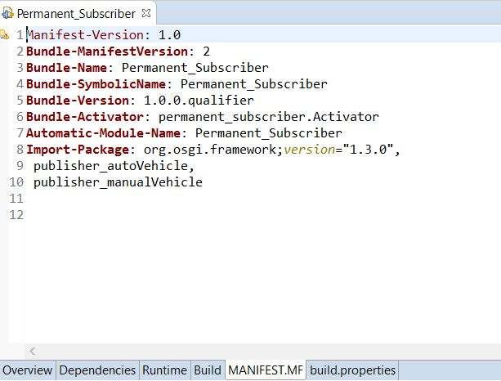

Figure 4: Manifest implementation of Permanent Subscriber

**Bundle install and run in OSGi framework**

1. **Publisher Installation**

Run As 🡪 Run Configurations 🡪 Osgi Framework 🡪 New Configuration 🡪 Give a name 🡪 select workspace as Publisher Bundle name (export bundle name) 🡪 Run

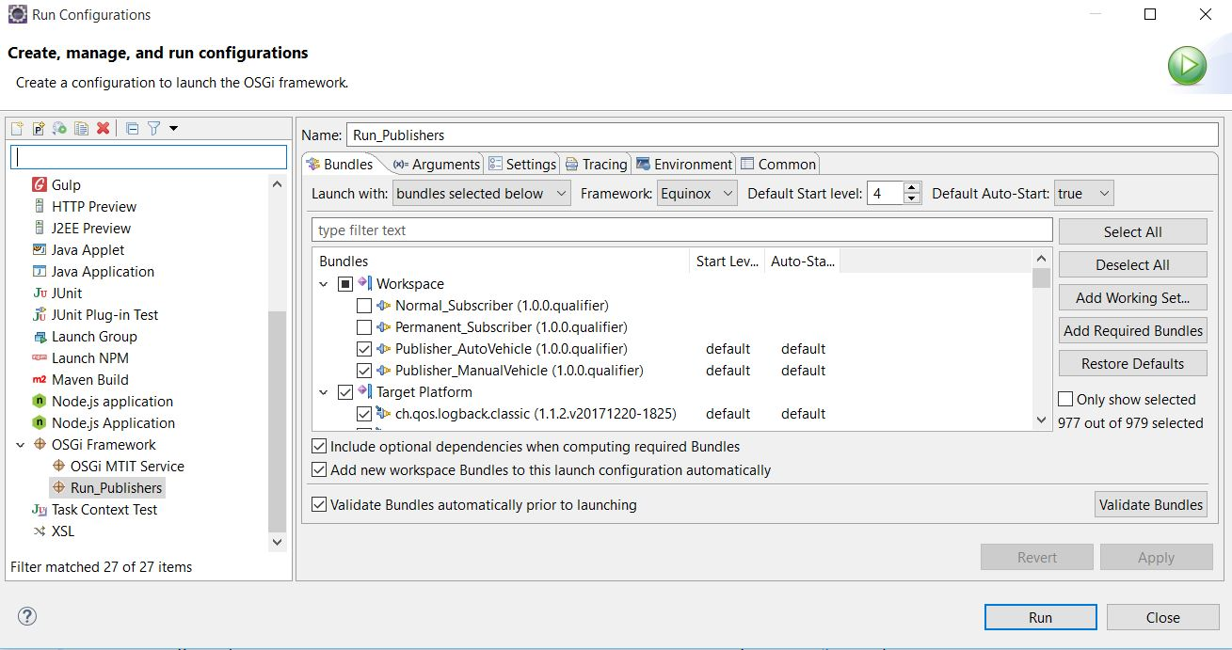

Figure 5: Publisher Installation

To clarify the installation of the bundles, Type SS in console. It will display the Active state on the installed bundles.

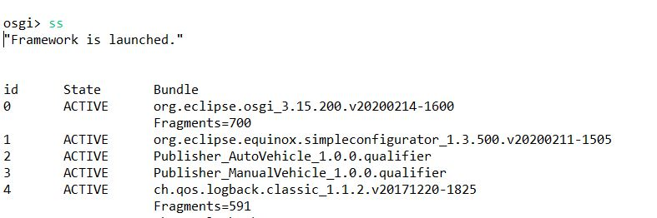

Figure 6: Publisher Installation Active State

1. **Subscriber Installation**

Run As 🡪 Run Configurations 🡪 Osgi Framework 🡪 New Configuration 🡪 Give a name 🡪 select workspace as Publisher Bundles and Subscriber Bundle name 🡪 Run

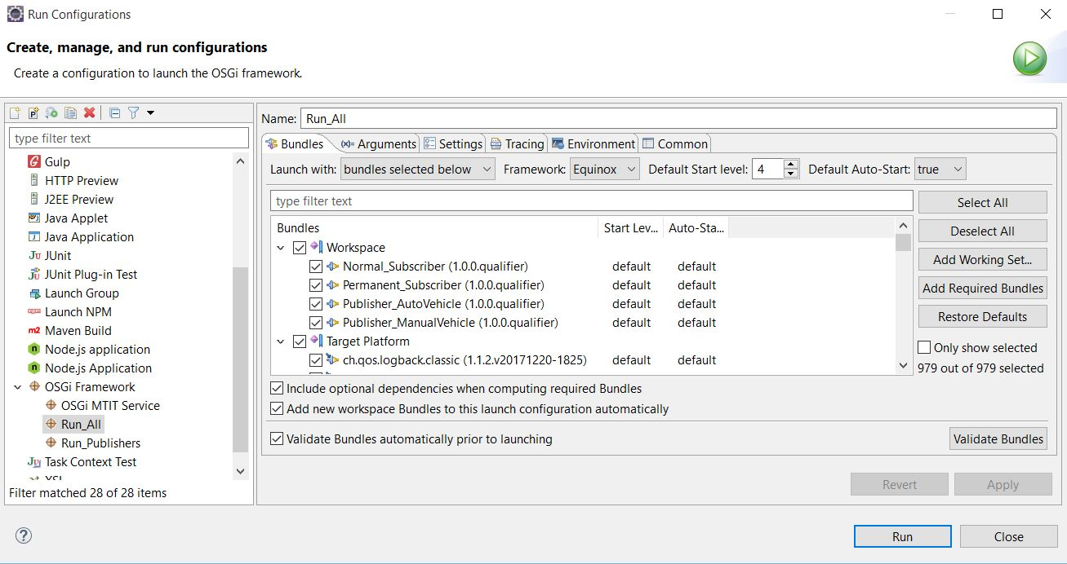

Figure 7: Subscriber Installation

To clarify the installation of the publisher and subscriber bundles, Type SS in console. It will display the Active state on the installed bundles.

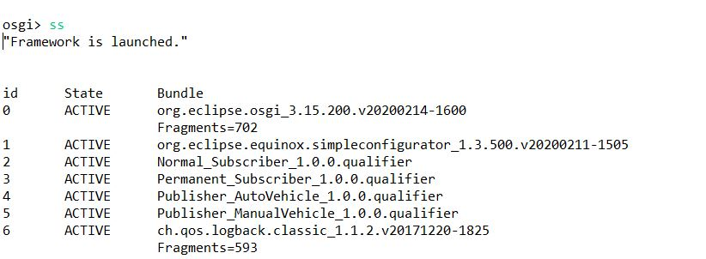

Figure 8: Subscriber Installation Active State

**Sample Screenshots of the Behavior & Outputs**









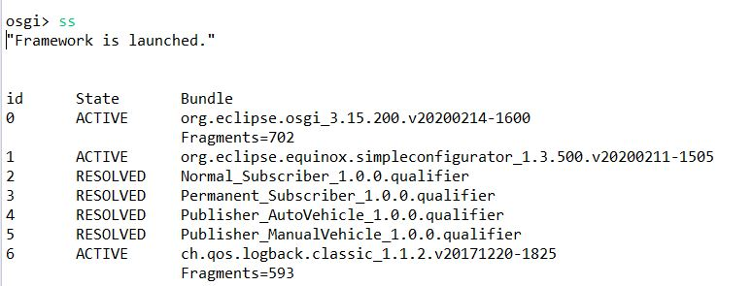

Figure 9: Stop all bundles and checking the state of the bundles.

* **Normal Subscriber Behavior and Output**

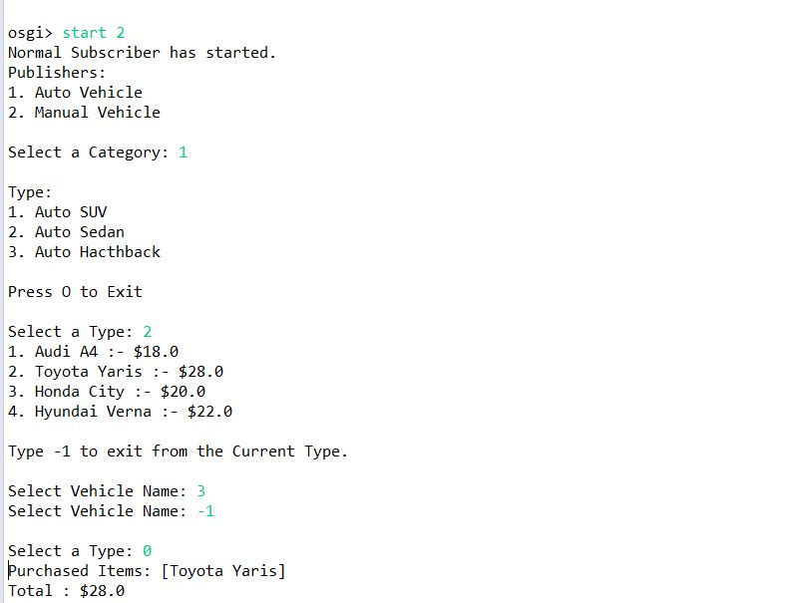

Figure 11: Normal Subscriber Behavior and Output. Purchased Items and Total price is displayed.

* **Permanent Subscriber Behavior and Output**

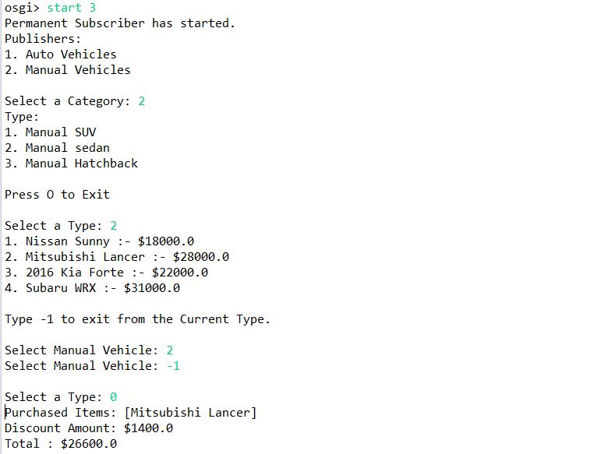

Figure 12: Permanent Subscriber Behavior and Output. Purchased Items, Total Price and the Discount amount is displayed according to the customers selected vehicles.

**Individual Contributions**

|  |  |  |
| --- | --- | --- |
| **Student ID** | **Student Name** | **Individual Contributions** |
| IT18121452 | Kooragama K.G.C.M. | * Permanent(rewarded) Subscriber Implementation with its manifest file. * Designing the high-level diagram * Contributions for the final report |
| IT18121902 | Jayashanka L.R.W.D | * Normal Subscriber Implementation with its manifest file. * Designing the high-level diagram * Contributions for the final report |
| IT18126884 | Munasinghe J.A. | * Auto vehicle Publisher Implementation with its manifest file. * Designing the high-level diagram * Contributions for the final report |
| IT18117738 | Jayawardhana K.W. | * Manual vehicle Publisher Implementation with its manifest file. * Designing the high-level diagram * Contributions for the final report |