SE2030 – Software Engineering
Group Project Report – Design Pattern
Observer Pattern in the Web-Based Help Desk System for University Students
Item | Detail
Group ID | MLB-WEB1G1-08
Batch | Y2.S1.WE.IT.01.01
Design pattern | Observer (behavioral)
Where it is applied | F2 Ticket Management, F5 Notifications and the F1 audit log (all triggered by ticket events)
Code location | com.helpdesk.observer and TicketServiceImpl (src/main/java)

1. Pattern selected: Observer
The Observer pattern is a behavioral design pattern that defines a one-to-many dependency between objects, so that when one object changes state, all of its dependents are notified and updated automatically (Design Patterns lecture, Part 01). It has four components:
- Subject: keeps a list of observers and offers methods to add and remove them and to notify them.
- Observer: declares an update() method that every dependent implements.
- ConcreteSubject: the real object being watched; it notifies its registered observers when its state changes.
- ConcreteObserver: implements the observer interface and reacts to the update.

2. The problem in our system
One change to a support ticket has to cause several independent reactions. The student must see a bell notification and receive an e-mail (UC-F2-01 step 9, UC-F5-01 step 1). Help Desk Staff must be told when a ticket enters their work-pool, receives a student reply, is transferred to them or is reopened. Every staff action must also be written to the audit log.
Before the refactoring, TicketServiceImpl did all of this itself. It held references to NotificationService, EmailService and AuditLogService and called them directly inside eight ticket operations: createTicket, assignToSelf, updateStatus, addComment, release, transfer, escalate and reopen. This caused four problems:
- Ticket business rules were mixed with notification wording, e-mail sending and audit logging in the same methods.
- The same “notify the student / write the audit entry” code was repeated in eight places.
- A new reaction (for example an SMS on escalation) meant editing every one of those operations.
- The class needed eight constructor dependencies, which makes it hard to unit test.

3. The solution
TicketServiceImpl no longer knows who reacts to a ticket change. After it updates a ticket it publishes one TicketEvent to a TicketSubject. Every registered TicketObserver then reacts on its own. The ticket is the subject, and the audit log, the staff notifications and the student notifications are its dependents.

3.1 Mapping to the lecture roles
Lecture role | Class (com.helpdesk.observer) | Responsibility
Subject | TicketSubject | Interface: addObserver, removeObserver, notifyObservers
ConcreteSubject | TicketEventSubject | Holds the observer list; calls update() on each one. Spring injects every observer bean, sorted by @Order.
Observer | TicketObserver | Interface with one method: update(TicketEvent)
ConcreteObserver | AuditLogObserver (order 1) | Writes the audit-log entry for staff actions
ConcreteObserver | StaffNotificationObserver (order 2) | Notifies the pool, the assigned staff member or the new owner
ConcreteObserver | StudentNotificationObserver (order 3) | Creates the bell notification and sends the e-mail to the student
Client | TicketServiceImpl | Changes the ticket, then calls ticketEvents.notifyObservers(event)
Message | TicketEvent, TicketEventType | Immutable record pushed to observers: type, ticket, actor, target, new status

3.2 Which observer reacts to which event
Event | AuditLogObserver | StaffNotificationObserver | StudentNotificationObserver
CREATED | – | Notify every pool member | E-mail only
ASSIGNED | ASSIGN_TICKET | – | Bell + e-mail
STATUS_CHANGED | TICKET_STATUS_<status> | – | Bell + e-mail
STUDENT_REPLIED | – | Assigned staff, else the pool | –
STAFF_REPLIED | TICKET_REPLY | – | Bell + e-mail
INTERNAL_NOTE | TICKET_INTERNAL_NOTE | – | – (student never sees it)
RELEASED | RELEASE_TICKET | Rest of the pool | –
TRANSFERRED | TRANSFER_TICKET | New owner | Bell + e-mail
ESCALATED | ESCALATE_TICKET | – | Bell + e-mail
REOPENED | – | Assigned staff | –

3.3 Class diagram
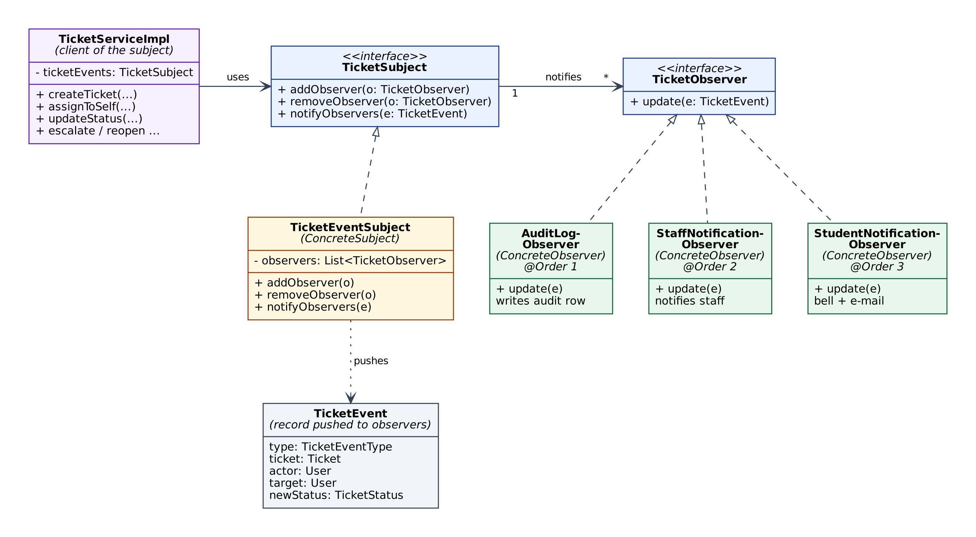
Figure 1 – Observer pattern class diagram for ticket events (follows the structure from the lecture slides).

3.4 Sequence: a staff member resolves a ticket
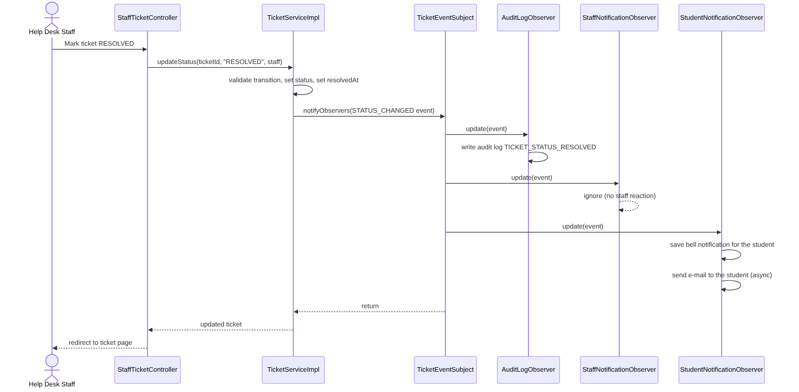
Figure 2 – Sequence diagram for “mark ticket RESOLVED”. The observers run in the order audit, staff, student.

4. Implementation

4.1 Subject and Observer interfaces
public interface TicketObserver {
void update(TicketEvent event);
}

public interface TicketSubject {
void addObserver(TicketObserver observer);
void removeObserver(TicketObserver observer);
void notifyObservers(TicketEvent event);
}

4.2 ConcreteSubject
@Component
public class TicketEventSubject implements TicketSubject {
private final CopyOnWriteArrayList<TicketObserver> observers = new CopyOnWriteArrayList<>();

// Spring injects every TicketObserver bean, already sorted by @Order
public TicketEventSubject(List<TicketObserver> registeredObservers) {
registeredObservers.forEach(this::addObserver);
}

public void addObserver(TicketObserver o) { if (o != null) observers.addIfAbsent(o); }
public void removeObserver(TicketObserver o) { observers.remove(o); }

public void notifyObservers(TicketEvent event) {
for (TicketObserver observer : observers) {
observer.update(event);
}
}
}

4.3 A ConcreteObserver (extract)
@Component
@Order(3)
public class StudentNotificationObserver implements TicketObserver {
@Override
public void update(TicketEvent event) {
Ticket ticket = event.ticket();
switch (event.type()) {
case ASSIGNED -> notifyStudent(ticket, "Your ticket " + ticket.getTicketRef()
+ " is now being handled by " + event.actor().getFullName() + ".");
case STATUS_CHANGED -> notifyStudent(ticket, "Your ticket " + ticket.getTicketRef()
+ " status changed to " + event.newStatus() + ".");
case ESCALATED -> notifyStudent(ticket, "Your ticket " + ticket.getTicketRef()
+ " has been escalated to senior staff.");
default -> { /* nothing for the student */ }
}
}
// notifyStudent(): saves the bell notification, then sends the e-mail
}

4.4 The client: TicketServiceImpl, before and after
Before – updateStatus() had to know about auditing, notifications and e-mail:
auditLogService.log(staff, "TICKET_STATUS_" + status, "Ticket", ticketId, ticket.getTicketRef());
notifyStudent(ticket, "Your ticket " + ticket.getTicketRef() + " status changed to " + status + ".");
// notifyStudent() -> notificationService.notify(...) + emailService.sendAsync(...)

After – it only announces what happened:
ticketEvents.notifyObservers(TicketEvent.statusChanged(ticket, staff, status));

4.5 Adding a new reaction
A new reaction is one new class. TicketServiceImpl and the existing observers stay unchanged. For example, an SMS on escalation (illustrative, not part of the delivered system):
@Component
@Order(4)
public class SmsObserver implements TicketObserver {
@Override
public void update(TicketEvent event) {
if (event.type() == TicketEventType.ESCALATED) {
// send the SMS here
}
}
}

5. Results and consequences

5.1 Before and after
Measure | Before | After
Constructor dependencies of TicketServiceImpl | 8 | 6
Lines in TicketServiceImpl | 399 | 344
Places that call notification / e-mail / audit code | 8 ticket operations + 2 private helpers | 0 (one event call per operation)
Effort to add a new reaction | Edit up to 8 methods | Write 1 new @Component class
Reaction logic location | Spread across TicketServiceImpl | One class per concern

5.2 Advantages
- Loose coupling: the subject and its observers only know each other through two small interfaces.
- Open for extension, closed for modification: new reactions need no change to the ticket logic.
- Single responsibility: ticket rules, auditing, staff alerts and student alerts are now separate classes that can be tested alone.

5.3 Disadvantages and how we handled them
- More classes and indirection (the lecture’s “increased complexity” point): eight new small files, offset by a simpler TicketServiceImpl.
- Update order: the lecture notes that observers are updated in an unpredictable sequence. We fixed this with @Order: audit (1), staff (2), student (3), so the order is explicit and repeatable.
- Same transaction: observers run synchronously inside the ticket operation’s transaction, so a notification or audit row is saved or rolled back together with the ticket change, exactly as before. E-mail is sent asynchronously and a mail failure is caught, so it can never undo a ticket change.
- In-process only: this is not a message broker. It is appropriate for a single-server system of this size.

6. Verification
- Behaviour preserved. The original and the new TicketServiceImpl were run side by side through the same 17-step ticket workflow (create, reply, take, resolve, reopen, internal note, transfer, release, escalate, close, and a category without a pool). All 46 resulting notification, e-mail and audit-log entries were identical. The only difference is ordering: on a public staff reply the audit entry is now written before the student notification.
- Unit tests (JUnit 5 + Mockito, src/test/java/com/helpdesk/observer): TicketEventSubjectTest checks notification order, removal, duplicate registration and event delivery. TicketObserversTest checks the audit, staff and student observers for the events listed in section 3.2, including that an e-mail failure does not break the observer.
- Standalone demo (docs/design-pattern/ObserverDemo.java): a plain-Java version of the same structure that adds and removes an observer at run time. Run with: java ObserverDemo.java

7. Files
File | Purpose
observer/TicketSubject.java, TicketObserver.java | Subject and Observer interfaces
observer/TicketEventSubject.java | ConcreteSubject
observer/AuditLogObserver.java, StaffNotificationObserver.java, StudentNotificationObserver.java | ConcreteObservers
observer/TicketEvent.java, TicketEventType.java | Event message and event kinds
service/impl/TicketServiceImpl.java | Client: publishes events (modified)
src/test/.../observer/*Test.java | Unit tests
docs/design-pattern/ | ObserverDemo.java, class and sequence diagrams

