**CSCI 333 Assignment 04**

**Data structures**

**(List, tuple, set, and dict)**

**50 points**

1. (15 points) Given the list values = [], write code that fills the list with each set of numbers below. Note: use loops if it is necessary
2. 1 2 3 4 5 6 7 8 9 10
3. 0 2 4 6 8 10 12 14 16 18 20
4. 1 4 9 16 25 36 49 64 81 100
5. 0 0 0 0 0 0 0 0 0 0
6. 1 4 9 16 9 7 4 9 11
7. 0 1 0 1 0 1 0 1 0 1
8. 0 1 2 3 4 0 1 2 3 4

# python code

#a

values = [i for i in range(1,11)]

#b

values = [i for i in range(0,21,2)]

#c

for i in range(1,11):

values.append(i*i)

#d

values = [0 for i in range(10)]

#e

values = values + [1,4,9,16,9,7,4,9,11]

#f

values = values + [0,1,0,1,0,1,0,1,0,1]

#g

for i in range(2):

for j in range(5):

values.append(j)

1. (5 points) Write a function that takes a tuple as an argument and returns the tuple sorted.

# python code

def sortTuple(Tup_1):

return sorted(Tup_1)

1. (5 points) Write a statement that creates a dictionary containing the following key-value pairs:

'a' : 1

'b' : 2

'c' : 3

# python code

myDict = {'a':1,'b':2,'c':3}

1. (5 points) What will the following code display?

dct = {'Monday':1, 'Tuesday':2, 'Wednesday':3}

print(dct.get('Monday', 'Not found'))

# result

1

1. (5 points) After the following code executes, what elements will be members of set3, ?

set1 = set([10, 20, 30, 40])

set2 = set([40, 50, 60])

set3 = set1.union(set2)

set4 = set1.intersection(set2)

set5= set1.difference(set2)

# result

set3 = {50,20,40,10,60,30}

1. (15 points) Given a dictionary

gradeCounts = { "A": 8, "D": 3, "B": 15, "F": 2, "C": 6 }

write the Python statement(s) to print:

1. all the keys.
2. all the values.
3. all the key and value pairs.
4. all of the key and value pairs in key order.
5. the average value.
6. a chart similar to the following in which each row contains a key followed by a number of asterisks equal to the key’s data value. The rows should be printed in key order, as shown below.

A: ********

B: ***************

C: ******

D: ***

F: **

* (10 points) Python program

# python source code

gradeCounts = {"A":8, "D":3, "B":15, "F":2, "C":6}  
  
print("a")  
print("___")  
print(gradeCounts.keys())  
print("--------------")  
print("b")  
print("___")  
print(gradeCounts.values())  
print("--------------")  
print("c")  
print("___")  
print(gradeCounts.items())  
print("--------------")  
print("d")  
print("___")  
print("Sorted dictionary: ")  
sorted_dict = sorted(gradeCounts.items())  
print(sorted_dict)  
print("--------------")  
print("e")  
print("___")  
sum = 0  
for key in gradeCounts:  
 sum += gradeCounts[key]  
print("Average: ", sum/len(gradeCounts))  
print("--------------")  
print("f")  
print("---")  
  
emp_st = ""  
for key,value in sorted_dict:  
 emp_str = ""  
 for i in range(0,value):  
 emp_str = emp_str + "*"  
 print(key,":", emp_str)  
  
print("End of program")

* (3 points) Screenshot of the output

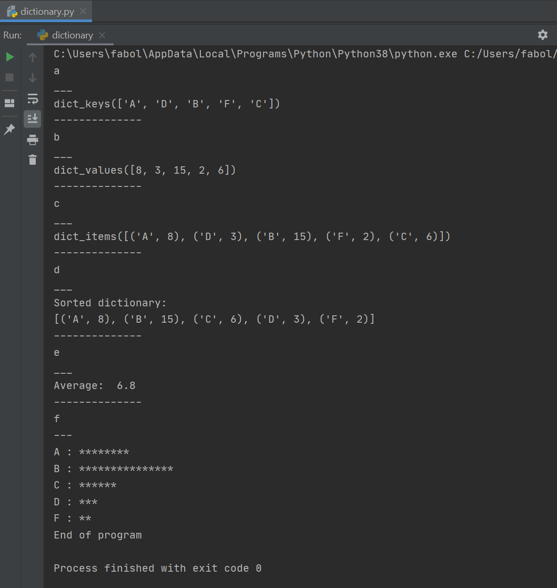

* (2 points) Save the python program and submit it to D2L