OS PRACTICAL 3

Develop a C program using fork() that creates a parent and child process. Display the Process ID (PID), Parent Process ID (PPID), and process states at different stages of execution.Design an experiment to observe process state transitions (Ready, Running, Waiting, Terminated) using Linux monitoring tools such as ps, top, and /proc. Document the observations.

created a C program using the fork() system call. The fork() function creates a new child process from the existing parent process.
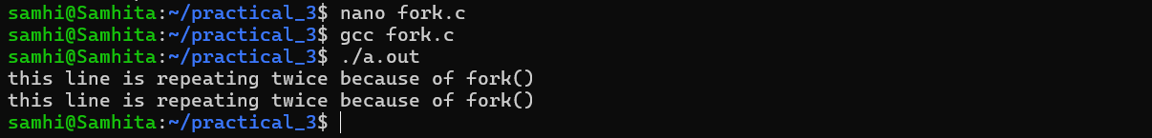

created the child process displayed the PID and PPID of both the parent and child processes to identify them separately.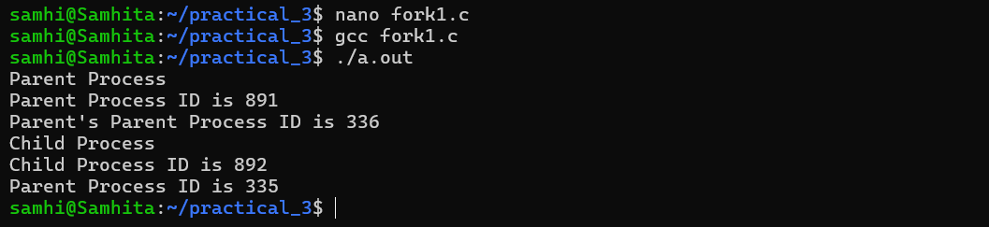

During the execution of the program, the ps command was used to view the processes currently running in the terminal. It displayed the process IDs and the corresponding commands.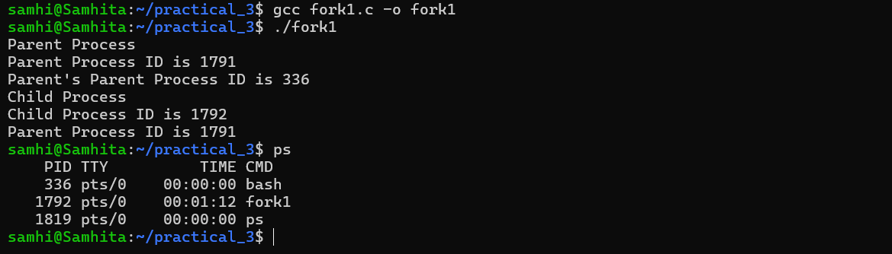

Used the top command to continuously monitor the processes while they were executing. It provided a real-time view of the processes and their activity. This helped in observing how the process status changes during execution.
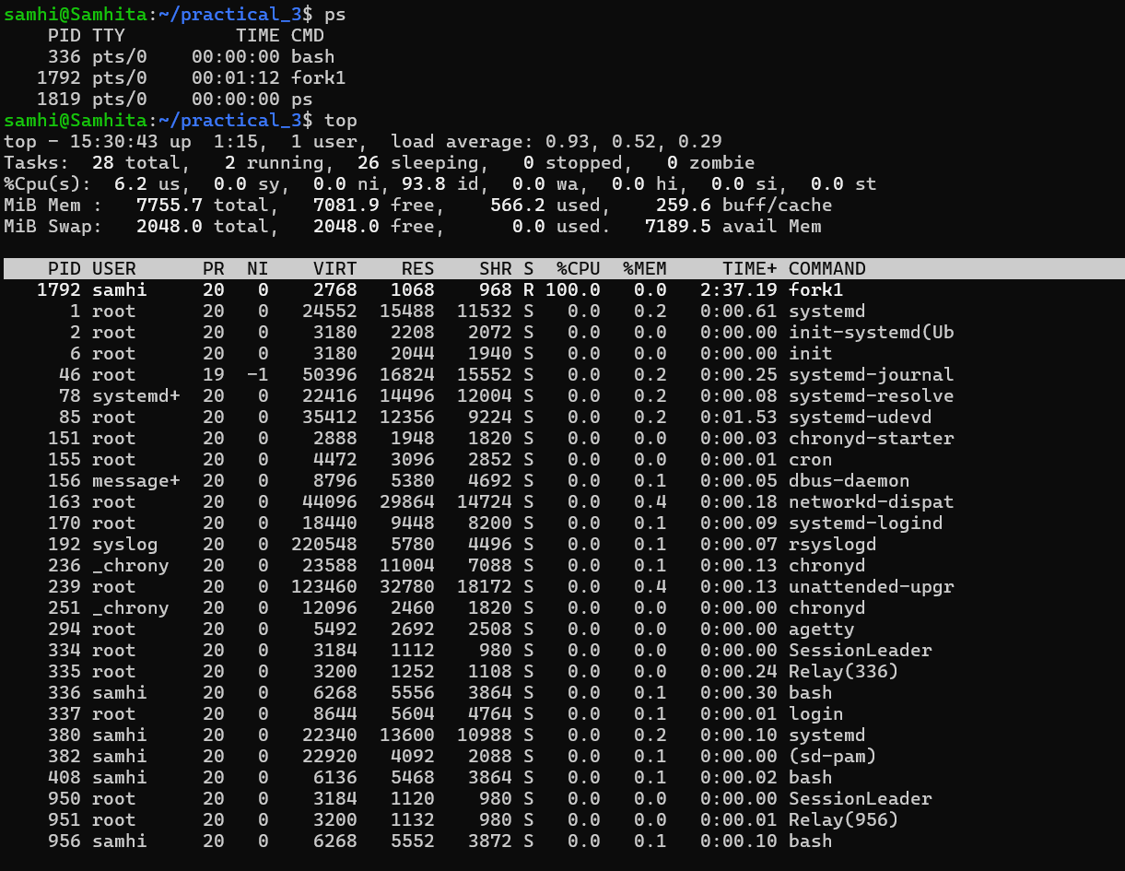

Used the /proc filesystem to inspect the process with PID 1792, which was the fork1 process identified using the ps command. The /proc/1792 directory contains different files and directories that provide information about the process, such as its status, memory, scheduling, file descriptors and other process-related details. This helped me observe how Linux maintains information about an active process.

