OS PRACTICAL 2
Develop a C program that uses the system calls open(), read(), write(), and close() to copy the contents of one file to another. Explain how control transitions between user space and kernel space during execution.Use the strace utility to trace all system calls generated by the command cat sample.txt. Analyze the sequence of system calls and identify the kernel services involved.

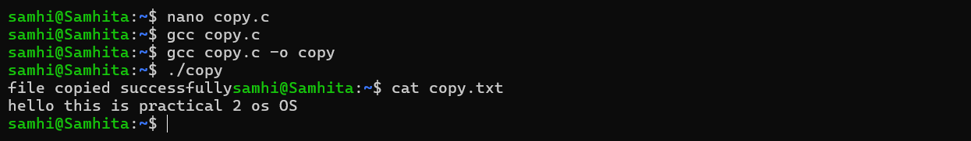
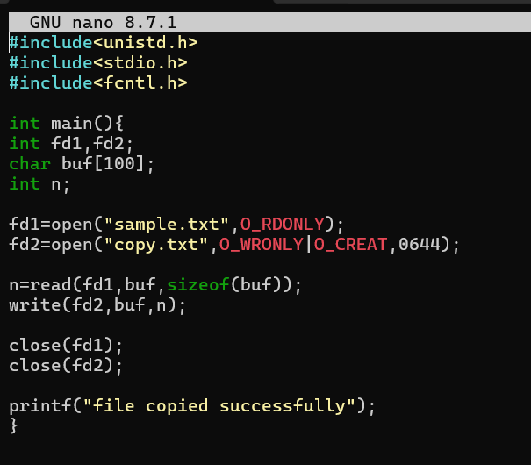The program uses open() to open the source and destination files. read() reads the contents of the source file into a buffer, and write() writes the contents from the buffer into the destination file. Finally, close() closes both files. The output confirms that the file was copied successfully, and the contents of copy.txt were verified using cat.

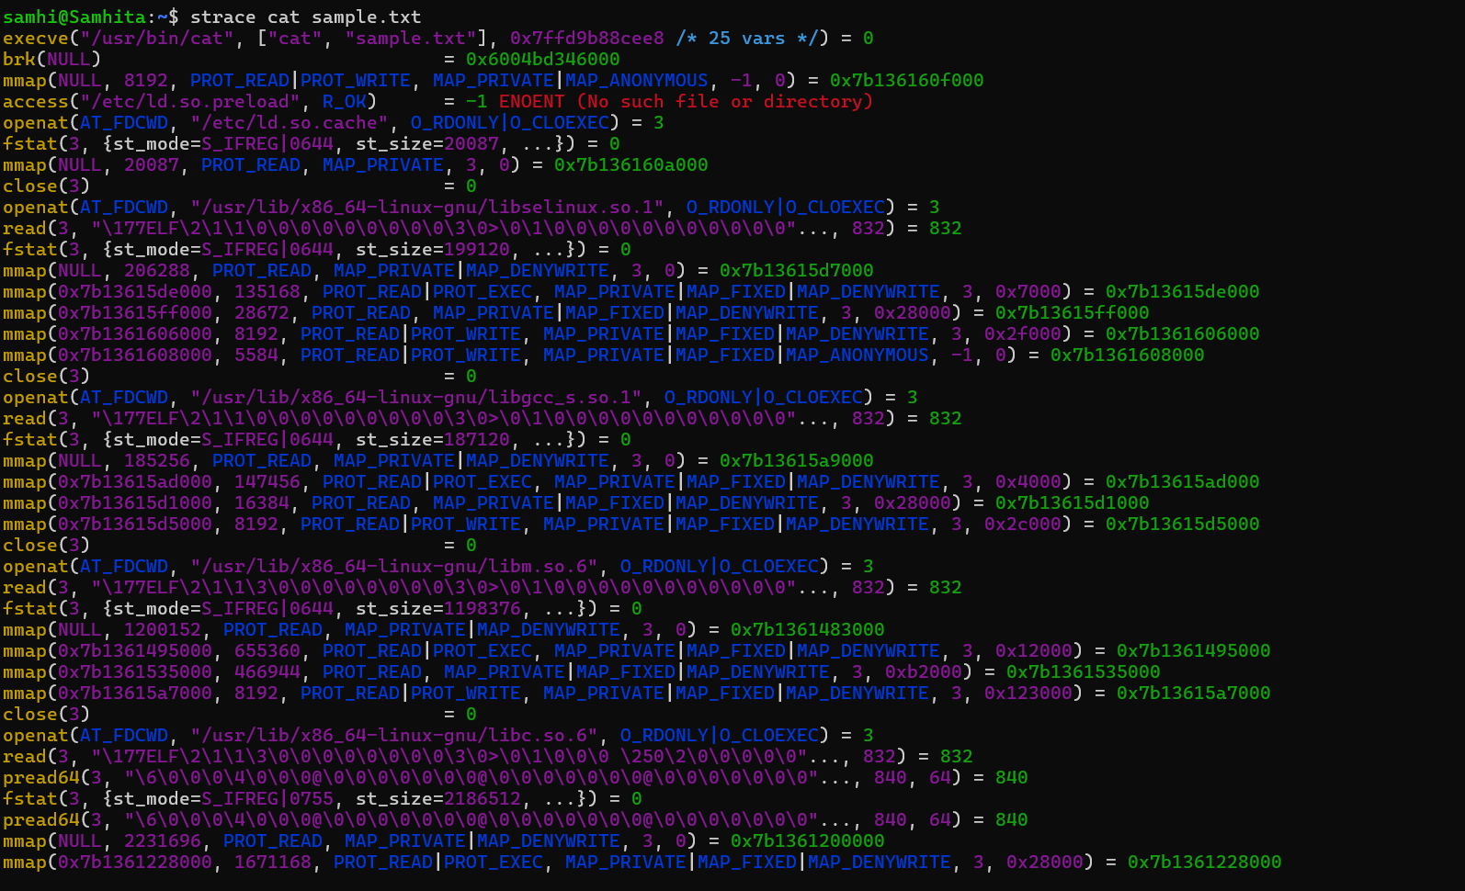used the strace utility with the command cat sample.txt to observe the system calls generated during execution. The strace output shows that the cat command accesses the file using system calls such as openat() and then transfers the file contents to the terminal. The file is finally closed using close(). This shows that when a user-space command needs to access a file, it requests the required services from the Linux kernel through system calls.
open() → opens sample.txt
read() → reads data
write() → displays data (conceptually)
close() → closes the file

