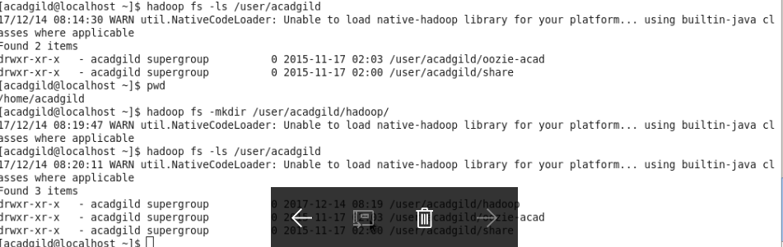

Create a file in HDFS under directory /user/acadgild/Hadoop, with name word-count.txt, whatever we type on screen is appended to the file.

