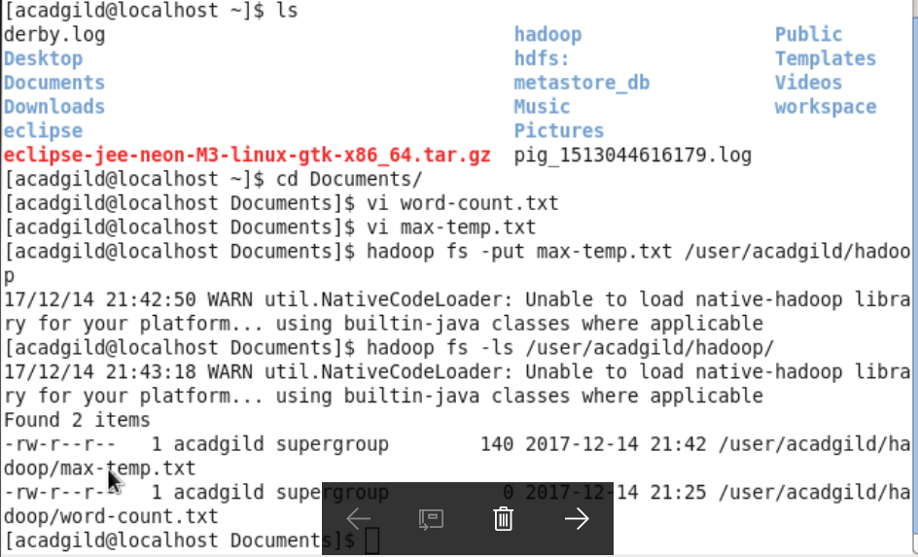

Change the permission to the file /user/acadgild/Hadoop/max-temp.txt, such that only the owner and the group members have full control over the file .Others dont have control on it.