1.Open the terminal and type the command jps to chec the list of daemons, we need to start all the daemons for the first time

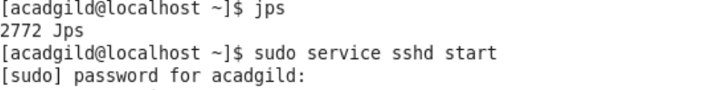

2.Open the terminal and start the ssh server



3.Start all the daemons

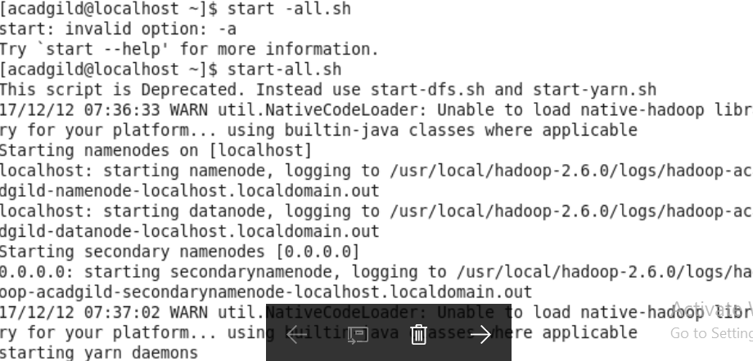

4.Start the history server

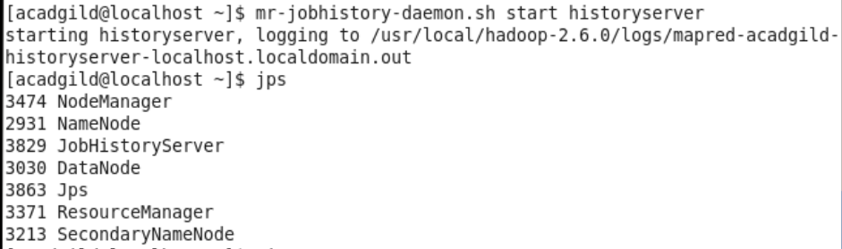

5.To start pig in hdfs mode, type the command pig in terminal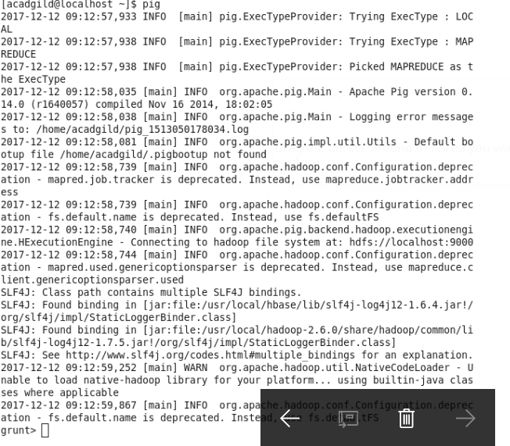

6.To start hive first start mysql service and then type the command hive

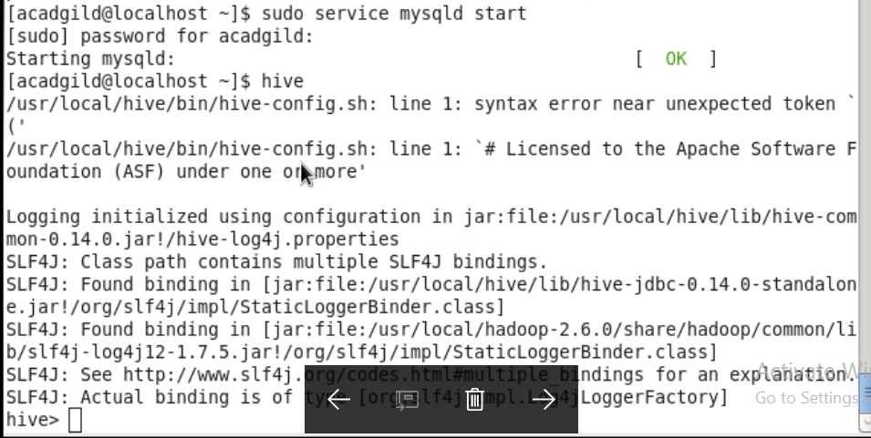

7.To start hbase type the below command as shown in the below

