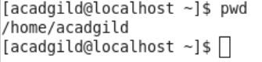  
pwd means present working directory

Vi is used to edit the file.

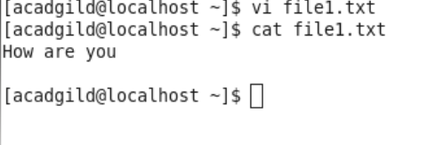

Touch command creates a zero size file

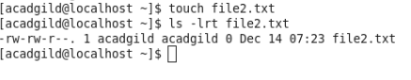

Mkdir will create the new directory

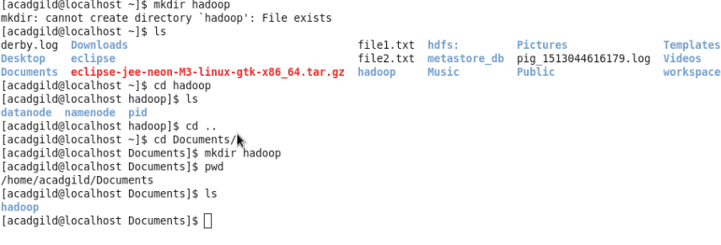 rm will remove the files.



ls command will list the files

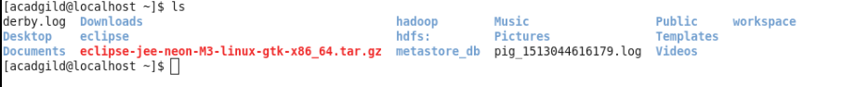

Echo will write arguments to standard output

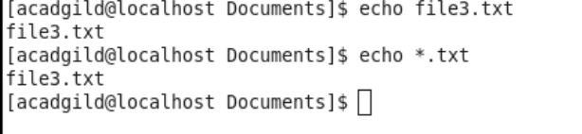

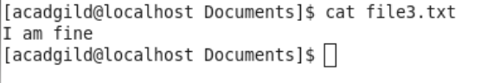

Who command will show who am i(user)

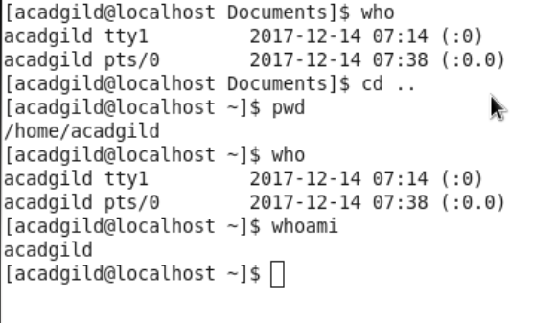

Cd represents change directory

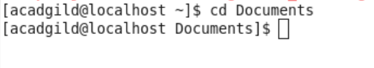

date command displays present date

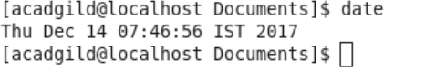

Cal displays calendar

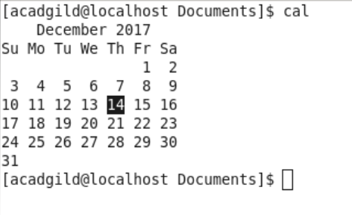

Mv means cut and paste

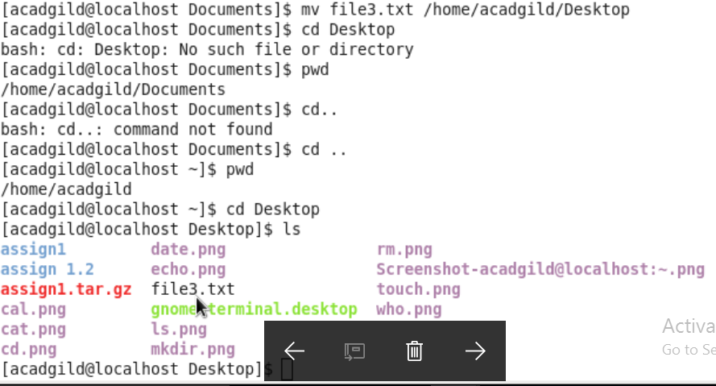

Cp : This command will copy the file from one directory to another directory

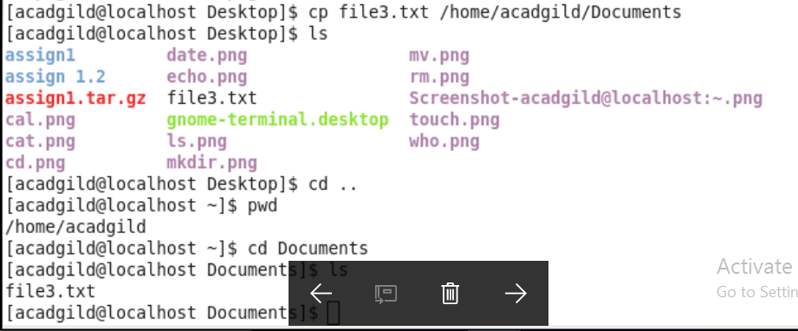

Which is used to identify location of executables

