E-Commerce Customer & Sales Analytics

Dr. N. Sunanda  Department of Computer Science  and Engineering  Koneru Lakshmaiah Education  Foundation  Hyderabad, India | Challapalli Harini  Department of Computer Science  and Engineering  Koneru Lakshmaiah Education  Foundation  Hyderabad, India  [2420030629@klh.edu.in] | Bingi Nageshwari  Department of Computer Science  and Engineering  Koneru Lakshmaiah Education  Foundation  Hyderabad, India  [2420030426@klh.edu.in] | Ananya Remani  Department of Computer Science  and Engineering  Koneru Lakshmaiah Education  Foundation  Hyderabad, India  [2420030086@klh.edu.in]

Abstract—E-commerce platforms generate large volumes of transaction data that are difficult to interpret through individual records. This paper presents an interactive analytics framework that combines customer profiling, sales monitoring, anomaly detection, and baseline forecasting in a single Streamlit dashboard. The application processes transaction-level CSV data, applies date, region, and category filters, and calculates key performance indicators. Customer behavior is summarized using annual spending, purchase frequency, and average order value, followed by K-Means segmentation with six clusters. Anomaly detection is performed using the interquartile range (IQR) rule or Isolation Forest, while monthly sales are analyzed using a baseline linear-trend forecast. The supplied sample dataset contains 1,200 transactions and 179 customers, with total sales of ₹1,014,780 and total profit of ₹54,064. The dashboard also reports data-quality checks, including zero duplicate rows and zero missing cells in the filtered sample. The results demonstrate how descriptive statistics and machine-learning methods can be combined to support accessible, evidence-based e-commerce analysis.

Index Terms—E-commerce analytics, customer segmentation, K-Means, anomaly detection, Isolation Forest, IQR, sales forecasting, Streamlit, data visualization.
I. INTRODUCTION
Digital commerce has transformed the way organizations collect, store, and interpret customer information. Each order contributes information about purchasing frequency, spending behavior, product categories, sales performance, and profitability. When these records are analyzed together, they can reveal patterns that are difficult to identify from isolated transactions. Knowledge discovery processes provide a structured way to convert raw records into useful information [1].
A major challenge is that overall revenue alone does not explain customer behavior. A customer who places frequent low-value orders may contribute a similar amount to a customer who places only a few high-value orders. Customer relationship management research therefore emphasizes the use of data mining to identify valuable customers, understand behavior, and improve customer development and retention [2], [3].
This work develops an interactive E-Commerce Customer & Sales Analytics application. Its main modules are: (i) transaction filtering and key performance indicators, (ii) customer-level behavioral segmentation, (iii) unusual-transaction detection, (iv) monthly sales trend and baseline forecasting, and (v) data-quality inspection and CSV export. The goal is to make analytical outputs understandable through an integrated visual interface.
The increasing availability of digital payment systems, online marketplaces, and web-based shopping applications has made transaction data an important resource for modern businesses. Every completed order records several attributes, including the customer, product category, purchase date, quantity, discount, sales amount, and profit. When these attributes are examined together, organizations can identify changes in demand, recognize purchasing patterns, compare regional performance, and understand which customer groups contribute most to business outcomes. However, the volume and variety of records make manual inspection difficult, particularly when managers need timely information from multiple dimensions of the business.
Customer analytics is therefore an important part of data-driven decision-making in electronic commerce. Instead of considering customers only through their total spending, businesses can study several behavioral indicators such as purchase frequency, average order value, and the timing of transactions. Earlier online-retail research demonstrated that transaction data can be used with data-mining techniques to identify meaningful customer groups and support customer-centric marketing [14]. More recent work has combined customer profiling, RFM measures, clustering, and predictive models to improve the understanding of customer behavior and sales-related outcomes [15]. These studies show that customer-level analysis can provide information that is not visible from overall revenue figures alone.
Sales monitoring is another essential requirement because revenue and profit may vary across months, regions, and product categories. A dashboard that presents key performance indicators together with interactive filters allows users to examine these changes without repeatedly preparing separate reports. Visual analytics can also help users identify unusual transactions that may require further inspection. Statistical approaches such as the interquartile range and machine-learning methods such as Isolation Forest can highlight records that differ from the general distribution. Such observations should be treated as candidates for review rather than automatically classified as errors or fraudulent transactions. Similarly, forecasting can provide an initial view of possible future sales, although the reliability of estimates depends on the available history and the assumptions of the selected model.
Recent research has also emphasized the value of combining transaction history with online customer activity. Integrating customer characteristics and browsing behavior has been shown to support purchase prediction and more detailed customer segmentation [16]. In practical applications, however, organizations may need a compact tool that brings together customer profiling, sales indicators, anomaly inspection, forecasting, and data-quality checks. When these functions are separated across different programs, comparing their results can become time-consuming and may lead to inconsistent interpretations. An integrated analytical environment can make the workflow easier to follow by applying common filters and presenting related outputs in one place.
To address this need, the present work develops an interactive E-Commerce Customer & Sales Analytics application using Python and Streamlit. The system accepts transaction-level CSV data or a built-in sample dataset, validates the input, and provides date, region, and category filters. It calculates key performance indicators for sales and profitability, creates customer-level features from annual spending, purchase frequency, and average order value, and applies K-Means clustering to group customers. It also supports transaction outlier detection through the IQR rule or Isolation Forest, monthly sales analysis with a baseline linear-trend forecast, and data-quality inspection with CSV export. The objective is to provide an accessible, unified view of customer and sales information while keeping the analytical results transparent and interpretable. sales trend analysis, forecasting, and data-quality inspection. By combining these functionalities, the proposed framework provides a structured and accessible approach to analyzing e-commerce customer and sales data.

II. LITERATURE REVIEW
Fayyad et al. [1] described knowledge discovery in databases as a multi-stage process involving data preparation, pattern discovery, and interpretation. Their work provides the conceptual foundation for transforming raw e-commerce transactions into actionable findings.
Rygielski et al. [2] reviewed data-mining techniques for customer relationship management and explained how customer databases can support identification of valuable customers and prediction of future behavior. Their discussion motivates customer-level analysis rather than transaction-only reporting.
Ngai et al. [3] classified CRM data-mining research across customer identification, attraction, retention, and development. They identified clustering, forecasting, classification, and visualization as useful functions, supporting the combination of several analytical modules in this project.
Chen et al. [4] discussed business intelligence and analytics as a means of turning organizational data into improved decision-making. Their work supports the dashboard-oriented presentation of sales and customer indicators.
Verhoef et al. [5] examined the evolution from multichannel to omnichannel retailing and highlighted the growing importance of integrating customer interactions across channels. Their findings reinforce the value of a unified view of customer and sales activity.
Wedel and Kannan [6] discussed marketing analytics in data-rich environments, emphasizing the use of statistical and computational methods to understand customers and improve marketing decisions. This provides a broader analytical basis for customer profiling and visualization.
Kumar and Reinartz [7] presented customer relationship management as a strategic process for creating and managing customer value over time. Their perspective supports interpreting customer groups in terms of spending and purchase behavior, not only sales totals.
Wu et al. [8] proposed an improved RFM-based customer-value identification approach combined with K-means++. Their study shows how customer scoring and clustering can be combined to distinguish customers with different value profiles.
Li et al. [9] investigated weighted RFM features with K-means for e-commerce customer segmentation. Their work is closely related to the use of transaction-derived customer indicators and unsupervised grouping in this study.
Wu et al. [10] introduced an improved K-medoids method and additional online behavior variables for e-commerce customer segmentation. They also discussed cluster-number selection and robustness to noise, highlighting the importance of feature choice and evaluation.
Gomes and Meisen [11] reviewed customer-segmentation methods used for personalized targeting in e-commerce. Their review identifies segmentation as a practical foundation for differentiated customer communication and marketing actions.
Mehta and Sehgal [12] studied retail micro-segmentation using K-means clustering. Their work illustrates the use of clustering to reveal smaller groups with distinct purchasing characteristics.
The 2023 IEEE study on RFM and K-means [13] applied transaction-derived RFM measures to British e-retail data. It reported that clustering can support more precise user targeting and improved marketing efficiency.
Recent RFM-based segmentation studies have also examined additional behavioral dimensions and alternative clustering strategies. These findings suggest that spending, order frequency, and purchase timing can provide complementary evidence when customer groups are interpreted [8]–[10].
Recent customer analytics studies continue to combine RFM scoring, clustering, and validation measures. These approaches underline the need to inspect cluster size, separation, and business meaning rather than treating cluster labels as self-explanatory [8]–[13]. [14] Chen et al. (2012) demonstrated how RFM analysis and data-mining techniques can identify valuable customer segments and improve targeted marketing strategies.
[15] Kasem et al. (2024) combined AI-based customer profiling, K-Means clustering, and sales prediction to improve customer segmentation and personalized marketing.
[16] Kim et al. (2024) integrated customer characteristics and browsing patterns to improve online purchase prediction and understand customer behaviour.

A. Research Gap
Prior studies establish the value of RFM analysis, clustering, and CRM data mining. However, customer segmentation is often presented separately from sales monitoring, anomaly inspection, forecasting, and data-quality reporting. This project addresses that integration gap by placing these tasks in one interactive dashboard. The application combines customer-level features with transaction-level analysis and presents the outputs through consistent filters and downloadable results.

III. PROPOSED METHODOLOGY
The proposed methodology follows a data-to-insight pipeline. A CSV file is uploaded or the built-in sample dataset is selected. The application validates and prepares the records, applies user-selected date, region, and category filters, computes transaction and customer indicators, and executes the selected analytical modules. The workflow is summarized in Fig. 1.

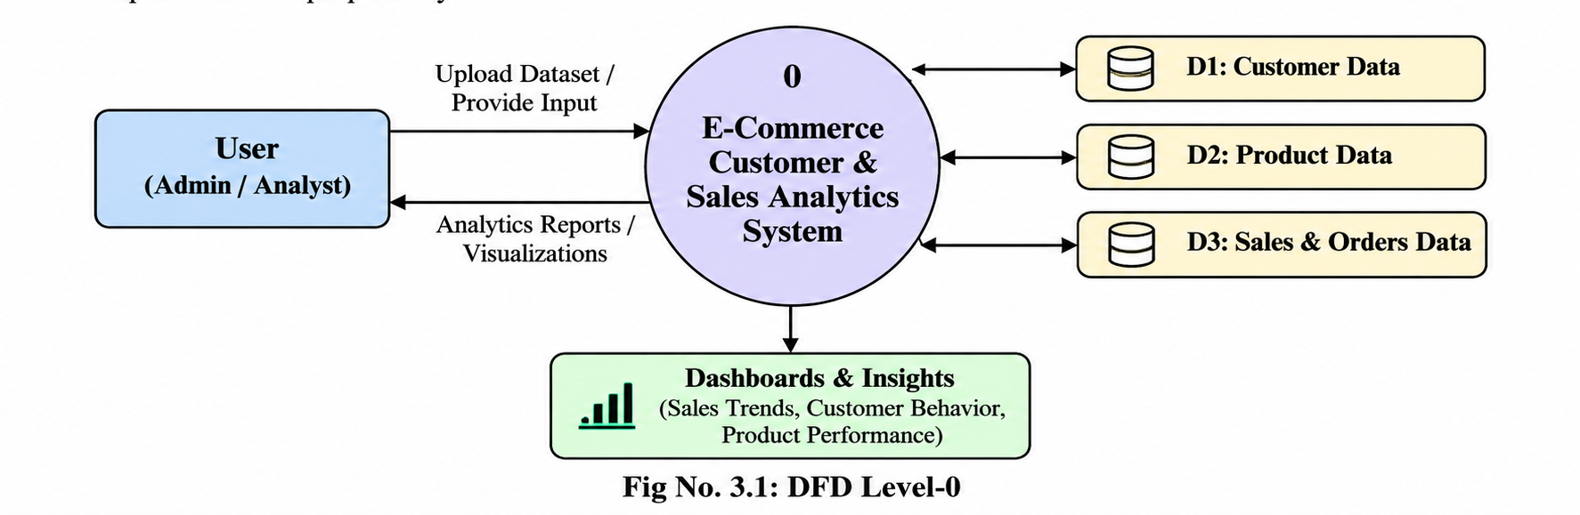

Fig. 1. Workflow of the proposed e-commerce analytics framework.

A. Data Collection and Preprocessing
The input is a transaction-level dataset containing order identifiers, order dates, customer identifiers, product and category information, region, sales, profit, quantity, and discount fields. The dashboard accepts CSV files and includes a built-in Superstore-style sample dataset. Preprocessing checks missing values, duplicate records, date validity, and numerical fields. The sidebar supports date-range, region, and category filtering; all displayed metrics reflect the active filters.

B. Customer Feature Engineering
For each customer, the system aggregates transaction history into three behavioral variables: Annual Spending, Purchase Frequency, and Average Order Value (AOV). Annual Spending represents the customer's total spending in the selected period; Purchase Frequency counts purchase activity; and AOV is the average monetary value per order. These complementary measures distinguish customers who spend frequently from those who make fewer but larger purchases.

C. K-Means Customer Segmentation
K-Means partitions customer feature vectors into K groups by minimizing the within-cluster sum of squared distances to cluster centroids. The dashboard exposes the number of clusters as an interactive parameter; the displayed run uses K = 6. Cluster profiles are summarized using customer count, average spending, average frequency, average order value, and average profit. The silhouette score is shown as a compact indication of cluster cohesion and separation.

D. Transaction Outlier Detection
The outlier module offers two methods: the interquartile range rule and Isolation Forest. For IQR detection, the lower and upper limits are calculated as Q1 − 1.5 × IQR and Q3 + 1.5 × IQR. Transactions outside the selected bounds are flagged for review. Isolation Forest provides an alternative unsupervised machine-learning approach. A flagged record is an unusual observation and is not automatically evidence of fraud or an error.

E. Monthly Sales Trend and Forecast
Transactions are aggregated by month to construct the historical sales series. A baseline linear-trend model is used to project the selected number of future months. Holdout mean absolute error (MAE) and root mean squared error (RMSE) are reported to communicate forecast error. The forecast is intended as an educational baseline; it does not model all seasonal, promotional, or external demand factors.

F. Data Quality and Export
The data-quality module reports the number of rows after filtering, number of columns, duplicate rows, missing cells, unique customers, and unique orders. Users can inspect a preview of the filtered records and download analytical outputs such as customer segments, flagged transactions, forecast values, and filtered data.
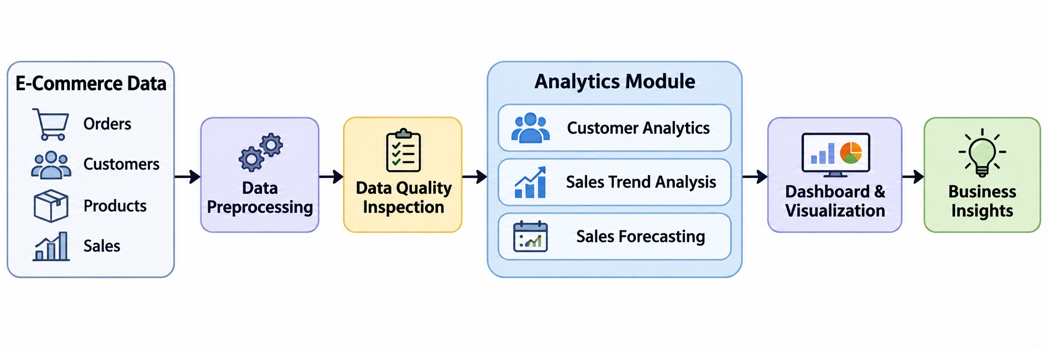

Fig.1 ARICHTECTURE OVERFLOW

IV. IMPLEMENTATION
The application is implemented in Python using Pandas for data manipulation, Scikit-learn for machine-learning operations, Plotly for interactive visualizations, and Streamlit for the web-based interface. The sidebar contains the CSV uploader and filter controls. KPI cards summarize total sales, total profit, order count, customer count, and average order value. Navigation tabs separate the analysis into Overview, Customer Segments, Outlier Detection, Sales Trends, and Data Quality & Export.
The implementation is modular: filtered transaction data is reused across the analysis views; customer aggregation feeds the clustering module; the outlier module evaluates transaction-level numeric variables; and monthly aggregation feeds the forecasting module. This arrangement keeps the dashboard consistent when users change filters or upload a different dataset.

V. RESULTS AND DISCUSSION
The supplied sample dataset contains 1,200 transaction rows and 179 unique customers. With the displayed date, region, and category filters, the dashboard reports total sales of ₹1,014,780, total profit of ₹54,064, 1,200 orders, 179 customers, and an average order value of ₹846. The reported profit margin is 5.3%. These are the values visible in the supplied dashboard screenshots and describe the sample-data run, not a universal result for other uploaded files.

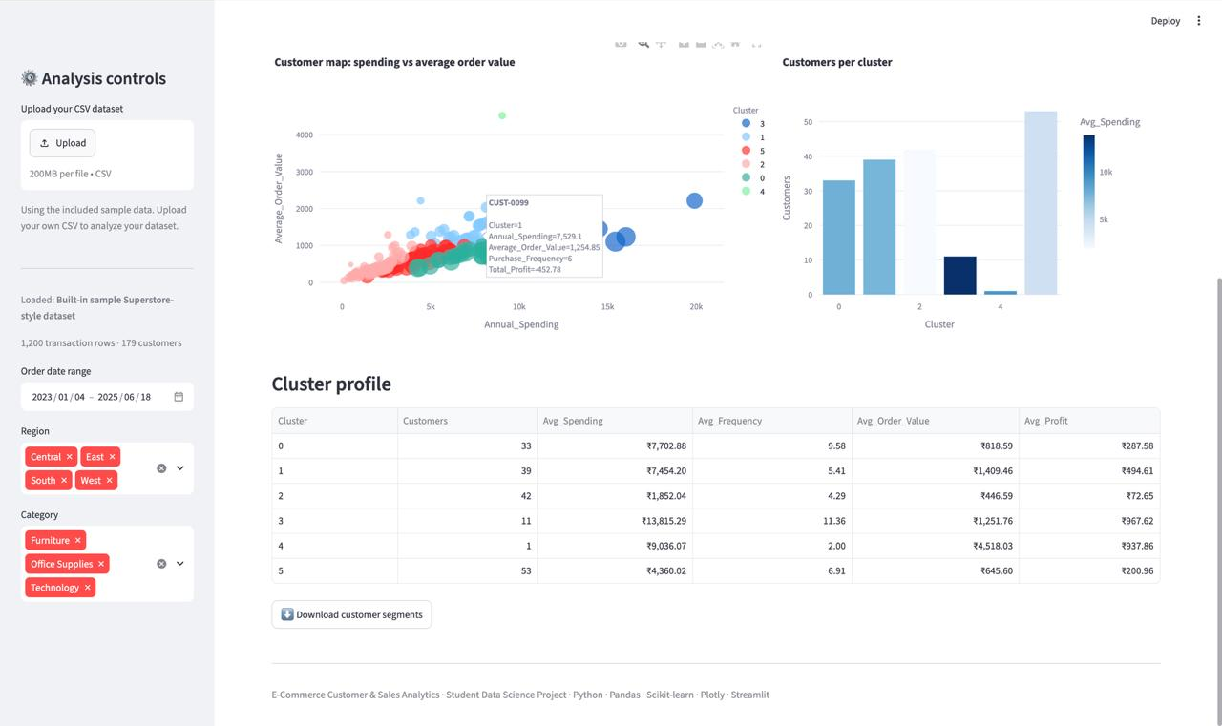

Fig. 2. Customer segmentation dashboard showing the six-cluster setting and customer behavior map.

The customer segmentation view uses K = 6 and reports a silhouette score of 0.335 for 179 clustered customers. The customer map plots annual spending against average order value, with colors indicating cluster membership. The cluster profile table in Fig. 3 gives the following customer counts: Cluster 0—33, Cluster 1—39, Cluster 2—42, Cluster 3—11, Cluster 4—1, and Cluster 5—53. Cluster 5 is the largest group, while Cluster 4 contains a single customer. The silhouette score indicates some cluster structure, while the visible overlap in the scatter plot suggests that customer behavior is not perfectly separated.

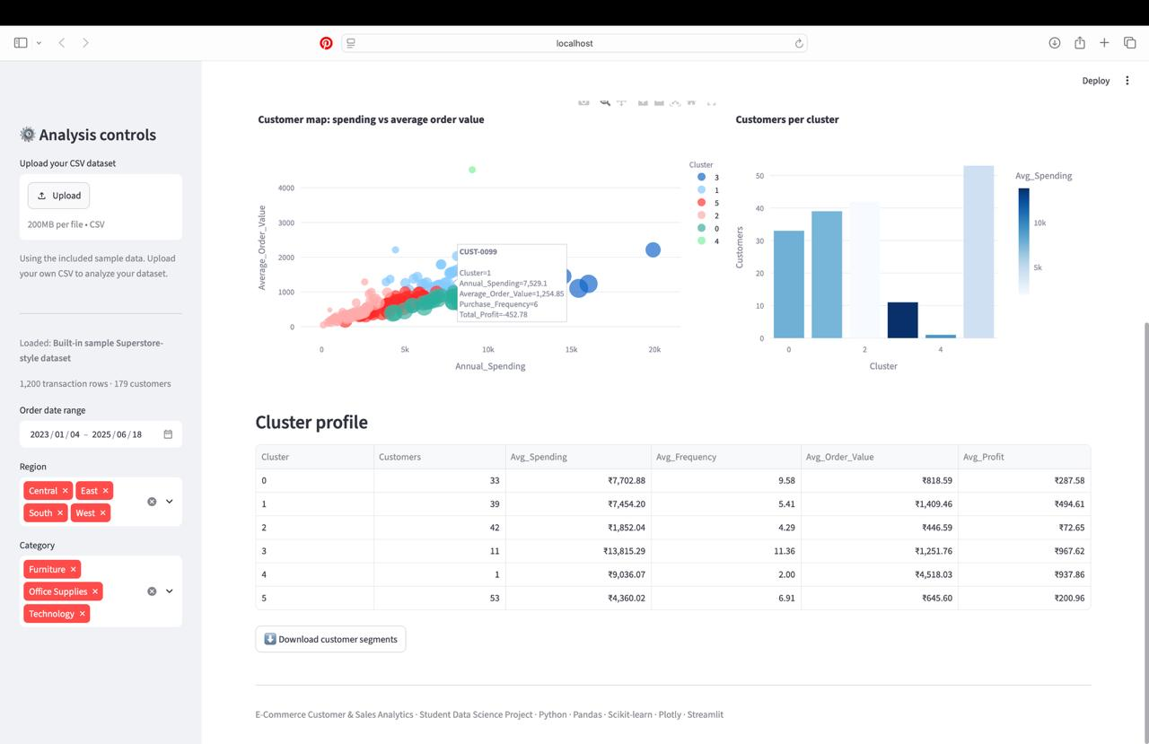
Fig. 3. Cluster scatter plot and cluster-level profile statistics.

The cluster profile further shows differences in spending patterns. Cluster 3 has the highest displayed average spending (₹13,815.29) and average profit (₹967.62), while Cluster 4 has the highest average order value (₹4,518.03) but contains only one customer. Cluster 5 has 53 customers and average spending of ₹4,360.02. These results demonstrate why a customer group should be interpreted using multiple measures and its population size.
For transaction anomaly detection, the supplied run uses the IQR method on sales. The dashboard reports a lower bound of −₹1,277.92 and an upper bound of ₹2,541.09. It flags 96 transactions, representing 8.0% of the records, with ₹354,980 in sales among flagged rows. The chart and review table show the transactions that exceed the statistical limits. These records require contextual review and should not be labelled fraudulent solely because they are statistical outliers.

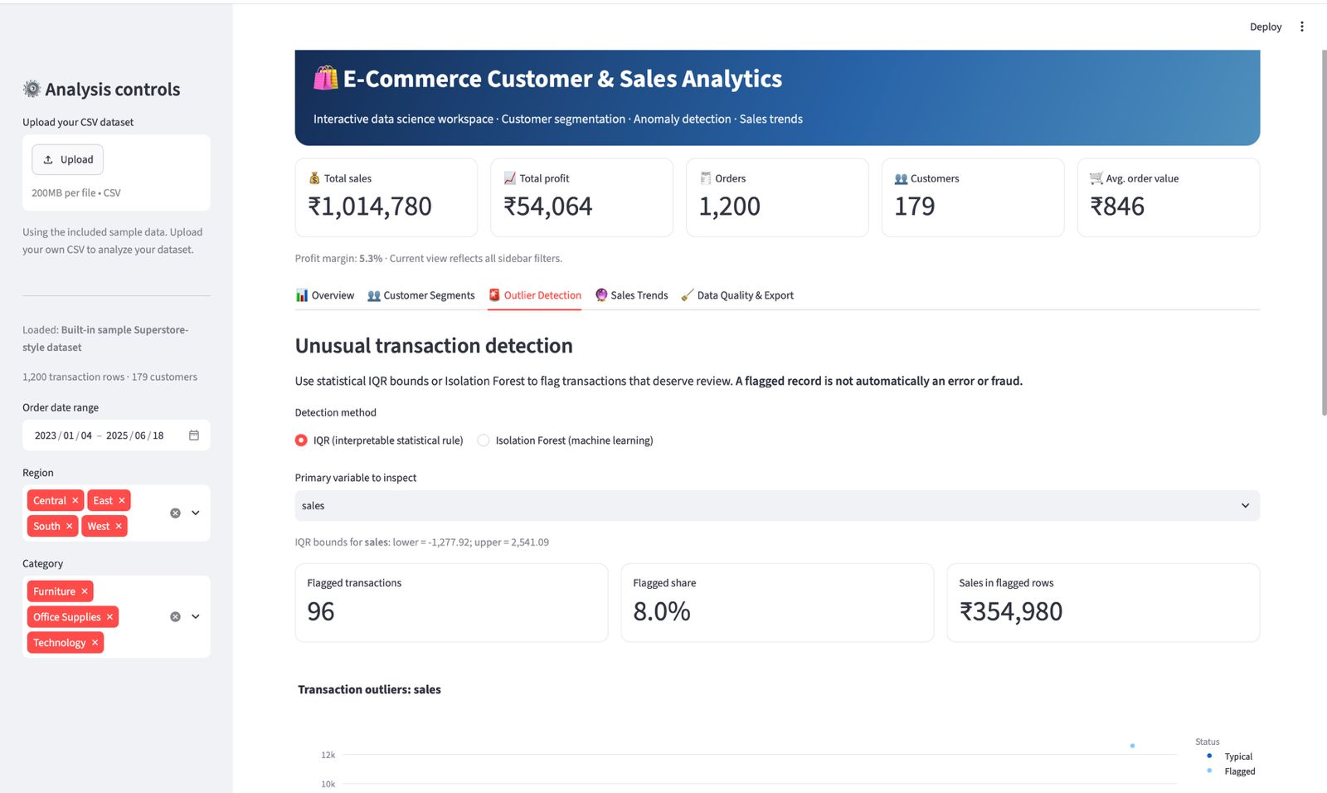
Fig. 4. Outlier detection controls and summary of flagged transactions.

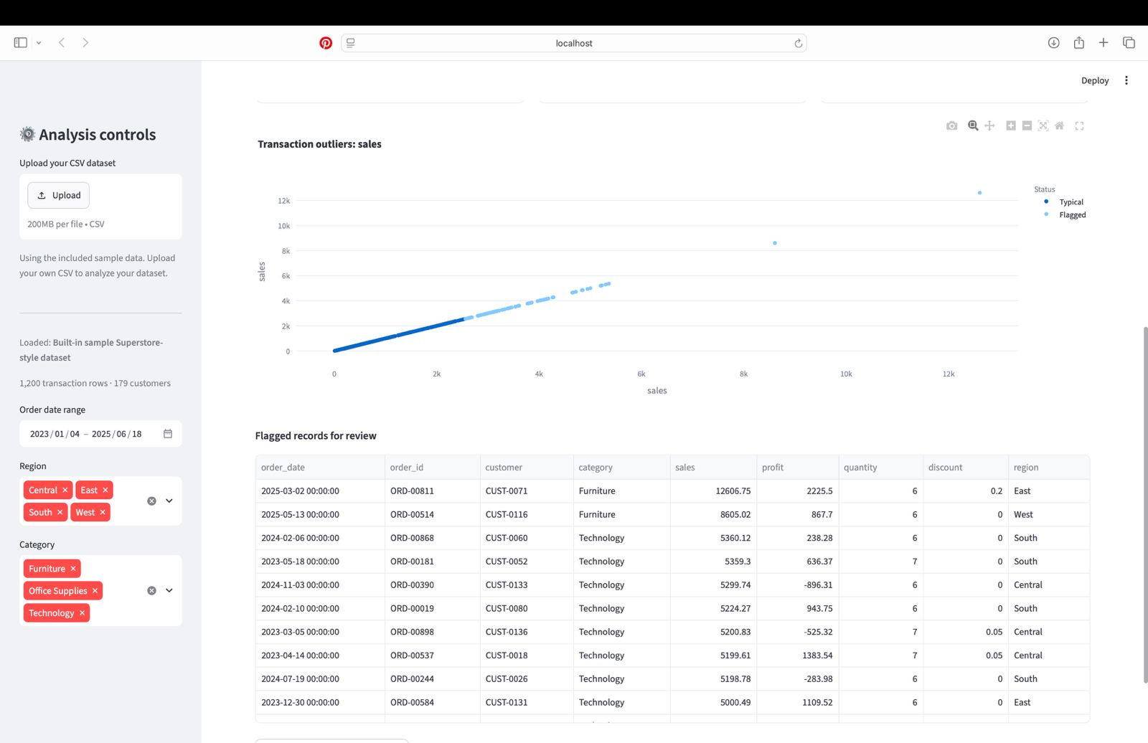
Fig. 5. Sales outlier visualization and sample flagged records.

The sales-trend module aggregates monthly sales and displays a baseline forecast for three months. The dashboard reports a holdout MAE of ₹8,576 and RMSE of ₹10,868. The forecast values shown are ₹31,156.92 for July 2025, ₹30,984.72 for August 2025, and ₹30,812.52 for September 2025. The forecast line is relatively stable and slightly decreasing. Because the application labels this as a baseline linear-trend forecast, the values should be treated as indicative estimates rather than guaranteed future sales.

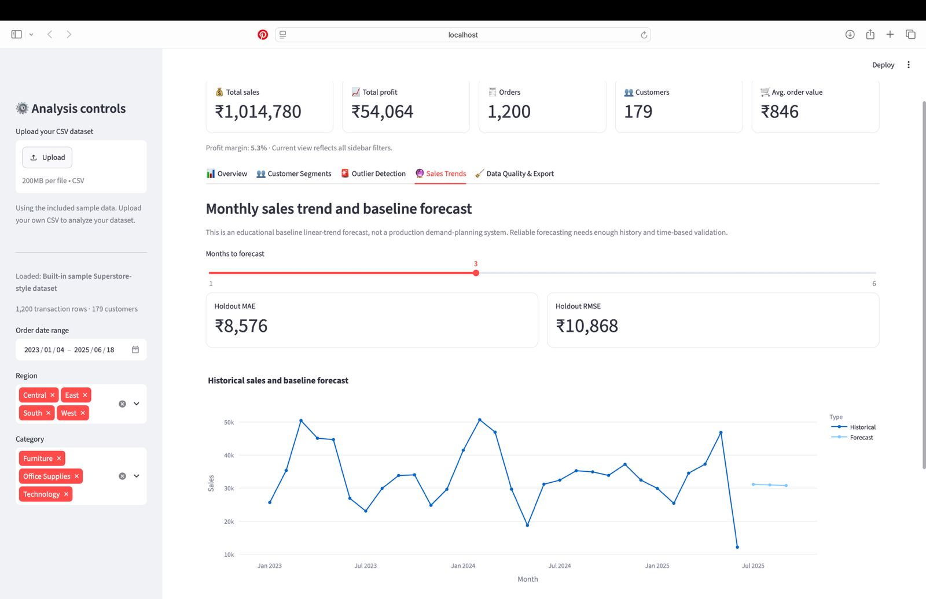
Fig. 6. Monthly historical sales and baseline forecast.
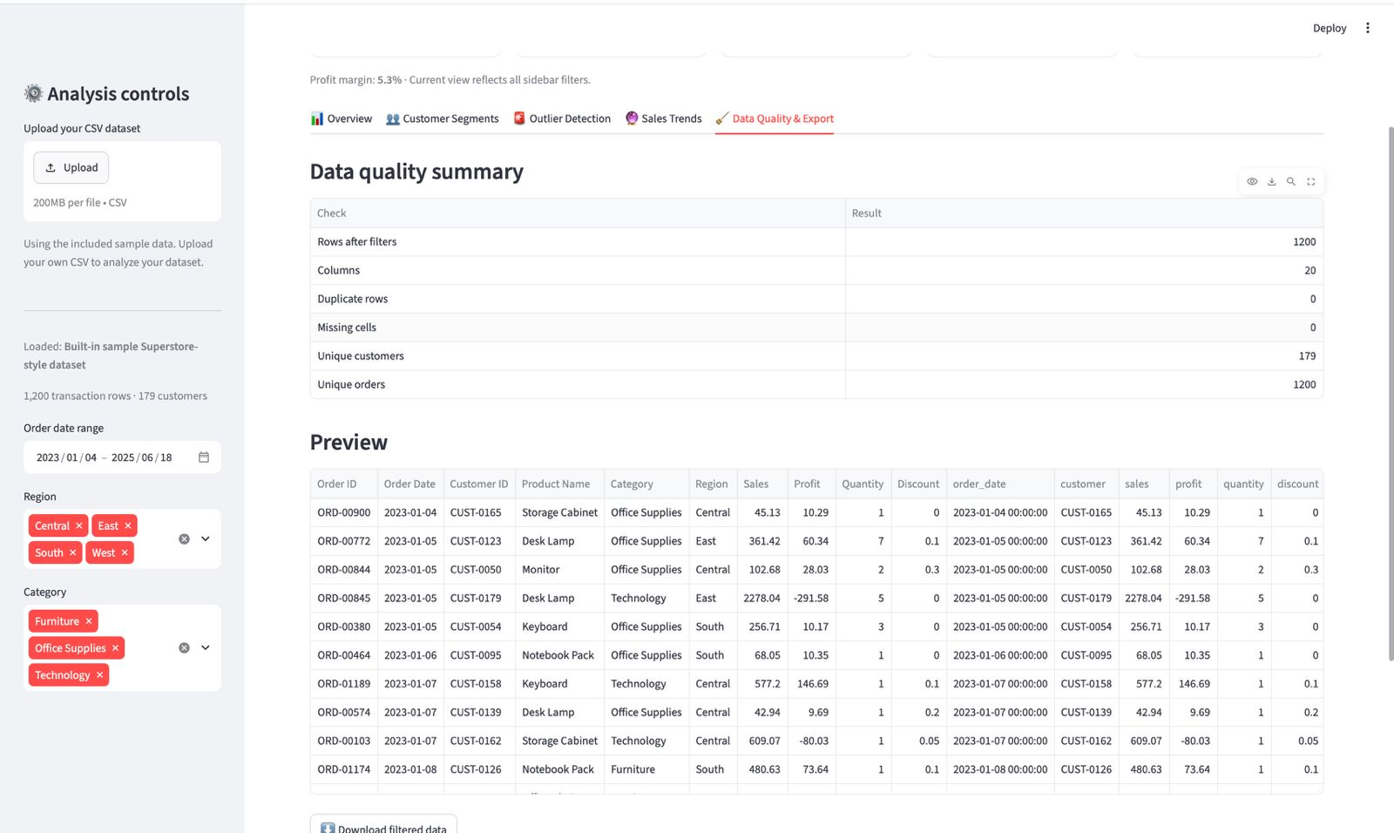

Fig. 7. Forecast error metrics and projected monthly sales.

The data-quality summary reports 1,200 rows after filtering, 20 columns, zero duplicate rows, zero missing cells, 179 unique customers, and 1,200 unique orders. The preview table allows users to inspect the filtered dataset before export. These checks indicate that the displayed sample run is structurally complete according to the dashboard's reported tests.

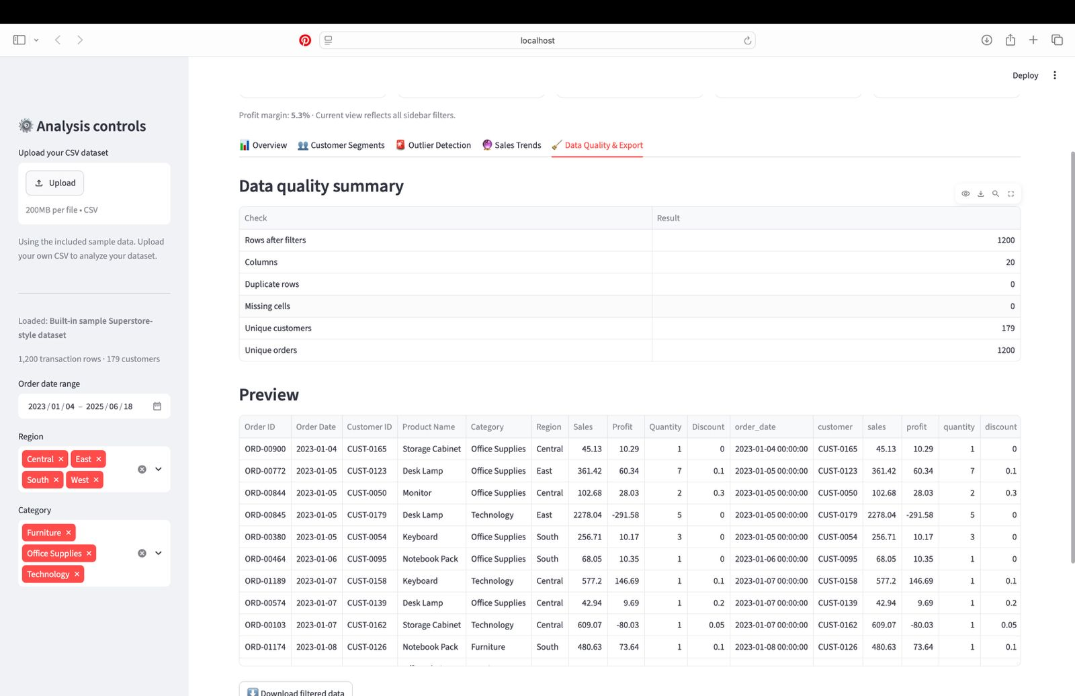
Fig. 8. Data-quality summary and filtered transaction preview.

VI. CONCLUSION
This paper presented an integrated e-commerce analytics framework that transforms transaction records into customer, sales, anomaly, and forecasting insights. The sample run contains 1,200 transactions and 179 customers, with total sales of ₹1,014,780 and total profit of ₹54,064. K-Means produced six customer groups with a silhouette score of 0.335. The IQR method flagged 96 transactions (8.0%) for review, while the monthly baseline forecast generated three future estimates with a holdout MAE of ₹8,576 and RMSE of ₹10,868. Data-quality checks reported no missing cells or duplicate rows in the filtered sample.
The dashboard demonstrates the value of combining customer segmentation with transaction-level monitoring and visual reporting. Its interactive filters and export functions make the analysis easier to inspect and reproduce. The results should nevertheless be interpreted within the limits of the supplied sample dataset, the selected filters, and the baseline models.
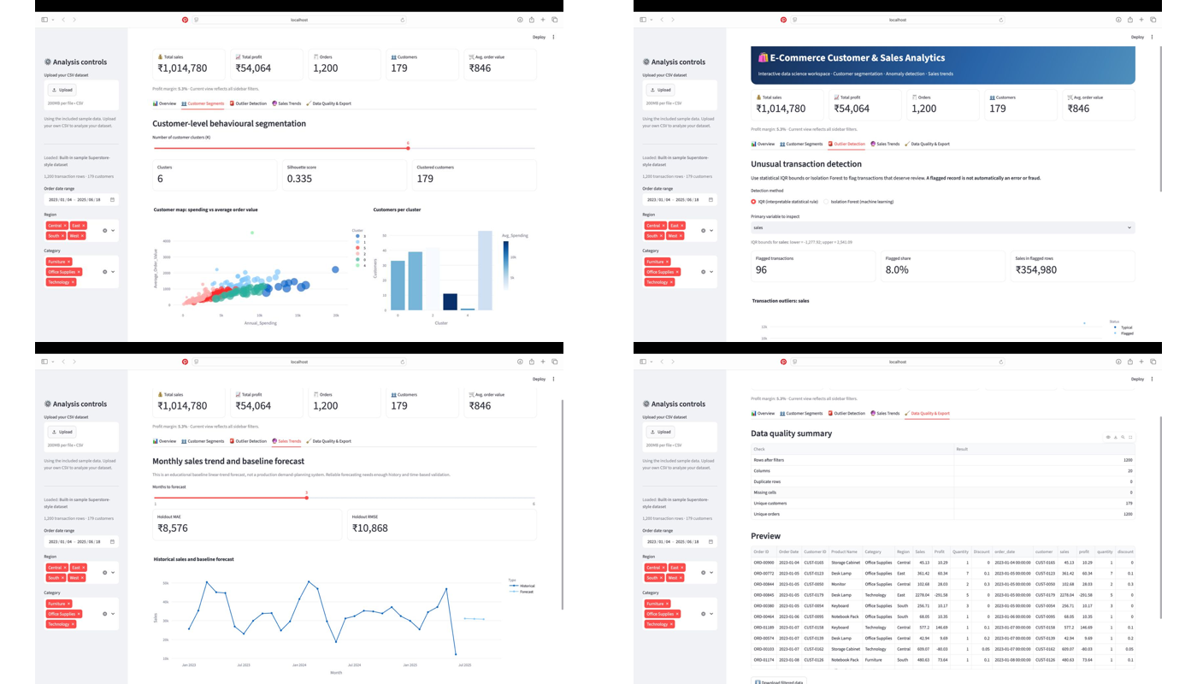
Fig. 9. Consolidated views of customer segmentation, outlier detection, sales trends, and data quality.

VII. FUTURE SCOPE
Future work can incorporate product-category diversity, discount sensitivity, return behavior, customer lifetime value, and more detailed recency measures when these fields are available. Cluster quality can be improved by comparing different K values and alternative algorithms such as K-medoids or DBSCAN. Forecasting can be extended with seasonal models and longer validation periods. Additional modules may include churn-risk prediction, personalized recommendations, and customer-level drill-down reports.

REFERENCES
[1] U. Fayyad, G. Piatetsky-Shapiro, and P. Smyth, “From data mining to knowledge discovery in databases,” AI Magazine, vol. 17, no. 3, pp. 37–54, 1996, doi: 10.1609/aimag.v17i3.1230.
[2] C. Rygielski, J.-C. Wang, and D. C. Yen, “Data mining techniques for customer relationship management,” Technology in Society, vol. 24, no. 4, pp. 483–502, 2002, doi: 10.1016/S0160-791X(02)00038-6.
[3] W. T. Ngai, L. Xiu, and D. C. K. Chau, “Application of data mining techniques in customer relationship management: A literature review and classification,” Expert Systems with Applications, vol. 36, no. 2, pp. 2592–2602, 2009, doi: 10.1016/j.eswa.2008.02.021.
[4] H. Chen, R. H. L. Chiang, and V. C. Storey, “Business intelligence and analytics: From big data to big impact,” MIS Quarterly, vol. 36, no. 4, pp. 1165–1188, 2012, doi: 10.2307/41703503.
[5] P. C. Verhoef, P. K. Kannan, and J. J. Inman, “From multi-channel retailing to omni-channel retailing: Introduction to the special issue on multi-channel retailing,” Journal of Retailing, vol. 91, no. 2, pp. 174–181, 2015, doi: 10.1016/j.jretai.2015.02.005.
[6] M. Wedel and P. K. Kannan, “Marketing analytics for data-rich environments,” Journal of Marketing, vol. 80, no. 6, pp. 97–121, 2016, doi: 10.1509/jm.15.0413.
[7] V. Kumar and W. Reinartz, Creating Enduring Customer Value. Berlin, Germany: Springer, 2016.
[8] J. Wu, L. Shi, L. Yang, X. Niu, Y. Li, X. Cui, S.-B. Tsai, and Y. Zhang, “User value identification based on improved RFM model and K-means++ algorithm for complex data analysis,” Wireless Communications and Mobile Computing, vol. 2021, Art. no. 9982484, 2021, doi: 10.1155/2021/9982484.
[9] P. Li, C. Wang, J. Wu, and R. Madleňák, “An e-commerce customer segmentation method based on RFM weighted K-means,” in Proc. 2022 Int. Conf. Management Engineering, Software Engineering and Service Sciences (ICMSS), Wuhan, China, 2022, pp. 61–68, doi: 10.1109/ICMSS55574.2022.00017.
[10] Z. Wu, L. Jin, J. Zhao, L. Jing, and L. Chen, “Research on segmenting e-commerce customer through an improved K-medoids clustering algorithm,” Computational Intelligence and Neuroscience, vol. 2022, Art. no. 9930613, 2022, doi: 10.1155/2022/9930613.
[11] M. A. Gomes and T. Meisen, “A review on customer segmentation methods for personalized customer targeting in e-commerce use cases,” Information Systems and e-Business Management, vol. 21, no. 3, pp. 527–570, 2023, doi: 10.1007/s10257-023-00640-4.
[12] D. Mehta and S. Sehgal, “A study on micro-segmentation of retail customers using K-means clustering,” Journal of Business Thought, vol. 15, pp. 75–87, 2024, doi: 10.18311/jbt/2024/44468.
[13] “Research on the classification of e-commerce users based on RFM model and K-means algorithm,” in Proc. 2023 IEEE Int. Conf. Electrical, Automation and Computer Engineering (ICEACE), 2023, doi: 10.1109/ICEACE60673.2023.10441878.
[14] D. Chen, S. L. Sain, and K. Guo, “Data mining for the online retail industry: A case study of RFM model-based customer segmentation using data mining,” Journal of Database Marketing & Customer Strategy Management, vol. 19, no. 3, pp. 197–208, 2012, doi: 10.1057/dbm.2012.17.
[15] M. S. Kasem, M. Hamada, and I. Taj-Eddin, “Customer profiling, segmentation, and sales prediction using AI in direct marketing,” Neural Computing and Applications, vol. 36, pp. 4995–5005, 2024, doi: 10.1007/s00521-023-09339-6.
[16] S. Kim, W. Shin, and H.-W. Kim, “Predicting online customer purchase: The integration of customer characteristics and browsing patterns,” Decision Support Systems, vol. 177, Art. no. 114105, Feb. 2024, doi: 10.1016/j.dss.2023.114105.

