CREATE TABLE PERSON1(LAST_NAME Varchar(20),FIRST_NAME Varchar(20),EMPLOYEE_ID Number(15),SALARY Number(20),DEPARTMENT_NAME Varchar(20),DEPARTMENT_ID Number(18)); 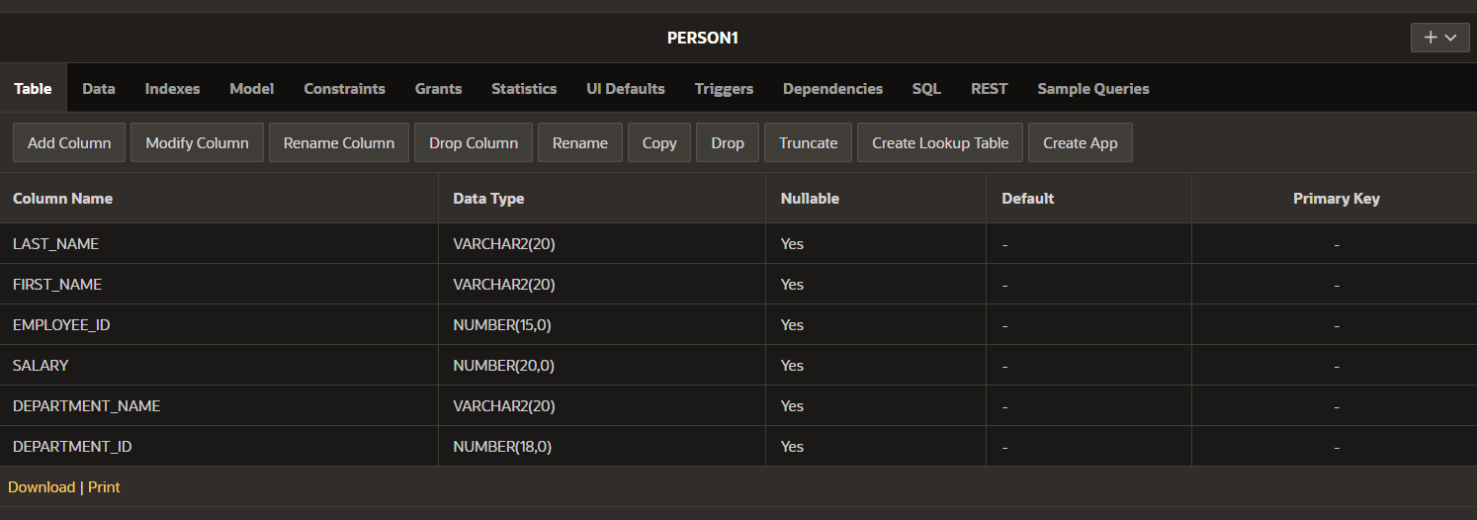

INSERT INTO PERSON1 VALUES('PRIYADARSHINI','CHALLA',105,100000,'CSE',121);

INSERT INTO PERSON1 VALUES('NEHACHATURYA','CHALLA',137,200000,'MEDICAL',345);

INSERT INTO PERSON1 VALUES('SEETHARAMULU','CHALLA',543,640000,'AIML',542);

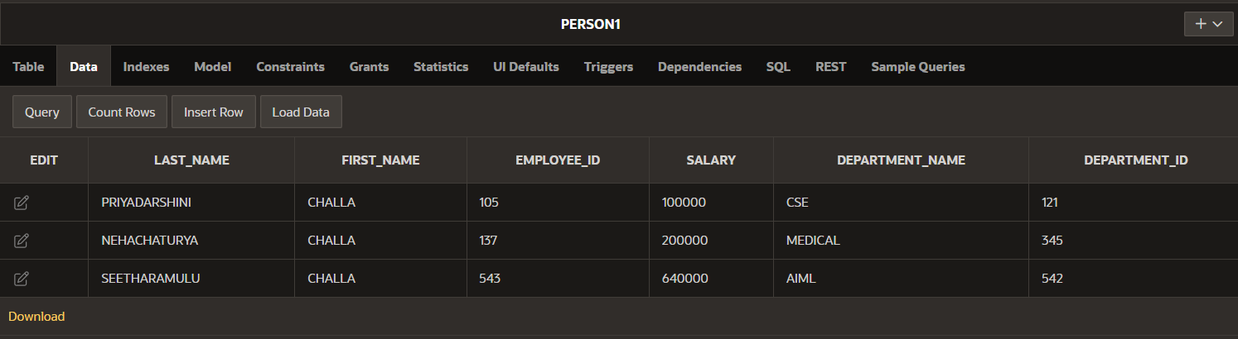

SELECT MAX(SALARY), MIN(SALARY), MIN(EMPLOYEE_ID)

FROM PERSON1

WHERE DEPARTMENT_ID = 121;

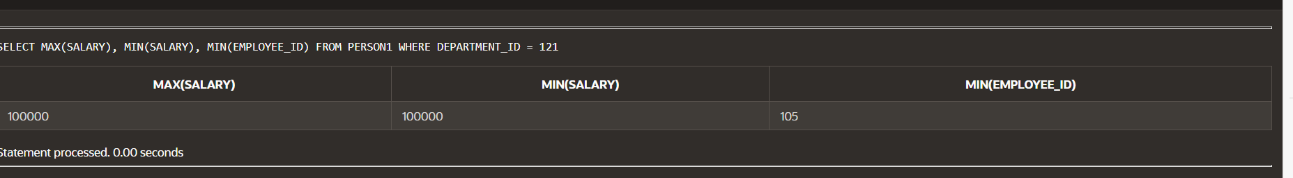

SELECT COUNT(EMPLOYEE_ID)

FROM PERSON1;

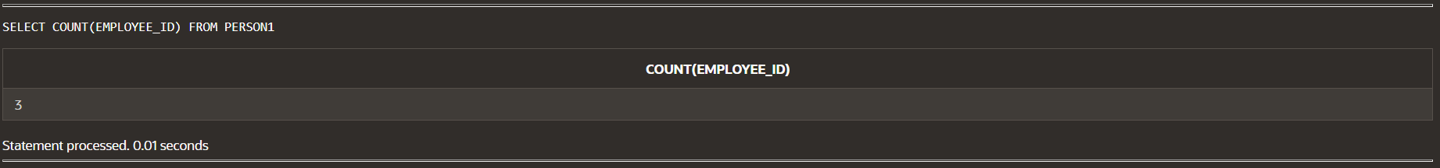

SELECT COUNT(*)

FROM PERSON1

WHERE DEPARTMENT_ID < 400;

-----🡪DISTINCT:



SELECT DISTINCT EMPLOYEE_ID

FROM PERSON1;

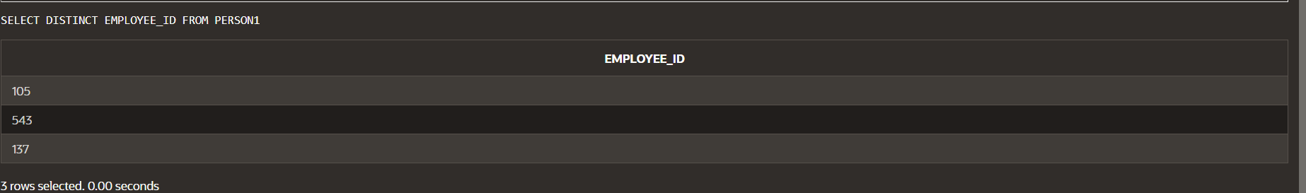

SELECT AVG(DEPARTMENT_ID)

FROM PERSON1;

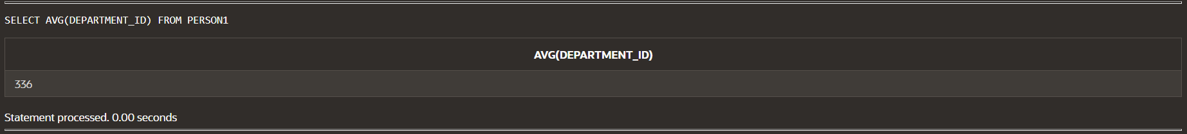

SELECT AVG(NVL(DEPARTMENT_ID, 0))

FROM PERSON1;

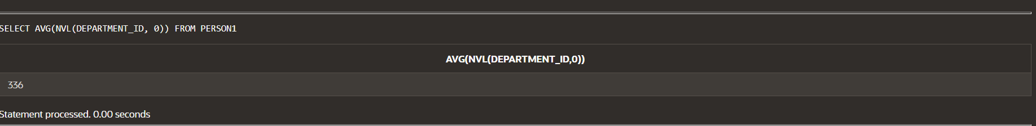

SELECT DEPARTMENT_ID,AVG(SALARY)

FROM PERSON1

GROUP BY DEPARTMENT_ID

ORDER BY DEPARTMENT_ID;

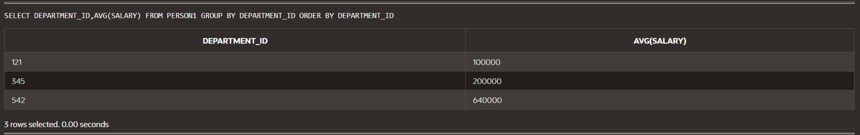

SELECT DEPARTMENT_ID,MAX(SALARY)

FROM PERSON1

GROUP BY DEPARTMENT_ID;

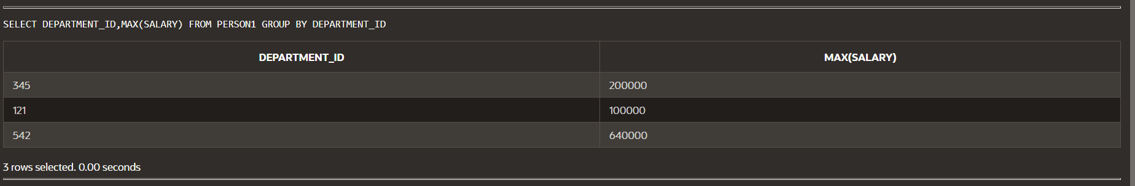

SELECT DEPARTMENT_ID,EMPLOYEE_ID,

COUNT(*)

FROM PERSON1

WHERE DEPARTMENT_ID > 200

GROUP BY DEPARTMENT_ID,EMPLOYEE_ID;

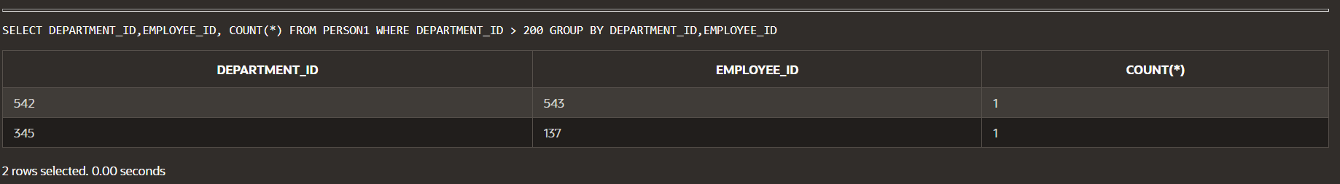

SELECT EMPLOYEE_ID,MAX(SALARY)

FROM PERSON1

GROUP BY EMPLOYEE_ID

HAVING COUNT(*)>400

ORDER BY EMPLOYEE_ID;

---🡪ROLLUP:

SELECT DEPARTMENT_ID,EMPLOYEE_ID,SUM(SALARY)

FROM PERSON1

WHERE DEPARTMENT_ID < 200

GROUP BY ROLLUP(DEPARTMENT_ID,EMPLOYEE_ID);

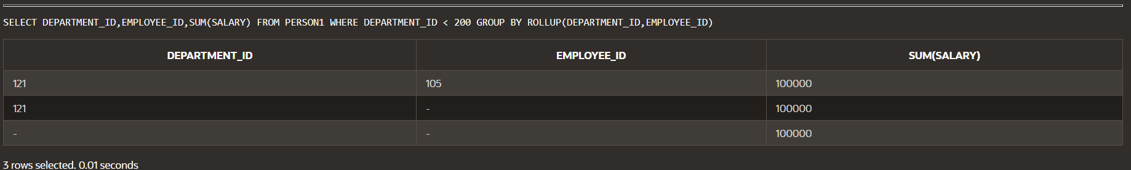

---🡪WITHOUT ROLLUP:

SELECT DEPARTMENT_ID,EMPLOYEE_ID,SUM(SALARY)

FROM PERSON1

WHERE DEPARTMENT_ID < 200

GROUP BY (DEPARTMENT_ID,EMPLOYEE_ID);

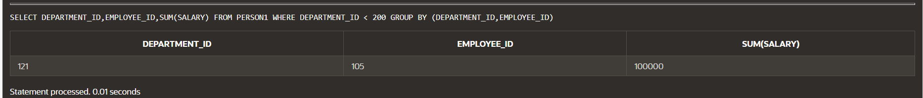

----🡪CUBE:

SELECT DEPARTMENT_ID,EMPLOYEE_ID,SUM(SALARY)

FROM PERSON1

WHERE DEPARTMENT_ID < 200

GROUP BY CUBE (DEPARTMENT_ID,EMPLOYEE_ID);

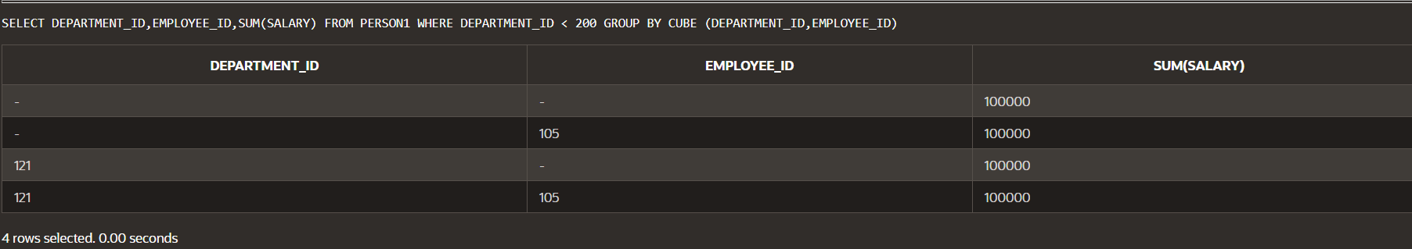

---🡪GROUPING SET:

SELECT DEPARTMENT_ID,EMPLOYEE_ID,SUM(SALARY),DEPARTMENT_NAME

FROM PERSON1

WHERE DEPARTMENT_ID < 200

GROUP BY GROUPING SETS

((DEPARTMENT_ID,EMPLOYEE_ID),(DEPARTMENT_ID,DEPARTMENT_NAME),(EMPLOYEE_ID,DEPARTMENT_NAME));

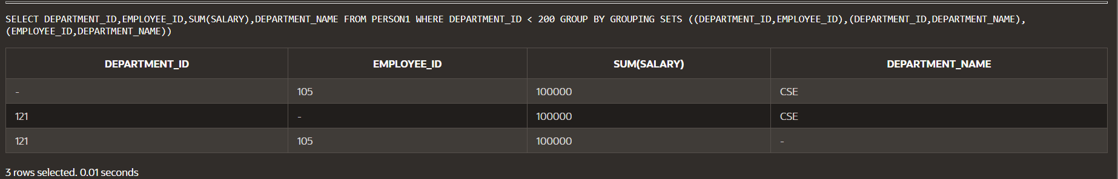

---🡪UNION:

SELECT DEPARTMENT_ID

FROM EMPLOYEES

UNION

SELECT DEPARTMENT_ID

FROM DEPARTMENTS;

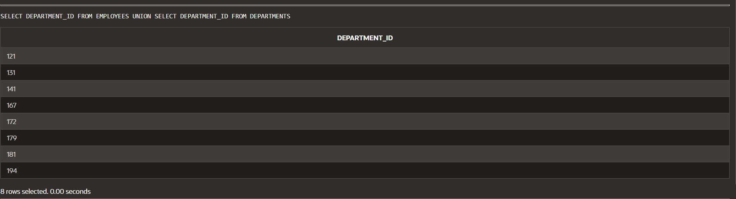

---🡪UNION ALL:

SELECT DEPARTMENT_ID

FROM EMPLOYEES

UNION ALL

SELECT DEPARTMENT_ID

FROM DEPARTMENTS;

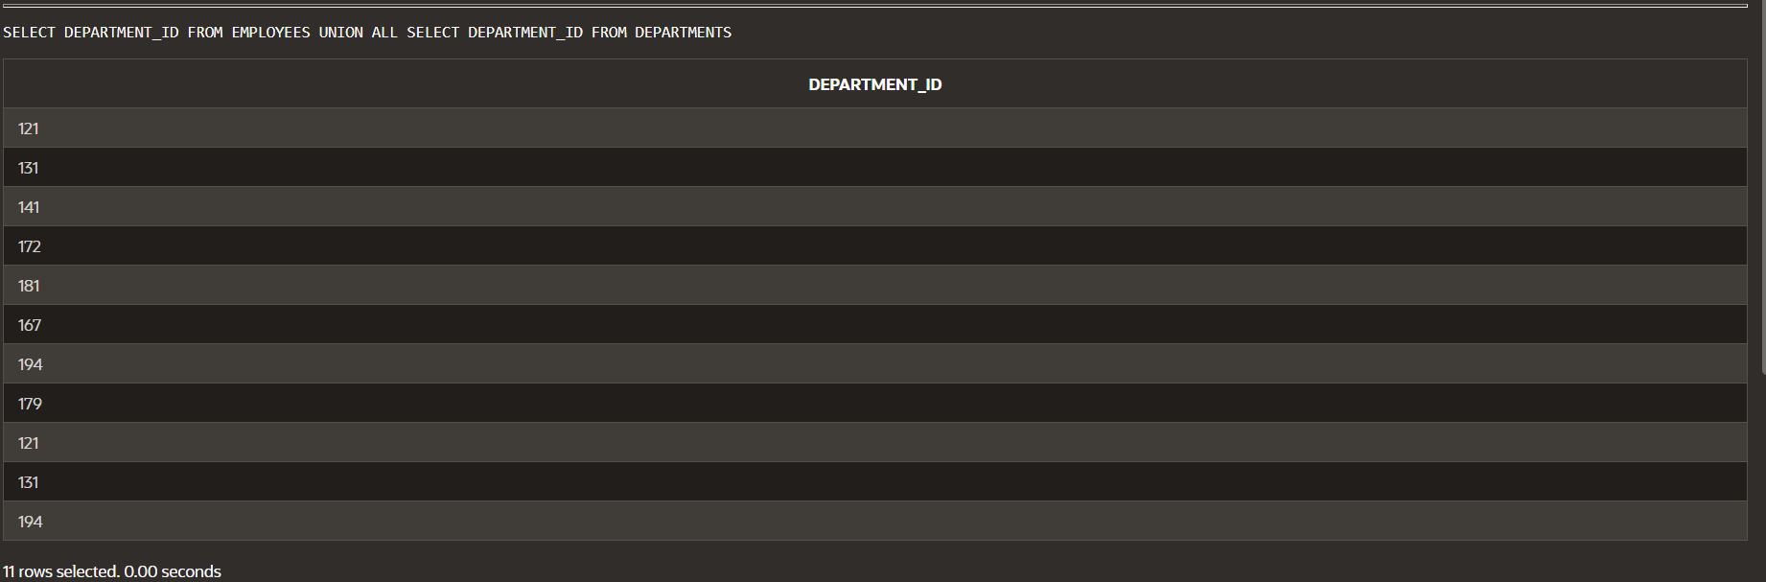

----🡪INTERSECT:

SELECT DEPARTMENT_ID

FROM EMPLOYEES

INTERSECT

SELECT DEPARTMENT_ID

FROM DEPARTMENTS;

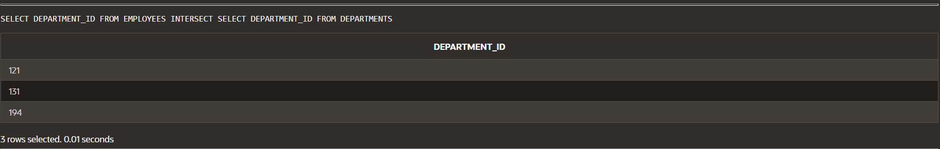

----🡪MINUS:

SELECT DEPARTMENT_ID

FROM EMPLOYEES

MINUS

SELECT DEPARTMENT_ID

FROM DEPARTMENTS;

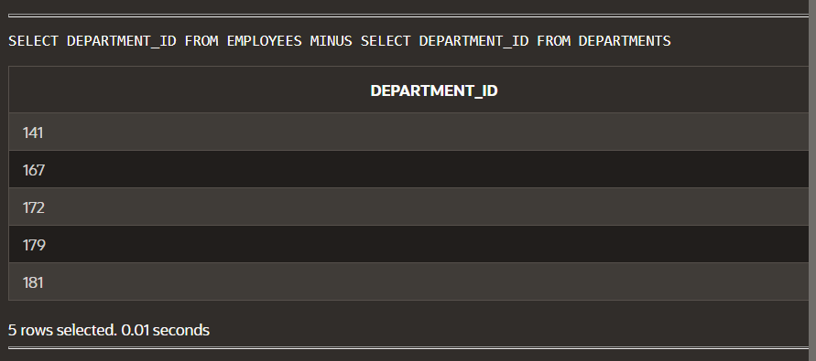

----🡪UNION USING ORDER BY:

SELECT DEPARTMENT_ID

FROM EMPLOYEES

UNION

SELECT DEPARTMENT_ID

FROM DEPARTMENTS

ORDER BY DEPARTMENT_ID;

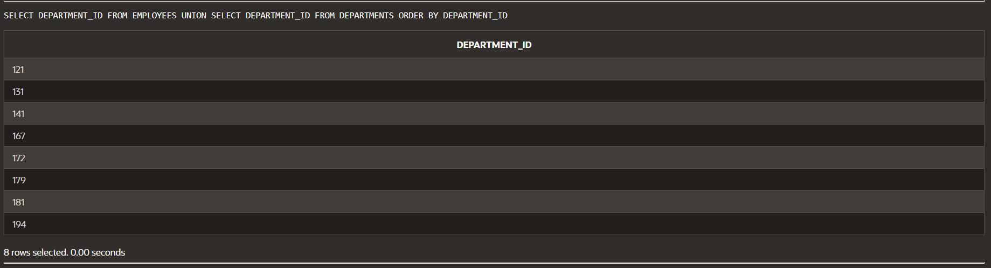

----🡪MERGE: 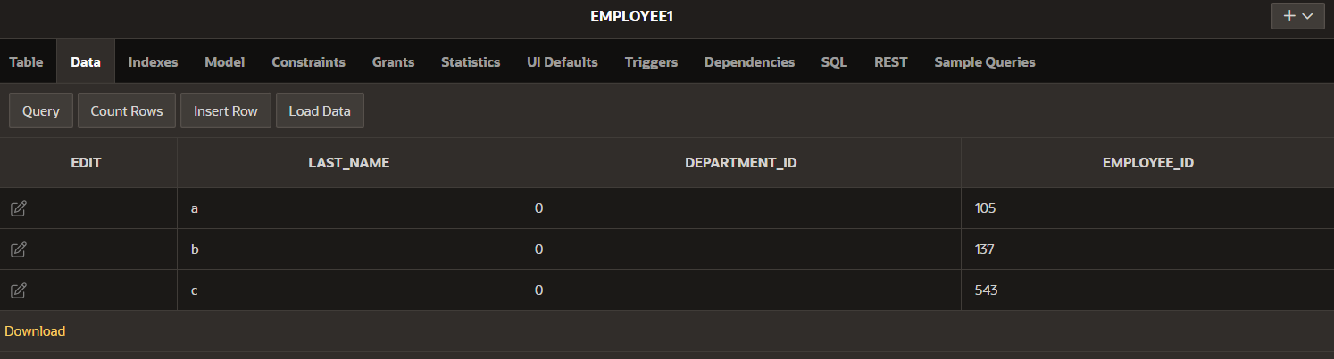

MERGE INTO PERSON1 p USING EMPLOYEE1 e

ON (p.EMPLOYEE_ID = e.EMPLOYEE_ID)

WHEN MATCHED THEN UPDATE

SET

p.LAST_NAME = e.LAST_NAME,

p.DEPARTMENT_ID = e.DEPARTMENT_ID;

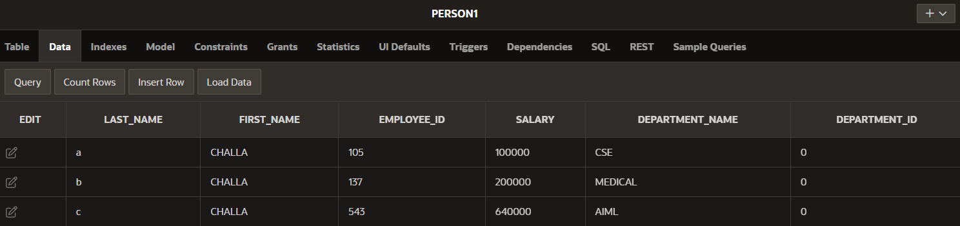

CREATE SEQUENCE runner_id_seq

INCREMENT BY 1

START WITH 1

MAXVALUE 50000

NOCACHE

NOCYCLE;

SELECT sequence_name, min_value, max_value, increment_by, last_number

FROM user_sequences;

