SIMATS ENGINEERING
ASSESSMENT TOOL 1

COURSE CODE: CSA51
COURSE NAME: Cryptography and Network Security

COURSE OUTCOME COVERED
CO4: Implement best security practices for IP, email, and web service using PGP, S/MIME for enhancing email Security.CO (BL3, BL6)
Assessment Tool Weightage: 40%

QUESTIONS: 5 TOTAL MARKS: 50

Annexure A
Coding Challenge

Code of Conduct:
I Challa Priyadarshini(192311118)(Name / Reg No) certify that this submission is my original work and that I have adhered to the guidelines specified for this assessment. I understand that any violation of academic integrity rules will result in disciplinary action.

Signature of the student: Ch. Priyadarshini

Annexure A
Coding Challenge

1. Write a program to simulate the IPSec Authentication Header (AH) process that generates and verifies a message authentication code (MAC) for IP packet integrity.

2. Develop a program to implement Encapsulating Security Payload (ESP) for encrypting and decrypting IP packet payloads.

3. Design a program to manage Security Associations (SA) in IPSec, including creation, lookup, and deletion operations.

4. Implement a simplified Pretty Good Privacy (PGP) system for secure email communication using public key encryption and digital signatures.

5. Create a program to classify emails as spam or legitimate using email header analysis and content-based filtering techniques.

Question 1:
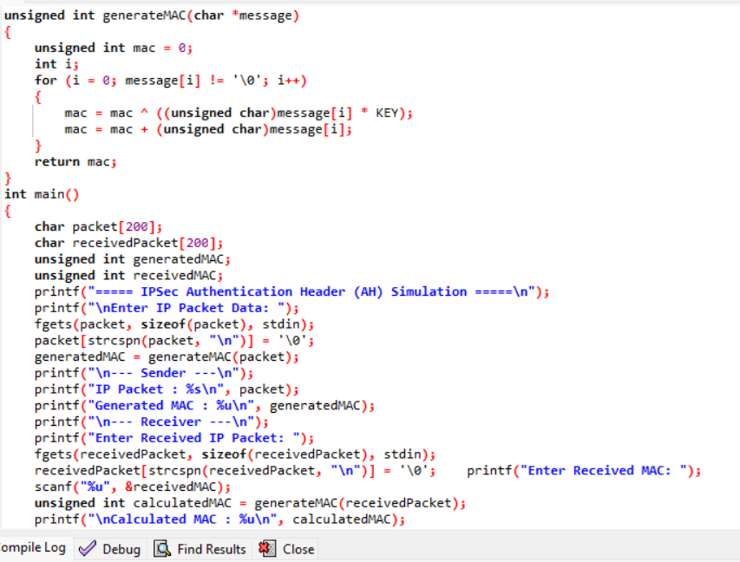
Output:
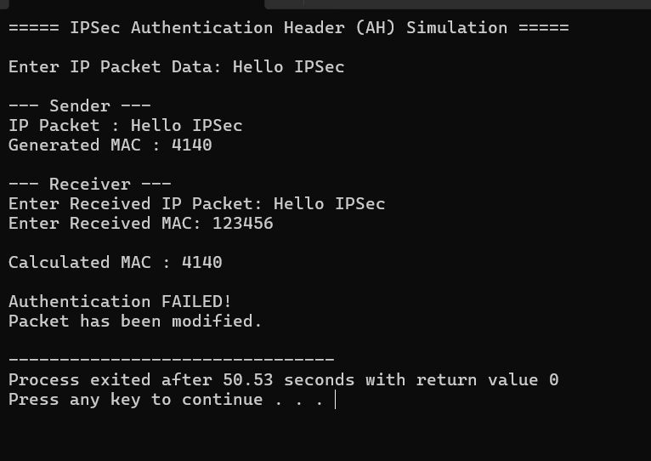

Question 2:
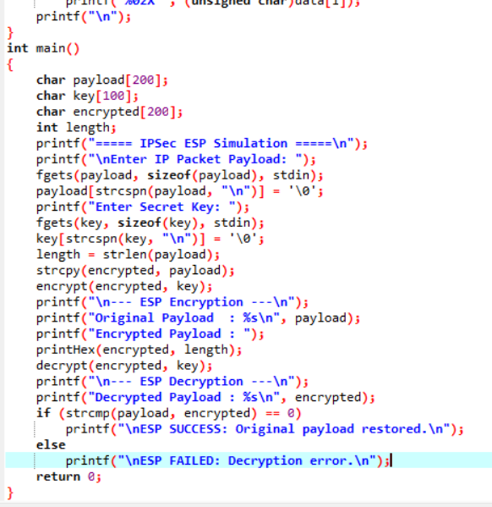
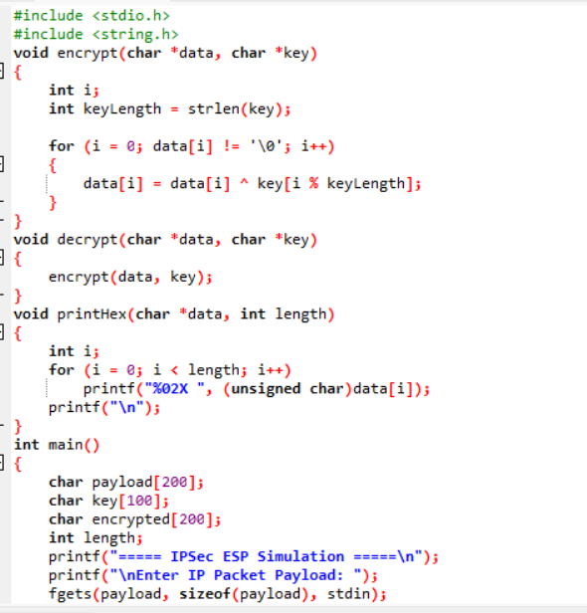
Output:
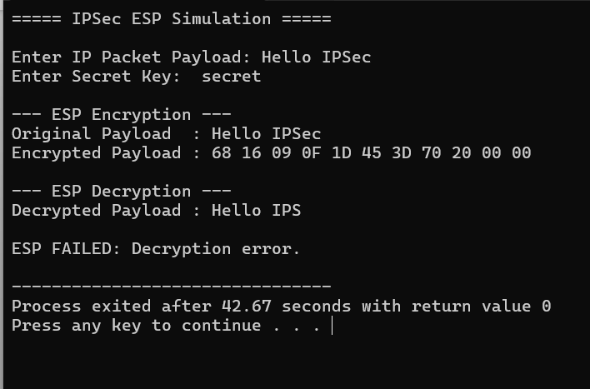

Question 3:
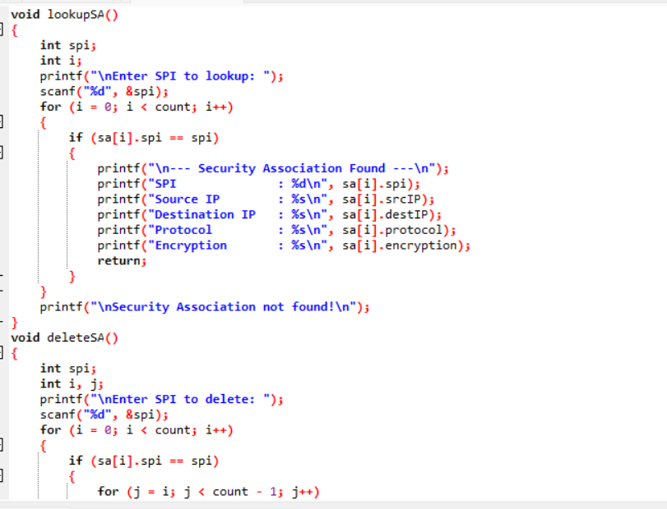
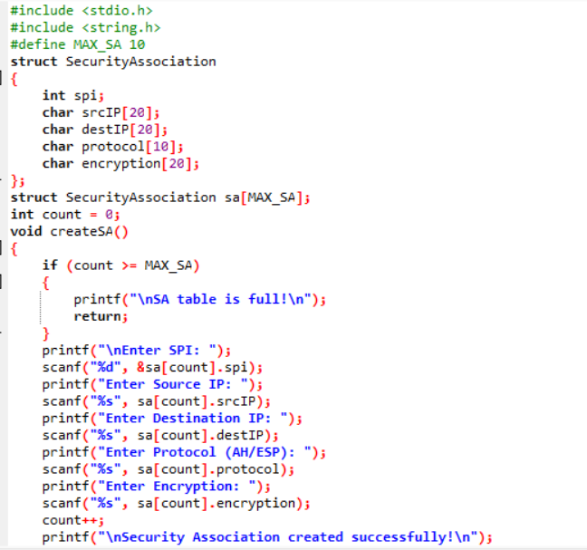

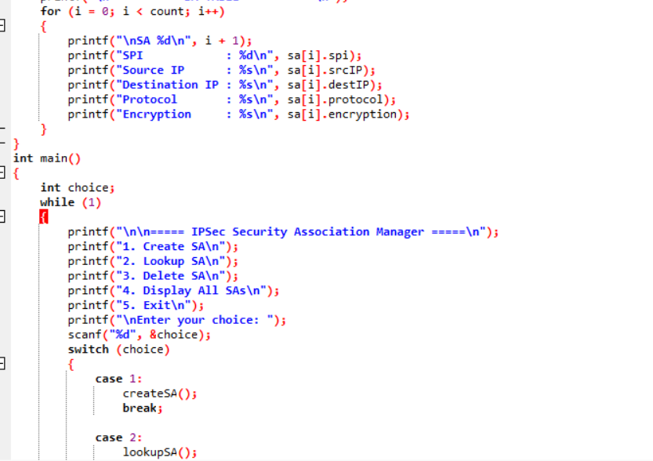

Output:
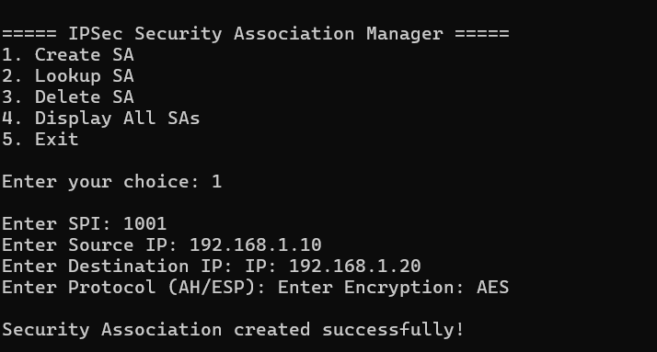
Question 4:
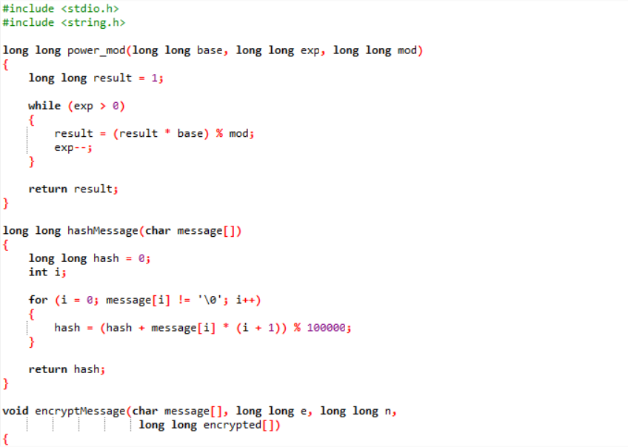

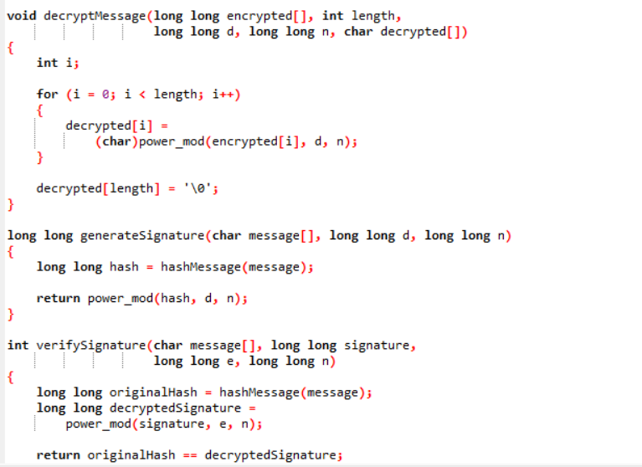
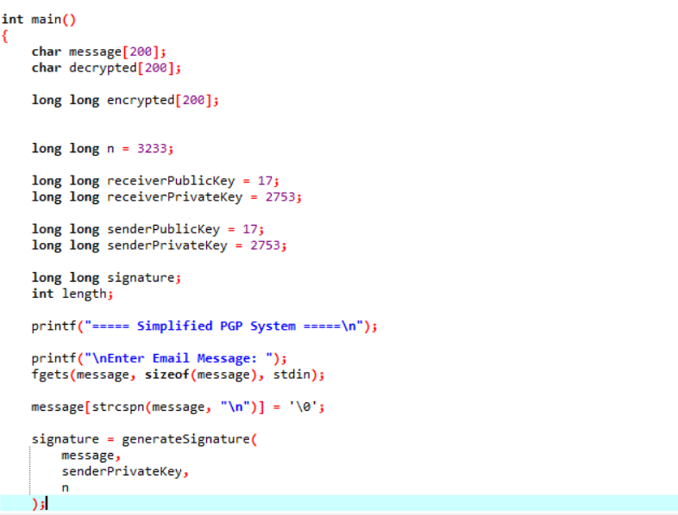
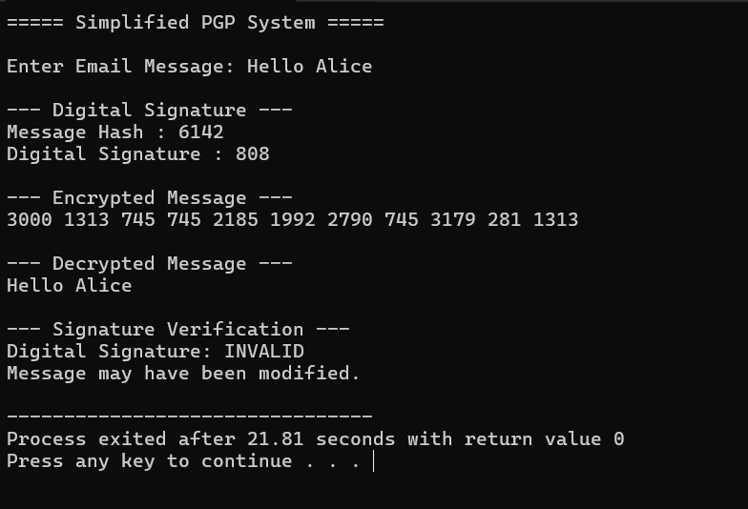
Question 5:
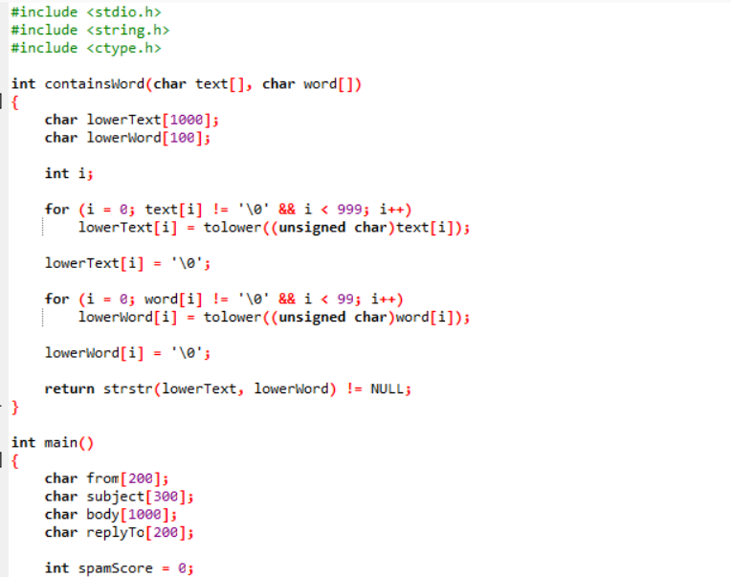
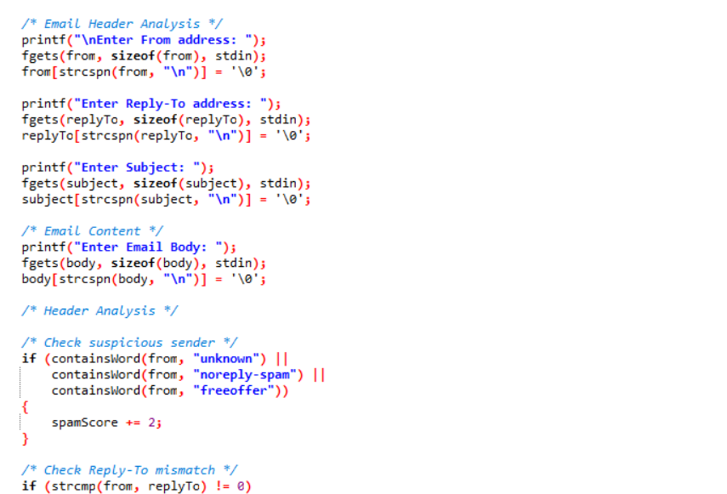
Output:
