**Assignment – 9.5**

**HTNO: 2403A51410**

**NAME: AMGOTH VIKAS NAYAK**

**BATCH: 24CSBAIAIB16**

Assignment Title: Lab 9 – Documentation Generation: Automatic Documentation and Code Comments

# Task 1: Automatic Code Commenting

🎯**Moto:** The main goal of Task 1 is to learn how to add inline comments and docstrings to explain code clearly, making it more understandable and maintainable. It also compares auto-generated vs manually written comments.

**Code/Output:**

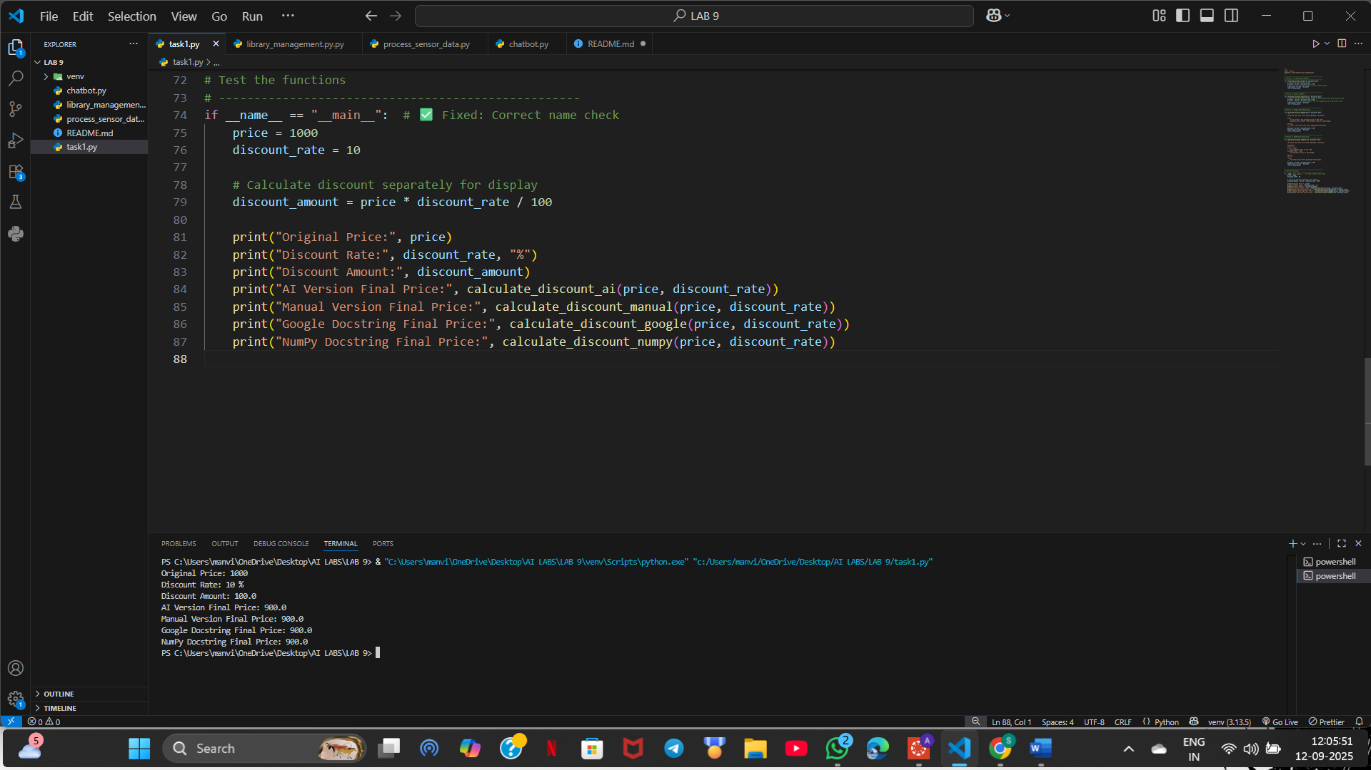

# Task 2: API Documentation Generator

🎯**Moto:** The main goal of Task 2 is to practice writing docstrings for functions and using auto-documentation tools like Sphinx or MkDocs to generate structured API documentation.

**Code/Output:**

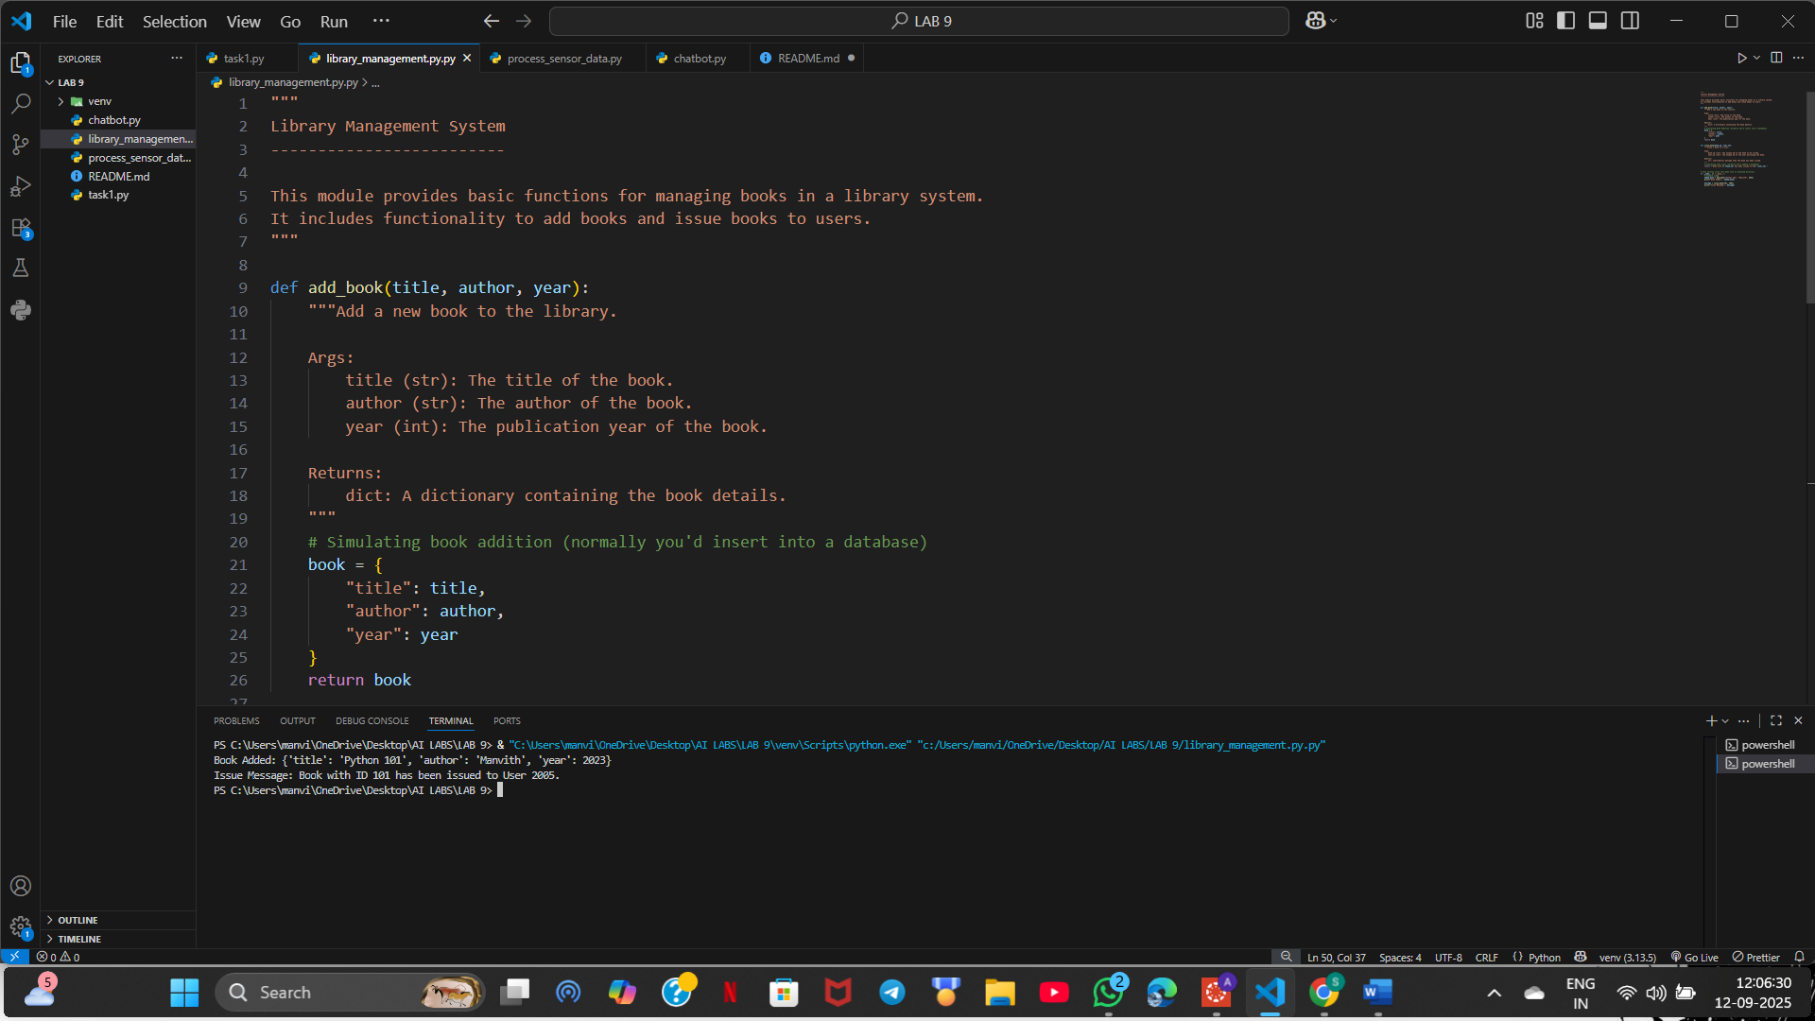

# Task 3: AI-Assisted Code Summarization

🎯**Moto:** The goal of Task 3 is to practice summarizing functions using concise comments, step-by-step flow explanations, and documenting real-world use cases.

**Code/Output:**

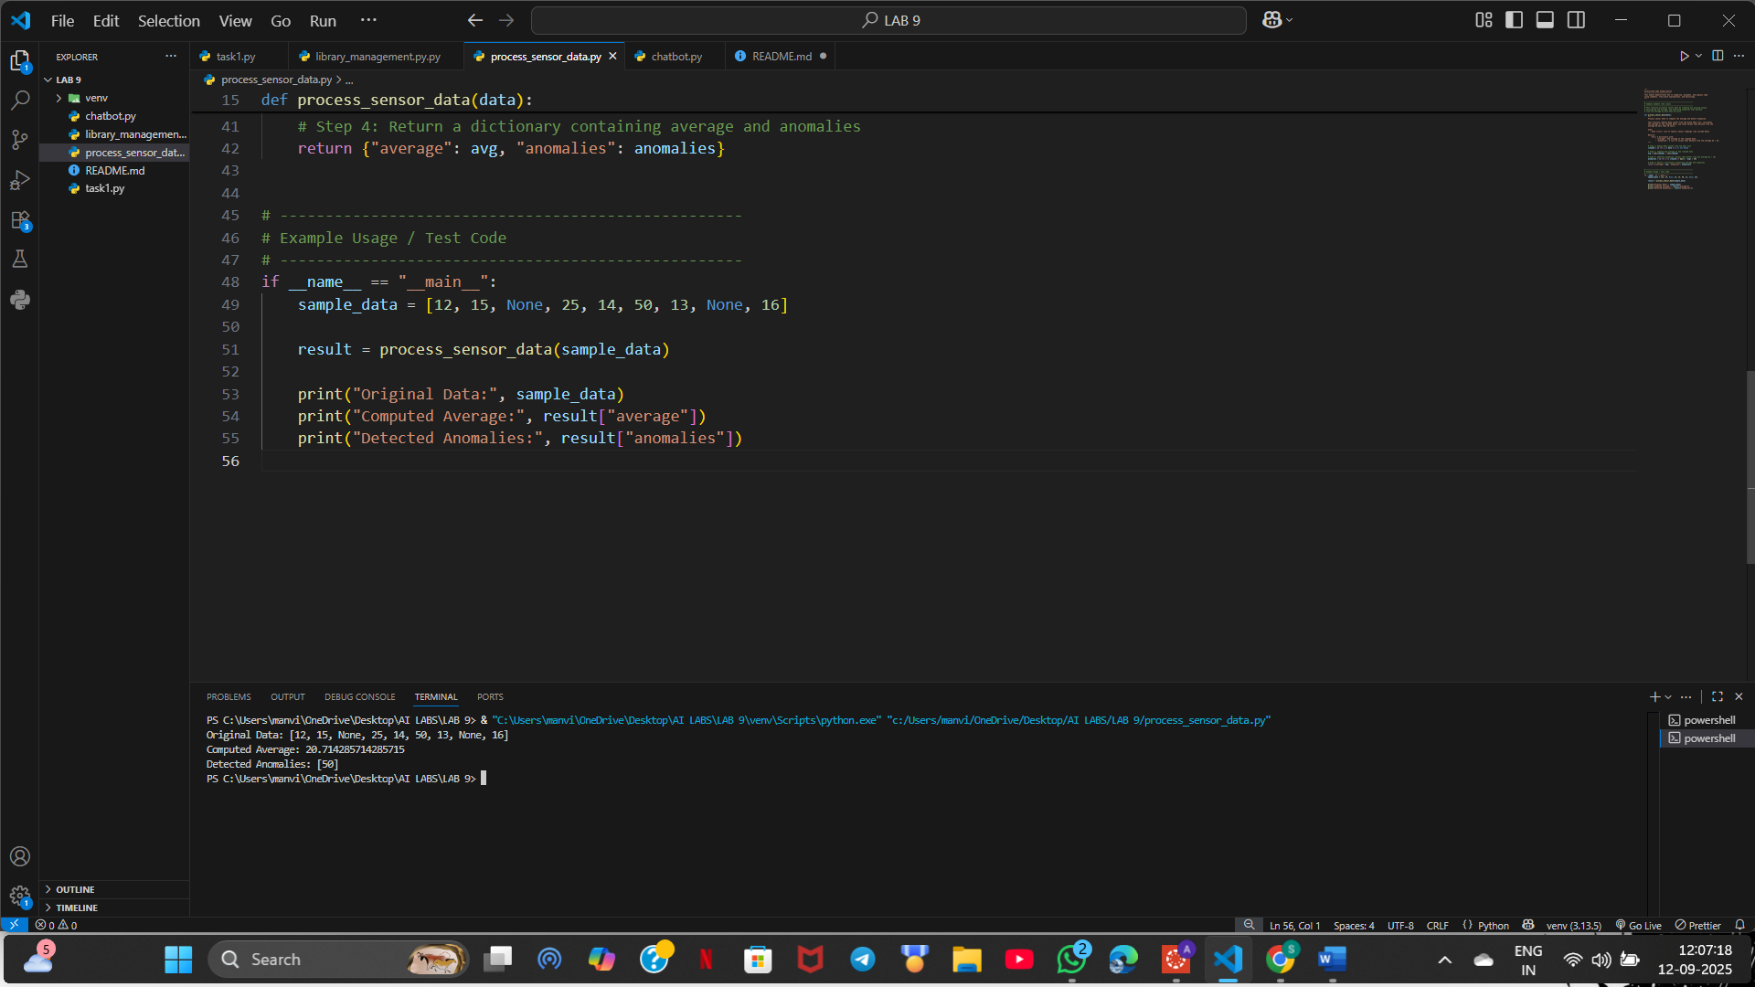

# Task 4: Real-Time Project Documentation

🎯**Moto:** The main goal of Task 4 is to practice creating real-time project documentation with README, inline comments, AI-assisted guides, and reflection on automated documentation.

**Code/Output:**

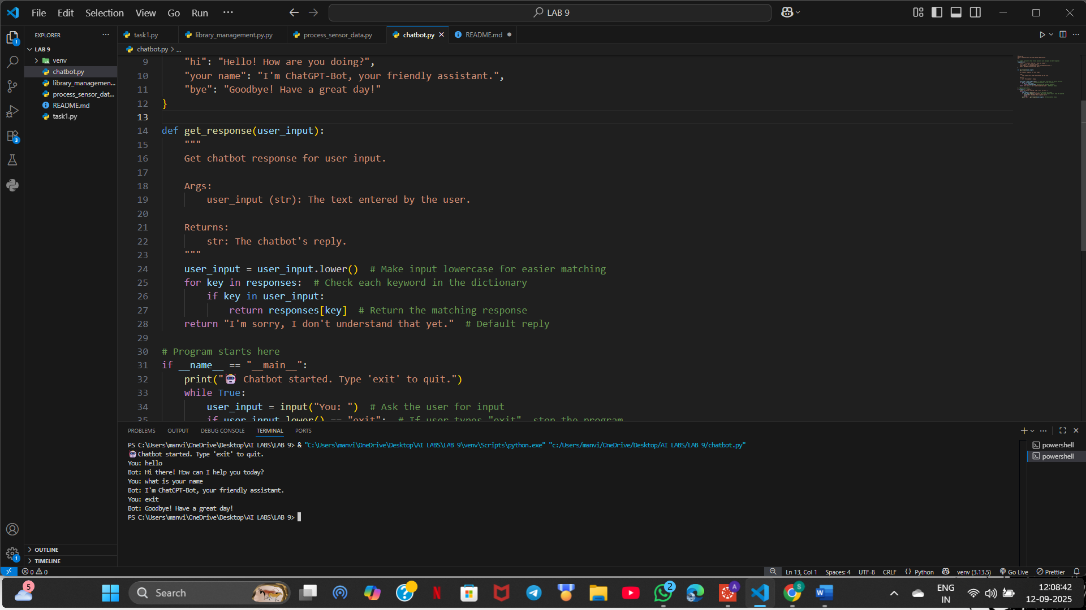

# Observation

In this lab, I learned the importance of inline comments, docstrings, and documentation tools. Automated documentation keeps code easy to maintain, while manual notes provide context. Combining both approaches helps in building reliable and maintainable projects.