1.Create on Bash script to check if a directory is available or not.

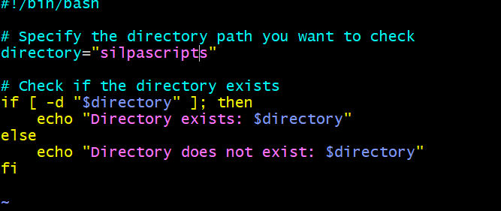

Output:

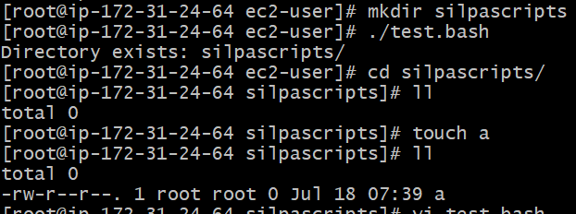

2.Create a bash script which will create multiple files.

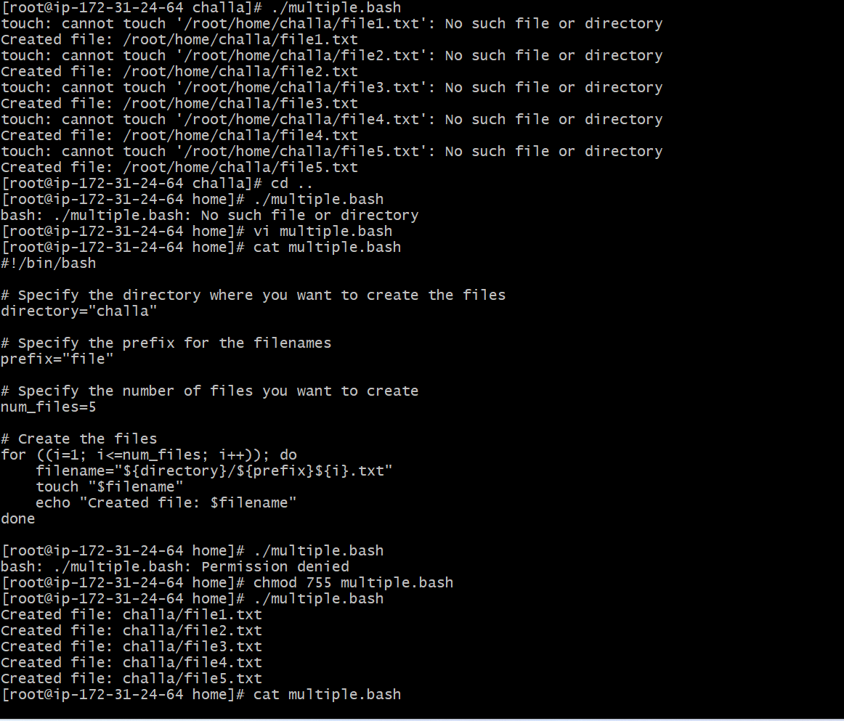

3.Create a bash script to take backup of a directory.

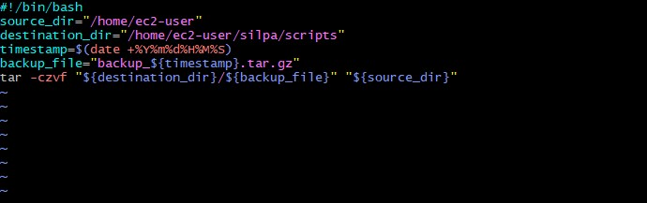

Output:

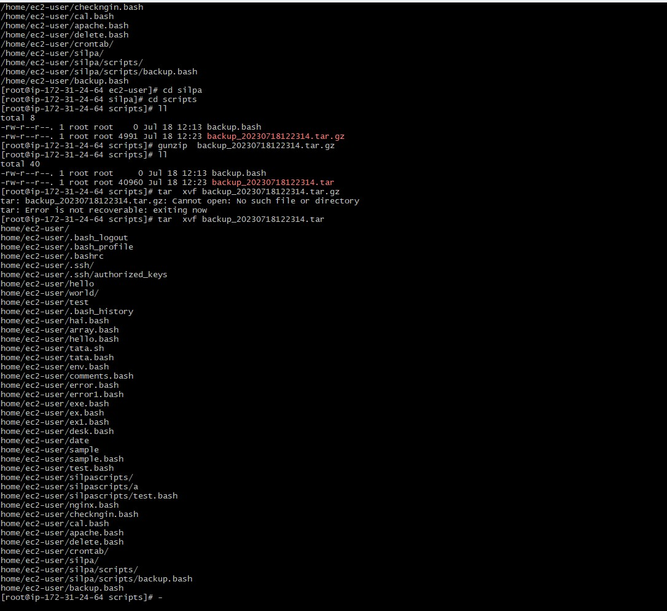

4. Create a bash script to install nginx in ec2 server. 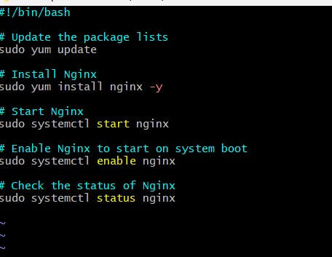

Output: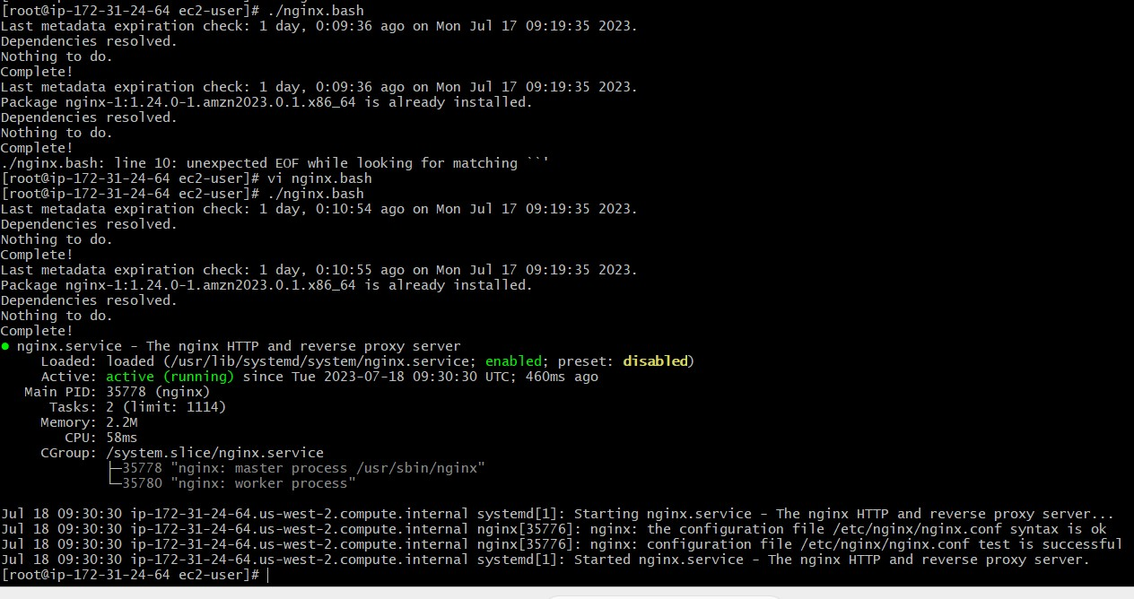 5) Create a bash script to install ApacheTomcat in ec2 server.

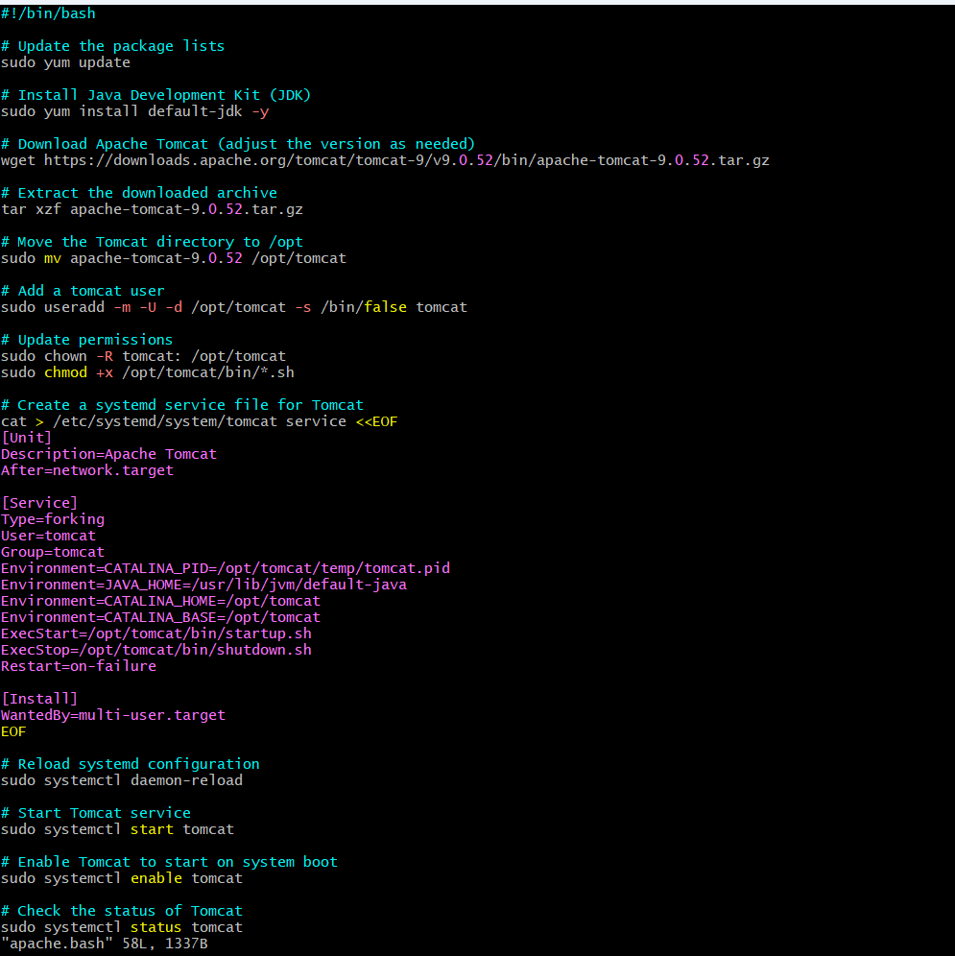

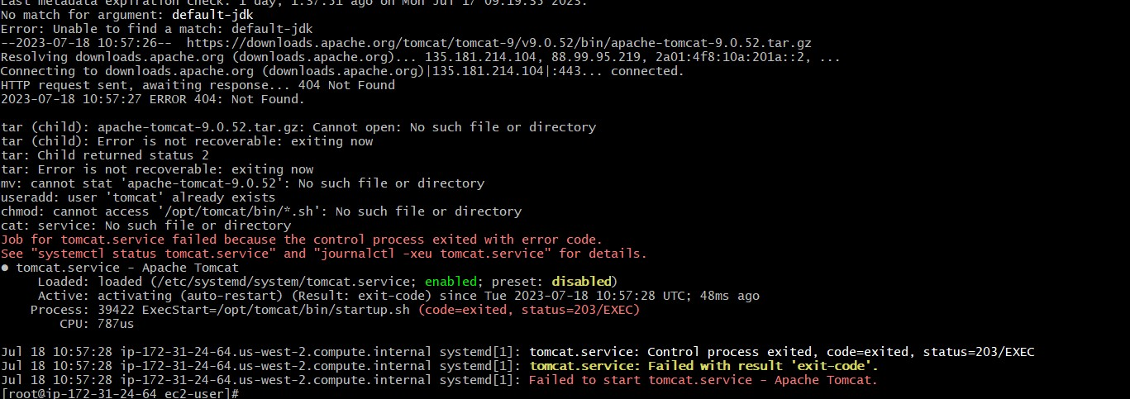

6) Create a bash script to check list if nginx service is running or not,if not running

then script should start the service.

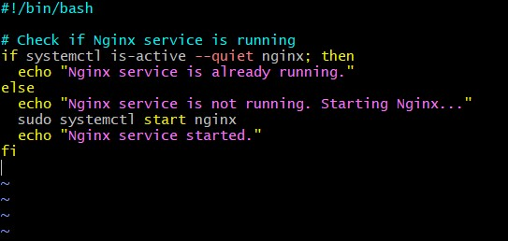

Output:

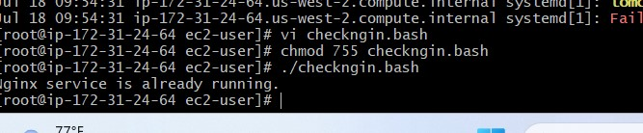

7) Create a bash script for calculator.

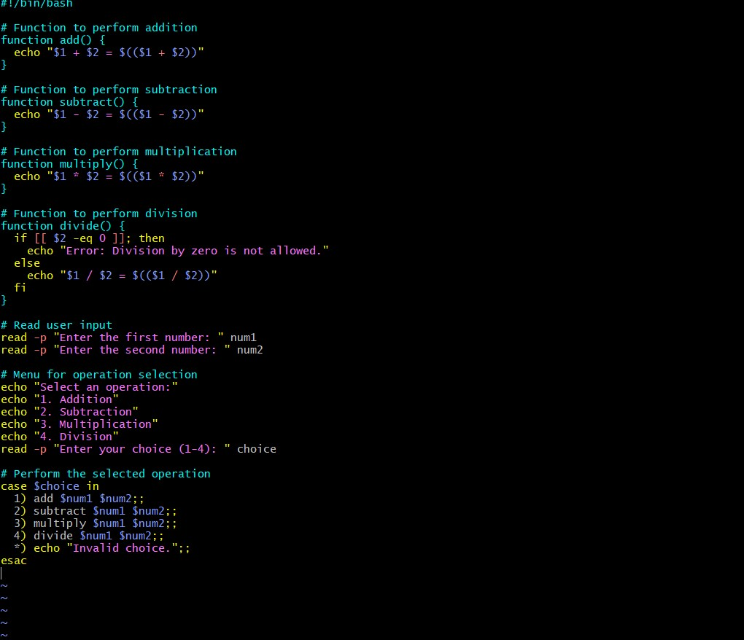

Output: 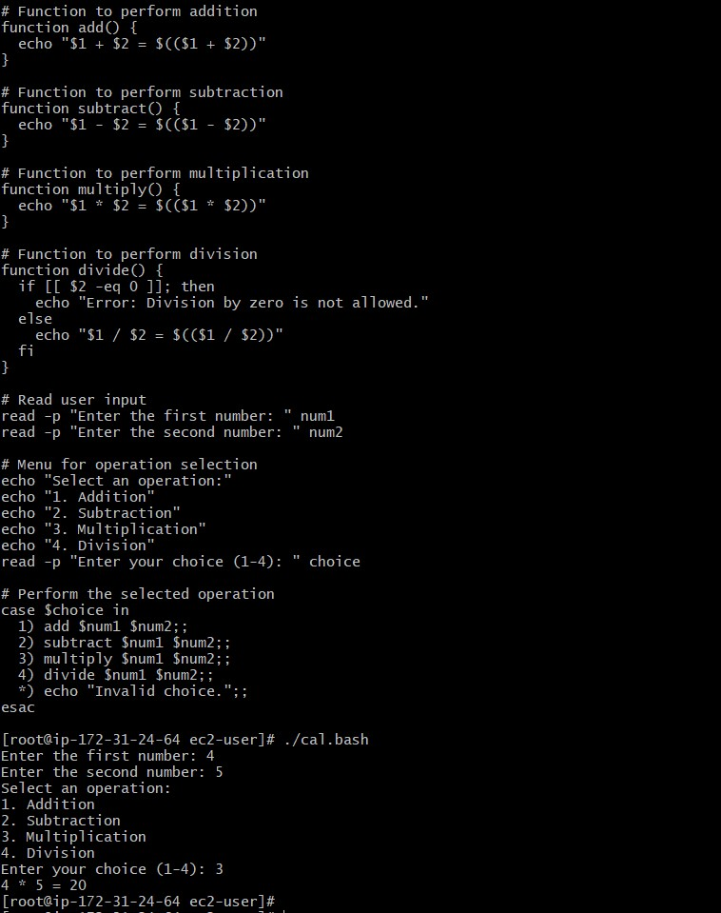

8) Create a bash script to check if directory is avaialble or not,if not then create a directory.



Output:



9) Create bash script to delete last 3 lines for a file.

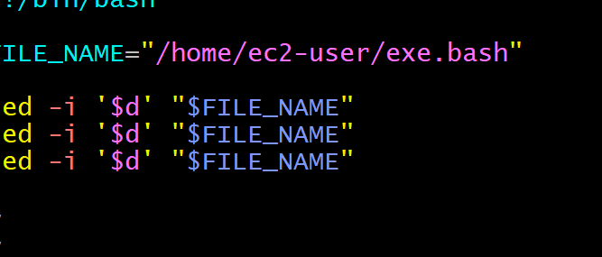

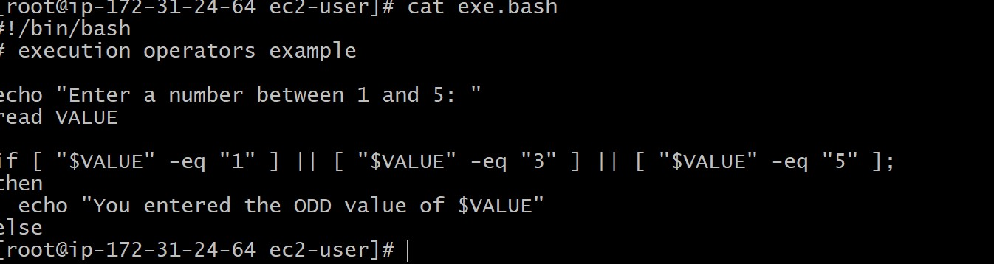

1. April 5th Midnight

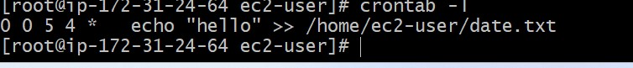

1. 5 th of Every November,Jan,June if it is a Thursday.

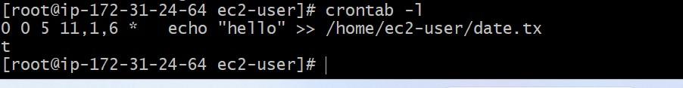

1. At 05 and 27th minutes of 9,10,11 hours everyday.

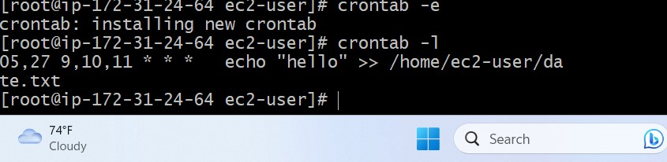

1. 15th second of 34 min. of 9th hour on 15th Aug.

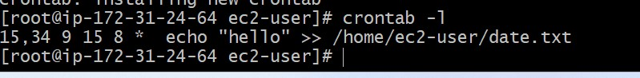i

1. Every midnight.

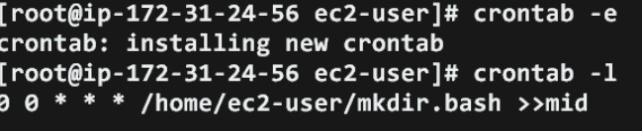

1. Every Weekend ( Saturday night 11.59 )

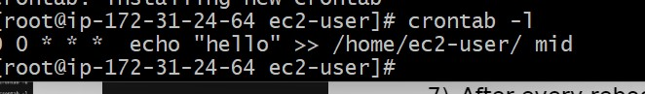

7) After every reboot

