Educational Performance Analysis Tool
Data Collection and Integration (10 Marks)
1.Source Diversity (2 Marks): Integrate data from at least five different sources in various formats (JSON, XML, CSV, Excel, HTML).
and
2.Data Fetching and API Integration (3 Marks): Set up APIs, handle connections, and manage data fetching with error handling.
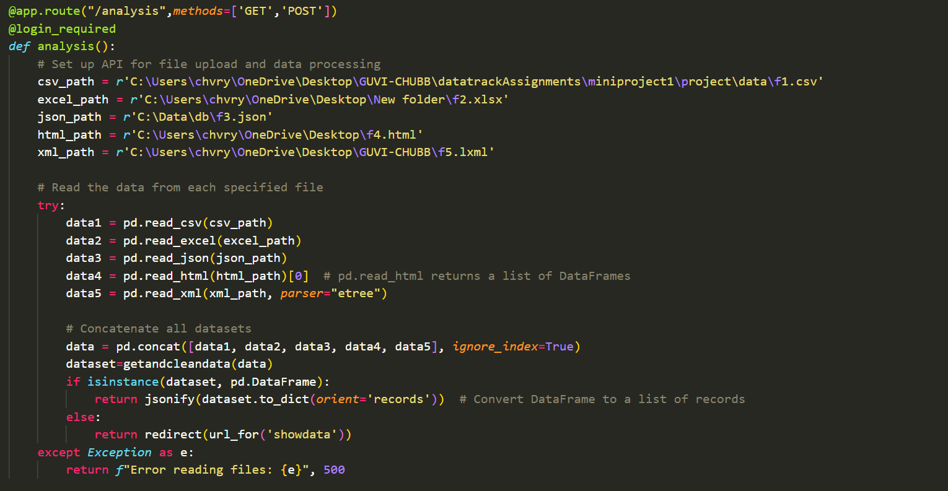
3.Data Pre-processing (2 Marks): Clean and normalize raw data, handling null values, duplicates, and inconsistencies.
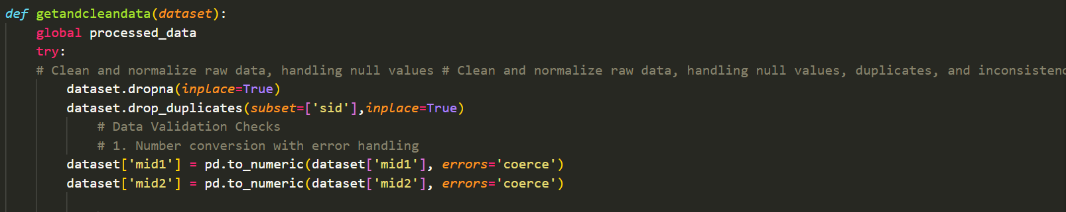

4.Documentation (3 Marks): Document data sources, formats, and integration setup in detail.
Converting existing csv to different formats like XML,EXCEL,JSON,HTML
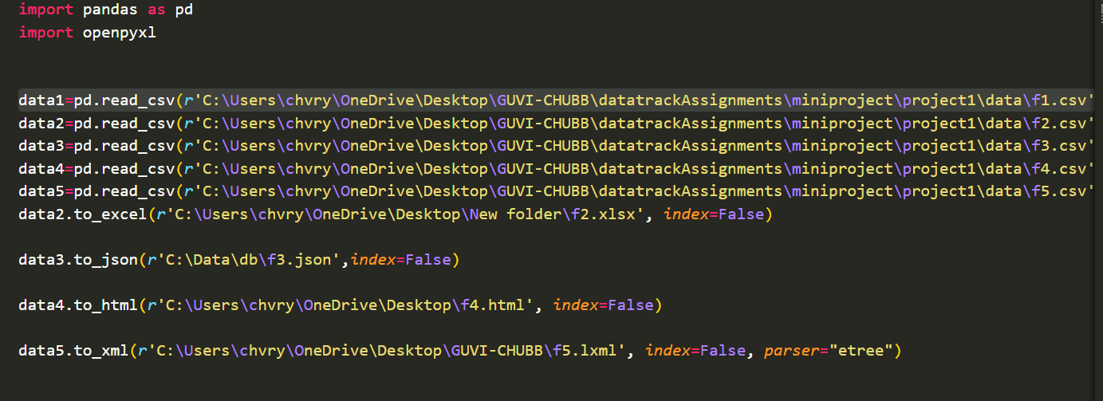
2. ETL (Extract, Transform, Load) Pipeline (15 Marks)
1.Data Validation (3 Marks): Implement five data validation checks for data quality, format checks, range checks, and handling missing values.
And 2. Data Transformation Logic (3 Marks): Apply at least five transformations (e.g., formatting, aggregations, joining datasets).
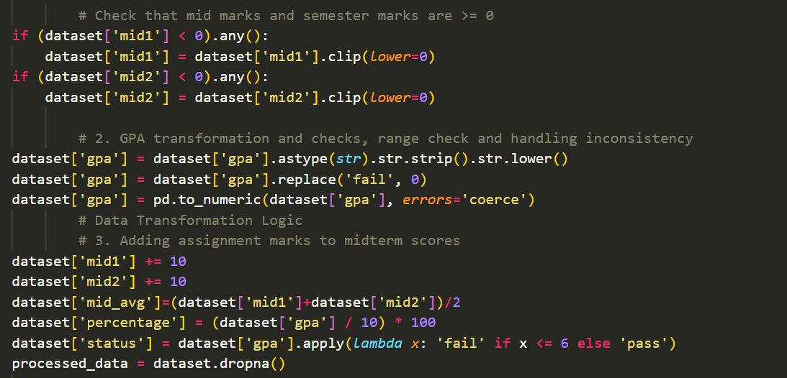

3. Data Loading (3 Marks): Efficiently load data into the database using ORM with data integrity.
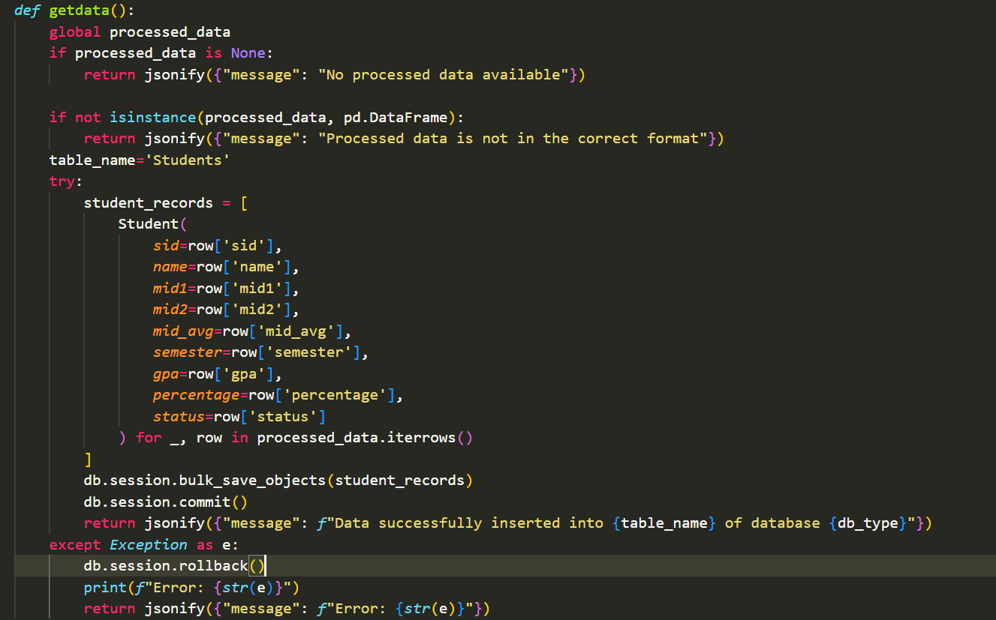
4. Pipeline Automation (3 Marks): Automate the ETL pipeline and document each stage with clear steps.
Extract
Function: getandcleandata(files) -- Extracts and concatenate data from multiple file formats and sources (CSV, Excel, JSON, HTML, XML).
Inputs: files- Dictionary of uploaded files.
Outputs: Data Frame of cleaned data or error message.
Transform
Description: Cleans and normalizes the raw data, including handling null values, duplicates, and applying transformations on GPA, percentage calculation and status, assignment marks to midmarks.
Data Validation Checks: - Number conversion - GPA transformation - Null value handling - Duplicates removal - Format checks for input data.
Load
Function: getdata () --Description: Loads transformed data into the PostgreSQL database.
Outputs: Confirmation message on successful insertion or error message.
5.Exception Handling (3 Marks): Handle errors gracefully at every stage of the ETL pipeline.
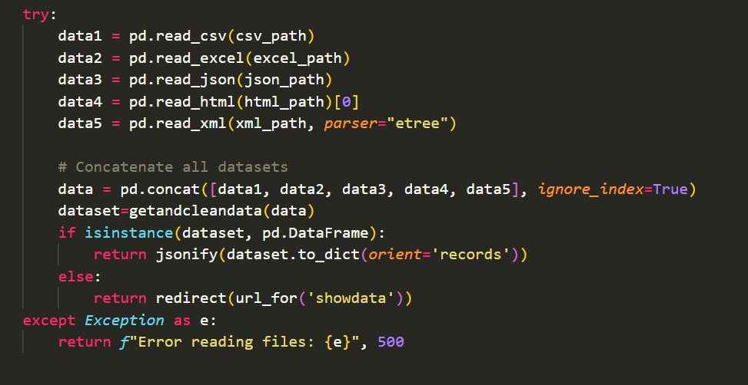
Database Management and ORM (10 Marks)
1.Database Schema Design (2 Marks): Design an optimized schema to accommodate ETL needs.
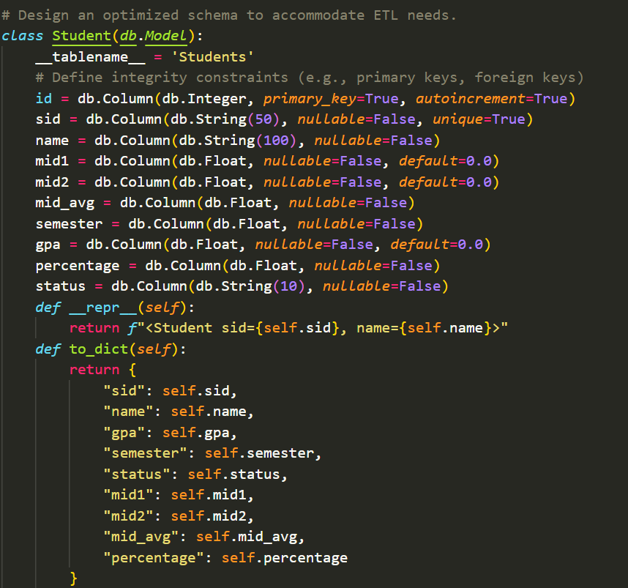
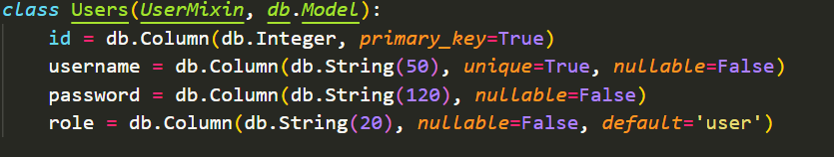
2.ORM and Multi-database Switching (3 Marks): Set up ORM models and demonstrate switching databases (e.g., PostgreSQL, SQLite) during the final demo.
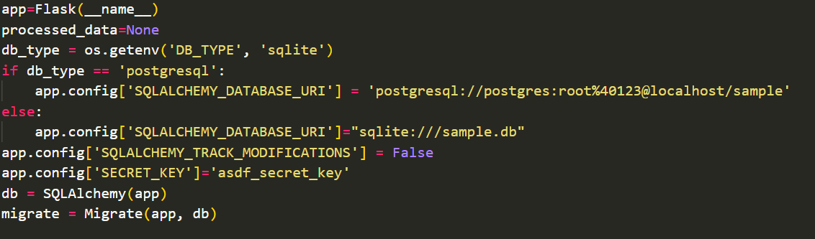
3.Data Integrity Constraints (2 Marks): Define integrity constraints (e.g., primary keys, foreign keys).
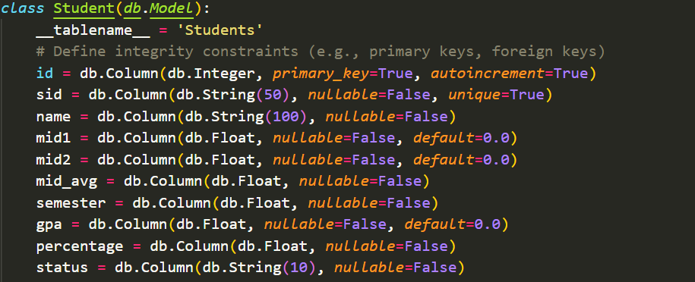
4.Documentation and Code Quality (3 Marks): Include clear explanations for schema, ORM, and database switching code.

User Management and Authentication (10 Marks)
Outputs are shown at the end
1.User Registration and Authentication (2 Marks): Set up secure user registration, login, and logout
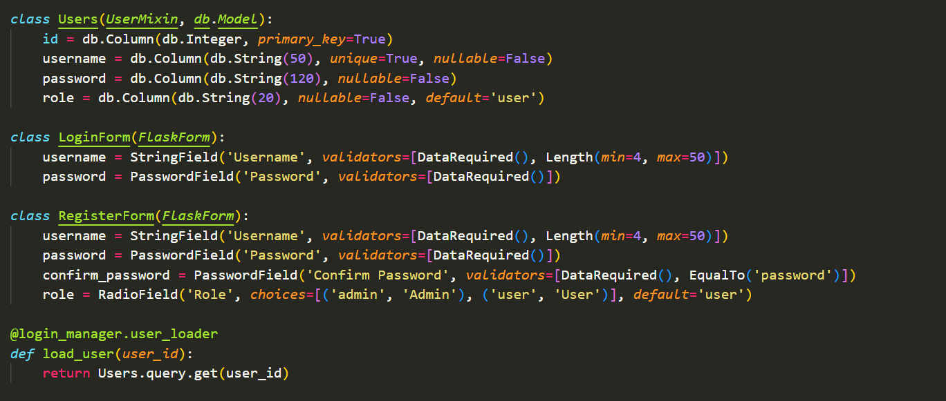
2. Role-based Access Control (3 Marks): Implement distinct user roles with appropriate access levels (e.g., admin, analyst, viewer).
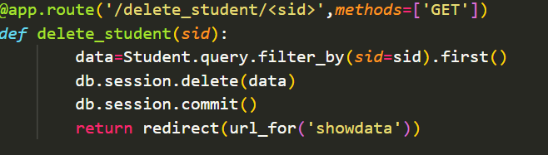
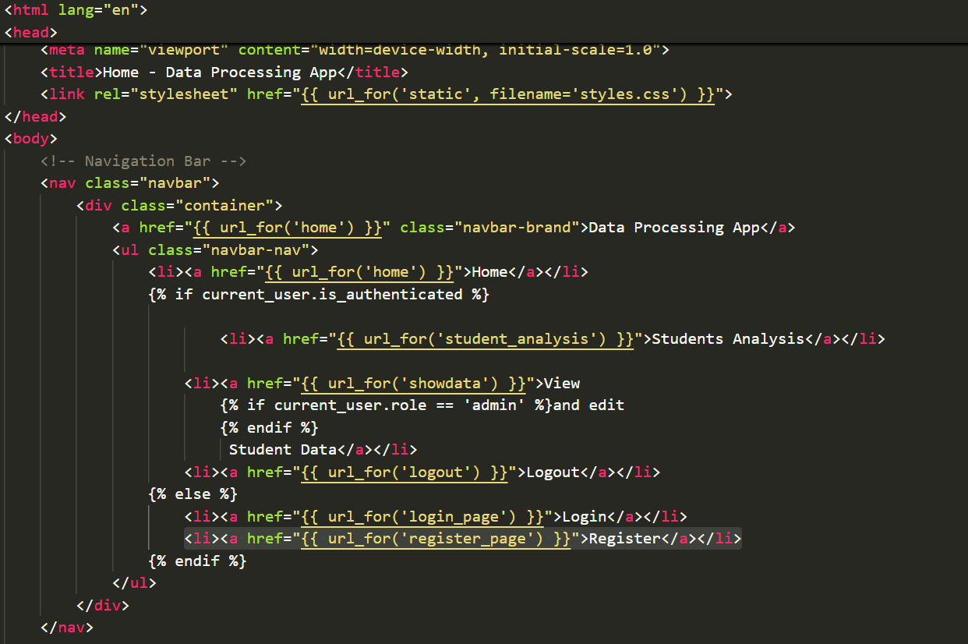

3.Form Validation and Security (2 Marks): Use Flask-WTF for form validation and secure data handling.
And
4.Session Management (2 Marks): Ensure secure session handling and expiration for logged-in users.
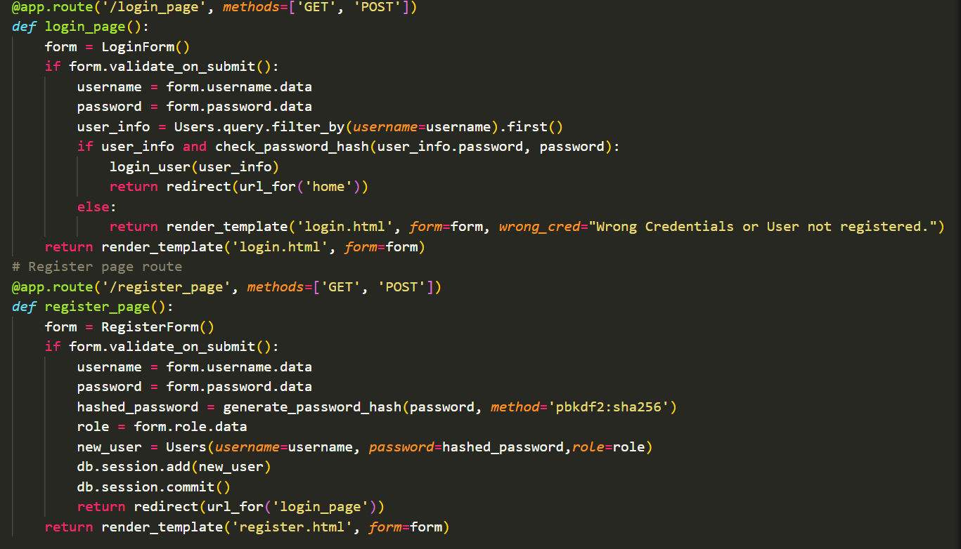
5.Documentation of Roles and Access (1 Mark): Describe roles and associated permissions.
There are two types of roles one is the user another is the admin
Where user can only see the sales analysis and see the data, where as the admin can see and delete the data also
Data Visualization and Dashboard Creation (15 Marks)
Are presented at the end with insights

MVC (Model-View-Controller) Architecture (5 Marks)

Users students.html
Student students_analysis.html
login.html
Model compute data register.html
user input Template
Design and updates display data

'/login_page',
'/register_page', '/delete_student/<sid>',
'/getdata', '/showdata'
"/analysis","/student_analysis"
( App.py)
View

Flask Skills and Code Optimization (10 Marks)
1.Flask Core Concepts (3 Marks): Show a good understanding of Flask by using Blueprints, URL routing, and request handling
@app.route("/student_analysis")
@app.route("/analysis",methods=['GET','POST'])
@app.route('/showdata', methods=['GET'])
@app.route('/logout')
@app.route('/register', methods=['GET', 'POST'])
@app.route('/delete_student/<sid>',methods=['GET'])
@app.route('/register_page', methods=['GET', 'POST'])
@app.route('/login_page', methods=['GET', 'POST'])
@app.route("/", methods=['GET', 'POST'])
2.Code Optimization (3 Marks): Implement optimized code with efficient querying, looping, and logic to reduce redundancy.
data = Student.query.all()
student_data = [
{
'sid': student.sid,
'name': student.name,
'mid1': student.mid1,
'mid2': student.mid2,
'mid_avg': student.mid_avg,
'semester': student.semester,
'gpa': student.gpa,
'percentage': student.percentage,
'status': student.status
}
for student in data
]
return render_template('students.html', students=student_data)

try:
student_records = [
Student(
sid=row['sid'],
name=row['name'],
mid1=row['mid1'],
mid2=row['mid2'],
mid_avg=row['mid_avg'],
semester=row['semester'],
gpa=row['gpa'],
percentage=row['percentage'],
status=row['status']
) for _, row in processed_data.iterrows()
]

3. Library and Package Usage (2 Marks): Use suitable libraries (e.g., Pandas for ETL, SQLAlchemy for ORM) effectively.
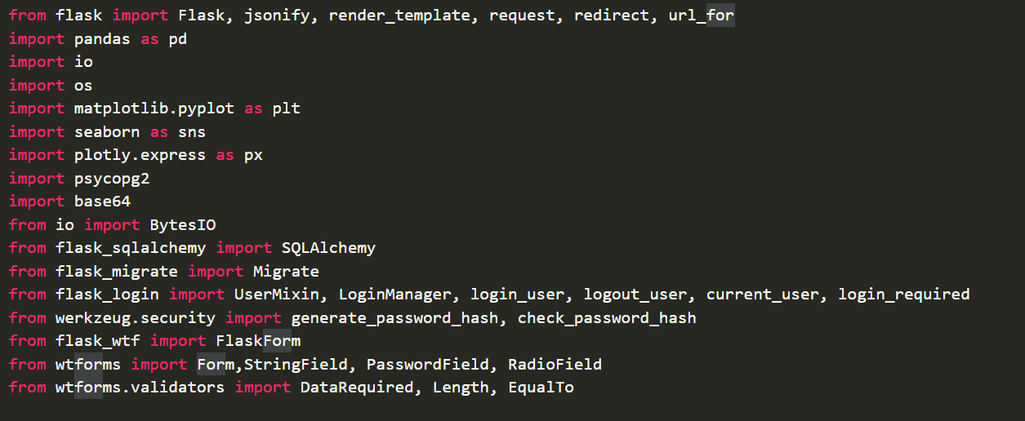
4. Code Readability and Comments (2 Marks): Ensure readable code with meaningful comments and naming conventions.
Overall code has the required comments and good code readability with meaningful names
Dynamic Form Handling with Flask-WTF (5 Marks)
Form Validation (2 Marks): Use Flask-WTF to validate forms, handling all field types effectively.
Dynamic Input Handling (2 Marks): Allow dynamic form handling based on user input or role.
Error Messaging (1 Mark): Implement clear error messages for validation issues.
Presentation and Demo (10 Marks) and Data Model and Design (5 Marks) and Final Deliverables and Evaluation (5 Marks)
Will be considered as this whole document
Database Switching Demo , Project Presentation, Screenshots and Documentation, Self-reflection
Complete Working Code, Output Screenshot Accuracy------all these are already mentioned above
“/”
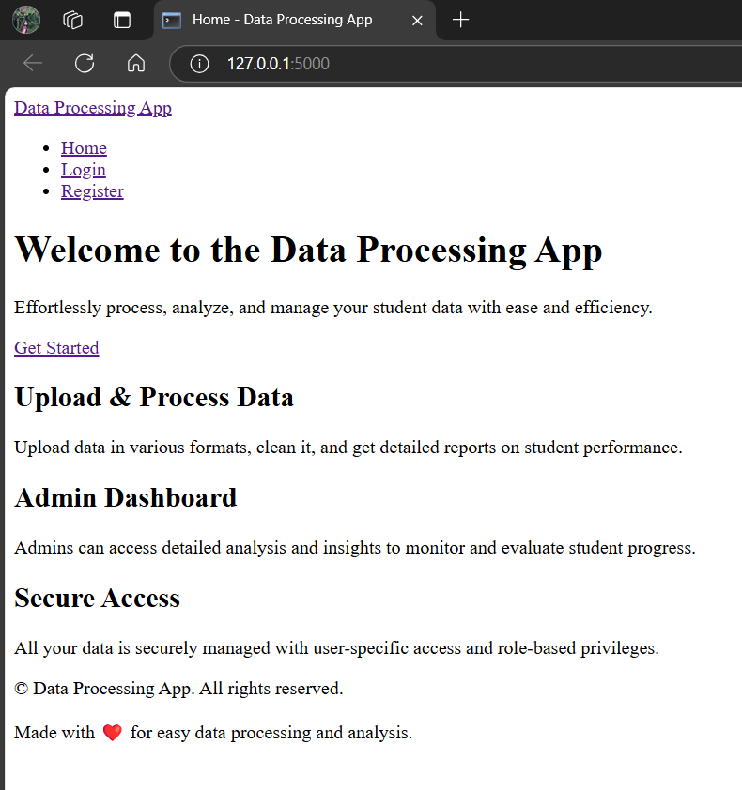
Login page
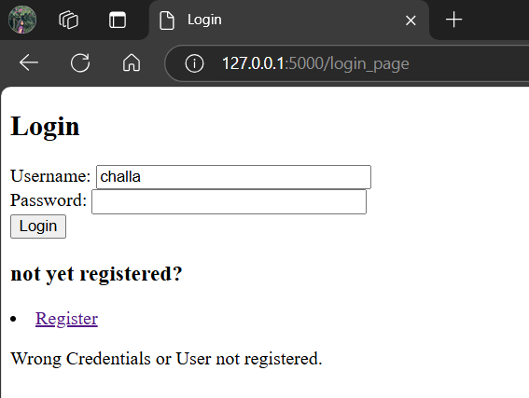

ADMIN LOGIN

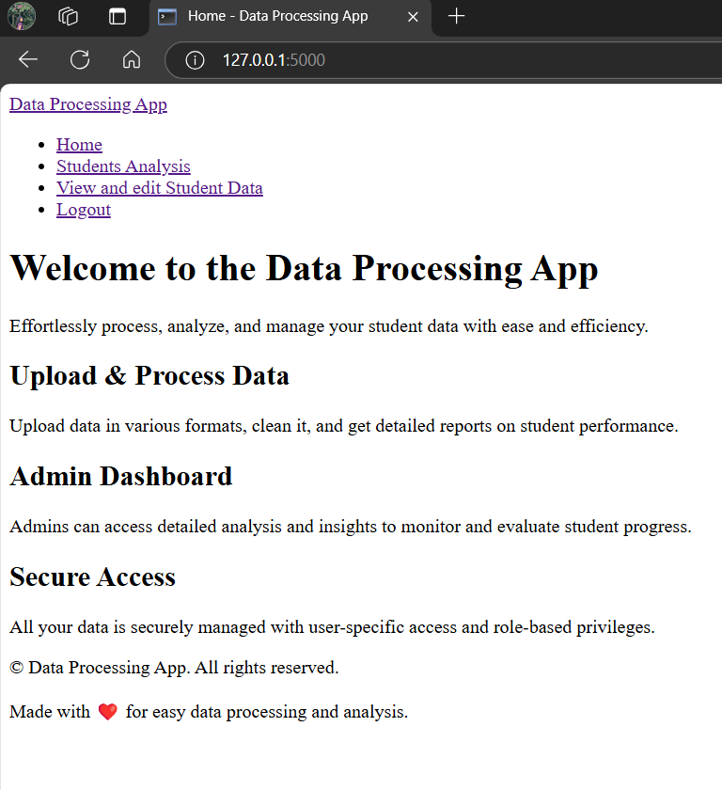
Student_analysis
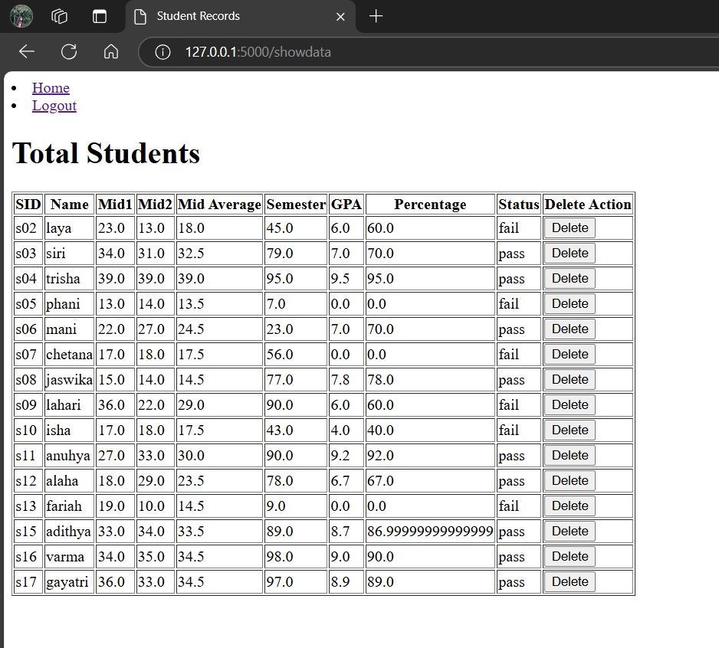
Student_analysis
Shows both passed and failed people
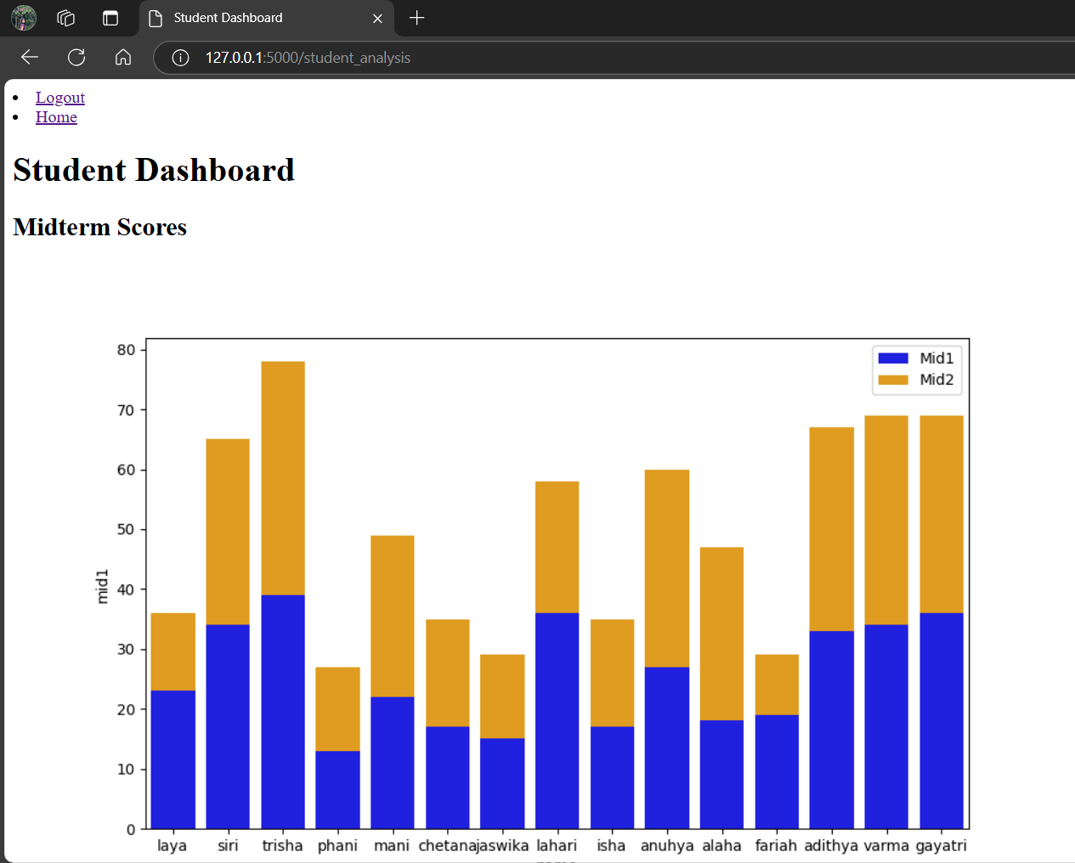
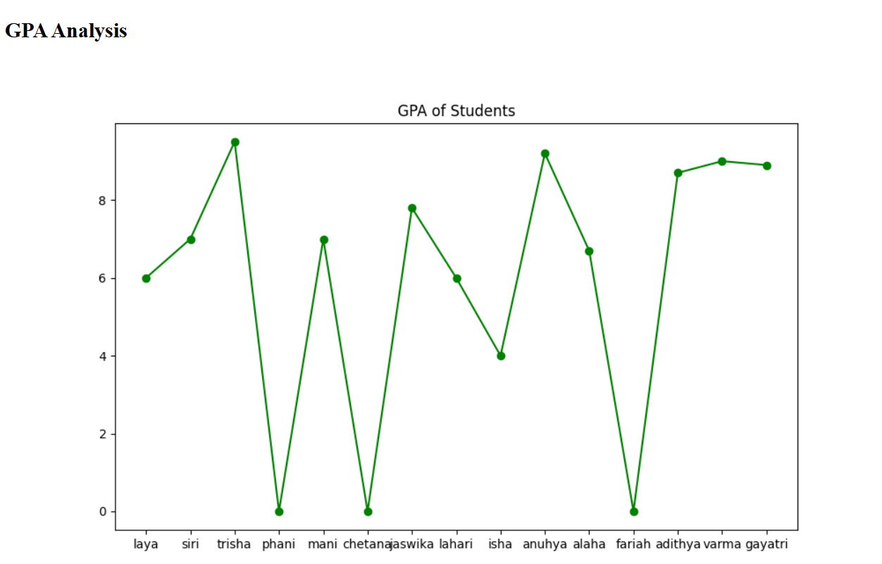

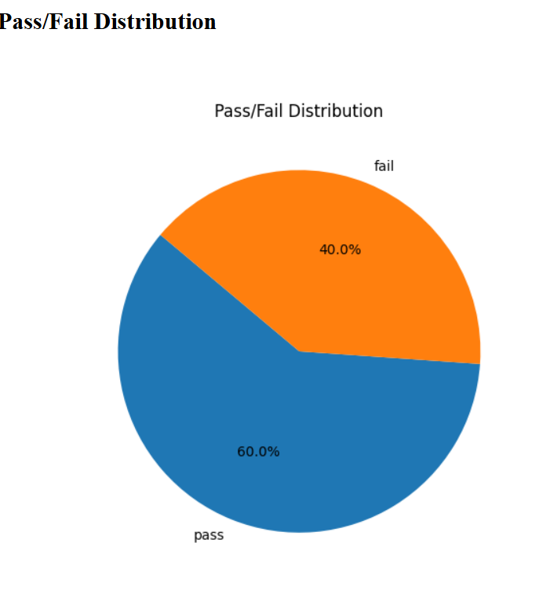
USER LOGIN

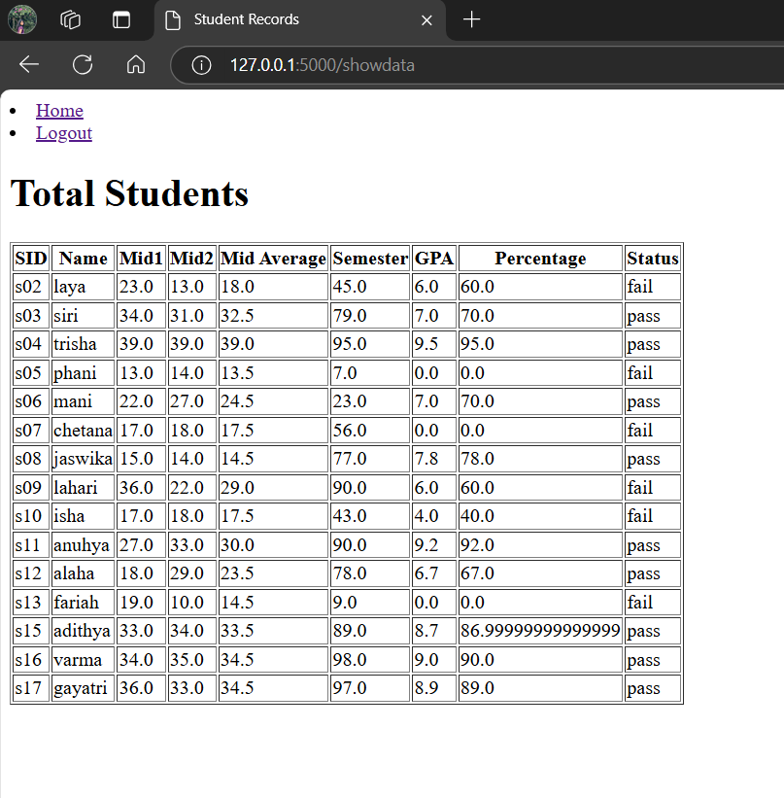
Student_analysis
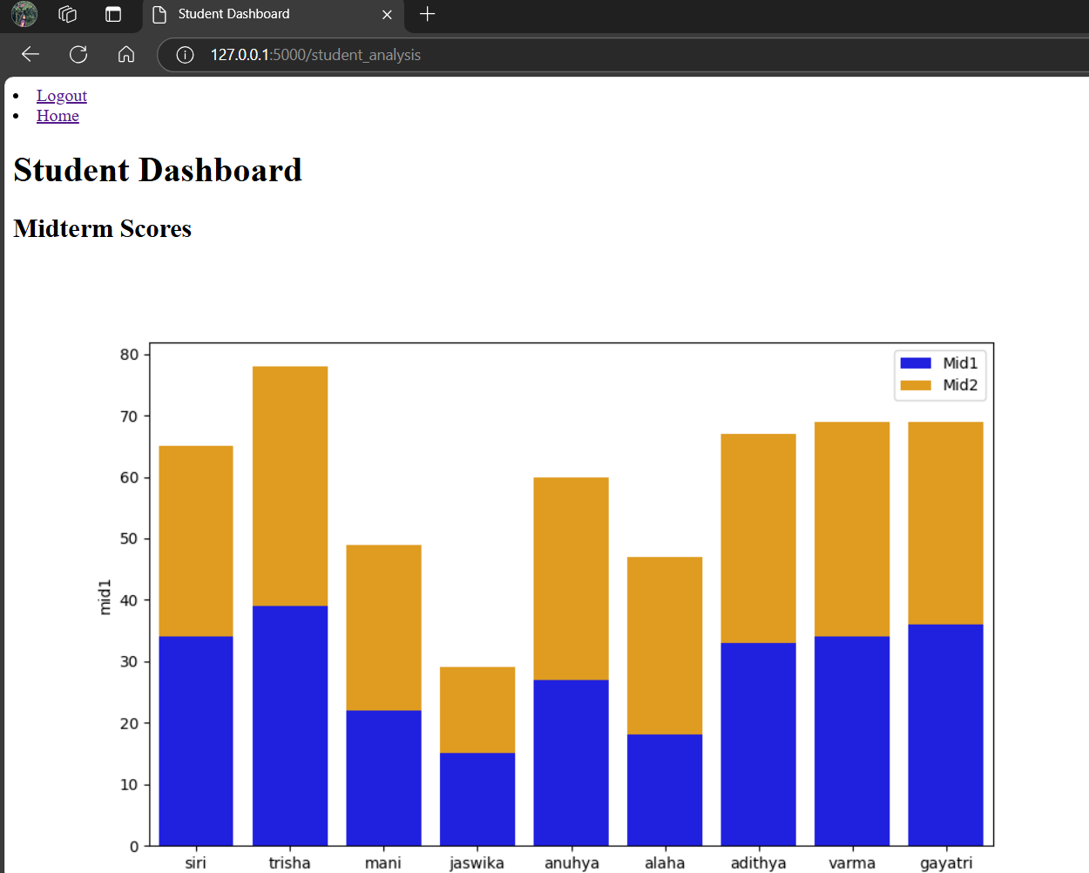
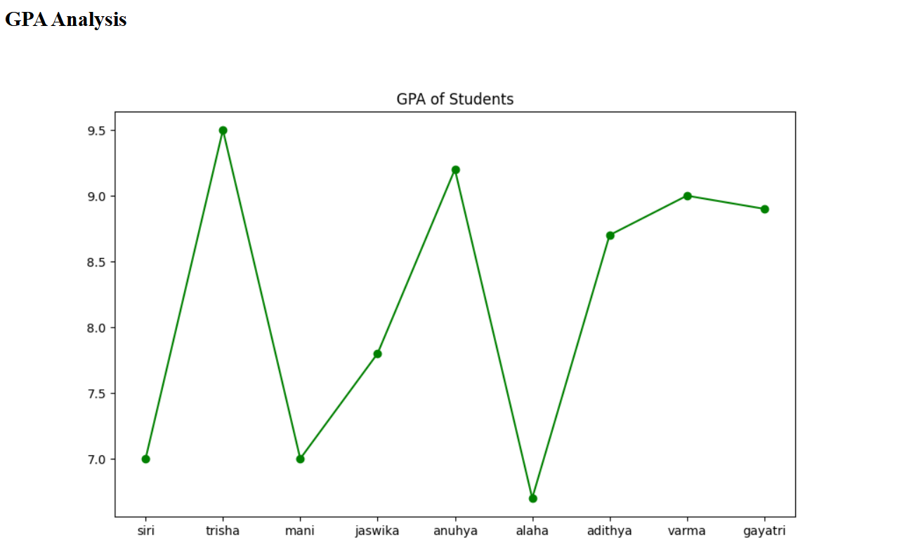

INSIGHTS:
On average, students performed better on Midterm 2 with an average score of 74.50.
TOP Score Laya92 Trisha88
Bottom Anusha 55 jaswika 60
Areas for Improvement: Students like Phani, jaswika, and Anusha have lower GPAs and could benefit from additional support or targeted strategies.
- Pass Rate: 60% of the students passed the exam.
- Fail Rate: 40% of the students failed the exam.
Possible Conclusions:
- Performance Gap: There seems to be a significant gap in performance between the passing and failing students.
- Need for Improvement: Strategies to improve the pass rate are needed.
- Analysis of Failure: Understanding the reasons for the high failure rate can help in identifying areas for improvement.
IMPROVEMENTS:
• Targeted Interventions: Provide additional support or remedial classes for students who need help in specific areas.
• Review Teaching Methods: Evaluate the effectiveness of teaching methods and consider alternative approaches to improve student understanding.
• Assessment Review: Review the assessment methods to ensure they are fair and accurate.

