# **DREAM** **MAKERS**

BV RAJU INSTITUTE OF TECHNOLOGY

Project title: Protection of crops from Animals using intelligent security system.

**Introduction:**

In the world, the economy of many countries is dependent upon agriculture. In spite of economic development agriculture is the backbone of the economy. Agriculture is the main stay of economy. It contributes to the gross domestic product. Agriculture meets food requirements of the people and produces several raw materials for industries. But because of animal interference in agricultural lands, there will be huge loss of crops. Crop will be totally getting destroyed. There will be large amount of loss of farmer. To avoid these financial losses it is very important to protect agricultural field or farms from animal. To overcome this problem, in our proposed work we shall design a system to prevent the entry of animals into the farm. Our main purpose of project is to develop prohibitive fencing to the farm, to avoid losses due to animals. These prohibitive fencing protect the crop from damaging that indirectly increase yield of the crop. The develop system will not harmful and injurious to animal as well as human beings. Theme of project is to design a intelligent security system for farm protection by using sensors and providing sounds effects and lights through the scare crow.

**Abstract:**

Crops are vulnerable to wild animals. Therefore, it is very important to monitor the nearby presence of animals. Then the actuation of various devices should follow to repel the hazardous animals. Traditional methods have been widely applied depending on the kinds of produce and imperiling animals. In this project, we propose a method to protect farms from wild animals by using ultra sonic sensors, which is applied to farm along with traditional methods to improve the protection performance. Ultra sonic sensors are utilized mainly for the detection of animal intrusion from the outside of farms. The proposed monitoring scheme is to provide an early warning about possible intrusion and damage by wild animals

**Block diagram:**

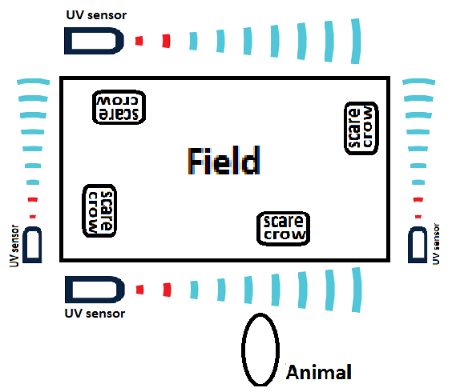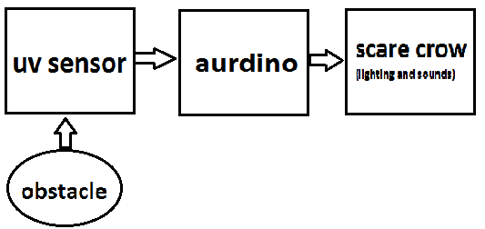

**Components required:**

1. Aurdino.
2. UV sensor.
3. Buzzer.
4. Lights.
5. Other connecting accessories.

**proposal working:**

In our proposal, ultra sonic sensor is used as a fencing for detecting presence of wild animals. When animals try to cross the fencing (ultrasonic waves) then the obstacle is provided which indicates that there is a presence of animal for the sensor, then the sensor gets actuated and it sends a signal to turn on sound and light effects from the scarecrow .

**Advantages:**

1. Mainly it does not harm to wild animals just it scared by the sounds and lights provided
2. Continuous monitoring can be done.
3. Works on Solar panel, AC mains or batteries.
4. Fine design.

**Disadvantages:**

1. In large scale devise handling will be complex.
2. Battery always checks for charging.
3. It may not respond for small animals.

**Applications:**

1. Main application it is used to protect farm.
2. To be used in orchard/fruit garden.
3. To be used for vegetable garden.
4. To be used for security system for houses and schools.