**LAB 1**

*Student code: 18520726*

*Student name: Do Hoang Hiep*

# **Environment set-up: Anaconda**

1. Create a Jupyter notebook

1. Export Jupyter notebook and run it as a Python script

# **Github**

1. Install Github desktop and create a Github account

1. Create new repository

1. Cloning your repository

1. Add a new file to your repo

1. Push a branch to GitHub

# **Python basics**

1. Data types
2. Numbers

1. Variable assignment

1. Strings

1. Printing

1. Lists

1. Dictionaries

1. Booleans

1. Tuples

1. Sets

1. Comparison Operators

1. Logic Operators

1. If, elseif, else Statement

1. For loops

1. While loops

1. Range

1. List Comprehension

1. Functions

1. Lambda expression

1. Map and filter

1. Methods

# Exercises

Q1:



Q2:



Q3:

Q4:



Q5:

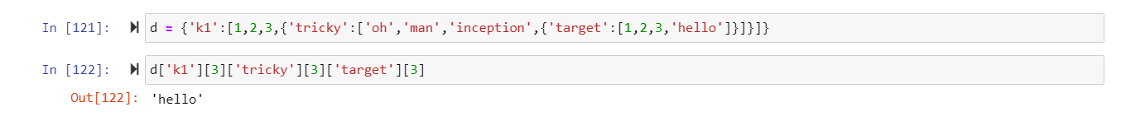

Q6:

Q7:

Q8:

Q9:

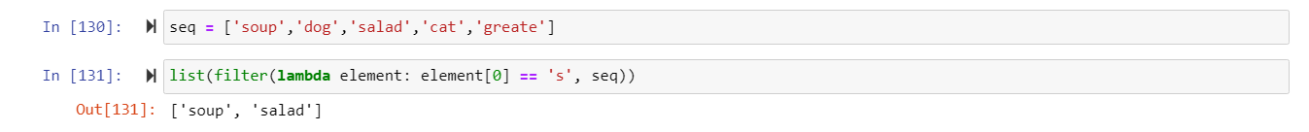

Q10:

I uploaded file Python on Github: <https://github.com/challengecup/DataMining_lab1>