Android tips

1\ about output log
C/C++: 就用ALOGI/ALOGD/ALOGW/ALOGE；
JAVA: 就用Log.i/Log.d/Log.w/Log.e.

2\ Binder机制
数据传输的流程是这样的：
1. Client将数据从用户空间传输到Binder驱动；
2. Binder驱动将第1步得到的数据拷贝到Service通过mmap申请得到的那块物理空间；
3. Binder驱动将第2步得到的物理空间对应的虚拟地址传递给Service的用户空间；
4. Service的用户空间通过Binder驱动传递过来的虚拟地址来访问Client传输过来的数据。
整个过程只有第2步是需要拷贝数据的，这也是Binder进程间通信机制的精华所在。

===================================================

1\ paul@paul-Workstation:~/work/wifi_android$ adb shell
* daemon not running. starting it now on port 5037 *
* daemon started successfully *
error: insufficient permissions for device

So you probably need to do “adb start-server” as root first:

ubuntu$ sudo ./out/host/linux-x86/bin/adb kill-server
ubuntu$ sudo ./out/host/linux-x86/bin/adb start-server
* daemon not running. starting it now *
* daemon started successfully *
ubuntu$ ./out/host/linux-x86/bin/adb shell

2\ Start the ENV for Windows
copy this directory to windows:
wifi_android/vendor/qcom/proprietary/usb/host
and install the USB driver, also this directory includes the adb.ext and fastboot.exe tools, you could copy the tools and dll to windows/win32 directory.

Get other QCOM tools from here: \\cold\tools\Installers
Such as QXDM, QPST, CrashScope and USB driver

3\ About flash the single image (ref to the flowing pic) [QPST]
a\ starting QPST Configuration and eMMC Software Download app
b\ \\qrdshare\qrd_projects\cdt\phase2\emmc_cdt_program_script_qrd\qpst\sahara.xml (for 8x26)
\\10.231.203.64\qrd-metabuild\8x10_metabuild\M8610AAAAAWLGD1020039\Images\sahara.xml (for 8x10/8x12)
c\ Do not choise “Program Boot Loaders”
d\ Click Build Contents … and Put in this:
\\sun\builds501\TEST\M8626AAAAANLGD1620061H.2
then choise “contents.xml” click “Open”
then choise “asic” click “OK”
e\ Click “Switch device to DLOAD...” and click “OK”
f\ Wait a moment, and click “Disable”
g\ Choise the line “Qualcomm MMC ...”
h\ Then click “Download”
i\ Waiting to the end …
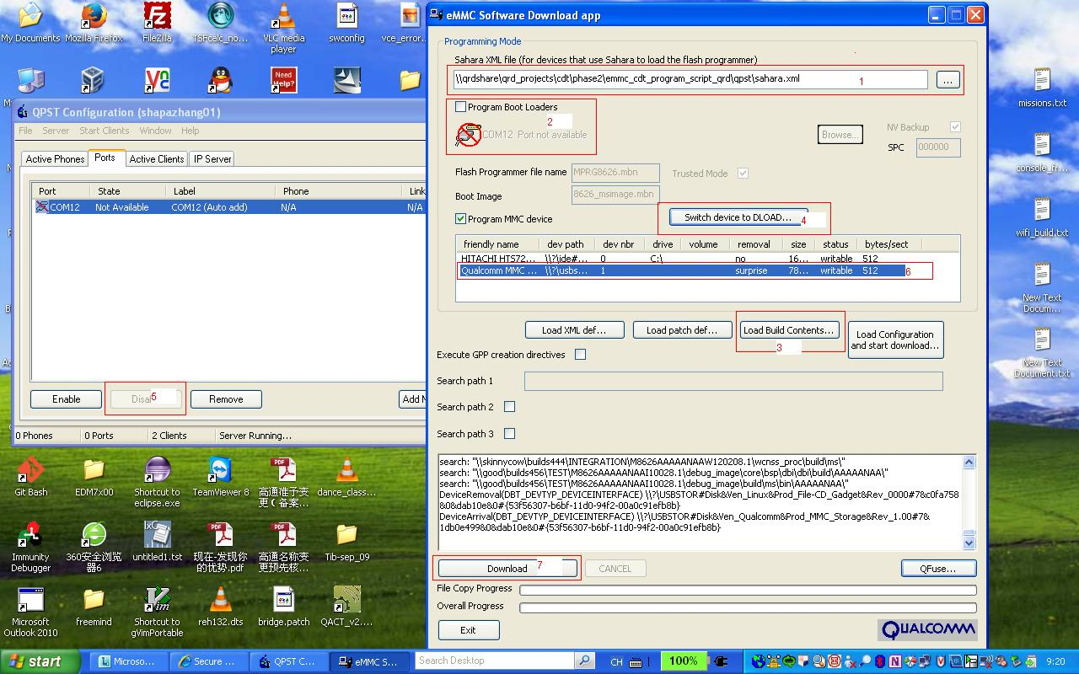

4\ How to flash the image:
adb reboot bootloader
sudo ./out/host/linux-x86/bin/fastboot flash aboot out/target/product/msm8226/emmc_appsboot.mbn
sudo ./out/host/linux-x86/bin/fastboot flash system out/target/product/msm8226/system.img
sudo ./out/host/linux-x86/bin/fastboot flash userdata out/target/product/msm8226/userdata.img
sudo ./out/host/linux-x86/bin/fastboot flash boot out/target/product/msm8226/boot.img
sudo ./out/host/linux-x86/bin/fastboot reboot

compile the kernel:
source build/envsetup.sh
lunch msm8226-userdebug
make bootimage // bootimage includes the kernel image

After finishing, try to enter the debug mode:
Settings - - > About phone - - > Quickly clink on “Build number ...” about 5 times - - > go back, then you will find the “Developer options” - - > choise “USB debugging”

5\ Use tr32 to trace the crash issue
a\ git clone git@10.231.217.37:wifi_doc.git
b\ go to dir wifi_doc/debug
c\ uncompress RIVA_Debugging.7z
d\ go to dir RIVA_Debugging/ARM Simulator, right click, then do as

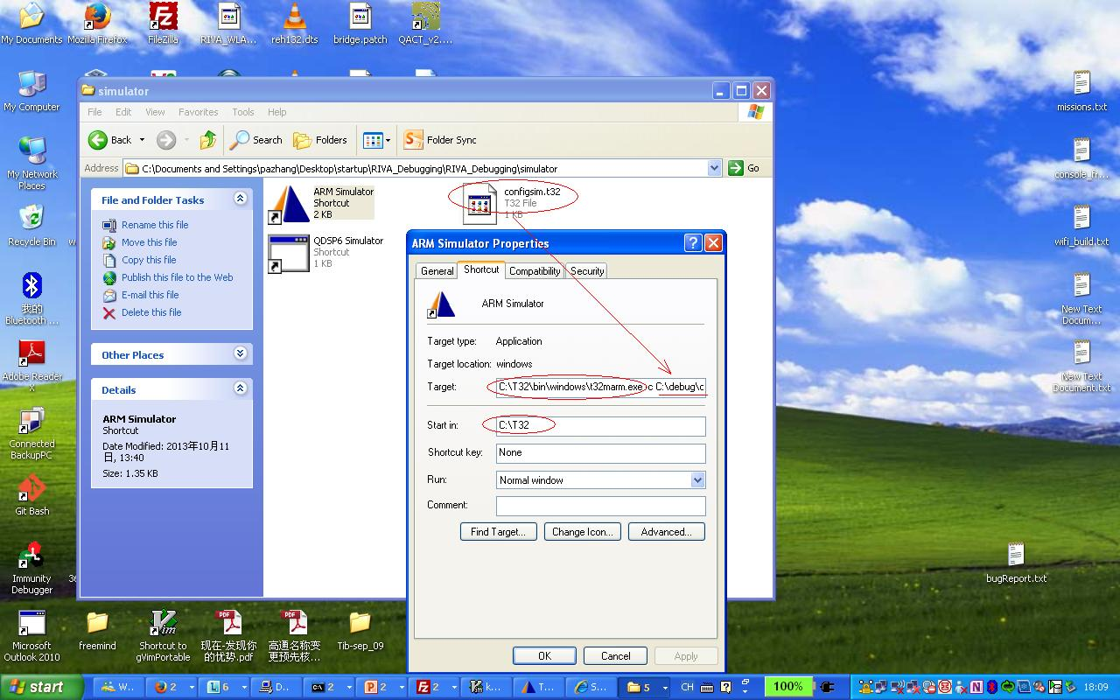
e\ double click: ARM Simulator
f\ in the command line:
cd c:\....\wifi_doc\debug
do load_pronto.cmm

(From crashScope.exe)
10:24:05.692 Processing log folder \\asw-wlan-hrs\Shared\CR_MSBug\CR\CR552644\191494_DedicatedDump_7_1 //wlan0.bin

10:23:55.193 WCNSS : \\dreyers\builds491\PROD\M8626AAAAANAZW140126.1
// wcnss_proc\build\ms\8x26_PRONTO.elf

6\ How to fix the country code as CN
a\ add this option to the file WCNCSS_qcom_cfg.ini
gCountryCodePriority=1
b\ adb shell
$ su
# wpa_cli -pwlan0 -iwlan0
> driver country CN //Notice, if the wifi turns off and then turns on, please issue the command again.

7\ How to update the firmware
Pronto firmware upload for the 8x26 phone
adb shell mount -t vfat -o remount,rw /dev/block/platform/msm_sdcc.1/mmcblk0p1 /firmware
adb push <path_to_your_split_images> /firmware/image/
adb shell sync
adb reboot

/persist/WCNSS_qcom_wlan_nv.bin

8\ VCE
You have to installed perforce. and set P4PORT variable to aswp401:1666.
You need python installed with version greater than or equal to 2.6.5.
You can download the latest version of vce from the following perforce path: //source/qcom/tools/scm/hci/pw/VCE/main/latest/...

You can get the usage of vce from go/vce

