# Part 1 – Manual Testing

## Test Plan 1 – Test Win/Loss Confirmation

### Purpose

This test will check to see whether or not the tic-tac-toe game accurately gives the user feedback on the outcome of a game at the end.

### Steps

1. Navigate to game.
2. Click start to begin a game.
3. Win a game / view the phrasing of the confirmation.
4. Repeat 1-2
5. Lose a game / view the phrasing of the confirmation.

### Test Post-Condition

* The test should pass if the confirmation message says whether X’s or O’s won the game, accurately.

## Test Plan 2 – Test AI

### Purpose

This test will check whether the AI responds to the user and attempts to win the game.

### Steps

1. Navigate to game.
2. Click start and attempt to win.
3. Observe moves of the AI.
4. Repeat several times, and sometimes attempt to lose.
5. After several games, log when the AI made intelligent attempts to win the game, and when moves seemed just random.

### Test Post-Condition

* After the test, the player should feel as if they are competing against an AI that is at least attempting to win the tic-tac-toe game.

## Test Plan 3 – Movement testing

### Purpose

This test will check whether the movement of their player is accurate. Whether the moves are legal to the rules of the game, and accurately display on the screen.

### Steps

1. Navigate to game.
2. Click start on game, and refresh as many times as necessary to complete test.
3. Attempt to move to an unused space. Log results.
4. Attempt to move to used space by player. Log results.
5. Attempt to move to used space by AI. Log results.

### Test Post-Conditions

* The player should only be able to move to unused spaces, and when they do it should demonstrate that on the screen.

## Test Plan 4 – Accurate sprites

### Purpose

This test is to ensure that the sprites on the screen, the X’s and the O’s, are consistent and all look the same.

### Steps

1. Navigate to game.
2. Click start.
3. Play several rounds, clicking refresh when necessary. Ensure that all the X’s and O’s look the same.

### Test Post-Conditions

The X’s and O’s should all look the same

## Bug Report: Win/Loss Confirmation

### Summary

When the player wins or loses, there is a confirmation message at the top of the screen which is inaccurate on the outcome of the game.

### Steps to reproduce

1. Navigate to game.
2. Click start.
3. Play a game and win. Observe it says “X lost.”
4. Click refresh.
5. Click start.
6. Play and game and lose. Observe it says “O lost.”

### Expected results

When X wins the confirmation would say “X Won” and vice-versa when O wins.

### Actual results

It says “X lost” when X won, and “O lost” when O won.

### Attachments

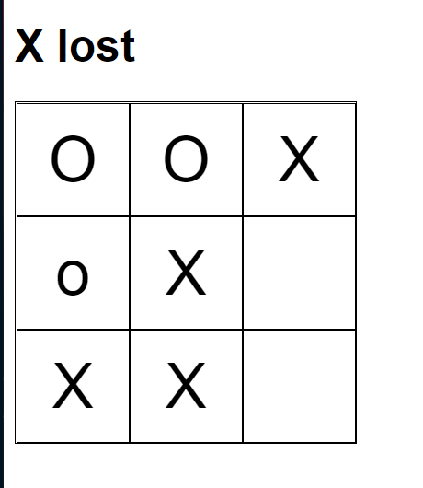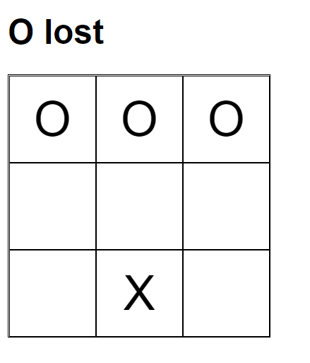

## Bug Report: Player Movement

### Summary

The player can move into used spaces.

### Steps to reproduce

1. Navigate to game.
2. Click start.
3. Move to spaces already in use by player.
4. Move to spaces already in use by AI.

### Expected results

* Player cannot move onto used spaces.

### Actual results

* Player can move onto spaces occupied by both the X’s and O’s. The X’s will override the O’s.

### Attachments

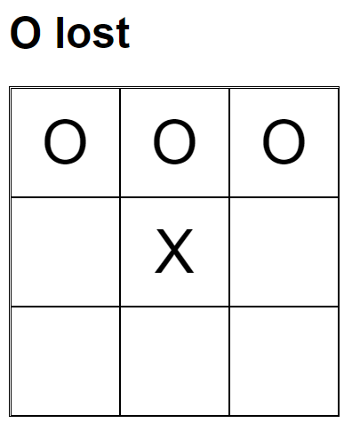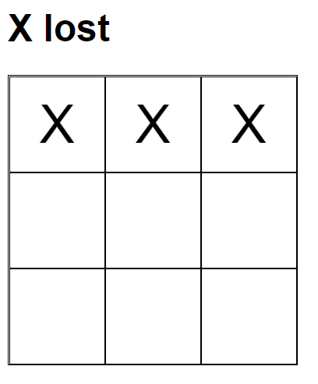

## Bug Report: “O” Sprite Consistency

### Summary

The “O” on the left middle square is lowercase and all the others are capital.

### Steps to reproduce

1. Navigate to game.
2. Click start
3. Place X’s at top of screen so the AI places an “O” on the left side.

### Expected results

* All X’s and O’s are consistent.

### Actual results

* Some of the sprites need to be changed for consistency.

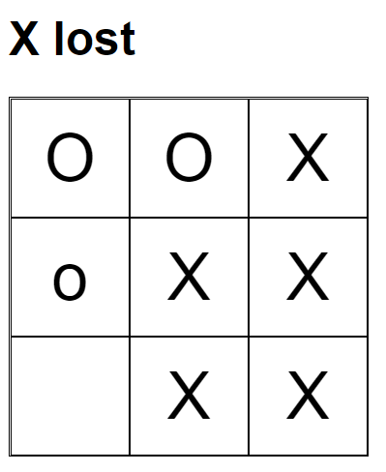

# Part 3 - Deployment Sketch

