Threat Model: Bellevue School District ParentVUE System
Student: Chaltu Abafita
Course: Skillspire – Cybersecurity 2510
Instructor: Alpha Diallo
Date: February 8, 2026

Contents
1. Executive Summary 3
2. Introduction 3
3. System Overview 3
4. Key Stakeholders 3
4.1. Figure 1: Shared Responsibility Model with Trust Boundaries for the ParentVUE System. 4
5. High-Level Architecture Overview 5
5.1. Figure 2: Architecture Diagram 5
6. Assets 5
7. Trust Boundaries and Data Flows 6
8. Data Flow Diagrams 6
8.1. Figure 3: DFD Level 0 6
8.2. Figure 4: DFD Level 1 7
9. Threat Modeling Framework Selection 7
10. STRIDE Threat Model 7
11. Risk Assessment 10
11.1. Risk Matrix / Heat Map 10
11.2. Key Risks Identified 11
12. Mitigation Summary 13
13. Conclusion 13
14. Author Contribution Statement 13
15. References 13

Executive Summary
The Bellevue School District (BSD) ParentVUE system provides parents, teachers, and administrators with secure access to student information, including grades, attendance, health records, and communication tools. Because the system handles sensitive student data protected under FERPA, a structured security assessment was conducted using Data Flow Diagrams (DFD Level 0 and Level 1), the STRIDE threat-modeling framework, and a qualitative risk matrix.
The assessment identified several high-risk threats, including credential theft, unauthorized access to student records, and potential database compromise. Medium-high risks include tampering with grades, messaging impersonation, and denial-of-service attacks targeting authentication services. A comprehensive mitigation strategy was developed, incorporating multi-factor authentication, encryption, RBAC, secure coding practices, and availability protections.
This report provides a complete threat model, risk analysis, and mitigation plan to strengthen the confidentiality, integrity, and availability of the ParentVUE system.

Introduction
ParentVUE is a critical component of BSD’s digital ecosystem, enabling families to stay informed and engaged in their children’s education. Because the platform handles sensitive personal and academic information, a formal threat model is necessary to ensure the system remains secure, compliant, and resilient. This report evaluates ParentVUE using industry-standard methodologies and provides actionable recommendations to enhance system security.

System Overview
BSD ParentVUE is a web and mobile platform that allows parents to access report cards, review daily attendance, message teachers, and update student details such as demographics, emergency contacts, addresses, and health information. The system integrates with the Synergy Student Information System (SIS), which stores all district student data.

Key Stakeholders
The ParentVUE system involves several stakeholders, including parents, teachers, school administrators, district IT staff, and Edupoint as the software vendor. Each group plays a specific role in accessing, managing, or supporting the platform.
Vendor and District Security Responsibilities: ParentVUE follows a shared responsibility model between Edupoint and the Bellevue School District. Edupoint secures the ParentVUE/Synergy platform, including software updates, patches, and backend infrastructure. The district manages user accounts, RBAC settings, internal network security, and local incident response. Both parties share monitoring and coordination duties, which is essential for accurate threat modeling and risk assessment.
Parents: Primary users who access student grades, attendance, and update information. Teachers: Enter grades, attendance, and communicate with families. School Administrators: Manage enrollment, student records, approvals, and data accuracy.
BSD IT and Security Teams: Maintain identity management, system configuration, and security controls.
BSD Leadership: Set policies, compliance requirements, and oversee system governance. Edupoint (Vendor): Hosts the ParentVUE/Synergy platform, maintains backend services, and provides software updates.
State Education Agencies: Rely on accurate reporting and compliance with FERPA and state data rules.

Figure 1: Shared Responsibility Model with Trust Boundaries for the ParentVUE System.

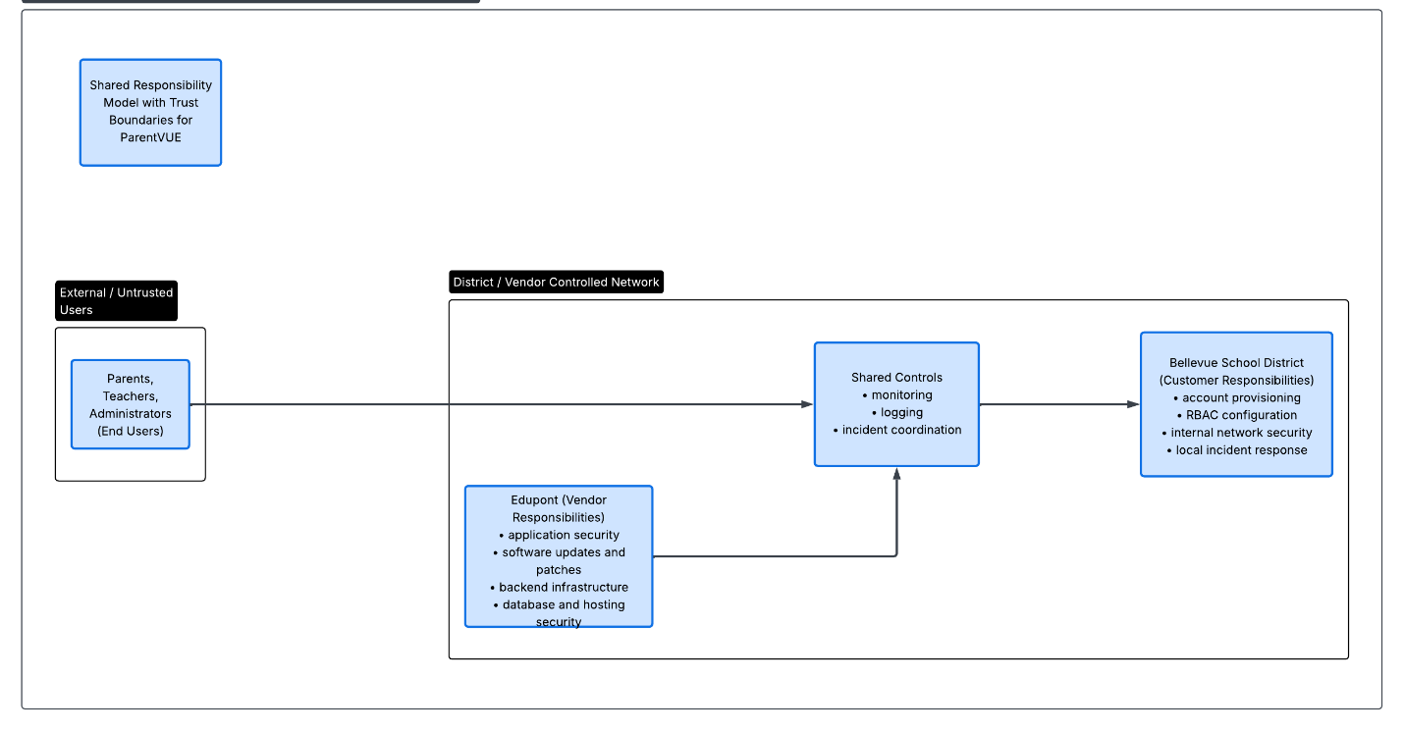

High-Level Architecture Overview

Figure 2: Architecture Diagram
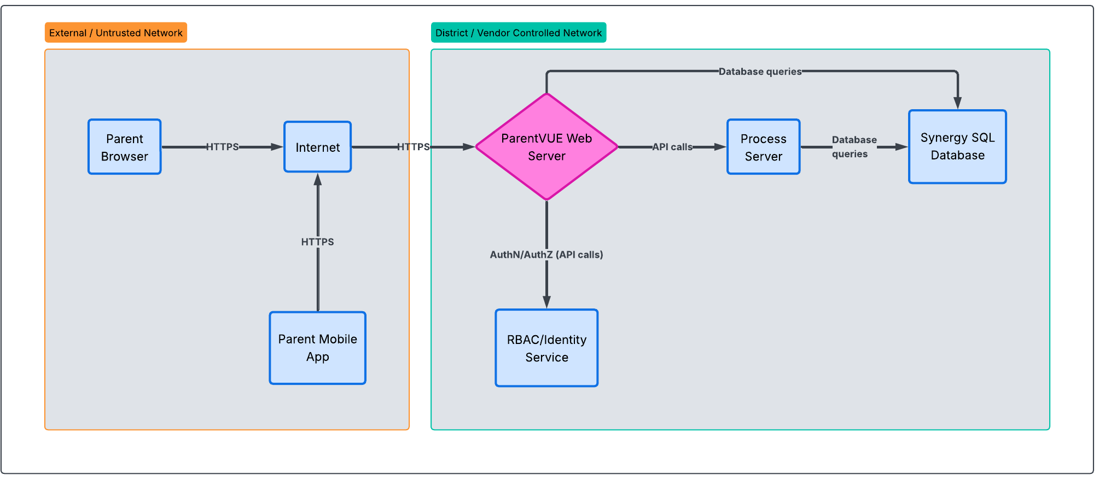

Presentation Layer (Interfaces)
Web Portal: Parents access ParentVUE through the district’s portal. Mobile Apps (iOS/Android): Native apps communicate with the same backend APIs as the web portal.
Application Layer (Logic)
Web Server: Manages traffic from browsers and mobile devices. Process Server: Handles high-resource tasks such as generating PDF report cards or transcripts.
Data Layer (Storage)
SQL Database Server: Stores all district student data. Role-Based Access Control (RBAC): Ensures that user roles strictly define what data can be read or edited.

Assets
- ParentVUE web portal
- ParentVUE mobile app
- Parent credentials (usernames, passwords, activation keys)
- Student personal information
- Academic records
- Attendance logs and schedules
- Health information
- Synergy Mail messaging
- District reputation
- District infrastructure

Trust Boundaries and Data Flows
ParentVUE includes several trust boundaries:
External Boundary: Parents, teachers, and administrators accessing the system from personal devices. Internal District Boundary: Web servers, process servers, and the Synergy database. Vendor Boundary: Edupoint’s hosted backend services.

Data Flow Diagrams

Figure 3: DFD Level 0
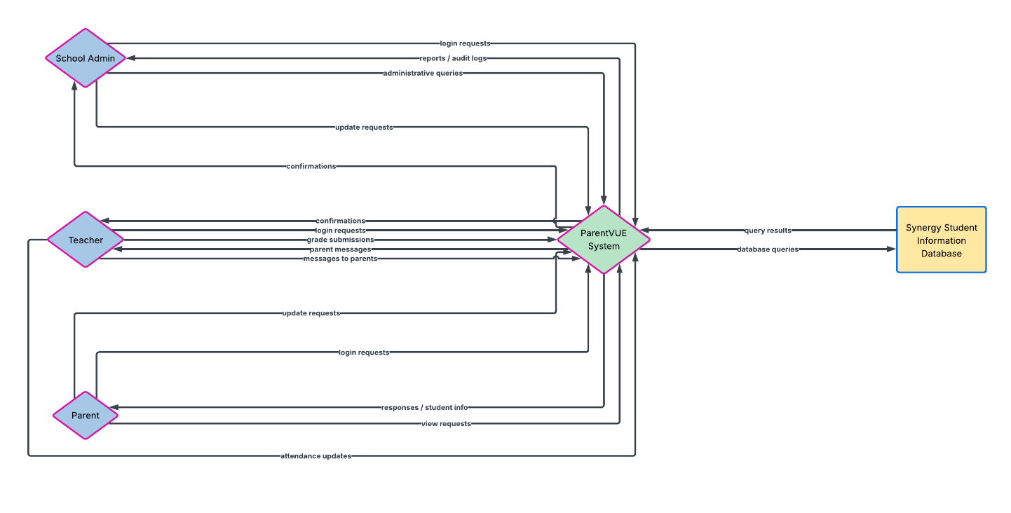
The DFD Level 0 diagram provides a high-level view of how external users—parents, teachers, and school administrators—interact with the ParentVUE system. It shows the primary data flows entering and leaving the system, including login requests, grade and attendance inquiries, messaging, and student-information updates. This context diagram establishes the system boundary and illustrates how ParentVUE communicates with the Synergy Student Information System (SIS) as the central data store.

Figure 4: DFD Level 1
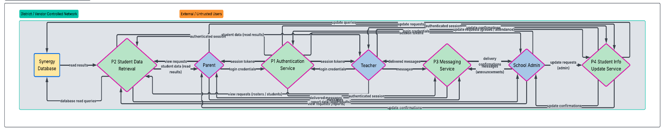
The DFD Level 1 diagram expands the ParentVUE system into its internal processes, including authentication, student-data retrieval, messaging, and information display. It illustrates how user requests move through these processes and how each component interacts with the Synergy Student Information System (SIS) to retrieve or update data. This diagram provides a more detailed view of system behavior and highlights the trust boundaries where security controls must be enforced.

Threat Modeling Framework Selection
STRIDE was selected because it aligns with the types of threats relevant to ParentVUE, including authentication, data retrieval, messaging, and interactions with the Synergy SIS backend. STRIDE provides a structured method for identifying threats across Spoofing, Tampering, Repudiation, Information Disclosure, Denial of Service, and Elevation of Privilege.

STRIDE Threat Model
The STRIDE analysis identified threats across external entities, internal processes, data flows, and the Synergy database.
Table 1. STRIDE Threat Analysis for the ParentVUE System
STRIDE Category | Threat Description | Affected Components | Impact | Recommended Mitigations
Spoofing | Stolen or guessed parent credentials allow attackers to impersonate legitimate users. | Login Page, Authentication Service (P4), Parent Accounts | Unauthorized access to student records; privacy violations | MFA, strong password policy, account lockout, secure session tokens, login anomaly monitoring
Spoofing | Compromised teacher/admin accounts used to impersonate staff. | Messaging Service (P3), Admin Accounts | False communication, misinformation, reputational damage | MFA for staff, RBAC enforcement, device-based authentication
Tampering | Unauthorized modification of grades, attendance, or student information. | Student Data Retrieval (P1), Synergy Database | Data integrity loss; academic manipulation | Server-side validation, audit logs, RBAC, database integrity constraints
Tampering | Alteration of messages sent through Synergy Mail. | Messaging Service (P3) | False messages, misinformation, trust issues | Message signing, TLS, input validation
Repudiation | Users deny actions such as updating student info or sending messages. | Web Portal, Mobile App, Synergy Mail | Disputes, lack of accountability | Audit logging, timestamping, non-repudiation controls
Information Disclosure | Exposure of PII during transmission (e.g., intercepted traffic). | Client ↔ Web Server ↔ Database Data Flows | FERPA violations, privacy breaches | TLS 1.2+, encryption at rest, secure API endpoints
Information Disclosure | Over-privileged accounts accessing unauthorized data. | RBAC System, Synergy Database | Unauthorized data exposure | Least privilege, RBAC review, access-control audits
Denial of Service | Flooding authentication endpoints to block logins. | Authentication Service (P4), Web Server | System unavailability | Rate limiting, traffic throttling, load balancing
Denial of Service | Excessive requests for large PDF reports overload the Process Server. | Process Server | Performance degradation | Queue management, resource throttling, caching
Elevation of Privilege | Attackers escalate from parent to teacher/admin roles. | RBAC, Web Server, Database | Full system compromise; unauthorized data modification | Strict RBAC enforcement, privilege separation, server-side authorization
Elevation of Privilege | Exploiting API vulnerabilities to bypass role checks. | Backend APIs, Web Server | Unauthorized access to restricted data | API gateway validation, input sanitization, penetration testing

High-Risk STRIDE Findings
Spoofing: Credential theft, account impersonation Tampering: Unauthorized modification of grades or attendance Information Disclosure: Exposure of PII during transit or storage Denial of Service: Flooding authentication or messaging endpoints Elevation of Privilege: Unauthorized escalation to administrative roles.
Impact on STRIDE and Risk Assessment: The shared responsibility model determines which threats belong to Edupoint and which belong to the Bellevue School District. Platform and backend vulnerabilities fall under Edupoint, while account misuse, RBAC issues, and internal network risks fall under BSD. Shared threats—like credential theft or suspicious logins—require coordinated monitoring and response. This division is reflected in the STRIDE table and risk ratings.

Risk Assessment

Risk Matrix / Heat Map
The risk matrix illustrates how threats are distributed across likelihood and impact categories. High-risk items appear where “Likely” or “Possible” threats intersect with high or critical impact, indicating areas requiring immediate mitigation. The heat map visually highlights these concentrations, helping prioritize security controls.
Table 2: Risk Assessment Matrix
Likelihood \ Impact | Low | Medium | High | Critical
Rare | Low | Low | Medium | Medium
Unlikely | Low | Medium | Medium | Medium-High
Possible | Medium | Medium-High | High | High
Likely | Medium-High | High | High | Critical
Almost Certain | High | High | Critical | Critical

Heat Map
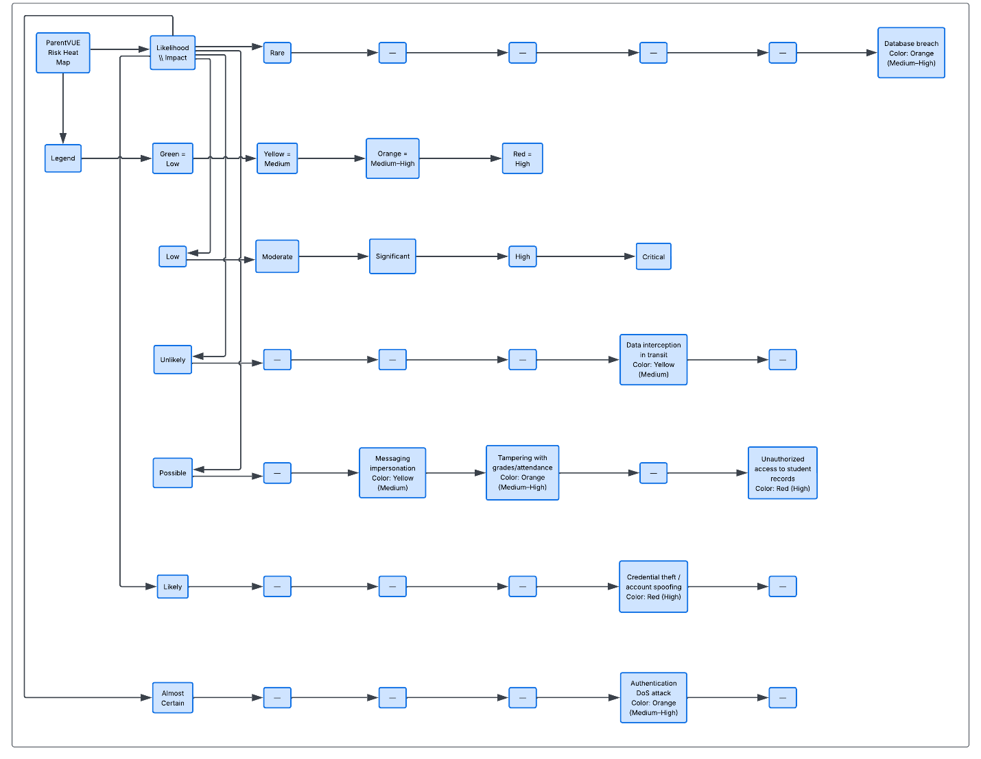

Key Risks Identified
The key risks table summarizes the most significant threats to the ParentVUE system, including credential theft, unauthorized access to student records, and database compromise. These risks are rated based on severity and potential impact on confidentiality, integrity, and availability. Medium-high risks such as messaging impersonation and authentication DoS attacks also require proactive mitigation to maintain system reliability and trust.
Table 3: Key Risks Identified
Risk | Description | Severity | Reasoning / Impact
Credential Theft / Account Spoofing | Attackers steal parent or staff credentials to access student data. | High | Leads to unauthorized access to PII; FERPA violation; high likelihood.
Unauthorized Access to Student Records | Exploiting weak RBAC or compromised accounts. | High | Exposure of sensitive academic, demographic, and health data.
Database Breach | Compromise of Synergy SIS backend. | High | Catastrophic data loss, manipulation, or mass disclosure.
Grade or Attendance Tampering | Unauthorized modification of student records. | Medium-High | Impacts data integrity and academic trust.
Messaging Impersonation | Sending fraudulent messages via Synergy Mail. | Medium-High | Misinformation, reputational harm, parent–teacher trust issues.
Authentication DoS Attack | Flooding login endpoints to block access. | Medium-High | Prevents parents and staff from accessing critical information.
Data Interception in Transit | Sniffing or intercepting unencrypted traffic. | Medium | Privacy risk, but mitigated by TLS when properly configured.

The assessment identified several high-priority risks that pose significant threats to the confidentiality, integrity, and availability of the ParentVUE system. High-risk threats include credential theft or account spoofing, unauthorized access to student records, and potential database compromise—each of which could result in severe privacy violations and FERPA non-compliance. Medium-high risks include tampering with grades or attendance, messaging impersonation, and denial-of-service attacks targeting authentication services, all of which could disrupt system reliability or undermine trust between families and the district. Medium-level risks, such as data interception in transit, remain important but are effectively mitigated through encryption and secure communication protocols.

Mitigation Summary
Authentication Security: MFA, strong passwords, secure session tokens Data Protection: TLS encryption, encryption at rest, data minimization Access Control: RBAC, least privilege, server-side authorization Integrity Controls: Input validation, message signing, audit logging Availability Protections: Rate limiting, load balancing, anomaly detection Error Handling: Sanitized error messages
These controls support a defense-in-depth strategy.

Conclusion
The ParentVUE system plays a vital role in supporting communication and transparency between BSD and families. This assessment provides a comprehensive understanding of system risks and actionable recommendations to enhance security. By aligning controls with actual data flows and trust boundaries, BSD can better protect sensitive student information and maintain public trust.

Author Contribution Statement
Copilot supported the writing process, while I completed the system analysis, diagrams, and security evaluation myself.

References
- https://copilot.microsoft.com/
- https://www.lucidchart.com/

