
KARNATAKA STATE COUNCIL FOR SCIENCE AND TECHNOLOGY
Indian Institute of Science campus, Bengaluru
Telephone: 080 – 23341652, 23348848 || Email: spp@kscst.org.in Website: www.kscst.org.in/spp.html or https://kscst.karnataka.gov.in/en

FORMAT FOR STUDENT PROJECT PROPOSAL FOR THE 49th SERIES OF STUDENT PROJECT PROGRAMME
(Handwritten proposals will not be accepted, please fill all the details in this MS word file, insert images / diagrams wherever necessary. Convert to pdf file, get it approved from the project guide / head of the department and principal of your institution. Keep ready the scanned pdf file of 1) Declaration and Endorsement 2) details of processing fees made and fill- up the Google Form.
https://forms.gle/iXiR81MyoLWn871x7

1. | Name of the College: Vivekananda Institute of Technology
2. | Project Title: PrintChakra: AI Powered Smart Print & Capture Solution
3. | Branch: Artificial Intelligence and Machine Learning
4. | Theme (as per KSCST poster):  (The project proposals shall mandatorily be from one of the broad themes  / areas. Visit website www.kscst.org.in/spp.html)  Data Science, Cyber Security, Computing, Pattern Recognition and Image Processing, Signal Processing
5. | Name(s) of project guide(s):  1. Name: Dr. Shaila K  Email id: dr.shailak.aiml@gmail.com  Contact No.: 9964579958
6. | Name of Team Members (Strictly not more than four students in a batch):  (Type names in Capital Letters as provided in your college)  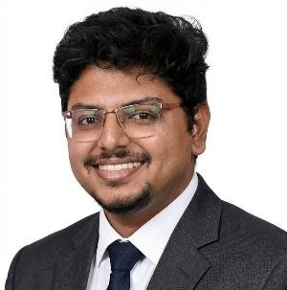  (Please paste the latest passport size photograph adjacent to your respective names)  Name: CHAMAN S  USN No.: 1VK22AI007  Email id: chamans79952@gmail.com  Mobile No: 6361005641

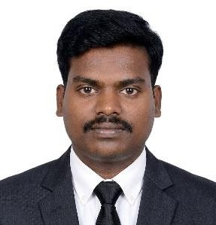
Name: GOWTHAM S
USN No.: 1VK22AI013
Email id: gr231202@gmail.com
Mobile No.: 8431792673

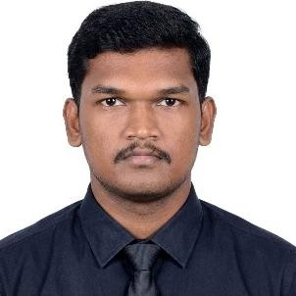
Name: KARTHIK KUMAR V GUPTA
USN No.: 1VK22AI016
Email id: guptakarthik41@gmail.com
Mobile No.: 7892096813
7. | Team Leader of the Project: Name: Chaman S  USN No.: 1VK22AI007  Email id: chamans79952@gmail.com  Mobile No.: 6361005641
8. | Processing Fee Details (Through Online Payment only):  (processing fee of Rs. 1180/-)  - UTR NO: 543735294752  - TRANSACTION ID: T2512151442231472320512  - NAME OF THE SENDER: CHAMAN S  - CONTACT NUMBER: 6361005641  - NAME OF THE BANK: INDIAN BANK  - PROCESSING FEES: Rs. 1,180/-  - DATE OF PAYMENT MADE: 15/12/2025  - TIME: 2:42 PM  - MODE OF PAYMENT MADE: UPI
9. | Date of commencement of the Project: 05/March/2025
10. | Probable date of completion of the project: 10/ December/2025
 | Timeline Structure
 |  | Task | Start Date | End Date | Duration | Milestone achievable
 |  | Project Initiation | 4, March  2025 | 24,  November 2025 | 8 months | Project topic finalized (PrintChakra), guide approval obtained, initial planning completed
 |  | Research Phase | 4, March  2025 | 27, April  2025 | 2 months | Literature survey completed, problem statement defined, objectives finalized

 |  | Development Phase | 8, August  2025 | 17, October  2025 | 3 months | System design completed, application modules developed, integration of printer, OCR, LLM & Web  application.
 |  | Testing Phase | 31,  October 2025 | 28,  November 2025 | 2 Months | Functional testing completed, bugs resolved, synchronization and performance validated
 |  | Submission of PPT and Abstract to KSCST for conducting mid- term evaluation  (Upload to Google Form) | Middle of March – 2nd Week of April 2026
 |  | Final Review | 28,  November 2025 | 28,  November 2025 |  | Internal evaluation completed, guide approval for final submission
 |  | Project Submission | 28  November 2025 | 28  November 2025 |  | PPT and abstract successfully completed
 |  | Submission of Project Completion Report to KSCST (Upload to Google Form) | April / May 2026
11. | Scope / Objectives of the project:  - AI-Driven Workflow Automation: Automates printing, scanning, and document conversion end-to-end using an integrated LLM (smolllm:135B), minimizing manual intervention.  - Natural Language–Based Control: Allows users to operate the system through simple voice or text commands interpreted by the LLM for intelligent task execution.  - AI-Based Image Processing and OCR: Enhances document images and extracts accurate text using image processing and OCR for reliable digitization.  - Offline-First Intelligent Operation: Executes scanning, processing, and LLM-driven automation over a local network without requiring internet connectivity.  - Scalable and Adaptive Architecture: Provides a cost-effective, modular solution that can scale across institutions and adapt to future AI-driven enhancements.

12. | Methodology:  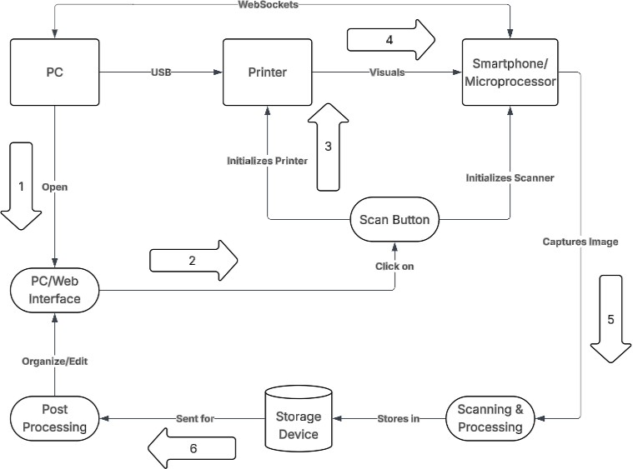  - PC/Web Interface Initialization: The user opens the PrintChakra web interface on the PC to configure print, scan, and document processing actions through manual controls or AI (LLM) commands.  - Printer Initialization and Document Preparation: The PC initializes the printer via USB/Wi-Fi and outputs the document, preparing it for capture while system parameters are set.  - Scanner Activation via Mobile/Device: On user or LLM instruction, the smartphone/mobile device initializes the scanner and captures the printed document using the camera.  - Image Capture and Visual Transfer: The captured document image is transferred over the local network to the processing system for further analysis.  - Scanning, Image Processing, and OCR: The system performs image enhancement, edge detection, and OCR to extract structured text and digitize the document.  - Storage and Post-Processing: The processed data is stored securely in the storage device (MongoDB/GridFS) and sent for post-processing, where documents can be organized, edited, converted, or printed automatically using the AI-based LLM.
13. | Expected Outcome of the project:  - Intelligent Document Automation: Real-time AI-driven automation enables seamless printing, scanning, and document conversion with minimal human intervention.  - Accurate and Reliable Digitization: Image processing and OCR ensure high accuracy in text extraction and document enhancement, reducing manual errors.  - Accessible and User-Friendly Interaction: Natural language control via the LLM allows users to manage document workflows easily through voice or text commands.  - Efficient and Secure Offline Operation: Local network processing with secure storage improves reliability, data privacy, & overall system efficiency.

14. | Is the project proposed relevant to the Industry / Society or Institution? Yes / No: Yes, relevant to the society and institutions.  If yes, please provide details of the industry / institution and contact details:  The project is intended for educational institutions, government offices, examination departments, libraries, and administrative organizations that manage high volumes of printed and scanned documents. It provides an AI- powered document automation and management system for printing, scanning, OCR-based digitization, and intelligent document conversion, particularly suitable for offline or secure institutional environments. Contact details: Institutional-level deployment (college offices, government departments, and administrative units); no single external industry partner at the proposal stage.  Industry support (technology / funds / use of final product):  - Technology support: Provided through institutional infrastructure, academic mentorship, and open-source AI/OCR frameworks.  - Use of final product: The final system can be directly used and deployed by institutions for document processing and automation.  - Funds: No direct industry funding; project developed as an institution- focused and socially relevant solution.  (Note: Preference will be given to those projects relevant to the industry / institution. Hence be specific in giving detailed information). Is the industry extending support - technology / funds / use the final product, please specify.)
15. | Can the product or process to be developed in the project be taken up for filing a Patent?  Yes / No: yes  Prior Art search done? Yes/No: yes  Note: If your answer is “Yes”, you may contact Patent Information Centre of  KSCST. For more details, email: pic@kscst.org.in
16. | Budget details (break-up details should be given):  Note: KSCST will provide nominal grant support for carrying out the project by students if selected by the project selection committee.
 |  | Budget | Amount
 |  | a) Materials / Consumables (Please specify) | 3200.00
 |  | b) Labor (Describe) | 200.00
 |  | c) Travel (Describe) | 600.00
 |  | e) Miscellaneous (Please specify) | 1000.00
 |  | Total | 5000.00
17. | Any other technical details (Please specify):  Unified web-based interface accessible from both Android devices and laptops, integrated with OpenCV-based scanning, Tesseract OCR, Flask REST APIs, MongoDB with GridFS, JWT/SSL security, and LLM-based automation (smolllm:135B) for intelligent printing, scanning, and document conversion.

18. | SPP Coordinator (Identified by the college):  Note: To be identified by the principal of the institution. The project proposals must be submitted to KSCST through SPP coordinator designated by the principal.  Name: Dr. Suresh P M  Email id: spm_dvg@yahoo.co.in Contact No.: 9886756991

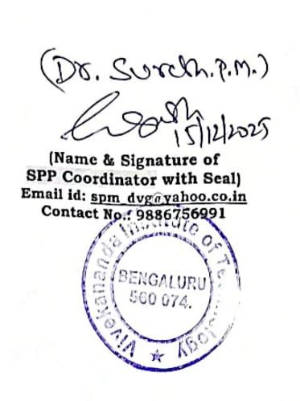
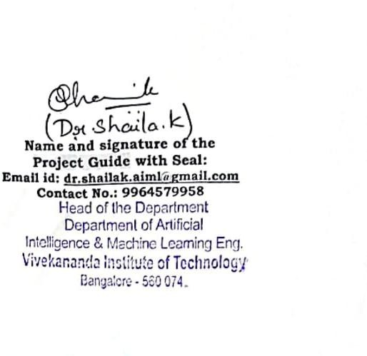

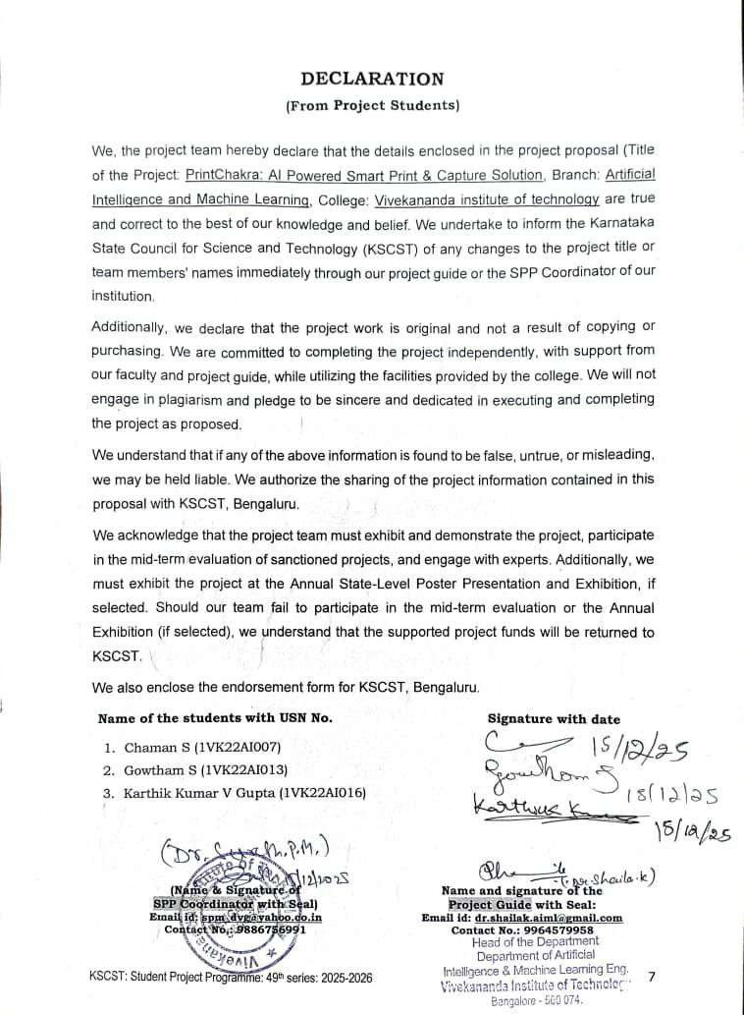

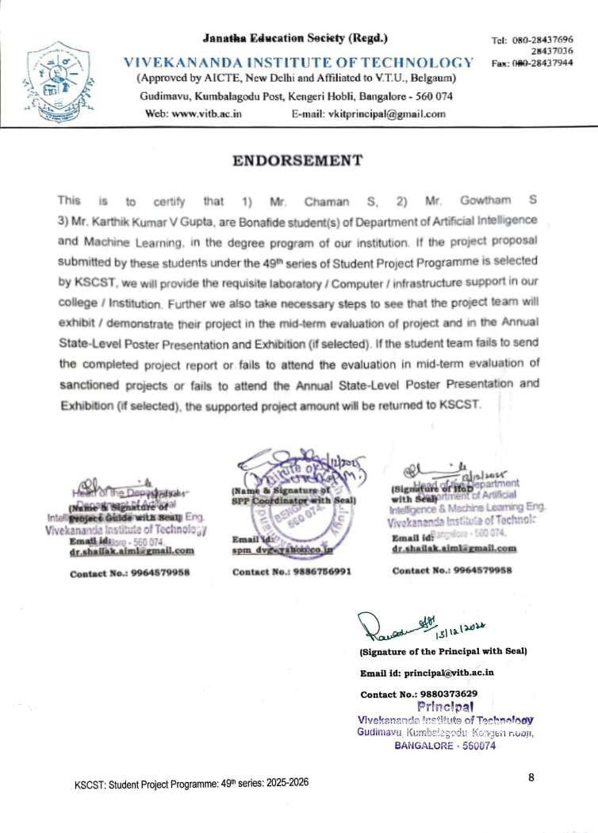

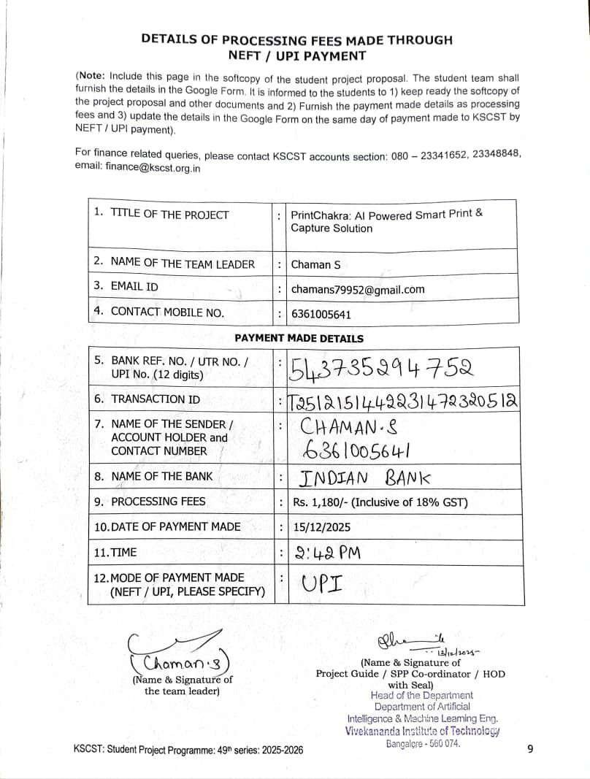

KARNATAKA STATE COUNCIL FOR SCIENCE AND TECHNOLOGY
Indian Institute of Science campus, Bengaluru
49th SERIES OF STUDENT PROJECT PROGRAMME (SPP)

(Note: This page is for information about bank details of KSCST to the student team and college / institution and not to include this page in the project proposal softcopy)

BANK ACCOUNT DETAILS OF KSCST

Name and address of the Institution | Karnataka State Council for Science and Technology, IISc Campus, Bangalore -560012
Account holder’s name / Designation | Secretary, Karnataka State Council for Science and Technology
Bank Account No. & Name of the bank | Current A/C No. 0683201000024  Canara Bank, IISc Campus Branch, Bangalore-560012
IFSC Code | CNRB0000683
MICR Code | 560015023
Bank Branch Address | Canara Bank, Indian Institute of Science, Bangalore-560012
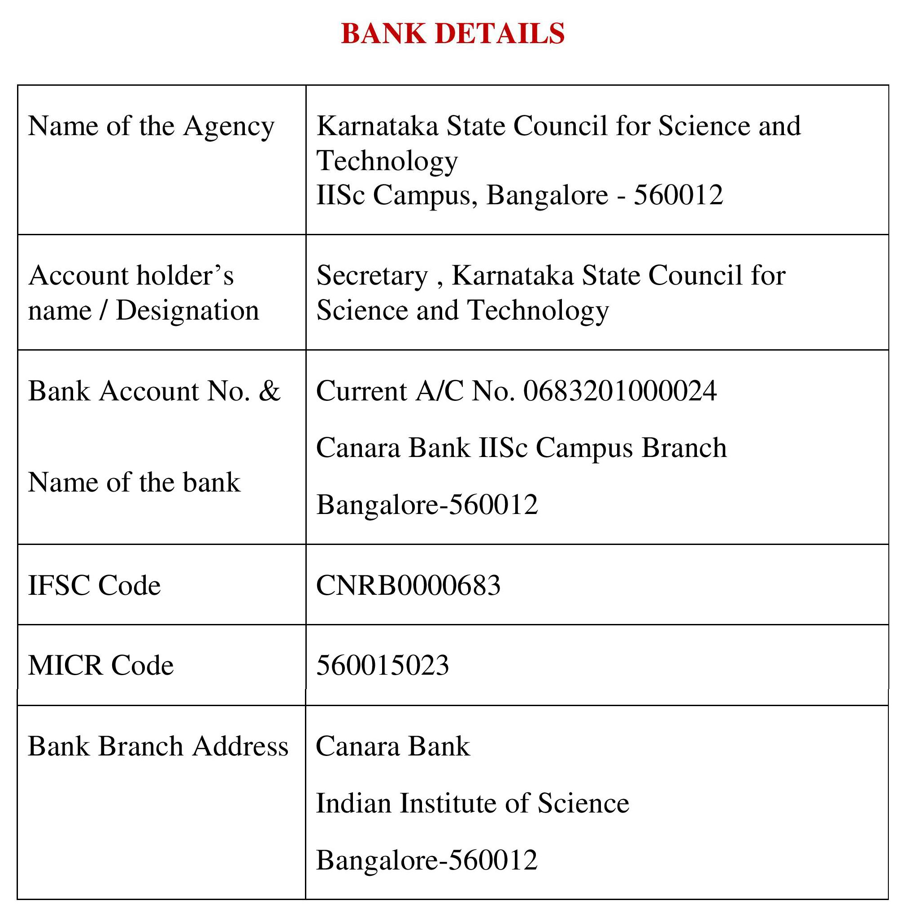
Note: For finance related queries, please contact KSCST accounts section: 080 – 23341652, 23348848 during office hours between 3.00 pm to 5 pm, email: finance@kscst.org.in with a copy to spp@kscst.org.in

KSCST: Student Project Programme: 49th series: 2025-2026 10

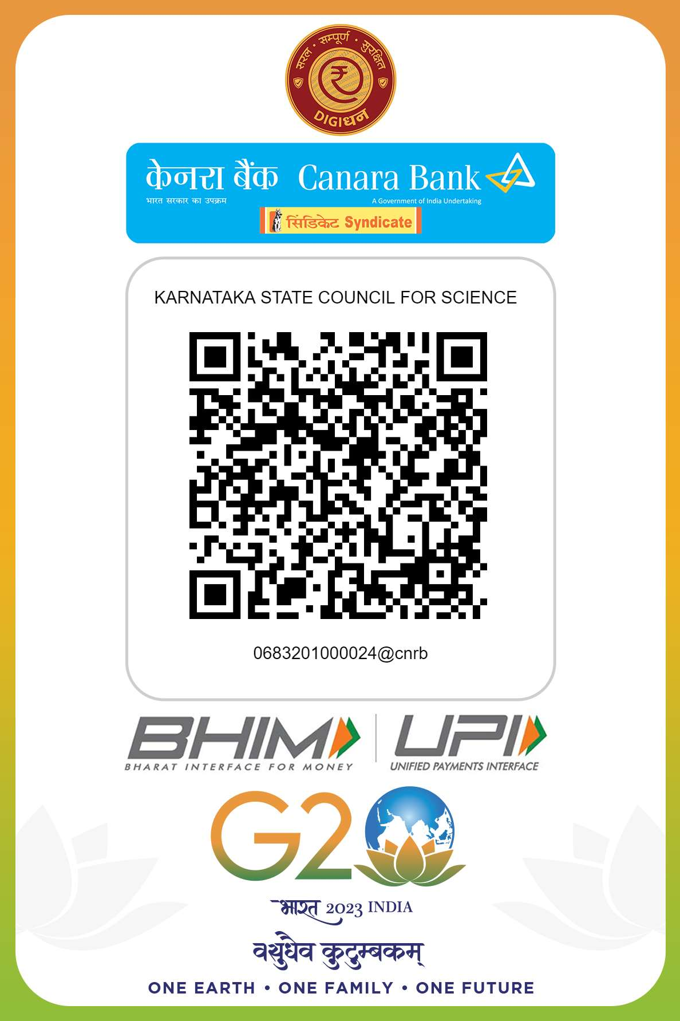

Note: For finance related queries, please contact KSCST accounts section: 080 – 23341652, 23348848 during office hours between 3.00 pm to 5 pm, email: finance@kscst.org.in with a copy to spp@kscst.org.in

KSCST: Student Project Programme: 49th series: 2025-2026 11

