VISVESVARAYA TECHNOLOGICAL UNIVERSITY
Jnana Sangama, Belagavi - 590 018


PROJECT PHASE II REPORT ON
“PrintChakra – AI-Powered Smart Print and Capture Solution”
Submitted in partial fulfilment of the requirements for the VII Semester (BAI786)
Bachelor of Engineering
in
ARTIFICIAL INTELLIGENCE AND MACHINE LEARNING
Submitted By
CHAMAN S 1VK22AI007
GOWTHAM S 1VK22AI013
KARTHIK KUMAR V GUPTA 1VK22AI016
Under the Guidance of
Dr. Shaila K
Professor & HOD, Department of AIML-VKIT

JANATHA EDUCATION SOCEITY

VIVEKANANDA INSTITUTE OF TECHNOLOGY
Gudimavu, Kumbalgodu(P), Kengeri(H), Bengaluru -560074
2025-2026

VIVEKANANDA INSTITUTE OF TECHNOLOGY

Gudimavu, Kumbalgodu (P), Kengeri (H), Bengaluru – 560074 DEPARTMENT OF ARTIFICIAL INTELLIGENCE AND MACHINE LEARNING

CERTIFICATE

This is to certify that Project entitled “PrintChakra – AI-Powered Smart Print and Capture Solution” carried out by CHAMAN S (1VK22AI007), GOWTHAM S (1VK22AI013), and KARTHIK KUMAR V GUPTA (1VK22AI016) Bonafide students of Vivekananda Institute of Technology, have satisfactorily completed the Project Phase II (BAI786) prescribed for 7th semester in Artificial Intelligence and Machine Learning, Visvesvaraya Technological University, Belagavi during the year 2025-2026. The Project report has been approved as it satisfies the academic requirements prescribed for the said degree.

Signature of the Guide Signature of the HOD Signature of the Principal

Dr. Shaila K
Prof. & HOD Department of AI & ML

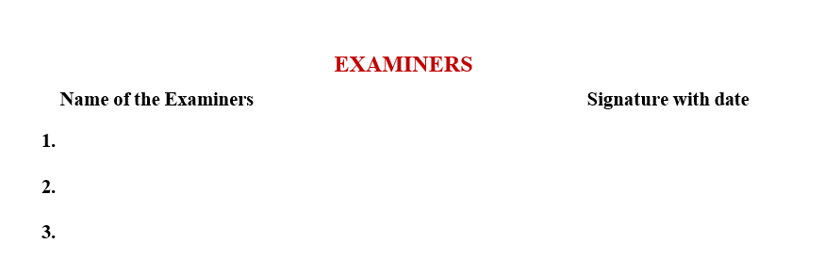
Dr. Shaila K
Prof. & HOD
Department of AI & ML

Dr. K M Ravi Kumar
Principal VKIT, Bangalore

ACKNOWLEDGEMENT

The satisfaction and euphoria that accompany the successful completion of any task would be incomplete without the mention of people who made it possible because “Success is the abstract of hard work and perseverance, but steadfast of is encouraging guidance”. So, we acknowledge all those whose guidance and encouragement served as a beacon light and crowned our efforts with success.
We would like to thank Visvesvaraya Technological University, Belagavi, for having this dissertation as a part of Curriculum, which has given us this wonderful opportunity.
We whole heartedly express our gratitude to our honorable Principal Dr. K M Ravikumar, Vivekananda Institute of Technology for the encouragement and support.
We would like to sincerely thank our guide Dr. Shaila K, Professor & HOD, Department of Artificial Intelligence and Machine Learning for their valuable guidance, constant assistance, support and constructive suggestions for the betterment of the practical assessment, without which this practical assessment would have not been possible.
We wish to express our gratitude to our Project coordinators Prof. Lavanya C, Professor, Department of Artificial Intelligence and Machine Learning and Prof. Sneha L S, Professor, Department of Artificial Intelligence and Machine Learning for their encouragement and support throughout the course of this Project.
Ultimately, we express our deep sense of gratitude to the institution in particular and everybody who have supported us in accomplishing this Project.

CHAMAN S (1VK22AI007)
GOWTHAM S (1VK22AI013)

KARTHIK KUMAR V GUPTA (1VK22AI016)

DECLARATION

We hereby declare that project entitled “PrintChakra – AI-Powered Smart Print and Capture Solution” submitted by us, for the award of degree of Bachelor of Engineering in Artificial Intelligence and Machine Learning to Visvesvaraya Technological University is a record of Bonafide work carried out by us under the guidance of Dr. Shaila K, Professor & HOD, department of Artificial Intelligence and Machine Learning, Vivekananda Institute of Technology. We further declare that the work reported in this project has not been submitted and will not be submitted, either inpart or full, for the award of any degree or diploma in this institute or any other university.

CHAMAN S (1VK22AI007)
GOWTHAM S (1VK22AI013)

KARTHIK KUMAR V GUPTA (1VK22AI016)

Date: 12/12/2025
Place: Bangalore
Signature: 1.
2.
3.

ABSTRACT

In today’s rapidly digitizing world, manual document processing remains a bottleneck in educational institutions, offices and government sectors. Traditional workflows involving physical printing, manual scanning and text extraction are inefficient, time-consuming and prone to human error. To address these challenges, this project introduces PrintChakra – an AI-Powered Smart Print and Capture Solution that combines AI, mobile computing and offline synchronization to automate the print-to-digital pipeline.

The system integrates an Android application and a Windows desktop interface to streamline real- time document capture, enhancement and OCR-based text extraction. Using deep learning- enhanced edge detection via OpenCV, the mobile app automatically captures and corrects document images, while Paddle OCR extracts text data with high accuracy. A Flask-based REST API enables seamless offline synchronization between the mobile and desktop applications over a local Wi-Fi network, removing the need for internet access.

Data including extracted text and document images is securely stored in local storage system, while JWT-based authentication and SSL encryption ensure secure communication. A React.js-powered dashboard on the desktop allows users to view scanned documents, access extracted content and manage files in real time.

The project involved challenges like accurate edge detection, OCR tuning for different fonts and lighting conditions and real-time offline communication, all addressed through AI model tuning, multi-threaded processing and adaptive scanning techniques.

By ensuring reliable synchronization and accurate OCR the system reduces manual effort speeds up document processing and supports intelligent record management. Future improvements may include handwriting recognition automatic language detection and cloud integration to allow remote access and better scalability.

PrintChakra represents a significant advancement in document automation by eliminating fragmented manual workflows and introducing a secure intelligent and autonomous print and capture system built to meet the needs of modern institutions and enterprises.
TABLE OF CONTENTS

- Introduction 1
  - Challenges 2
  - Motivation 2
  - Problem Statement 3
  - Objectives 3
  - Scope of the Project 4
  - Organization of the Report 4
- Literature Survey 6
  - Background 8
- Requirement Analysis 9
  - Hardware Requirements 9
  - Software Requirements 10
  - Computational Requirements 11
  - Data Requirements 12
  - System Design and Architecture 13
  - System Overview 13
  - Architectural Components 14
  - System Architecture 16
  - System Flow 17
  - Components and Technologies Used 18
  - Security and Privacy Considerations 19
- Methodology 20
  - Laying the Foundation for Efficient Automation 20
  - Core Development Tools and Technologies 22
  - Setting Up Environment and UI Considerations 24
  - Testing and Deployment Considerations 26
- Outcomes 28
  - Project Overview 28
  - Core Technology Implementation 28
  - Technical Achievements 30
  - Project Impact 30
  - User Interface Pages and Sections 31
- Conclusions and Future Scope 37
  - Conclusions 37
  - Future Scope 38
References 39

LIST OF FIGURES

FIGURE NO. | FIGURE NAME | PAGE NO.
Figure 4.1 | Block Diagram | 16
Figure 6.1  Figure 6.2  Figure 6.3  Figure 6.4  Figure 6.5  Figure 6.6 | Dashboard Page  Phone Interface Page  Device Info Interface  Print Queues Interface  Scan Mode Configuration Interface  Print Mode Configuration Interface | 31  32  33  34  3536

CHAPTER 1

INTRODUCTION

Document management plays a critical role in the daily operations of educational institutions, corporate offices, and government organizations. Traditional methods involving manual printing, scanning, and text entry are not only time-consuming but also susceptible to errors and inefficiencies. These workflows often require multiple tools and human intervention at every stage — from placing a print command to scanning physical documents, enhancing the image, extracting content, and finally storing the results. The lack of automation significantly hampers productivity, especially in environments that demand large-scale documentation and digitization.

To address these inefficiencies, PrintChakra – an AI-Powered Smart Print & Capture Solution is designed to automate the end-to-end process of physical document handling. This intelligent system integrates AI-based image enhancement, Optical Character Recognition (OCR), and offline synchronization to bridge the gap between physical and digital documents. Leveraging OpenCV for real-time edge detection and perspective correction, combined with Paddle OCR for accurate text extraction, the system allows users to capture printed content directly through an Android smartphone and transfer it seamlessly to a Windows desktop application over a local network.
Unlike traditional workflows that depend on internet connectivity or multiple standalone applications, PrintChakra functions entirely offline using a secure Wi-Fi network. Handling the backend storage of large image and text files at local storage, while JWT and SSL ensure secure communication. A React.js-based dashboard allows real-time document monitoring, editing, and management from the desktop interface.

By embedding AI directly into the capture & processing stages, this project not only reduces manual workload but also enhances speed, accuracy, & data integrity. PrintChakra transforms conventional document workflows into a streamlined, intelligent & autonomous system, paving the way for efficient document automation across domains..

CHALLENGES

- Hardware Interfacing: Establishing offline connectivity between mobile, printer, and desktop requires precise setup and synchronization.
- Real-Time Processing: Mobile devices have limited resources for edge detection, correction, and OCR, needing optimized algorithms.
- OCR Reliability: Varying fonts, formats, lighting, and paper quality affect OCR accuracy and output clarity.
- Offline Sync: Ensuring fast, secure data transfer over local networks introduces latency and sync issues.
- Storage Scalability: Managing large image/text data in local storage where we can add more resources while ensuring quick access demands efficient design.
- Security: Sensitive document handling requires robust SSL and JWT-based API protection to ensure data privacy.

MOTIVATION

In a world increasingly driven by information, efficient document management is critical. Yet, in many institutions and workplaces, traditional print-scan workflows remain manual, time-consuming, and prone to errors—leading to productivity loss and data inconsistencies.
Employees often spend valuable time printing, scanning, and manually entering information, especially in environments with limited internet connectivity or legacy systems. These inefficiencies highlight the need for a smarter, more integrated approach.
PrintChakra is motivated by the vision to bridge the gap between physical documents and digital systems. By leveraging advancements in AI, image processing, and OCR, the project aims to automate document capture, extraction, and syncing—all in real-time and without internet dependency.
This solution empowers users with a seamless, secure, and intelligent document workflow— enhancing accuracy, reducing human effort, and adapting to real-world constraints like offline environments and hybrid device usage. It’s about transforming everyday document tasks into a streamlined, smart experience.

PROBLEM STATEMENT

Traditional document workflows involving physical printing, manual scanning, & data entry are inefficient, labor-intensive, & error-prone. These systems lack automation, require continuous human involvement, & are not scalable for institutions handling large volumes of documents. Moreover, the dependency on internet connectivity & multiple disconnected tools adds friction to the process. This project aims to develop an AI-powered smart print & capture solution PrintChakra that automates real-time document capture, image enhancement & OCR-based text extraction. By integrating mobile-based scanning, AI- driven image processing, & offline synchronization with a desktop system, the solution will improve productivity, accuracy & operational efficiency in document handling.

OBJECTIVES

    - To automate the capture and digitization of printed documents using an Android-based scanning application.
    - To apply AI-based edge detection and perspective correction for enhanced image clarity and accuracy.
    - To implement OCR using Paddle for reliable text extraction from captured images.
    - To enable secure offline synchronization between the mobile app and Windows desktop via Flask APIs.
    - To design a React.js dashboard for viewing scanned documents, managing extracted text, and generating printable reports.
    - To ensure secure data handling through JWT-based authentication and SSL-encrypted communication.
    - To build a scalable backend using python’s flask for efficient document storage and retrieval from local storage.

SCOPE OF THE PROJECT

    - Automated Document Capture: Enable on-demand and triggered scanning of printed documents using AI-enhanced mobile capture, eliminating the need for manual scanning
    - AI-Enhanced Processing: Use OpenCV for edge detection and Paddle OCR for high- accuracy text extraction under various lighting conditions and document types.
    - Real-Time Processing and Syncing: Perform edge detection, perspective correction, and OCR in real-time, with immediate syncing between mobile and desktop.
    - Intelligent Storage Management: Automatically store extracted text and images in local storage while managing space by avoiding redundant captures.
    - User-Friendly Dashboard: Develop an intuitive React.js-based interface for monitoring scans, editing text, organizing files, and exporting documents.
    - Multi-Device Synchronization: Ensure seamless coordination between Android mobile and Windows desktop apps over a local Wi-Fi network for offline workflows.
    - Edge Device Optimization: Perform all scanning and processing directly on the mobile device to enable offline functionality and reduce latency.
    - Automated Document Logging: Log and timestamp every scan, extracted text, and user action for audit and tracking purposes.

ORGANISATION OF THE REPORT

Chapter 1 introduces the project by outlining the challenges of traditional document workflows & the need for automation in print-&-scan environments. It highlights the inefficiencies of manual processes such as scanning, text entry & synchronization, and sets the foundation for PrintChakra as a smart, AI-powered solution. The chapter also covers the motivation behind the project, clearly defines the problem statement, & lists specific objectives aimed at building an offline, intelligent, & secure document capture system.

Chapter 2 presents a thorough literature survey, exploring existing technologies in image processing, OCR, offline synchronization, and mobile-desktop integration. It reviews research studies related to edge detection algorithms, multilingual OCR, and AI-based enhancements in document capture. The survey also includes techniques like OpenCV for perspective correction, Paddle for text recognition, and Flask APIs for offline communication, identifying the gaps in current systems that PrintChakra aims to address.

Chapter 3 focuses on the system requirements, detailing both functional and non-functional aspects of the proposed solution. It specifies hardware components such as Android smartphones, LaserJet printers, and desktop systems, along with software stacks including React, Python, MongoDB.. The chapter also outlines performance goals, scalability expectations, data privacy needs, and system constraints to ensure the final implementation is robust and practical for real-world use.

Chapter 4 describes the architectural design of the PrintChakra system. It includes detailed block diagrams, workflow explanations, and component interactions, illustrating how the mobile app, desktop application, database, and APIs work together. Special focus is given to modularity, real-time synchronization, and offline capability, ensuring that the system remains efficient and extensible for future upgrades such as handwriting recognition and cloud integration.

Chapter 5 explains the development and implementation methodology followed throughout the project lifecycle. It outlines the step-by-step workflow—from hardware setup and mobile app development to API creation, OCR testing, and web dashboard integration. This chapter also discusses the challenges encountered, including lighting variability, OCR accuracy, and offline syncing, and explains how they were resolved through AI optimization, multi- threading, and adaptive processing techniques.

CHAPTER 2

LITERATURE SURVEY

Liu et al. [1] proposed a low-profile inkjet-printed interconnect solution for high-speed and compact hardware interfacing, addressing the limitations of traditional large-form communication architectures. Their work has significant implications for embedded systems where compactness, precision, and latency-free communication are essential. In PrintChakra, this ensures that print jobs and scan responses can be initiated and acknowledged without delay, mimicking real-time hardware interactions in standalone environments such as examination halls and print labs.

Hämäläinen et al. [2] explored the power of deep neural networks (DNNs) in OCR systems, particularly emphasizing the importance of multilingual support, adaptive training, and post- processing optimization. This aligns closely with PrintChakra's integration of the Paddle OCR engine, which must deal with a variety of document types often printed in different Indian languages, fonts, and formats. By building on their findings, PrintChakra enhances institutional accessibility, enabling scanning of vernacular medium documents and region- specific formats that traditional OCR often struggle.

Yasin et al. [3] investigated decentralized P2P systems for secure and reliable file sharing. Although PrintChakra doesn’t adopt a full-fledged P2P framework, the principles of decentralized, peer-to-peer architecture resonate in its offline-first, localized design. This ensures users are not dependent on central cloud services or constant internet availability, which is particularly vital in areas with restricted or sensitive data handling policies.

Frei et al. [4] contributed to foundational work on real-time edge detection using orthogonal polynomial-based methods. Their influence is evident in PrintChakra’s OpenCV-based preprocessing, which includes document localization & noise filtering. This reduces the need for manual cropping or image correction, making mobile capture significantly faster & user-friendly, especially scanning multiple documents in succession.

Li et al. [5] expanded on conventional edge detection by creating adaptive models capable of operating effectively in noisy or variable environments. This is directly applicable to PrintChakra, which operates in real-world conditions such as indoor classrooms or offices with mixed lighting. The adaptive nature allows the app to self-tune contrast and sharpness dynamically, improving OCR outcomes even when image quality is suboptimal.

Mansouri et al. [6] evaluated storage performance in edge computing environments with a focus on bandwidth usage, latency, and energy efficiency. Their conclusions support PrintChakra’s use of a local file system–based storage approach for efficiently managing scanned images and extracted text. The ability to access document metadata independently without loading large image files improves performance and keeps the dashboard responsive, even when thousands of documents are stored locally.

Siripurapu et al. [7] compiled a taxonomy of synchronization protocols, discussing their suitability under various offline and edge use cases. Inspired by this, PrintChakra employs an acknowledgment-based REST sync system with error handling and retry mechanisms. This not only maintains file integrity across devices but also prevents data duplication or corruption, a crucial feature in academic documentation workflows.

Boškov et al. [8] examined trade-offs in sync protocol design, particularly focusing on REST-over-LAN scenarios. Their analysis influenced PrintChakra’s approach to minimize overhead by batching requests and reducing unnecessary polling. This results in better battery life on mobile devices and reduced CPU load on desktops, which is important for long- duration scanning tasks in low-resource settings.

Phung et al. [9] addressed REST-based mechanisms for resource-constrained IoT systems with a focus on resiliency and low resource consumption. Their recommendations led PrintChakra to implement stateless and secure Flask-based APIs for mobile-desktop communication. Even when used on older Android phones or in congested Wi-Fi networks, this approach guarantees responsive performance and secure synchronization.

Agrawal et al.[ 10] enhanced Paddle’s architecture to minimize OCR errors in poor- quality scans. PrintChakra extends this with preprocessing filters & multilingual packs, improving accuracy for complex tables, numbers, & handwritten exam or admission forms.

2.1 BACKGROUND

The PrintChakra project arises from the limitations of traditional print–scan workflows, which are often slow, manually intensive, and reliant on internet connectivity. These challenges are magnified in institutional settings such as schools, libraries, and government offices where large volumes of paperwork require reliable processing.
To overcome these constraints, PrintChakra integrates edge AI, offline communication protocols, and robust storage mechanisms. The foundational hardware interfacing strategy mirrors the inkjet-interconnect model proposed by Liu et al. [1], ensuring seamless visual communication between a PC and a printer without cloud mediation.
At the front-end of the workflow, image capture begins on an Android device, where document edges are detected using OpenCV implementations rooted in the theories of Frei and Chen [4], further optimized with adaptive models introduced by Li et al. [5]. These models allow the app to crop and straighten printed material, even under suboptimal lighting, ensuring clean input to the OCR system.
Text recognition is performed using Paddle, enhanced by insights from Agrawal [10] and Hämäläinen & Haapalainen [2], who proposed DNN-based post-processing for improved multilingual recognition. Extracted data is pushed via secure REST APIs modeled after Boškov et al. [8] & Phung et al. [9] to the Windows backend, where it is logged and indexed. Crucially, PrintChakra operates offline, with synchronization handled over a Wi-Fi LAN between mobile and desktop systems, drawing on architectural models proposed by Yasin [3] and Siripurapu [7]. This ensures continuous functionality in low-connectivity environments. Finally, document metadata and OCR outputs are stored using structured local storage, aligned with edge-computing efficiency principles discussed by Mansouri et al. [6], providing scalable and efficient handling of large-format scanned documents.
Together, these components make PrintChakra a resilient, intelligent, and offline-capable document automation solution.

CHAPTER 3

REQUIREMENT ANALYSIS

HARDWARE REQUIREMENTS

MOBILE DEVICE
The mobile device (Preferably Android), is the primary input interface of the system, used for real-time document capture through its rear camera. A phone with a high-resolution camera (min 12 MP), good autofocus, & stable performance under various lighting conditions ensures crisp image acquisition for accurate OCR processing. Devices supporting AI hardware acceleration or embedded vision modules are ideal for enhancing edge detection & image preprocessing. A sturdy tripod or overhead mount is recommended to maintain alignment between the camera & printed documents during scanning.

DESKTOP SYSTEM
The desktop or laptop system serves as the central hub for image processing, synchronization, document storage, and user access. It should have a modern multi-core processor (Intel i5 or above), a minimum of 8 GB RAM, and at least 256 GB of SSD storage for smooth performance. It runs the backend application built with Flask, handles incoming data from the mobile device, and initiates operations like OCR conversion, PDF export, and document archiving. Optional GPU support improves processing speeds.

PRINTER STATION
The printer station in PrintChakra functions as a passive but essential element. It provides a uniform, well-lit surface where printed documents are placed for capture. Any standard LaserJet or inkjet printer with a flat output tray can be used. While not directly connected for scanning or printing purposes, the alignment of documents on the tray ensures consistent framing and stable edges, essential for edge detection and high OCR accuracy.

ROUTER OR HOTSPOT DEVICE
A local Wi-Fi router or mobile hotspot device provides the communication channel between the smartphone and the PC. It supports REST API–based offline data exchange over a local network without the need for internet access. For optimal performance, the router should support at least 802.11n or higher standards, providing stable bandwidth for transferring image and metadata files in real time. LAN support is a bonus for connecting the desktop for faster sync operations and improved reliability.

STORAGE HARDWARE
Reliable storage is essential for managing high-resolution document images and their corresponding OCR outputs. A solid-state drive (SSD) is recommended over HDD for faster read/write cycles, especially during real-time image processing and file exports. In long-term or high-volume deployments, external drives or Network Attached Storage (NAS) devices can be integrated for archival and backup. Storage must support organized data structuring, secure access, and backup scheduling for institutional usage.

SOFTWARE REQUIREMENTS

DOCUMENT CAPTURE APP
The Android application built using React and OpenCV libraries is responsible for document scanning, edge detection, enhancement, and transmission. It uses AI-powered visual cues to identify document boundaries, auto-capture well-aligned scans, and compresses image files for faster transmission. The app communicates with the desktop using secure REST APIs and supports offline queuing in case of connectivity loss. It also allows users to review and re-scan if needed.

BACKEND SERVER SOFTWARE
The desktop backend application is developed using Python with Flask. It exposes REST endpoints to receive scanned images from the mobile app, processes them using OpenCV and Paddle OCR, and handles conversion to searchable PDFs or text files. The server also logs metadata, manages sync confirmations, and stores processed data in either local storage or MongoDB/GridFS. It supports multithreading and robust error handling to ensure smooth document workflows.

USER DASHBOARD INTERFACE
The desktop or browser-based user dashboard, built using React.js, provides access to scanned documents, logs, and system configurations. It enables administrators to view history, manage storage, search records, and export documents. Real-time status updates and sync indicators help monitor ongoing tasks. The interface is responsive and supports role- based access using JWT tokens to protect sensitive data.

OCR AND IMAGE PROCESSING TOOLS
The system employs Paddle OCR for multilingual text recognition and OpenCV for real- time image preprocessing. Functions include brightness normalization, noise filtering, edge detection, and perspective correction. FFmpeg may be used for handling any media format conversion. These tools work in tandem to deliver high-quality text extraction, even from skewed, faded, or shadowed documents.

COMPUTATIONAL REQUIREMENTS

PROCESSING POWER
To support real-time scanning and processing, the desktop system must feature a multi-core CPU (Intel i5/i7 or equivalent Ryzen processor) with optional GPU support for accelerated OpenCV operations. Tasks include receiving images, performing edge detection, running OCR, and exporting results—all with minimal delay. For mobile devices, at least an quad core processor and 4 GB RAM is required to run the scanning app and perform pre-upload enhancement smoothly.

STORAGE CAPACITY
Each document scanned at high resolution requires between 1–5 MB of storage. With hundreds of scans daily in institutional settings, the system must have at least 256 GB SSD for desktop storage. Local storage is used to manage chunked storage, allowing better performance for large image files. External backup or NAS devices may be used for data redundancy and archival.

Network Bandwidth
The system uses local Wi-Fi for syncing. Though no internet is needed, local file transfer over Wi-Fi must support at least 5 MB/s to ensure smooth image and metadata exchange without lag. A dual-band router (2.4 GHz and 5 GHz) is preferred for better stability and performance.

DATA REQUIREMENTS

High-Resolution Image Data
Captured images must be of high clarity to ensure accurate OCR results. The mobile app captures images at resolutions between 1080p and 4K, depending on the camera. OpenCV processes these to enhance text legibility before OCR extraction. Noise reduction and contrast enhancement are applied automatically.

Text Data (Ground Truth)
Labeled datasets for different fonts, layouts, and languages are necessary to test OCR accuracy. Sample documents with known content are used to evaluate extraction reliability under different lighting and alignment conditions, serving as ground truth during testing.

Metadata and Document Logs
Each scan is associated with metadata including timestamp, document type, user ID, and device ID. This is stored alongside text output in MongoDB, enabling advanced search, analytics, and audit trails. Logs also track file transfers and system performance for maintenance and debugging.

CHAPTER 4

SYSTEM DESIGN AND ARCHITECTURE

SYSTEM OVERVIEW

PrintChakra is an AI-powered solution built to automate and simplify document digitization in environments where traditional scanning methods are inefficient or disconnected. It enables real-time capture, processing, and synchronization of printed materials into searchable digital formats—without relying on internet connectivity.

The system consists of two main components: an Android-based mobile app and a Windows- based desktop application, connected via secure RESTful APIs over local Wi-Fi. The mobile app uses the phone camera to scan documents, leveraging OpenCV for edge detection, perspective correction, and image enhancement in real time. Once processed, the images are compressed and securely transmitted to the desktop module.

On the desktop, additional enhancements are applied, followed by text extraction using Paddle OCR. The extracted content and metadata such as timestamps and device/user IDs are stored efficiently in local storage, which handles both large images and structured data.

A user-friendly, role-based React.js dashboard allows users to manage scanned documents— reviewing, editing, organizing, and exporting them as searchable PDFs. JWT-based authentication ensures secure access, making it suitable for sensitive or institutional use cases. Optimized for offline-first and low-bandwidth environments, PrintChakra supports multiple mobile devices connecting to a single desktop hub, with future-ready provisions for cloud integration and multi-user scalability.

By combining mobile AI processing, secure offline syncing, and modular architecture, PrintChakra eliminates the need for traditional scanners and cloud-reliant apps—offering a smart, secure, and autonomous document management solution.

ARCHITECTURAL COMPONENTS

DOCUMENT CAPTURE MODULE
The Document Capture Module is implemented as a mobile application that uses the Android device’s rear camera to scan physical documents. It incorporates OpenCV-based edge detection, contrast enhancement, and auto-cropping features to capture clean, high-resolution document images. The app assists users through visual guides and auto-snap functionality, ensuring that the document is aligned properly during capture. It also includes image preprocessing techniques like brightness normalization and noise filtering, improving OCR accuracy. Once captured, the image is temporarily stored and prepared for transmission to the desktop backend. The capture module is optimized for speed and minimal interaction, reducing scanning time and manual correction.

IMAGE TRANSMISSION AND SYNC MODULE
This module establishes a secure, offline communication channel between the mobile device and the desktop system using Flask-based REST APIs over a local Wi-Fi network. Images captured by the mobile app are encoded and transmitted as HTTP POST requests to the server. The sync module features retry logic, data validation, and response verification to ensure reliable delivery even under unstable connections. It queues unsent files locally when offline and transmits them automatically when the connection is restored. The communication layer supports lightweight encryption to interact with the backend.

OCR AND TEXT PROCESSING ENGINE
Once the image is received by the desktop system, it is passed to the OCR and Text Processing Engine. This module utilizes OpenCV for further image enhancement, including resizing, sharpening, and binarization. Paddle OCR is used for extracting text from the processed image. The engine converts the raw scan into searchable text and optionally generates PDF or .txt output formats. Custom pre- and post-processing logic is implemented to handle layout retention, error correction, and noise filtering, improving the usability and readability of the extracted content.

LOCAL STORAGE MODULE
The Storage Module employs a local file system to store large document images along with their OCR-extracted data. Files are stored directly on the local disk in an organized directory structure, enabling efficient storage and retrieval of large documents without relying on a database. Each stored document includes the original image, the extracted text output, and a metadata file containing details such as timestamp, device ID, document type, and user-defined tags. The structure supports indexing through filenames and metadata, allowing fast searching of documents by keyword, date, or category. The local storage architecture ensures simplicity, low latency, and offline reliability, making it suitable for standalone systems, institutions, or multi-user environments with growing document repositories.

DOCUMENT MANAGEMENT AND ALERT SYSTEM
This module is responsible for tracking scan activity and optionally alerting users when uploads or OCR tasks fail or succeed. It maintains logs for each transaction, noting timestamps, processing status, and any errors encountered. Notifications are pushed to the user dashboard in real time. This ensures visibility into system behavior and provides accountability for document processing in sensitive environments like schools or offices.

WEB INTERFACE AND ADMIN DASHBOARD
The user interface is built as a web-based dashboard using React.js for the frontend and Flask for the backend API. It offers a centralized workspace where users can view scanned documents, manage metadata, download OCR outputs, and search records using filters. The dashboard supports login authentication, user management, and role-based access control. Admins can monitor processing logs, update system configurations, and view sync status between mobile and desktop. Designed with usability in mind, the dashboard includes mobile-responsive views, real-time progress indicators, and PDF preview functionality for document verification and export.

SYSTEM ARCHITECTURE

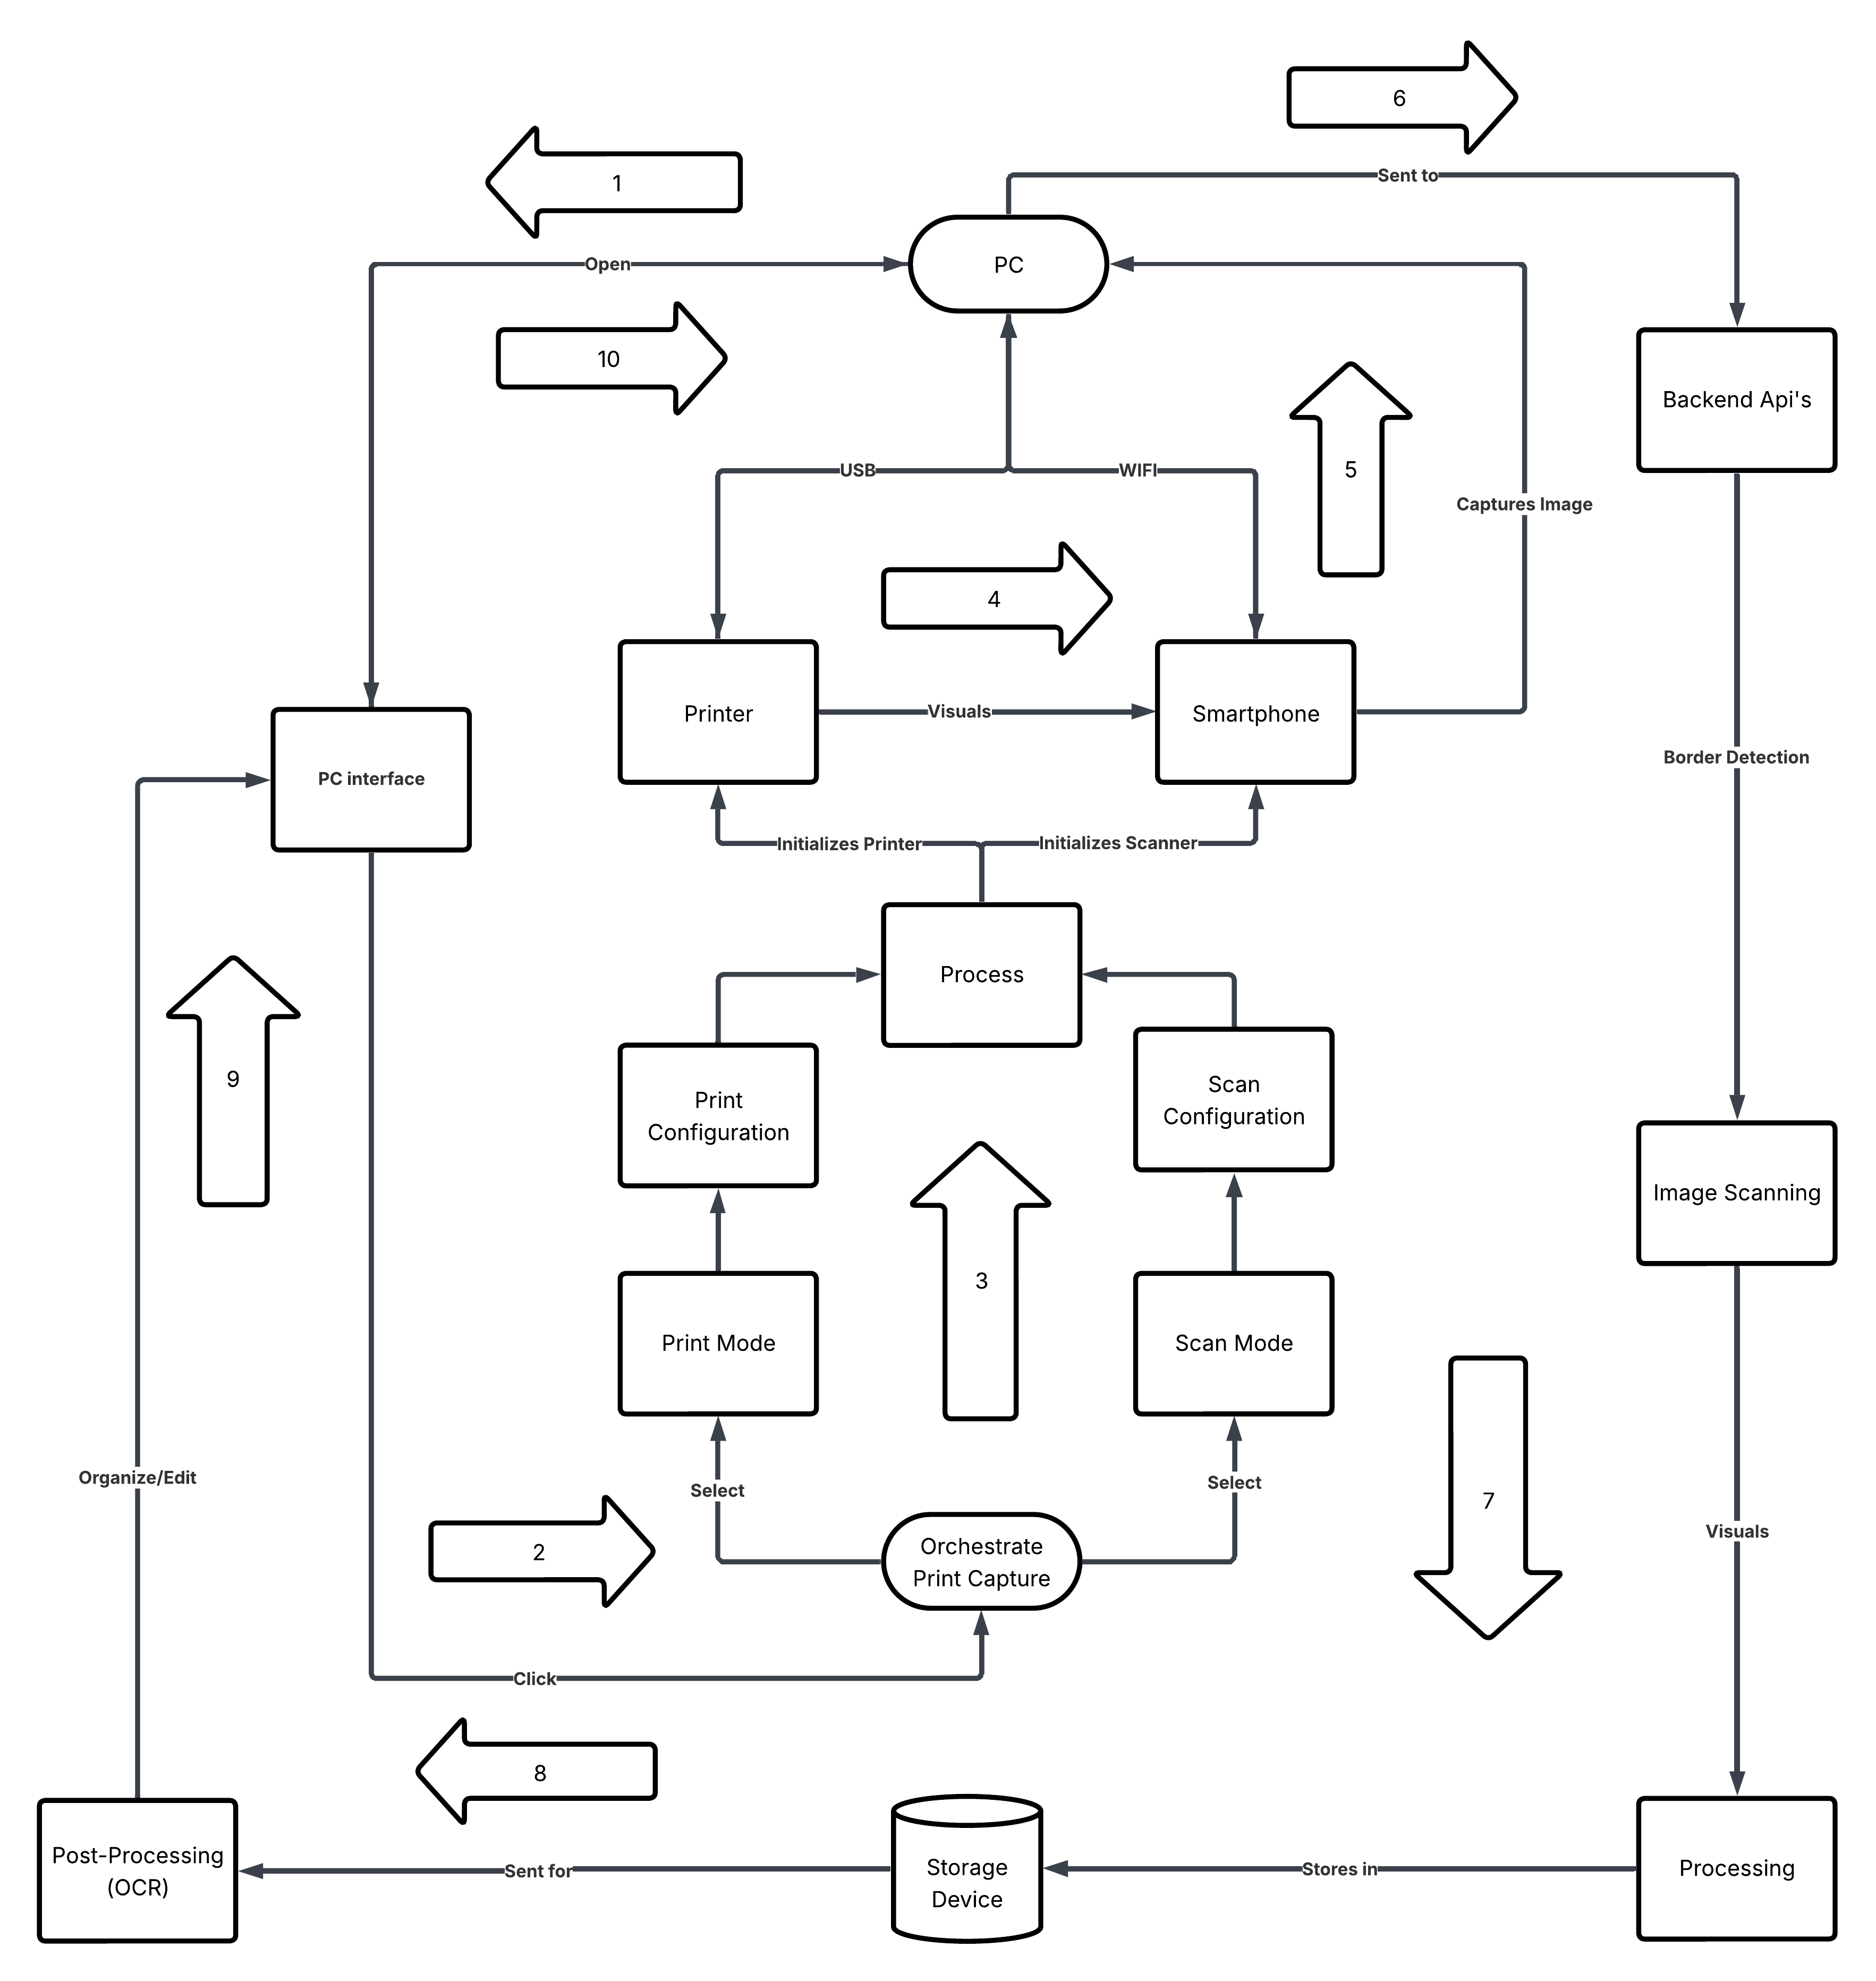

Figure 4.1: Block Diagram
The above diagram outlines the high-level workflow of the PrintChakra – AI-Powered Smart Print & Capture Solution, designed for intelligent, offline-first document scanning and synchronization between a mobile device and a PC.

SYSTEM FLOW

PC Interface Initialization
The workflow begins when the user opens the PrintChakra PC Interface. The interface allows users to view, organize, or edit existing documents and to initiate new print–capture operations.

Orchestrate Print & Capture
From the PC Interface, the user clicks to start the workflow. The Orchestrate Print Capture module is activated, and the user selects either Print Mode or Scan Mode.

Process Activation
Based on the selected mode, the Process module is triggered. It initializes both Print Configuration and Scan Configuration to prepare the connected devices for operation.

Printer and Scanner Initialization
The printer is initialized through a USB connection, and the smartphone scanner is initialized via Wi-Fi. The printer visually outputs the document, and the smartphone captures the document image using its camera.

Backend API Communication
The captured image is sent from the smartphone to the Backend APIs. The backend performs border detection and scan validation before forwarding the image for further handling.

Image Scanning and Processing
The validated image enters the Image Scanning and Processing modules, where visual enhancement, alignment, and preparation are performed.

Local Storage
The processed image is stored in the local Storage Device, ensuring offline-first operation and secure data retention.

Post-Processing (OCR)
Stored images are sent for Post-Processing (OCR), where text is extracted and refined from the scanned document.

PC Interface Update
The OCR results and processed documents are returned to the PC Interface, enabling users to organize, edit, and review the content.

Document Management
The complete scanned and processed documents are available for local management, search, and further use, completing the offline print–capture–process cycle.

COMPONENTS AND TECHNOLOGIES USED

COMPONENT | TECHNOLOGY USED
Image Capture | OpenCV, Android Camera2 API
Edge Detection & Processing | OpenCV, NumPy
OCR Engine | Paddle OCR, Pillow (PIL)
Backend Server | Flask (Python)
Frontend Dashboard | React.js, HTML, CSS, Bootstrap
Database | Local Storage
Communication (Sync) | REST API (Flask), JWT, HTTPS
Authentication & Security | JWT Tokens, SSL
System Deployment | Python, MongoDB, Ubuntu, Local Wi-Fi or Hotspot

Table 4.2: Table of Components and Technologies used

The table above outlines the core technologies that form the foundation of the PrintChakra system. The image capture module uses Camera2 API via getUserMedia web function and OpenCV to capture and preprocess high-resolution document scans via the Android device. Edge detection and perspective correction are performed using OpenCV and NumPy libraries to ensure proper framing before OCR.

The OCR engine is powered by Paddle OCR, integrated with Python’s Pillow library for image handling and pre-processing tasks such as grayscale conversion and noise removal. The backend server is developed using Flask, a lightweight and flexible Python framework that handles image reception, processing, and data storage workflows.

The frontend dashboard is developed using React.js, along with HTML, CSS, & Bootstrap to provide a responsive and intuitive user interface for reviewing scanned documents, managing metadata, and exporting outputs. MongoDB is used for backend data storage, while local storage handles the large binary files, enabling efficient image and document management.

For communication between mobile and desktop, the system uses a secure REST API, protected with JWT authentication and SSL encryption. This ensures safe, offline-first synchronization over local Wi-Fi or hotspot networks.

Deployment of the system is done using Python on Ubuntu-based desktops or laptops, with MongoDB running as the local data store. The system is designed for offline operability, and can function independently in secure, air-gapped environments, such as government offices or academic institutions with restricted internet access.

SECURITY AND PRIVACY CONSIDERATIONS

Authentication
PrintChakra secures system access using encrypted user credentials, stored via bcrypt or SHA- 256 hashing in MongoDB. Login sessions are managed through JWTs, which include expiry times and signature verification to prevent unauthorized access. This ensures that only authenticated users can interact with protected system components.

Encrypted Data Transfer
All data exchanged between the mobile app and desktop backend is secured using HTTPS and SSL encryption. This protects REST API communication during offline Wi-Fi synchronization, ensuring that scanned documents and OCR metadata remain confidential and tamper-proof during transfer.

Encrypted Storage
PrintChakra uses encryption at both file and field levels. Document images are stored in local storage as encrypted chunks, while text and metadata are protected using Fernet encryption. Even if local storage is compromised, unauthorized users cannot access.


CHAPTER 5

METHODOLOGY

5.1 LAYING THE FOUNDATION FOR EFFICIENT AUTOMATION

Building a robust and intelligent document capture and processing solution like PrintChakra begins with setting up a structured and well-optimized development environment. This foundational phase plays a critical role in ensuring consistent performance, modular design, and seamless integration across devices. Just like a well-laid foundation determines the stability of a building, the design of the development environment directly influences system reliability, deployment scalability, and real-time responsiveness.
A thoughtfully configured setup enables rapid testing, debugging, and adaptation of core components such as edge detection, OCR pipelines, file synchronization, and document management. It also allows for efficient evaluation of AI performance in varied real-world scenarios, such as document misalignment, lighting inconsistencies, and network fluctuations in offline settings.

The environment includes several core components critical to the success of the system:

Programming Tools & Languages:
Python is the core development language due to its extensive ecosystem for computer vision, web APIs, and backend development. Flask is used for the backend REST API, while JavaScript (React.js) is used for the user dashboard. Together, these tools allow developers to build scalable, maintainable modules across both the desktop and mobile environments.

Image Processing & OCR Libraries:
OpenCV forms the backbone of image preprocessing functions like document edge detection, noise reduction, and perspective correction. Paddle OCR is used for accurate text extraction from scanned images, supporting multilingual input and text layout preservation. These libraries allow real-time conversion of printed content into searchable digital formats, even under inconsistent visual conditions.

AI-Powered Enhancements:
While the current system leverages rule-based preprocessing and OCR, it is designed for easy integration of deep learning enhancements. This includes optional AI modules for improved edge detection or layout classification using TensorFlow Lite or ONNX models in future iterations.

Database and File Management:
Local storage or MongoDB combined with GridFS, handles large document images and associated text or metadata. This schema-less database structure allows flexible indexing and quick querying of scanned records, user logs, and synchronization status. File chunks are stored efficiently, ensuring stability during high-volume data operations.

Deployment & Platform Integration:
The system is developed and tested on Ubuntu-based desktops and Android mobile devices, using Python-based deployment scripts. Local Wi-Fi is used to simulate offline synchronization, while Flask APIs manage data exchange between the smartphone and the desktop. Docker may be used in future iterations to containerize services for simplified cross- platform deployment and scalability across departments.

By grounding the development process in a modular, AI-ready, and offline-first methodology, PrintChakra is positioned to deliver a reliable, intelligent, and scalable print-to-digital solution that works seamlessly across varied institutional settings.

CORE DEVELOPMENT TOOLS & TECHNOLOGIES

5.2.1 Programming Language & IDE
  - Python
Python serves as the backbone of PrintChakra’s backend system due to its extensive support for OCR, image processing, and web frameworks. Libraries like OpenCV, Paddle, and Flask make it a perfect choice for building AI-driven, modular applications. Python’s readability and rich package ecosystem enable rapid prototyping and integration with cloud or local data pipelines.

JavaScript (React)
JavaScript powers both the frontend admin dashboard and the mobile scanning interface. React is used for building a responsive web dashboard, orchestration interface and File conversion interface. The component-driven architecture of JavaScript frameworks ensures modular, maintainable UI development.

HTML, CSS, and Bootstrap
These technologies are used in combination with React.js to create a modern and intuitive user interface. Bootstrap enhances responsiveness and layout consistency, making the dashboard accessible on multiple screen sizes. While HTML provides the structure of the web interface where CSS is used to style the HTML interface.

  - VS Code (Python, JavaScript)
Lightweight and highly customizable, Visual Studio Code is used for both backend and frontend development. Its built-in terminal, Git integration, and Python/JavaScript extensions streamline cross-stack development.

5.2.2 REST API Development & Offline Sync

  - Flask RESTful API
The REST API, built using Flask, is responsible for receiving scanned images, triggering OCR processing, and sending responses to the mobile client. The use of lightweight APIs over local Wi-Fi allows real-time, offline-first communication between the mobile app and the desktop server.

JWT Authentication
To ensure secure interactions, the REST APIs are protected using JSON Web Tokens (JWT). Tokens validate user identity, manage permissions, and prevent unauthorized data sync or access.

Ngrok Tunnelling
Ngrok is used to securely expose the locally running PrintChakra backend services to the internet during development and testing. It creates a temporary public URL that tunnels requests to local servers, enabling real-time testing of APIs, webhooks, and mobile app–backend communication without deploying to production. This simplifies debugging, cross-device testing, and remote demonstrations while maintaining secure encrypted connections.

Offline Synchronization Logic
The mobile app is designed to queue unsent scans during disconnections and automatically transmit them when the network is restored. The sync module supports retries, integrity checks, and time-stamped logs for each document transfer.

OCR, Image Processing, and AI Integration
  - OpenCV
Used extensively on both mobile and desktop for edge detection, noise filtering, and image transformation. Features like contour detection and adaptive thresholding help ensure accurate document capture even in non-ideal conditions.

Paddle OCR
Integrated on the backend for extracting text from scanned images. PrintChakra uses custom configurations and preprocessing steps to enhance recognition accuracy across various fonts, layouts, and languages.

Pillow (PIL)
Python Imaging Library (Pillow) is used for image conversion and manipulation tasks like resizing, cropping, and format optimization before OCR is applied.

Deep Learning Add-ons
lightweight AI models using TensorFlow or PyCUDA for smarter classification, auto-alignment, handwriting recognition & smart conversation, especially in academic settings.

Version Control with Git
Git is used as the version control system to manage the entire PrintChakra codebase, spanning the mobile app, desktop backend, and frontend dashboard. It ensures every code change, bug fix, or new feature is traceable and reversible. Using Git allows for organized collaboration, streamlined feature branching, & rollback of unstable releases.

GitHub
Primary repository host for the project. It includes issue tracking, pull request workflows, and actions for automated testing or linting.

SETTING UP THE ENVIRONMENT & UI CONSIDERATIONS

Setting up a well-structured development environment is essential for the reliable and efficient development of PrintChakra. As a cross-platform, AI-powered, and offline-first application, it involves both mobile and desktop components. Proper setup ensures seamless testing, integration, and deployment, while also allowing developers to address platform- specific requirements early in the development cycle.

Local Development Environment
The first step involves preparing the desktop development environment with all necessary dependencies and tools. Python 3.x is used as the core programming language for the backend server, image processing, and OCR modules. A virtual environment (using venv or virtualenv) is recommended to manage project-specific packages such as Flask, Paddle, OpenCV, Pillow, and MongoDB drivers. This prevents conflicts with global installations and allows for cleaner dependency management.

Version control is managed using Git, with the entire project structured into logical modules for UI, backend, database, and sync logic. Integrated development environments (IDEs) such as Visual Studio Code (for Python and JavaScript) and Android Studio (for mobile) support linting, real-time debugging, and terminal operations to boost productivity and reduce development errors.

Device Integration (Real or Simulated)
To fully test the functionality of PrintChakra, both real and simulated hardware environments are used. For scanning, a physical Android smartphone with at least 12 MP camera is used for realistic image capture scenarios. The app is mounted above a printer tray or flat surface to replicate actual use conditions involving skewed alignment, lighting variation, and background noise.
On the desktop side, Ubuntu-based laptops or PCs are configured with Flask, MongoDB, and necessary OCR/image libraries. A local Wi-Fi router or hotspot is set up to simulate an offline-only environment. This allows testing of real-time document sync, offline API transfer, and retry logic without relying on internet connectivity.
If mobile devices are not available during early-stage development, Android emulators with camera simulation plugins can be used. However, real device testing is strongly preferred to evaluate camera behavior, resolution handling, and edge detection under practical conditions.

User Interface (UI) Considerations
PrintChakra offers two main user interfaces: a mobile app UI for document capture and a desktop web dashboard for reviewing and managing scanned files.
The mobile UI is developed using React and emphasizes usability with features like auto-capture, real-time edge detection feedback, and scan history. The interface is kept clean and intuitive, using minimal controls to guide users during scanning without requiring technical expertise.
The desktop dashboard is built using React.js and Bootstrap. It offers responsive layouts for document review, OCR text viewing, and PDF export. Admin controls such as sync status, file search, and metadata filtering are organized in collapsible panels and accessible menus. JWT-based login protects access, and role-based permissions ensure that users only see what they're authorized to view.
Design principles such as consistency, error feedback, and accessibility are followed to ensure a smooth user experience across different devices and screen sizes. The dashboard is optimized for both mouse and keyboard use, supporting institutional staff working with high document volumes.

5.4 TESTING & DEPLOYMENT CONSIDERATIONS

5.4.1 Testing Frameworks

Comprehensive testing plays a vital role in ensuring the stability and reliability of the PrintChakra system, especially as it involves multi-device synchronization, real-time processing, and OCR accuracy. The testing process spans across unit testing, integration testing, and simulated end-to-end scenarios to validate system workflows from document capture to storage and export.
For the backend Flask API, OpenCV image handling, and OCR modules, Python-based testing frameworks are utilized:
- unittest – Python’s built-in testing module is used for validating core functions like edge detection, REST API responses, and file processing routines.

- pytest – Offers simplified syntax and powerful fixtures, making it ideal for testing the OCR pipeline, MongoDB interactions, and error-handling logic.
- coverage.py – Ensures that all critical paths of the application are tested, identifying untested code segments for improvement.
The React mobile app uses tools like Jest for unit tests (e.g., camera permission handling, image validation) and Detox for end-to-end testing of document capture workflows. Automated testing is executed during every development cycle to catch regressions, validate new features, and ensure stability across offline syncing scenarios and cross-platform interactions.

5.4.2 Deployment Considerations

Deploying PrintChakra involves setting up the desktop server and mobile app in real-world environments such as schools, offices, or scanning stations. Key deployment strategies include:
- Persistent Backend Service: The Flask server is deployed as a persistent service using systemd or Supervisor on Ubuntu, ensuring automatic restarts in case of system failure or reboot.
- Scheduled Automation: Tasks such as file cleanup, metadata backup, and periodic export
can be handled using cron jobs or Python’s schedule module.
- Environment Replication: The production environment mirrors the development setup, including Python version, MongoDB configuration, and all dependencies declared in requirements.txt. Virtual environments ensure isolation and consistency.
- Docker (Optional): The backend and OCR components can be packaged in a Docker container for standardized deployment across different machines. This also simplifies updates, scaling, and potential migration to cloud platforms in future iterations.
Before deployment, configuration files are tailored per site, including local network credentials, folder paths, and user roles. Final testing is performed on live devices to ensure seamless sync, stable performance, and full offline functionality.

CHAPTER 6

Outcomes

PROJECT OVERVIEW

PrintChakra represents a comprehensive end-to-end document processing and printing solution that seamlessly integrates multiple advanced technologies. The platform combines OCR capabilities, AI-assisted document understanding, voice-enabled interaction, & cloud-based printing infrastructure into a unified system. This integrated approach enables users to capture, process, analyze, & print documents with minimal manual intervention while maintaining high accuracy & efficiency.

6.2 CORE TECHNOLOGY IMPLEMENTATION

The Document Processing Pipeline module automates the entire workflow from document input to final output. The system utilizes Poppler for automated PDF to image conversion, ensuring high-quality image generation from various document formats. The platform supports multi-format document handling including PDFs, images, and text files, providing users with flexibility in document input methods. The system includes efficient file handling mechanisms with organized data management structures and automated processed text extraction and storage capabilities.

The Optical Character Recognition implementation integrates advanced OCR technology to extract accurate text from scanned documents & images. The system demonstrates support for multiple document types & maintains organized OCR result storage & retrieval mechanisms. This enables users to quickly access & utilize extracted text data across the platform.

The AI-Assisted Document Understanding module provides intelligent document analysis capabilities through its AI enhancement module. It performs contextual document processing based on user input and commands, while offering customizable settings for personalized processing workflows. The system handles command-based actions and maintains flexible settings management for different processing scenarios.

Voice Integration features enable hands-free operation through comprehensive voice command support and integrated voice API capabilities. The platform includes audio processing capabilities and accessibility features specifically designed for users who prefer voice interaction. This makes PrintChakra particularly valuable in scenarios where hands-free operation is essential or preferred.

The Printing Infrastructure component provides direct printer communication and printing capabilities with support for PCL format output. The system includes comprehensive print configuration management and printer testing utilities to ensure reliable output. This foundation enables the platform to work seamlessly with various printer models and configurations.

The Modern Web Interface is built using React and TypeScript, providing a responsive design that adapts to different screen sizes and devices. The interface includes a comprehensive dashboard for document management, orchestration features for workflow management, and voice command integration. Real-time communication via WebSocket enables instant updates and responsive user interactions.

The Robust Backend Architecture is powered by Flask, implementing a modular structure with organized components for maintainability and scalability. The system includes CORS configuration for cross-origin requests, comprehensive error handling middleware, and request logging capabilities. A sophisticated logging system tracks all operations for monitoring and debugging purposes.

Data Management infrastructure provides structured storage for PDFs, images, and processed text files. The system includes model management for machine learning components and organized upload and conversion pipelines. Dedicated data directories ensure efficient file organization and quick retrieval.

The Orchestration and Workflow module manages the entire document processing pipeline with workflow orchestration capabilities. It handles multi-step document transformations and manages API endpoints, enabling complex processing workflows to be executed seamlessly.

6.3 TECHNICAL ACHIEVEMENTS

The platform demonstrates significant technical accomplishments through its full-stack implementation using TypeScript & Python. The architecture is microservice-ready, allowing for independent scaling & deployment of different components. The REST API design follows industry best practices, while real-time bidirectional communication through WebSocket ensures responsive user experiences. Comprehensive error handling & logging systems provide visibility into system operations & facilitate troubleshooting. The modular component structure allows developers to extend functionality easily & the environment-based configuration system supports deployment across different environments.

6.4 PROJECT IMPACT

PrintChakra delivers substantial value through streamlined document handling workflows that reduce manual processing steps. The platform significantly reduces manual document processing time by automating capture, OCR, analysis, and printing stages. Accessibility improvements through voice integration make document processing available to users with different preferences and abilities. The scalable platform architecture supports document management at any scale, while intelligent document processing with AI provides context-aware handling. Users benefit from a seamless printing experience across multiple devices and printer configurations.

6.5 USER INTERFACE PAGES & SECTIONS

6.5.1 Dashboard Page

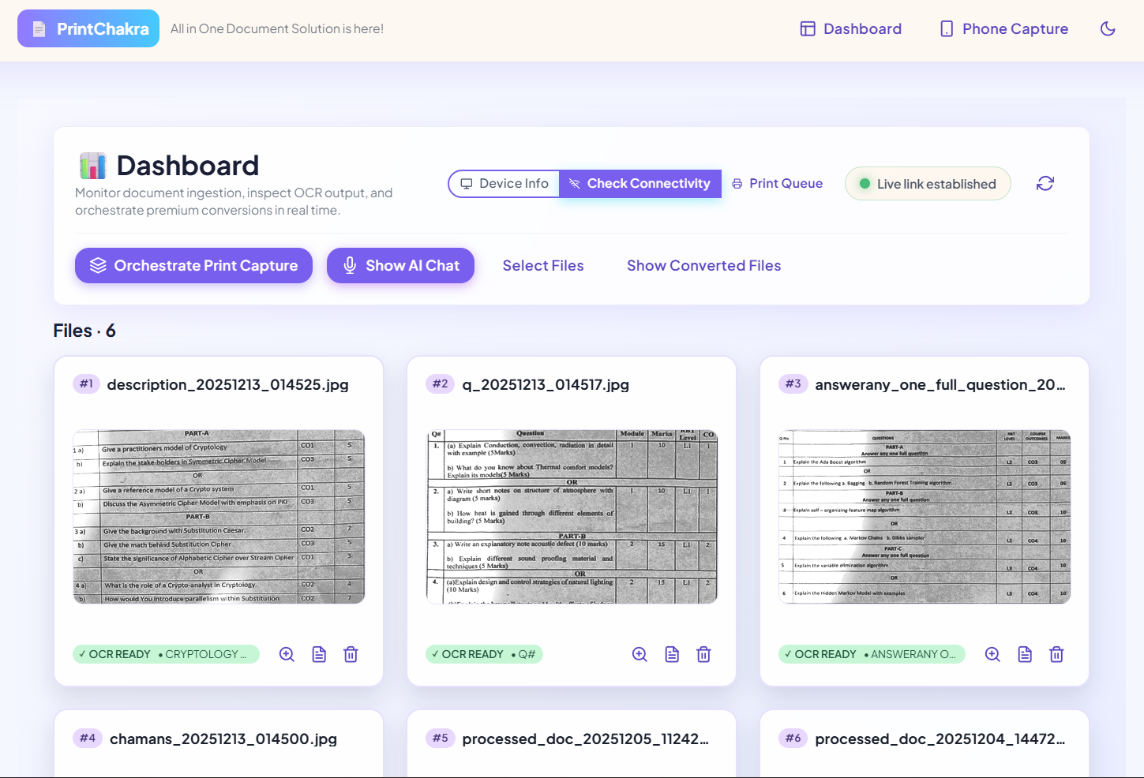

Figure 6.1: Dashboard Page

The Dashboard serves as the primary control center of the PrintChakra system.

It provides real-time visibility into document uploads, processing stages, and OCR results.

Users can preview files such as images, PDFs, and documents along with thumbnails and associated metadata.

The dashboard allows verification of extracted text after OCR processing.

Processing status indicators show OCR readiness, detected language, & assigned content tags.

Quick-action controls enable users to orchestrate print workflows directly from the dashboard.

Users can access the AI chat assistant for document interaction and queries.

File management options are available to organize, review, and manage uploaded documents.

Converted outputs can be viewed and accessed directly through the dashboard.

6.5.2 Phone Interface Page

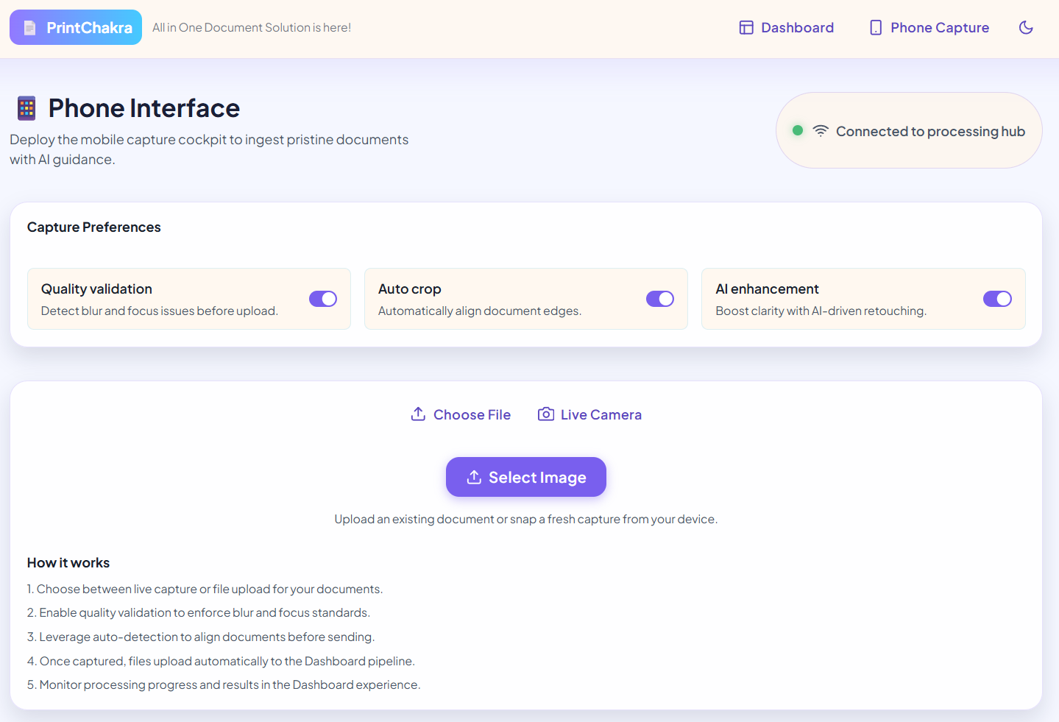

Figure 6.2: Phone Interface Page

The Phone Capture page functions as a mobile capture cockpit for ingesting documents with AI guidance.

It displays the connection status to the processing hub, confirming readiness for upload and processing.

A Select Image action allows quick upload of captured or stored images from the device.

The interface provides a real-time camera preview optimized for document framing and clarity.

Once captured or selected, images are automatically uploaded to the system without manual transfer.

Uploaded documents are immediately routed into the dashboard processing pipeline.

The page includes a guided “How it works” section explaining capture, validation, auto-detection, upload, and monitoring steps.

The interface is fully mobile-optimized, enabling remote document scanning without the need for a desktop scanner.

6.5.3 Device Info Interface

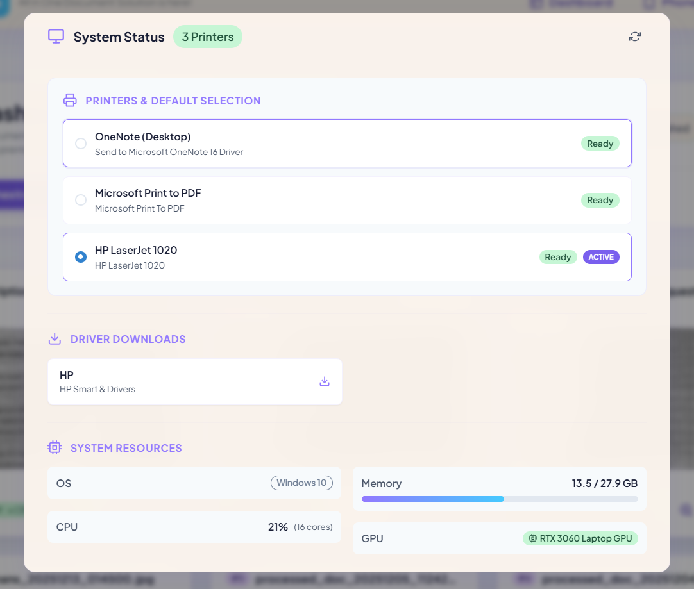

Figure 6.3: Device Info Interface

This section provides a unified view of overall system and device status within PrintChakra.

It displays the total number of detected printers and their current availability.

The Printers & Default Selection panel lists all installed printers with manufacturer names, models, and driver details.

Real-time status indicators show whether each printer is ready or active.

Users can select and set a default printer directly from this interface.

A dedicated Driver Downloads area provides quick access to printer driver installations and updates.

The System Resources panel displays operating system information.

Real-time resource usage is shown, including memory consumption, CPU load, & GPU details

Refresh controls enable users to update system and connectivity status in real time.

6.5.4 Print Queue Interface

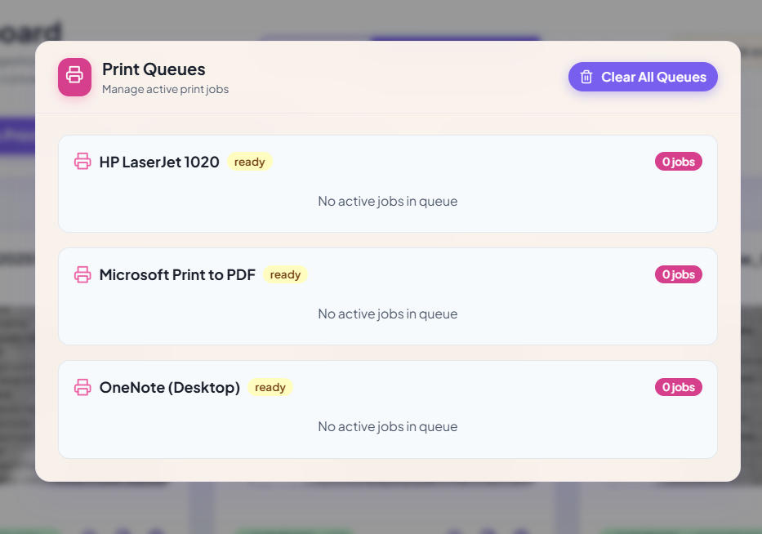

Figure 6.4: Print Queues Interface

The Print Queue section provides a centralized, in-app mechanism to manage all active and pending print jobs.

It eliminates the need to manually navigate OS printer settings to clear print queues.

All detected printers, including physical and virtual printers, are displayed with real-time readiness status.

Each printer queue shows the number of active or pending jobs, with clear indicators when queues are empty.

Users can monitor print activity across multiple printers from a single dashboard view.

A global Clear All Queues action allows users to cancel flush all pending or unwanted print jobs at once.

This approach prevents print job backlogs and resolves stuck queues efficiently.

Centralized queue control improves reliability & reduces user intervention during failueres.

The design simplifies print management in multi-printer environments.

6.5.5 Scan Mode Configuration Interface

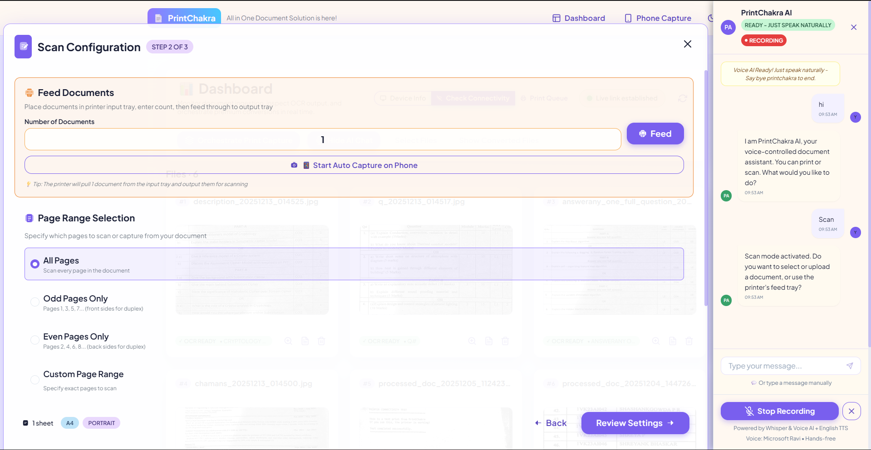

Figure 6.5: Scan Mode Configuration Interface

Scan Mode Configuration allows users to configure and control the document scanning process before execution.

Users can feed multiple documents by specifying the number of pages placed in the printer input tray.

An option is provided to start automatic capture on the phone, enabling synchronized mobile-based scanning.

Page range selection settings allow users to choose all pages, odd pages, even pages, or a custom page range.

The interface supports bulk and continuous scanning for multi-page documents.

Automatic document detection assists in proper page alignment & edge cropping during capture.

Scan behaviour can be adjusted based on document requirements like quality & accuracy

Integrated voice or AI assistant guidance helps users activate scan mode and proceed hands-free.

6.5.6 Print Mode Configuration Interface

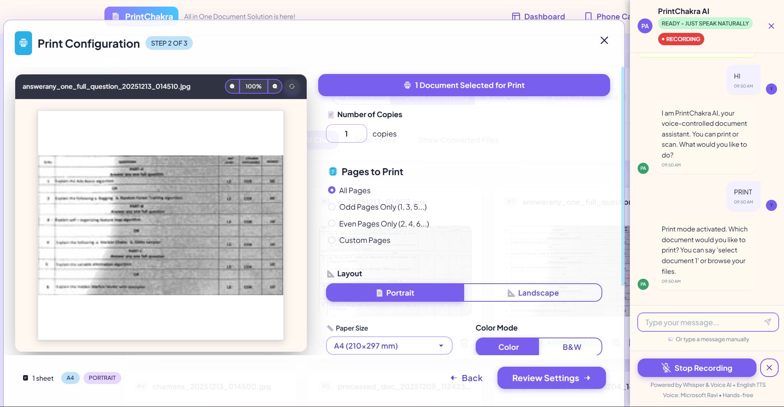

Figure 6.6: Print Mode Configuration Interface

Print Mode Configuration provides fine-grained control over print jobs before execution.

Users can select the document to print and preview it to verify output accuracy.

The number of copies can be specified for each print job.

Page range options allow printing all pages, odd pages, even pages, or custom page selections.

Layout settings support portrait and landscape orientations.

Paper size selection (such as A4) ensures compatibility with the selected printer.

Color mode options allow users to choose between color and black-and-white printing.

Print settings can be reviewed and adjusted before final submission.

Integrated AI/voice assistance supports hands-free configuration and guidance.

The configuration step ensures accurate, organized, and efficient print execution.

CHAPTER 7

CONCLUSIONS AND FUTURE SCOPE

CONCLUSIONS

The integration of AI-powered tools such as OpenCV and OCR into a unified mobile–desktop system represents a significant advancement in document digitization. Conventional print-to-digital workflows that rely on scanners, USB transfers, or manual handling are often slow, error-prone, and inefficient for environments such as educational institutions, offices, and remote setups. PrintChakra addresses these limitations through an offline-first architecture that automates document capture, AI-based preprocessing, text extraction, and structured local storage using only a smartphone and a desktop PC, without reliance on cloud infrastructure.

In this system, the mobile interface captures documents through the smartphone camera and applies real-time edge detection, alignment, and enhancement using OpenCV. The captured images are securely transmitted over a local Wi-Fi network via RESTful APIs to the desktop processing hub. The desktop component performs OCR using Paddle OCR and stores both the processed images and extracted text along with metadata in local storage. This streamlined pipeline enables fast, searchable digitization while ensuring data privacy and reliable operation in bandwidth-limited environments.

A React-based dashboard serves as the central control interface, providing role-based access for managing scans, reviewing OCR outputs, exporting documents, and monitoring system and device status. The modular architecture supports multiple mobile devices connected to a single desktop hub, enabling scalable and distributed document processing. With secure authentication, encrypted communication, and efficient resource usage, PrintChakra reduces manual errors, improves OCR accuracy through real-time feedback, and supports organizations transitioning toward secure, paperless workflows in constrained, real-world environments.

PrintChakra – AI-Powered Smart Print & Capture Solution (BAI786)

FUTURE SCOPE

Real-Time Handwriting OCR Support:
Extend the system’s capabilities to recognize & digitize handwritten documents using AI- based handwriting recognition models such as Transformers for handwritten text datasets.

Cloud and Hybrid Synchronization:
Introduce optional cloud-based backup and remote document access for multi-site institutions, enabling scalable deployments with encrypted document syncing and role- aware cloud dashboards.

Intelligent Document Categorization:
Integrate machine learning classifiers that automatically label and categorize documents based on content, layout structure, or visual features to simplify storage and retrieval.

Contextual Keyword Highlighting:
Enhance post-OCR text viewers by allowing dynamic keyword detection and visual emphasis to help users find relevant content faster in large documents.

Multilingual OCR & Layout Retention:
Add support for additional scripts such as Tamil, Urdu, or Arabic, & enhance OCR pipelines to retain complex layouts like tables, headers, or multi-column text.

Decentralized Multi-Device Sync:
Enable peer-to-peer document sync among mobile devices in group scanning environments using local mesh networking or Bluetooth to eliminate desktop dependency when needed.

Embedded and Portable Systems:
Deploy a lightweight version of PrintChakra on Raspberry Pi or Jetson Nano for use in field offices or rural institutions, enabling low-cost, high-efficiency document digitization in mobile units.

REFERENCES

- Jian Liu, Longfei Zhang, Yan Zhang, “Inkjet-Printed Electrical Interconnects for High-Resolution Integrated Circuits,” Nature Electronics, Volume 6, Issue 1, 2023, Pages 1–7, ISSN 2520-1131, https://doi.org/10.1038/s44172-023-00073-4.

- Yaohe Li, Long Jin, Min Liu, Youtang Mo, Weiguang Zheng, Dongyuan Ge, Yindi Bai, “Research on Adaptive Edge Detection Method of Part Images Using Selective Processing,” Processes, Volume 12, Issue 10, 2024, Article 2271, ISSN 2227-9717, https://doi.org/10.3390/pr12102271.

- Mengyang Pu, Yaping Huang, Yuming Liu, Qingji Guan, Haibin Ling, “EDTER: Edge Detection with Transformer,” arXiv preprint, March 2022, arXiv:2203.08566, https://arxiv.org/abs/2203.08566.

- Callen MacPhee, Madhuri Suthar, Bahram Jalali, “PAGE: Phase-Stretch Adaptive Gradient-Field Extractor,” arXiv preprint, February 2022, arXiv:2202.03570, https://arxiv.org/abs/2202.03570.

- Shaik Nazeema, Sanjay G. Gundabatini, “Real-Time Text Detection and Translation Using OpenCV and Paddle OCR,” International Journal of Innovative Research in Technology, Volume 11, Issue 6, 2024, ISSN 2349-6002, https://ijirt.org/Article?manuscript=169353.

- Richa Agrawal, “Improving the Efficiency of Paddle OCR Engine,” San José State University Graduate Research Projects, 2021, Paper 415, https://scholarworks.sjsu.edu/cgi/viewcontent.cgi?article=1416&context=etd_projects.

- Dileep Kumar Siripurapu, “Real-Time Data Synchronization in Distributed Systems: A Comprehensive Analysis of Architectures, Strategies, and Implementation,” International Journal of Research in Computer Applications and Information Technology, Volume 8, Issue 1, 2025, Pages 3412–3424, ISSN 2349-5162, https://iaeme.com/MasterAdmin/Journal_uploads/IJRCAIT/VOLUME_8_ISSUE_1/IJRC AIT_08_01_245.pdf.

- Yaser Mansouri, Victor Prokhorenko, Faheem Ullah, M. Ali Babar, “Evaluation of Distributed Databases in Hybrid Clouds and Edge Computing: Energy, Bandwidth, and Storage Consumption,” arXiv preprint, September 2021, arXiv:2109.07260, https://arxiv.org/abs/2109.07260.

- Novak Boškov, Ari Trachtenberg, David Starobinski, “Enabling Cost-Benefit Analysis of Data Sync Protocols,” arXiv preprint, March 2023, arXiv:2303.17530, https://arxiv.org/abs/2303.17530.

- Cao Vien Phung, Jasenka Dizdarevic, Admela Jukan, “An Experimental Study of Network-Coded REST HTTP in Dynamic IoT Systems,” arXiv preprint, February 2020, arXiv:2003.00245, https://arxiv.org/abs/2003.00245.

