Title of the Project
PrintChakra – AI-Powered Smart Print and Capture Solution

Abstract
PrintChakra is an AI-powered smart system that automates printing, scanning, and document digitization. Traditional print–scan workflows are slow, need scanners, and depend on internet connectivity. PrintChakra solves these problems by using a smartphone, a computer, and AI.
In this system, a smartphone captures printed documents using its camera. AI-based image processing improves the image quality, and OCR extracts text from the document. All data is transferred securely over local Wi-Fi and stored in local storage.
In addition, PrintChakra includes an AI voice assistant that can control the entire workflow using voice commands. A lightweight AI model SmolLM2 (135M) is run locally on the laptop using Ollama as a local AI service provider. The AI assistant communicates with the system through the Flask backend API. This allows users to start scanning, printing, and document management using voice commands without manual interaction.
The system works fully offline, improves efficiency, reduces manual work, and ensures data privacy.

Introduction
Document handling is an important task in colleges, offices, and government organizations. Traditional methods require printers, scanners, manual scanning, and repeated transfers. These methods are time-consuming, costly, and error-prone.
PrintChakra is designed to automate this entire process. It replaces the scanner with a smartphone camera and uses AI to enhance images and extract text automatically. The system works without internet by using local Wi-Fi.
An additional feature of PrintChakra is the AI voice assistant, which allows users to control printing and scanning using voice commands. This makes the system faster, smarter, and easier to use.

Block Diagram
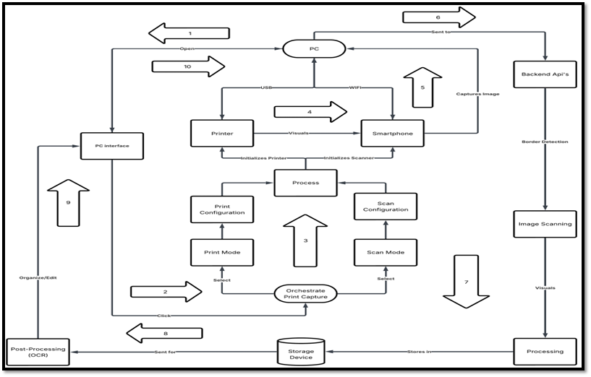
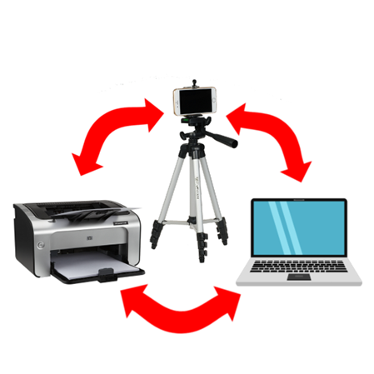
(Explanation)
The block diagram shows how PrintChakra works.
- The PC interface starts the print or scan process.
- The printer prints the document.
- The smartphone captures the printed document using the camera.
- The backend API sends the image to the computer.
- Image processing improves the scanned image.
- OCR extracts text from the image.
- Local storage saves images and text.
- The dashboard shows documents to the user.
All devices are connected in a loop and work together.

Technical Details
1. Image Capture
- Smartphone camera captures the document.
- Phone is placed above the printer for stable capture.
2. Image Processing
- OpenCV is used.
- Detects document edges.
- Removes noise and improves clarity.
3. OCR (Text Extraction)
- Paddle OCR extracts text from images.
- Converts scanned documents into searchable text.
4. Offline Communication
- Flask REST API’s as backend is used.
- Works on local Wi-Fi.
- No internet required.
5. Storage
- Images and text are saved in local storage.
- Metadata like date and time is also stored.
6. User Interface
- React.js dashboard.
- Used to view, edit, convert and download documents.
7. AI Voice Assistant
- AI assistant automates the workflow using voice commands.
- SmolLM2 (135M) model is used.
- The model runs locally using Ollama on the laptop.
- Ollama acts as a local AI service provider.
- Voice commands are sent to the Flask backend API.
- The backend triggers actions like scan, print, OCR, and file management.

Interpretation of Results
The system works correctly in offline conditions. Documents are scanned clearly, text is extracted accurately, and files are stored safely. Manual work is reduced and document processing is faster.
The results show that PrintChakra is effective and reliable for real-world use.

Advantages
- Works without internet
- No scanner needed
- Fast document processing
- AI improves scan quality
- Voice-controlled automation
- Secure local storage
- Easy to use

Disadvantages
- Handwritten text is not supported
- Needs proper lighting for best OCR results
- Initial setup required

Conclusion
PrintChakra is an AI-powered smart print and capture system that automates traditional document workflows. It uses a smartphone for scanning, AI for image processing and OCR, and local storage for data security.
The addition of a local AI voice assistant using SmolLM2 and Ollama makes the system more advanced by enabling voice-based automation. PrintChakra is suitable for colleges, offices, and institutions where offline, secure, and efficient document handling is required.
Future improvements can include handwriting recognition, cloud backup, and multilingual support.

