**Jenkins-**

**Running freestyle Git project (cucumber with maven in selenium) from Jenkins**

Following settings need to be made:-

1) Add proxy setting for allowing jenkin to use browser to download or run

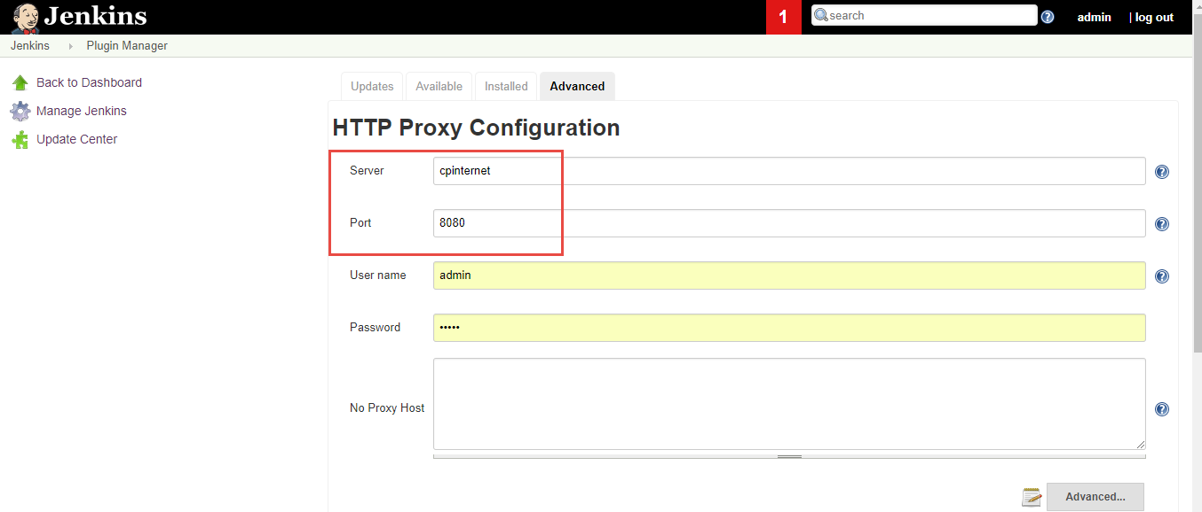

2) Add tool configurations and path:-

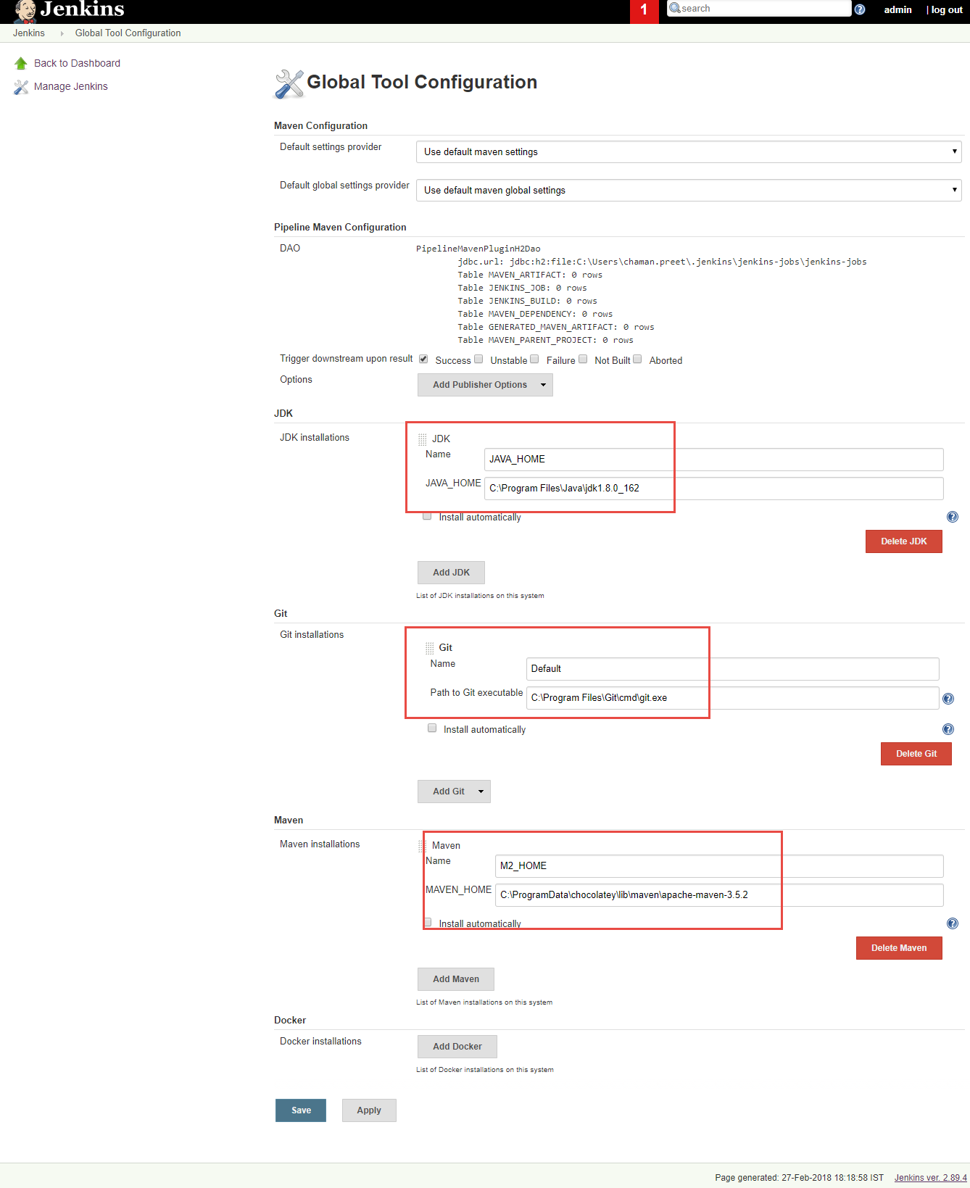

3) Create freestyle project from Git with following details:-

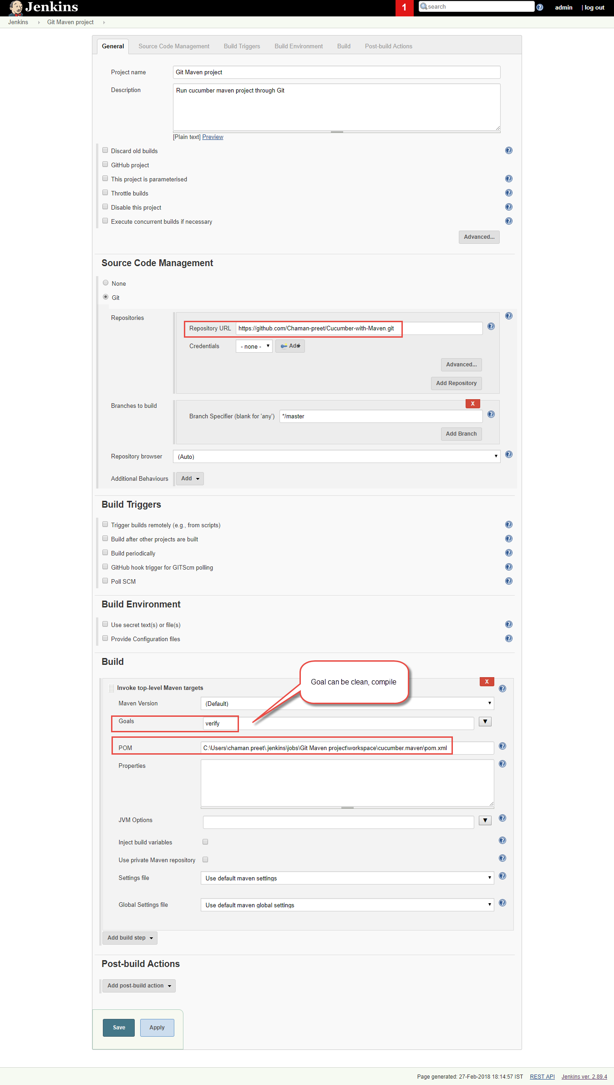

**Running Git project (cucumber with maven) using Pipeline project:-**

For cucumber report- First Add plugin (cucumber report)

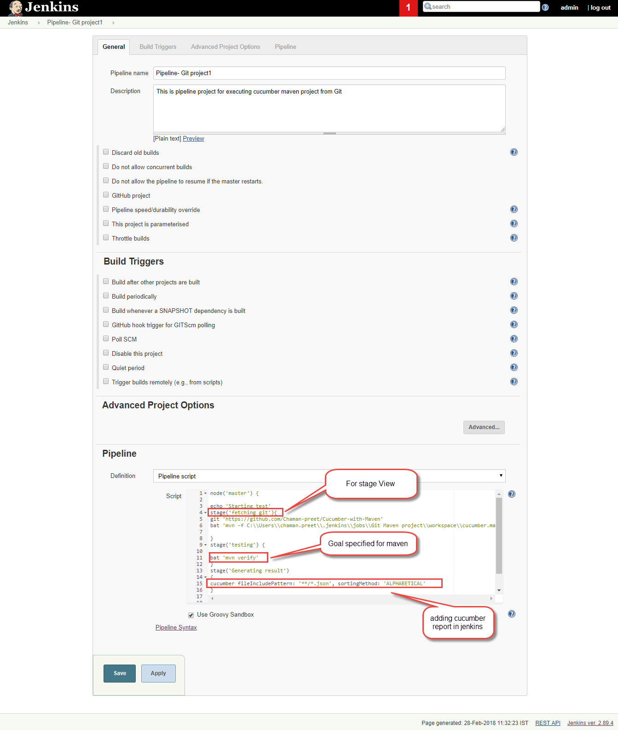

node('master') {

echo 'Starting test'

stage('fetching git'){

git 'https://github.com/executeautomation/SeleniumWithCucucumber'

//bat 'mvn -f \\cucumber.maven\\pom.xml'

}

stage('testing') {

bat 'mvn verify'

}

stage('Generating result')

{

cucumber fileIncludePattern: '**/*.json', sortingMethod: 'ALPHABETICAL'

}

}

Cucumber report and stage View will display like:-

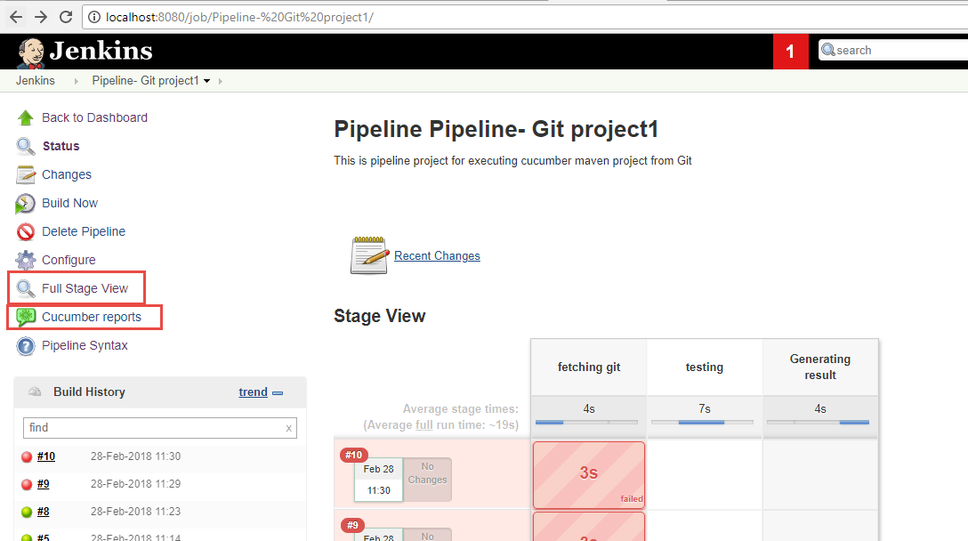

**Running Maven project present in eclipse from Jenkins:-**

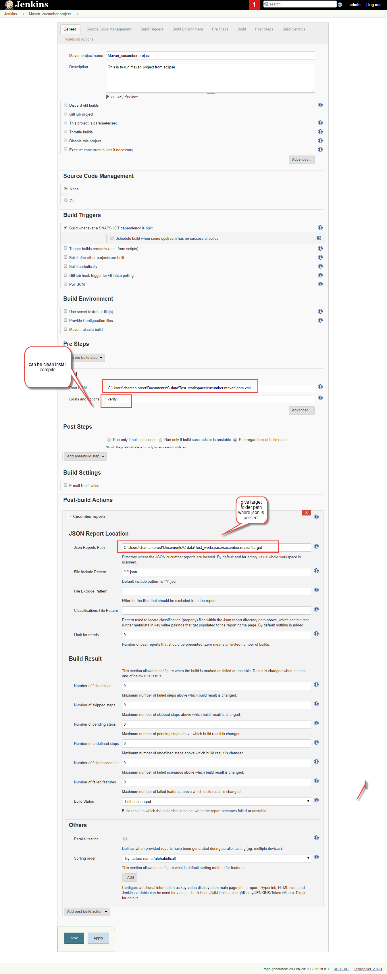

**Build triggers-** Can schedule builds from option Build periodically under build triggers and provide schedule.

**Configuring Build agents-**

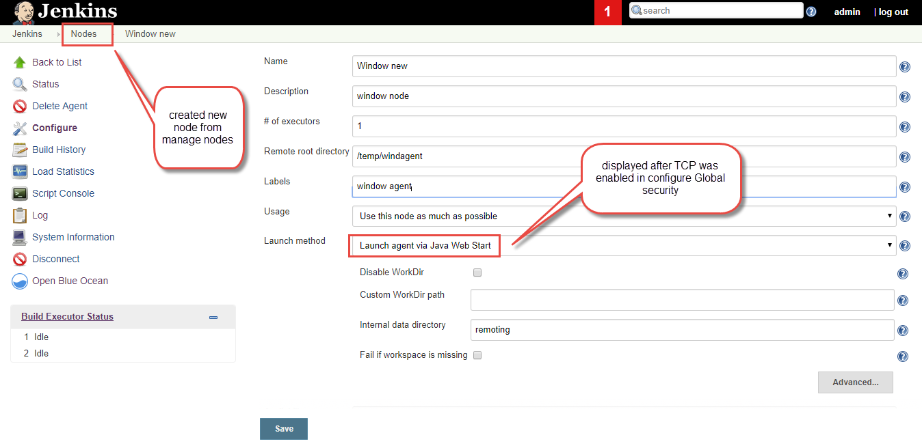

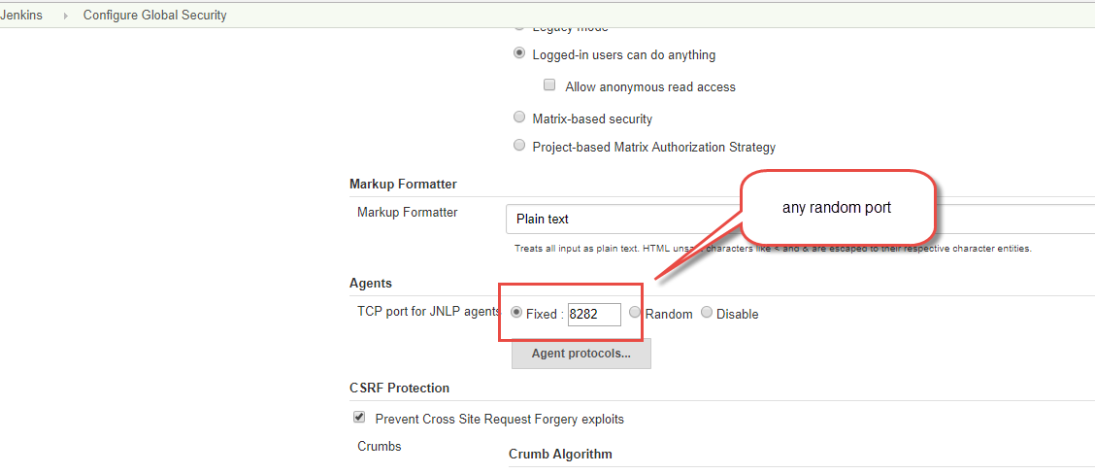

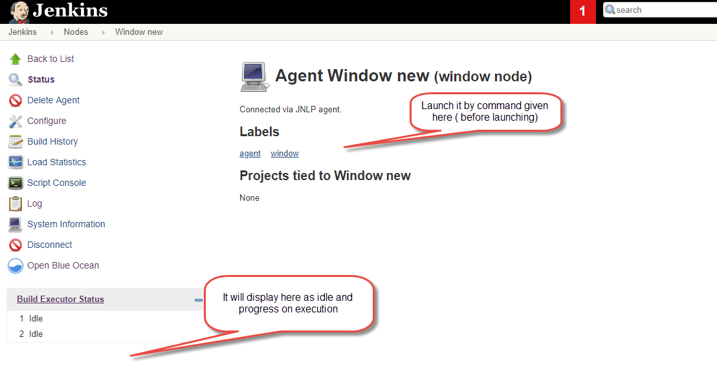

**Parallel cross browser execution in Jenkins**

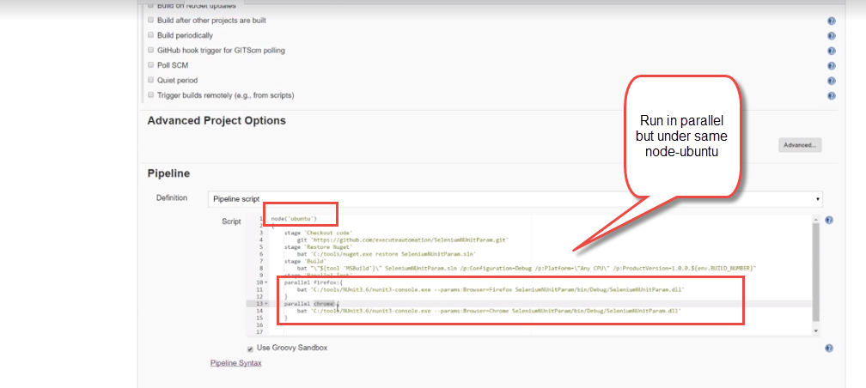

**To work in different nodes for different browsers-**

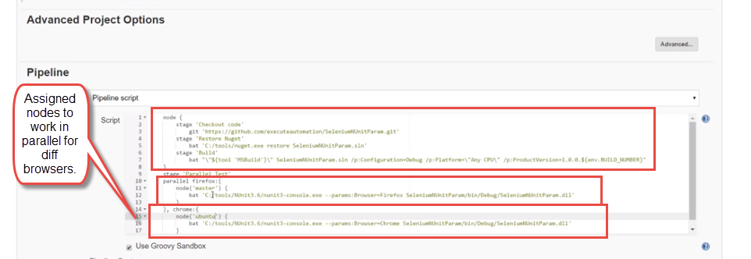

XXXXXXXXXXXXXXXXXXXXXXXXXXXXXXXXXXX print till here

**Protractor project using Jenkins-**

Copy project to home directory folder- C:\Users\chaman.preet\.jenkins\

Create freestyle project and give this in custom workspace- ${JENKINS_HOME}/Protractor_package

Build using windows command line—npm install (to install all dependencies in other system)

And then Build using windows command line— npm run run_protractor (run script)

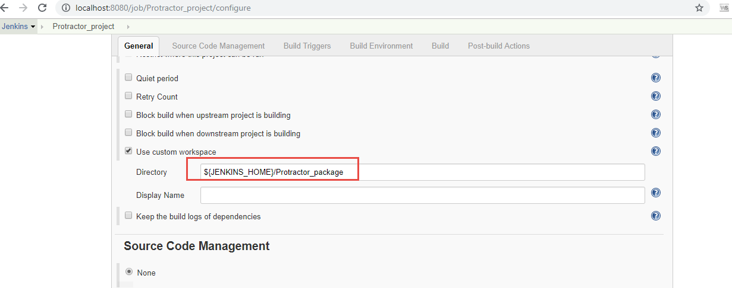

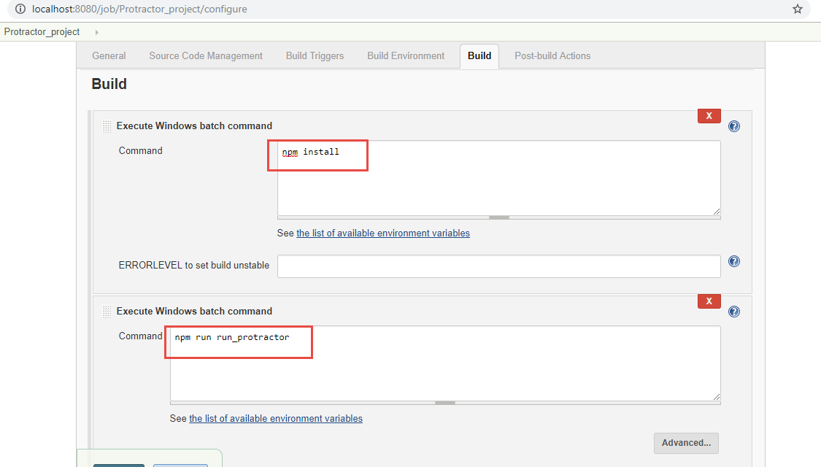

**Web hooks**- Plugin is available in Jenkins.

A webhook (also called a web callback or HTTP push API) is a way for an app to provide other applications with real-time information. A webhook delivers data to other applications as it happens, meaning you get data immediately. A web application implementing WebHooks will POST a message to a URL when certain things happen. These are used for developing push notifications.

Webhooks are used for continuous integration in Jenkins.

This help insteps to have Jenkins automatically create a build if it detects changes to a GitHub repository. This tell Jenkins to attempt a new build when a change is detected rather than polling on an interval.

<https://thepracticalsysadmin.com/setting-up-a-github-webhook-in-jenkins/>

**Jenkins current path-**

C:\Users\chaman.preet\Downloads>java -jar jenkins.war

