LW_03 Student num - CT/2001/010

Q_01

package Q_01;  
  
public class Temperature {  
 private double celsius; //internally veriable  
 Temperature(){  
 }

Temperature(double celsius){  
 this.celsius=celsius;  
 }  
  
 public double toCelsius(){  
 return celsius;  
 }  
  
 public double toFahrenheit(){  
 return (celsius * ((double) 9/5) + 32);  
 }

public void setCelsius(double celsius){  
 this.celsius=celsius;  
 }

public void setFahrenheit(double fahrenheit){  
 this.celsius=(fahrenheit - 32)*((double) 5/9);  
 }  
}

Output

package Q_01;  
  
import java.util.Scanner;  
  
public class Main {  
 public static void main(String[] args) {  
 Scanner scanner = new Scanner(System.*in*);  
 System.*out*.print("Enter Temperate in celsuis value:");  
 double celsius = scanner.nextDouble();  
  
 Temperature temp = new Temperature();  
 temp.setCelsius(celsius);  
 System.*out*.println("The celsius is converted into fahrenheit :"+temp.toFahrenheit());  
  
 //Q_02  
 System.*out*.print("Enter the Temperate in fahrenheit :");  
 double fahrengeit = scanner.nextDouble();  
  
 Temperature temp1 = new Temperature();  
 temp1.setFahrenheit(fahrengeit);  
 System.*out*.println("The fahrenheit is converted into fahrenheit " +temp1.toCelsius());  
  
  
 }  
}

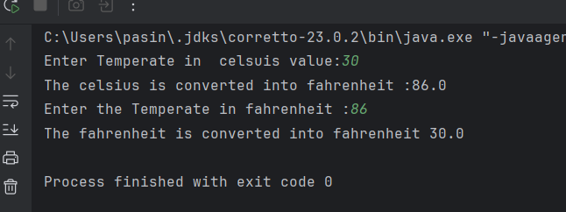

Q_03

package Q_03;  
  
public class Circle {  
 private double r;  
  
 public Circle(){  
 }

public Circle(double r){  
 this.r = r;  
 }

public double getR() {  
 return r;  
 }

public void setR(double r) {  
 this.r = r;  
 }

public double computeArea(){  
 return Math.*PI*\*r*r;  
 }

public double computeCircumference(){  
 return 2*Math.*PI*\*r;  
 }  
}

Output

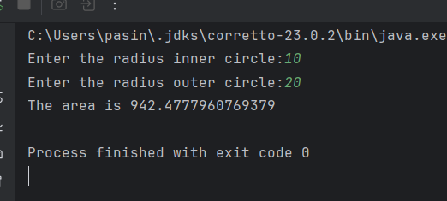

Q_04

package Q_04;  
  
public class Bicycle_New {  
 Owner bicycleOwner;  
  
 public Bicycle_New(Owner bicycleOwner) {  
 this.bicycleOwner = bicycleOwner;  
 }  
  
 public Owner getBicycleOwner() {  
 return bicycleOwner;  
 }  
  
 public void setBicycleOwner(Owner bicycleOwner) {  
 this.bicycleOwner = bicycleOwner;  
 }  
}

package Q_04;  
  
import java.util.Scanner;  
  
public class Main {  
 public static void main(String[] args) {  
 Scanner scanner = new Scanner(System.*in*);  
  
 System.*out*.println("Enter Owner Name: Chamara");  
 System.*out*.println("Enter Phone Number: 0717125993");  
 }  
 }

package Q_04;  
  
public class Owner {  
 private String ownerName;  
 private String phoneNo;  
  
 public Owner(String ownerName, String phoneNo){  
 this.ownerName = ownerName;  
 this.phoneNo = phoneNo;  
 }  
 public String getOwnerName() {  
 return ownerName;  
 }  
 public void setOwnerName(String name) {  
 ownerName = name;  
 }  
 public String getPhoneNo() {  
 return phoneNo;  
 }  
 public void setPhoneNo(String num) {  
 phoneNo = num;  
 }  
  
}

Output

Q_05

package Q_05;  
  
public class Course {  
 private String courseName;  
 private String courseCode;  
 private Lecture lectureIncharge;  
  
 public String getCourseName(){  
 return courseName;  
 }  
  
 public void setCourseName(String courseName){  
 this.courseName = courseName;  
 }  
 public String getCourseCode(){  
 return courseCode;  
 }  
 public void setCourseCode(String courseCode){  
 this.courseCode = courseCode;  
 }  
 public Lecture getLectureIncharge(){  
 return lectureIncharge;  
 }  
 public void setLectureIncharge(){  
 this.lectureIncharge = lectureIncharge;  
 }  
}

package Q_05;  
  
public class Lecture {  
 private String lectureName;  
 private String CourseTeaching;  
  
 public String getLectureName() {  
 return lectureName;  
 }  
  
 public void setLectureName(String lectureName) {  
 this.lectureName = lectureName;  
 }  
  
 public String getCourseTeaching() {  
 return CourseTeaching;  
 }  
  
 public void setCourseTeaching(String courseTeaching) {  
 CourseTeaching = courseTeaching;  
 }  
}

package Q_05;  
  
public class Student {  
 private String studentName;  
 private String degreeName;  
 private String courseFollowing;  
  
 public String getStudentName() {  
 return studentName;  
 }  
  
 public void setStudentName(String studentName) {  
 this.studentName = studentName;  
 }  
  
 public String getDegreeName() {  
 return degreeName;  
 }  
  
 public void setDegreeName(String degreeName) {  
 this.degreeName = degreeName;  
 }  
  
 public String getCourseFollowing() {  
 return courseFollowing;  
 }  
  
 public void setCourseFollowing(String courseFollowing) {  
 this.courseFollowing = courseFollowing;  
 }  
}

Output

package Q_05;  
  
public class Main {  
 public static void main(String[] args) {  
 Course course = new Course();  
 course.setCourseName("OOP");  
 course.setCourseCode("CTEC-22043");  
  
 Lecture lecture=new Lecture();  
 lecture.setLectureName("Dr.Kumara");  
 lecture.setCourseTeaching("OOP");  
  
 Student student = new Student();  
 student.setStudentName("Chamara");  
 student.setCourseFollowing("OOP");  
 student.setDegreeName("BICT");  
  
 System.*out*.println("Course Name :-"+course.getCourseName());  
 System.*out*.println("Course Code :- "+course.getCourseCode());  
  
 System.*out*.println("Lecture Name:- "+lecture.getLectureName());  
 System.*out*.println("Course Teaching:- "+lecture.getCourseTeaching());  
  
 System.*out*.println("Student Name:- "+student.getStudentName());  
 System.*out*.println("Course Following:- "+student.getCourseFollowing());  
 System.*out*.println("Degree Name:- "+student.getDegreeName());  
 }  
}

