LW_0 4 Student num - CT/2001/010

Q_01

import java.util.*;  
  
  
public class Q_01 {  
 public static void main(String[] args) {  
  
  
 int num1, num2, num3;  
 int smallNum = 0;  
 Scanner scanner = new Scanner(System.*in*);  
  
 System.*out*.print("input first number :");  
 num1 = scanner.nextInt();  
 System.*out*.print("input second number :");  
 num2 = scanner.nextInt();  
 System.*out*.print("input therd number :");  
 num3 = scanner.nextInt();  
  
 if(num1 < num2){  
 if(num1 < num3){  
 smallNum = num1; }  
 }else {  
 if(num2 < num3){  
 smallNum = num2;  
 }else {  
 smallNum = num3;  
 }  
 }  
  
 System.*out*.println("Smallest number is : "+ smallNum);  
  
 }  
}

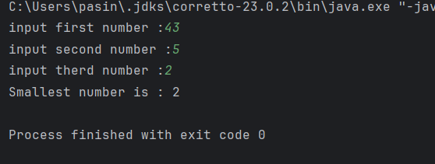Output

Q_02

import java.util.Scanner;  
  
public class Q_2 {  
 public static void main(String[] args) {  
 Scanner scanner = new Scanner(System.*in*);  
 System.*out*.println("0.Magenta");  
 System.*out*.println("1.Cyan");  
 System.*out*.println("2.Red");  
 System.*out*.println("3.Blue");  
 System.*out*.println("4.Green");  
 System.*out*.println("Select one color from the above list:");  
 int selection = scanner.nextInt();  
  
 switch (selection){  
 case 0:  
 System.*out*.println("You selected Magenta");  
 break;  
 case 1:  
 System.*out*.println("You selected cyan");  
 break;  
 case 2:  
 System.*out*.println("You selected Red");  
 break;  
 case 3:  
 System.*out*.println("You selected Blue");  
 break;  
 case 4:  
 System.*out*.println("You selected Green");  
 break;  
 default:  
 System.*out*.println("Invalid selection");  
  
  
 }  
 }  
}

case 4:  
 System.*out*.println("You selected Green");  
 break;  
 default:  
 System.*out*.println("Invalid selection");  
  
  
 }  
 }  
}

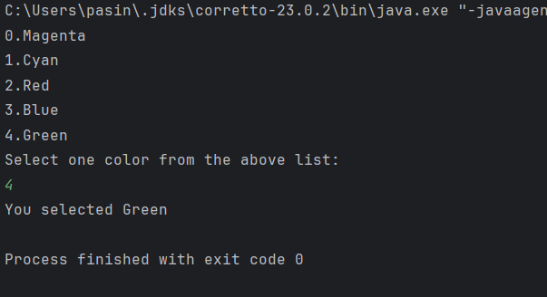

Q_3

import java.util.Scanner;  
  
public class Q_3 {  
 public static void main(String[] args) {  
 Scanner scanner = new Scanner(System.*in*);  
 System.*out*.print("Enter a power of 10 (e.g., 6, 9, 12...): ");  
 int power = scanner.nextInt();  
  
 String name;  
  
 switch (power) {  
 case 6:  
 name = "Million";  
 break;  
 case 9:  
 name = "Billion";  
 break;  
 case 12:  
 name = "Trillion";  
 break;  
 case 15:  
 name = "Quadrillion";  
 break;  
 case 18:  
 name = "Quintillion";  
 break;  
 case 21:  
 name = "Sextillion";  
 break;  
 case 30:  
 name = "Nonillion";  
 break;  
 case 100:  
 name = "Googol";  
 break;  
 default:  
 name = "No corresponding word for that power of 10.";  
 }  
  
 System.*out*.println(name);  
 }  
  
}

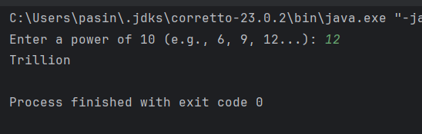

Q_4

import java.util.Scanner;  
  
public class Q_4 {  
 public static void main(String[] args) {  
 Scanner scanner = new Scanner(System.*in*);  
 System.*out*.print("Enter a year: ");  
 int year = scanner.nextInt();  
  
 boolean isLeap = false;  
  
 if (year % 4 == 0) {  
 if (year % 100 != 0 || year % 400 == 0) {  
 isLeap = true;  
 }  
 }  
  
 if (isLeap) {  
 System.*out*.println("Leap Year");  
 } else {  
 System.*out*.println("Not a Leap Year");  
 }  
}

}

Output

Q_05

import java.util.Scanner;  
  
public class Q_5 {  
 public static void main(String[] args) {  
 Scanner scanner = new Scanner(System.*in*);  
  
 // Display menu options  
 System.*out*.println("Choose one from each category:");  
 System.*out*.println("Entrees: 1. Tofu Burger $3.49 2. Cajun Chicken $4.59 3. Buffalo Wings $3.99 4. Rainbow Fillet $3.99");  
 System.*out*.println("Side Dishes: 1. Rice Cracker $0.79 2. No-Salt Fries $0.69 3. Zucchini $1.09 4. Brown Rice $0.99");  
 System.*out*.println("Drinks: 1. Cafe Mocha $1.99 2. Cafe Latte $1.99 3. Espresso $2.49 4. Oolong Tea $0.99");  
  
 // Input  
 System.*out*.print("Enter your entree choice (1-4): ");  
 int entree = scanner.nextInt();  
  
 System.*out*.print("Enter your side dish choice (1-4): ");  
 int side = scanner.nextInt();  
  
 System.*out*.print("Enter your drink choice (1-4): ");  
 int drink = scanner.nextInt();  
  
 double total = 0.0;  
  
 // Entree  
 switch (entree) {  
 case 1: total += 3.49; break;  
 case 2: total += 4.59; break;  
 case 3: total += 3.99; break;  
 case 4: total += 3.99; break;  
 default: System.*out*.println("Invalid entree choice.");  
 }  
  
 // Side  
 switch (side) {  
 case 1: total += 0.79; break;  
 case 2: total += 0.69; break;  
 case 3: total += 1.09; break;  
 case 4: total += 0.99; break;  
 default: System.*out*.println("Invalid side dish choice.");  
 }  
  
 // Drink  
 switch (drink) {  
 case 1: total += 1.99; break;  
 case 2: total += 1.99; break;  
 case 3: total += 2.49; break;  
 case 4: total += 0.99; break;  
 default: System.*out*.println("Invalid drink choice.");  
 }  
  
 System.*out*.printf("Total Price: $%.2f\n", total);  
 }  
 