Lab worksheet 1: Introduction to Program Components.

CT/2021/010

Q1.

Code:

|  |
| --- |
| ***package Q_01;  import javax.swing.*;  public class Q1 {  public static void main(String[] args) {  JFrame myWindow;  myWindow = new JFrame();  myWindow.setSize(800, 600);  myWindow.setTitle("Welcome to Java");  myWindow.setVisible(true);  } }*** |

Output:

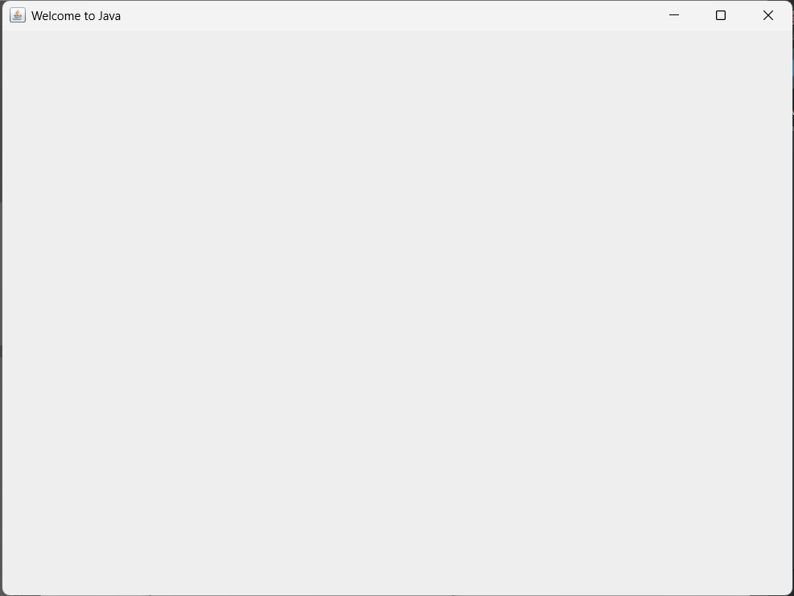

Q2

package Q_02;  
  
import javax.swing.*;  
import java.util.Scanner;  
  
public class Q2 {  
 public static void main(String[] args) {  
 Scanner scanner = new Scanner(System.*in*);  
 System.*out*.print("Enter first name: ");  
 String firstName = scanner.next();  
 System.*out*.print("Enter last name: ");  
 String lastName = scanner.next();  
  
 JFrame frame = new JFrame();  
 frame.setSize(300, 250);  
 frame.setTitle(firstName + " " + lastName);  
 frame.setVisible(true);  
 }  
}

Output

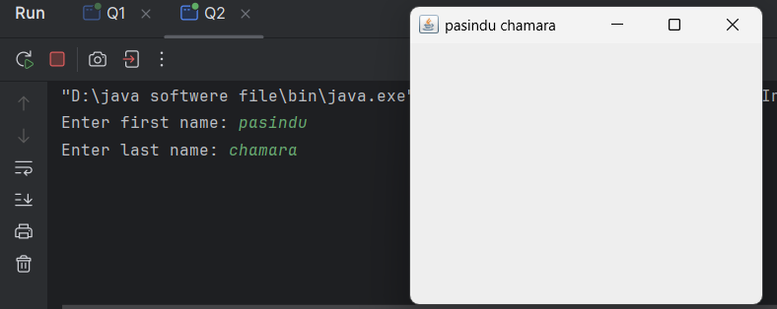

Q3

package Q_03;  
  
import javax.swing.*;  
import java.util.Scanner;  
  
public class Q3 {  
 public static void main(String[] args) {  
 Scanner scanner = new Scanner(System.*in*);  
  
 System.*out*.print("Enter first name: ");  
 String firstName = scanner.next();  
  
 System.*out*.println("Enter middle name: ");  
 String middleName = scanner.next();  
  
 System.*out*.print("Enter last name: ");  
 String lastName = scanner.next();  
  
 String initial = middleName.substring(0,1);  
 System.*out*.println(firstName+" "+initial+". "+lastName+".");  
 }  
}

Output

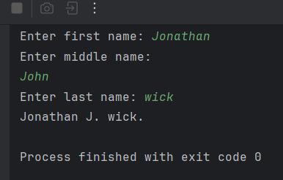

Q4

package Q_04;  
  
import javax.swing.*;  
import java.text.SimpleDateFormat;  
import java.util.Date;  
  
public class Q4 {  
 public static void main(String[] args) {  
 Date today = new Date();  
 System.*out*.println(today);  
  
 SimpleDateFormat sdf = new SimpleDateFormat("dd/MMM/yyyy");  
 System.*out*.println(sdf.format(today));  
 }  
}

Output

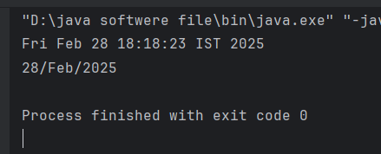

Q5

package Q_05;  
  
import javax.swing.*;  
import java.text.SimpleDateFormat;  
import java.util.Date;  
  
public class Q5 {  
 public static void main(String[] args) {  
 Date today = new Date();  
 System.*out*.println(today);  
  
 SimpleDateFormat sdf = new SimpleDateFormat("EEEE/MMM/yyyy");  
 System.*out*.println(sdf.format(today));  
 }  
}

Output

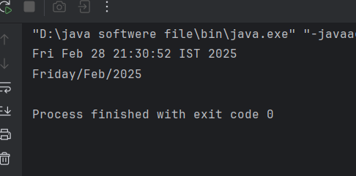

Q6

package Q_06;  
  
import javax.swing.*;  
import java.util.Scanner;  
  
public class Q6 {  
 public static void main(String[] args) {  
 JFrame frame = new JFrame();  
 Scanner scanner = new Scanner(System.*in*);  
 System.*out*.println("Enter the frame width:");  
 int width = scanner.nextInt();  
 System.*out*.println("Enter the frame height:");  
 int height = scanner.nextInt();  
 frame.setSize(width, height);  
 frame.setVisible(true);  
  
 }  
}

Output

Q7

package Q_07;  
  
import javax.swing.*;  
import javax.xml.crypto.Data;  
import java.text.SimpleDateFormat;  
import java.util.Date;  
  
public class Q7 {  
 public static void main(String[] args) {  
 JFrame frame = new JFrame();  
 Date date = new Date();  
 SimpleDateFormat sdf = new SimpleDateFormat("hh:mm:ss a");  
 String time = sdf.format(date);  
  
 frame.setSize(300, 300);  
 frame.setTitle(time);  
 frame.setVisible(true);  
 }  
}

Output

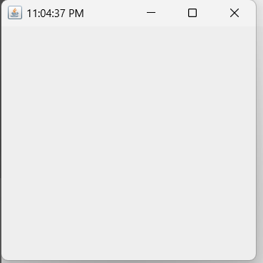

Q8

package Q_08;  
  
import java.util.Scanner;  
  
public class Q8 {  
 public static void main(String[] args) {  
 Scanner scanner = new Scanner(System.*in*);  
 System.*out*.println("Enter a string with an exclamation mark(!):");  
 String input = scanner.nextLine();  
 scanner.close();  
 int index = input.indexOf('!');  
 String before = input.substring(0, index).trim();  
 String after = input.substring(index + 1).trim();  
  
 System.*out*.println(before);  
 System.*out*.println(after);  
  
 }  
}

Output

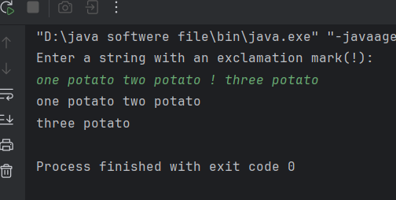

Q9

package Q_09;  
  
import java.util.Scanner;  
  
public class Q9 {  
 public static void main(String[] args) {  
 Scanner scanner = new Scanner(System.*in*);  
  
   
 System.*out*.println("Enter a string:");  
 String input = scanner.nextLine();   
 scanner.close();  
 int length = input.length();  
 char firstChar = input.charAt(0);  
 char lastChar = input.charAt(length - 1);  
   
 System.*out*.println(length);  
 System.*out*.println(firstChar);  
 System.*out*.println(lastChar);  
 }  
}

Output

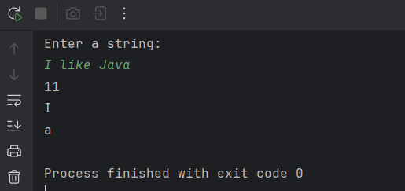

Q10

package Q_10;  
  
import java.util.Scanner;  
  
public class Q10 {  
 public static void main(String[] args) {  
 Scanner scanner = new Scanner(System.*in*);  
  
 System.*out*.println("Enter an odd-length word:");  
 String word = scanner.next();  
  
 scanner.close();  
 int lecngth = word.length();  
  
 if (lecngth % 2 == 0) {  
 System.*out*.println("The word is not odd-length.");  
 } else {  
 int middleIndex = lecngth / 2;  
 char middleChar = word.charAt(middleIndex);  
 System.*out*.println(middleChar);  
 }  
 }  
}

Output

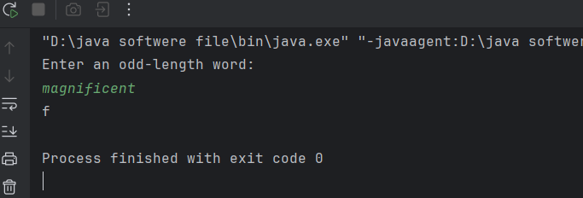

Q11

package Q_11;  
  
import java.util.Scanner;  
  
public class Q11 {  
 public static void main(String[] args) {  
 Scanner scanner = new Scanner(System.*in*);  
  
 System.*out*.println("Enter full name:");  
 String fullName = scanner.nextLine();  
 scanner.close();  
 String[] nameParts = fullName.split(" ");  
  
 if (nameParts.length != 3){  
 System.*out*.println("Enter correct full name.");  
 } else {  
 String firstName = nameParts[0];  
 String middleName = nameParts[1].substring(0, 1);  
 String lastName = nameParts[2];  
  
 System.*out*.println(lastName + ", " + firstName + " " + middleName + ".");  
  
 }  
 }  
}

Output

Q12

package Q_12;  
  
import javax.swing.*;  
import java.awt.*;  
  
public class Q12 {  
 public static void main(String[] args) {  
 JFrame frame = new JFrame("My first Frame");  
  
 frame.setSize(300, 250);  
 frame.setLocation(100,50);  
  
 frame.setDefaultCloseOperation(JFrame.*EXIT_ON_CLOSE*);  
 frame.setVisible(true);  
  
 }  
}

Output

