Lab 02 Student num = CT_2021_010

Q1.

Code:

|  |
| --- |
| ***package Q_01;  public class Q1 {  public static void main(String[] args) {  double B = 3, A = 2, C = 5;  double X = 4, Y =2;  double r = 7;   double result1 = Math.sqrt(Math.pow(B, 2)+ 4 * A * C);  double result2 = Math.sqrt(X + 4 * Math.pow(Y, 3));  double result3 = Math.cbrt(X * Y);  double area = Math.PI * Math.pow(r, 2);     System.out.println("Result 1:" +result1);  System.out.println("Result 2: " + result2);  System.out.println("Result 3: " + result3);  System.out.println("Circle Area: " + area);   } }*** |

Output:

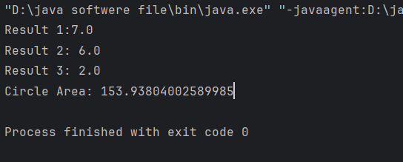

Q2.

Code:

package Q_02;  
  
import java.util.Scanner;  
  
public class Q2 {  
 public static void main(String[] args) {  
 double inch = 2.54;  
 Scanner scanner = new Scanner(System.*in*);  
  
 System.*out*.print("Enter the number of cm: ");  
 double centimeter = scanner.nextDouble();  
  
 double inches = centimeter / inch;  
 double feet = inches / 12;  
  
  
 System.*out*.printf("%.2f cm = %.2f feet and %.2f inches%n", centimeter, feet, inches % 12);  
  
 scanner.close();  
 }  
}

Output

Q3

Code

package Q_03;  
  
import java.util.Scanner;  
  
public class Q3 {  
 public static void main(String[] args) {  
 Scanner cel = new Scanner(System.*in*);  
 System.*out*.print("Enter the temperature in Celsius: ");  
 double celsius =cel.nextDouble();  
 double fahrenheit = (1.8 * celsius) + 32;  
 System.*out*.printf("%.2f Celsius = %.2f Fahrenheit%n", celsius, fahrenheit);  
 cel.close();  
 }  
}

Output

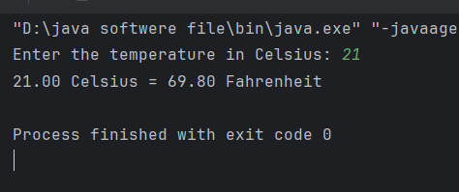

Q4

Code

package Q_04;  
  
import java.util.Scanner;  
  
public class Q4 {  
 public static void main(String[] args) {  
 Scanner weight = new Scanner(System.*in*);  
 System.*out*.print("Enter the weight in kg : ");  
 double bodyweight =weight.nextDouble();  
 double calories = bodyweight * 19;  
 System.*out*.printf("%.2f bodyWeight = %.2f calories%n", bodyweight, calories);  
 weight.close();  
 }  
}

Output

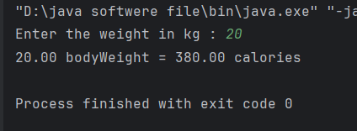

Q5

Code

package Q_05;  
  
import java.util.Scanner;  
  
public class Q5 {  
 public static void main(String[] args) {  
 Scanner Fah = new Scanner(System.*in*);  
 System.*out*.print("Enter the temperature in Fahrenheit: ");  
 double fahrenheit = Fah.nextDouble();  
 double celsius =(fahrenheit - 32)*(5.0/9.0);  
  
 System.*out*.printf("%.2f Fahrenheit = %.2f Celsius%n", fahrenheit, celsius);  
 Fah.close();  
 }  
}

Output

Q6

Code

package Q_06;  
  
import java.util.Scanner;  
  
public class Q6 {  
 public static void main(String[] args) {  
 Scanner born = new Scanner(System.*in*);  
 System.*out*.print("Enter your born year :");  
 int bornYear = born.nextInt();  
  
 int curretYear = 2025;  
  
 int age = -1 * (bornYear - curretYear);  
  
 System.*out*.println("You Were born in "+ bornYear + "and will be (are) " + age + " this year.");  
   
 born.close();  
 }  
}

Output

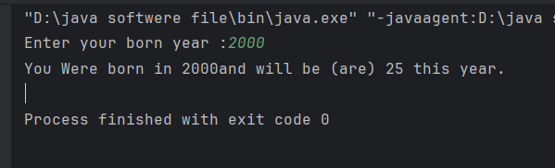

Q7

Code

package Q_07;  
  
import java.util.Scanner;  
  
public class Q7 {  
 public static void main(String[] args) {  
 Scanner scanner = new Scanner(System.*in*);  
  
 System.*out*.print("Enter your weight in kg:");  
 double weight = scanner.nextDouble();  
  
 System.*out*.print("Enter your height in cm:");  
 double height = scanner.nextDouble();  
  
 double heightM = height / 100.0;  
  
 double BMI = weight /(heightM * heightM);  
  
  
 System.*out*.printf( "Your BMI is:%.2f%n", BMI);  
 scanner.close();  
   
 }  
}

Output

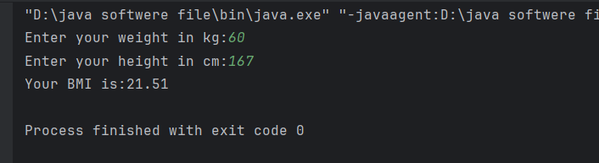

Q8

Code

package Q_08;  
  
import java.util.Scanner;  
  
public class Q8 {  
 public static void main(String[] args) {  
 Scanner r =new Scanner(System.*in*);  
  
 System.*out*.print("Enter radius value:");  
 double radius = r.nextDouble();  
  
 double volume =(4.0/3.0)* Math.*PI* * Math.*pow*(radius, 3);  
  
 System.*out*.println("The volume :" + volume);  
  
  
 }  
}

Output

Q9

Code

package Q_09;  
  
import java.util.Scanner;  
  
public class Q9 {  
 public static void main(String[] args) {  
 Scanner scanner =new Scanner(System.*in*);  
  
 System.*out*.print("Enter initial investment amount (P): ");  
 double P = scanner.nextDouble();  
  
 System.*out*.print("Enter annual interest rate (R) in percentage: ");  
 double R = scanner.nextDouble();  
  
 System.*out*.print("Enter number of years (N): ");  
 int N = scanner.nextInt();  
  
 double finalAmount = P * Math.*pow*(1 + (R / 100), N);  
  
 System.*out*.printf("The investment will grow to: %.2f%n", finalAmount);  
  
 scanner.close();  
   
 }  
}

Output

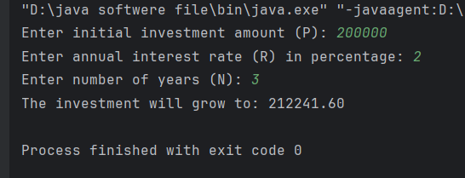

Q10

Code

package Q_10;  
  
import java.util.Scanner;  
  
public class Q10 {  
 public static void main(String[] args) {  
 Scanner scanner = new Scanner(System.*in*);  
  
 System.*out*.print("Enter loan amout :");  
 double loanAmount = scanner.nextDouble();  
  
 System.*out*.print("Enter annual interest rate (in %) : ");  
 double AnnuIn = scanner.nextDouble();  
  
 System.*out*.print("Enter loan period (In years):");  
 int loanP = scanner.nextInt();  
  
 double monthlyIn = AnnuIn / 100.0 / 12;  
 int numOfPayment = loanP * 12;  
  
 double monthlyPayment = (loanAmount * monthlyIn)/(1-Math.*pow*(1 + monthlyIn, - numOfPayment));  
  
 double totalPayment = monthlyPayment * numOfPayment;  
  
 System.*out*.printf("Monthly Payment: %.2f%n", monthlyPayment);  
 System.*out*.printf("Total Payment: %.2f%n", totalPayment);  
  
 scanner.close();  
   
 }  
}

Output

