Programming with Python and Generative AI
:Scripting, Data Analysis, Visualization, Problem-Solving, and Optimization

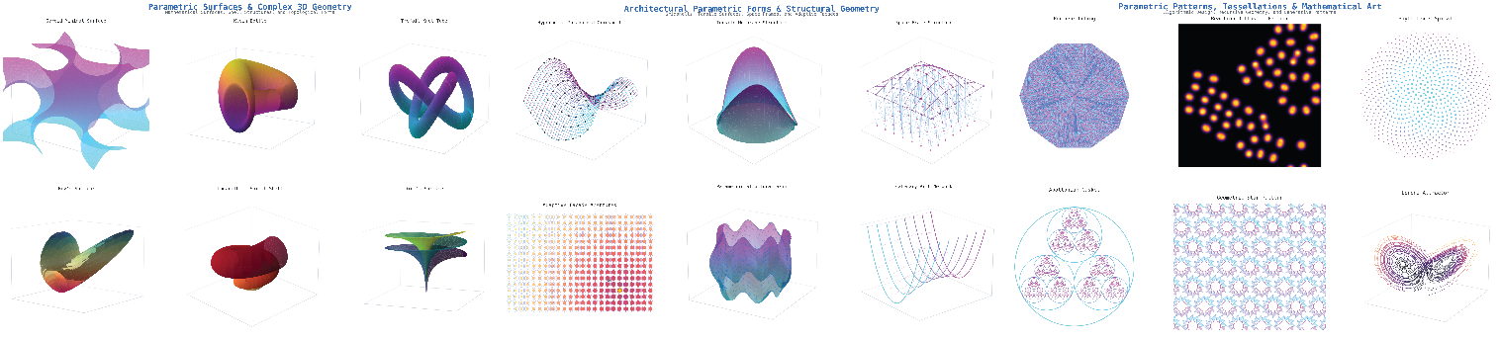

This course introduces Python programming from the ground up, integrating generative AI as a tool for learning and developing code. Students begin with core programming concepts — syntax, data types, logic, and functions — and progressively apply these skills to filter and screen data, create visualizations, solve optimization problems, and explore introductory machine learning. The emphasis is on building genuine programming literacy: students learn to write, read, debug, and extend code, with AI serving as an accelerator rather than a replacement.

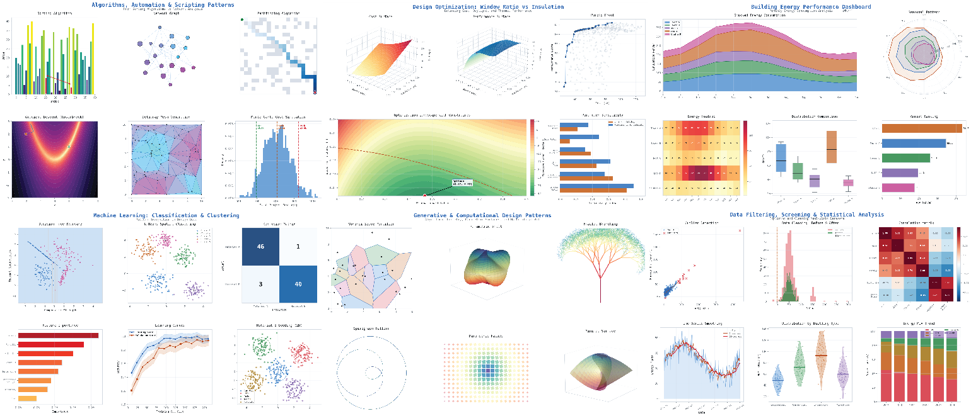

This course introduces Python programming from the ground up, integrating generative AI as a practical tool for learning and developing code. Students begin with core programming concepts—syntax, data types, logic, and functions—and progressively apply these skills to filter data, create visualizations, solve optimization problems, and explore introductory machine learning. The emphasis is on building genuine programming literacy: students learn to write, read, debug, and extend code, with AI serving as an accelerator rather than a replacement. Beyond writing scripts, the course provides a crucial foundation in the theoretical principles that underpin computational problem-solving. Students will explore the conceptual and mathematical foundations of key topics, including optimization theory (objective functions and constraints), machine learning fundamentals (classification, regression, and model evaluation), and data analysis methodology. This dual emphasis ensures that students not only know how to implement solutions in code but also understand why those methods work and when to apply them. Through a hands-on approach combining instruction and practice, the course prioritizes professional application over pure theoretical computer science, ensuring students gain experience that is immediately applicable across disciplines.

Designed for beginners with no prior coding experience, this course will cover key concepts such as:

- Python fundamentals: Writing, running, and debugging Python scripts while understanding core concepts like data types, control flow, and functions.
- AI-assisted coding: Using generative AI tools to safely and effectively assist in code development, debugging, and continuous learning.
- Data analysis & visualization: Filtering, screening, and transforming datasets, and translating that data into clear, compelling visualizations.
- Applied optimization: Learning the theoretical foundations of optimization including objective functions and constraints and applying these techniques to solve constrained, real-world problems.
- Machine learning principles: Understanding the core concepts of ML, such as classification, regression, model training, and evaluation, alongside their practical implementation.
- Computational thinking: Developing structured, readable, and reusable code tailored for interdisciplinary problem-solving

As generative AI reshapes the landscape of programming, the primary objective of this course shifts away from the memorization of syntax. Rather, the curriculum is designed to cultivate computational thinking, problem formulation, and the evaluation of AI-generated outcomes. Students who integrate core programming fundamentals with advanced AI literacy will be equipped with the resilience and adaptability necessary to navigate and leverage future technological advancements.

