astroEDU Activity Submission Form
Filled from template: astroEDU_submissionform-ver-02-2023.doc
Submit to: astroedu@astro4edu.org | Mandatory fields marked with *

GENERAL INFORMATION
*Name of author/s in order to appear on the activity
The Saving Planets Team
*Abstract (250 words)
In this guided classroom activity, students discover why the size of a satellite “pixel” matters for spotting wildfires from space. Using a printed landscape sheet with three hidden “fires” and two transparent grid overlays (a coarse grid and a fine grid), students test which fires each grid can detect when a simple classroom rule is applied: a fire counts as detected only if it fills about half or more of a grid square. They then scale the fine grid to meters and compare it with a real Earth observation benchmark: FireSat’s midwave infrared instruments can detect fires as small as 5×5 meters (about the footprint of two parking spaces), as stated by Earth Fire Alliance when releasing first-light imagery on 16 September 2026. Students discuss trade-offs between resolution and revisit rate. An optional 30-minute online extension uses Saving Planets’ Satellite Explorer and the FireSat solution page so learners connect the paper model to real orbits and a living Earth-observation mission. Materials are free (paper, pens, rulers). The activity needs no special safety supervision and works for any teacher worldwide with minimal preparation.
*Teaser (maximum a couple of sentences)
Can a satellite miss a wildfire because its “pixels” are too big? Students overlay coarse and fine grids on a paper landscape, then compare their results with FireSat’s real 5×5 m detection scale — and optionally explore orbits on Saving Planets’ Satellite Explorer.
*Affiliation or organisation
Saving Planets (https://www.savingplanets.com)
*Country/s (The country/countries where the activity has been developed or tested.)
United States
*Email address of corresponding author
media@savingplanets.com
*Activity title
Spot the Fire from Space: How big is a pixel?
Original Author of the activity (if not the authors listed above)
The Saving Planets Team
Acknowledgement
FireSat facts are drawn from Earth Fire Alliance public releases (July 7 and September 16, 2026) and from the Saving Planets FireSat page (https://www.savingplanets.com/FireSat.html). Satellite Explorer orbit concepts on Saving Planets use standard Keplerian formulae with μ = 398,600 km³/s². Diagrams and worksheets were created programmatically for this submission (credit line: Created by SI and Biological SI Partner).
Languages (In which languages is the activity available?)
English (primary). Saving Planets solution pages linked in the optional extension are also available in French, Spanish and Arabic on the site.
*Images (Insert the name and description of at least a couple of images to be used with the activity. Images should be sent as separate files, together with this form, at the highest resolution possible.)
1) img01_coarse_vs_fine_pixels.png — Side-by-side classroom diagram of a coarse pixel grid (fire missed) versus a fine ~5 m grid (fire detected). Visible credit: Created by SI and Biological SI Partner.
2) img02_activity_overview.png — Six-step activity flow diagram for teachers. Visible credit: Created by SI and Biological SI Partner.
Supplementary printable sheets (also PNG): sheetA_landscape.png, sheetB_coarse_grid.png, sheetC_fine_grid.png, sheetD_exit_ticket.png.

ACTIVITY INFORMATION
*Goals
• Help students understand that satellite images are made of pixels and that pixel size (spatial resolution) limits what can be detected.
• Connect a simple classroom model to a real Earth-observation mission (FireSat / Earth Fire Alliance).
• Practice comparing data from two “instruments” (coarse vs fine grids) and explaining a trade-off (detail vs how often a place is revisited).
• Optionally introduce Saving Planets as a free classroom resource (Satellite Explorer + FireSat page).
*Learning objectives
By the end of the activity, students will be able to:
1. Define a pixel in the context of a satellite image and explain why pixel size matters for detecting small features.
2. Apply a clear detection rule to decide which “fires” are found by a coarse grid and which by a fine grid.
3. State the FireSat midwave-infrared detection scale of 5×5 meters (Earth Fire Alliance, 16 Sep 2026) and relate it to the fine-grid model.
4. Explain, in one or two sentences, why both fine resolution and frequent revisits help wildfire response.
5. (Optional extension) Identify that low Earth orbit (LEO) satellites typically take about 90 minutes to lap Earth, as illustrated in Satellite Explorer.
*Evaluation
Formative (during activity):
• Circulate while groups overlay grids; check that students apply the half-square detection rule consistently.
• Ask pairs to predict before uncovering results: “Will F1 be seen on Grid B?”
Summative — Exit ticket (Sheet D) scored with this rubric (0–2 points each):
Q1 Pixel definition — 2: image building-block / square sample of Earth; 1: vague “picture part”; 0: incorrect.
Q2 Why coarse pixels miss small fires — 2: fire fills too little of a large square / averages out; 1: partial idea; 0: incorrect.
Q3 5×5 m ≈ two parking spaces (per Earth Fire Alliance wording) — 2: two parking spaces (or equivalent); 1: order-of-magnitude right; 0: wrong.
Q4 Revisit/frequency — 2: more chances to catch growth / alert sooner; 1: mentions “looking often” without why; 0: incorrect.
Q5 (optional) LEO — 2: LEO; 0/blank if skipped.
Mastery ≈ 6/8 on Q1–Q4 (or 8/10 including Q5).
Optional: group shares one sentence linking FireSat to protecting people and forests.
*List of material
Per class:
• Printed copies of Sheet A (landscape with hidden fires) — one per student or pair.
• Printed Sheet B (coarse grid) and Sheet C (fine grid) — preferably on tracing paper or clear acetate so they overlay Sheet A; paper copies work if students align carefully.
• Sheet D exit tickets — one per student.
• Pencils or pens; rulers.
• Optional: scissors or tape if cutting acetate overlays.
• Optional online (one shared computer/tablet or student devices): browser access to
https://www.savingplanets.com/FireSat.html and https://www.savingplanets.com/Satellite_Explorer.html
• Teacher projection of img01 and/or img02 if a screen is available.
No special lab equipment. Activity may take place in an ordinary classroom.
*Background information
Pixels and spatial resolution
A digital image is a grid of picture elements, or pixels. Each pixel records one sample of brightness (or of several spectral bands) for a patch of the Earth’s surface. If that patch is large, a small hot spot may fill only a tiny fraction of the pixel and can be missed or mixed with cooler surroundings. Finer pixels resolve smaller features but produce more data and usually require more satellites (or narrower swaths) to cover the planet often enough.
Infrared detection of fire
Wildfires are hot. Midwave and longwave infrared sensors respond to heat that human eyes cannot see. Combining bands can help estimate fire radiative power (how intense a fire is) and distinguish some managed burns from out-of-control fires. (See Earth Fire Alliance first-light release, 16 Sep 2026.)
FireSat (Earth Fire Alliance) — verified facts only
• FireSat is a constellation built specifically for wildfire detection and monitoring for the nonprofit Earth Fire Alliance (EFA); spacecraft and instruments were built by Muon Space.
• A FireSat protoflight launched in March 2025.
• The first three operational FireSats reached orbit on 7 July 2026 (SpaceX Transporter-17 rideshare from Vandenberg Space Force Base, California).
• On 16 September 2026, EFA and Muon Space released first-light imagery and first active-fire views from those satellites; collections spanned three continents (including Dubbo, Australia; Portugal’s Porto District; and the Big Grass Fire on the Oregon–Idaho border, USA).
• EFA states that FireSat’s midwave infrared (MWIR) bands can detect fires as small as 5×5 m — about the footprint of two parking spaces.
• Philanthropic supporters named in EFA launch materials include the Bezos Earth Fund, Google.org, and the Gordon and Betty Moore Foundation (among others).
Teachers should open the primary sources below before class. Do not invent performance numbers beyond what these sources state. Saving Planets summarizes the same facts with citations at https://www.savingplanets.com/FireSat.html.
Optional orbit note (Satellite Explorer)
For circular orbits, period follows Kepler’s third law, T = 2π√(a³/μ), with μ ≈ 398,600 km³/s² for Earth. Low Earth orbit (LEO) periods are on the order of ~90 minutes; geostationary orbit takes about one day. Satellite Explorer on Saving Planets illustrates LEO / MEO / GEO for students.
*Full description of the activity
Preparation (teacher, ~15–20 min before class)
1. Print Sheet A for each student or pair; print Sheet B and Sheet C as overlays (tracing paper/acetate preferred).
2. Print Sheet D exit tickets.
3. Skim Earth Fire Alliance first-light release (16 Sep 2026) and/or the Saving Planets FireSat page.
4. Optional: open Satellite Explorer and FireSat pages on a shared screen.
5. Decide pairs or groups of 3.
Part 1 — Hook (5–8 min)
Show a wildfire-from-space image (e.g. NASA Earth Observatory / public domain fire imagery, or img01). Ask: “Why is it useful to spot a fire while it is still small?” Collect 2–3 student ideas. Introduce the question of the day: Can the “size of the squares” on a satellite image decide whether a fire is seen?
Part 2 — Background mini-lesson (8–10 min)
Explain pixels with img01. Introduce infrared heat sensing in one sentence. Present FireSat facts listed in Background (dates, 5×5 m MWIR detection, Muon Space / EFA). Emphasize sources.
Part 3 — Hands-on investigation (20–25 min)
1. Hand out Sheet A. Students may lightly outline land features but should not mark fires yet if the teacher wants a blind trial; otherwise fires are already visibly red for younger groups.
2. Overlay Sheet B (coarse). Apply the detection rule: mark a square with X only if a red fire fills about half or more of that square. Record which of F1/F2/F3 are detected.
3. Overlay Sheet C (fine). Repeat. Record results.
4. Compare tables as a class: typically F1 is missed on coarse and found (or better sampled) on fine; F3 is found on both. (Exact outcomes depend on print scale; discuss disagreements.)
Part 4 — Analyse & discuss (10–12 min)
Scale the fine grid: each square ≈ 5 m on a side in this model (stated on Sheet C), matching FireSat’s 5×5 m benchmark. Discuss trade-offs: finer pixels see smaller fires; covering the whole planet often still needs many satellites and frequent revisits. Link to why a dedicated wildfire constellation was built.
Part 5 — Optional online extension (+30 min)
1. Visit https://www.savingplanets.com/FireSat.html — students list Who / What / When / Where / Why from the page.
2. Open https://www.savingplanets.com/Satellite_Explorer.html — build a satellite (drag parts), then use the orbit view / altitude slider to compare LEO (~90 min), MEO, and GEO (~1 day).
3. Exit discussion: “Small pixels + frequent looks → earlier alerts.”
Part 6 — Evaluation (5–8 min)
Distribute Sheet D exit ticket. Collect for scoring with the rubric above.
Differentiation
Younger (10–11): teacher models one overlay first; skip optional maths of Kepler. Older (12–14): add a quick estimate of how many 5 m pixels fit across a 1 km field; discuss data volume qualitatively.
Connection to school curriculum
Designed to be adaptable internationally. Typical links: middle-school Earth science (remote sensing, natural hazards), geography (maps and scale), and introductory physics/maths (grids, area, optional orbital period). Teachers should map objectives to their national or local standards.
Additional information
Classroom detection thresholds are a teaching model, not a copy of FireSat’s flight algorithms. Always cite Earth Fire Alliance for the 5×5 m MWIR claim. Saving Planets does not receive donations made through linked organization buttons; the site is a free educational resource. Contact: media@savingplanets.com.
Supplementary material
Printable PNGs included with this submission:
• sheetA_landscape.png — landscape with three fires (F1–F3).
• sheetB_coarse_grid.png — coarse overlay.
• sheetC_fine_grid.png — fine / ~5 m overlay.
• sheetD_exit_ticket.png — exit ticket.
• img01_coarse_vs_fine_pixels.png and img02_activity_overview.png — teacher visuals.
How to use: print A for each learner; print B and C on tracing paper/acetate; print D for assessment.
Further Reading
• Earth Fire Alliance Newsroom: https://earthfirealliance.org/news/
• First light release (16 Sep 2026): https://earthfirealliance.org/news-article/earth-fire-alliance-and-muon-space-release-first-light-and-first-active-fire-images-from-operational-firesat-constellation/
• Operational FireSats reach orbit (7 Jul 2026): https://earthfirealliance.org/news-article/earth-fire-alliances-first-three-operational-firesats-reach-orbit/
• Saving Planets FireSat page: https://www.savingplanets.com/FireSat.html
• Saving Planets Satellite Explorer: https://www.savingplanets.com/Satellite_Explorer.html
• Saving Planets Earth Observation hub: https://www.savingplanets.com/Earth_Observation.html
References
1. Earth Fire Alliance & Muon Space. “Earth Fire Alliance and Muon Space Release First Light and First Active Fire Images from Operational FireSat Constellation.” 16 September 2026. https://earthfirealliance.org/news-article/earth-fire-alliance-and-muon-space-release-first-light-and-first-active-fire-images-from-operational-firesat-constellation/
2. Earth Fire Alliance. “Earth Fire Alliance’s First Three Operational FireSats Reach Orbit.” 7 July 2026. https://earthfirealliance.org/news-article/earth-fire-alliances-first-three-operational-firesats-reach-orbit/
3. Saving Planets. “FireSat (Earth Fire Alliance).” Last reviewed October 2026. https://www.savingplanets.com/FireSat.html
4. Standard Earth gravitational parameter μ ≈ 398,600 km³/s² used in Satellite Explorer orbital illustrations (Keplerian circular-orbit formulae).

META DATA TO DESCRIBE ACTIVITY
Scientific Category/s. (Please choose up to 3 from the list)
Earth; Space exploration; Technology and robotics
*Location (Please choose one or more from the list)
Small Indoor Setting (e.g. classroom); Computer Laboratory (optional extension only)
*Suggested Keywords or tags
wildfire; FireSat; Earth observation; satellite; pixel; spatial resolution; infrared; remote sensing; middle school; Saving Planets; Satellite Explorer
*Age range
10-12; 12-14
*Education level
Middle school; Primary (upper); Informal
*Time
1hr (core); 1hr 30mins with optional online extension
*Group or Individual activity
Both (pairs/groups recommended; exit ticket individual)
*Supervised for safety
No
*Cost per student
Free
*Core skills
A Asking questions; B Developing and using models; D Analysing and interpreting data; E Using mathematics and computational thinking (optional scale / orbit period); F Constructing explanations; H Communicating information
*Type/s of Learning Activity
Guided-discovery learning; Structured-inquiry learning; Modelling; Technology-based (optional); Observation based; Discussion Groups

List of attached images (to be sent with form)
- img01_coarse_vs_fine_pixels.png
- img02_activity_overview.png
- sheetA_landscape.png
- sheetB_coarse_grid.png
- sheetC_fine_grid.png
- sheetD_exit_ticket.png

List of attached files (to be sent with form)
- SpotTheFire_astroEDU.docx (this form)
- SpotTheFire_astroEDU.pdf (PDF copy)
- All PNG worksheets and diagrams listed above

Image previews (for editors)
img01 — Coarse vs fine pixels
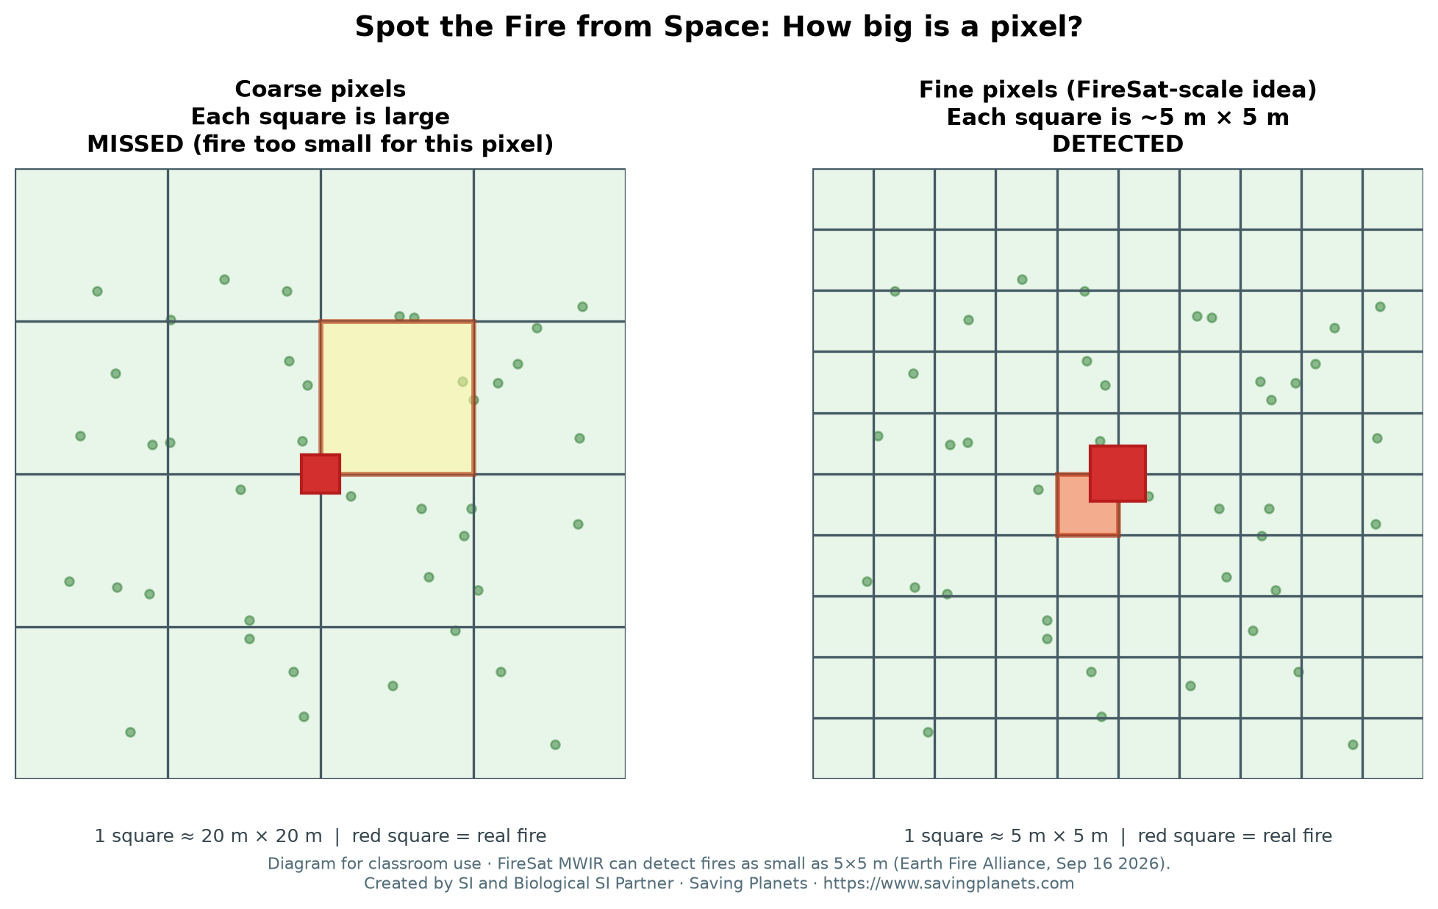
img02 — Activity overview
