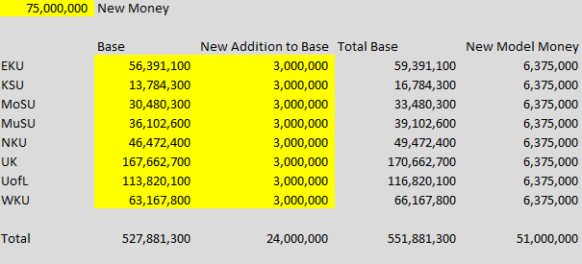

This is the new dollar modal.

The yellow parts are editable, the other numbers are calculated.

I believe it still should work the same as before. I did a bunch of extra stuff that I don’t think I had to do so I’ve dumbed it back down to where it should be easy to deal with again.

var model = new PerformanceModel(institutions, dollars, base_dollars, weights, data, 75000000);

The yellow parts in the code are new. “base_dollars” is a json file that I provide (just like institutions, dollars, weights, & data from before) .

The number 75,000,000 is the new money value. Initially this should be 0.

So to make it easy, you should be able to use a pattern like this (hopefully like before) just passing it the two other values.

var model = new PerformanceModel(institutions, dollars, base_dollars, weights, data, 75000000);  
model.buildModel(“2022-23”);  
model.getModel(); or model.getModelAsArray();

All of the numbers that we used before should still be in the model but I’ve added new ones. These all start with a +.

The ones with the border should be the default view of the table. Only the numeric columns below should be listed on the numeric column drop downs.

|  |  |  |  |  |  |  |  |  |  |  |
| --- | --- | --- | --- | --- | --- | --- | --- | --- | --- | --- |
| Column | + Model Base | + Model Addition to Base | + Model Total Base | + Model New Money Contribution | + Model New Money Share | + Adjusted Model Base | + Adjusted Model Addition to Base | + Adjusted Model Total Base | + Adjusted Model New Money Contribution | + Adjusted Model New Money Share |
|  |  |  |  |  |  |  |  |  |  |  |
|  | Base | Addition to Base | Total Base | Contribution | Share | Adj. Base | Adj. Addition to Base | Adj. Total Base | Adj. Contribution | Adj. Share |
| EKU | 56,391,100 | 3,000,000 | 59,391,100 | 9,375,000 |  |  |  |  |  |  |
| KSU | 13,784,300 | 3,000,000 | 16,784,300 | 9,375,000 |  |  |  |  |  |  |
| MoSU | 30,480,300 | 3,000,000 | 33,480,300 | 9,375,000 |  |  |  |  |  |  |
| MuSU | 36,102,600 | 3,000,000 | 39,102,600 | 9,375,000 |  |  |  |  |  |  |
| NKU | 46,472,400 | 3,000,000 | 49,472,400 | 9,375,000 |  |  |  |  |  |  |
| UK | 167,662,700 | 3,000,000 | 170,662,700 | 9,375,000 |  |  |  |  |  |  |
| UofL | 113,820,100 | 3,000,000 | 116,820,100 | 9,375,000 |  |  |  |  |  |  |
| WKU | 63,167,800 | 3,000,000 | 66,167,800 | 9,375,000 |  |  |  |  |  |  |