|  |
| --- |
| nandimith inc. |
| Restaurant Order Management Mobile Application |
| Proposal for the Outsourcing Development – Version 0.1 |
|  |
| **Chameera Wijebandara** |
| **4/9/2015** |

|  |
| --- |
| This proposal is forwarded to Retail IT (Pvt.) Ltd in response to Definition of requirements / specification for “Restaurant Order Management Mobile Application” communicated verbally on 07th of April, 2015. The scope of this proposal is to develop the above said functionality. |

Table of Contents

Document History 2

1. Introduction 3

2. Requirements 4

3. Functional Points 5

3.1. Summary 5

3.2. Assumptions 5

3.3. Limitations 5

3.4. Development 5

3.4.1. Graphical User Interface For Customers 5

3.4.2. admin Graphical User Interface 5

3.4.3. PRINTING and Communication 6

3.4.4. Reading/Writing Intermidiate Format 6

3.4.4. Render Deformation Data 6

3.4.5. GUI 7

3.4.6. Animation 8

4. Testing procedures 8

5. Technologies to use 9

6. Environment Setup 9

6.1. Testbed Specifications 9

6.2. Security 9

7. Clarifications 9

8. Delivery Schedule 0

9. Effort Estimation 0

10. Progress Reporting 1

11. Commercials 1

12. Company Profile 1

13. Conclusion 1

# Document History

|  |  |  |  |  |
| --- | --- | --- | --- | --- |
| Ver. | Date | Description | Author | Approved by |
| v-0.1 | 05-April | Initial Draft | Nandimith Inc.(Chameera) | Nandimith Inc. |

Proposal for outsourcing development for Restaurant Order Management Mobile Application

# Introduction

Nandimith Inc. is delighted to submit a quote to supply software development services to implement a Restaurant Order Management Mobile Application to Retail IT (Pvt.) Ltd, Sri Lanka. We believe that a comprehensive proposal would ensure a risk free software delivery to the expectations of Retail IT (Pvt.) Ltd, Sri Lanka.

This proposal covers the requirement review, raise of clarifications, study of related technologies, effort estimation, development environment setup, project management and coordination, test plan, delivery plan, and project acceptance procedures.

To ensure the continuous visibility of the progress of the project to all the stakeholders involved, we would be following the best project management practices through Github.

Whilst appreciating the opportunity extended to us to provide this proposal for the above software development system, we believe that the information contained in this proposal would meet the requirements and the expectations of Retail IT (Pvt.) Ltd, Sri Lanka.

# Requirements

This is a project to build a mobile application for a restaurant management system. This would be an Android application. This will be an extension to the existing restaurant management system.

Application handle order placing process at restaurants. Customer can access the order catalogue from the application. Oder catalogue will be maintained offline in the tablet device. Customers can add, delete or edit the selections, under the assistance of a staff member at a restaurant. Once the selection is finalized, a confirmation is sent to the cashier and the kitchen printer (and bar printer). Table number selected at the confirmation. Customer may order additional items later and those will be added as additional invoices to the main invoice. Application will be connected via WIFI.

Application can be configured for appearance changes such as logo and the main theme color. Application can be configured for direct printing or let cashier to handle the printing presses.

The developers are free to choose the technology and frameworks to build the product

# Functional Points

## Summary

The major requirement of this outsource development is to build an Android application that can handle restaurant ordering process. The restaurant order catalogs can be accessed using the application and order selection can be made through the application. Details of each functional item are described below.

## Assumptions

* App will be deployed in 7” android tabs (Android versions 4.2+).
* Tab will have the required functionalities such as Wi-Fi.
* Application will have continues Wi-Fi access.
* Database access will be provided using HTTP API.

## Limitations

* Application will be optimized for 7” display.

## Development

### 3.4.1. Graphical User Interface For Customers

* View hierarchical catalog
* Place orders (add/remove items, change item quantities and confirm the order)
* Add additional items to previous order
* Can view current billing information

Value Added Suggestions

* Provide order suggestions based on ordering patterns.

### 3.4.2. admin Graphical User Interface

* Passwords protected UI
* Select application theme color
* Set the application logo
* Set restaurant name and title
* IP configuration (printers, server)
* Printing configuration (direct printing available or not , available printers)

### 3.4.3. PRINTING and Communication

* After confirmation of the customer,
  + Update the database
  + Send printing requests to relearnt printers (kitchen and bar)
* Communication will use Wi-Fi
* Printing request contains
  + Table
  + Item
  + Quantities
  + Special request from customers (Description)

Value Added Suggestions

* Communications should be encrypted.

### 3.4.4. Sever Manager

* Confirm and control the order placing process
* When an order request received, validate the order and send feedback to the Android application (customer)

### 3.4.4. Central Server api

* Use HTTP protocol
* Stateless REST Full

Value Added Suggestions

* Massages should be encrypted.

# NON FUNCTIONAL POINTS

* User friendly Graphical Interface
* Easy to learn by non-technical people
* Security of the application should be in acceptable range
* Application has expendability capabilities

# Testing procedures

* The GUI operations involved will be tested against simple test case document by a different person other than the developer to assure the intended functionality after developer confirmation.
* After the initial GUI testing application will provided to Retail IT (Pvt.) Ltd for further testing and feedbacks.
* The end-to-end functionality as per above functional points will be tested against system.
* Then application will be provided for system testing to Retail IT (Pvt.) Ltd and refine for feedbacks.

# Technologies to use

* Programming Language: Java, PHP
* Special libraries:
* IDE: Android Studio
* Repository: GIT (<https://github.com/chameerawijebandara/MagicMenu>)
* PM portal: Github (<https://github.com/chameerawijebandara/MagicMenu/issues>)

# Environment Setup

## Testbed Specifications

* OS: Android 4.2
* Display: 7”
* CPU: N/A
* RAM: N/A
* Graphics: N/A

## Security

* All the TEAM members are back-to-back bound with an NDA with Nandimith Inc. for not disclosing any customer and project related information to 3rd parties.
* The code repository is access restricted and permitted only to the corresponding developers with password projection through GIT protocol.
* The project portal is also access restricted and password protected through secured HTTPS.
* Developer computers have source code on any encrypted partition which is password protected.
* On completion of project the corresponding encrypted partition file will be deleted from developer machines assuring removal of all source codes and related documents unless customer advised otherwise.

# Clarifications

* NONE

# Delivery Schedule

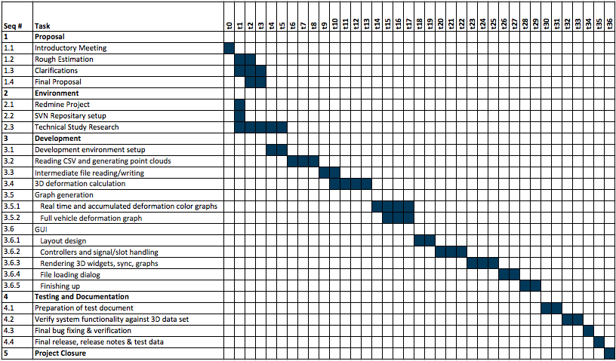

# Effort Estimation

|  |  |  |
| --- | --- | --- |
| Outsource Development of Addition of volume data STL export function to Neo3D | | |
|
| Seq # | **Task** | **Effort Estimation (Days)** |
| 1 | **Preparation** |  |
| 1.1 | Study | 6 |
| 1.2 | PM environment setup | 1 |
| 1.3 | Estimation | 1 |
| 1.4 | Proposal | 3 |
| 1.5 | Communication | 1 |
|  |  |  |
| 2 | **Development** |  |
| 2.1 | Reading CSV and generating point clouds | 3 |
| 2.2 | Intermediate file reading/writing | 2 |
| 2.3 | 3D deformation calculation | 4 |
| 2.4 | Graph generation |  |
| 2.4.1 | Real time and accumulated deformation color graphs | 4 |
| 2.4.2 | Full vehicle deformation graph | 3 |
| 2.5 | GUI |  |
| 2.5.1 | Layout design | 2 |
| 2.5.2 | Controllers and signal/slot handling | 3 |
| 2.5.3 | Rendering 3D widgets, sync, graphs | 4 |
| 2.5.4 | File loading dialog | 2 |
| 2.5.5 | Finishing up | 1 |
|  |  |  |
| 3 | **Testing** |  |
| 3.1 | Testing the product | 2 |
| 3.2 | Bug fixing, verification | 2 |
|  |  |  |
| 4 | **Overhead** |  |
| 4.1 | Weekly release (x4) | 2 |
| 4.2 | Project Management, reporting & communication | 7 |
|  |  |  |
| 5. Total |  | **53** |

# Progress Reporting

* Nandimith Inc. use progress update on Github with provision for the customer to see live progress of the project at any time through the web portal (<https://github.com/chameerawijebandara/MagicMenu/issues> )
* Additionally, Nandimith Inc. project team is available to contact via email and phone during usual office hours when the customer needed.
* Nandimith Inc. gives weekly update on project including a buildable release of the software (if any)
* Nandimith Inc. has a dedicated technical project manager for this project, who will arrange weekly online progress meetings in addition to regular weekly update via emails
* At any point of time customer can request for an online meeting. Nandimith Inc. will arrange the same within a day, depending on the team availability

# Commercials

|  |  |  |  |  |  |
| --- | --- | --- | --- | --- | --- |
| **Effort** | **Description** | |  | **Unit Price (RS)** | **Total (RS)** |
| **(Days)** |  |  |  | **(Per Man Month)** |  |
| 53.00 | **Outsource development work** | |  |  |  |

# Company Profile

* Company name Nandimith Incorporated.
* Location No 146/7, Pasal Mawatha, Attidiya, Dehiwala, Sri Lanka
* Telephone +94 78 386 6853(Chameera) / +94 71 591 3556(Buddhika)
* Business Outsourced and in-house software development, ICT solutions for non-IT organizations, ICT consultancy for government and semi-government organizations
* Current TEAM 8 members
* Contact Person Chameera Wijebandara
* Email : [chameerawijebandara@gmail.com](mailto:chameerawijebandara@gmail.com)
* Tel: +94 78 386 6853
* Skype: chameerawijebandara

# Conclusion

Based on the specifications we received by now, we have done certain assumption as stated above. Hope this proposal meets your requirements.

But we are flexible to amend the scope according to your requirements. We will see the feasibility of utilizing available resources to meet your delivery schedule requirements. We have done our best to provide the most optimized schedule and effort estimation to provide the most attractive pricing for the job.

We would like to make this a win-win opportunity to both Nandimith Inc. and 3D Incorporated to continue the businesses with better and quality service to the end users of the project and services. We at Nandimith Inc. are bound to do our best in achieving this objective.

Contact: [chameerawijebandara@gmail.com](mailto:chameerawijebandara@gmail.com) / Tel: +94 78 386 6853 / Skype: chameerawijebandara