|  |  |  |  |
| --- | --- | --- | --- |
| **KING SAUD UNIVERSITY**  **COLLEGE OF COMPUTER AND INFORMATION SCIENCES**  **COMPUTER SCIENCE DEPARTMENT** | | | |
| **CSC 329: Computer Network** | **Tutorial 2** | | **1st Semester 1437-1438** |
| **Name:** | | **Student ID:** | |
| **Serial Number:** | | **Section Number:** | |

**Part1: Multiple-Choice Questions (Model Answer)**

1. **Which of the following can be determined from a frequency-domain graph of a signal?**

a. Bandwidth

b. Phase

c. Power

d. All the above

1. **In a time-domain plot, the vertical axis measures the ________**
2. Amplitude
3. Frequency
4. Phase
5. Slope
6. **A periodic signal can always be decomposed into _______**
7. Exactly an odd number of sine waves
8. A set of sine waves.
9. A set of sine waves, one of which must have a phase of 0º
10. None of the above
11. **A sine wave is ______**

a. Periodic and continuous

b. Aperiodic and continuous

c. Periodic and discrete

d. Aperiodic and discrete

1. **If the maximum amplitude of a sine wave is 2 V, the minimum amplitude is___ V.**

a. 2

b. 1

c. -2

d. Between -2 and 2

1. **Given two sine waves A and B, if the frequency of A is twice that of B, then the period of B is _________ that of A.**

a. One-half

b. Twice

c. The same as

d. Indeterminate from

1. **As frequency increases, the period** 
   1. Decreases
   2. Increases
   3. Remains the same
   4. Doubles
2. **A periodic signal completes one cycle in 0.001 s. What is the frequency?**

a. 1Hz

b. 100Hz

c. 1KHz

d. 1MHz

1. **If the bandwidth of a signal is 5 KHz and the lowest frequency is 52 KHz, what is the highest frequency?**
2. 5KHz
3. 10KHz
4. 47KHz
5. 57KHz
6. **What is the bandwidth of a signal that ranges from 40 KHz to 4 MHz?**
7. 36 MHz
8. 360 KHz
9. 3.96 MHz
10. 396 KHz
11. **Twisted-Pair and coaxial cable are used**
12. copper
13. light
14. unwired
15. wireless
16. **Cable that accepts and transports signals in form of light is**
17. Unwired
18. fiber optic cable
19. coaxial cable
20. twisted pair cable
21. **A repeater takes a weakened or corrupted signal and ______________it.**

a. Amplifies

b. Regenerates

c. Re-samples

d. Reroutes

**Part2: Exercises**

1. **What is the phase shift for the following?**

a. A sine wave starts at time Zero with minimum amplitude. The amplitude is increasing. The phase shift = 270

b. A sine wave with minimum amplitude after 3/4 cycle. The phase shift = 0

c. A sine wave with zero amplitude after 1/2 cycle and increasing. The phase shift = 180

1. **What is the bit rate for each of the following signals?**
2. A signal in which 1 bit lasts 2 ms. 1/2*10-3 = 500 bps
3. A signal in which 10 bits last 20 μs. 10/20 * 10-6 =500000 bps =0.5 Mbps
4. **A device is sending out data at the rate of 500 bps.**

**Bit interval (how long it takes a bit to travel )=1/ bit rate =1/500 =0.002 s**

1. How long does it take to send out a single character (8 bits)?

Time to send 8 bits = 8 * bit interval = 8 * 0.002 =0.016 s

1. How long does it take to send a file of 100,000 characters?

Time to send 800,000 bits = 800,000 * bit interval = 800,000 * 0.002 =1600 s

1. **What is the bit rate for the signal in the following figure?**

**30 ns**

**Time**

Number of bits per level =log2 L = log2 4 = log2 4 = 2

Bit rate = 2* 8 /(30* 10-9 ) = 0.533 Gbps

1. **What is the frequency of the signal in the following figure?**

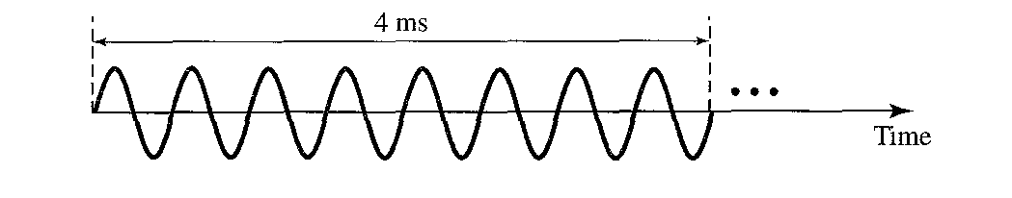

8 cycles in 4ms

? cycles in 1 s

1*8 / 4*10-3 = 2000Hz

1. **What is the bandwidth and the lowest frequency of the composite signal shown in the figure?**

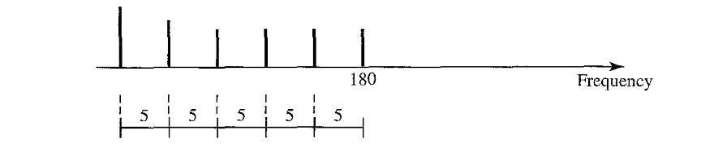

B = 5 * 5 = 25 Hz

B = *fh - fl*

*fl* = B - *fh* **=**180-25 =155 HZ

1. A periodic composite signal with a bandwidth of **200 Hz** is composed of constant signal of **10 V** and three sine waves: The first one has a frequency of **40 Hz** with amaximum amplitude of **5**V; the second one has a frequency of **120 Hz** with a maximum amplitude of **20** Vand the third one has a maximum amplitude **of 10 V**. Draw the frequency spectrum of the signal.

20 V

10 V

200

40

10 V

Frequency

1 20

5V

1. A non-periodic composite signal contains frequencies from **10 to 30 KHz**. The amplitude is **10 V** for the extreme (min and max) frequencies and **30 V** for middle frequency. Assuming that the amplitudes change gradually from the minimum to the maximum. Draw the frequency spectrum of the signal.

