TryHackMe – W1seGuy Room Write-Up

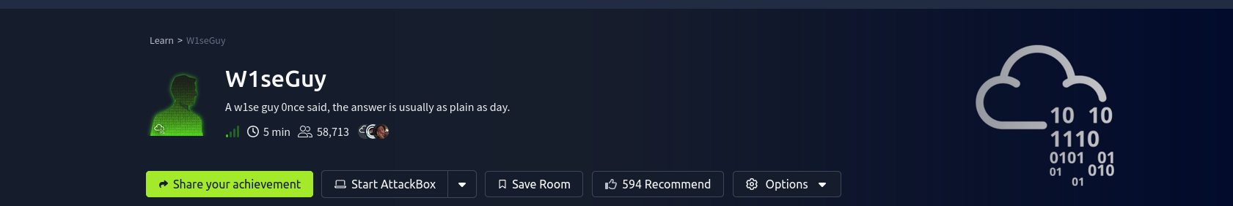

Room Name: W1seGuy
Platform: TryHackMe (THM)
Category: Cryptography / XOR Encoding
Difficulty: Easy–Medium
Author: Chamika Jayasooriya
Date:

1. Introduction
The W1seGuy room focuses on breaking a cryptographic challenge where a flag is encoded using the XOR (Exclusive OR) encoding method with five randomly generated keys. The objective is to analyze the provided source code, interact with the remote service, recover the encryption key, and finally obtain both flags.

2. Learning Objectives
- Understand how XOR encryption works
- Analyze source code to identify encryption logic
- Use known-plaintext attacks to recover XOR keys
- Interact with remote services using Netcat
- Decode hexadecimal-encoded data

3. Tools & Environment
- Kali Linux / Linux OS
- OpenVPN (TryHackMe connection)
- Netcat (nc)
- CyberChef
- Text Editor

4. Challenge Overview
The challenge consists of two main tasks:
- Analyze the provided source code to understand how the flag is encrypted
- Interact with the remote server to:
  - Retrieve the XOR-encoded flag
  - Guess the correct encryption key
  - Obtain the second flag

5. Source Code Analysis
After downloading the source code, the following observations were made:
- The flag is XOR-encoded
- A 5-character key is randomly generated
- The encoded output is returned in hexadecimal format
- If the correct key is provided, the server reveals Flag 2

Key Insight
XOR encryption is reversible when the key is known. Since TryHackMe flags always start with:
THM{
This predictable structure enables a known-plaintext attack.
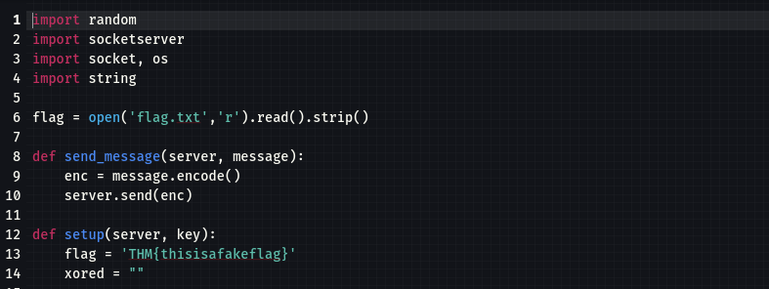

6. Connecting to the Remote Server
First, establish a VPN connection to TryHackMe:
sudo openvpn yourfile.ovpn
Once connected, use Netcat to interact with the challenge service:
nc <TARGET_IP> 1337
The server returns a hex-encoded XOR output (Flag 1 encrypted).
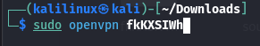

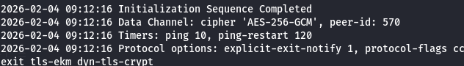

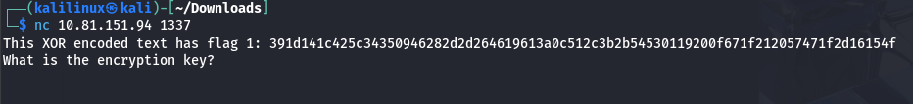

7. Extracting the XOR Key

Step 1: Analyze Hex Structure
- The encoded output is split into space-separated hex bytes
- The first 8 hex values correspond to THM{

Step 2: Known-Plaintext XOR
By XOR-ing the known plaintext (THM{) with the encrypted bytes, 4 key characters were recovered.
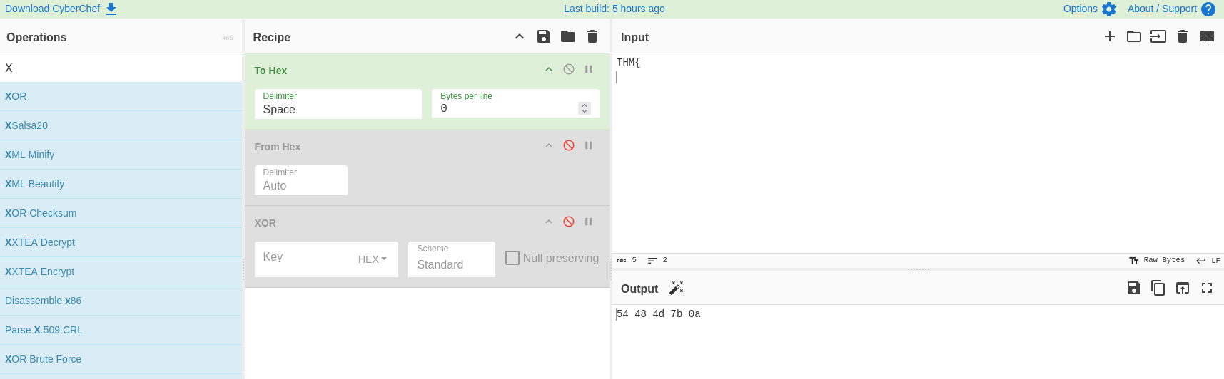

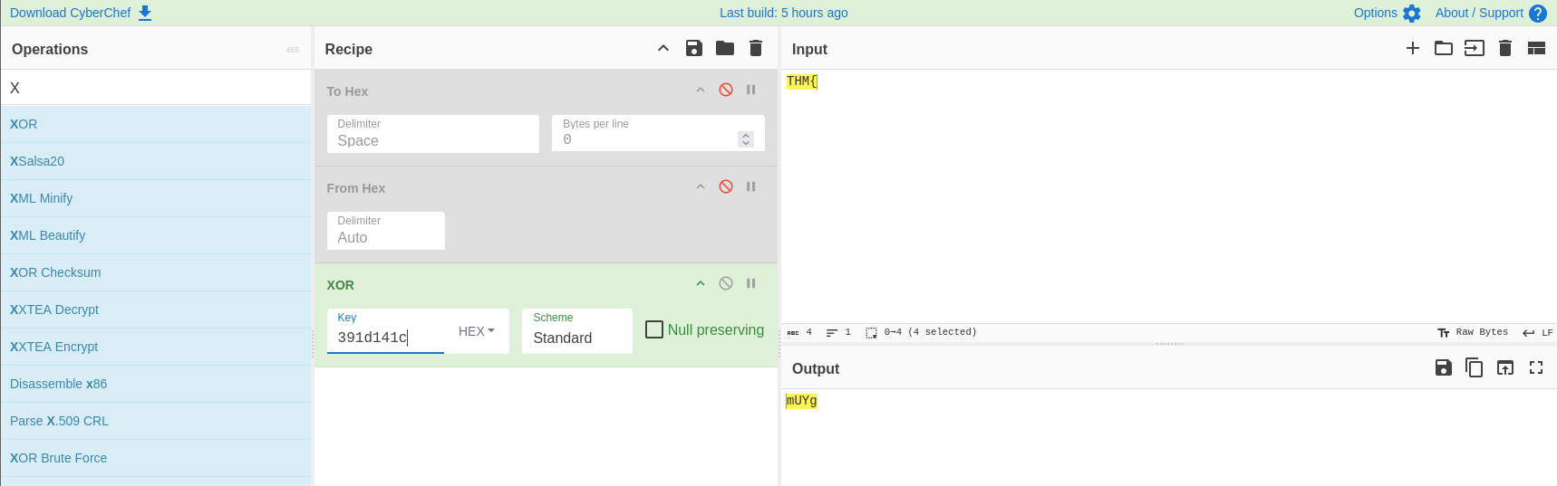

8. Brute-Forcing the Final Key Character
Only one key character remained unknown.
Using CyberChef:
- XOR decode with the known 4-character key
- Bruteforce the final character using:
  - Digits (0–9)
  - Lowercase letters (a–z)
  - Uppercase letters (A–Z)
Once the output produced a readable flag format, the correct key was identified.
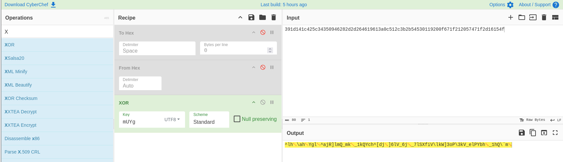

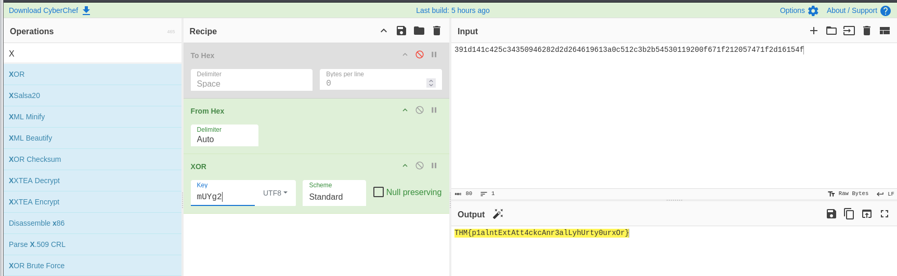

9. Flag Validation
The decoded flag was submitted to TryHackMe and successfully validated.

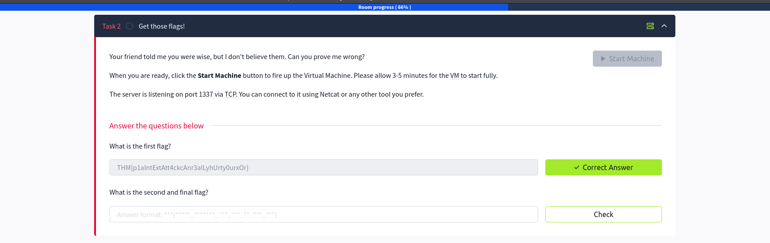

10. Retrieving Flag 2
The recovered 5-character XOR key was then submitted back to the Netcat prompt. The server returned Flag 2, completing the challenge.
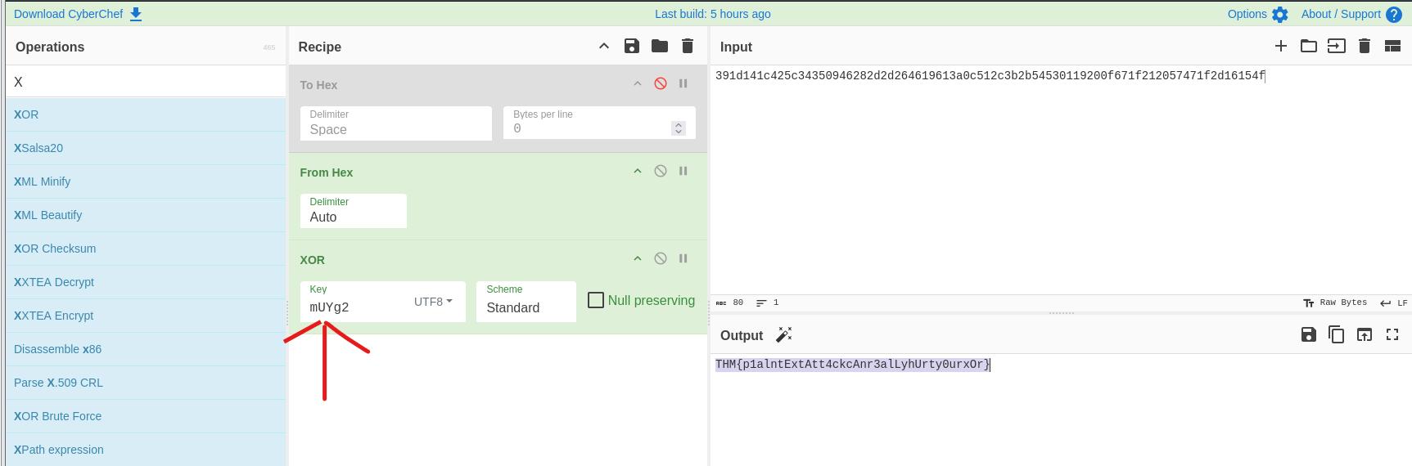
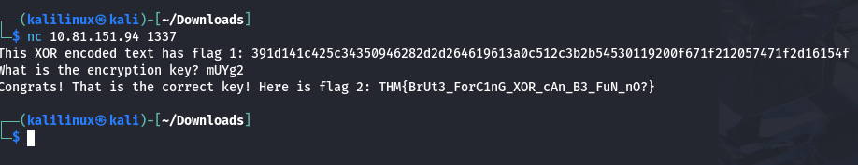

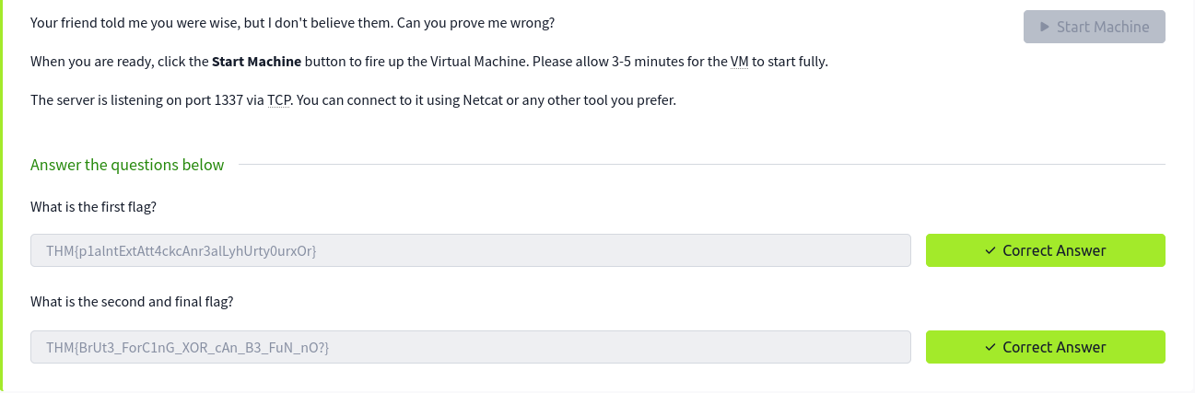

11. Final Results
- ✅ Flag 1 obtained via XOR decryption
- ✅ Flag 2 obtained by submitting the correct key
- ✅ Room successfully completed

12. Key Takeaways
- XOR encryption is weak when keys are reused or partially known
- Known-plaintext attacks are extremely effective against XOR
- Source code review provides critical exploitation clues
- CyberChef is a powerful tool for cryptographic analysis

13. Conclusion
The W1seGuy room is an excellent beginner-friendly cryptography challenge that demonstrates real-world weaknesses in XOR-based encryption. By combining source code analysis, known-plaintext techniques, and practical tooling, the challenge can be solved efficiently and methodically.

14. References
- TryHackMe – W1seGuy Room
- XOR Encryption Theory
- CyberChef Documentation

