TryHackMe – Corridor Walkthrough | MD5 Enumeration & Web Logic Exploitation



PART 1 – Initial Connectivity Check
The first step was to confirm that the target machine was reachable.
This was done by sending ICMP echo requests to the target IP address using the ping command.
ping <TARGET_IP>
The target responded successfully, confirming that the machine was online and accessible. This verification ensured that there were no network connectivity issues before proceeding with further enumeration and analysis.

- Terminal displaying successful ping replies
- Successful ping response confirming target availability

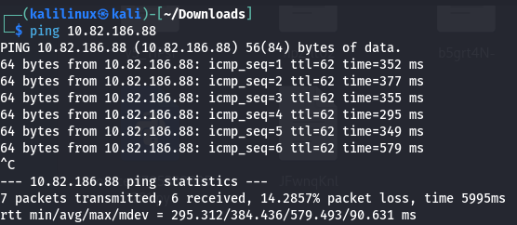

PART 2 – Port Scanning with Nmap
After confirming that the target was reachable, a port scan was performed using Nmap to identify open services running on the machine.
nmap 10.82.186.88
The scan results showed that the target host was active and had only one open TCP port:
- Port 80/tcp – HTTP service
All other scanned ports were closed, indicating that the target exposed a web service as the primary attack surface.
This finding suggested that further investigation should focus on web application enumeration via a browser.
- Terminal displaying the Nmap scan output
- Nmap scan revealing an open HTTP service on port 80
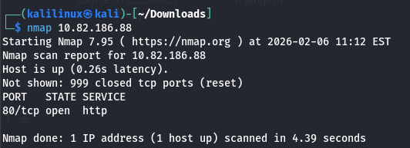

PART 3 – Web Application Enumeration
After identifying that the HTTP service was running on port 80, the target IP address was opened in Firefox to inspect the web application.
http://10.82.186.88
The webpage displayed a corridor-like interface with multiple numbered doors, each representing a different path or room.
When one of the doors was clicked, the browser redirected to a URL in the following format:
http://10.82.186.88/c4ca4238a0b923820dcc509a6f75849b
The value appended to the URL appeared to be a hash-like string rather than a readable path, indicating that the application was likely using encoded or hashed values to represent each door.
This behavior suggested that the application logic relied on predictable or reversible values, making the URL itself an important target for further analysis.
- Corridor webpage showing multiple doors
- Initial Corridor webpage displaying multiple doors

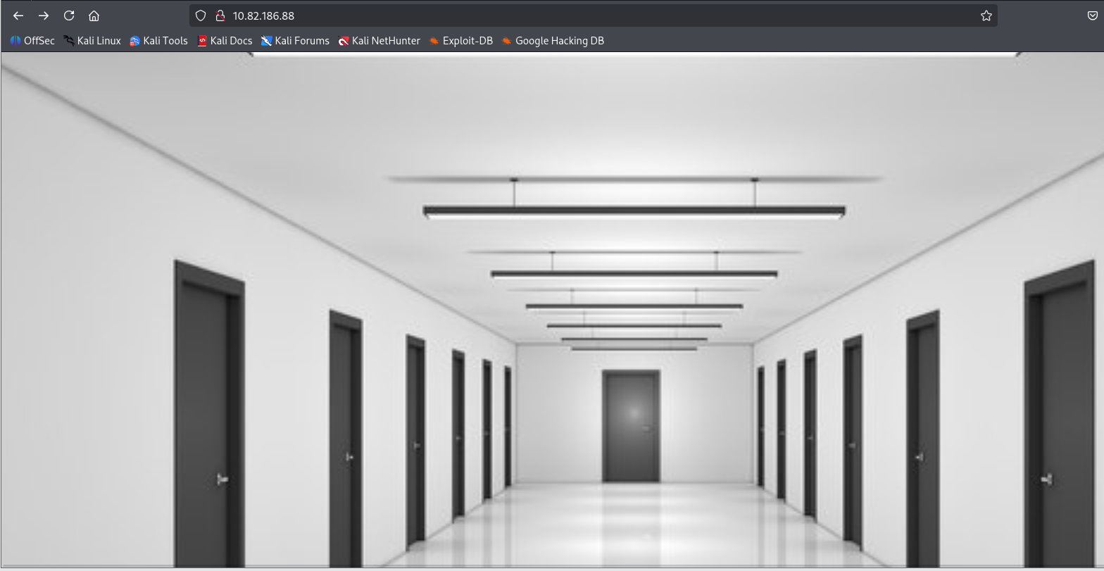

Browser address bar showing the hash-like URL after clicking a door
Hash-like value observed in the URL after selecting a door

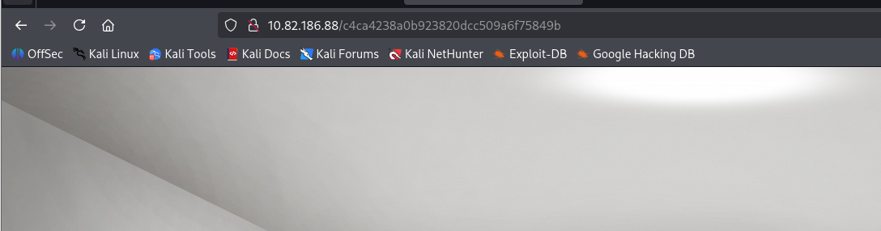

PART 4 – Hash Identification
After observing the hash-like value in the URL, the next step was to identify the type of hash being used.
For this purpose, the Hash Identifier tool was used on the extracted value.
c4ca4238a0b923820dcc509a6f75849b
The hash identification results indicated that the value was most likely:
- MD5
This finding was significant because MD5 is a weak and fast hash, commonly used in simple encoding scenarios and often reversible through online databases or basic cracking techniques.
Identifying the hash type confirmed that the URL paths were likely generated using MD5 hashes of predictable values, making the application logic vulnerable to enumeration.

- Terminal showing Hash Identifier results
- Hash Identifier output indicating the URL value is an MD5 hash

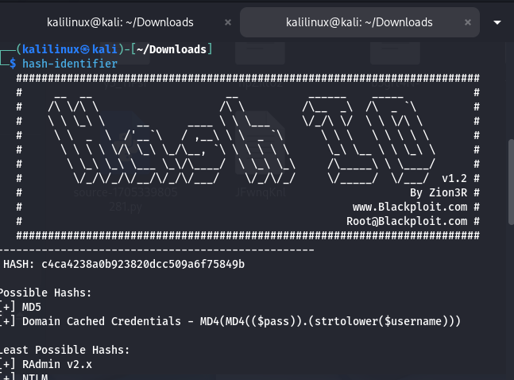

PART 5 – Hash Analysis Using CyberChef
After identifying the URL value as an MD5 hash, the next step was to further analyze it using CyberChef, a web-based data manipulation tool commonly used for encoding, decoding, and hashing operations.
The extracted hash was loaded into CyberChef and processed using the MD5 operation to observe how the application might be generating subsequent door values.
Input value:
c4ca4238a0b923820dcc509a6f75849b
Output value:
28c8edde3d61a0411511d3b1866f0636
This result indicated that the application was likely following a consistent hashing logic to generate door URLs, suggesting that navigating through the corridor depended on predictable MD5-based transformations rather than random values.
Understanding this behavior confirmed that the challenge relied on analyzing and manipulating hash values directly through the URL.

- CyberChef interface showing the MD5 operation and output
- Using CyberChef to analyze and transform the MD5 hash used in the door URL

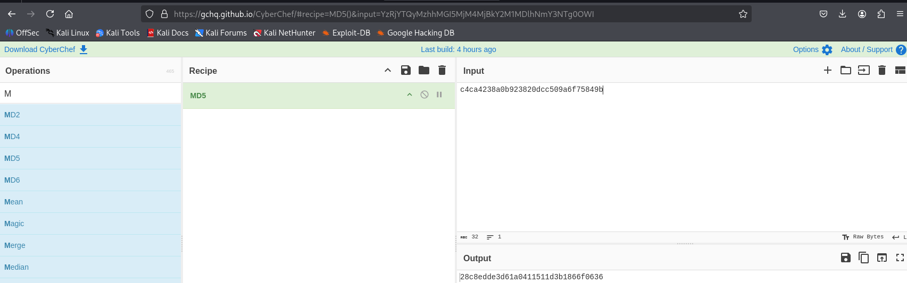

PART 6 – Hash Cracking with CrackStation
Since the identified hash was MD5, an online hash-cracking database was used to determine whether the value could be reversed.
For this purpose, CrackStation was used.
The following hash was submitted:
c4ca4238a0b923820dcc509a6f75849b
CrackStation successfully cracked the hash and revealed the original plaintext value:
1
This result confirmed that the URL path was generated by applying MD5 hashing to a simple room number.
This meant that each door in the corridor corresponded to the MD5 hash of a numeric value, making the application logic predictable and easily enumerable.
By understanding this pattern, it became possible to manually generate or modify URLs to navigate through the corridor without clicking each door individually.

- CrackStation results showing the decoded value
- CrackStation revealing the original room number from the MD5 hash

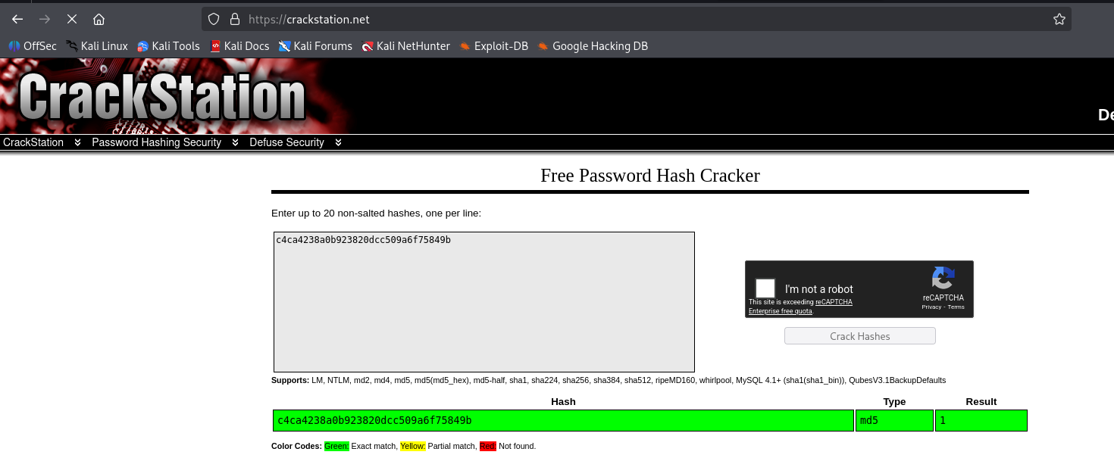

PART 7 – Predictable MD5 Enumeration and Flag Discovery
After cracking the MD5 hash and identifying that it represented a simple room number, the next step was to exploit this predictable logic.

🔢 Enumeration Method Explanation
The web application generated door URLs by applying MD5 hashing to sequential values.
Instead of using random or secure identifiers, the system relied on hashing simple inputs such as numbers.
A common enumeration approach in such scenarios is to test:
- Numbers starting from 0–9
- (Optionally letters A–Z, though numbers were sufficient in this case)
Each value is hashed using MD5 and tested directly in the URL.

🔍 Hash Generation Using CyberChef
Using CyberChef, the value 0 was hashed with the MD5 operation.
Input:
0
MD5 Output:
cfcd208495d565ef66e7dff9f98764da

🌐 Direct URL Manipulation
The generated hash was then manually appended to the target IP address in the browser:
http://10.82.186.88/cfcd208495d565ef66e7dff9f98764da
Upon visiting this URL, the correct room was accessed and the flag was revealed.
This confirmed that the application was vulnerable due to the use of predictable MD5 hashing without access control, allowing direct navigation to protected resources through URL manipulation.

CyberChef showing MD5 hash generation for value 0
Generating MD5 hash for sequential value using CyberChef
Browser displaying the flag after URL manipulation
Flag obtained by directly accessing the MD5-hashed URL

