**Assignment M1(Fall 2018)**

Chamikara Dharmasena  
cdharmasena3@gatech.edu

**Abstract.** Apple Music app on iPhone is trendy and cool. Simple and clean, easy to use interface with all the music you could ever ask for. However, some of the functionalities of the app fail to give users the ability to accomplish their intended tasks quickly. As a daily user of the iTunes mobile app, I have observed a number of functionalities that could use efficient redesigning. In this assignment, I would like to redesign the way of transitioning between playlists while playing music.

# Problem Space :

Listening to music is an essential part of my daily routine. I use iTunes to play music while driving, running, studying or exercising. There are several playlists in my iTunes, which I would change playlists while doing the activities mentioned earlier because my preference for music during each activity tends to change frequently. Changing the iTunes playlist from to another seem to have a wide gulf of execution.

Steps to change the playlist in iTunes mobile app

1. Unlocking the Phone (passcode or thumbprint)
2. Opening the iTunes App (optional if the app is already open)
3. If the current playlist page is open – Go back to the playlists page

Else – go to “Library” -> “Playlists”

1. Tap on a listed playlist
2. Tap of “Play” or “Shuffle” button

Following the steps listed above, just to change a playlist can be distracting from the activity that the user focused on. (running, driving, etc). By unlocking the phone to change the playlist, I would tend to open other apps (social media) as well. I find this situation to be a huge distraction, especially during workouts and studying.

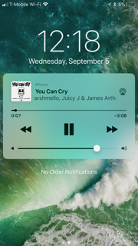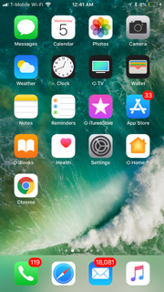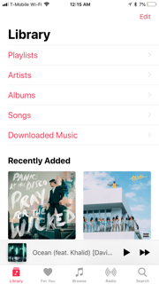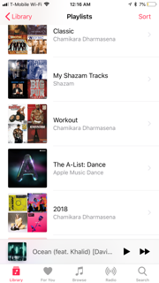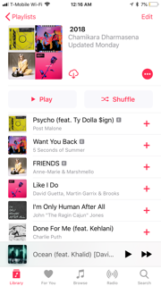

**Figure 1.** Navigation screens to accomplish the task of changing the playlist.

Figure 1 indicates the number of screens to go through in order to reach the target of changing the playlist. Design that I have in mind is to change the interface in the first screen itself to reach the goal by narrowing the gulf of execution.

# User Types :

As of 2018, Apple Music has 40 million paying subscribers worldwide. Users who use the app while engaging in another task could benefit from an efficient design. Users who listen to music while studying, working, driving, outdoor activities, exercising, etc. would be the target group for this redesigning process. These users can be spread out through various age groups. The ideal target age group would be aged 16–45, assuming the majority of this age group would be familiar with music streaming services such as Apple Music and Spotify. High schoolers and college students who are in the target age group, can be assumed as users who would listen to music while studying and playing sports. Millennials and high schoolers between ages 16-35, assuming potential or existing Apple Music subscribers, would be motivated to engage in the task if they are informed about the end goal of the redesign process and how it would change the user experience.

# Needfinding Plan 1 :

### Participant observation

Participant observation is based on need-finding based on the designer’s own experience. However, the designer needs to keep in mind that “you are not your user” perspective.

#### What Will I do:

#### I will start using the iTunes app and let it play music during an exercise session. My goal is to change the current playlist to another while running or doing some type of a cardio activity. As a follow-up activity, I will try to change the playlist through the app while driving and to monitor the process. I will target two user groups in this need finding task, people who are exercising and drivers.

#### Steps to follow:

I will observe my own activity of changing the playlist. Following items would be my observations.

While exercising,

1. Stopping or slowing down running in between to accomplish the task while running.
2. Accidentally opening other apps or did some other activity on the same app.
3. Changes in momentum.
4. Keeping up with peers in a group setting.

While driving,

1. Feeling distracted from focusing on surroundings.
2. Losing control of the wheel.
3. Having to switch from navigation app to music app back and forth.

***What data will you gather:***

With my observations, I would come to a conclusion that the task I am performing causes distractions or not. I will try to calculate the time spent changing playlists while exercising, Time it takes to complete the task can be measured with help of a friend.

Potential bias for this need finding task would be the confirmation bias since I am seeing and doing what I exactly want to accomplish. Other users may not find the task as a hassle the same way I prefer. The timing of the task may be different from the one user to another. I would try to avoid the bias by asking a peer to go through the task and measure the timing.

**Needfinding Plan 2:**

**Interviews**

In this needfinding exercise, my plan is to interview a few of my friends and collegues who use Apple’s music app and find out of if they have similar concerns while performing the specific task of changing the playlist. Interviewing them individually and also in the form of a focus group will be helpful to explore different perspectives.

***Who will you ask:***

People who use the Apple’s music app for their listening needs are the target group for this needfinding task. Group can be further divided in to sub categories based on when and where and how they use the app. My focus would be more in people who listen to music while exercising and driving. Every user may not want to change playlists during the activities described above. But I can get a brief idea about how the proposed design might be useful or not useful to them based on their answers, if they ever have to go through the specific task of switching between playlist.

***What will you ask:***

1. How often do you use apple’ s music app?
2. When do you use it (while doing another activity, what activities ?).
3. Do you change songs or playlists while doing the activities often and how often during the same activity?
4. How do you change the playlist/song ?
5. Do you find the process to be a smooth transition? If yes or no, Please explain why.
6. Would you use a different approach to complete the task if available?
7. Do you use any other music apps? What are they?
8. Did you find the same task is easier or difficult with other apps? Why?(if answered yes for No. 7)
9. Did you find anything else that could be improved to be more efficient?

If a user has never come across the scenario of the task, I could show them how the task is currently performed and ask for their inputs on how it should be done according to them.

Observer bias and social desirability bias may occur during the interviews where some people might agree with my point of view without giving much of a thought. I would try avoiding any biases by interviewing some people who I do not interact on a regular basis.

**Needfinding Plan 3:**

**Thinking out Loud**

In this needfinding plan, I am planning to use “Thinking out loud” method with few of my friends and colleagues. Using the thinking out loud method could expose functionalities which need improvements that I was not aware. Targeted Participants would be people who use Apple’s music app while engaged in various other activities.

***What will participants do?***

Participants will be asked to go through the task (changing playlists) in their own time. They will execute the task during activities such as exercising, biking or driving. Participants will perform the same task multiple times and will be asked to keep notes of the experience. Some participant may prefer communicating with me about the task than keeping notes. I would encourage them to talk to me right after they are done with the task while the memory of the experience is new.

***What will you ask them while or after they do it?***

I will ask about the overall experience, concerns and possible solutions they might have.

1. What activity or activities were they involved in while executing the task?

2. How easy or difficult was to complete the task?

3. Were they distracted by the task from their activity?

4. Did it take longer to accomplish the task than the participant had expected?

5. Did the participant use any shortcuts to complete the task?

6. Did the participant feel that there is a need for a better design?

7. What suggestions that they might have for a potential solution?

8. The Number of times the participant executed the task, differences between each attempt.

Observer bias may occur with some participants when they respond with the details that they think I might want to hear. Recall bias could be obvious since I am asking them about their experience certain time after completing the task. I would try to conduct interviews during the activity itself to avoid the case of bias. Having users think out loud during the activity could also help avoid recall bias.

# References

1. <https://www.statista.com/statistics/604959/number-of-apple-music-subscribers/>
2. Udacity Lectures.
3. Thinking Aloud” The #1 Usability Tool.

<https://www.nngroup.com/articles/thinking-aloud-the-1-usability-tool/>