“Sanwada” API Documentation.

Sanwada is a Dialog act recognition tool for Sinhala. The web application is available at [www.sanwada.lk](http://www.sanwada.lk). The REST API is exposed to developers to integrate Dialog act recognition for text based Sinhala functionality into the online applications built.

**Publicly Exposed Endpoints**

www.sanwada.lk /classify – POST

www.sanwada.lk /Upload/fileUpload – POST

www.sanwada.lk /Summarize/fileSummarize – GET

**POST /** **classify**

In this RESTful API function you can get classify any Sinhala utterance in to defined tag set. In order to use this functionality you can send a JSON object that having Sinhala utterance and you will get a JSON object response with the relevant matching tag with HTTP 200 OK for the input utterance.

**Resource URL**

[www.sanwada.lk /classify](www.sanwada.lk%20/classify%20)

**Parameters**

String inputText

**Sample Request JSON**

**JSON Object**

[{  
" inputText " : " ඇයි ඔයා මෙච්චර කෑම ගත්තේ?"   
}]

**Sample Response JSON**

HTTP 200 OK

[{  
" tagType" : "Open Question "  
}]

**How to Use**

For example assume that you are sending an ajax request to Sanwada server in order to get classify your utterance. For that you can use following code sniff**.**

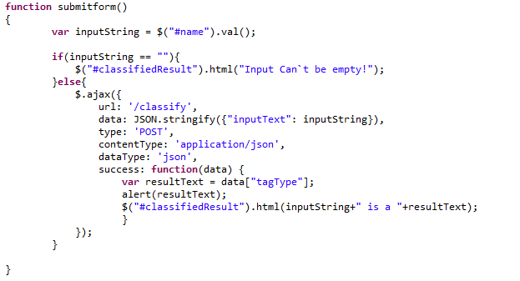

As well as if you want to get classify your Sinhala text file first you must upload your file in to our Sanwada server for that you can use our upload RESTful API function and then you can use summarize RESTful API function.

**Example Use of Other Sanwada API functions to summarize a Sinhala text data file.**

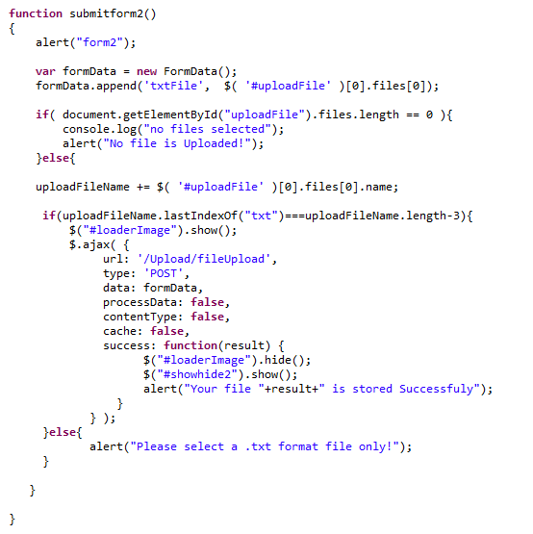

As above you can use such a function in your file uploading form to upload files to Sanwada server. For URL you may use [www.sanwada.lk /Upload/fileUpload](www.sanwada.lk%20/Upload/fileUpload) instead of /Upload/fileUpload.

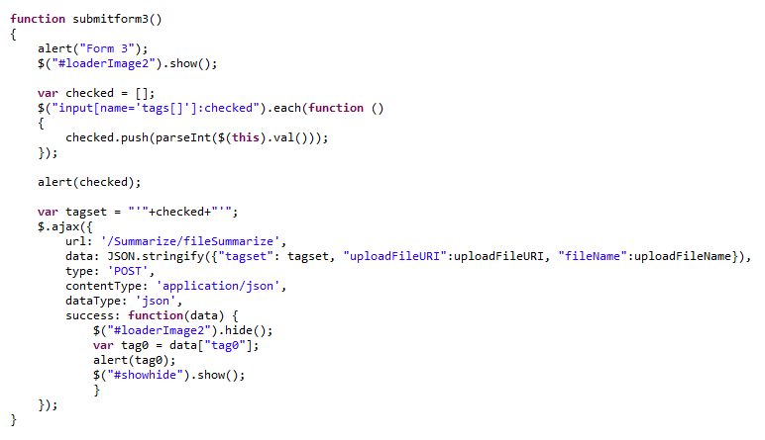

Here how you need to create your functions to get summarized your upload file to the server. Like above function you may use full URI instead of /Sumarize/fileSummarize  
  
**If you need further clarification please send us a mail.   
Thank you,  
Developing Team,  
Sanwada.**