SRI LANKA INSTITUTE OF INFORMATION TECHNOLOGY
SE3092 - Platform Based Development
Year 3, Semester 2

Spendly
Smart Personal Finance Management System
Corrected Technical Design Document

Group Member | Student ID
D B Y Binuwara | IT23184558
W P C L Pathirana | IT23230910
M V M Linash | IT23442566
A M N D Bandara | IT23148840

Prepared for Kavindu Silva scenario and aligned with the implemented Android/Kotlin codebase.

Table of Contents
- 1. Introduction
- 2. Kavindu Scenario and Problem Analysis
- 3. Requirements Analysis
- 4. System Constraints and Assumptions
- 5. Proposed Solution Overview
- 6. System Architecture Design
- 7. MVVM Architecture Mapping
- 8. Navigation Architecture
- 9. Firestore Schema Design
- 10. Room Database Design
- 11. Repository and Synchronization Design
- 12. Security and Authentication
- 13. Feature Design Details
- 14. Analytics Design
- 15. UI/UX and Wireframe Evidence
- 16. Testing and Verification
- 17. Future Improvements
- 18. References
- Appendix A. Codebase Reference Map

1. Introduction
Spendly is a mobile personal finance management application developed for users who manage irregular income streams, multi-currency earnings, fragmented expenses, and long-term savings goals. The project is implemented as an Android application using Kotlin, Jetpack Compose, Material Design 3, MVVM architecture, Hilt dependency injection, Firebase Authentication, Cloud Firestore, Room, Kotlin coroutines, StateFlow, and WorkManager.
The design is scenario-driven. It is built around Kavindu Silva, a 25-year-old junior software engineer in Colombo who earns from salary, freelance projects, Google AdSense, and cryptocurrency trading. Although Kavindu earns from several sources, he lacks consistent visibility into how money enters, leaves, and supports his MacBook Pro M4 savings goal.
Correctness note: Firestore collections are automatically created after first writes, profile photos remain local URI values, and all user-owned cloud records are stored below users/{uid}. These details match the implementation and should not be described as manual collection setup, Firebase Storage, or a device-specific account key.
This document reflects the current implemented Spendly codebase. It documents the actual Firestore paths, Room version 4 migrations, repository-backed synchronization, goal icon persistence, analytics calculations, and Firebase Authentication flows used in the Android project.

2. Kavindu Scenario and Problem Analysis

2.1 Scenario Summary
- Kavindu receives income from monthly salary, freelance software work, AdSense revenue in USD, and cryptocurrency trading.
- His expenses are spread across card payments, cash, rent, subscriptions, food delivery, transport, utilities, and auto-debits.
- He struggles to separate committed expenses such as rent and subscriptions from discretionary expenses such as food delivery and entertainment.
- His MacBook Pro M4 goal is important, but previous tracking methods did not connect daily spending with progress toward the target.
- He needs a low-friction mobile app that works offline and synchronizes across devices after login.

2.2 Root Problems
Problem | Evidence from Scenario | Spendly Design Response
Income fragmentation | Salary, freelance, AdSense, and crypto have different timing and currencies. | Income sources, original/default currency fields, exchange rate support, and crypto fields.
Expense invisibility | Expenses occur through many channels and categories. | Categorized expense capture with payment method and expense type.
Low tracking adherence | Spreadsheets and generic budgeting apps require too much effort. | Quick add FAB, reusable categories/sources, defaults, and concise forms.
Goal disconnection | MacBook savings is not linked to daily spending. | Goals, progress, add savings, linked goal expense transactions, and projections.
Weak awareness | Kavindu cannot identify spending distribution or trends. | Analytics dashboard with monthly totals, donut chart, split, and 5-month overview.

3. Requirements Analysis

3.1 Functional Requirements
ID | Requirement | Implemented Design
FR1 | User registration, login, forgot password, change password, logout, and persistent session. | Firebase Authentication through AuthRepository and FirebaseAuthRepository.
FR2 | Income entry for salary, freelance, AdSense, crypto, and recurring income. | AddIncomeViewModel, IncomeRepository, IncomeDao, income_entries table, Firestore income subcollection.
FR3 | Expense entry with amount, category, payment method, type, date, note, edit, and delete. | AddExpenseViewModel, ExpenseRepository, ExpenseDao, expense_entries table, Firestore expenses subcollection.
FR4 | Transaction history with month filter, type chips, grouped records, edit, and delete. | TransactionsViewModel prepares month options and grouped rows for TransactionsScreen.
FR5 | Goal add/edit/delete/details/add-savings with primary goal support. | GoalsViewModel and GoalRepository manage goals and linked savings expenses.
FR6 | Dashboard summaries and recent transactions. | HomeViewModel calculates total balance, monthly income, expenses, savings, yearly savings, and recent rows.
FR7 | Analytics based on live data. | AnalyticsViewModel computes totals, category percentages, committed/discretionary split, and 5-month overview.
FR8 | Profile management and currency preferences. | ProfileViewModel and UserRepository manage name, image URI, default currency, exchange settings, and password flow.
FR9 | Offline-first persistence and cross-device sync. | Room stores local data, Firestore stores cloud data, WorkManager syncs unsynced records.

3.2 Non-Functional Requirements
- Reliability: local Room writes happen before Firestore sync so network failure does not lose user input.
- Security: every Firestore document is scoped by Firebase uid under users/{uid}.
- Maintainability: MVVM separates Compose UI, ViewModels, repositories, DAOs, services, and workers.
- Performance: ViewModels expose StateFlow and Room Flow data, keeping UI updates reactive.
- Usability: Material Design 3 components, bottom navigation, month dropdowns, and consistent amount formatting reduce friction.
- Extensibility: repository interfaces and Hilt modules allow future services such as bank imports, Firebase Storage, and richer notifications.

4. System Constraints and Assumptions
- The current app supports email/password Firebase Authentication only.
- Firestore collections are created automatically only after the first successful document write.
- Profile images are stored as local URI/path values. Firebase Storage is not implemented in the current version.
- Money is stored as Long cents in default currency for stable calculations and display.
- dateMillis is the event date selected by the user. createdAtMillis is only for audit/creation time.
- The app is local-first: writes can succeed locally even when Firestore is temporarily unavailable.
- No bank API integration is included. Currency/crypto API failure must not block manual save.

5. Proposed Solution Overview
Spendly solves Kavindu's problem through a layered mobile system. The UI captures financial events quickly, ViewModels perform validation and calculations, repositories write to Room and synchronize to Firestore, and WorkManager retries unsynced changes when network connectivity is available.
Module | Primary Responsibility | Main Code Areas
Authentication | Session, create account, login, password reset/change, logout. | AuthScreen.kt, CreateAccountScreen.kt, FinanceViewModel.kt, CreateAccountViewModel.kt, AuthRepository.kt
Dashboard/Profile | Summary, profile entry, preferences, currency, account actions. | HomeScreen.kt, ProfileScreen.kt, HomeViewModel.kt, ProfileViewModel.kt
Transactions | Income/expense forms, history, filtering, edit/delete. | TransactionsScreen.kt, AddIncomeScreen.kt, AddExpenseScreen.kt, TransactionsViewModel.kt
Goals | Goal list, details, add/edit/delete, savings, icon selection. | GoalsScreen.kt, GoalScreen.kt, AddGoalScreen.kt, EditGoalScreen.kt, GoalsViewModel.kt
Analytics | Charts and financial calculations from persisted data. | AnalyticsScreen.kt, AnalyticsViewModel.kt
Data/Sync | Room, Firestore, repositories, mappers, workers. | data/local, data/remote, data/repository, util/SyncManager.kt, SpendlySyncWorker.kt

6. System Architecture Design
The system follows layered MVVM. Compose screens do not directly call Firebase or DAOs. They collect ViewModel state and send user events to the ViewModel. Repositories abstract Room and Firestore. Hilt provides dependencies and WorkManager performs background synchronization.
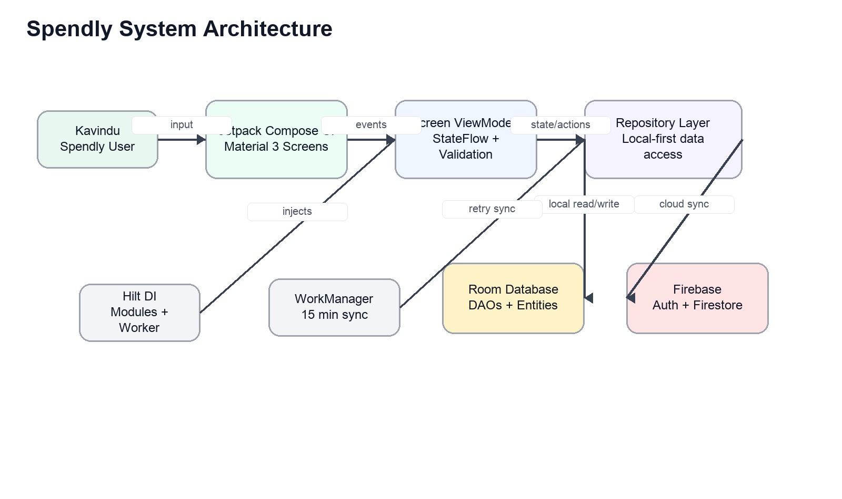
Figure 1: System architecture showing Compose, ViewModels, repositories, Room, Firebase, Hilt, and WorkManager.

7. MVVM Architecture Mapping
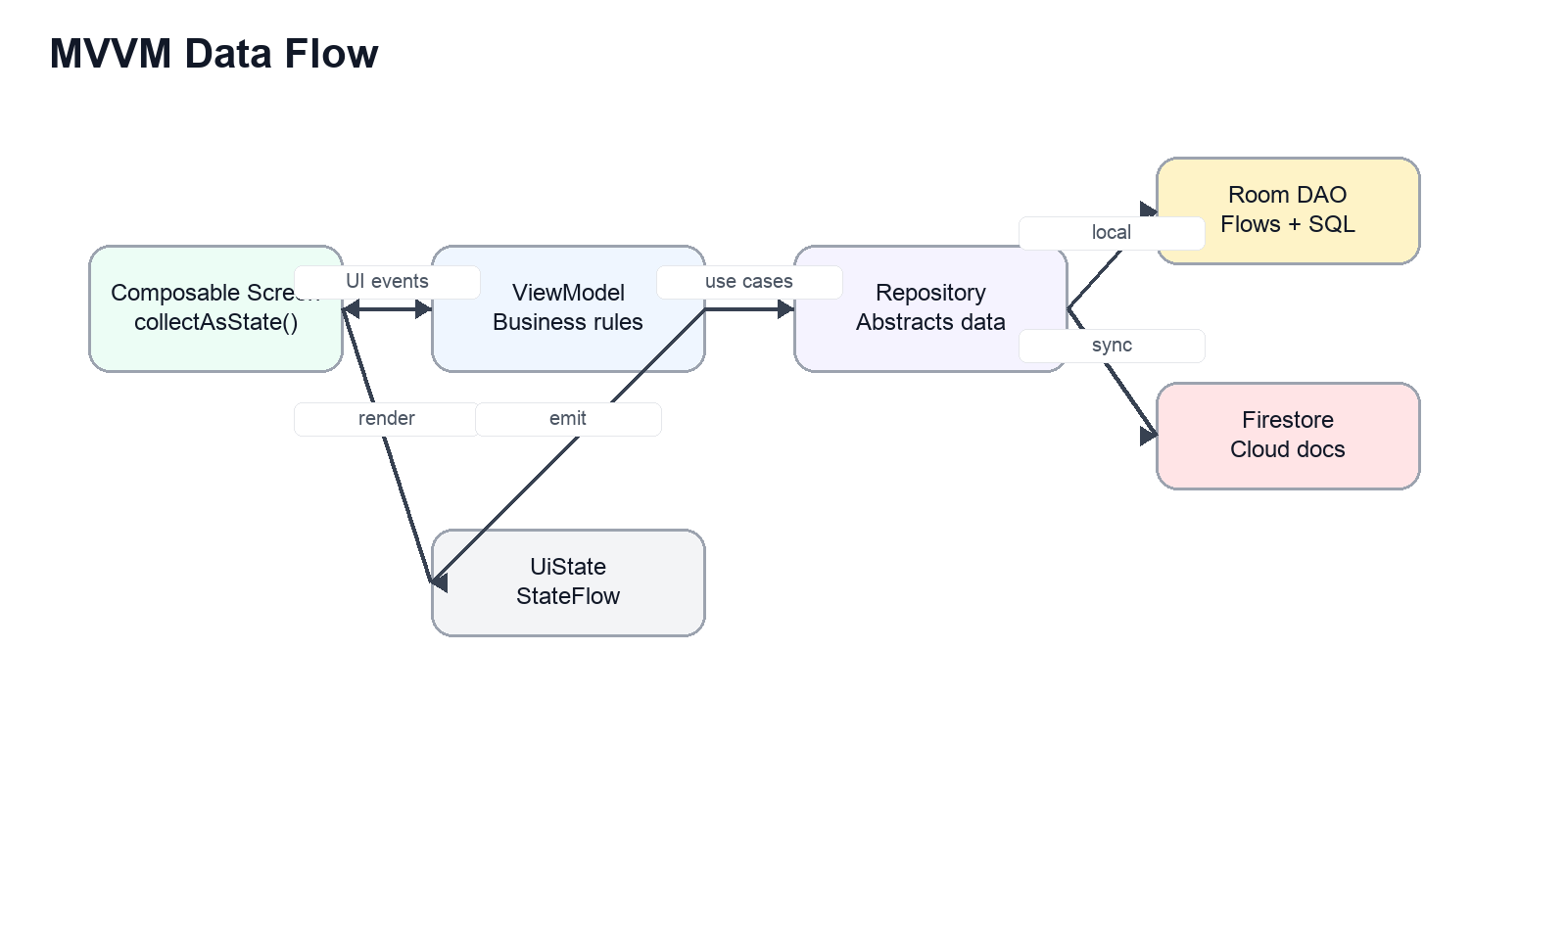
Figure 2: MVVM event and state flow.
Screen/Feature | ViewModel | Repository/Data Source
Splash/Login | FinanceViewModel | AuthRepository, UserRepository, TransactionRepository, GoalRepository
Create Account | CreateAccountViewModel | AuthRepository
Dashboard/Home | HomeViewModel | FinanceUiState prepared from transactions, goals, and profile
History/Transactions | TransactionsViewModel | FinanceTransaction state from TransactionRepository
Add Income | AddIncomeViewModel | IncomeRepository, UserRepository, CurrencyRateService, CryptoRateService
Add Expense | AddExpenseViewModel | ExpenseRepository, UserRepository, CurrencyRateService
Goals | GoalsViewModel | GoalRepository, ExpenseRepository through linked goal-saving records
Analytics | AnalyticsViewModel | Room-backed finance transaction state
Profile | ProfileViewModel | UserRepository, AuthRepository

The important architecture rule is that business calculations stay in ViewModels. For example, AnalyticsViewModel calculates category percentages and monthly overview data; HomeViewModel calculates dashboard totals; GoalsViewModel validates savings and prepares progress state.

8. Navigation Architecture
Spendly uses a single-activity architecture with Navigation Compose. Screen routes are defined in ui/navigation/Screen.kt. Bottom navigation is visible only for main tabs and hidden for splash, authentication, add/edit, and setup screens.
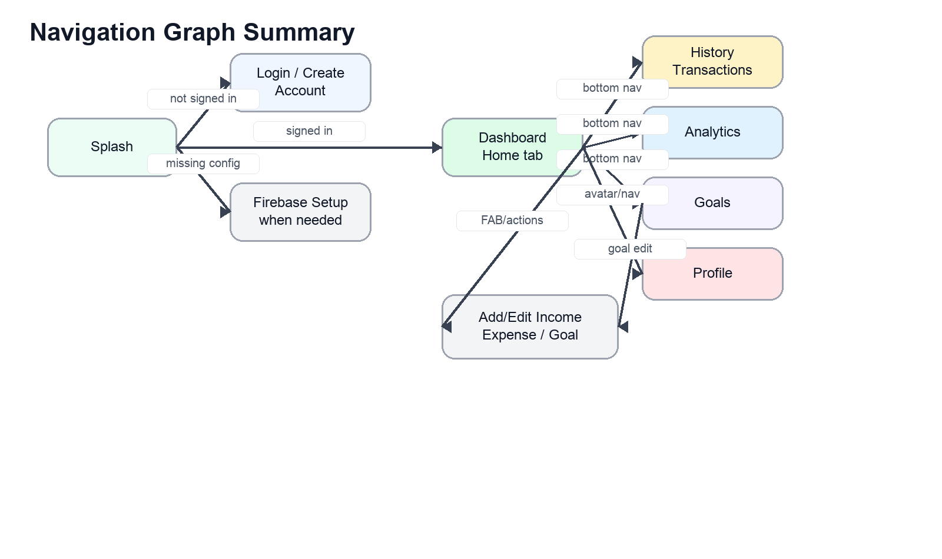
Figure 3: Navigation graph summary.
Navigation Area | Routes/Screens | Behavior
Startup | Splash, FirebaseSetup, Login/CreateAccount | Splash waits and routes based on Firebase setup/session state.
Bottom tabs | Home, History, Analytics, Goal, Profile | Persistent main app destinations. History label is shown while events route compatibility is preserved.
Action screens | Add Income, Add Expense, Add Goal, Edit Goal, Goal Details | Opened from FABs or detail flows. Bottom nav is hidden where appropriate.
Profile navigation | Dashboard avatar to Profile, bottom Home to Dashboard | Home tab maps back to Dashboard instead of staying in nested Profile navigation.

9. Firestore Schema Design
Firestore is the cloud persistence layer. User ownership is based only on Firebase Authentication uid. Collections are not manually created in the Firebase console; Firestore creates them when the app writes the first document.
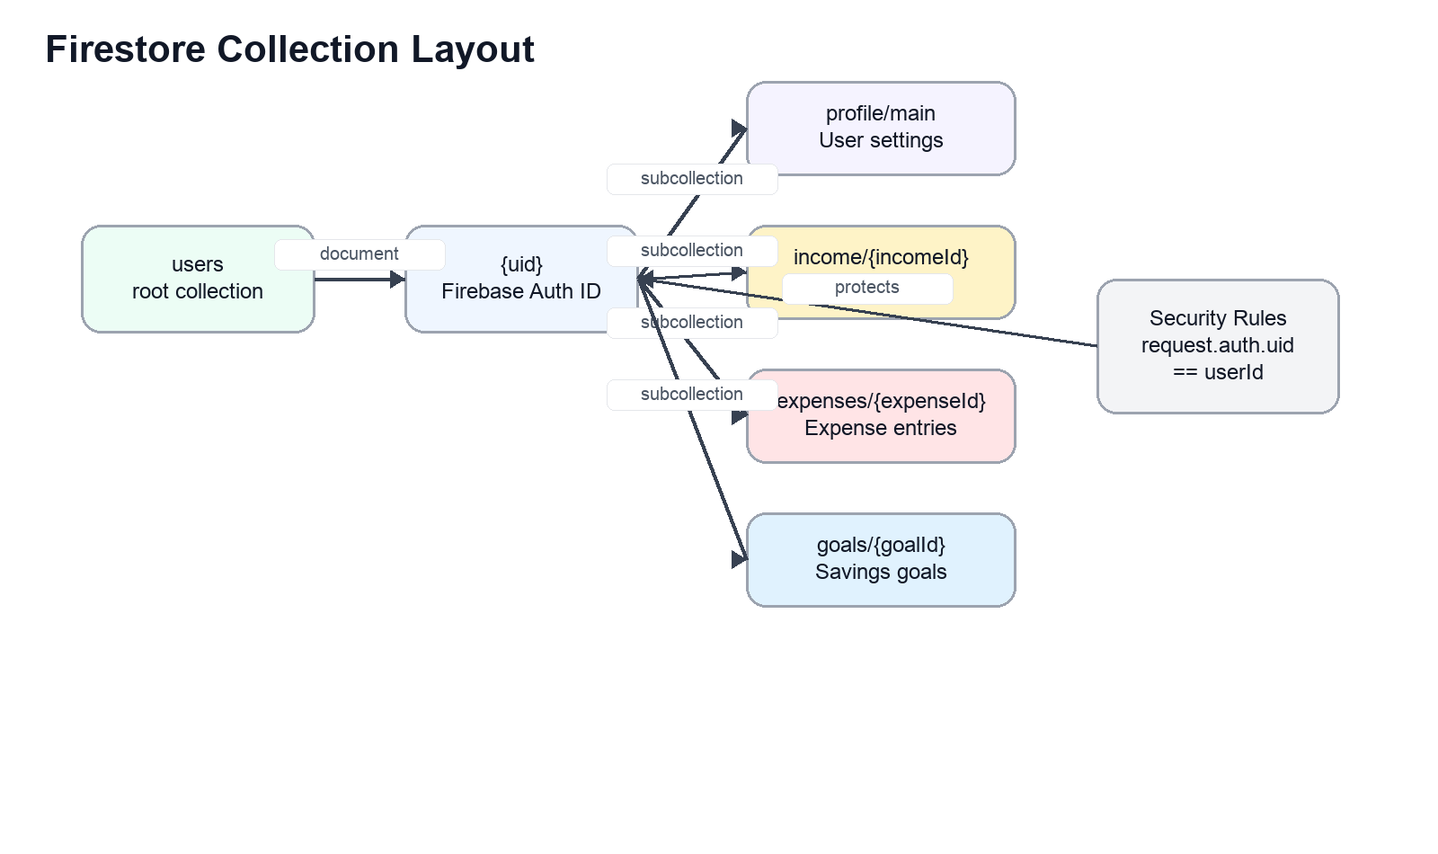
Figure 4: Firestore schema under users/{uid}.
Path | Purpose | Important Fields
users/{uid}/profile/main | Single user profile and settings document. | uid, name, email, defaultCurrency, profileImageUri, exchangeRateSettings, notificationFrequency, reminderTime, categorySettingsJson, createdAtMillis, updatedAtMillis
users/{uid}/income/{incomeId} | Income records. | id, userId, name, amountCents, source, dateMillis, note, originalAmount, originalCurrency, defaultCurrency, exchangeRate, isRecurring, cryptoCoin, cryptoAmount, cryptoRate, cryptoRateSource, cryptoRateFetchedAt, createdAtMillis, updatedAtMillis
users/{uid}/expenses/{expenseId} | Expense records. | id, userId, name, amountCents, category, dateMillis, note, originalAmount, originalCurrency, defaultCurrency, exchangeRate, paymentMethod, expenseType, goalId, createdAtMillis, updatedAtMillis
users/{uid}/goals/{goalId} | Savings goals. | id, userId, title, status, targetCents, savedCents, dueDateMillis, category, isPrimary, initialSavedCents, defaultCurrency, iconKey, createdAtMillis, updatedAtMillis

9.1 Indexing Strategy
The current implementation reads per-user collections into Room and performs most filtering in local/ViewModel state. Firestore automatic single-field indexes are enough for the current version. Composite indexes can be added later if server-side queries are introduced for date range, source/category, or status filtering.
Future Query | Recommended Composite Index | Reason
Income month by source | dateMillis descending, source ascending | Server-side filtering for large income histories.
Expenses month by category | dateMillis descending, category ascending | Server-side filtering for analytics/history.
Goals by status/primary | isPrimary ascending, status ascending, updatedAtMillis descending | Optimized goal list sections.

10. Room Database Design
Room is the local source of truth for offline-first behavior. The implemented database is SpendlyDatabase version 4. It contains four entities and four DAOs. Sync state is not stored in a separate queue table; each persisted record carries isSynced, createdAtMillis, and updatedAtMillis so repositories and WorkManager can identify pending uploads safely.
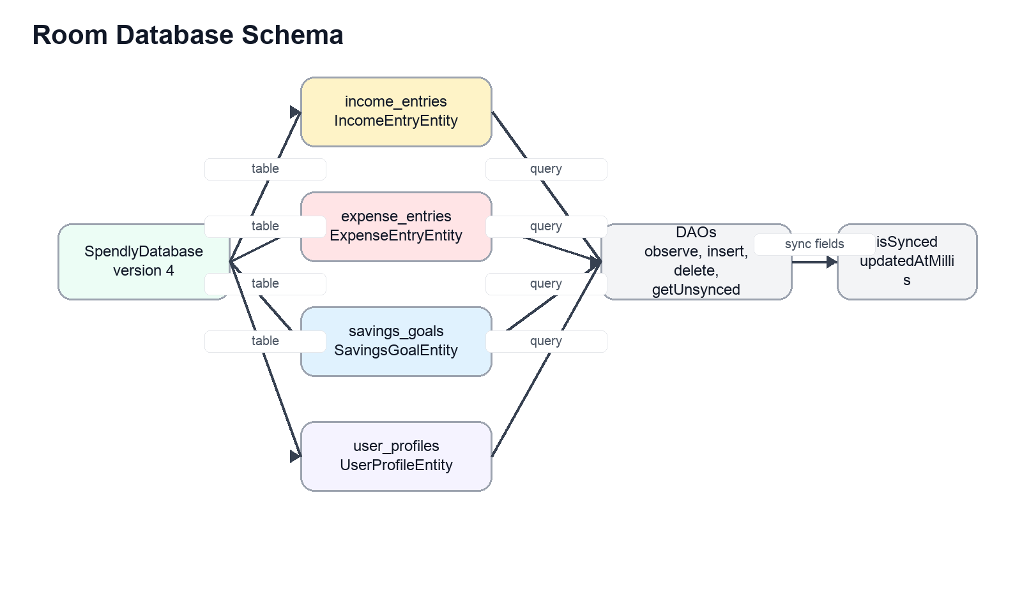
Figure 5: Room schema summary.
Entity/Table | DAO | Purpose
IncomeEntryEntity / income_entries | IncomeDao | Stores income records, original/default currency data, crypto data, recurrence, and sync fields.
ExpenseEntryEntity / expense_entries | ExpenseDao | Stores expenses, category, payment method, expense type, linked goal ID, currency data, and sync fields.
SavingsGoalEntity / savings_goals | GoalDao | Stores target, saved amount, due date, status, primary flag, initial saved amount, default currency, and iconKey.
UserProfileEntity / user_profiles | UserProfileDao | Stores uid, profile information, default currency, local profile image URI, exchange settings, category settings JSON, and sync fields.

10.1 Migrations
Migration | Changes | Reason
1 -> 2 | Adds currency fields, crypto fields, profile image/settings fields, goal initialSavedCents, and goal defaultCurrency. | Preserves existing saved data while expanding income, expense, profile, and goal capabilities.
2 -> 3 | Adds user_profiles.categorySettingsJson. | Synchronizes custom/hidden income sources and expense categories per user.
3 -> 4 | Adds savings_goals.iconKey. | Persists automatic/manual selected goal icons.

11. Repository and Synchronization Design
Repositories provide the boundary between ViewModels and data sources. The app writes to Room first, then attempts Firestore. If Firestore succeeds, the local row is marked synced. If Firestore fails, the row remains local with isSynced=false and is retried later by WorkManager.
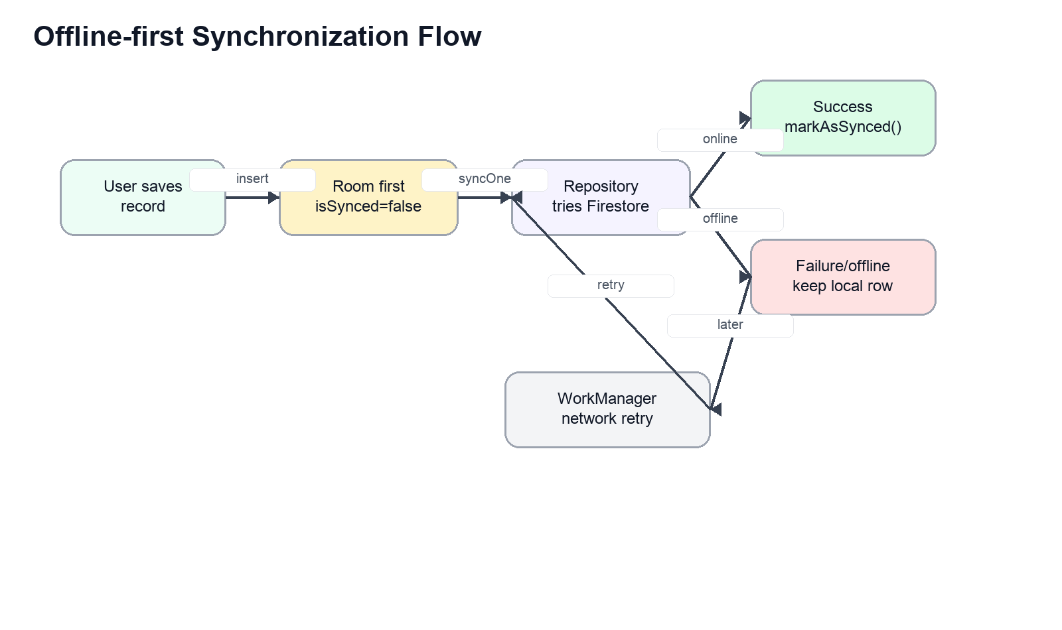
Figure 6: Offline-first synchronization flow.
Repository | Main Responsibility
AuthRepository / FirebaseAuthRepository | Firebase session, create account, sign in, password reset, password update, account delete, sign out.
UserRepository / UserRepositoryImpl | Profile observe/upsert and Firestore profile sync with newest updatedAtMillis preference.
IncomeRepository / IncomeRepositoryImpl | Income observe/add/update/delete/sync using Room and users/{uid}/income.
ExpenseRepository / ExpenseRepositoryImpl | Expense observe/add/update/delete/sync using Room and users/{uid}/expenses. Deletes linked goal-saving expense updates the goal saved amount.
GoalRepository / GoalRepositoryImpl | Goal observe/save/delete/addSavings/sync. Initial savings and add savings create linked Goal expense transactions.
TransactionRepository / FirebaseTransactionRepository | Combines income and expense streams for history/dashboard/analytics state.

The background worker is SpendlySyncWorker. SyncManager schedules periodic sync every 15 minutes and can start immediate sync after sign-in or writes. The worker requires network connectivity and syncs profile, income, expenses, and goals for the current Firebase uid.

12. Security and Authentication
Authentication is handled by Firebase Authentication. Firestore data is partitioned by the authenticated uid. The app should deploy Firestore rules that protect all nested user subcollections, not only the users/{uid} document itself.

12.1 Firestore Security Rules
rules_version = '2';

service cloud.firestore {
match /databases/{database}/documents {
match /users/{userId}/{document=**} {
allow read, write: if request.auth != null
&& request.auth.uid == userId;
}
}
}

These rules allow a signed-in user to read and write only their own profile, income, expenses, and goals. They prevent one user from accessing another user's financial data.

12.2 Password Flows
- Forgot password uses FirebaseAuth.sendPasswordResetEmail(email).
- Change password reauthenticates the current user with current password and then calls FirebaseAuth.updatePassword(newPassword).
- Logout clears Firebase session and returns the app to auth flow.

13. Feature Design Details

13.1 Dashboard and Profile
- Dashboard displays total balance, monthly income, monthly expense, monthly net savings, yearly net savings, goal component, and recent transactions.
- HomeViewModel prepares totals using dateMillis so historical entries appear in the correct month.
- Profile displays avatar/name/email, edit profile, default currency, exchange rate, change password, and logout.
- Profile image selection stores a local URI/path. Firebase Storage is a future improvement, not part of the current implementation.

13.2 Income and Expense
- Amount values are stored as cents and displayed with comma separators.
- Income supports default currency, USD/manual exchange rate, recurring toggle, and crypto income fields.
- Expense supports category, payment method, expense type, date, note, and linked goalId for goal-saving transactions.
- User category/source settings are synchronized through categorySettingsJson in the profile document.

13.3 Goals
- Goals support title, target amount, target date, status, primary flag, initial saved amount, and selected icon key.
- Automatic icon suggestion is based on goal title keywords such as car, home, travel, education, laptop, phone, wedding, emergency, savings, shopping, and business.
- The manual icon picker allows the user to override the suggested icon.
- Initial saved amount and add savings both create expense transactions with category Goal and linked goalId.
- Savings are rejected when savedCents + addedCents exceeds targetCents, showing the message: Amount exceed target value.

14. Analytics Design
Analytics is a core feature because Kavindu needs financial awareness, not only raw transaction storage. The Analytics screen is designed around the reference UI: a title row, month dropdown pill, income/expense summary tiles, spending by category card with donut chart, committed vs discretionary card, and 5-month overview chart.
Analytics Output | Calculated In | Data Used
Selected month total income | AnalyticsViewModel | Income transactions filtered by selected month/dateMillis.
Selected month total expenses | AnalyticsViewModel | Expense transactions filtered by selected month/dateMillis.
Spending by category percentages | AnalyticsViewModel | Expense category totals / selected month expense total.
Committed vs discretionary split | AnalyticsViewModel | Expense type values such as COMMITTED and DISCRETIONARY.
5-month overview | AnalyticsViewModel | Income and expense totals for five months relative to the selected month.
Income sources | AnalyticsViewModel | Income grouped by source.

The donut chart should be a Canvas-based chart in Compose, not fake fixed bars. Values must come from Room/Firestore-backed transactions. Empty states should be shown when there is no data for a selected month.

15. UI/UX and Wireframe Evidence
The UI follows Material Design 3, Spendly green/red color constants, bottom navigation, green quick-add FABs, compact month dropdowns, and low-friction financial entry forms. The following embedded images are retained from the provided design document as visual evidence. Each figure should be annotated in the final PDF submission if the instructor expects visible callouts.
No extractable wireframe images were found in the provided document.
Wireframe | Required Annotations
Dashboard | Greeting/profile access, total balance, monthly income/expense, monthly and yearly net savings, goal component, recent transactions, add FAB, bottom nav.
Add Income | Currency selector attached to amount field, source chips, date, note, recurring toggle, exchange/crypto fields when needed.
Add Expense | Amount input with currency, category icons, payment method, expense type, date, note, save action.
History | Month dropdown, income/expense filters, grouped date sections, expandable rows, edit/delete actions.
Goals | Primary goals, other goals, add goal, icon suggestion/manual picker, add savings, projections.
Analytics | Month dropdown, summary tiles, category donut/legend, committed/discretionary split, 5-month overview.

16. Testing and Verification

16.1 Build Verification
JAVA_HOME=/Library/Java/JavaVirtualMachines/jdk-17.jdk/Contents/Home sh gradlew :app:compileDebugKotlin
JAVA_HOME=/Library/Java/JavaVirtualMachines/jdk-17.jdk/Contents/Home sh gradlew :app:assembleDebug

16.2 Manual Test Scenarios
- Create account with name, email, password, confirm password, and default currency.
- Sign in on a second device/emulator and verify Firestore records sync into Room for the same uid.
- Add income with selected date and verify dashboard/history/analytics use dateMillis.
- Add expense with category, payment method, expense type, date, note, and verify history edit/delete.
- Create custom categories/sources, restart app, sign in on another device, and verify categorySettingsJson sync.
- Create, edit, delete, and mark multiple primary goals; verify initial savings and add savings create Goal expenses.
- Attempt savings above target and verify the app blocks it with Amount exceed target value.
- Open Analytics, change month, and verify totals, donut percentages, split, and 5-month overview update from live data.
- Use forgot password and change password flows; verify Firebase success/error feedback.
- Go offline, create records, reconnect, and verify WorkManager sync marks data as synced.

17. Future Improvements
- Firebase Storage for cross-device profile photos.
- Google Sign-In and biometric unlock.
- Bank statement import or open banking integration where available.
- Push notifications and recurring transaction generation.
- Budget limits and alerting per category.
- CSV/PDF export for monthly reports.
- Dedicated Firestore composite indexes for large-scale server-side analytics queries.
- Unit tests for ViewModels/repositories and UI tests for Compose user flows.
- Richer crypto portfolio analytics and cached rate history.

18. References
- Android Developers: Jetpack Compose, Navigation Compose, Room, WorkManager, Hilt, and Material Design 3 documentation.
- Firebase Documentation: Firebase Authentication, Cloud Firestore data model, Firestore security rules.
- Kotlin Documentation: Coroutines and Flow/StateFlow.
- SE3092 Assignment 01 specification.
- Spendly implemented project files in package com.spendly.financetracker.

Appendix A. Codebase Reference Map
Area | Files/Folders
Application entry | MainActivity.kt, SpendlyApplication.kt
Navigation | ui/FinanceTrackerApp.kt, ui/navigation/Screen.kt, SpendlyNavGraph.kt, SpendlyBottomNavBar.kt, BottomNavItem.kt
Screens | ui/screen/AuthScreen.kt, CreateAccountScreen.kt, SplashScreen.kt, FirebaseSetupScreen.kt, home/HomeScreen.kt, transactions/*, goals/*, analytics/AnalyticsScreen.kt, profile/ProfileScreen.kt
ViewModels | FinanceViewModel.kt, CreateAccountViewModel.kt, HomeViewModel.kt, TransactionsViewModel.kt, AddIncomeViewModel.kt, AddExpenseViewModel.kt, GoalsViewModel.kt, AnalyticsViewModel.kt, ProfileViewModel.kt
Room | data/local/db/SpendlyDatabase.kt, data/local/entity/*, data/local/dao/*
Repositories | data/repository/*, data/remote/*
Sync/services | worker/SpendlySyncWorker.kt, util/SyncManager.kt, data/service/CurrencyRateService.kt, data/service/CryptoRateService.kt
Utilities | util/Mappers.kt, ui/util/GoalIconUtils.kt, ui/util/CategorySettings.kt, ui/util/MonthOptions.kt, ui/util/UiUtils.kt

