Impacts of Artificial Intelligence

Chamika Munithunga

Sa23091184



|  |  |  |  |  |  |  |  |  |  |  |  |
| --- | --- | --- | --- | --- | --- | --- | --- | --- | --- | --- | --- |
| Student Details (Student should fill the content) | | | | | | | | | | | |
| Name | | | H.D.C.S.Munithunga | | | | | | | | |
| Student ID | | | SA23091184 | | | | | | | | |
| Scheduled course details | | | | | | | | | | | |
| Course code | | IT1212 | | | | | | | | | |
| Course title | | Probability and Statistics | | | | | | | | | |
| Assignment Details | | | | | | | | | | | |
| Nature of the Assessment | | | | | Assignment – Individual Report | | | | | | |
| Topic of the Case Study | | | | | GIVEN | | | | | | |
| Learning Outcomes covered | | | | | YES | | | | | | |
|  | | | | |  | | | | | | |
| Word count | | | | | 3000 words | | | | | | |
| Due date / Time | | | | | 22th May 2024 | | | | | | |
| Declaration | | | | | | | | | | | |
| I certify that the attached material is my original work. No other person’s work or ideas have been used without acknowledgement. Except where I have clearly stated that I have used some of this material elsewhere, I have not presented it for examination / assessment in any other course or unit at this or any other institution | | | | | | | | | | | |
| Signature. | |  | | | | Date | | 19-05-2024 | | | |
| Result (Assessor use only) | | | | | | | | | | | |
| Marks for the Report |  | | Marks for viva | | | |  | | | | Final Mark |
| For Assessor use: Assessment feedback | | | | | | | | | | | |
| Strengths  Area for improvements | | | | | | | | | | | |
| Name & Signature of the Assessor: | | | |  | | | | | Date: |  | |

Abstract

Artificial Intelligence (AI) stands as one of the most transformative technological advancements of the modern era, promising to reshape industries, revolutionize workflows, and redefine societal norms. The report includes the social impact on AI and how it navigates through the diverse array of AI applications across various domains The report begins with the literature review which covers the researches done on AI technology.to analyze information a survey is used. This information is used to focus on monitoring the individuals has positive and negative impacts of AI and their experience.

Declaration

I, Chamika Munithunga hereby declare that the research project titled “exploring the impacts of AI on society “is accurate to the best of my knowledge. This is done independently with the guidelines given by the institution. The information collected using a survey is intended only for research purposes, and every effort has been made to ensure the confidentiality of the responses.

Acknowledgements

I like to include my gratitude to Mr. Chamith Jayasinghe, my advisor, for his support and guidance throughout this research.

I am also thankful to all those who assisted in gathering information and helping in the survey on the impacts of the pandemic.

In conclusion I appreciate the given help and participation

Table of Contents

**Abstract**.............................................................................................................................................................. ….2

**Declaration ................................................................................................................................................... 2**

**Acknowledgement** ...............................................................................................................................................2

**List of Figures** ..................................................................................................................................................... 4

**List of Tables** ....................................................................................................................................................... 5

**List of Abbreviation** ........................................................................................................................................... 6

**1. Chapter 1 – Introduction** ............................................................................................................................. 7

1.1. Background …..............................................................................................................………………………………...8

1.2. Problem Identification .................................................................................................................................. 9

1.3. Significance of Research ...............................................................................................................................10

1.4. Objectives of the Study ................................................................................................................................11

1.5. Chapter Framework .................................................................................................................................... 12

**2. Chapter 2 – Literature Review** .................................................................................................................13

**3. Chapter 3 – Theory and Methodology** ................................................................................................... 14

3.1. Research Design .......................................................................................................................................... 14

3.2. Data Collection Method ................................................................................................................................15

3.3. Structure of the Questionnaire.....................................................................................................................16

3.4. Preliminary Data Analysis ............................................................................................................................. 17

3.4.1. Descriptive Analysis ................................................................................................................................... 17

3.4.2. Analyzing Demographic Data .................................................................................................................... 18

**4. Chapter 4 – Results** ...................................................................................................................................... 19

4.1. Descriptive Data Analysis .............................................................................................................................. 19

**5. Chapter 5 – Discussion and Conclusion** ...................................................................................................31

**References** ....................................................................................................................................................... 32

List of Figures

Figure 4.1-1 Composition of age ……………………………………………………………………………...14

Figure 4.1-2 Composition of gender ……………………….………………………………………………...17

Figure 4.1-3 Composition of knowledge on AI ……………………………………………………………...18

Figure 4.1-4 Composition of usage of AI …………………………………………………………………....19

Figure 4.1-5 Composition of familiarity with the technology …………………………………………...20

Figure 4.1-6Composition of the area people encounter AI in life……………………………………....23

Figure 4.1-7 Composition of positive impact………………………………………………...................24

Figure 4.1-8 Composition of how confident on restriction and risks………………………………...25

Figure 4.1-9 Composition of effectiveness ………………………………………………………………...26

Figure 4.1-10 Composition of how satisfied with AI tools……………………………………………...27

Figure 4.1-11 rstudio code for Composition of age ……………………………………………………...14

Figure 4.1-12 rstudio code for Composition of gender …………………………………………….…...17

Figure 4.1-13 rstudio code for Composition of knowledge on AI ……………………………………...18

Figure 4.1-14 rstudio code for Composition of usage of AI ……………………………………………...19

Figure 4.1-15 rstudio code for Composition of familiarity with the technology ……………….…...20

Figure 4.1-16 rstudio code for Composition of the area people encounter AI in life ……………...23

Figure 4.1-17 rstudio code for Composition of positive impact ………………………………………...24

Figure 4.1-18 rstudio code for Composition of how confident on restriction and risks …………...25

Figure 4.1-19 rstudio code for effectiveness ……………………………………………….....................26

Figure 4.1-20 rstudio code for how satisfied with AI tools ………………………………………………...27

Figure 4.1-21 rstudio code for mean…………………………………………………………………………....16

Figure 4.1-22 rstudio code for frequency……………………………………………….………………………16

Figure 4.1-23 rstudio code for chi squared……………………………………………….…………………….21

Figure 4.1-24 rstudio code for chi squared……………………………………………………………………...21

List of tables

Table 1 ……………………………………………………………………………...15

Table 2 ……………………………………………………………………………...15

Table 3……………………………………………………………………………...15

List of Abbreviation

1. SD -Standard Deviation

2. Max - Maximum

3. Min - Minimum

4. f- frequency

5.𝑥𝑖: individual values

6.𝑓xi​-mean.

7.𝑋′- mean

8.𝑐𝑓- cumulative frequency

9.(𝑥𝑖−𝑋′)2- mean.

10.𝑓(𝑥𝑖−𝑋′)2-standard deviation.

**1.Chapter 1-Introduction**

**1.1. Background**

Nowadays Artificial Intelligence is widely used through industry.AI deals with creating systems that are capable of performing tasks that require human intelligence. These tasks can include problem-solving, learning, understanding, and making decisions. Artificial intelligence was founded as an academic study in 1956. AI has applications in various fields like healthcare, finance, education, transportation, and entertainment. Some examples for AI are virtual assistants, Maps and Navigation, Chatbots. In order to make use of Artificial Intelligence software applications are developed. Some examples for the AI tools are ChatGPT, Gemini

AI has potential benefits and potential risks. The most immediate benefit of AI is that it is time saving. It can unlock new scientific discoveries and opportunities, and help tackle humanity’s greatest challenges in today and in the future. When it comes to benefits the healthcare system can be improved and it is also efficient.

Also, AI has revolutionized many aspects of society, but it also raises ethical and societal concerns, such as job, an impact on privacy and security. [AI-powered job automation](https://builtin.com/artificial-intelligence/ai-replacing-jobs-creating-jobs) is a pressing concern as the technology is adopted in industries like [marketing](https://builtin.com/artificial-intelligence/ai-in-marketing-advertising), [manufacturing](https://builtin.com/artificial-intelligence/ai-manufacturing-robots-automation) and [healthcare](https://builtin.com/artificial-intelligence/artificial-intelligence-healthcare).

As [AI robots](https://builtin.com/artificial-intelligence/robotics-ai-companies) become more smarter, the tasks will require fewer humans and many employees won’t have the skills needed for these technical roles

AI technology could result in the reduce in human influence and human functioning in some parts of society

Therefore, this report is to collect information about how people are influenced and their experience on AI and positive and negative impact of this. As we begin our statistical investigation; the results will clarify individual ideas on this topic on Artificial Intelligence

**1.2. Problem Identification**

Alongside its potential benefits, AI also presents a lot of risks and challenges that must be carefully considered.

As AI technologies become increasingly entering our daily lives, it is very much important to recognize the potential risks they have. These risks encompass a range of concerns, including ethical, social, economic, and technical dimensions.

The release of ChatGPT-3 in 2022 marked a significant access to the technology. As people were impressed by its capabilities it introduced the Version 4 in 2023 which took everyone’s attention. Likewise with the improvements of the AI tools the society started to use for efficient tasks

The purpose of this problem identification section is to bring attention to the problems and clarify on the areas that need careful consideration and research about Artificial Intelligence

Here are some common problems associated with AI,

1. Privacy Concerns as personal information can be misused
2. Job displacements with the development of the technology
3. Security Risks as they are vulnerable for attacks
4. Reduce human capabilities and creativity
5. AI systems become independent and capable of making decisions without human intervention

**1.3. Significance of Research**

Research on the impacts of AI include a wide range of information examining how AI influence various aspects of society, economy, and technology

* This highlights the impact of AI on jobs and how AI automation affects different industries and occupations
* Studies show how the impact on AI will benefit on health care like medical diagnosis, drug discovery
* Shows the use of AI for education and learning and its impact
* Highlight the security and privacy effect of AI

**1.4. Objectives of the Study**

As AI continues to a diverse sector, understanding its implications becomes increasingly hard for the general public. The Objective of this research is to find out and explore various impacts of AI

### Promote synergy between humans and AI- complement each other's capabilities instead of relying on one source of information.

1. To Investigate Technological Advances- developments in machine learning, computer vision, robotics, and autonomous systems.
2. To Analyze Labor Market change - Understand how AI automation affects and the potential for job creation in related fields.

1.5. chapter framework

**Chapter 01: background-** the background of Artificial Intelligence

Chapter 02: Literature review - Analysis of previous studies, findings and explore the impacts from Artificial Intelligence

**Chapter 03: Theory& Methodology -**outline the research designand a survey is used as a source of data collection

**Chapter 04: results -** analyses the data used from the survey providing various impacts and how individuals use AI in day to day lives

**Chapter 05:** **Discussion and Conclusion –** the information and data in chapter 4 are clarified in this chapter and summaries the key information

2.Chapter2: Literature Review

The use of AI has significantly impacted the society worldwide, this literature review on the impact of Artificial Intelligence covers a spectrum of research across various disciplines. Understanding the multifaced aspects of this global crisis make necessary an examination of existing researches

This chapter aims to provide an idea about existing researches on the impact of AI across various domains, exploring its implications for economy, Societal, education

Economy impacts of artificial intelligence have gained a significant attention lately. The research by Jim Probasco (2023) shows that AI can displace and create new jobs. Also shows that the economy will be increasing the level of productivity through direct efficiency gains. In the study done by [Kristalina Georgieva](https://www.imf.org/en/Blogs/authors?author=Kristalina%20Georgieva)(2014) shows that the labor market will decrease as AI applications may execute tasks that are performed by humans.

The rise of AI has brought with it a wave of automation that changing the workforce, healthcare approaches, the way we interact with technology, making a potential impact in the society is shown in the research done by Amarjit Sen (2023). It shows that the healthcare is one of the significant developments with AI. With ai-driven machines the cost can be reduced and improved outcomes. This also highlight that the automation is replacing human workers, with AI-powered machines taking over work and low-skilled jobs. positive impact is that this can improve efficiency and reduce costs, it also raises risks about the displacement of jobs. Intelligent assistants play a major role in changing the way we use devices as they can understand natural language and respond to voice commands.

AI has the potential to disrupt education significantly, challenging and reshaping traditional pattern. The research done by eschool news (2024) highlights both positive and negative impacts of using AI in education. AI-driven educational tools can prepare students for the future workforce and provide a diverse of learning styles. For negative impacts the research shows that there’s a critical risk on thinking and creativity, raising concerns about the security of children’s information and each and every student is not access to AI- driven tools

**3.Chapter 3: Theory& Methodology**

3.1 Research Design

This study uses a survey to learn more about impact of Artificial intelligence. A detailed questionnaire is created in order to find out the challenges faced by the individuals on use of AI in order to gather and analyze information. My survey aims to collect information from people who are familiar with AI- driven tools across different demographic backgrounds.

By this research design I can investigate the impacts of AI using statistical representations

3.2. Data Collection Method

For this research about AI, I used a survey a google survey to collect information which includes questions on the impacts the artificial intelligence how it benefits to the society. Through this online questionnaire I aim to understand how individuals interact with AI, their feedbacks and the statistical diagrams helps in analyzing data.

3.3 Structure of the Questionnaire

A questionnaire was made to collect information from individual ideas titled “the impacts of Artificial Intelligence”.

Following are the 13 questions used;

1. What is your age?
2. what is your gender
3. what is your knowledge on artificial intelligence (AI) technologies?
4. how often do you use artificial intelligence (AI) technologies?
5. Are you familiar with the concept of artificial intelligence
6. In which areas of your life do you encounter AI technologies the most?
7. Has AI positively impacted your life or your endeavors?
8. Have you ever experienced any negative consequences or challenges related to AI? If so, describe
9. How confident are you in the ability of regulations and policies to address the potential risks associated with AI technologies?
10. Do you feel that AI is more effective?
11. How satisfied are you with the AI-based tools currently available?
12. What concerns do you have about the use of AI?
13. How do you think AI will continue to evolve and impact society in the next 5-10 years?

**3.4 Preliminary Data Analysis**

3.4.1. Descriptive Analysis

In the survey there were 30 responses in different age groups. This descriptive analysis includes the summary and the analysis of the data. Measurements like variation, standard deviation, mean, mode, median and statistical representations like box plot, scatterplots, histograms and pie charts are used.

The most responders are of in the age of 18-24 of 78.6% of total responses and out of the response 53.9% are males and the rest are females. Age ranges from 25-39 is showing moderate interest contributing 14.3% and ages from 40-55 shows a less interest with 7.1% of total responses. Theres no responses for both under 18 and above 55. The highest response rate from the 18 to 24 age group suggests a wide area of individuals who use Artificial Intelligence in day to day.

50% of responders are very familiar with the knowledge of AI. 42.9% responders are moderately familiar and 7.1% is extremely familiar about this. It seems like there’s no one that doesn’t know about Artificial Intelligence

3.4.2. Analyzing Demographic Data

Analyzing demographic data involves using artificial intelligence to examine and interpret information. This can include information from such as age, gender, level of knowledge, ethnicity among 30 responders. Analyzing demographic data is helping to understand the preferences and requirements of individuals, which will help on targeted strategi

Chapter 4: Results

4.1 Descriptive data analysis

The following section presents a comprehensive overview of the results obtained from the analysis conducted on the dataset. Through a combination of summary statistics and graphical representations, this report aims to provide insight into the key characteristics and trends observed within the data. From measures of central tendency to visual representations of distribution patterns, the following analysis endeavors to offer a clear and detailed understanding of the dataset under examination

* Composition of age

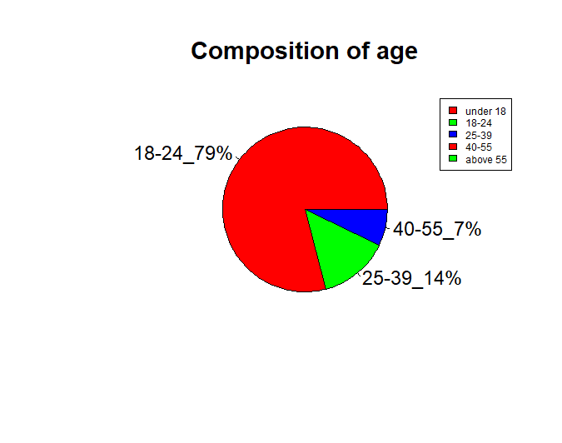

Figure 4.1-1

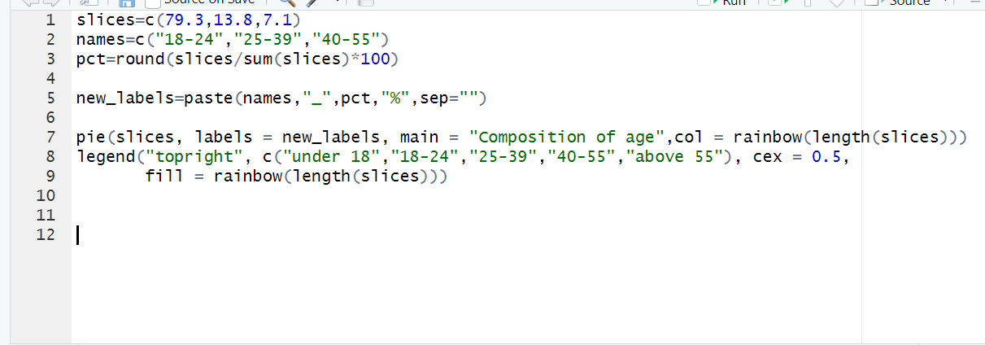

Figure 4.1-11

The most responders are of in the age of 18-24 of 78.6% of total responses and out of the response 53.9% are males and the rest are females. Age ranges from 25-39 is showing moderate interest contributing 14.3% and ages from 40-55 shows a less interest with 7.1% of total responses. Theres no responses for both under 18 and above 55. The highest response rate from the 18 to 24 age group suggests a wide area of individuals who use Artificial Intelligence in day-to-day lives

|  |  |  |
| --- | --- | --- |
| Age groups | count | percentage |
| under 18 | 0 | 0 |
| 18-24 | 23 | 78.6 |
| 25-39 | 4 | 14.3 |
| 40-55 | 2 | 7.1 |
| 55+ | 0 | 0 |

Table 1

|  |  |
| --- | --- |
| Mean | 5.8 |
| Median | 2 |
| Max | 0 |
| Min | 23 |
| SD | 9.75 |

Table 2

|  |  |  |  |  |  |  |  |
| --- | --- | --- | --- | --- | --- | --- | --- |
| Age limit | f | xi | fxi | X’ | cf | (xi-x’)2 | f(xi-x’)2 |
| 18-24 | 78.6 | 21.0 | 1650.6 | 24.5 | 78.6 | 11.9 | 937.9 |
| 25-39 | 4.3 | 32.0 | 457.6 | 24.5 | 92.9 | 56.9 | 814.2 |
| 40-55 | 7.1 | 48 | 337.3 | 24.5 | 100.0 | 531.0 | 3770.8 |

Table 3

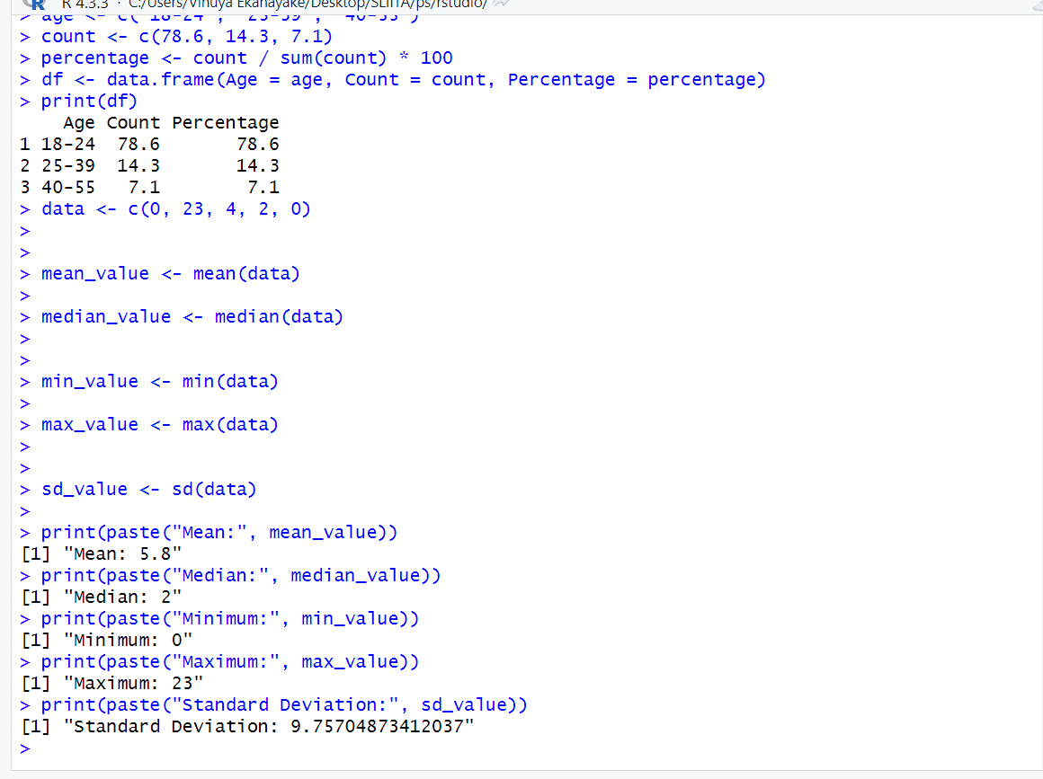

Figure 4.1-21

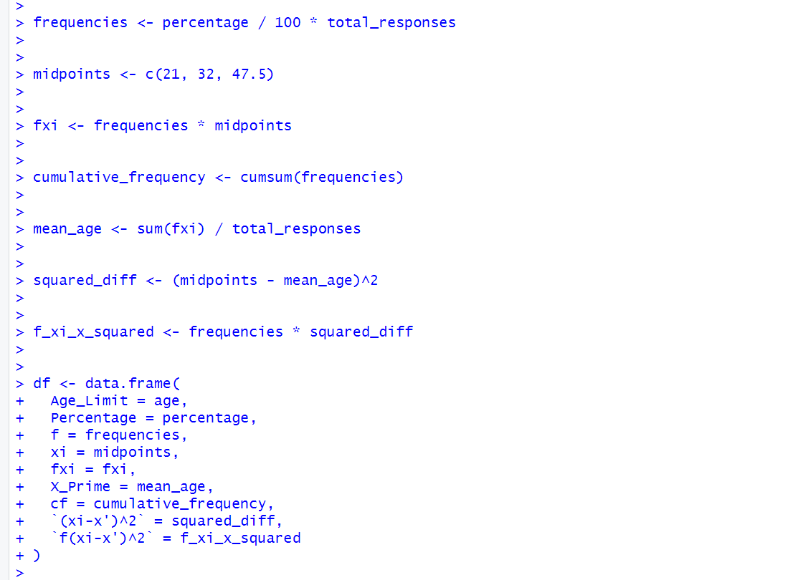

Figure 4.1-22

* Composition of gender

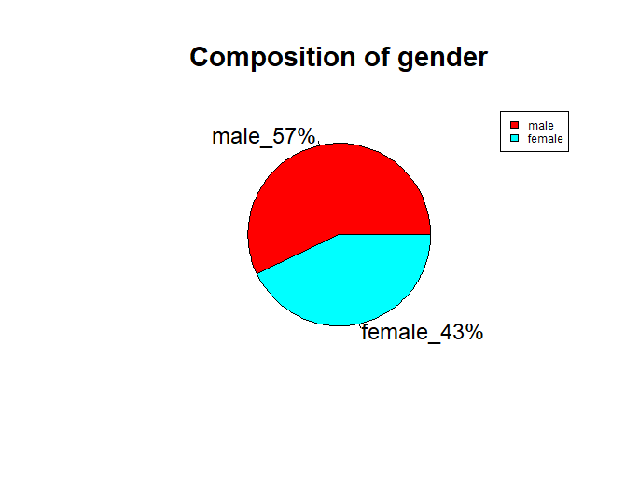

Figure 4.1-2

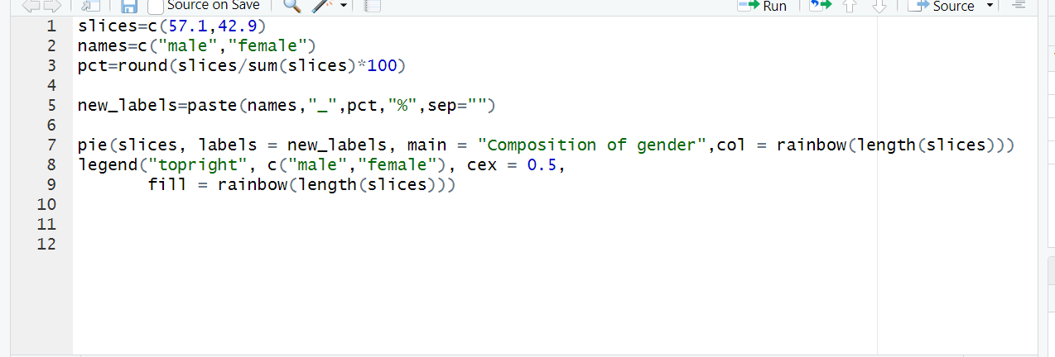

Figure 4.1-12

The above pie chart shows the composition of gender. There are 57.1% of males out of all the responses and 42.9% are females

* Composition of knowledge on AI

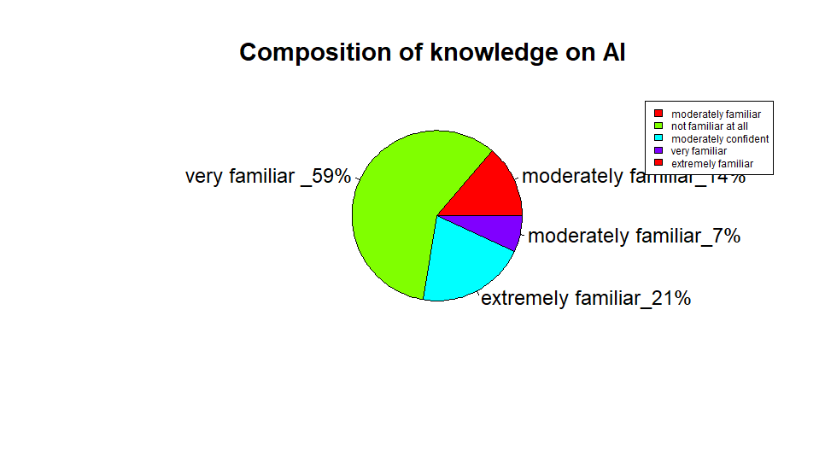

Figure 4.1-3

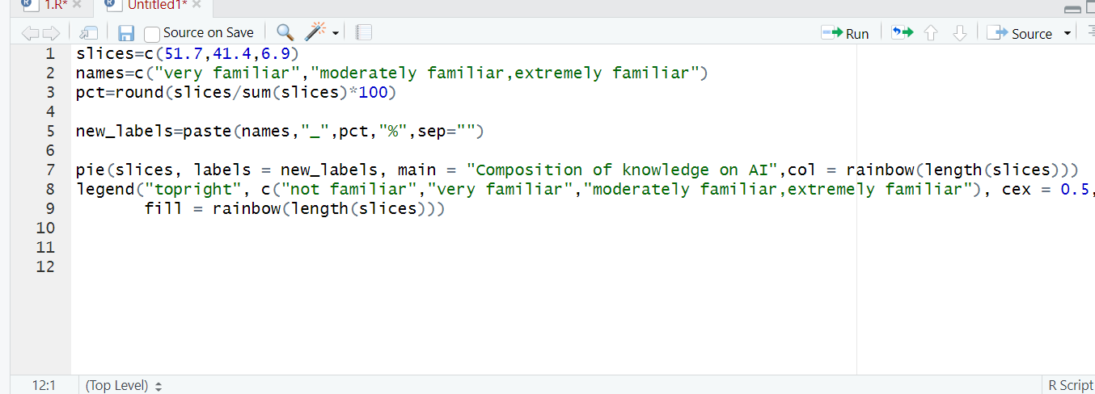

Figure 4.1-13

6.9% is extremely familiar with the AI technology.51.7% have a very familiar knowledge on artificial intelligence and 41.4% is moderately familiar about AI. There’s no one that doesn’t know about the technology.

* Composition of usage of AI

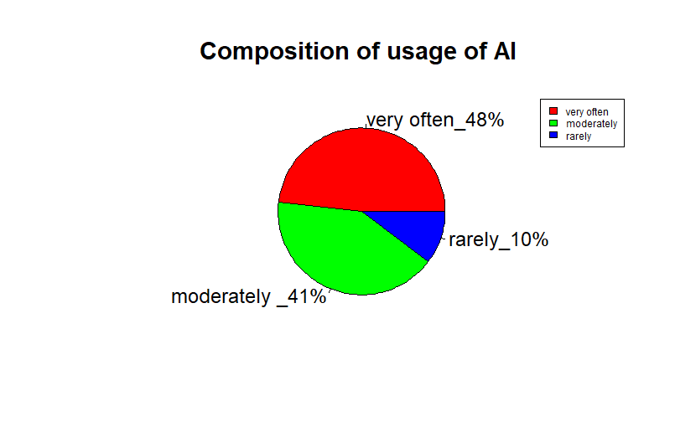

Figure 4.1-4

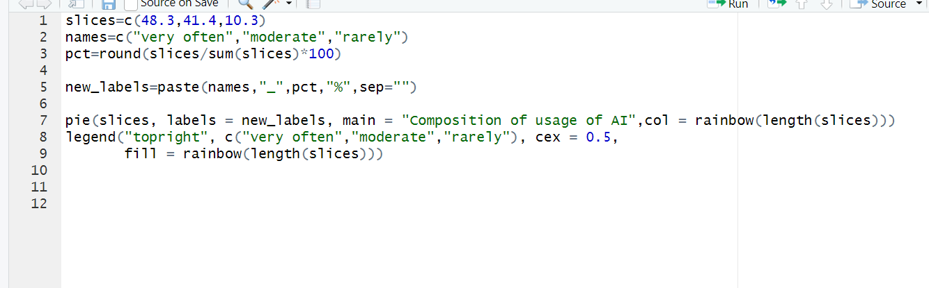

Figure 4.1-14

Nowadays people are used to use AI very often which can be seen by the above image because 48.3% of the society use very often. 41.4% use moderately and 10.3% rarely use Artificial Intelligence.

* Composition of familiarity with the technology

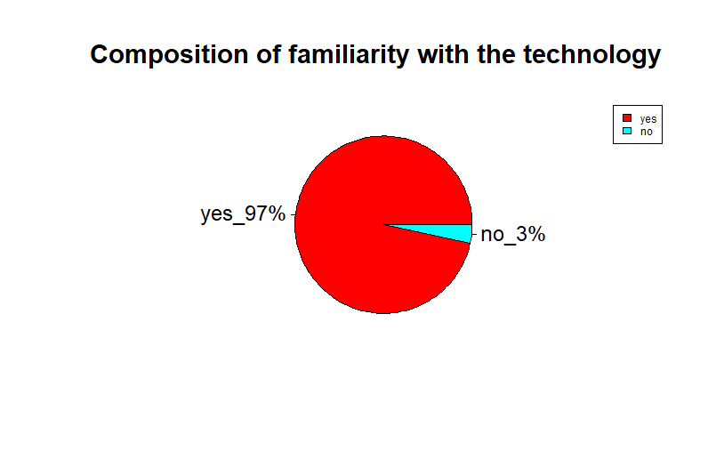

Figure 4.1-5

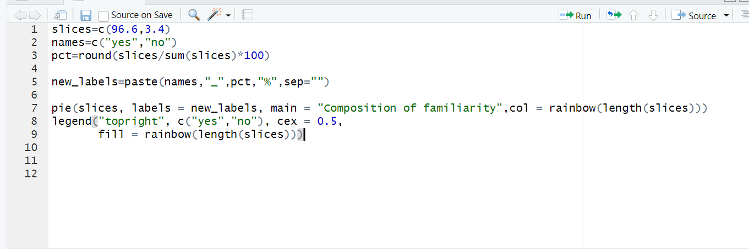

Figure 4.1-15

96.6% are familiar with the concept of artificial intelligence and the rest have no idea. therefore, the majority of people are familiar with this concept.

Chi-Squared Testing

This is my Chi-Squared Testing for how people are familiar with the concept of artificial intelligence.

H0: there is no connection between the gender and the familiarity of the concept of artificial

intelligence.

H1: there is a connection between the gender and the familiarity of the concept of artificial

Intelligence

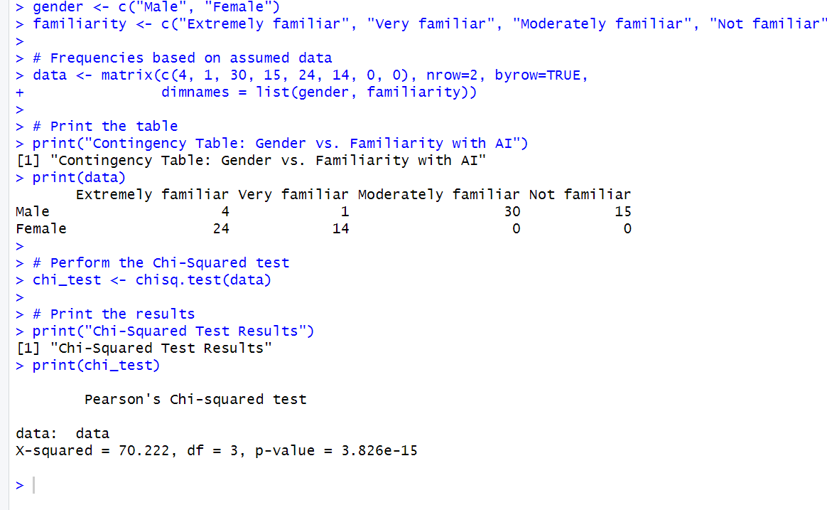

Figure 4.1-23

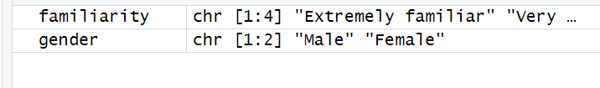

Figure 4.1-24

Significance_∝ = 0.05

Degree_of_freedom = (R-1) (C-1)

=3

Critical Value = 2.3534

Critical Value (2.3534) > Chi-Squared value (70.222)

So, we do not reject the Null hypothesis h0. Therefore, the association between how people familiarity and gender suggest that the observed data is not supporting the null hypothesis, so it rejects the null hypothesis.

* Composition of the area people encounter AI in life

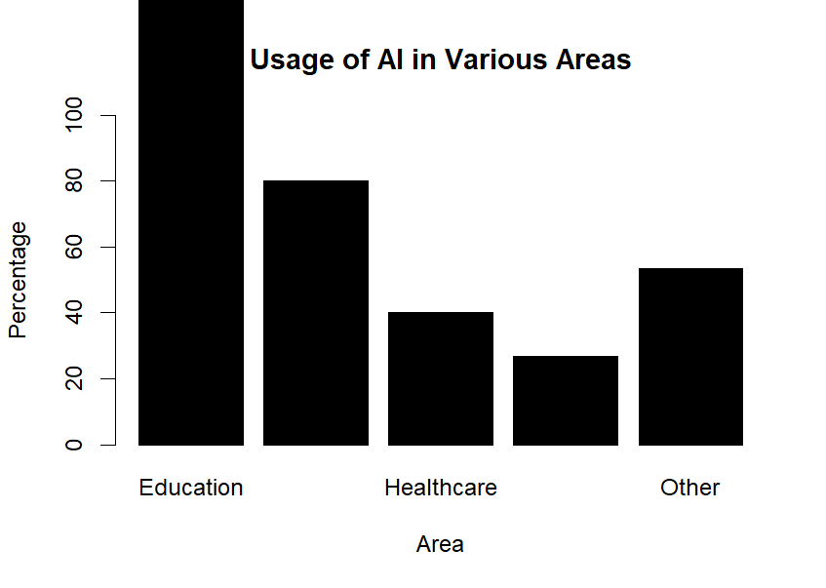

Figure 4.1-6

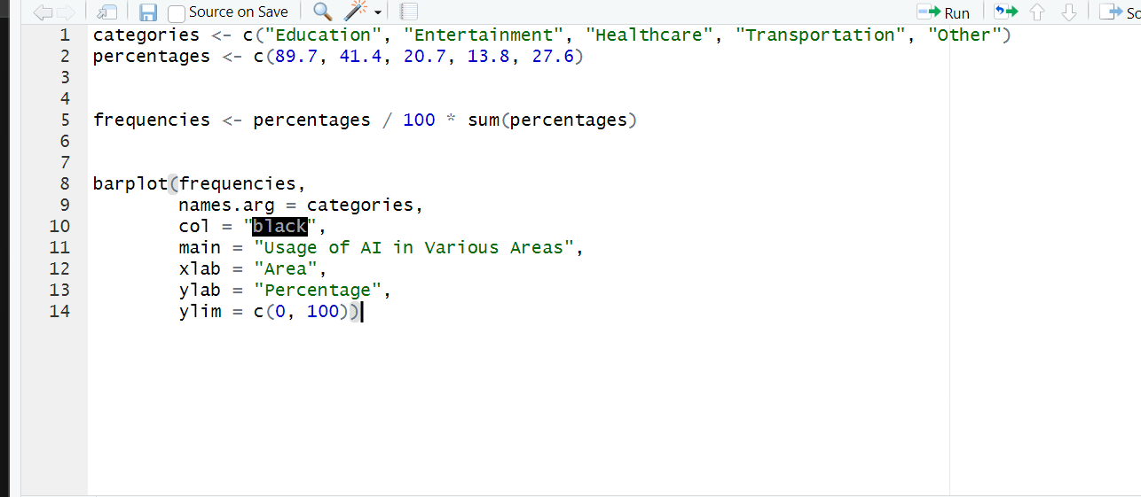

Figure 4.1-6

Mostly people use AI for education purposes which is 89.7%. 41.4% use AI for entertainment, 20.7% use for healthcare purposes and 13.8% use for transportation. 27.6% have responded that they use AI for other areas in life.

* Composition of positive impact

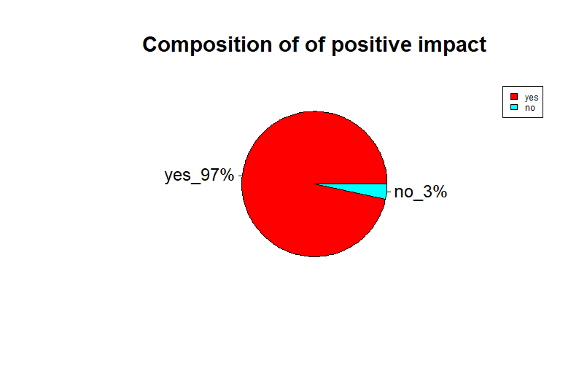

Figure 4.1-7

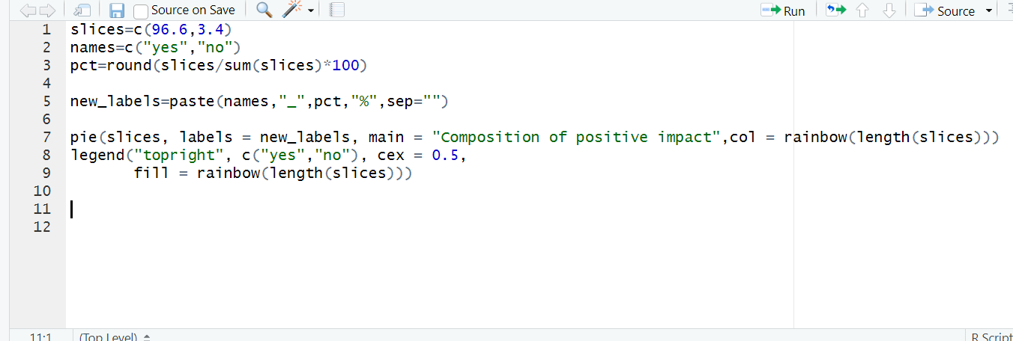

Figure 4.1-1

For 96.6% of the responders AI have positively impacted their lives. For the rest of the responders, AI hasn’t positively impacted

* Composition of how confident on restriction and risks

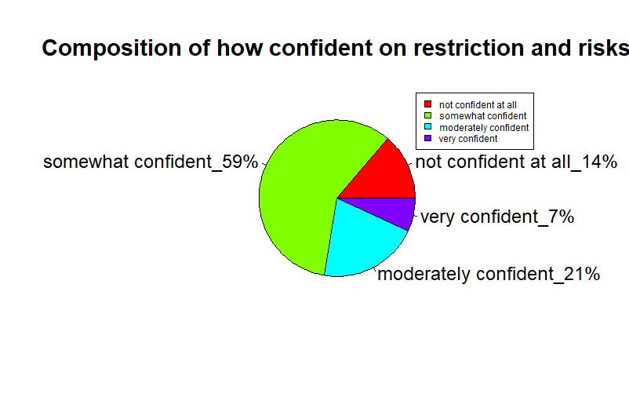

Figure 4.1-8

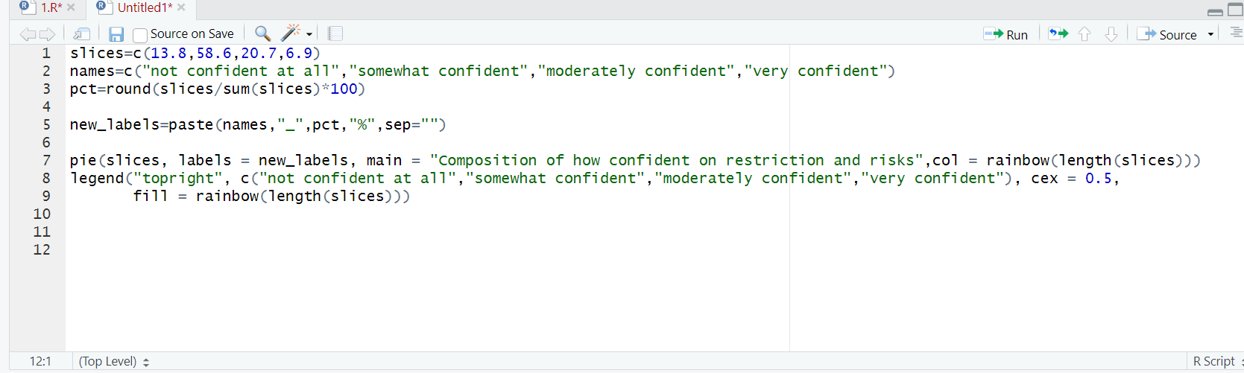

Figure 4.1-18

The above pie chart shows that most people are somewhat confident about the regulations and policies on AI, 58.6% of the responders show that. 20.7% are moderately confident and 6.9% are very confident. This shows that 13.8% of the responders are not confident at all

* Composition of effectiveness

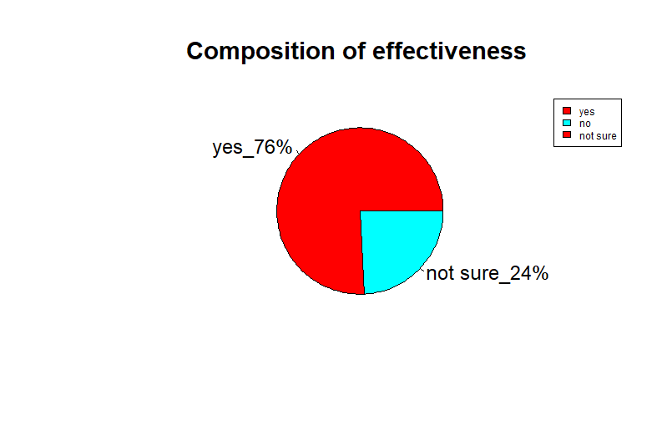

Figure 4.1-9

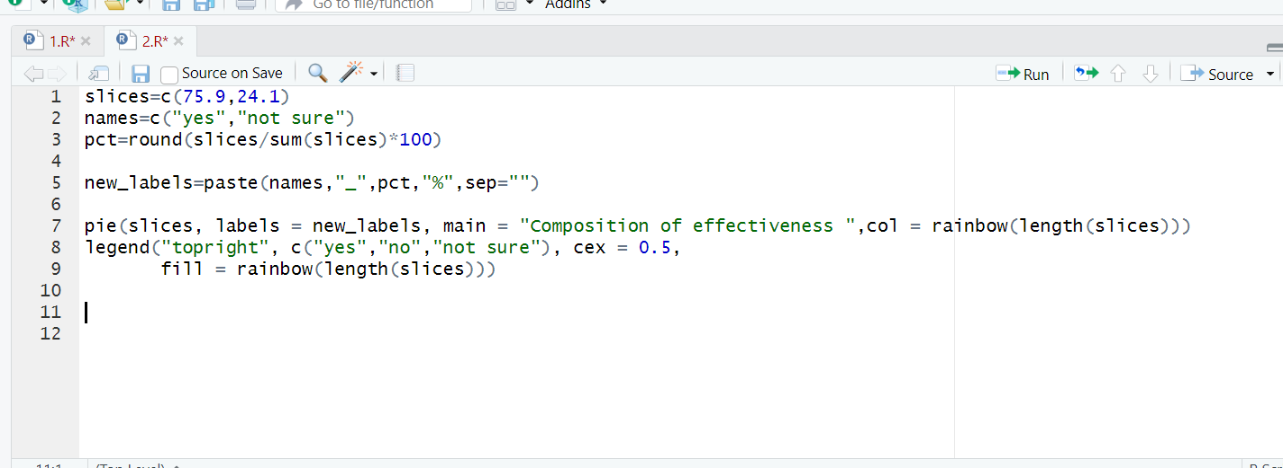

Figure 4.1-19

The above pie chart shows that 75.9% the responders shows that they feel that AI is more effected and the rest shows that they feel it’s not sure. There’s no one that felt it is not effective.

* Composition of how satisfied with AI tools

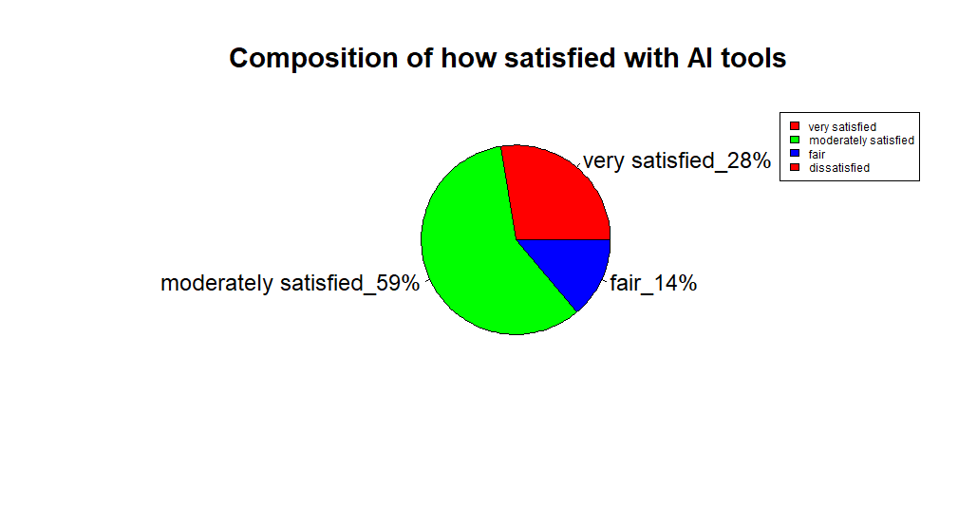

Figure 4.1-10

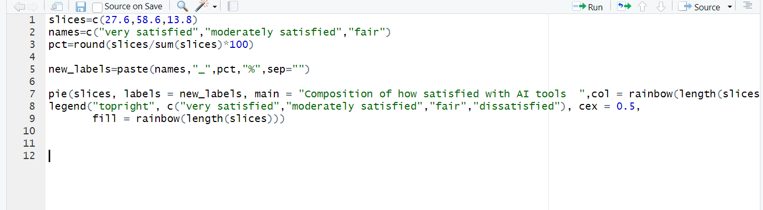

Figure 4.1-20

The above pie chart shows 58.6% of the people are moderately familiar about the AI based tools that are currently available. Nowadays people mostly use tools like ChatGPT and other tools to make work more efficient. 27.6% of the responders are very satisfied about the tools and 13.8% are fairly satisfied. Theres no one who’s dissatisfied with the AI based tools.

Chapter_5_Discussion_&_Conclusion

In conclusion, this report shows the multifaceted impacts of artificial intelligence across the society. Firstly, AI has demonstrated immense potential to revolutionize industries such as healthcare, finance, and transportation, leading to increased efficiency, productivity, and innovation. However, these advancements also bring challenges, including concerns about job displacement, data privacy.

Secondly, the ethical and social implications of AI cannot be overlooked. Issues like justice, accountability, and transparency must be carefully seen to ensure that AI technologies are developed in a way that can adjust with societal values and principles.

Next it shows that it is important that stakeholders collaborate to use the benefits of AI while mitigating its risks. Policymakers must approve law to protect individuals' rights and promote responsible AI development. Businesses should prioritize ethical considerations in their AI strategies. Educators must prepare the workforce for the AI-driven education systems in the future, emphasizing the importance of continuous learning and adaptability.

Moreover, the future of AI holds both promise and uncertainty. As technology continues to evolve, it is essential that we approach AI with a sense of cautious optimism, recognizing its potential to shape our world for the better while remaining vigilant against its unintended consequences.

In conclusion, by working together to navigate the complex landscape of AI, we can ensure that this transformative technology benefits humanity as a whole.

References

<https://ilaglobalnetwork.org/rise-of-the-machines/?gad_source=1&gclid=CjwKCAjwz42xBhB9EiwA48pT78Y-i6mibAVDtzKlCDPf2g02xvhkav68FsMKqvNiKYky6a5eAo5SGxoCu-cQAvD_BwE>

<https://ieltsmaterial.com/living-with-artificial-intelligence-ielts-reading-answers/>

<https://www.linkedin.com/pulse/what-objectives-ai-turabit-ai-1f/>

<https://business.bofa.com/en-us/content/economic-impact-of-ai.html>

<https://www.linkedin.com/pulse/impact-artificial-intelligence-society-opportunities-challenges-sen/>

<https://ilaglobalnetwork.org/rise-of-the-machines/?gad_source=1&gclid=CjwKCAjwz42xBhB9EiwA48pT78Y-i6mibAVDtzKlCDPf2g02xvhkav68FsMKqvNiKYky6a5eAo5SGxoCu-cQAvD_BwE>

<https://www.linkedin.com/pulse/what-objectives-ai-turabit-ai-1f/>