

Administrator guide
Chamilo 1.9

Table of contents
Chapter 1. Introduction 6
1.1 Chamilo, what is it ? 6
1.2 About this guide 6
1.3 Whom is this guide meant for? 6
1.4 How to read this guide? 7
Chapter 2. Installation and configuration 9
2.1 Server 9
2.2 Installation wizard 11
2.2.1 Launching the installation wizard 12
a Step 1 of 6 : Language 12
b Step 2 of 6 : Prerequisites 13
c Step 3 of 6: License 15
d Step 4 of 6 : MySQL database parameters 16
e Step 5 of 6: Configuration settings 18
f Step 6 of 6 : Last check before installation 19
2.2.2 Last installation settings 20
2.3 Updating Chamilo 21
2.3.1 Download the latest stable version 22
2.3.2 Replace the older version by the new one 22
Chapter 3. Backups 23
3.1 External backups 23
3.1.1 PhpMyAdmin database backup 23
3.1.2 Command-line backup 24
3.1.3 The Chamilo root directory 24
3.2 Saving the Chamilo interface 25
3.2.1 Learning path export 25
3.2.2 Saving a course 26
3.3 Recovering a backup 31
3.3.1 Learning paths 31
3.3.2 Courses 32
3.3.3 Complete recovery 32
Chapter 4. Platform administration 34
4.1 Chamilo configuration settings 34
4.1.1 Portal 34
4.1.2 Training (courses) 36
4.1.3 Sessions 37
4.1.4 Languages 38
a Creating a sub-language 39
b Defining one's own terms 40
c Assigning the new sub-language 40
4.1.5 Users 41
4.1.6 Modules 41
4.1.7 HTML Editor 43
4.1.8 Security 43
4.1.9 Tuning 44
4.1.10 Assessments 45
4.1.11 Time zones 45
4.1.12 Reporting 45
4.1.13 Search 45
4.1.14 Stylesheets 46
4.1.15 Templates 47
4.1.16 Plugins 47
4.1.17 LDAP 48
4.1.18 CAS 48
4.1.19 Shibboleth 49
4.1.20 Facebook 49
4.2 Portal news 49
4.3 Global agenda 50
4.4 Edit portal homepage 50
4.5 Setting the registration page 51
4.6 Statistics 51
4.7 Reports 53
Chapter 5. Users management 54
5.1 User roles 55
5.1.1 Learner (or student) 56
5.1.2 The course assistant 56
5.1.3 The human resources manager (or supervisor) 57
5.1.4 The course coach 57
5.1.5 The session coach (or session tutor) 58
5.1.6 Teacher (or trainer) 58
5.1.7 Sessions administrator 58
5.1.8 Portal administrator 59
5.1.9 Global administrator 59
5.1.10 Special case: the anonymous user 59
5.2 Users list 60
5.2.1 Learner 61
5.2.2 Teacher 61
5.2.3 Administrator 61
5.2.4 Anonymous 62
5.3 Add a user 62
5.4 Export users list 63
5.5 Import users list 64
5.6 Add groups 65
5.7 Groups list 66
5.8 Profiling 67
Chapter 6. Courses management 68
6.1 Courses list 68
6.1.1 Update course details 69
6.1.2 Tracking and backup 69
6.2 Create a course 70
6.3 Export courses 71
6.4 Import courses list 72
6.5 Courses categories 72
6.6 Add users to course 73
6.7 Import users list 73
Chapter 7. Sessions management 75
7.1 Use cases 76
7.1.1 The academic year 76
7.1.2 Personal tutoring 77
7.1.3 Corporate induction courses 77
7.2 Managing the sessions 78
7.3 Add a session 78
7.4 Sessions categories (or periods) 80
7.5 Export sessions list 81
7.6 Copy from course in session to another session 81
7.7 Move users results from/to a session 82
7.8 Careers and promotions 82
7.8.1 Careers 83
7.8.2 Promotions 85
7.8.3 Copy 86
7.8.4 Use case 86
7.9 Classes 87
Chapter 8. System 90
8.1 Special exports 90
8.2 System status 90
8.3 Data filler 90
8.4 Archive directory clean-up 91
Chapter 9. Global features 92
9.1 Multi-URL 92
9.1.1 Use case – University faculties 92
9.1.2 Use case – Corporate branding 92
9.1.3 The solution 93
9.1.4 Installation 93
9.2 Video-conference 94
9.3 Chamilo Rapid 96
9.4 Style sheets 97
9.5 Templates 98
9.6 Web services 99
9.7 The Prestashop plugin 100
9.8 The Drupal plugin 100
9.9 Logging in with OpenID 100
9.10 Securing your site with SSL / HTTPS 101
9.11 Optimization 103
Chapter 10. Appendix 104
10.1 Frequently asked questions 104
10.1.1 Sending e-mails from the platform doesn't work 104
10.1.2 How do I prevent teachers to subscribe or unsubscribe learners into/from their courses? 104
10.1.3 How do I block access to the course catalog for learners? 104
10.1.4 How much bandwidth does the videoconference tool (BigBlueButton) consume? 104
10.2 Security in Chamilo LMS 104
10.3 Database structure 106
10.4 Accessing the database 107
10.5 Configuration settings list 107
10.6 Glossary 123
10.7 Document license 123
10.8 Document history 123
10.9 Index 124

Introduction

Chamilo, what is it ?

Chamilo LMS is an e-learning system (that is it manages learning) developed in a collaborative way by several companies, associations and people, through an open model called « free software » (as in freedom).

You can download and use Chamilo freely, given you accept its license (GNU/GPLv3) which gives you, in short, four essential freedoms, given your compromise to maintain those freedoms : the freedom to use, study, modify and distribute the software.

Illustration 1: Right to use, study and modify, share and distribute the software
Chamilo is not only developed collaboratively by dozens of people in the world at large ; it is also supported by a non-profit association with the objective of promoting the platform and ensure its continuity. In this sense, Chamilo LMS is the only free software e-learning platform that generates so many guarantees of open access.

You can contribute to Chamilo too, promoting its use, reporting errors, suggesting improvements, translating it (or its manuals) to your native language, or even developing extensions or fixes by yourself.

About this guide
This guide has been written through the collaborative action of several companies which contribute, their own way, to the improvement of education around the world.

You can contribute to the writing and improving of this guide too. Just drop us an e-mail at info@chamilo.org and send us back the modified version. It's that easy!

Whom is this guide meant for?
This guide has been written in particular with, in mind, the numerous Chamilo administrators and services providers who will have (by their own will or by necessity) to manage an e-learning platform. Entering the e-learning world is a complex process, but we believe we've got a nice solution for you. By explaining to you how to manage Chamilo, we'll actually send you on a very easy road to getting up and running with e-learning platforms.
If you are already a seasoned Chamilo administrator, this guide will also be useful to you as it delves deeply into every Chamilo administration feature, and will allow you to extend the way you use the tool to improve your services to the community.
Chamilo has two main goals : increasing the teacher's availability for his students in need, and improving the quality of course contents by making them so easy to create and update that you'll just love to come back to edit them to improve elements you didn't think about at first. The role of the administrator in this context is crucial, as it allows teachers to bypass their fears and have moral and technical support to make them build better courses.

How to read this guide?
This guide has been written as a reference with a smooth learning curve, getting you through the installation, configuration and backup process (Chapter 2, Installation and configuration), then the general configuration options (Chapter 4, Platform administration), then user management (Chapter 5, Users management), then through courses management (Chapter 6, Courses management), sessions management (Chapter 7, Sessions management), and then a series of global features or extensions you need to know about (Chapter 9, Global features).
We recommend you take a quick look at the glossary on page 123. It will give you an overview of the terms used within this guide and will probably avoid confusion in a certain number of sections of this guide.

If you want to go along practising with this book without installing your own Chamilo portal (which we do not recommend, as you will miss the first requirement to be a Chamilo admin: be able to install it), you can have a go as admin on our development portal: http://stable.chamilo.org. This portal is normally only there for development purposes, but you can access it as a temporal fix if you are stuck.

A considerable amount of seriously relevant information has been added as footnotes, so make sure you check them if you think the guide is missing something.

You will find this guide can serve as a quick reference too, thanks to its Frequently asked questions on page 104.

If this guide doesn't answer your questions, you can use the Chamilo forum, where numerous other users, teachers or administrators, but also developers of the software, will be able to help you find the answers.

Finally, in the eventuality of having greater needs, you might also use the services of our official providers, a group of companies and institutions which provide professional services around Chamilo, have proven their involvement and seriousness in the project and are sustaining its collaborative model.

Installation and configuration

Server

To install Chamilo, you will need a web server, a database server and an FTP client (or any other, preferably secure, way to upload files to the server, such as SFTP, to ensure the security of your future Chamilo server).

The platform works on most operating systems:
- GNU/Linux, BSD, UNIX
- Windows (XP, Vista, 7)
- Mac OS X

It is recommended to install a Wamp server (Windows), or the components of a LAMP server (Linux). LAMP goes for:
- Linux
- Apache
- MySQL
- PHP5

This server must support PHP 5.3 or superior and MySQL 5.1 or superior (or, alternatively, MariaDB).

During the site and database creation, be it online or local, the hosting provider must provide the parameters which will be asked during the installation, i.e.:
- the FTP (or SFTP) server name,
- the username for this server,
- the password for this server,
- the name of the SQL server (if different from the FTP server),
- the name of the database,
- the username and password for this database.

Under GNU/Linux, most distributions (Debian, RedHat, Suse, CentOS, ...) allow you to easily configure a LAMP server. In this tutorial, we will use the GNU/Linux Ubuntu distribution, version 12.04 Long Term Support as an example. Although other distributions will work just fine, Chamilo's development team uses Debian or Ubuntu as preferred distribution of GNU/Linux for their security as well as their very stable and intelligent packaging system, which avoid fighting against dependencies when the need to install new packages presents itself.

Installing Apache (in its version 2) :
user@server: sudo apt-get install apache2-mpm-prefork

Installing MySQL:
user@server: sudo apt-get install mysql-server

Installing PHP5 with bindings for Apache and MySQL, and other recommended features:
user@server: sudo apt-get install libapache2-mod-php5 php5-mysql php5-pear php5-gd php5-xml php5-intl php5-curl

You could also install all these applications at once using the following command:
user@server: sudo apt-get install apache2-mpm-prefork mysql-server libapache2-mod-php5 php5-mysql php5-pear php5-gd php5-xml php5-intl php5-curl

The installation process will ask you some information about the configuration of your system. Please read the instructions carefully and answer in full judgement capacity. If you don't know, you can probably leave the default values enabled.

For those of you planning to use Chamilo locally to run tests or updates, we recommend the installation of the Xdebug module and the Web developer tool in Firefox. The recommended command for installing a full development/testing environment are:
user@server: sudo apt-get install apache2-mpm-prefork mysql-server libapache2-mod-php5 php5-mysql php5-pear php5-gd php5-xml php5-intl php5-curl php5-xdebug php5-dev

Be aware that using Xdebug might have very serious consequences on the efficiency of your portal, so it is really recommended, in case you did install it, to disable it when moving to production (see PHP configuration in php.ini, xdebug.ini or in your VirtualHost).
To measure the weight of the different processes in Chamilo, you can use the XHProf library developed (mainly) by Facebook. See BeezNest's blog for more info on how to configure it.

Finally, on fairly-loaded production server, we recommend the use of a PHP cache memory management system like Xcache, APC or Memcache and the quick reading of the optimisation guide embedded into the documentation directory of your Chamilo package. To include the installation of Xcache to the full installation, use this command:

user@server: sudo apt-get install apache2-mpm-prefork mysql-server libapache2-mod-php5 php5-mysql php5-pear php5-gd php5-xml php5-intl php5-curl php5-xdebug php5-dev php5-xcache

Consider using MemCached to store sessions, but be aware this can lead to tricky problems with loss of sessions if not configured properly.

Installation wizard
Download the source from Chamilo's download page and unpack it (with a tool such as 7-zip under Windows or tar under Linux/MacOS).
- If it is a remote server (i.e. you are not directly connected to the computer by a keyboard and a screen), send the archive through FTP (or SSH) to the online space (we recommend you send the file and then unzip it on the server, this will be much faster and secure, but you can also send all the files you find under the chamilo directory – beware, sometimes the FTP transfer is interrupted and the installation cannot be completed safely – make sure all files have been transferred by checking the log and sending them a second time, checking the option Don't overwrite existing files in your FTP client).
- If it is a local installation, just copy the files in the root web folder on your server (on Ubuntu, that is, inside /var/www).

Ex.: user@server:(sudo) mv /home/user/Desktop/chamilo /var/www

Note : You might want to rename the directory to something more convenient once unpacked.

Chamilo can be installed to whichever directory you like. Choose the root directory of the site so that the platform is directly accessible through the « http://www.mydomain.com/ » address, for example.
The directory where the files are copied must be writeable by the same system user running the web server (i.e. www-data on Ubuntu, or httpd or nobody on some other UNIX-based operating systems). Remotely, you must be able to change the permissions on the files and folders through FTP, SSH or any other type of access.

Launching the installation wizard
Once the files have been copied to the server, point your browser at « http://www.mydomain.com/chamilo » or, locally, at the « http://localhost/chamilo », depending on where exactly you put the directory.
If you were able to configure a VirtualHost in your web server's configuration, you are better off loading directly an address of this form: « http://www.virtualhost.com/ » without the chamilo suffix. VirtualHosts are out of the scope of this guide, but you can learn about them from Apache's documentation website or Nginx's (if you use it).

In the following screenshots, we install Chamilo 1.9.4. The installation of all versions of 1.9.* are almost exactly the same, so the procedure is also valid for 1.9.0, 1.9.2, 1.9.4, 1.9.6 and 1.9.8.

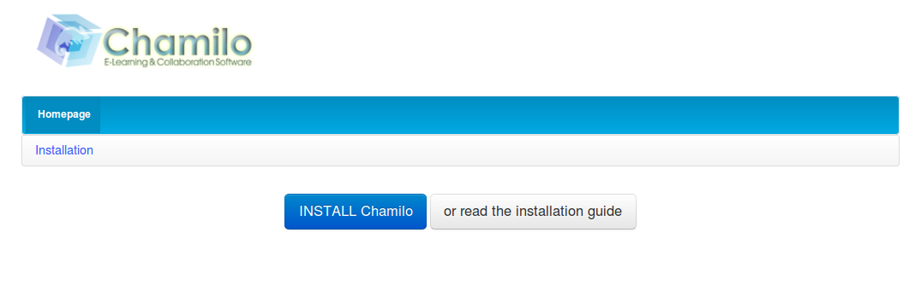Illustration 2: Installation – Welcome screen
You must then follow a series of steps to indicate your platform parameters. These steps are almost identical for local and remote installations.

Step 1 of 6 : Language
This screen prompts you to choose the installation language. Since version 1.8.8, your language is automatically detected via your browser's parameters, and this screen simply requires you to confirm whether the detected language is correct.
Beware that this is not the final language of the platform, but rather the one for the installation procedure, nothing more.
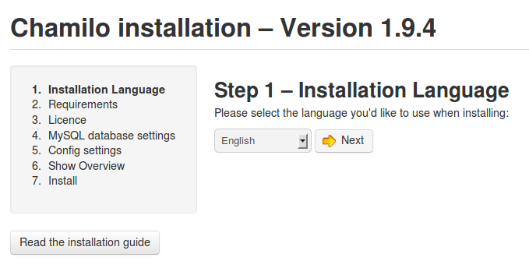Illustration 3: Installation – Choosing the language

Step 2 of 6 : Prerequisites
This step checks your server has all the required elements for a complete and correct installation of Chamilo.
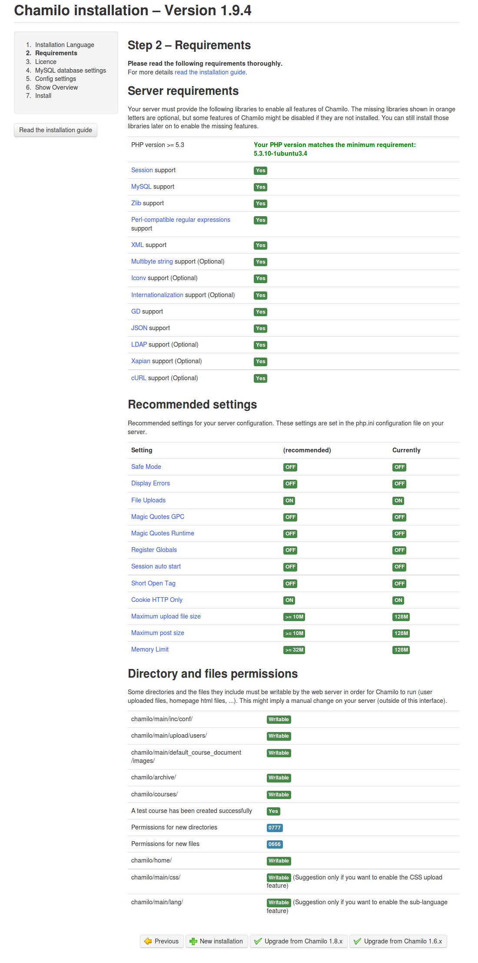Illustration 4: Installation - Prerequisites
The prerequisites already fulfilled by your system are marked in green, the mandatory but non-satisfied ones are marked in red and the ones non-satisfied but not mandatory either are marked in orange.
Almost all prerequisites relate to the PHP installation and offer links to more details. The recommended parameters represent variables that you can modify in your PHP configuration (php.ini) or inside the VirtualHost configuration.

At the end of the prerequisites page, you will find a Permissions on directories and files section.
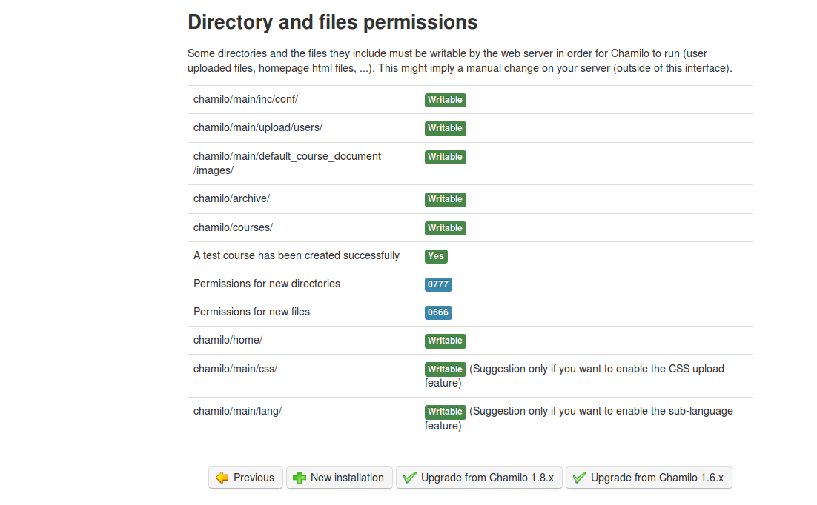Illustration 5: Installation - Prerequisites (end)
By default under GNU/Linux, writing is not authorized on directories. You must change files accesses to optimise the security and give the sufficient permissions to the user running the web server. These ensure confinement of permissions during the execution of a service (in this case Apache) and avoid a cracker to be able to take control of your server too easily.
Under Windows, this is generally easier by default (but much less secure) and the permissions are already sufficient (but too permissive).
Note : Chamilo is frequently reviewed (at least once a year) against security flaws that would endanger your server. You can be kept aware of the latest security flaws found and fixed by subscribing to our dedicated security mailing list: http://lists.chamilo.org/listinfo/security or on http://support.chamilo.org/projects/chamilo-18/wiki/Security_issues. Alternatively, we have a Twitter feed for Chamilo's security-related news: http://twitter.com/chamilosecurity
Chamilo has an excellent track record of fixing every security flaw and publishing patches to its users within 4 days of being reported. You can check our public record on Secunia's website

Locally, on Ubuntu, go to the directory where the Chamilo directory is. Give it sufficient permissions to user www-data (the web server user under Ubuntu) and reload the page in your browser. If you use another operating system, you might need to update the following command a little bit.

Ex.: user@server:/var/www$ chown -R www-data:www-data chamilo/

These permissions are nowhere near secure, and we assume you will seek advise about permissions to a properly qualified Linux administrator. Security should matter to you, but we cannot possibly cover all cases of permissions and servers out there just with this guide.

Click on « + New installation ».
Note : if you run an update of a previous version of Chamilo, this chapter is not the right one for you. You should rather check out chapter 2.3 : Updating Chamilo. We also recommend you to read the installation and update guide of Chamilo, available inside the documentation directory of your Chamilo package.

Step 3 of 6: License
Here, Chamilo explains it is a free software distributed under the terms of the GNU General Public Licence (GPL) (version 3 or superior) and that part of its content is released under BY-SA Creative Commons.

To go to the next step, you'll have to read the license and approve it, otherwise you are not authorized to use this software (it is very important for you to understand that you are only allowed to use it if you accept these conditions). You will find other translations of this license (probably in your own language) if you need it, connecting to the Free Software Foundation, which is the organisation which publishes this license.

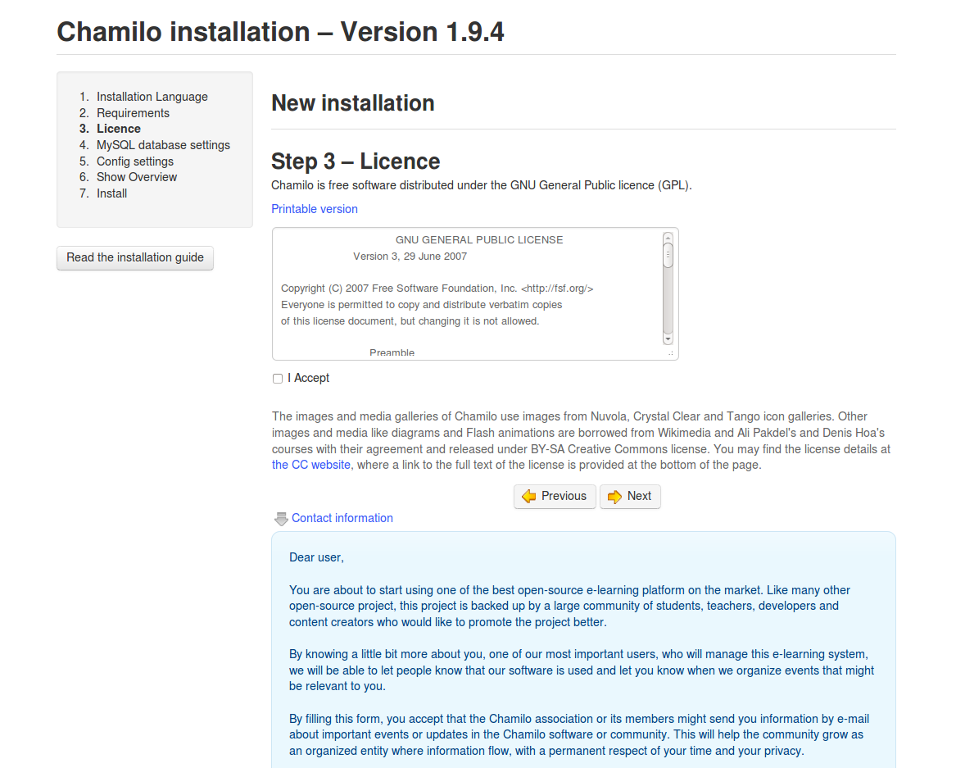Illustration 6: Installation - License
Note: Starting with version 1.8.8, you will also find an optional form below the license approval. This form allows us some contact data about you and let you know of any event organised by the Chamilo Association or its members, which happen near your location.
We will treat your contact information with care and will not provide it to third parties. It will be kept within the association itself. As per most privacy laws, you are entitled to have your data removed or updated in our database by sending an e-mail at info@chamilo.org
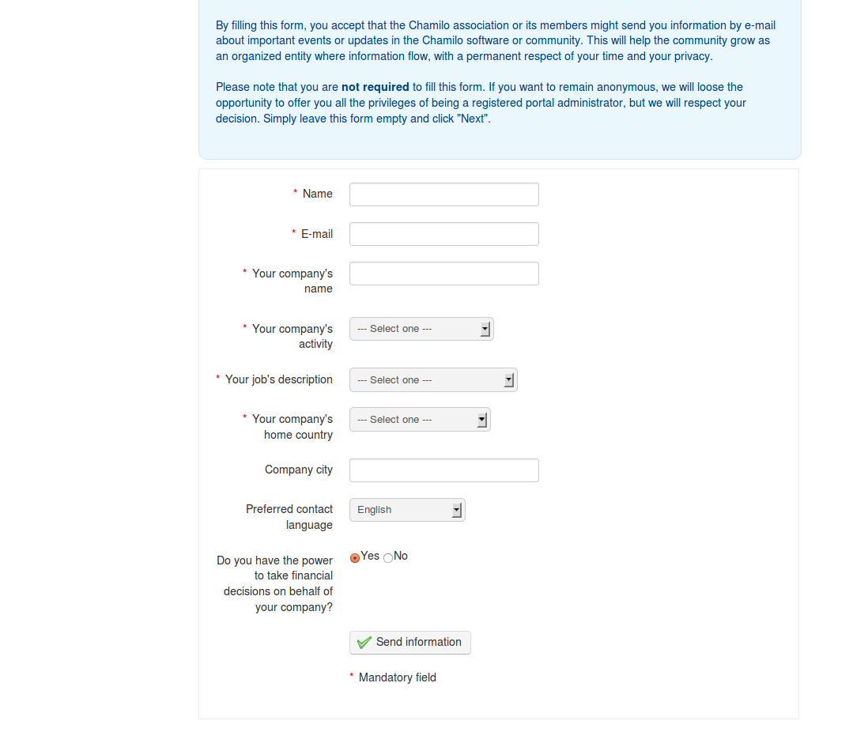Illustration 7: Installation contact form

Step 4 of 6 : MySQL database parameters
We'll now check the database management system (DBMS) works and is configured as expected :
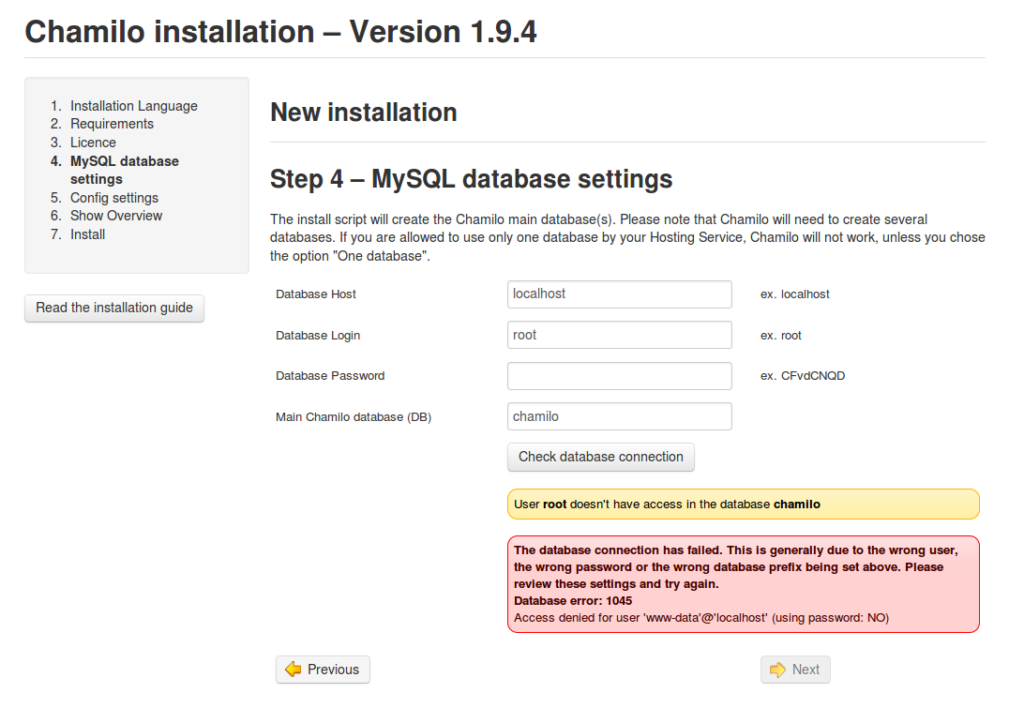Illustration 8: Installation – MySQL settings
To allow for the settings check, you will have to fill in the required fields. These elements have probably been given to you when you rented your hosting service the first time, or you did them yourself when configuring your LAMP server locally.
- Database host : the name of the SQL server. If this is a local installation, the MySQL server is probably local too, and its name will be localhost.
- Database user : the name of the database user. If this is a local installation, the name will probably be root by default, but we recommend the creation of another user for your Chamilo databases, because using root represents a significant security risk for your other databases on that server. Typically, you can create a new user through a web interface, but if you have to do this in the terminal, and assuming you want a user named “chamilo” with a password “olimahc”, these 2 commands will help you out:
  - grant all privileges on chamilo.* to chamilo@localhost identified by 'olimahc';
  - flush privileges;
- Database password: the password that has been given/created during the hiring/creation of the database, at the same time as the user. Locally, the password is generally empty by default, but once again we recommend defining your own password here, for security reasons.
- Database name: the name of the database to create and in which to store all of your Chamilo's data

Since Chamilo 1.9.0, the installation process has been simplified and the database structure has been migrated so that only one database is used, which greatly simplifies the installation process and th maintenance of Chamilo portals.
Check the data entered in the form, then click the Check database connection button. If an error message appears, check the data again. Maybe this password is not the right one?
Once everything is OK (and the green confirmation block appears), move on to the next step.

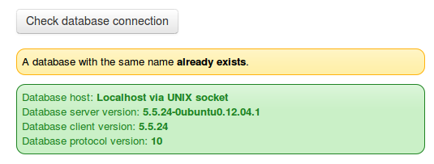Illustration 9: Installation database check - OK
If a database with the same name already exists, a yellow-background message will tell you so, because this database will get overridden with your new database! To avoid this, make sure you use another database name in the previous form.

Step 5 of 6: Configuration settings
Every setting of this step can be modified after the installation through the Chamilo Administration page, except for the Encryption method and the Portal URL.
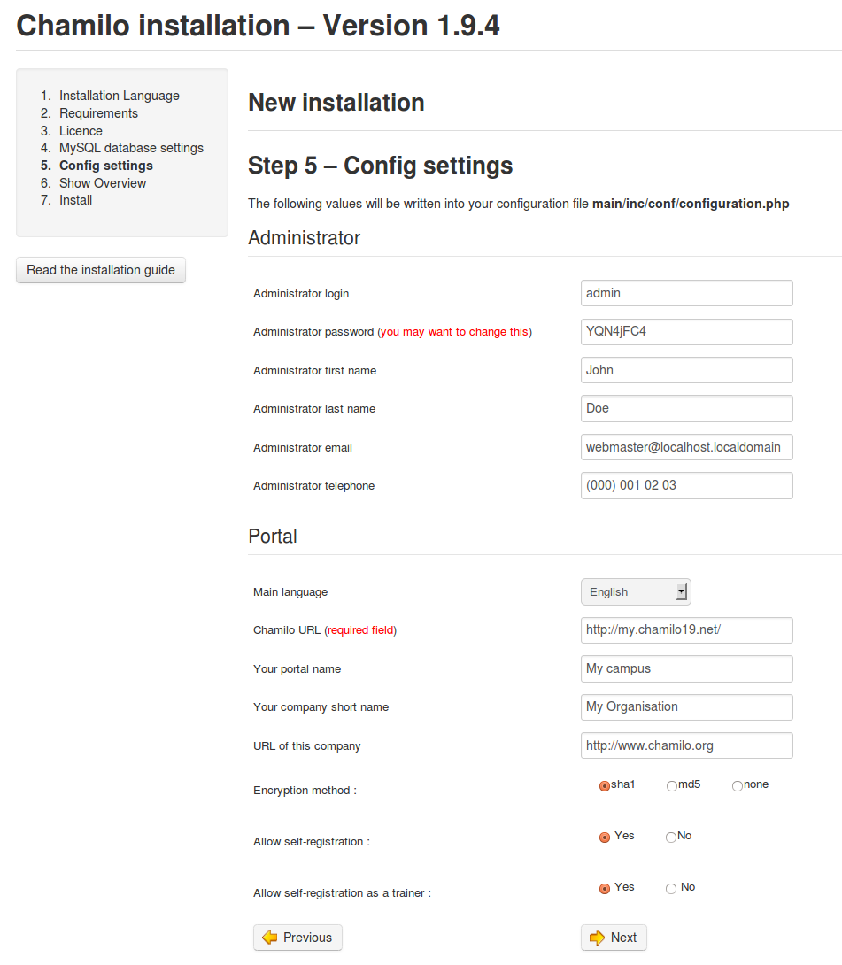Illustration 10: Installation – General configuration settings

Encryption method is almost impossible to change afterwards as it would imply re-generating new passwords for all users and sending them by e-mail. The default option is always the most secure, so we recommend you leave it as it is.

Portal URL could be updated but only through the configuration file, which could prove tricky. Please select these two wisely.

- Main language : default language on your portal.
- Chamilo URL : URL of your Chamilo portal (locally : http://localhost/chamilo; remotely : http://www.mydomain.com/chamilo).
- Admin's e-mail : portal administrator's e-mail contact address (or support team)
- Admin's first name and last name : will be shown in the footer as the link to the admin's e-mail address. You can put any information there, like “Support team” as an example.
- Admin's login and password : IMPORTANT – will allow you to connect to your portal as administrator later on. One option is to set a global functional admin account here (named “admin”) and have multiple people use that account. It is, however, recommended to create a more personalized account for each administrator (so this first one should be yours), to be able to keep track of all actions taken by other administrators.
- Portal's name and organisation's short name : will be visible, only in specific visual themes, in the top left corner of the page (on all pages).
- Encryption method : hashing and cryptographic functions that will be used to secure the users passwords in your database. We recommend (and select by default) the most secure one available in Chamilo: SHA1.
- Self registration : will allow user to register alone; set to No for a private portal.
- Self registration as teacher : will allow user to register alone as a teacher; only taken into account if the previous setting is set to Yes. This will allow new users to register as teachers, and thus to create new courses.

Note : The user defined on this screen will have full administration permissions. He will be able to update the settings on this page afterwards.

Step 6 of 6 : Last check before installation
Here, you'll be able to check all your settings a last time before launching the installation. We recommend you take a screenshot (or print it) and keep it in a safe place. It might be useful when reporting a bug to the Chamilo community, or in case you forgot the settings you set. If you spot a mistake in the settings, just go back and update it. Alternatively, just click on the Install Chamilo button and proceed...
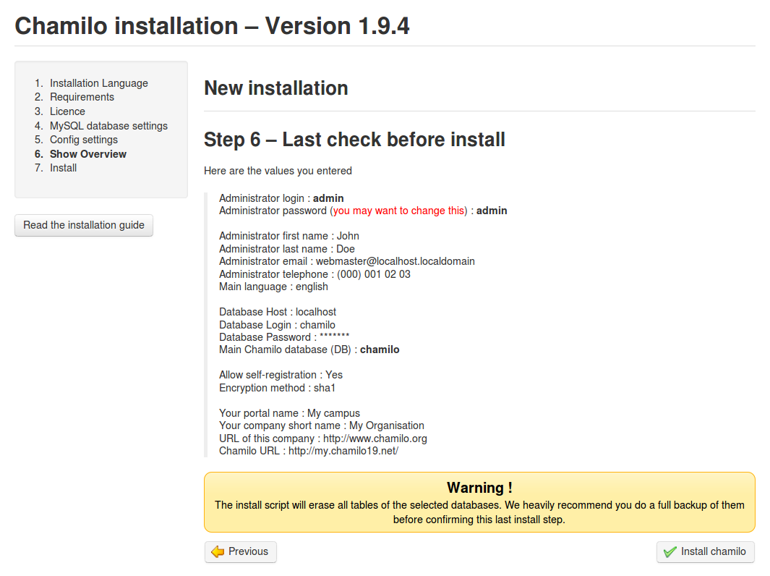Illustration 11: Installation - Reminder

Once the installation is over, just go to the site by following the link given and connect with the account you just set.

Last installation settings
Once Chamilo is installed, the success message also brings a short warning message

« Security hint: To protect your site, please change permissions on main/inc/conf/configuration.php and main/install/index.php (not their directories) to read-only (CHMOD 444). »

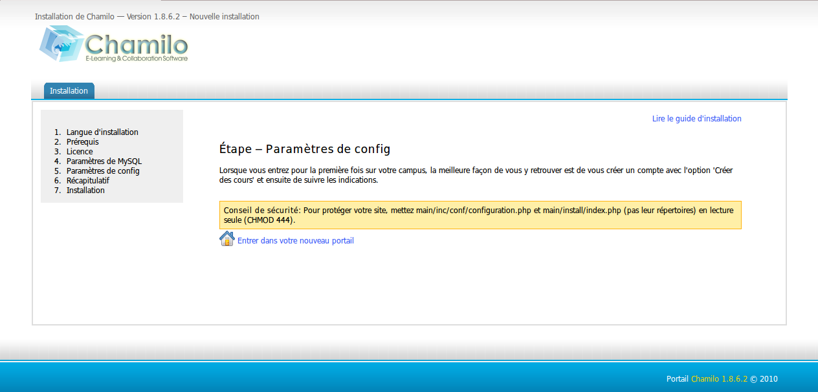Illustration 12: Installation – Installation report
It is preferable, in fact, to remove the main/install/ directory completely (the confirmation text is not really accurate about this):

user@server:/var/www/chamilo$ sudo rm -rf main/install/

This will prevent anybody (except the root user) to see this directory, and thus to use it.

For the configuration.php file, 0444 are the appropriate permissions to assign:
user@server:/var/www/chamilo/$ cd main/inc/conf/
user@server:/var/www/chamilo/main/inc/conf$ sudo chmod 0444 configuration.php

When this operation is completed, using Chamilo can begin safely clicking on the Go to the newly created portal link.

Updating Chamilo
If you already have a Chamilo installation (any previous version) and a new version has been released, we strongly suggest you update yours to benefit from new features and fixes, but more importantly from the security patches that might be fixing flaws detected in previous versions.

Before updating Chamilo, bear in mind that any software update, considering the great number of contexts in which it can run, can generate new bugs or regressions. As such, it is highly recommended you take a full backup of your complete system (Chamilo folder and databases).

As an admin, you can enable the version update notification from the Administration tab, Chamilo block.
Just click on the Enable version check button once to enable the feature.
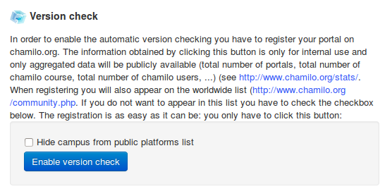Illustration 13: Administration – Chamilo block
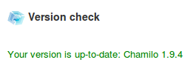Illustration 14: Administration – Version check block (up to date)
Whenever a new version is published, a notification of availability will appear in the interface.
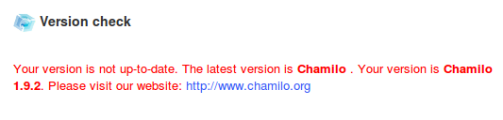Illustration 15: Administration - Version check block (outdated)
Note that this feature at the same time sends us some statistical information about your portal: the public e-mail address of its support team, its public portal URL, its number of users and courses. This way, we can easily count how many people are using Chamilo around the world.

Download the latest stable version
Go get latest package from Chamilo's website. Once you got it, uncompress it and move to the next chapter.

Replace the older version by the new one
Before applying a more recent version “on top of” your current Chamilo version, you might want to apply a few changes to the package “just in case”. For example, the following directories could be removed from the Chamilo package before you copy them over your current installation:
- home/
- courses/
- main/inc/conf/
- main/upload/users/
- main/searchdb/
These directories are all supposed to be about the same in the new version, and might all have been altered by your use of Chamilo through the web interface, so to avoid any file clash, just remove them from the Chamilo package, then continue...

There is only one recommended way to update your Chamilo version for now:
- Don't delete the previous folder, otherwise the older configuration files will be lost.
- Simply copy the new Chamilo directory over the old one.
- if you use a GNU/Linux distribution, you'll have to copy the entire new directory to the old one, i.e.:
user@server: sudo cp -r chamilo-1.9.4/* /var/www/chamilo/
or, with SSH : use the command « scp » -r local-computer-path remote-path

- Then go through the steps from «2.2.2 Last installation settings».
- Connect to your site and check that everything is there.

Backups

External backups

PhpMyAdmin database backup
Databases can be saved from the PhpMyAdmin interface, connecting using the login and password created during the LAMP server installation, the database installation, or in the data transmitted by your hosting provider.
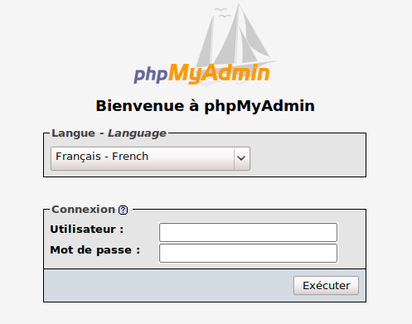Illustration 16: Administration - PHPMyAdmin
Once in the graphical interface of PhpMyAdmin, go to the Export tab and select the database to be saved. There's probably another one called “information_schema”, which you can just ignore.

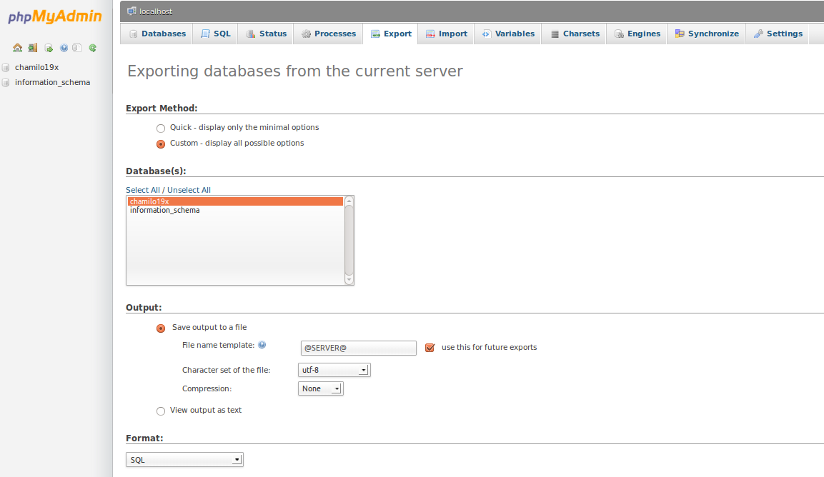Illustration 17: Administration - Export through PHPMyAdmin
You may want to change the output format of the backup file. To save, choose on the desired format below the databases to export. In the present example we chose SQL.

The name of the saved file can also be changed in the Output section. It can be compressed using one of the three offered formats. Do not forget to select the Save output to a file option, otherwise it will just print the backup result on screen, which will not really help you.

You're only left with downloading the file. It will be saved by default in your Downloads directory or on your desktop, depending on your browser's configuration.

Saving the databases through hpMyAdmin is over. The saved file will be to the SQL format (.sql extension) and will be importable later on, in case of problem, through PhpMyAdmin.

Command-line backup
If you are more of a Linux sysadmin, you can take a backup with a command of this type, where the final part is the file where you want to save it (and 'olimahc' is the password):
mysqldump -u chamilo -polimahc chamilo19x > chamilo-backup-file.sql

The Chamilo root directory
The root directory is (in this context) the directory which contains the Chamilo files. For the example in this tutorial, let's consider it has been installed in /var/www/chamilo and is available through http://localhost/chamilo/ (for a remote server, we will need to use FTP o SSH/ SFTP).

To save, you will have to compress the files through your terminal going to the /var/www/ directory.
user@server:cd /var/www
Compress the directory using the “ tar “ command to generate a tar.gz file:
user@server:/var/www$ sudo tar cvfj /home/you/bkp/backup_chamilo.tar.gz chamilo/
It can be practical to give a name composed using the date, like 2010-05-07-backup-chamilo.tar.gz. This way, if you store a series of backup files, it will be easy to sort them by date.

This backup copy will contain all information from the Chamilo database accesses and all its configurations. It is then useful in case of data loss or an undesired incursion on your server. It is the only reliable way to rebuild your Chamilo server if any major problem occurs.

This backup can be executed automatically by a scheduling system (cron process under GNU/Linux) on the server, but it can be executed manually in case the server doesn't do it right.
If you do not have access to a terminal, it is possible you might need to execute a backup copy through FTP. This operation, however (without compression), can be much longer.

Saving the Chamilo interface
Chamilo offers different ways to save data. It is possible to save a complete course (or almost so) or a course element in particular, but only as administrator or teacher.

Learning path export
To export a learning path, first go to the My courses tab (generally the 2nd tab from the left).
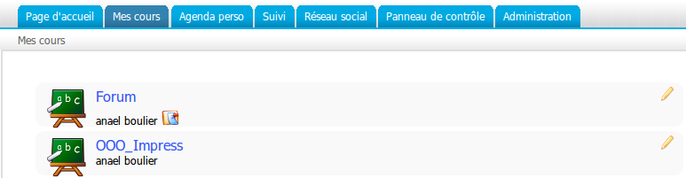Illustration 18: Interface – Courses list
Here, you can see the courses of which you are the teacher (through the pencil icon). To continue, click on one of them then enter the Learning path tool.
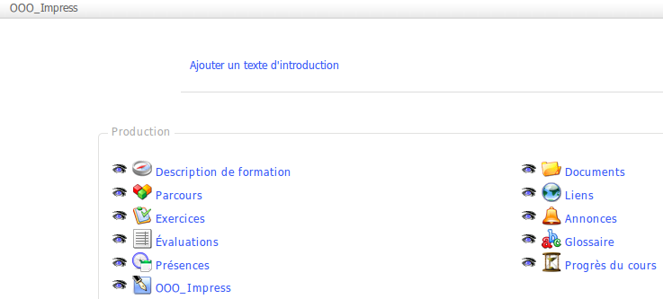
Illustration 19: Interface – List of course tools
Once in the learning paths list, click on the CD icon to generate a backup file.

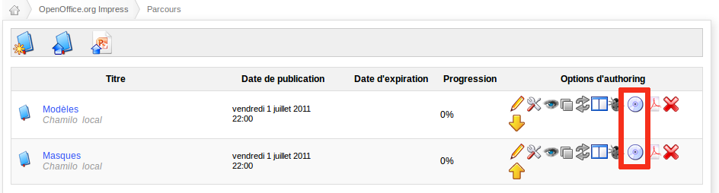Illustration 20: Interface – Learning paths export
At this stage, you only have to select where to save the file on your disk. The export is available as a .zip file.

Note this export is generated in the SCORM 1.2 standard format (which also defines it must be compressed as a .zip), that you might want then to re-use on another LMS, be it Chamilo or any other, as far as it is SCORM 1.2-compatible (which means more or less any other e-learning portal), but this format makes the edition complex, not to say impossible. As such, it is a non-modifiable backup, in most circumstances.
You can also export any learning path to PDF, although dynamic elements like audio, video and flash animations, will not be exported.

Saving a course
The platform administrator can save any course from (among other methods) the administrative interface.

- Go to : « Administration » → « Courses list » :
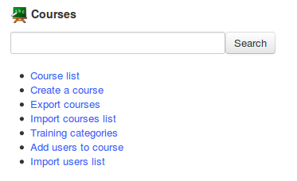Illustration 21: Administration – Courses block
- Click on the CD icon, for the course to export.

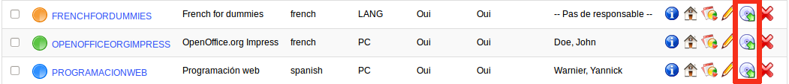Illustration 22: Administration – Courses list – Backup
- Chamilo then suggests to « Generate a backup » or « Import backup information » from backup. Click on Generate backup.
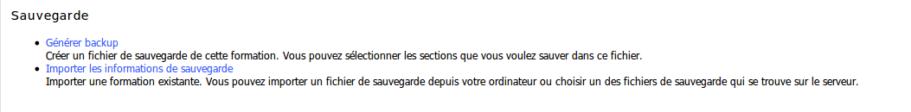Illustration 23: Administration - Backup
- You can choose between a complete backup and a specific selection (depending on your needs). Let's pick Complete backup for the example.
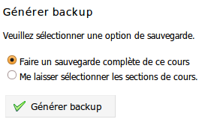Illustration 24: Administration – Backup settings
- The backup is generated and you just have to click the zip file button to download it.

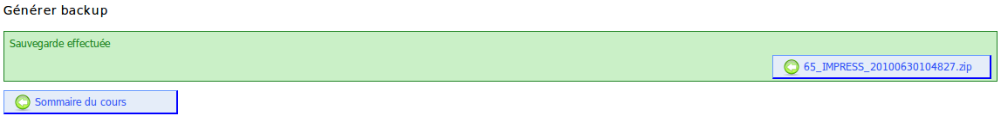Illustration 25: Administration – Backup, results of backup generation
- On clicking the Generate backup button, Chamilo creates a backup file which, by default, ends up in its chamilo/archive directory. You can thus recover it by direct access, but that means other people can also have access to it. This means, as an admin, that you should both have a regular process to clean this directory (we offer one in the main/cron directory but you have to execute it) and that you should set your configuration (through .htaccess or VirtualHost config) to avoid direct navigation inside the main/archive directory.

There is also another way to generate backups...

As admin or teacher, click on the My courses tab, then on one of the courses available. Then it is possible to generate a backup pretty much the same way clicking on the Maintenance tool.
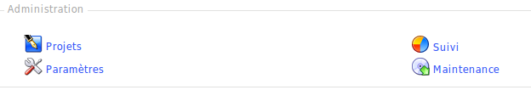Illustration 26: Interface – Course administration tools
The interface is slightly different...

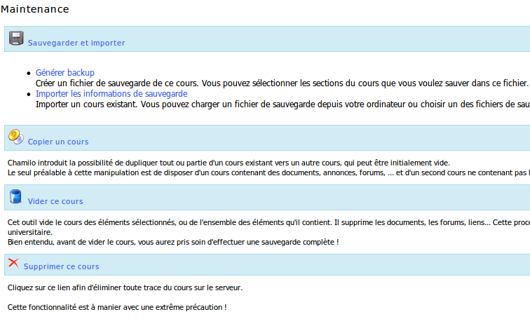Illustration 27: Interface – Course backup options
With the course backup options, you can still execute three more functions:

- Course copy allows you to duplicate all or part of a course into another (preferably empty) course. The only required state before this is to have a first course with something to copy, and another course which doesn't contain the elements of the first one.

- Empty course allows you to empty the whole contents of a course. Let's say you want to start a fresh course inside the same “shell” as the previous one... just click this link and all the resources previously created will be gone, with no chance to recover them. Obviously, before you do that, you might want to recover the course element through a Course backup operation.
- Delete allows you to delete the whole course, this also means removing its empty shell. A confirmation is required, but once it's removed, don't expect it to be available as a safe copy anywhere...

Note : when opening the backup's .zip file, you will find a close similarity with the Documents tool documents hierarchy.

For your information, the default .zip file for a course initially created with example content weighs around 8.9MB.
It contains :
- one internal structure file named course_info.dat
- one directory called Document
- a series of files and folders containing the course documents, anything not linked to the users (assignments and other stuff user-related are not saved)

The Document directory has a structure similar to the one presented in illustration 28, which reproduces the documents tool structure as shown in illustration 29.

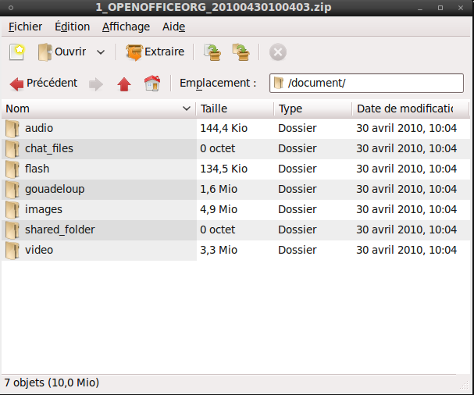Illustration 28: Backup – Backup files structure

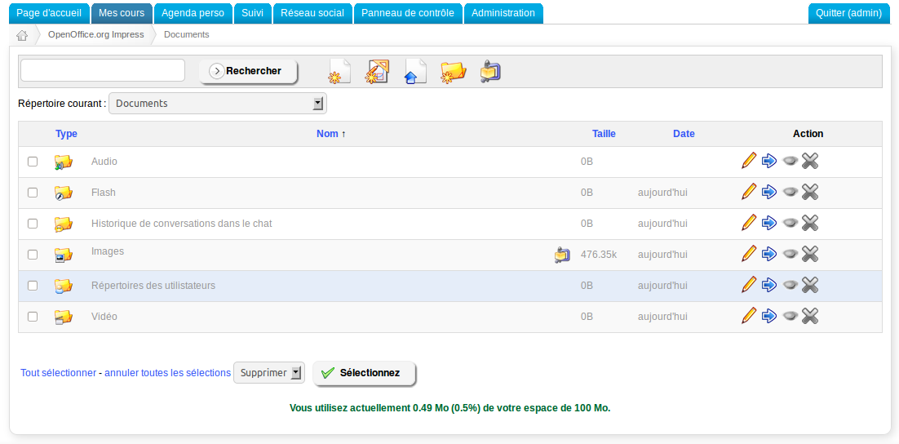Illustration 29: Interface – Documents list
These documents are the default contents of the course.

Furthermore, the backup will only recover documents (images, videos, etc.) related to the course.

Recovering a backup

Learning paths
After exporting the learning paths, you might want to know how to import them back into another (or the same) Chamilo portal.

In the My courses tab, create an empty course matching the one which has to be imported (or re-use an existing course). Once in the course, click Learning paths.

In the learning paths tool, you have three options:
- « Create new course » (1st icon),
- « Import SCORM courses » (2nd icon),
- « Chamilo Rapid » (3rd icon)

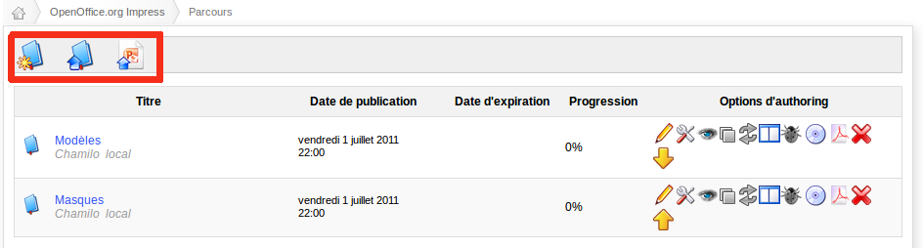Illustration 30: Interface – Learning paths import
To import the learning path previously exported, click on Import SCORM course (2nd icon).
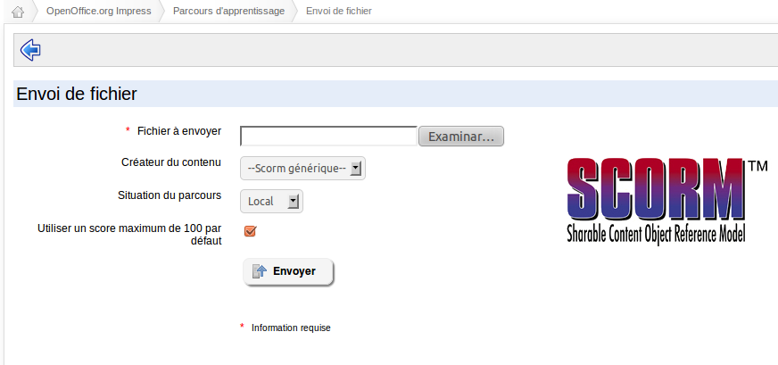Illustration 31: Interface – SCORM learning paths import
The backup must obviously be compatible with SCORM and, something less obvious, SCORM 1.2, which is a particular version of SCORM. Chamilo does not fully support SCORM 2004, so you will probably have a valid learning path import, but it will not remain fully functional, most of the time. Your learning path package can also be AICC compatible, but that's another story.
Note the Authoring tool field is only an informational field and doesn't generate any behaviour modification.

Courses
There are two ways to import a course back into Chamilo:
- import a previous course backup file from your computer
- import a backup file directly from the server
The two options are very easy to use from the Import backup tool inside the backup tool of any course.

Complete recovery
This recovery procedure has been tested a few times, but your configuration might vary considerably from this example. Here we will use a local installation case, using PhpMyAdmin and a backup of the Chamilo root directory. For a remote server, it would require SSH / SFTP or FTP access to the server.

This recovery might be necessary after you mistakenly delete some or all of the Chamilo databases, or after serious damage has been caused on your server by a cracker.

- Copy the backup file into the root directory (/var/www) and unzip it. Keeping the same directories structure allows you not to loose some of the pre-configured access path to some data.
- Import the database backup from PhpMyAdmin (after removing the previous database if it was still present).
- Connect to your site and check everything is in order.

The backup contains users, passwords, courses, learning paths, and all the resources of your portal.
We actively recommend taking automatic backups on another server at least once a day for critical Chamilo servers.

Platform administration
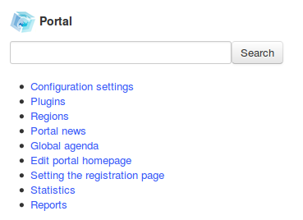Illustration 32: Administration – Portal block
The platform configuration is done through the Administration tab, Portal block.

Chamilo configuration settings
These settings join several categories, shown in the following illustration.

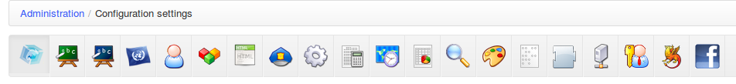Illustration 33: Administration – Portal settings categories
Chamilo offers a default configuration, which is not necessarily the one you would prefer. Even if all options are worth being explained, as an admin should know his environment perfectly, we're only going to see here the ones we consider the most important or more likely to be changed in comparison with the default settings. You can always find a complete list of settings in the Appendix on page 104.

Due to the number of settings now available to reconfigure your Chamilo portal, the Chamilo team built a nice and easy search feature. If you don't know where the option is, just search one related word and Chamilo will filter all the corresponding options for you!

The three links: Configuration settings, Plugins and Regions are actually direct links to different sections of the configuration settings, so they won't be explained separately.

Portal
This category allows you to configure globally-visible information, users registration, or other options that do not fit in any other category. Some of this information can be left empty. In this case, it will not be shown.

Registration allows you to authorize the creation of accounts by external users, to only allow the admin to create them, or to require the admin's approval for the creation of the user account.

Registration as teacher allows you to let any new user choose to be a teacher (and as such to create new courses). You generally don't want this option to be enabled.

Enable learner view allows you to let teachers have a preview of what their course would look like seen as a student. It is a highly useful tool and we don't recommend you remove this feature.

Page after login allows you to select whether you want the user to get back to your platform welcome page (Homepage), to go directly to their courses list (My courses) or to go to the courses catalogue.

Tabs in header allows you to select which tabs you want to show in the tabs bar. Any tab unselected from this list will cease to appear in the tabs bar, but it will still be accessible through the user vertical menu on the My courses page. Make sure you don't remove them all from the header at the same time.

Allow non admin to create courses allows teachers to create courses. It is allowed by default, but in a strongly-structured organization, you'll want the admin to setup the courses and their teachers, so this option might be better turned off.

Learners access to courses catalogue lets you decide whether the students can see the courses catalogue (available as a link on their courses list page) or not. The course catalogue gives links to course subscription, so removing the access will also prevent them from registering by themselves.

Enable terms and conditions enables the special terms and conditions feature (that you will then have to configure from the administration page). Terms and conditions deal with languages and versions, and ensure your students have access to your portal only if they agree with the latest version.
Show link to report bug allows you to remove the little ladybug in a green floating tab on the right of the screen. It is recommended to disable this option on any production portal.

Courses validation allows you to enable a feature by which “requests” for courses can be done by teachers. The admin will have an additional interface through which he'll authorize the creation of new courses.

Enable watermark in PDF export allows you to upload an image or text to be added to all PDF exports on the system.

Font resize accessibility feature allows you to show a small set of letters on the top-right side of your portal to let users make fonts larger (for better reading) without affecting the platform.

Show admin toolbar allows you to control the top-page floating admin bar that has appeared by default in Chamilo versions after 1.9. If you don't like it, just disable it.

Allow global chat allows you to disable the new FB-like chat feature at the bottom-right of your browser. This feature only works with Chamilo's-social-network-friends, and it is automatically disabled when entering an exercise. However, we haven't tried it under high load conditions, and you might want to make sure it will not slow down your server before you let this feature enabled.

Use the email as username this very recent feature allows you to let users identify themselves using their e-mails as a username, rather than their maybe-difficult-to-remember alias on this portal.

Allow unsubscription from platform is a feature that comes as a response to administrators' requests to let users unsubscribe from a Chamilo portal if they do not want their data to be kept. When unsubscribing, all user information will be definitively removed from the portal, so you might want to think about enabling it. When enabled, an additional menu entry will appear in the user's social network page.

Enable e-mail alerts templates, although still incomplete at this time, allows you to configure templates for e-mails to be sent upon specific events detected in Chamilo.

Show hot courses will allow you to disable the default option of showing the most popular courses on the homepage.

Training (courses)

This tab allows you to configure the options related to the courses, be them in relation to the course user, its creator or even the purely technical side. Check each option carefully to match your needs.

Some choices are available that influence the usability of the platform, as the way you show the homepage or the tools shortcuts bar.

Training homepage design allows you to switch the appearance of your course homepage (where all tools icons reside). Previously, the design of the course homepage was “Activity view”, but it has now been replaced by the more mobile-friendly “Big activity view”, which gives larger and more inviting icons.

Tools shortcuts makes a toolbar appear inside the course, allowing you to quickly jump from one tool to another. It is a popular feature amongst many Chamilo users, but it can only be enabled/disabled at the platform level. It appears horizontally, just below the page's breadcrumb.

Default hard disk space is the space allowed for documents in a specific course's document tool. It is set to 95.4MB by default, which is for historical reasons (it's the equivalent of 100,000,000 bytes, in 1024 base). You can change this option on a course basis through the courses list in the administration page. Only an admin can do that, though. Changing the option here will only affect future courses.

Display training navigation menu is another type of toolbar, appearing on the right hand side of the courses pages.

Show glossary terms in documents allows you to enable the auto-parsing of glossary terms in documents of the same course.

Go directly to the course after login makes the user go directly to the course homepage in case he's only registered in one course. This makes for a much better user experience for users who only ever come to quickly get studying on their single active course.

Enable quiz scenario allows you to enable the adaptative exercises. These exercises can drive a student dynamically through a moving path of questions, depending on his answers to previous questions.

Default course visibility indicates which visibility new courses will have by default. It is recommended (for private portals) to set this option to “Private” so students cannot subscribe on their own. The default is “Open” and will allow students to subscribe.

Allow public certificates allows you to define whether students' certificates will be visible to the public or not. Certificates are generated from inside the Assessments tool in a course.

Sessions

In this category, you will find all sessions-related options. In the past, these options were spread across other sections, but the growth of the sessions-related features have made this section necessary. Sessions control groups of courses which are taught to common groups (classes) of students. By using sessions, you benefit from a series of advantages in terms or re-use of content and splitting of students tracking between two separate spaces. To learn more about sessions, check chapter 7 Sessions management.

Register users by coach, although its name is a bit unclear, lets you decide whether session coaches can subscribe new students to the platform.

Allow coaches to edit inside course sessions allows you to define whether session coaches can edit content into their session or not.

Hide courses list in sessions allows you to change the way the My courses page looks like, by putting the focus on the session rather than the course.

Allow session administrators to see all sessions allows you to define whether users who have the Session administrator role can see only the sessions they have created or also the ones other session administrators have created. This is kind of a privilege isolation feature.

Languages

In this category, you will find all language-related options (one link points to the external Languages entry on the administration page).

Portal language gives you a link to the languages management screen. See below for more details.

Allow definition and use of sub-languages makes possible the definition of variations for each language term used in the platform interface, as a language based on an existing language. This option can then be found in the languages list (follow the Chamilo Platform Languages).

This tool (available when clicking on the languages link) allows you to define which languages are visible by the users during their subscription to the platform or during the course creation process.

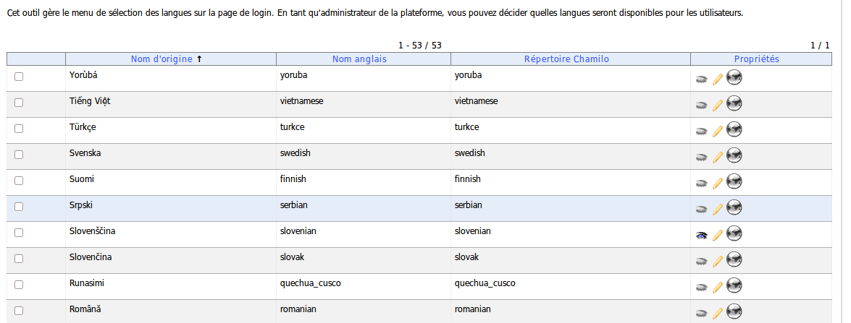Illustration 34: Administration – Languages management
When enabling the sub-languages feature, this tool also allows you to redefine certain terms of the portal interface. For this, enable the option in the languages configuration page, then open the languages list page. You will find an additional icon which allows you to add a sub-language to any existing language.
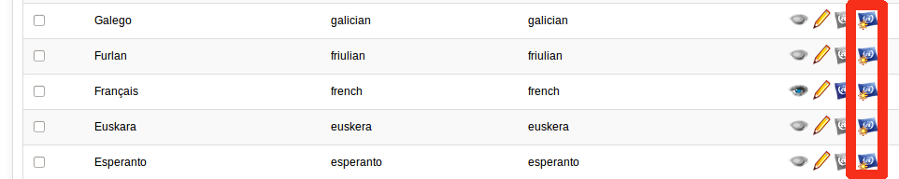Illustration 35: Administration – Sub-language creation icon
The definition of a sub-language is quite easy: you just indicate the name of the sub-language, its ISO code (2 letters, like “fr”, “en”, “es”) and its English name (the name the directory will take – which cannot be the same as an existing language).
Let's say you want to redefine the terms of the interface because you work in the medical sector and that the English terms proposed are not satisfying to you (note that it is much more practical to define this sub-language before new courses are created). For example, you thing the term Reporting should really be called Evaluation... Here is how it's done:

Creating a sub-language
Click on the sub-language creation icon on the extreme-right of the English language line. Fill-in the form by stating a common name for the language (e.g. “Medical English”) and an English name without spaces nor accents (e.g. “medical_english”), and an ISO code that is the same as the father language (in this case “en”).
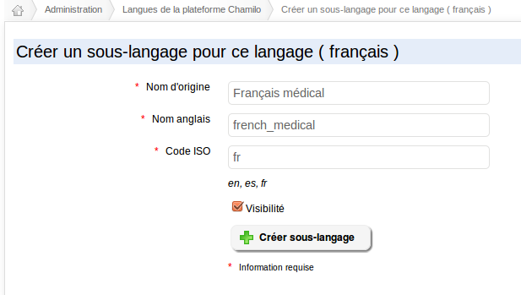Illustration 36: Administration – Sub-language creation
Select Visibility to make it selectable, and click on the Create sub-language button. The confirmation message suggests you come back to the languages list. Just follow the link...

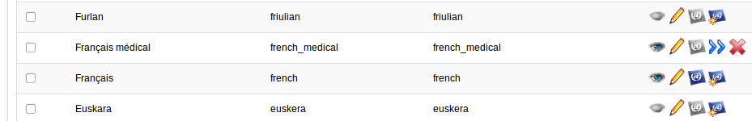Illustration 37: Administration – List of languages, with sub-languages
The results page shows one slightly different line. Click the double arrow icon to define your own terms.

Defining one's own terms
The new page is a search page. If you want to modify the term Reporting to Evaluation, just search for Reporting.
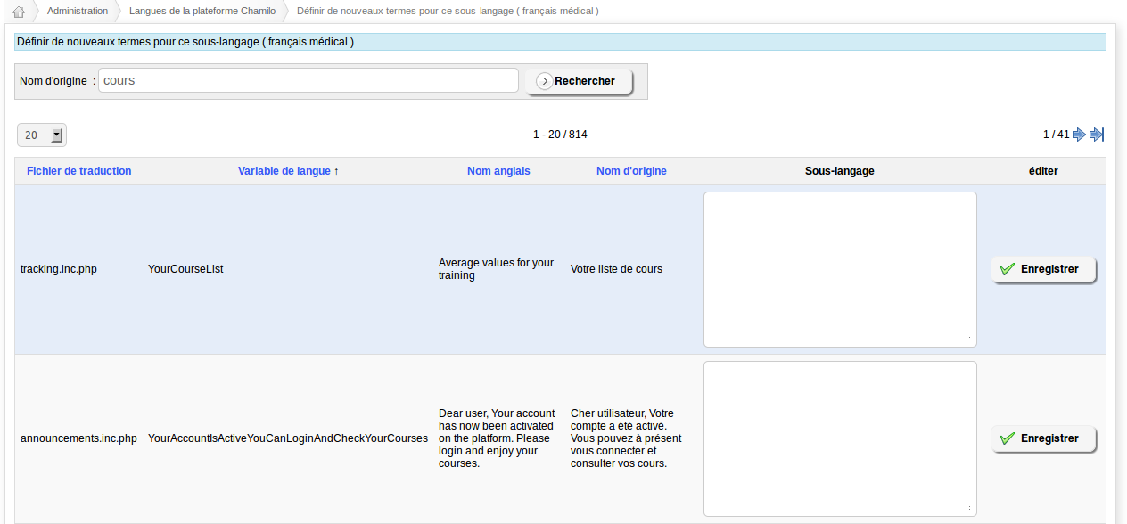Illustration 38: Administration – Sub-language terms re-definition
Once the search has generated results, redefine any of the terms appearing in the Original name column by giving another translation inside the Sub-language column. Once you're satisfied, click on the Save button, once for each redefined term. Note that some terms appear quite a lot in the interface translations, so it might take a while to process...

Assigning the new sub-language
Finally, you have re-defined your terms in your sub-language. The only step remaining is to assign it by default to all new users and all new courses. To do this, go back to the languages list and disable all other languages.

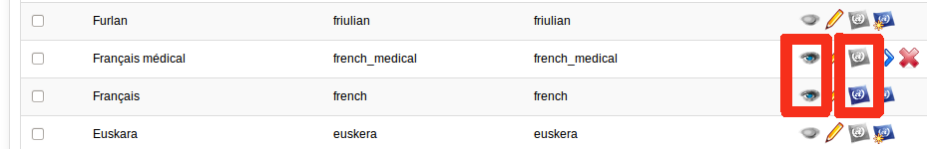Illustration 39: Administration - Sub-languages – Visibility and default usage
For your sub-language, click on the third icon to make it the default language on the platform. That's it, your platform is now personalised following your domain of activity.

Note : This advanced feature answers a double demand from our users and customers :
- allow for the edition, from the web interface, of the interface terms
- allow to re-use these terms without loss, after an update of the platform and without affecting the default language packages


Users
This category presents the options relative to users properties and permissions.

Profile defines which fields of the profile will be modifiable by the user. By default, the e-mail cannot be modified by the user himself.

Personal agenda lets you decide whether a user can register personal events in his calendar.

Allow users to change e-mail without password allows users to change their e-mails without having to provide their password. This is particularly dangerous as the e-mail address is where the password reminder is sent, so if someone steals another user's connection, he can change the password and prevent access by the legitimate user. The default option is to not allow it without having to give one's password, which is more secure but a little more complicated.

Modules

This category defines the properties of the course tools and global tools, globally (influences all courses).

Modules active upon course creation are the tools which will be visible by default in a newly created course. Teachers can then update these settings to fit their needs.

Deleted files cannot be restored if a file is deleted, you have a choice whether you want the system to delete it completely or to keep a secret backup file with a _DELETED suffix. Delete files will not be visible through the system any more, but you'll be able to find them on disk.

Online e-mail editor enabled lets you decide whether you want to give your users a way to send e-mails to other users of the platform (by e-mail) without requiring an external e-mail client. Try it by enabling the feature then clicking on the admin contact link in the portal footer.

Booking is a tool that lacks a lot of love (translate: has a very bad interface) but has potential: once well configured, you can set resources up inside your platform to book them and show their availability.

Internal messaging tool allows you to disable the messages box in the social network.

Social network tool (Facebook-like) allows you to disable the social network feature. If disabled, the Social network tab will say Profile and users won't be able to invite and communicate with friends through the portal.

Allow learners to create groups in social network allows normal students to create their own groups.

Allow sending messages to any platform user is a privacy feature to avoid spamming. On a large portal, users should probably be required to be “approved friends” before they can send messages to one another. The default is to allow anyone to message anyone else.

Create and edit SVG files enables the SVGEdit software inside the documents tool. We recommend to let this setting enabled as the tool is great and adds a lot of flexibility to the document building.

Enable online services for text to speech conversion lets you enable the text-to-speech feature in the documents tool. We recommend you enable it. It is not enabled by default to avoid users frustration in case the server does not have an internet connection (which is required for the feature to work).

Hide tools from teachers allows you to select tools that you want to hide on the whole platform. Not even the course teachers will be able to see them.

Enable external Pixlr services allows you to enable the photo edition tool in the documents tool. This requires the end user to have an internet connection (just connecting to the Chamilo server doesn't guarantee it will work).

Activate recorder - voice player Nanogong allows you to enable a voice recorder (Java Applet) in the documents tool.

Activate Wami-recorder enables another voice recorder, this one in Flash, in the documents tool. Enabling Wami or Nanogong really depends on what software is most available on your users' computers.

Enable Webcam Clip enables a feature taking pictures from your webcam in the documents tool. This allows for faster illustration of courses by the teachers (no need for digital camera, your webcam does the trick).

HTML Editor

This section contains all settings related to what you can do through the online editor. This includes setting up mathematical expressions editors and other online editor's extensions.

Advanced file manager for WYSIWYG editor lets you choose between the simple & easy file manager and an extended & somewhat more complicated file manager. Change the options, go to any course introduction edition section, choose the icon to upload an image, click Browse server and see the difference.

Note: WYSIWYG is an abbreviation of What You See Is What You Get, another way to say the editor allows you to edit things visually on screen while it is saved in a more complex format without having to worry about it.

Mathematical editors: MimeTeX, ASCIImathML or ASCIISVG: these are 3 separate options that allow you to enable the edition of mathematical formulaes. Their support may vary depending on the users browsers. To try these out, just enable them and try to edit a course's introduction section.
WIRIS mathematical editor allows you to link Chamilo's editor with the WIRIS editor, a very complete but, sadly, proprietary software to enhance mathematical or scientific courses. Using this feature will require your organization to hire WIRIS services.

Spell check enables a spelling checker inside the editor. Make sure this is not a problem for the context of specific courses (for example in orthography courses).

Activate Google maps allows you to integrate Google Maps in your documents. This requires a Google Maps API, which you can obtain in your Google account.

Allow insertion of widgets allows the users to have access to the “HTML widget” icon in the editor, which lets them paste <embed> tags taken from other sites (Slideshare, YouTube, Vimeo, etc).

Security

This category will allow you to configure a few things that have to do with security. The default settings are... acceptable, but you might want to restrict a few things to improve it.

Type of filtering on document uploads there are two different filtering types:
- Blacklist is a way to prevent files with a specific extension. That allows you to say, for example, that you don't want executable files to be uploaded (i.e. “.exe” files). This is considered the weakest filtering method though.
- White list is a way to say “I only want files which match my authorized extensions”, so it is really safe: no funny file will surprise you here. Case (upper-case or lower-case) doesn't matter here. This is the safest option, but it is somewhat limited.

Permissions for new directories sets which access permissions new directories will have. This is mostly an option for Linux-based systems, and allows you to increase security against pirates.

Warning: the default value is « 0777 » following a series of problems found by users with more restrictive permissions. This value guarantees greater portability, not greater security, and it sometimes needs to be modified if the Linux-based system you're installing it on requires a strict security policy. If this is the case, you will receive a server error when trying to enter a course you have just created. In this case, try to update this value to 0777, 0775, 0755 and 0750 alternatively, and create a new course each time. You can always delete the failed courses afterwards.

OpenID authentication enables the OpenID feature. You will also need to enable the OpenID field in the user profiling fields in order for this feature to provide the desire functionality. Be aware that, at this time, it does not allow for several identities combined, and you still have to paste your entire identity URL inside the OpenID box. We hope to improve this feature in the future.

Extend rights for coaches will let teachers edit the contents of courses inside the session context (modify documents, learning paths, exercises, links, etc.). See chapter Chapter 7. Sessions management on page 75.

Allow User Course Subscription By Course Admininistrator allows the teacher to subscribe users to his course. This option is enabled by default, but if you want to prevent this from happening, you know where to look...

Single Sign On enables the connection without login, based on a sister website which already processes the login (an intranet, for example). This feature requires a bit of customizing and you should really hire a developer with experience in Single Sign On methodologies to do that quickly. If lucky, this might work out of the box, though. Just make sure you check the other settings and the main/auth/sso/ directory for more information.

Filter terms allows you to automatically filter all given words by *** in forums and e-mails.

Tuning

This category allows you to configure only one setting so far to improve efficiency a little.

Split users' upload directory allow you to improve speed a little bit for very high load platforms by splitting the users directories (but this requires a manual operation on disk as well).

Since version 1.8.8.4, you can also find optimisation hints in chamilo/documentation/optimization.html.

Activate the browser sniffer will scan the users' browsers for specific features.

Assessments

These are global parameters for the assessments tool, which can be redefined (in most cases) tat the course level.

Marks thresholds colouring enables the colouring of marks in the assessments. It is also necessary to define the marks that will effectively be coloured red.

Marks levels labelling enables setting different levels of marks as labels (“E” level for less than 50%).

Time zones

This category defines general settings for time zones.

Enable users time zones will let the users define their own time zones, and thus get all times on the platform display in their own time zones. This will let them know more accurately when to submit a assignment, for example. Note that this setting has to go along with the activation of the time zone field for modification by the user in the user profile fields (see chapter 5.8 Profiling on page 67).

Time zone value is used to define the time zone of the portal. This allows, in cases where the server is hosted and configured in a different time zone than the customer's, to set things right and have time values show appropriately.

Reporting

This category offers only two options, oriented more towards “Analytics” than “Reporting”. You can use these options to add an extra header or an extra footer to your page. These will allow you to set the Google Analytics tag, for example.

Search

This category allows you to configure the full-text indexing feature of Chamilo. It requires, however, the php5-xapian module (as well as a few additional applications) to be installed on the server in order to work. This feature was previously available only in the medical version, but was added to mainstream Chamilo 1.8.8.4 as is the engagement from the Chamilo official providers.

You will need to enable this feature and define an additional search tag (ie “Author”) before you upload documents in order for these to be indexed (and searchable).

Don't hesitate to ask for dedicated hosting from one of the Chamilo's official providers if you've got issues setting it all up.

Stylesheets

The style sheets allow you to define your platform's global visual style.
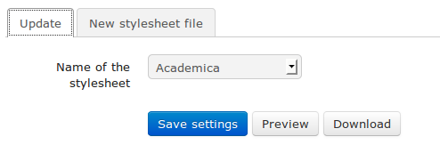Illustration 40: Administration – Stylesheets configuration
Since version 1.8.7, it is possible for you to create your own stylesheets and send them to the server. In order to do this, download a copy of one of the existing styles in chamilo/main/css/ and change the name of the recovered directory (on your computer, not on the server). Modify the style to your taste. Once you're happy with the changes, send the directory to the server as a .zip file and give it a name that corresponds to your portal.

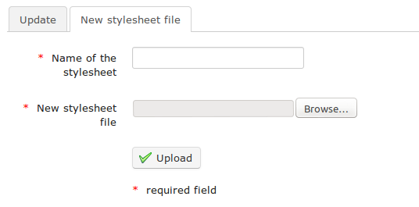Illustration 41: Administration - Stylesheets upload
Then, select the style in the drop-down list. If you're happy with it, click the Save settings button to apply it as a default style for your portal.
Check the video here for the complete procedure: https://www.youtube.com/watch?v=GA0Yw8AVp8U

Templates

Document templates allow you to speed up the creation of content in Chamilo. Creating new templates in this part of the platform will affect the whole portal.

Create, edit and remove templates easily. It is close from the documents edition tools inside the course. Don't hesitate to try it out and create a new template. You can always delete afterwards if you're not happy with it.
This feature is particularly useful to set your own templates to your organization's standards.

Plugins

This tab allows you to enable the plugins present in the plugin/ folder on the server.

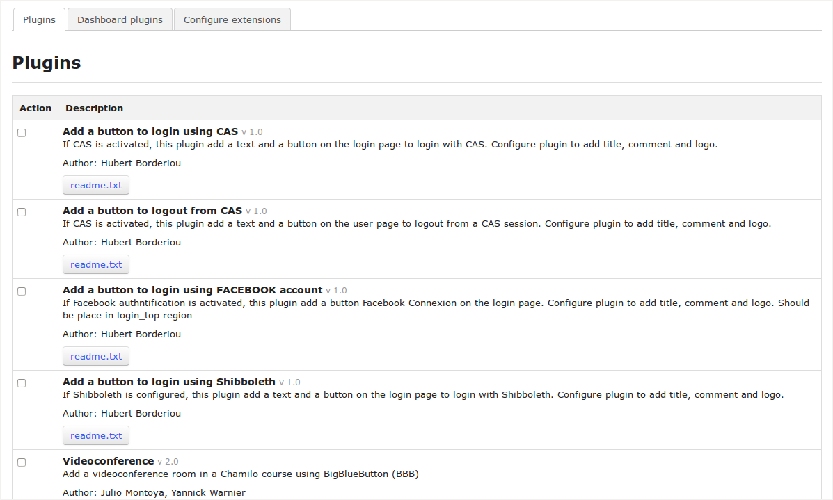Illustration 42: Administration – Plugins installation
Since version 1.8.8.2 of Chamilo, the plugins systems has been improved and you can now create and enable plugins that will appear as new course tools. This is the case of a new plugin called BigBlueButton. This plugin, once enabled, will allow you to connect your Chamilo portal to a video-conference server. The installation of a video-conference server, however, is not included in Chamilo. You will have to install it by yourself or ask an official provider to do that for you.


Note : In order to avoid any strong dependency on our providers' services, we have selected a video-conference server particularly easy to install (30 minutes on a fast and appropriate server). Such server can, however, cause issues at another level: it is a costly service to maintain, as it requires constant care to be available at all times, watched over by dedicated staff. This is one of the reasons why we cannot include it in Chamilo: it would simply not stand up to the simplicity of Chamilo as a standalone platform.

LDAP

This category allows you to configure the synchronization with an LDAP server. It contains a long series of settings which all require a good knowledge of LDAP.
For more information, we invite you to follow LDAP-specific documentation. Note that an ActiveDirectory server can be used as an LDAP server through enabling its LDAP-compatibility mode.

The new LDAP plugin must be configured in main/inc/conf/auth.conf.php through the customization of the following section (the in-line documentation for this plugin is wrong up to Chamilo 1.9.4):

$extldap_config = array(
//base dommain string
'base_dn' => 'DC=cblue,DC=be',
//admin distinguished name
'admin_dn' => 'CN=admin,dc=cblue,dc=be',
//admin password
'admin_password' => 'pass',
//ldap host
'host' => array('1.2.3.4', '2.3.4.5', '3.4.5.6'),
// filter
// 'filter' => '', // no () arround the string
//'port' => , default on 389
//protocl version (2 or 3)
'protocol_version' => 3,
// set this to 0 to connect to AD server
'referrals' => 0,
//String used to search the user in ldap. %username will ber replaced by the username.
//See extldap_get_user_search_string() function below
// 'user_search' => 'sAMAccountName=%username%', // no () arround the string
'user_search' => 'uid=%username%', // no () arround the string
//encoding used in ldap (most common are UTF-8 and ISO-8859-1
'encoding' => 'UTF-8',
//Set to true if user info have to be update at each login
'update_userinfo' => true
);

CAS

This section allows you to configure the CAS authentication method.

Shibboleth

This section gives details about the Shibboleth authentication configuration.

Facebook

This section explains how to configure the Facebook authentication method. Contrarily to the explanation in some translations, the configuration is made in main/inc/conf/auth.conf.php.

Portal news
Allows you to add a global announcement on the homepage of the portal (and on top of the courses list).

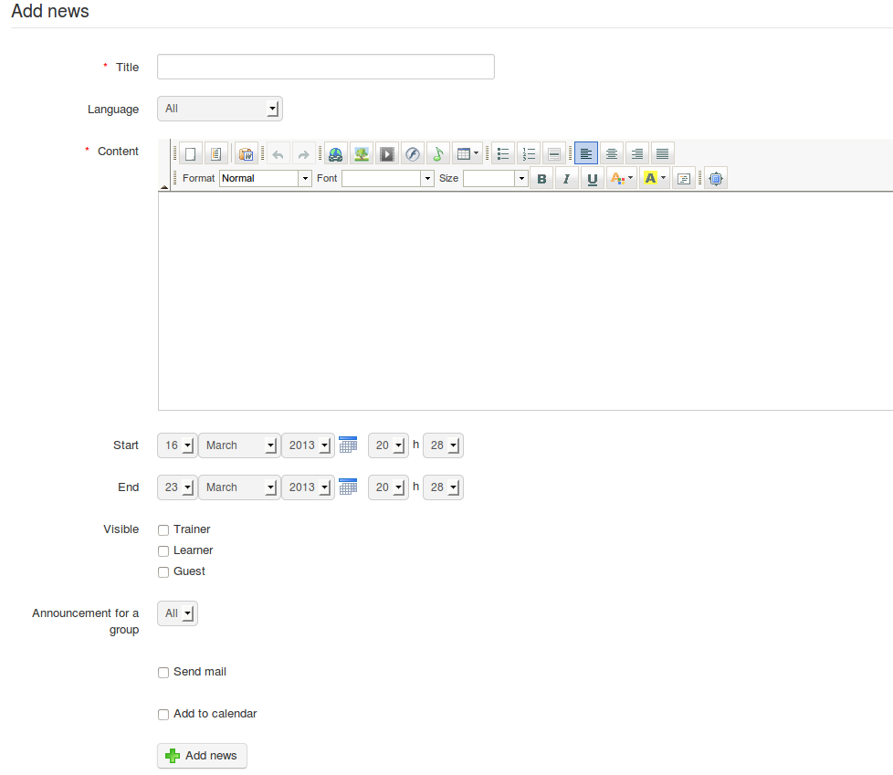Illustration 43: Administration – Global announcements
It is possible to choose the visibility of the announcement (by start and end date), the roles which this announcement is meant for, and to send it by e-mail. You can event send it to a social group.

If you want to publish this announcement in the global calendar, just tick the corresponding box.

This tool is particularly useful to send a maintenance, update or terms and conditions change on the portal.

Global agenda
The global agenda allows you to add events that will be visible from the agenda of any user of the platform.

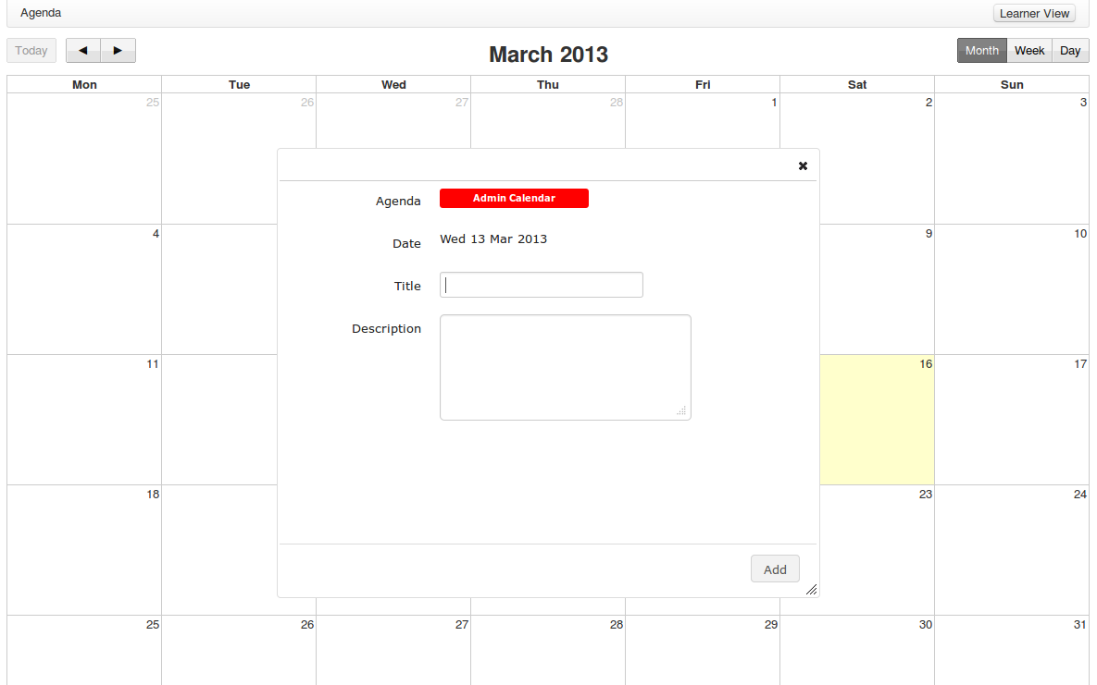Illustration 44: Administration – Global agenda
The feature is completely similar to the one you can find in the courses space, but the addition of an event there has a global reach, as all users will see it through their own calendar. Any event added this way is considered to be more important and will be shown in a different colour than other events.

Edit portal homepage
From this page, you can configure several things
- edit the homepage,
- edit categories of courses,
- insert links
- edit the notice block
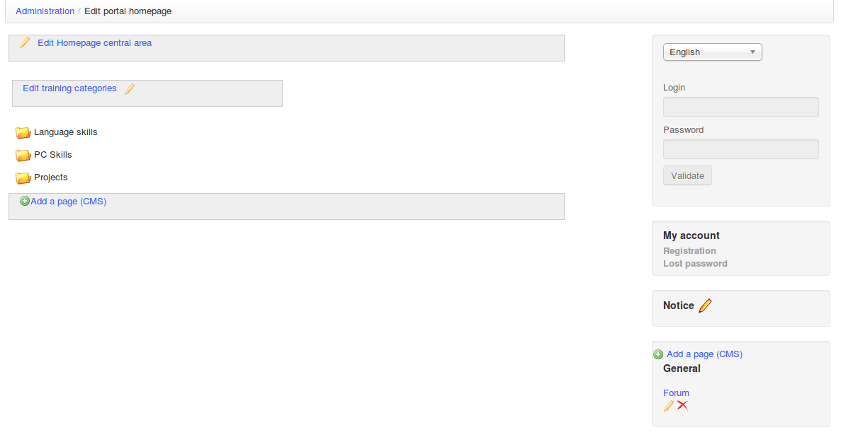Illustration 45: Administration – Homepage configuration
Note that this feature depends on the language selected. If you define a welcome page in French, it will only be visible if French is the selected language. This allows you to configure different welcome messages depending on your users.

Setting the registration page
This feature allows you to add a multimedia introduction on top of the registration page. For example, you could add a video explaining how to register and which are the terms and conditions of the portal. Fields of the form can be configured through the Users parameters of the platform configuration settings.

Statistics
This tool allows you to generate small statistical charts for four categories of data:
- courses,
- users,
- system,
- social.

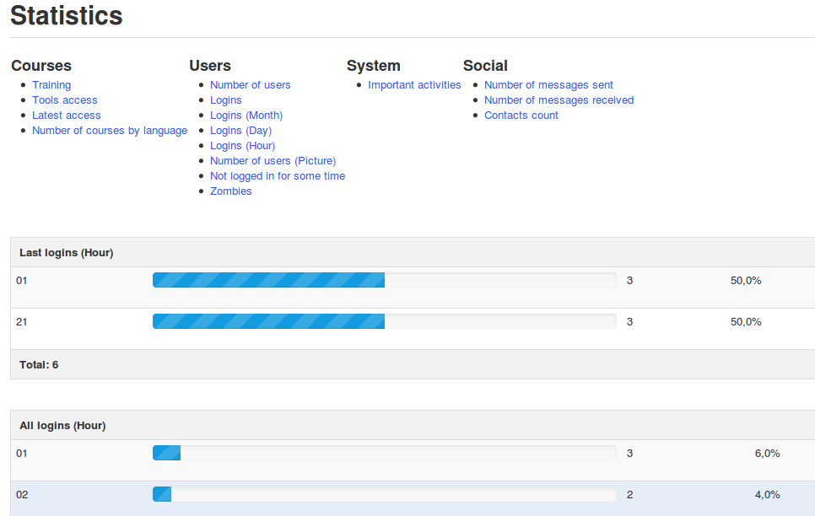Illustration 46: Administration – Global statistics
Although the statistical data is pretty summarised, it will give you a good idea of the general use of the platform.
Important activities group all the portal administration activities: creation and removal of courses, of users, of sessions; edition of configuration settings and some other... important activities.

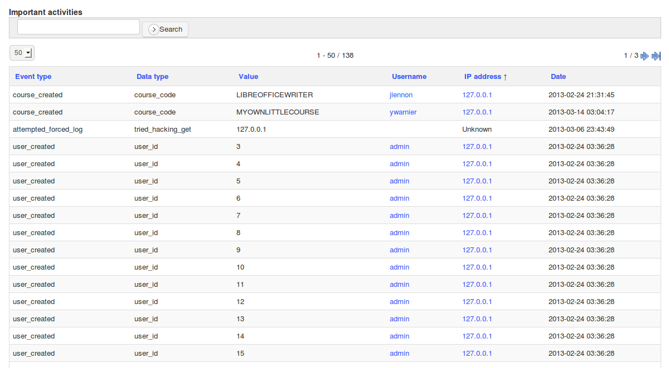Illustration 47: Administration - Statistics - Important activities
Note that you can also check from what IP address an action was taken. This gives you more possibilities in terms of ensuring the legitimate character of an action.

Reports
This section (available from Chamilo LMS 1.9.4) could be called “Executive reporting”, and gives you a special report about all users and all training hours they've been taking inside the platform. This is particularly useful for organizations providing training to other organizations' employees and having to account for that (in man*hours of training).
Assuming you've only got one learning path and one “assessment” in each course, it will also give you the learning path progress, whether the student reached 100% progress, and whether he printed his certificate or not.

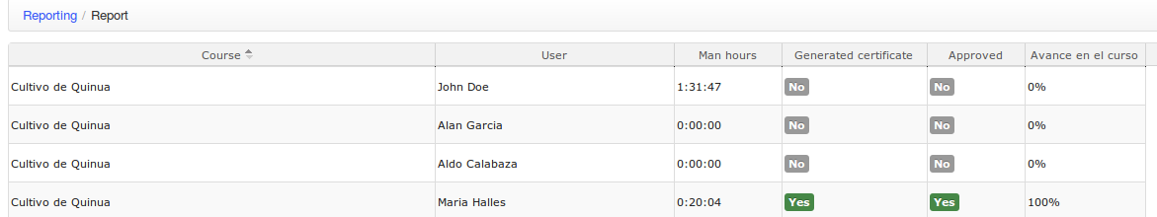Illustration 48: Administration - Executive reporting

Users management
The users management is done through generic and familiar icons, and some more specific icons.
Icons | Features
 | Modify the status of the user by clicking the icon (enabled/disabled)
 | Click to show the list of courses to which the user is subscribed
 | Connect as... allows the admin to take the identity of a specific user to check a bug he's reported on the platform (or to help making a quick demonstration using several user roles)
 | Assign courses to admins or supervisors to follow them up (dashboard)
 | Assign course sessions to admins or supervisors to follow them up (through the dashboard)
 | Gives all the information about the user, his sessions list, courses list and other details, plus many ways to know more from there
 | Assign users to admins or supervisors to follow them up (through the dashboard)
   | Gives a detailed reporting on the user (disabled for teachers and admins)
 |   Update user's information and settings
 | Show the free/busy calendar of the user
 | Remove a user (after approval)
 | Shows whether a user is admin or not. Only administrators accounts (or sessions administrators accounts) have a yellow star. Others show a grey star.
Tableau 1: Administration – Users administration icons

User roles
User roles are a fundamental part in the users management of a Chamilo portal, and their deep understanding allows you to go further than a private use, into a complete academical management where every person has its place and responsibility.

For the common administrator, it will seem there are only four roles in Chamilo: the ones which appear directly in the users creation form in the administration section. However, some roles actually offer sub-roles, of which one can only gain knowledge after a deeper use of the platform.
In order to guide you in the discovery of these roles, we will use the following schema as a reference, as it represents most of the roles and also the notion of sessions (as we will see it in chapter Chapter 7. Sessions management on page 75).
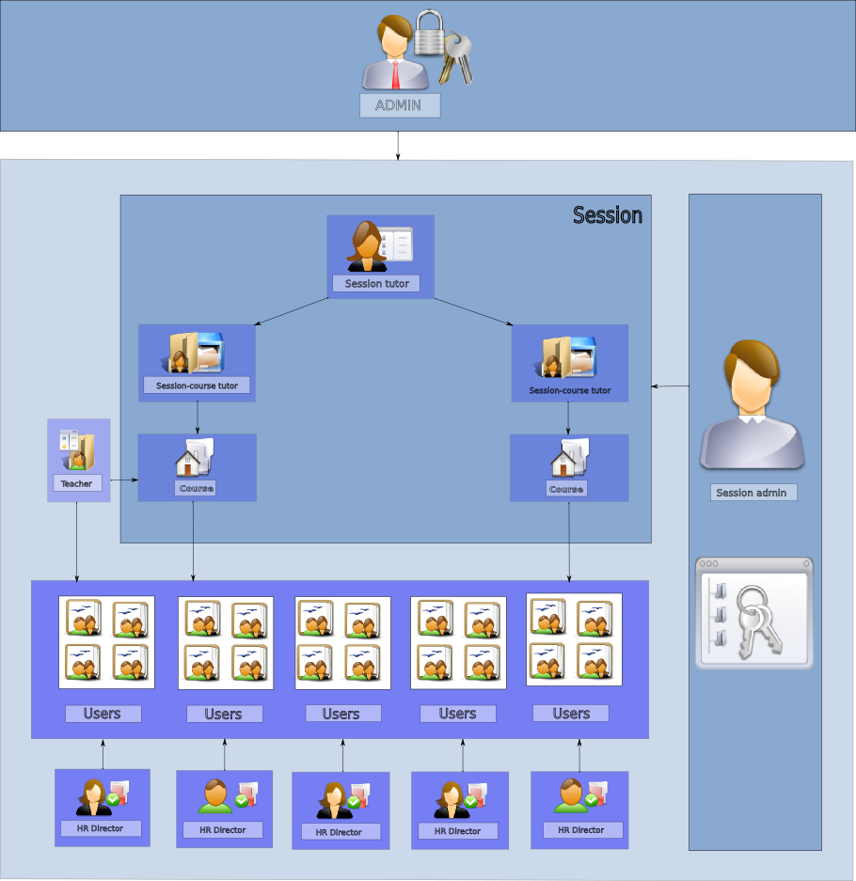Illustration 49: Roles and sessions
In this schema, we can see the main administrator (on top), the sessions administrator (on the right), the session coach (on top of the session block), the courses coaches (on top of the courses), the teacher (on the left of a course), the students (connected to the session) and the human resources manager (connected to the students).
Let's review these roles together, going from the less powerful up to the most powerful.

Learner (or student)

Description | The learner is the typical role of the person who follows one or several courses. He has access to the contents of the courses to which he subscribed (if that was made possible) or to which someone subscribed him.
Permissions in a course | By default, he can :  - follow a learning path  - check out visible documents  - contribute to the wiki  - communicate with his peers through the forum and the chat  - answer exercises or exams  - deliver assignments  If authorized :  - create course calendar events  - publish course announcements  - be part of a working group  - share documents
Global permissions | By default, he can :  - communicate with his peers within the platform through the social network messaging  If authorized :  - create interest groups in the social network  - create personal events inside his agenda

The course assistant

Description | The assistant is an extended learner role. It is normally a learner, but the teacher can assign him the role of assistant in one of his courses through the user edition, through the list of users in the users tool in the course (check-box « Assistant »).  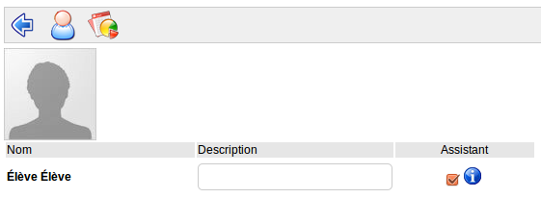Illustration 50: Course assistant
Permissions in a course | By default, he can:  - do whatever a learner can do  - see the answers of other learners, their assignments and their global results
Global permissions | By default, he can :  - do whatever a learner can do

The human resources manager (or supervisor)

Description | The human resources manager is a role given during the creation of a user (or later on in the user edition screen, but this might affect other permissions used until then). It is an exclusive role (it cannot be combined with another role). The aim of this role is to follow users, courses or sessions in particular, as a human resources manager would do with an employee he's been assigned to. It is an observation role. As such, he cannot modify anything.
Permissions in a course | See his students' results
Global permissions | By default, he can :  - follow the personal development of users (learners or teachers) which he's been assigned to, through the control panel  - follow the development of courses which he's been assigned to, through the control panel  - follow the development of sessions which he's been assigned to, through the control panel  - review users, courses or sessions details, but not modify them  - do whatever a learner can do

The course coach

Description | The course coach is a teacher who gives a course on the basis of a generic content that others have prepared for him, but on which he can extend with his own content.
Permissions in a course | By default, he can :  - accompany a users group inside a course (inside his session)  - follow the results of his students in his course (inside his session)  - mark and alter the results or assignments which are delivered to him inside the course  If authorized, he can :  - create new contents in the course (documents, exercises, learning paths, assignments, …) which will only be visible inside the session  - subscribe new users in his course (inside his session)
Global permissions | By default, he can:  - do everything a learner can do

The session coach (or session tutor)

Description | The session coach is a teacher who has a coordination role within a session. She communicates with other coaches in the session and can navigate into all the courses of the session in order to observe the users results and take the best decisions on he basis of more complete information.
Permissions in a course | By default, he can :  - do anything a course coach can do, in all the courses of the session  If authorized :  - register/unregister users into/from her session  - create content in each course (this feature is probably never really used, by respect for the active coaches)
Global permissions | Same permissions as a course coach

Teacher (or trainer)

Description | The teacher is the creator of courses by excellence. He creates content within a base course, and this content is either used directly (if you don't use sessions) or can be used in many sessions at the same time (in the case of sessions usage).
Permissions in a course | By default, he can:  - do administrative tasks inside his courses (copy/delete/rename/update)  - create all the contents of a course  - follow learners up inside his course  - register new learners to his course  - make some course tools visible/invisible to learners  If necessary :  - one can remove his right to create courses  - one can remove his right to register new users to his courses
Global permissions | By default, he can :  - create a course  - do whatever a learner can do

Sessions administrator

Description | The sessions administrator is an exclusive role (it cannot be combined with any other role) and is determined during the user creation or its later edition from the administration interface. This role is dedicated to the academical management of sessions of courses: he sets who will teach which course, at what time and to which learners.
Permissions in a course | Same permissions as a session coach
Global permissions | By default, he can:  - create/edit/remove sessions  - assign/unassign teachers as session coaches or course coaches  - follow the progress of users/courses/sessions through his control panel  - do whatever a learner can do  If authorized, he can :  - register new students on the platform

Portal administrator

Description | The portal administrator only makes sense if we use the multi-url mode (see 9.1Multi-URL on page 92). In this case, the administrator not authorized to modify all the portals is a portal administrator (as opposed to global administrator)
Permissions in a course | All permissions
Global permissions | By default, he can :  - Update all parameters related to his own URL  - Create/edit/delete all resources on this portal

Global administrator

Description | The global administrator is the all-mighty user. He can simply do anything. He has access to all interfaces.
Permissions in a course | By default, he can do anything.
Global permissions | By default, he can do anything (on all portals in the case of multi-url), including create other users, courses, sessions and... other portals.

Special case: the anonymous user
Description | The anonymous user is a very particular case: this user only exists to make the tracking possible for users who do not hold an account on the Chamilo portal. Thanks to this mechanism, the anonymous user can do most operations a learner can do, but only within courses marked as public.
Permissions in a public course | By default, he can :  - follow learning paths  - check visible documents out  - answer exercises or exams (results will not be show to the teacher)
Global permissions | By default, he can :  - open public courses  - see the list of public and private courses (but he can't officially subscribe to any of them)

There are a few special things you should also know about the aonymous user:
- it is the only role with an ID of 6 (if you search for anonymous users in your database, it's easy to find)
- anonymous users are shared by the anonymous people connecting to your portal.
- if you need public courses with tracking and it seems all your users are seeing weird live results when taking tests, this might be due to many anonymous users using the same entry in the database. You can reduce the impact of the number of users upon that tracking by creating more anonymous users. Just create them as student through the admin interface and set status=6 in the database

Users list
Here the administrator can manage all users in a simple click on an icon that we have seen previously.

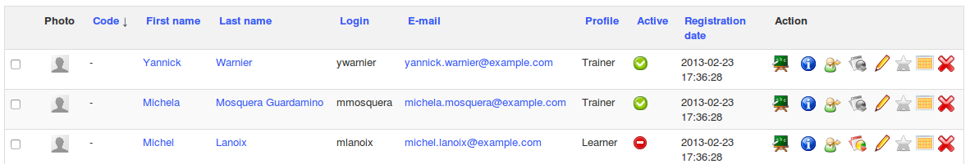Illustration 51: Administration – Users list
In order to visualise the users list in a clearer way, here is a reduced list of roles and types of options of which the administrator has access to regarding each of these roles.
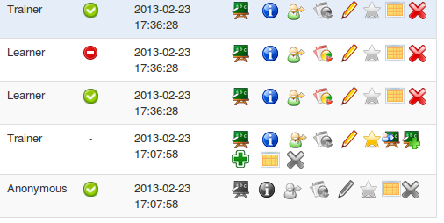Illustration 52: Administration – Users – Options by role

Learner
- Active/Inactive : a learner can be enabled/disabled at wish
- Courses list : a learner can be subscribed to several courses
- Login as... enabled for the learner
- Statistics : the learner is the only user role that can be tracked
- Edition : the learner account can be edited by the admin
- Administration : the learner can never be the administrator
- Free/busy calendar : shows the availability of the learner
- Removal : the learner account can be removed

Teacher
- Active/Inactive : a teacher can be enabled/disabled at wish
- Courses list : a teacher can be subscribed to several courses
- Login as... enabled for the teacher
- Statistics : the teacher cannot be “followed” any other way than through the control panel
- Edition : the teacher account can be edited by the administrator
- Administration : the teacher who would be administrator is administrator before anything else
- Free/busy calendar : shows the availability of the teacher
- Removal : the teacher account can be removed

Administrator
- Active/Inactive : an administrator cannot be disabled
- Courses list : an administrator can be subscribed to several courses
- Login as... disabled for an admin
- Statistics : the administrator cannot be “tracked” apart from the control panel
- Edition : the administrator account cannot be edited apart by the same administrator
- Administration : this user is administrator, as his star colour shows
- Follow users : only administrator-type users can follow the users progress (learners, teachers or administrator) through the control panel
- Follow courses : only the administrators can track the progress of a course through the control panel
- Follow sessions : only administrators can follow the sessions progress through the control panel
- Free/busy calendar : shows the availability of the administrator

Anonymous
The anonymous user is a particular case which only serves the purpose of allowing one of the non-subscribed users to benefit from the courses publicly made available. The number of tracking opportunities is thus reduced. Note that if no course is made public, this user account is useless and could be disabled (although this feature is not officially supported).

- Active/Inactive : the anonymous user can be enabled/disabled at wish
- Courses list : the anonymous user cannot be subscribed to courses
- Login as... disabled for the anonymous user
- Statistics : the anonymous user doesn't show statistics
- Edition : the anonymous user cannot be edited
- Administration : the anonymous user can never be an administrator
- Free/busy calendar : the anonymous user doesn't have a free/busy calendar
- Removal : the anonymous user account cannot be removed (to avoid system incoherences)

Additionally to these management options, it is possible to remove all or part of the users by selecting the check-box on the left of the user and removing him below, as in the users management of a course for a teacher.

Add a user
The administrator can add users by creating them out of an empty form. He will only need to give:
- « firstname »
- « lastname »
- « e-mail »
- « login »

There are, however, advanced options to which one should pay attention.

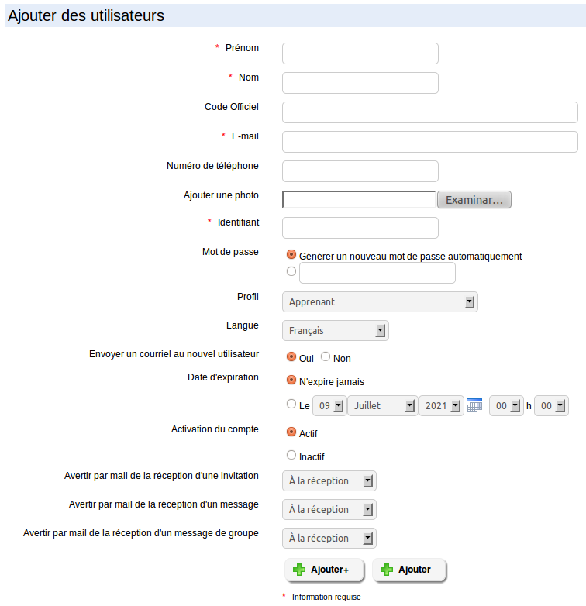Illustration 53: Administration - Users creation
The password can be automatically generated or can be assigned by the administrator. Depending on the needs of the situation, don't forget the option “Send an e-mail to the new user”.

The profile (or role) of the user is very important. See chapter 5.1User roles on page 55 for more info.

The user account can have an expiration date. In this case, one has to choose the end of the subscription period.

Finally, the user account can be created active or inactive, waiting for example for the start of a new sessions.
Three new fields have been added to Chamilo 1.8.8. These fields allow you to configure the frequency to which personal messages sent from the Chamilo social network to your account are sent to you by e-mail.
If the user picks No, then no message will be sent to his e-mail to notify him. This option requires the configuration of a chronological script launch (cron).

Export users list
In Chamilo, it is possible to export all or only some of the users.

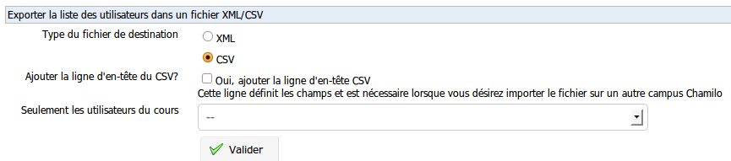Illustration 54: Administration – Users export
You can choose between two output save file formats: XML or CSV. Most users will use CSV, which can be read by MS-Excel® and OpenOffice.org Calc®.

Once you chose the format, it is recommended to check the “Yes, add the CSV header” option. Then you can pick a limited list of students to export (by course) or leave it as is to export all students of the platform. Click on Export to launch the export.

A new window opens to let you decide what to do with the file.

Import users list
Whether you have exported a list of users or not, you might want to import users into the platform...

Chamilo allows you to import the users using the same format in which it exported them, obviously, but you can also download two example files by clicking on the link (blue link in the following screen-shot). If you'd like to import users from an external source, the CSV format is generally an easy option as you can generate them with a simple spreadsheet tool.
Just
- download the example CSV file,
- open it with MS-Excel® and OpenOffice.org (or LibreOffice) Calc® as a CSV file
- choose the semi-column as a fields separator
- adjust your users list to the spreadsheet format to match the CSV example
- save in CSV format
- send it to the server using the form where you found the example files

To import a CSV/XML file, follow these steps:

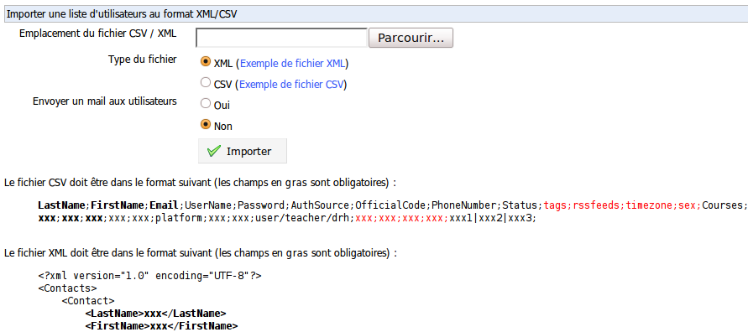Illustration 55: Administration – Users import
- in Browse, search for the file,
- choose the file format (CSV or XML),
- choose whether to send a welcome mail to new users created through this import,
- click on Import

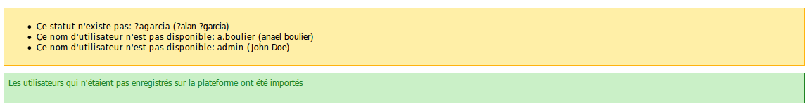Illustration 56: Administration – Users import report
The report message shows conflicts that might have occurred, and the list of users that might not have been imported.

Add groups

Chamilo integrates a Social network tool which allows you to create common interest groups where users will be able to discuss between themselves as on a forum. You can choose to create groups which can be either opened or closed.
Through the configuration settings, you can also decide to let users create their own interest groups.
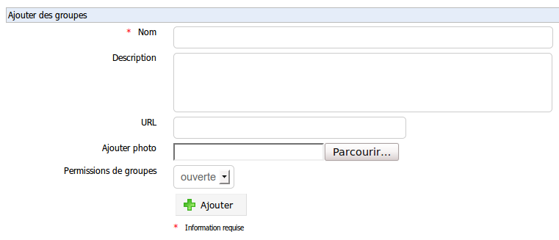Illustration 57: Administration – Social groups creation

Groups list
In this section, you can update or remove groups, and add users to a group thanks to icons we have already used previously.

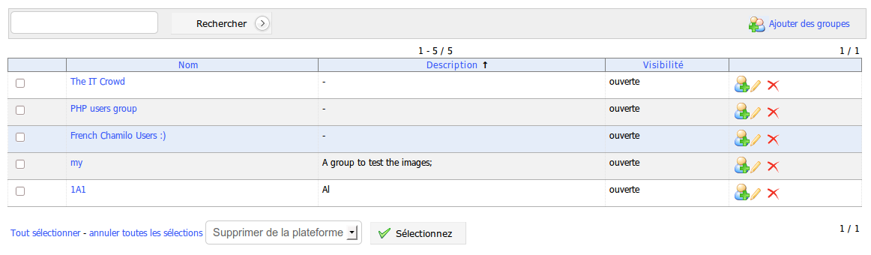Illustration 58: Administration – Social groups list
If you click the link of the group name, you'll be redirected to the Social network tab and the group page.

Profiling

This tool allows you to add extensions to the profile of all users. Each field created through this tool gives you a series of options:
- Visibility allows you to decide whether the field must appear on the extended profile page of the user (so that he can see – and maybe update - it himself)
- Modifiable lets you decide if the field can be updated by the user himself, or if the admin will assign a specific value for this field for all users
- Filter allows you to decide whether the field can be used as a filter and if it can be exported through exercises results exports

Usually, you can create fields of which the user has no knowledge but which are useful administratively to organise or synchronise the system with other systems (common unique identifier, for example). Other fields are submitted to the user, like his date of birth, country, mother tongue, etc., which will later allow you to generate better statistics depending on the age, culture, previous knowledges, etc.

For users familiar with Drupal, this is equivalent to a mini CCK module for Chamilo.

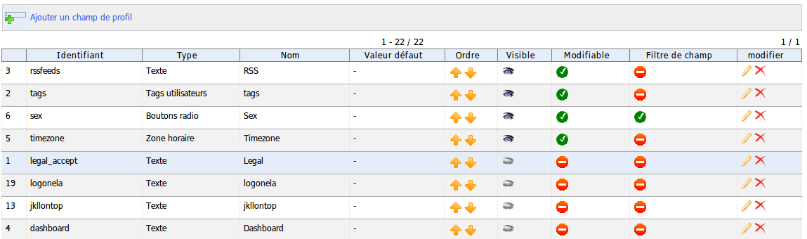Illustration 59: Administration – User profile fields list
Icons | Features
 | Update/Delete field
 | Make modifiable / non modifiable or enable/disable filter
 | Organise the fields
 | Show/hide a field to the user
Tableau 2: Administration – Profile fields management icons

Courses management
Courses are spaces within which teachers generate content using the 20-or so tools available to teach this content (and much more) to their student in a memorable, dynamical, multimedia and if possible entertaining way.

Courses can be used as timeless resources (and they are, most of the time), but they can also be inserted into a time-based context through the use of sessions (see Chapter 7. Sessions management on page 75).

Courses management can be done with icons you should already be familiar with at this time :

Icons | Features
 | Gives all information on the use of the course and its users
 | Gives a detailed tracking of the users, the course and resources report
 | Update the parameters or course details
 | Remove a course (after approval)
 | Generate or import a backup
 | Go to the course homepage
Tableau 3: Administration – Courses management icons

Courses list
This tool allows you to visualise all the courses contained on the platform.
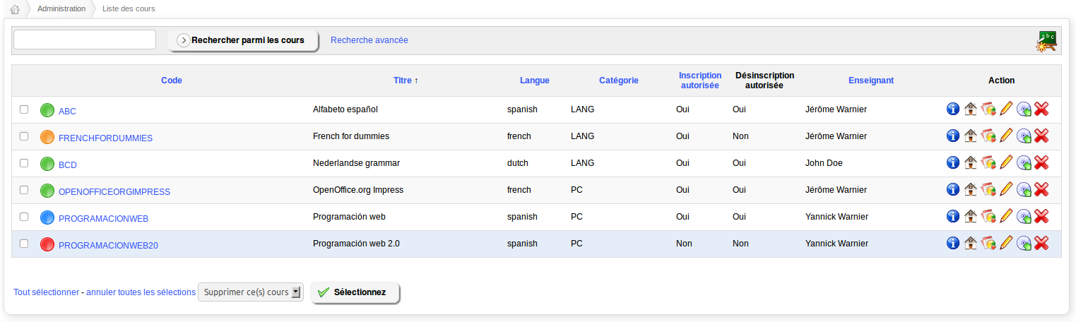Illustration 60: Administration – Courses list
This list gives us a great deal of information about the courses. Note the colours of the dots prefixing the courses titles: they represent the visibility of the courses:
- blue : public
- green : opened to platform users
- orange : private, users are subscribed by teachers or admins
- red : closed (for maintenance or expiration, generally), the course is not available except for course teachers and administrators
It also allows us to modify information in one click on an action icon on the right side.

From version 1.9.8 up, a new visibility: hidden (grey icon) allows courses to be hidden to everybody but administrators.

Update course details
To update the details of a course, click on the pencil icon on the right. As an admin, it is possible to change as many information as the teacher/creator of the course in the course settings.
However, the admin can also update the allowed disk space for the course and mark it as a Special course, which makes it visible on top of the list of courses for all users of the platform.

Tracking and backup
The tracking and the backup are the same for the admin as for the teacher (see Teacher guide).

These icons are shortcuts which send the admin inside the My courses tab.

Create a course
As an administrator, only the title is mandatory during the course creation.
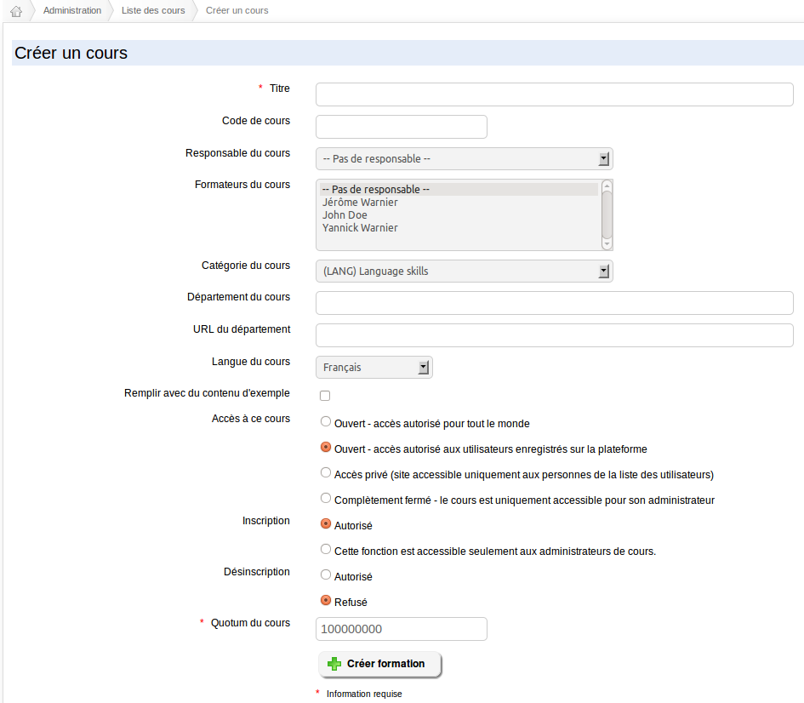Illustration 61: Course creation
Apart from this mandatory field, the following options are exclusively available to the admin:
- assign a teacher in charge of the course
- add one (or more) teacher(s) to the course,
- give a department and a department URL,
- manage its visibility,
- manage the registration and un-registration settings

Export courses

This feature allows you to export details of some or all the courses of the platform to the CSV format.

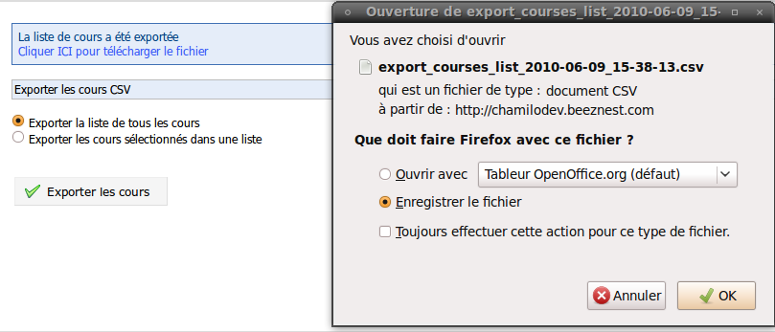Illustration 62: Administration – Courses export

Import courses list

This feature allows you to import a CSV file to create courses. If you use categories and you are importing the courses in another platform then the one you exported them from, you will need to ensure you have the same category codes on both portals.

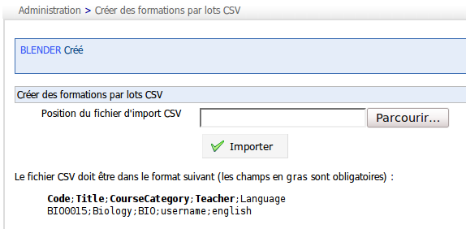Illustration 63: Administration – Creating courses by batches
Once imported, you will only need to fill learning paths.

Courses categories

You can create, update or remove courses categories through common action icons. It is possible to create numerous categories and sub-categories.

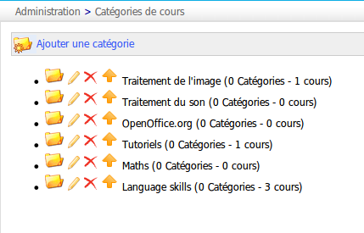Illustration 64: Administration – Courses categories
It is also possible to organise these categories thanks to the arrow icons. These categories are not internationalised, so if you use a multilingual portal, make sure the name or the categorisation of your courses is easy to understand for all users.

Add users to course
The admin can subscribe whomever to whichever course he wants:
- select one or several users in the list on the left (use CTRL or SHIFT to select multiple),
- Choose the course(s) to subscribe these users to,
- click Subscribe users to course.
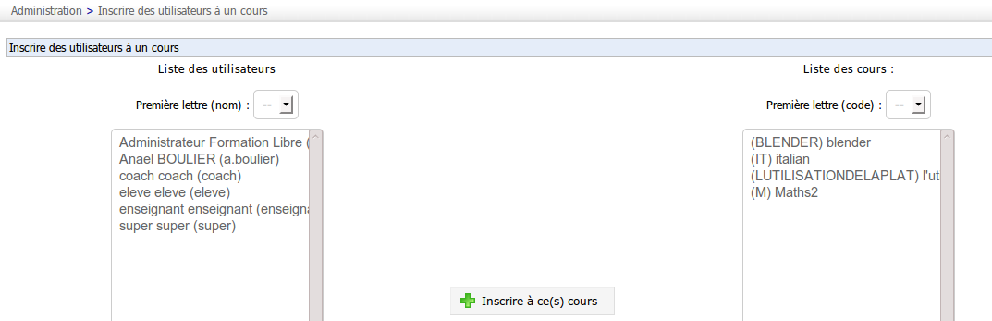Illustration 65: Administration – Subscribe users to courses

Import users list
This feature allows you, after a users export, to subscribe the users to another course directly with a CSV or XML file.

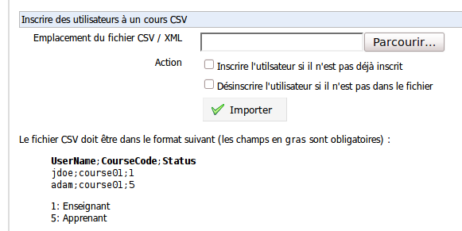Illustration 66: Administration – Subscribe users to courses in batches
This import allows you to execute two actions which will change the behaviour a little while importing.

Sessions management

A session is a mechanism which hover “above” one or several courses and allows groups of students to follow the same group of courses during the same period, in separate virtual spaces.

Sessions can group several courses of different categories.

The following schema has already been used in the users chapter to explain roles, but we will now use it in the context of Sessions.

Illustration 67: Global – Sessions schema
As you can see, the session is defined by a sessions administrator and has a general coach (also called the session coordinator, or session tutor in the schema) who watches over the session and assists teachers and students in need.
Several courses are registered to the session, each of them being taught by one or more course coaches (session-course tutor on the schema).
Although not clearly represented on this schema, a session allows you (optionally) to establish time limits for the coaches and learners of this session.

Use cases

There are several cases where the sessions can be a real time saver... but the whole concepts floats around one big advantage: content recycling.

The academic year
Let's imagine you work in a university in Europe. Every year, teachers teach new courses, but every year there is also a great number of courses which do not evolve much. These courses from last year could be recycled and used with the new group of fresh students coming in this year.

Without session, you'd have two options. The first one is to copy the course:
- copy the course to a new course, duplicate the 50MB of space (over and over),
- assign maybe another teacher and
- find a new course code that fits the fact that it's not entirely the same course but it's not really different either
- have your previous students remain with the previous course in their listing because it's not been “expired”
The other option is to clean the course up:
- remove all students from course
- remove all useless forums
- remove all useless wiki pages
- have your previous students remain without any access to the course they took last year

With the sessions, you change a little bit how it works:
- you define a session that spans the whole semester from January 2011 to July 2011
- you register 10 courses to it
- you register teachers responsible for these courses
- you register students in the session

This brings the following advantages:
- teachers can add content to the basic courses registered, but they cannot remove from them, and what they add is only visible to their students
- students must only be registered once to the whole 10 courses
- students will still have access to these courses after the semester is finished, but these courses will appear in their “sessions history”, which is on another page
- when you check the results or the forums, you will never have to distinct groups of students mixing up inside your course, because you selected a specific session to review

Personal tutoring
Let's say you work in a private college and most students have a right to personal tutoring. They can follow pre-recorded audio courses at their pace and have an assigned tutor which is available to them at any pre-agreed time.
Without sessions, you would have one course sharing several tutors and several students, and each tutor would share the “space” with others and would see the results of students he isn't in charge of. Worst, he could even modify the results of a students he isn't in charge of...

With the sessions, simply define one new session per student. Register the courses he has access to and his own coach to the session. These two will now be able to work in an isolated virtual space.

Corporate induction courses
You work as a company's human resources manager, and the “new guys” (5 new employees) come in and have to follow the “induction drill”, which consists of 7 small, 4h video courses, followed by an exam. Some of them, however, are going to work on the factory flour, where security regulations are not similar to the office regulations. This means 5 courses out of 6 will be identical for the 5 new employees, while 3 will have a “factory floor security” course, and 2 will have the “office floor security” course.
And to make it easier, this happens every month...

Because your 6 courses are all set, you “just” have to assign them to these courses. However, your management also requires you to be able to generate statistics on how well the new employees did pass the tests.

In a normal situation, you would stack up students into the 7 different courses, and repeat next month. However, as your requirements are to keep track of the progress of the whole employees database over time, you want to insert a time element here. Also, because some employees are factory workers (well, not really, but they do work a lot on the factory floor) and others are office workers, you'll want to configure a session dedicated to factory, and another to office.

Just create a “factory 2011-7” and an “office 2011-7” sessions, add your courses to it, then register the employees and... you're done. You can even use the promotions feature (in the next pages) to copy this session every month. This reduces management, improves readability of the results and allows your employees to access the induction courses whenever they want, at the cost of a single click, while still learning new courses every 3 months without having these old courses in the way.

Managing the sessions
Managing the sessions can be done with icons mostly familiar, and a few new ones...

Icons | Features
 | Update the settings/details of a session
 | Remove a session (after confirmation)
 | Subscribe users to a session
 | Add courses to a session
 | Add a session to a category
Tableau 1: Administration – Sessions management icons

Add a session

To add a session:
- go to administration,
- course sessions → « Add a course session »,
- give a name to the session,
- assign a coach who will have permissions to enter and follow all courses and learners inside this session,
- give a sessions category (optional),
- define whether there is a time expiry limit,
- give a few days of additional access for the coaches to the session,
- define the visibility of a session once expired:
  - read only (can access resources but not pass exams, answer forums, etc. anymore),
  - accessible (can be accessed freely, through the sessions history link on the courses list),
  - not accessible,
- click on Next step.
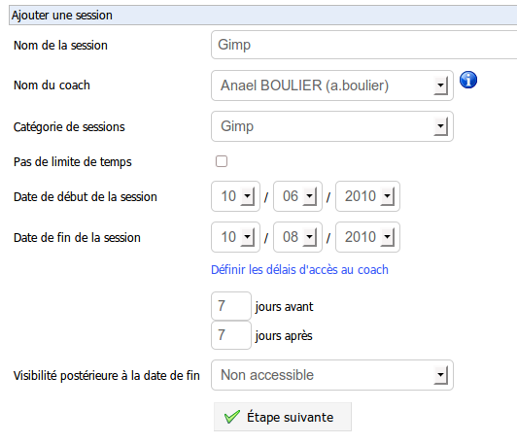Illustration 68: Administration – Session creation

The second step requires you to register courses to the session. Select one (or more) course(s) and click on the blue arrow button to add it (or remove it) then click on the Next step button to proceed.

Single registration allows you to not get lost within the courses that exist on the platform. You must write the start of the course title inside the search field and the corresponding courses will appear.
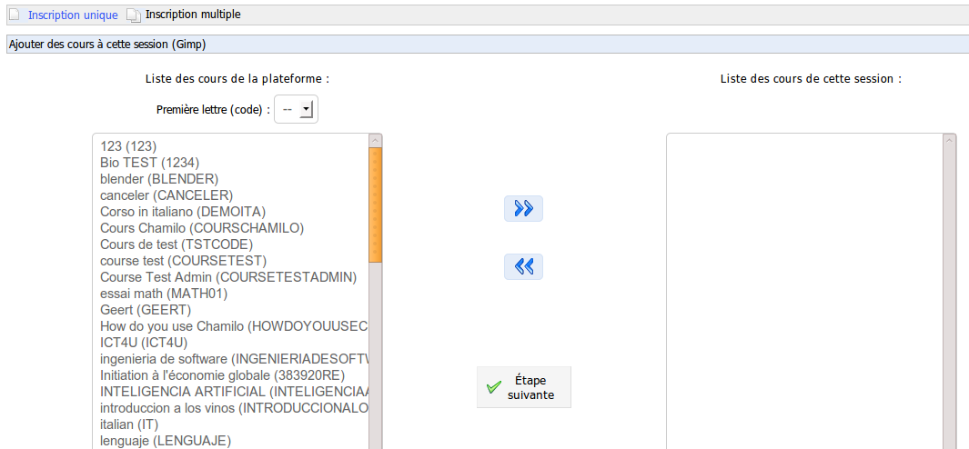Illustration 69: Administration – Registering courses into a session
The last step allows you to subscribe learners to the session (other coaches can be assigned later, this is just a learners subscription at this point).
Choose the users and, like for the courses, add them with the blue arrow button.

Single registration allows you to search for one user (by firstname or lastname).
Enrolment by classes allows you to register learners to your session by classes. Classes are defined in the next sections of this chapter.

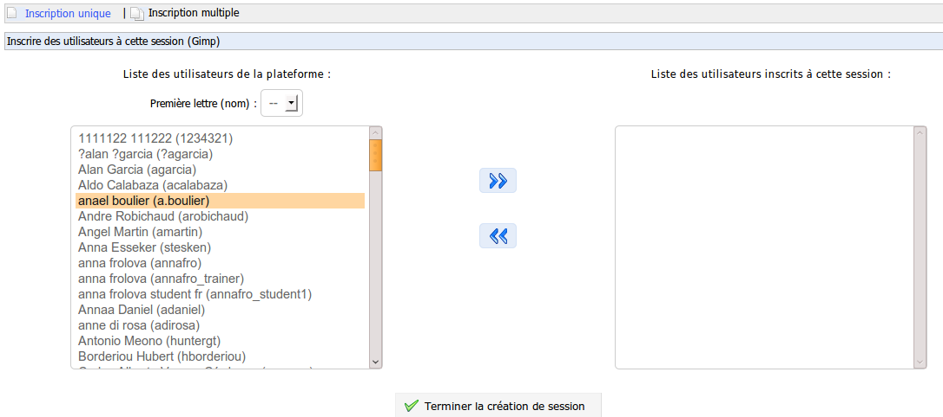Illustration 70: Administration – Subscribing students to sessions
Because of the special behaviour of course tools when used through sessions, we have written a technical report about how these should behave in the context of a session on our technical wiki: http://support.chamilo.org/projects/chamilo-18/wiki/Tools_and_sessions

Sessions categories (or periods)

Session categories are to be considered as any possible type of sessions categorisation. In our experience, however, they are mostly fit to group sessions together by periods of time (for example, the first semester of 2014). Of course, the type of time periods depends on the organisation using Chamilo. Sometimes quarter, sometimes semester, sometimes month or year.

The management of sessions categories is very similar to the management of courses categories, so we won't get into the details here. The only thing to know is that date of sessions categories are purely informational and do not bear any significance in terms of behaviour of the platform.

Export sessions list
Chamilo allows you to export a list of some or all of the sessions defined on the platform.
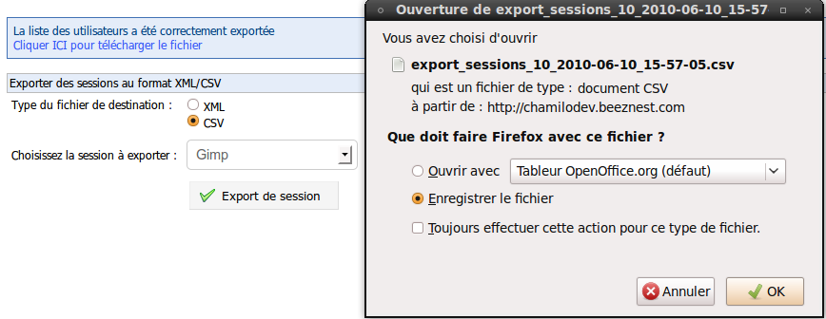Illustration 71: Administration – Exporting sessions
Choose the export format, choose a filter for the sessions, click Export session(s) and download the file.

Copy from course in session to another session

Given the possibility to define content in a course through a session and given the fact that this content will only be visible within this session, you will sometimes need to copy that session-specific content to another session containing the same course... and this is exactly what this tool does.

To use it, you must have an origin and a destination session, in which you can find the same course, from and to which you wish to copy the content of the session.

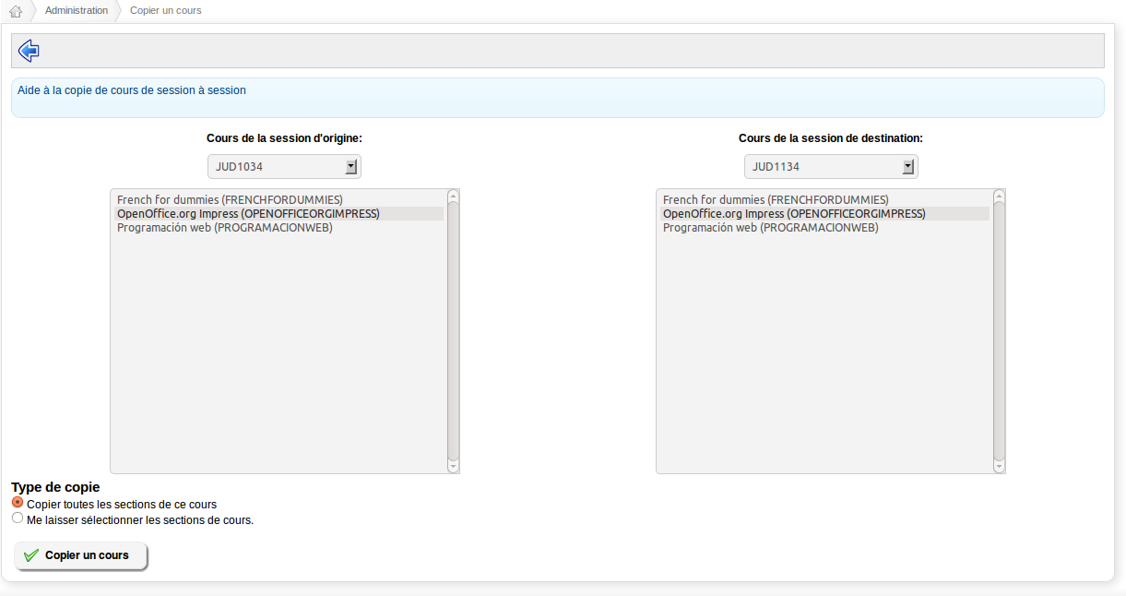Illustration 72: Copying course content from session to session
Once these conditions are met, you'll just have to select the session of origin, the course of origin, the session of destination and the course of destination, then decide whether you want all session-specific contents to be copied or only some of them.
Note : this tool is still in beta version. We recommend you use it with caution and you counter-check it does what you expected.

Move users results from/to a session

In the case you would want to move from a session-less mode to a session-full mode, you might (in exceptional cases) want to move a specific students' tracking data from a course-context to a session-context. This (still unstable) tool has been written exactly for that.
Its interface is complex but relatively self-explaining. If you have doubts, we recommend you take backups, act cautiously and maybe contact an official Chamilo provider to take care of it...

Careers and promotions

Careers and promotions are two new concepts in Chamilo 1.8.8. They allow you to manage careers (like “Medicine” or “Software engineering”) and promotions (like “Medicine, graduation of 2017”) almost the same way you would manage them in a normal academical institution once you combine them with sessions and periods (i.e. categories of sessions).
The interface of the tool is still a bit rough on the edges, and it will take you some time at first to find your way, but it is stable and you should be able to use it easily after a few minutes of practice.
Let's see how it's done...

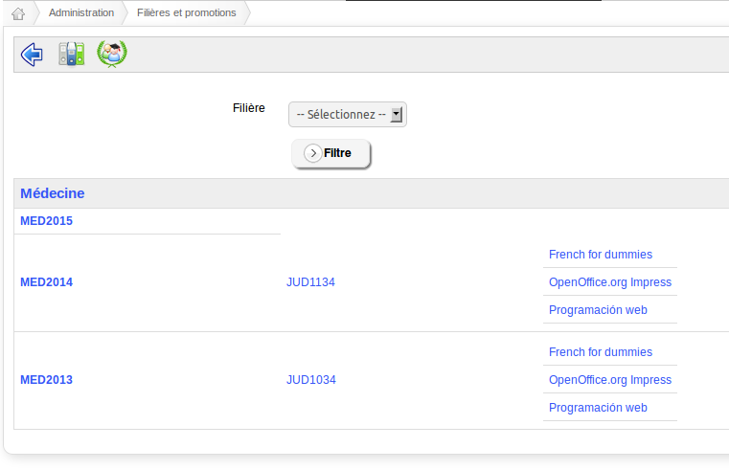Illustration 73: List of careers and promotions
The first page gives us a list of careers (grey-background line), of promotions that each career contains (first column), of sessions registered to these promotions (second column) and of courses included into these sessions (last column).
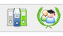

Careers

To add a new career, click on the tricolour folders icon. The following page appears.
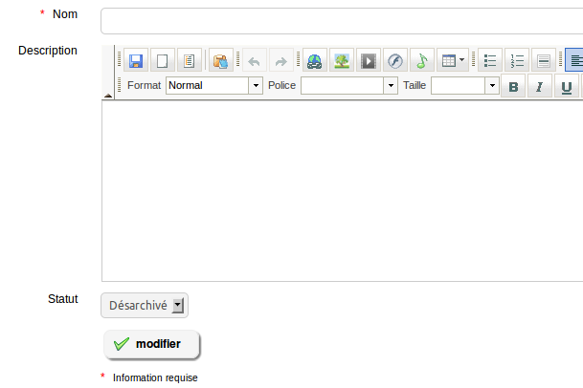Illustration 74: Career creation form

Only the career name is mandatory. Add a new career (e.g. Medicine) and save. The list of careers appears with an entry for the career you just created.
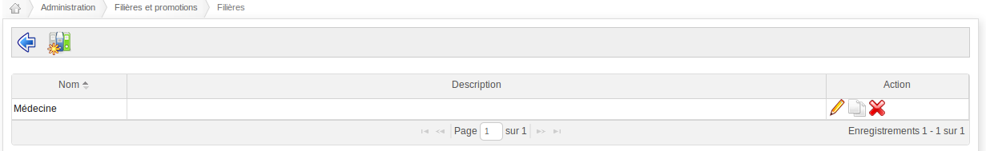Illustration 75: Careers list

This list highlights a double white page icon that allows you to copy a complete career and create a new one. The copy of a career also copies the whole underlying structure (promotions, sessions and courses) silently, which makes it a hugely powerful tool for administration.

To better understand the complete structure, including careers and promotions, let's try and represent them on the following schema (French labels should be easy to understand).
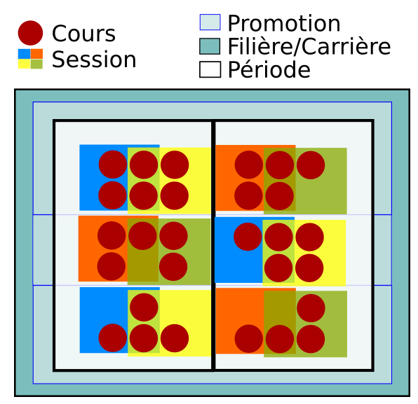Illustration 76: Courses, sessions, promotions and careers
Of all the entities at play here, only periods (categories of sessions) and promotions add at the same level (they group sessions together under a specific concept). If you take periods out of the equation for a while, the schema is probably easier to understand.

Promotions
The only two differences between careers and promotions is that a promotion can be included to a career, while a career cannot include sessions directly. Creating a promotion once you have created a career is then very easy.

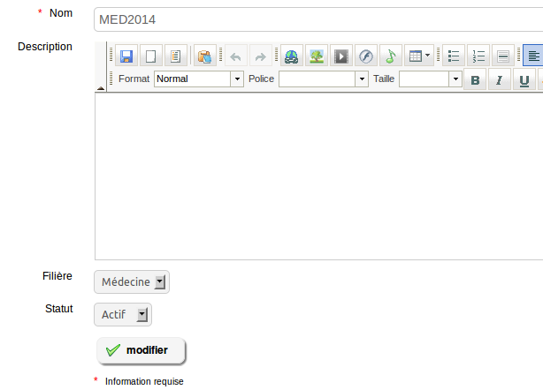Illustration 77: Promotion creation form
The creation of promotions is followed by the registration of sessions within these promotions, using the sessions icon for each promotion in the list of promotions.
One then obtains a list similar to the following (already show before).

Illustration 78: Careers and promotions list
On this page, we see our Medicine career, with its 3 promotions, one session in each promotion previous to 2015 and the list of courses of each session. Each element is a link to the corresponding resource.

Copy
Copying promotions or careers is made by using the lists of careers or promotions, by using a double-paper-sheet-shaped icon.
Note: for now, the copy of courses is a hard copy, which means you might loose considerable disk space by copying an entire career. Another mode is available (not yet enabled) to soft copy the courses through the sessions (use of the same courses through another session, which is just what sessions have been designed for).

Use case
Let's imagine your institution offers two careers: medicine and veterinary. These two careers last 5 years each. You are in August 2011, preparing the classes that will start in September 2011.

From year one (2011), you create promotion 2016 for both medicine (PROMMED2016) and veterinary (PROMVET2016).

Let's re-use the previous schema as a reference :
Illustration 79: Courses, sessions, promotions and careers
These two promotions will be the result of 5 years of study (let's agree that the minimum period of course is one year). You will thus have 5 periods of one year each, which lead to a promotion in 2016.

These periods are fixed and can thus be shared between the two careers. In your platform, these are categories of sessions, which you will name respectively 2011-2012, 2012-2013, 2013-2014, 2014-2015, and 2015-2016.
Of course, you can give them other names, as you would prefer to see them. Periods are simply classifications based on a time information. Nothing more. They aren't used to sort anything, either.

Within each period, your teachers will teach classes. Some courses are common to both the medicine and the veterinary careers, as the general biology course (BIOGEN), for example, but the course coaches who will be teaching still teach these students in separate groups depending on the career (that's just a matter of space in the classroom, really).

If a course is taught several years in a row with almost no modification, you don't want students results of the previous year to stack into the course history. You'd like to have a clear view on this year's students.

This is why you use a session. This session will spread one academical year and group students from the 2016 promotion of veterinary (PROVET2016), during the period 2011-2012.
These students will also follow courses of canine biology, medical ethics and medical laws. This is why you'd like to re-use this structure in other opportunities.

So you have all the variables required to establish the complete structure:
- create a career (VET)
- create a promotion (PROMVET2016)
- create a period (2011-2)
- create or select the courses for this promotion in 2011 (BIOGEN, BIOCAN, ETHMED, DROMED)
- create a session that contains these courses (VET2011-2-AAA)
- subscribe a session coach, who will deal with coordination
- subscribe a course coach for each course in this session, they will help with practices
- finally, subscribe the students to the session

This way, you allow your students to have access to their current courses, and also to have access later on to their history of previous courses (visibility depends on sessions settings).
On the administrative side, you have the whole academic structure and you'll be able to replicate the whole promotion in only one click when you start the next year...

Classes

Classes are a group of users (in general students). These groups can be assigned courses or sessions, so that all group users are subscribed personally to these courses or sessions.
Similarly, when you unsubscribe the class from a course or a session, each of the class users will be unsubscribed individually from the course or session.
Note : before 1.8.8, there was already a concept of class (slightly different), which was mutually exclusive with the sessions tool. Since version 1.8.8, it is possible to use classes in combination with sessions.
The classes interface is pretty basic. The list of classes is empty the first time. To add a class, just click the starred icon.

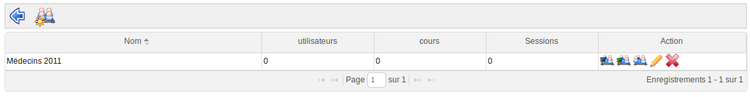Illustration 80: Administration - Classes – Empty list
The creation of a class requires only a name and an optional description.
You then come back to the list of classes to add users to them (through the users icon).

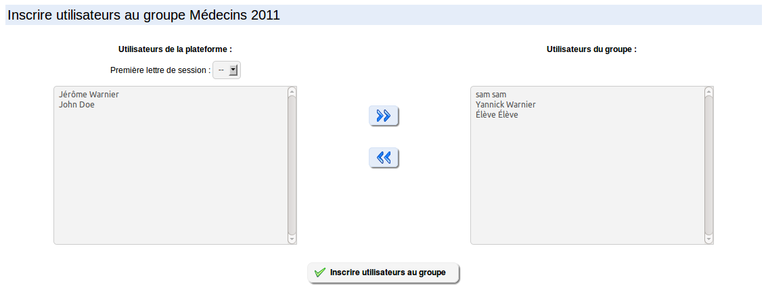Illustration 81: Administration - Classes – Adding users
The users subscription screen is similar to other users subscription screen you've seen before.
Once the users have been added, you can subscribe the class to one or more courses, and to one or more sessions.

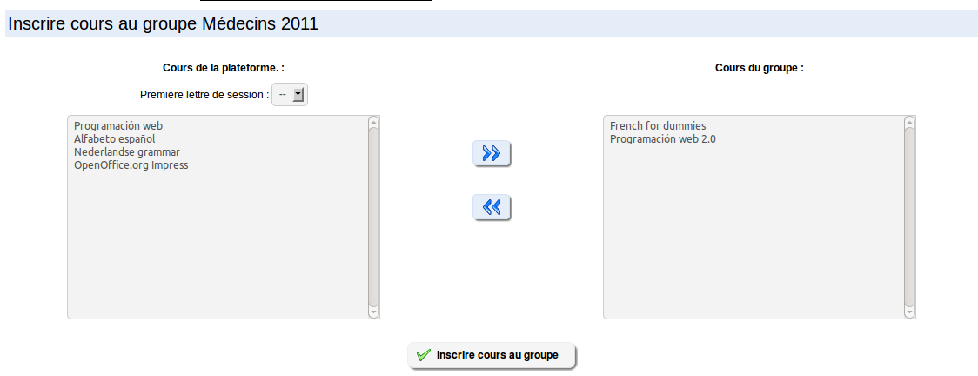Illustration 82: Administration - Classes – Adding courses
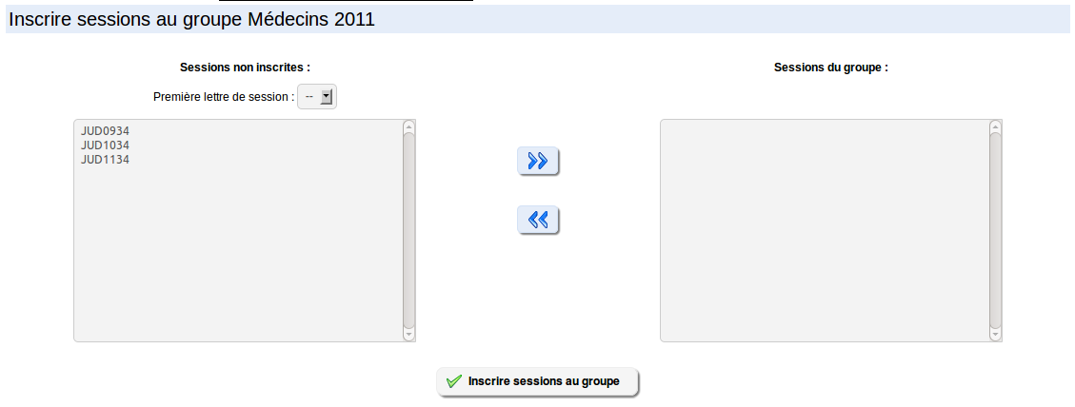Illustration 83: Administration - Classes – Adding sessions
Note that, as the sessions logic dictates, a class should never be subscribed to a course and to a session (which contains this course), otherwise you might end up confusing the student (and probably the teacher) with duplicated accesses in and out of a session.

System

Special exports
The special exports feature has been designed to help the academical inspector. It allows him to export all documents from all courses in one single (be it very heavy) operation. A second option allows him to choose the documents from the courses he wants.

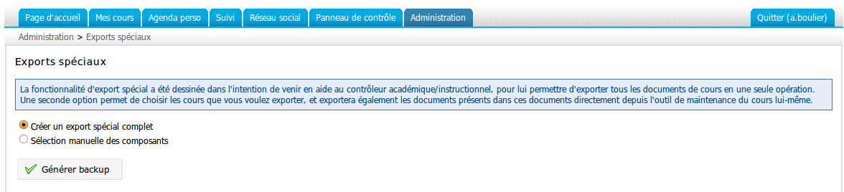Illustration 84: Administration – Special exports

System status
This section allows you to check a series of system variables and compare them to the recommendations made.
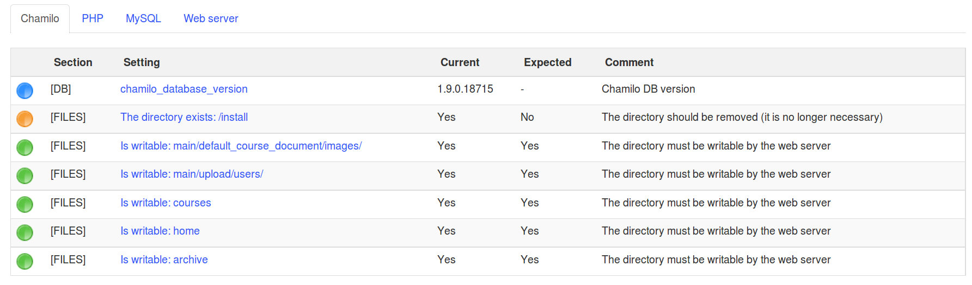Illustration 85: Administration - System status

Data filler
This feature is only available for development installations of Chamilo LMS (where the tests/ directory exists).
It allows the admin to fill the database with example data (users, courses, etc).

Archive directory clean-up
The archives/ directory is used to store temporary data. XLS exports, courses backups, etc. As such, and unless you have a cron job running regularly to clean it up, you should clean it manually once in a while. This link allows you to do just that, without requiring direct access to the files directory.

Global features

Multi-URL
Chamilo hides (within its many treasures) a discrete but practical feature in case you use your Chamilo portal for several categories of users, for which you have to consider making the portal available with a second domain name, another visual aspect and a pre-selection of only a few users and courses. An independent space sharing some of its content and all of its code, if you will.

For example, you might want to provide one Chamilo portal on http://one.campus.org/ and another one on http://two.campus.org/. Even if these are separate portal, you will probably have the same administration team managing all these, so it makes sense to share both the database and the files directory. This way, you even get to distribute users and courses over all portals as you please.

For those familiar with Drupal, this is not the same as a multi-site configuration, as Chamilo multi-url shares the database between all instances. It does provide multiple portals, but it is also more tightly bound through the database.

Use case – University faculties
Imagine the 12 faculties of your “John Smith University” (fictional name) want to show their portal under a distinct appearance (each one wants its own variation of the logo in the header and a background colour slightly different).
For example, you would have a general http://admin.jsu.edu/, then a specific law faculty: http://law.jsu.edu/, a sciences faculty: http://sci.jsu.edu/, etc.
Each one of them has its own teachers, whom, and I quote, “sometimes” have to give a course in more than one faculty. Students are also students from one single faculty (only a few “exceptional case” are not). Finally, courses are different, “except” in specific cases for very general courses...

Use case – Corporate branding
Imagine your company, KBTS (fictional name), offers health and safety courses for several customers. Imagine that one of your customers is Coca-Cola® and the other is Pepsi®. Maybe you don't want these two customers to know you are selling them the same course or that you are using the same portal to teach them. Of course, you would like to be able to re-use the same course (so as to not duplicate the amount of work), but without your learners seeing contributions from the learners of the other company... With multi-URL, you can set up cocacola.kbts.com and pepsi.kbts.com to serve that separation purpose.

The solution
We call this solution multi-URL. By enabling multi-URL, you enable the following mechanism:
- you use the same source code (so less maintenance)
- you use the same database (so less duplication of data)
- one “master” portal (which is not used directly by your customers) allows you to define “slave” portals
- each course is created inside a “slave” portal, and is only visible inside this slave portal
- each user is created inside a “slave” portal, is only visible inside this portal and has only access to this portal
- each slave portal uses a different domain name (or a different sub-domain)
- each portal can use its own graphic style
- one (or more) administrator can be assigned to each slave portal. This administrator doesn't have access to global settings, neither to the users and courses of other portals
- one session can use a global course, but each session only exists in one and only one portal

Using the same database, you benefit from these “extra features”:
- one course can be made “global” and be used through sessions on all slave portals
- one user (learner, teacher or administrator) can be given access to other portals by the global administrator

Installation
To configure the multi-URL mode, you will need
- access to your web server's configuration
- access to the definition of your domain names
- access to the Chamilo configuration file

The installation process is as follows
- update main/inc/conf/configuration.php by removing the comments marker before the line : $_configuration['multiple_access_urls'] = true;
- add ServerAlias directives inside your Apache's VirtualHost (see below)
- define domain or sub-domain names (DNS) so they point to your server
- [deprecated] add line “1,1” in your access_url_rel_user table (this line is not necessary anymore, starting from Chamilo LMS 1.9).
- go to the Chamilo admin page and follow the link Multiple URL portals
- redefine your main URL (replace localhost) and add the desired sub-portals, then add and enable a local administrator in each of them

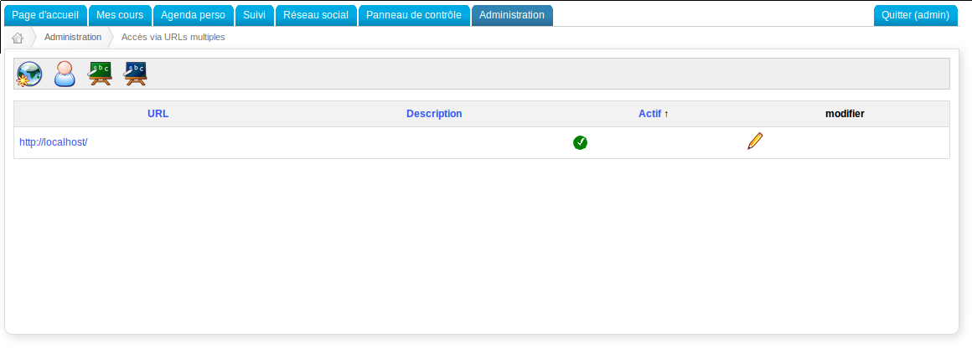Illustration 86: Administration - Multi-URLs
For two different Multi-URLs and one administrative one, based on the domain campusabc.com, the VirtualHost would look something like this:

<VirtualHost *:80>
ServerAdmin webmaster@campusabc.com
DocumentRoot /var/www/campusabc.com /
ServerName admin.campusabc.com
ServerAlias pepsi.campusabc.com
ServerAlias cocacola.campusabc.com
# other host settings here #
</VirtualHost>

Don't forget to always consider that your first portal will be a generic, administration, portal. You should preferably not use it for direct access by students. Declare something like admin.[domain-name] as the first host, then declare the URLs you will really use.

Video-conference
As previously indicated in the plugins section of this guide (see chapter 4.1.16 on page 47), the video-conference tool is not delivered together with Chamilo. You can easily install it and link Chamilo to it thanks to the BigBlueButton plugin, but this requires a dedicated server (or at least a server dedicated to something that is not critical).
To install the BigBlueButton video-conference server, we recommend you follow the instructions from the project's homepage: http://code.google.com/p/bigbluebutton/wiki/InstallationUbuntu

Once the video-conference installed and functional, you will have to know the public URL (sometimes just an IP address) and the secret key.
You will find the secret key tp use in the Chamilo plugin configuration in /var/lib/tomcat6/webapps/bigbluebutton/WEB-INF/classes/bigbluebutton.properties (look for Salt) or using the bbb-conf script on the videoconference server.

Once these two pieces of information are in your possession, go to the Chamilo settings, Plugins section. Enable the BigBlueButton plugin and save. Reload the page so that the new “Extra” category of settings appears in the action bar on top of the page (a magic wand) and click on it. Enter your video-conference server's information. Now you only need to check the integration by going into a course and clicking the Video-conference link.

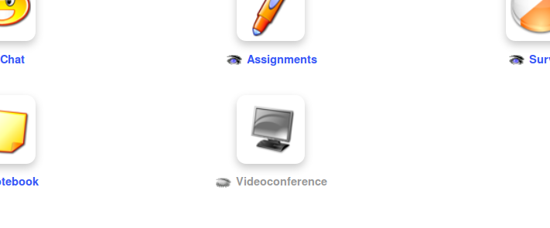Illustration 87: The videoconference tool inside a course

Course teachers and coaches are the only ones who can start a video-conference room. They are also the only ones to have the moderator status inside the conference.

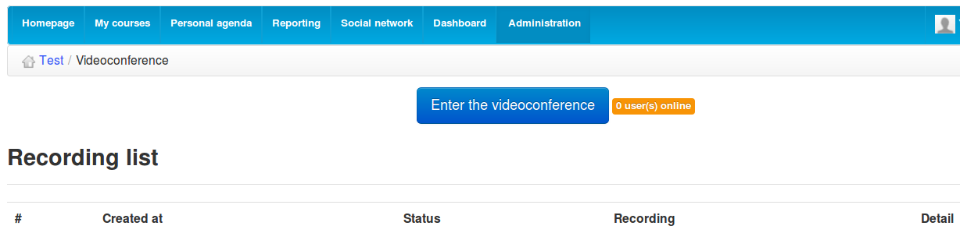Illustration 88: Videoconference tool's page with list of recordings

Learners cannot connect in video-conference if their teacher has previously started a room (otherwise, clicking on the video-conference link will just reload the course homepage).

If you want to enable recordings (which will use considerable space on your videoconference server), you will need to go to the course settings tool and enable the feature.
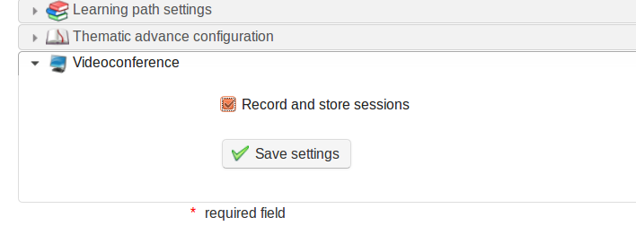Illustration 89: Videoconference course setting for recording

If you can't install it, don't hesitate to contact the Chamilo's official providers who will gladly rent you an access to their pre-configured video-conference servers.

Note: In Chamilo up to version 1.9.4, there was a bug in the plugin which prevented the use of audio. In subsequent versions up to 1.9.6, another minor bug prevented the videoconference to work for more than 30 minutes. This was fixed in version 1.9.8 and increased to 5 hours (search for “300” in plugin/bbb/lib/bbb.lib.php to customize).

Chamilo Rapid
The PowerPoint® or Impress® presentations conversion to learning paths is relatively complex to install the right way. There's only one known short-cut: install an OpenOffice.org or LibreOffice version 3 and the screen command.

$ sudo apt-get install libreoffice screen

Then launch the following commands

$ screen
$ sudo soffice -accept=”socket,host=127.0.0.1,port=2002,tcpNoDelay=1;urp;” -headless -nodefault -nofirststartwizard -nolockcheck -nologo -norestore &

ctrl-a + ctrl-d

Any finer explanation would largely be out of the context of this guide, but this recipe works well on Ubuntu server.
Note: the installation of the video-conference server already includes the installation of the OpenOffice.org server on port 8100, so if you have installed it, you won't need the command above. Just configure Chamilo to use the presentations conversion server from port 8100.

Once configured and running, you will be able to convert PPT from inside your courses' learning path tools.
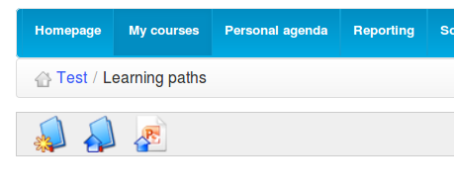Illustration 90: Rapid conversion icon in learning paths tool

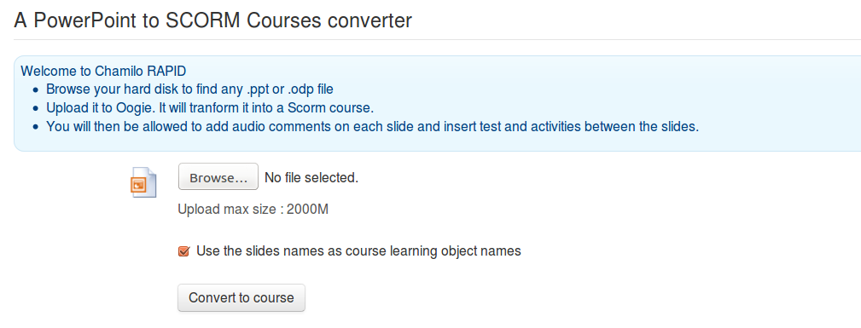Illustration 91: Learning path import PPT screen
Once imported this way, a PowerPoint or Impress presentation will be transformed to a full learning path, ready to be further edited and structured, then published to learners.

If you're stuck with the installation of this service, don't hesitate to ask one of our official providers to give you a hand or rent you one of their pre-configured servers.

Style sheets

As mentioned in section 4.1.14 Stylesheets on page 46, the Chamilo styles can be updated through a simple copy of any of the existing styles located in chamilo/main/css/. You'll find a series of styles directories in this directory, e.g. chamilo_green, which can be copied, renamed and modified at wish. To test them, just go to the Stylesheets section of your portal configuration page, upload your style as a .zip file and select the style uploaded, then save.

Templates
Since version 1.9, Chamilo uses the Twig templating system to generate parts of its visual appearance.
This means that you can now change Chamilo more easily. For example, the following screenshot is taken from a Chamilo 1.9 installation modified through templating. Although most visual changes can be done through CSS, there is a number of things that can just not be done this way, like showing new visual elements.

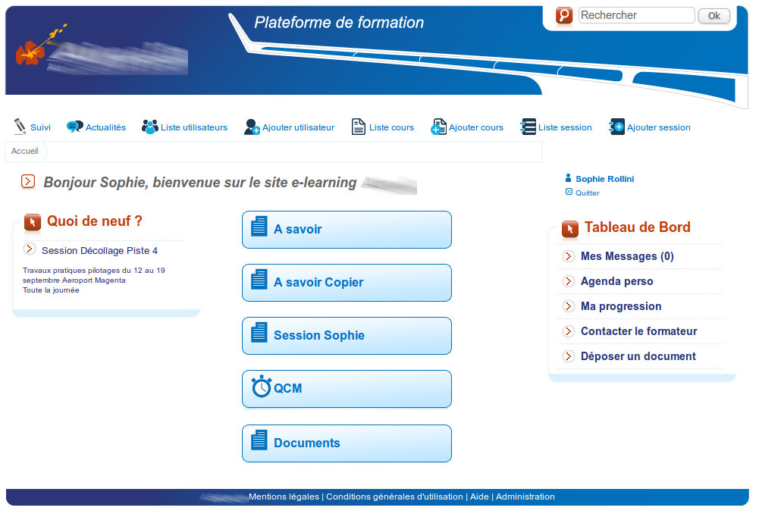Illustration 92: Example portal using another template
As you can see, classical elements of Chamilo have been moved around, shown or hidden depending on the desired final appearance.
To update a theme, we recommend you start with a copy of the existing one:

cd /var/www/chamilo/main/templates/
cp -r default mytemplate

Then you can start looking into that theme. You'll find that most header and footer elements are located in the layout directory. For example, the whole visible header on the page is declared in main/templates/default/layout/main_header.tpl.
Understanding the templates mechanism should be relatively easy if you have any experience with other templating systems.
Templates (ending in .tpl) will look something like this:

<body dir="{{ text_direction }}" class="{{ section_name }}">
<noscript>{{ "NoJavascript"|get_lang }}</noscript>

{% if show_header == true %}
<div class="skip">
<ul>
<li><a href="#menu">{{ "WCAGGoMenu"|get_lang }}</a></li>
<li><a href="#content" accesskey="2">{{ "WCAGGoContent"|get_lang }}</a></li>
</ul>
</div>

All {{ something }} markers are prepared into other scripts or libraries. Most of the very common tags are defined in main/inc/lib/template.lib.php, with an “assign” call, like this:

$this->assign('show_footer', $status);

In order for you to be able to test your new template, you will have to change line 13 of main/inc/lib/template.lib.php to replace 'default' by the name of your new template's directory (using the example above, it would be mytemplate).
During the development of a new template (which we recommend you do on a separate portal, not your production portal), you should disable caching. You can do that in a series of ways, but the easiest is probably to just put your portal in “test server” mode. You can do that in the first page of the Platform settings (option called Server Type).

Web services
Chamilo LMS offers a series of web services, which have been extended over time. Although the current basis is not well organized, you should be able to find what you're looking for easily in the main/webservices/ directory.

More details about all our web services are available on our wiki: http://support.chamilo.org/projects/chamilo-18/wiki/Web_services

Between others, the current SOAP web services (but we also have some REST and XML-RPC services available) allow you to:
- create, edit, enable, disable and delete users
- create, edit, enable, disable and delete courses
- create and edit courses' descriptions
- create, edit, enable, disable and delete sessions
- subscribe or unsubscribe users to courses or sessions
- subscribe courses to sessions
- get a list of courses

The services already implemented also allow you to easily extend and build your own. Check the main/webservices/registration.soap.php file for a starting point. More structured scripts are around, but registration.soap.php is the one implementing the highest number of features at this point.
If you happen to develop new services, please consider sharing them with us at http://support.chamilo.org/projects/chamilo-18/issues (open an issue and file a Feature suggestion with your code – we will “credit” you for this).

The testip.php script will allow you to identify your own IP for the setup procedure described on the wiki.

The Prestashop plugin
If you want to turn your Chamilo portal into an online shop for courses... you can't. Well, you can't do that directly, but there is an easy way to avoid that problem: using a real online shop system and connecting it to Chamilo.

Prestashop is a very popular, free software, online shop system that will allow you to setup your own online shop in a few hours.

Once you've got your shop installed and configure, go download the Chamilo plugin for Prestashop. On the plugin's wiki, you'll find a very extensive and simple installation guide to help you through the configuration. Once it's all configured, you'll be able to charge students to access your courses.

At this time, the plugin doesn't work with sessions, so you will sell an unlimited access to your courses, but we hope to have this plugin extended in this direction in the future.

The Drupal plugin

If you use Drupal, you will probably like the fact that we have a Drupal plugin with a series of features, like Single Sign On, printing of courses blogs, personal events block, etc.
The current plugin is undergoing a review at the time of writing these lines, but you can get more information in the issue queue of the plugin: http://drupal.org/project/chamilo

Logging in with OpenID
An OpenID feature is available inside Chamilo. It is not as complete as other OpenID implementations around, but if you want to enable it you will have to follow a series of steps:
- enable the OpenID login in the Portal settings page, Security section
- make the OpenID field editable by the user from the Portal settings, Users section
- each user will need to indicate and save his own OpenID identifier in his profile.
Work has been started to improve this, but it is likely to only be available in Chamilo 1.10 (because it requires database changes).

Securing your site with SSL / HTTPS
As Chamilo LMS has grown more popular in the last 12 months (roughly 400% increase in number of users), we have received several indications of password theft and that the security of Chamilo might be in question. Check out our Security in Chamilo LMS section (10.2) in the Appendix for more information about security in Chamilo.

The weakest link so far with our Chamilo portals has been the infrastructure, in that students can (relatively easily) steal accesses from a teacher connecting to the platform from the same computer room (due to some characteristics of network equipment). There are many ways to get to “spy” on the communication of another user with the server, and one of the most secure ways to avoid this kind of theft is to encrypt the whole communication between the user and the Chamilo server.

This can be done through SSL (or more commonly called HTTPS for the appearance of an “s” in the URL of those portals), a secure and standard way to encrypt any HTTP communication on the web.

Sadly, because of the inherent security of the system, an SSL certificate (required for the secure communication to happen) has to be “signed” (virtually) by a recognized authority, for a limited amount of time. This implies (in most cases until now) payment to said authority of a fee to sign the certificate. In other words, a certificate is not free and it is not permanent. For example, a simple (lowest-level of security) certificate, just for a single domain name, might cost between $25 and $100 a year.

You can “self-sign” your certificates, but this will show a scary screen to all users the first time they access the portal, and it will ask them to take a decision. The users will have to click a minimum of 3 times in very specific options in order to get to the site, as illustrated by the following screenshots.

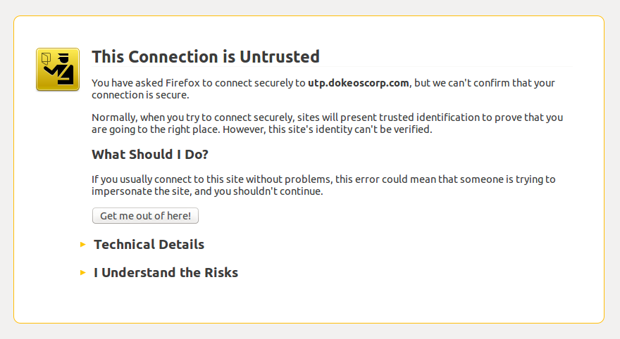Illustration 93: Browsers warn users of self-signed SSL certificates: Step 1/3: click on the “I Understand the Risks” link (example with Mozilla Firefox)
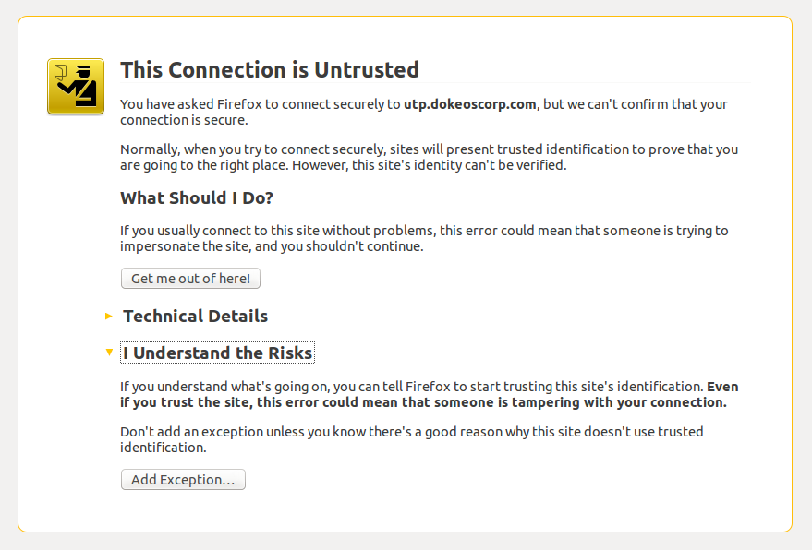Illustration 94: Browsers warn users of self-signed SSL certificates: Step 2/3: click the "Add Exception" button
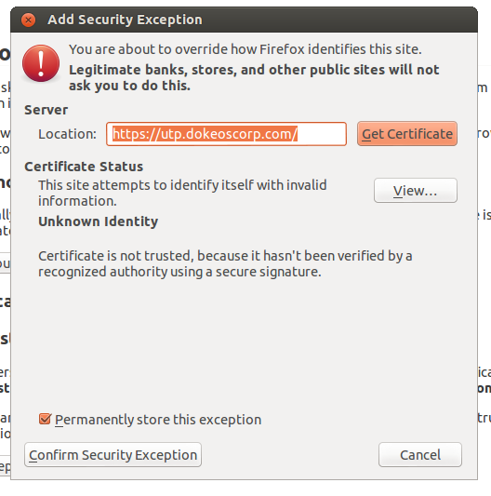Illustration 95: Browsers warn users of self-signed SSL certificates: Step 3/3: click "Confirm Security Exception"
These rather scary three steps completed, your user will have access to your site with an encrypted connection, but the process will not work for everyone.

To avoid these messages, you will need to purchase an SSL certificate (we have had some reasonable success with RapidSSL so far, but it is entirely up to you to choose the right SSL certificates provider for you).

If you'd rather go for a self-signed certificate because your team will be a finite number of people using it and you know they're able to manage the 3 steps of certificate acceptance, then you can follow this article to set it up: https://beeznest.wordpress.com/2008/04/25/how-to-configure-https-on-apache-2/

There is no more secure and practical way of securing your connections than SSL, so don't try to implement your own security mechanism. If you have comments about SSL, you should contact directly with the community managing the standard.

Optimization
If you ever run into efficiency issues and you have full access to your server, you might want to look into optimizing your Chamilo installation.
If so, have a look at the documentation/optimization.html document, as it has been designed to help out in these types of situations.

Appendix

Frequently asked questions

Sending e-mails from the platform doesn't work
Under Windows, you are required to configure the main/inc/conf/mail.conf.php file to use an SMTP server. The file is quite understandable. If you use an SMTP server with authentication, configure smtp_auth to 1 and define a user and a password. If you use an open SMTP server, set smtp_auth to 0.

Under GNU/Linux, you can choose to use an SMTP server like under Windows. Alternatively, if your browser allows it, you can use a local mails server. To configure one under Ubuntu, you can follow the documentation on the BeezNest blog: http://beeznest.wordpress.com/?s=exim4

How do I prevent teachers to subscribe or unsubscribe learners into/from their courses?
Locate and change the “Allow User Course Subscription By Course Admininistrator” option in the admin settings.

How do I block access to the course catalog for learners?
Locate and change the “Learners access to courses catalogue” option in the admin settings.

How much bandwidth does the videoconference tool (BigBlueButton) consume?

This depends on the features of the videoconference that you will be using, and how many people will use it simultaneously. Check http://code.google.com/p/bigbluebutton/wiki/FAQ#Bandwidth_Requirements for a comprehensive guide on how to calculate it. The BigBlueButton recommends, if you have no idea what load you will be dealing with, to aim for around 100Mbit/s.

Security in Chamilo LMS

While Chamilo is free software (and thus anyone can access its code), you can rest assure that security is a very important element for the development team and the official providers. This section gives you a few facts about security that you might be interested in knowing if you ever have to defend Chamilo against proprietary software.

First things first. Proprietary software generally means that the source code is hidden, or “obfuscated” by compilation. This means that you cannot “just” download the application and look through the code.
Open Source and Free Software software means that you can see the source code, which also means, in theory, that you can more easily find its weaknesses and, eventually, exploit them.

There's something inherently wrong about the conception that people have about proprietary software, though: it is not difficult to get to the source code. As many articles will explain, there are many de-compilation tools that will allow you to analyse the code of any compiled application.

Another case is when you use web applications, where users do not have access to the code at all. Free Software provides this code for download, which means a free software web application is more easily analysed than a closed source application. And that part is true.

The second huge misconception is that an application that doesn't reveal its source is more secure than an application that does. This isn't true, and comes, in a way, from the “web 2.0” effect: a system with open sources is more easily reviewed by people with interests in making it more secure, and the sharing of common security concepts across the different open source projects make it easier to protect a piece of software from malicious attacks.

Let's analyse this with facts: on Secunia's (an agency specialized in software security) website, you can find all security vulnerabilities reported publicly. Every report, when left unsolved long enough, gets a unique “CVE” code, which identifies the vulnerability and allows references to it later on.

Chamilo, since its creation and until now, has never laster more than 4 calendar days to solve a new security flaw reported to them. You can check the report here: http://secunia.com/advisories/product/34198/

A proprietary product in the same category, for example Blackboard® Learn 9.x (it's latest version), has yet to fix a security issue published in July 2012 (8 months ago): http://secunia.com/advisories/product/41718/?task=advisories. It's Academic Suite still suffrs from a security flaw reported in July 2008: http://secunia.com/advisories/product/18189/?task=advisories

The code of Blackboard is not only compiled: it is also not downloadable, so attackers cannot access it directly. Nevertheless, security flaws can still be detected, reported and remain unfixed for years.

The strength of the security chain is the one of its weakest link, and most of the time this link is the human laziness. We have never, so far, received any report of security flaws being exploited in Chamilo, but we did receive several reports of password theft, provoked by a bad infrastructure or just by distraction.

In conclusion, Chamilo is just as safe, if not safer, than equivalent proprietary software. If you want to avoid security issues, make sure you use password that are difficult to guess, and to always connect on a secure network. Check the SSL chapter on page 101 for a few tips.

Database structure

If you are interested in the database structure for Chamilo 1.9, please check our wiki for the full schematics: http://support.chamilo.org/projects/chamilo-18/wiki/Database_schema. Just know that there are around 180 tables, with a lot of interconnections, so make sure you get it right before trying to tamper with it. There are different mechanisms to develop plugins based on the current structure, without modifying it. Please contact the developers through IRC (see our website's footer) or though http://support.chamilo.org/projects/chamilo-18 if you feel lost.
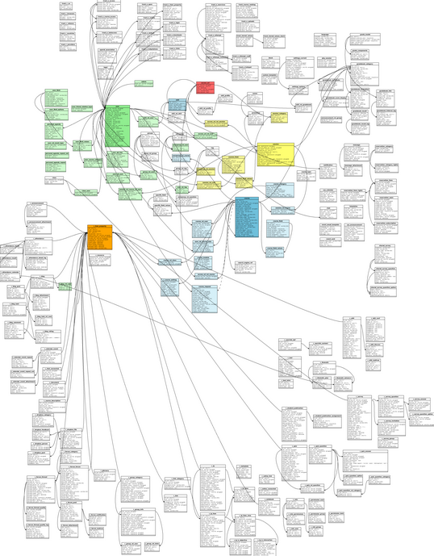Illustration 96: Chamilo LMS 1.9 database structure
The database structure has changed dramatically between Dokeos or Chamilo LMS 1.8 and Chamilo LMS 1.9. We moved everything into one single database with no table replication, which is giving us a series of new opportunities for inter-courses mash-ups now.

It is important to note that the database structure does not change between Chamilo LMS minor versions. Not a bit. This comes from a difficult-to-manage but very useful decision taken at the developers level to make sure users can easily upgrade from one version to another without risks of causing data losses or degradation.

So, if you have a Chamilo LMS 1.9.0 install, you can upgrade to 1.9.2, 1.9.4 or 1.9.6 easily, and your database structure will not change at all.

Accessing the database

We highly recommend you never access the database directly and always use Chamilo's admin tools to alter your data. This will ensure data integrity and will allow any administrator to safely an quickly analyse your data in case of problem.

We do, however, acknowledge the need to access the database in some very specific circumstances to execute large operations faster.

To do this, we recommend using applications that do not require too much work for installation and configuration, like adminer.php. Adminer is a small, one-script application that allows you to connect to your database, execute SQL operations, then remove the file when you're done. This way, you do not make your database server vulnerable to remote attacks for longer than required, and you do not increase the complexity of your system.

Configuration settings list

Title | Description | Default
Platform
Organization name | The name of the organization (appears in the header on the right)
Organization URL (web address) | The URL of the institutions (the link that appears in the header on the right)
E-learning portal name | The Name of your Chamilo Portal (appears in the header)
Portal Administrator: E-mail | The e-mail address of the Platform Administrator (appears in the footer on the left)
Portal Administrator: Last Name | The Family Name of the Platform Administrator (appears in the footer on the left)
Portal Administrator: First Name | The First Name of the Platform Administrator (appears in the footer on the left)
Platform Administrator Information in footer | Show the Information of the Platform Administrator in the footer?
Session's tutor's data is shown in the footer. | Show the session's tutor reference (name and e-mail if available) in the footer?
Show teacher information in footer | Show the teacher reference (name and e-mail if available) in the footer?
Server Type | What sort of server is this? This enables or disables some specific options. On a development server there is a translation feature functional that indicates untranslated strings
Who's Online | Display the number of persons that are online?
Registration | Is registration as a new user allowed? Can users create new accounts? | Yes
Registration as Trainer | Can one register as a trainer (with the ability to create training)? | Yes
Lost password | Are users allowed to request their lost password?
Display Code in Training name | Display Training Code in training list
Display trainer in training name | Display trainer in training list
Portal Administrator: Telephone | The telephone number of the platform administrator
Enable learner view | Enable the user view, which allows a trainer or admin to see a training as a participant or user would see it | Yes
Page after login | The page which is seen by the user entering the platform
Time limit on Who Is Online | This time limit defines for how many seconds after his last action a user will be considered *online*
Example material on training creation | Create example material automatically when creating a new course
Account validity | A user account is valid for this number of days after creation
Use training sessions | Training sessions give a different way of dealing with training, where training have an author, a coach and learners. Each coach gives a training for a set period of time, called a *training session*, to a set of learners who do not mix with other learner groups attached to another training session. | Yes
Show email addresses | Show email addresses to users
Show training number | Show the number of training in each category in the training categories on the homepage
Show empty training categories | Show the categories of training on the homepage, even if they're empty
Show back links from categories/training | Show a link to go back in the training hierarchy. A link is available at the bottom of the list anyway.
Show training languages | Show the language each training is in, next to the training title, on the homepage training list
Display categories on home page | This option will display or hide training categories on the portal home page
Tabs in the header | Check the tabs you want to see appear in the header. The unchecked tabs will appear on the right hand menu on the portal homepage and my training page if these need to appear
No-reply e-mail address | This is the e-mail address to be used when an e-mail has to be sent specifically requesting that no answer be sent in return. Generally, this e-mail address should be configured on your server to drop/ignore any incoming e-mail.
User theme selection | Allow users to select their own visual theme in their profile. This will change the look of Chamilo for them, but will leave the default style of the portal intact. If a specific course or session has a specific theme assigned, it will have priority over user-defined themes.
Display closed training on login page and portal start page? | Display closed training on the login page and training start page? On the portal start page an icon will appear next to the training to quickly subscribe to the training. This will only appear on the portal start page when the user is logged in and when the user is not subscribed to the portal yet.
Show session coach | Show the global session coach name in session title box in the training list
Allow non admin to create training | Allow non administrators (trainers) to create new training in the portal
Learners access to training catalogue | Allow learners to browse the training catalogue and subscribe to available training
Enable terms and conditions | This option will display the Terms and Conditions in the register form for new users
Email alert, of creation a new course | Send an email to administrator of the platform, each time the teacher register a new course
Show link to report bug | Show a link in the header to report a bug inside of our support platform (http://support.chamilo.org). When clicking on the link, the user is sent to the support platform, on a wiki page that describes the bug reporting process.
Training validation | When "Training validation" feature is activated, a teacher is not able to create a training alone. He/she fills a training request. The platform administrator reviews the request and approves it or rejects it.  This feature relies on automated e-mail messages; set Chamilo to access an e-mail server and to use a dedicated an e-mail account.
Training validation - a link to the terms and conditions | This is the URL to the "Terms and Conditions" document that is valid for making a training request. If the address here is set, before sending a training request the user should read and agree with these terms and conditions.  If you activate Chamilo's module "Terms and Conditions" and if you want its URL to be used, then leave this setting empty.
Enable watermark in PDF export | By enabling this option, you can upload an image or a text that will be automatically added as watermark to all PDF exports of documents on the system.
Enable watermark definition by course | When this option is enabled, teachers can define their own watermark for the documents in their courses.
PDF watermark text | This text will be added as a watermark to the documents exports as PDF.
Show classes to users | Show the classes to users. Classes are a feature that allow you to register/unregister groups of users into a session or a course directly, reducing the administrative hassle. When you pick this option, learners will be able to see in which class they are through their social network interface.
Font resize accessibility feature | Enable this option to show a set of font resize options on the top-right side of your campus. This will allow visually impaired to read their course contents more easily.
Hide courses list in sessions | When showing the session block in your courses page, hide the list of courses inside that session (only show them inside the specific session screen).
Courses
Training homepage design | How would you like the homepage of a training to look?
Tools shortcuts | Show the tool shortcuts in the banner?
Group categories | Allow trainers to create categories in the Groups tool?
Default hard disk space | What is the available disk space? You can override the quota for specific training through: platform administration > Training > modify | 100000000
Group disk space available | What is the default hard disk space available for a groups documents tool? | 5000000
Allow users profiling inside training | Can a trainer define learner profile fields to retrieve additional information?
Display training navigation menu | Display a navigation menu that quickens access to the tools
Enable tool introduction | Enable introductions on each tool's homepage
Training homepage breadcrumb | The breadcrumb is the horizontal links navigation system usually in the top left of your page. This option selects what you want to appear in the breadcrumb on courses' homepages
Default forum view | What should be the default option when creating a new forum. Any trainer can however choose a different view for every individual forum
Survey e-mail sender (no-reply) | Should the survey invitations use the coach email address or the no-reply address defined in the main configuration section?
Allow training themes | Allows training graphical themes and makes it possible to change the style sheet used by a training to any of the possible style sheets available to Chamilo. When a user enters the training, the style sheet of the training will have priority over the user's own style sheet and the platform's default style sheet.
Show session data title | Show session data comment
Show glossary terms in documents | From here you can configure how to add links to the glossary terms from the documents
Show the courses descriptions in the catalogue | Show the courses descriptions as an integrated popup when clicking on a course info icon in the courses catalogue
Allow coaches to edit inside training sessions | Allow coaches to edit inside training sessions comment
Show the glossary terms in extra tools | From here you can configure how to add the glossary terms in extra tools as learning path and exercise tool
Go directly to the course after login | When a user is registered in one course, go directly to the course after login
Minimum score of exercises | Define a minimum score (generally 0) for all the exercises on the platform. This will define how final results are shown to users and teachers.
Maximum score of exercises | Define a maximum score (generally 10,20 or 100) for all the exercises on the platform. This will define how final results are shown to users and teachers.
Enable Quiz scenario | From here you will be able to create exercises that propose different questions depending in the user's answers.
Languages
Portal Language | You can determine the platform languages in a different part of the platform administration, namely: Chamilo Platform Languages
Hide DLTT Mark-up | Hide the [= ... =] mark-up when a language variable is not translated | Yes
Character set | The character set is what pilots the way specific languages can be displayed in Chamilo. If you use Russian or Japanese characters, for example, you might want to change this. For all English, Latin and west-european characters, the default ISO-8859-15 should be al-right. | UTF-8
Allow definition and use of sub-languages | By enabling this option, you will be able to define variations for each of the language terms used in the platform's interface, in the form of a new language based on and extending an existing language. You'll find this option in the languages section of the administration panel.
Users
Profile | Which parts of the profile can be changed?
Registration: required fields | Which fields are required (besides name, first name, login and password)
Personal Agenda | Can the learner add personal events to the Agenda?
Extended profile | If this setting is set to 'True', a user can fill in following (optional) fields: 'My competences', 'My diplomas', 'What I am able to teach' and 'My personal open area'
Extended profile fields in registration | Which of the following fields of the extended profile have to be available in the user registration process? This requires that the extended profile is activated (see above).
Required extended profile fields in registration | Which of the following fields of the extended profile are required in the user registration process? This requires that the extended profile is activated and that the field is also available in the registration form (see above).
Modules
Modules active upon training creation | Which tools have to be activated (visible) by default when a new training is created?
Use a title for the document name | This will allow the use of a title for document names instead of document_name.ext | Yes
Deleted files cannot be restored | Deleting a file in the documents tool permanently deletes it. The file cannot be restored | No
Drop box: Can documents be overwritten | Can the original document be overwritten when a user or trainer uploads a document with the name of a document that already exist? If you answer yes then you loose the conversioning mechanism.
Drop box: Maximum file size of a document | How big (in bytes) can a drop box document be? | 100000000
Drop box: Upload to own drop box space? | Allow trainers and users to upload documents to their drop box without sending the documents to themselves
Drop box: Learner <-> Learner | Allow users to send documents to other users (peer 2 peer). Users might use this for less relevant documents also (mp3, tests solutions, ...). If you disable this then the users can send documents to the trainer only.
Drop box: allow group | Users can send files to groups
Drop box: Allow mailing | With the mailing functionality you can send each learner a personal document
Active online email editor | If this option is activated, clicking on an e-mail address will open an online mail editor. | No
Display the small month calendar in the agenda tool | This setting enables or disables the small month calendar that appears in the left column of the agenda tool
Display the upcoming events in the agenda tool | This setting enables or disables the upcoming events that appears in the left column of the agenda tool of the course
Number of upcoming events that have to be displayed. | The number of upcoming events that have to be displayed in the agenda. This requires that the upcoming event functionality is activated (see setting above).
Booking | The booking system allows you to book resources for your training (rooms, tables, books, screens, ...). You need this tool to be enabled (through the Admin) to have it appear in the user menu. | No
Internal messaging tool | Enabling the internal messaging tool allows users to send messages to other users of the platform and to have a messaging inbox. | Yes
Social network tool (Facebook-like) | The social network tool allows users to define relations with other users and, by doing so, to define groups of friends. Combined with the internal messaging tool, this tool allows tight communication with friends, inside the portal environment. | Yes
Allow students to download directories | Allow students to pack and download a complete directory from the document tool
Allow users to copy files from a course in your personal file area | Allows users to copy files from a course in your personal file area, visible through the Social Network or through the HTML editor when they are out of a course
Allow users to create groups in social network | Allow users to create groups in social network
Allow send message to all platform users | Allow send message to all platform users
Max upload file size in messages | Maximum size for file uploads in the messaging tool (in Bytes)
Create and edit SVG files | This option allows you to create and edit SVG (Scalable Vector Graphics) multilayer online, as well as export them to PNG format images.
Allow students to export web documents to PDF format in the documents and wiki tools | This feature is enabled by default, but in case of server overload abuse it, or specific learning environments, might want to disable it for all courses.
Show users folders in the documents tool | This option allows you to show or hide to teachers the folders that the system generates for each user who visits the tool documents or send a file through the web editor. [...]
Show in documents tool all folders containing multimedia resources supplied by default | Multimedia file folders containing files supplied by default organized in categories of video, audio, image and flash animations to use in their courses. Although you make it invisible into the document tool, you can still use these resources in the platform web editor.
Show the history folder of chat conversations | This will show to teacher the folder that contains all sessions that have been made in the chat, the teacher can make them visible or not students and use them as a resource
Enable online services to conversion text in audio | Online tool to convert text into speech. Uses speech synthesis systems and technology to provide voice resources.
Hide tools from teachers | Check the tools you want to hide from teachers. This will not prohibit access to the tool (no security purpose), but will make it invisible for the teachers in order to avoid confusion (with too many tools - usability purpose).
Enable external Pixlr services | Pixlr allow you to edit, adjust and filter your photos with features similar to Photoshop. It is the ideal complement to process images based on bitmaps
Activate recorder - voice player Nanogong | Nanogong is a recorder - voice player that allows you to record your voice and send it to the platform or download it into your hard drive. It also lets you play what you recorded. The students only need a microphone and speakers, and accept the load applet when first loaded. It is very useful for language learners to hear his voice after listening the correct pronunciation proposed by teacher in another wav or mp3 voice file.
HTML Editor
Public pages compliance to WAI | WAI (Web Accessibility Initiative) is an initiative to make the web more accessible. By selecting this option, the public pages of Chamilo will become more accessible. This also means that some content on the portal's public pages might appear differently.
Advanced file manager for WYSIWYG editor | Enable advanced file manager for WYSIWYG editor? This will add a considerable amount of additional options to the file manager that opens in a pop-up window when uploading files to the server.
mimeTEX mathematical editor | Enable mimeTeX mathematical editor. The activation is not fully realized if not previously installed on the server the executable MimeTex file. See the Chamilo installation guide.
ASCIIMathML mathematical editor | Enable ASCIIMathML mathematical editor
Mathematical graphics editor ASCIIsvg | Activation of mathematical graphics editor (ASCIIsvg).
Load the file ASCIIMathML.js in all the system's pages | Activate this setting if you want to show ASCIIMathML-based mathematical formulas and ASCIIsvg-based mathematical graphics not only in the "Documents" tool, but elsewhere in the system.
Allow students to insert videos from YouTube | Enable the possibility that students can insert YouTube videos
Block students copy and paste | Block students the ability to copy and paste into the WYSIWYG editor
Buttons bar extended | Enable button bars extended when the WYSIWYG editor is maximized
WIRIS mathematical editor | Enable WIRIS mathematical editor. Installing this plugin you get WIRIS editor and WIRIS CAS. [...]
Spell check | Enable spell check
Forcing to Wiki to paste as plain text | This will prevent many hidden tags, incorrect or non-standard, copied from other texts to stop corrupting the text of the Wiki after many issues; but will lose some features while editing.
Activate Google maps | Activate the button to insert Google maps. Activation is not fully realized if not previously edited the file main/inc/lib/fckeditor/myconfig.php and added a Google maps API key.
Activate Image maps | Activate the button to insert Image maps. This allows you to associate URLs to areas of an image, creating hotspots.
Allow insertion of widgets | This allows you to embed on your web pages your favourite videos and applications such as vimeo or slideshare and all sorts of widgets and gadgets
Security
Type of filtering on document uploads | Whether you want to use the blacklist or whitelist filtering. See blacklist or whitelist description below for more details.
Blacklist - setting | The blacklist is used to filter the files extensions by removing (or renaming) any file which extension figures in the blacklist below. The extensions should figure without the leading dot (.) and separated by semi-column (;) like the following: exe;com;bat;scr;php. Files without extension are accepted. Letter casing (uppercase/lowercase) doesn't matter.
Whitelist - setting | The whitelist is used to filter the files extensions by removing (or renaming) any file which extension does *NOT* figure in the whitelist below. It is generally considered as a safer but more restrictive approach to filtering. The extensions should figure without the leading dot (.) and separated by semi-column (;) like the following: htm;html;txt;doc;xls;ppt;jpg;jpeg;gif;sxw . Files without extension are accepted. Letter casing (uppercase/lowercase) doesn't matter. | htm;html;jpg;jpeg;gif;png;swf;avi;mpg;mpeg;mov;flv;doc;docx;xls;xlsx;ppt;pptx;odt;odp;ods;pdf
Filtering behaviour (skip/rename) | If you choose to skip, the files filtered through the blacklist or whitelist will not be uploaded to the system. If you choose to rename them, their extension will be replaced by the one defined in the extension replacement setting. Beware that renaming doesn't really protect you, and may cause name collision if several files of the same name but different extensions exist.
Replacement extension | Enter the extension that you want to use to replace the dangerous extensions detected by the filter. Only needed if you have selected a filter by replacement. | dangerous
Permissions for new directories | The ability to define the permissions settings to assign to every newly created directory lets you improve security against attacks by hackers uploading dangerous content to your portal. The default setting (0770) should be enough to give your server a reasonable protection level. The given format uses the UNIX terminology of Owner-Group-Others with Read-Write-Execute permissions.
Permissions for new files | The ability to define the permissions settings to assign to every newly created file lets you improve security against attacks by hackers uploading dangerous content to your portal. The default setting (0550) should be enough to give your server a reasonable protection level. The given format uses the UNIX terminology of Owner-Group-Others with Read-Write-Execute permissions. If you use Oogie, take care that the user who launch OpenOffice can write files in the course folder.
OpenID authentication | Enable the OpenID URL-based authentication (displays an additional login form on the homepage)
Register users by Coach | Coach users may create users to the platform and subscribe users to a session.
Extend rights for coach | Activate this option will give the coach the same permissions as the trainer on authoring tools
Extend rights for coaches on surveys | Activate this option will allow the coaches to create and edit surveys
Allow User Course Subscription By Course Administrator | Activate this option will allow course administrator to subscribe users inside a course
Single Sign On | Enabling Single Sign On allows you to connect this platform as a slave of an authentication master, for example a Drupal website with the Drupal-Chamilo plugin or any other similar master setup.
Domain of the Single Sign On server | The domain of the Single Sign On server (the web address of the other server that will allow automatic registration to Chamilo). This should generally be the address of the other server without any trailing slash and without the protocol, e.g. www.example.com
Single Sign On server authentication URL | The address of the page that deals with the authentication verification. For example /?q=user in Drupal's case.
Single Sign On server's logout URL | The address of the page on the server that logs the user out. This option is useful if you want users logging out of Chamilo to be automatically logged out of the authentication server.
Single Sign On server's protocol | The protocol string to prefix the Single Sign On server's domain (we recommend you use https:// if your server is able to provide this feature, as all non-secure protocols are dangerous for authentication matters)
Tuning
Split users' upload directory | On high-load portals, where a lot of users are registered and send their pictures, the upload directory (main/upload/users/) might contain too many files for the file-system to handle (it has been reported with more than 36000 files on a Debian server). [...]
Assessments
Competence thresholds colouring | Tick the box to enable Competences thresholds
Competence levels labelling | Tick the box to enable Competence levels labelling
Threshold | The threshold (in %) under which scores will be coloured red
Display score upper limit | Tick the box to show the score's upper limit
Number of decimals | Allows you to set the number of decimals allowed in a score | 0
LDAP
Main LDAP server address | The IP address or URL of your main LDAP server.
Main LDAP server's port. | The port on which the main LDAP server will respond (usually 389). This is a mandatory setting.
LDAP domain | This is the LDAP domain (dc) that will be used to find the contacts on the LDAP server. For example: dc=xx, dc=yy, dc=zz
Replicate server address | When the main server is not available, this server will be accessed. Leave blank or use the same value as the main server if you don't have a replicate server.
Replicate server's port | The port on which the replicate server will respond.
Search term | This term will be used to filter the search for contacts on the LDAP server. If you are unsure what to put in here, please refer to your LDAP server's documentation and configuration.
LDAP version | Please select the version of the LDAP server you want to use. Using the right version depends on your LDAP server's configuration.
Tutor identification field | A check will be done on this LDAP contact field on new users insertion. If this field is not empty, the user will be considered as a tutor and inserted in Chamilo as such. If you want all your users to be recognised as simple users, leave this field empty. You can modify this behaviour by changing the code. Please read the installation guide for more information.
Authentication login | If you are using an LDAP server that does not support or accept anonymous access, fill the following field with the user login that should be used. Do not include "cn=". Leave empty for anonymous access.
Authentication password | If you are using an LDAP server that does not support or accept anonymous access, fill the following field with the user password that should be used.
Tutor identification value | When a check is done on the tutor field given above, this value has to be inside one of the tutor fields sub-elements for the user to be considered as a trainer. If you leave this field blank, the only condition is that the field exists for this LDAP user to be considered as a trainer. As an example, the field could be "memberof" and the value to search for could be "CN=G_TRAINER,OU=Trainer".
Time zones
Use users time zones | Enable the possibility for users to select their own time zone. The time zone field should be set to visible and changeable in the Profiling menu in the administration section before users can choose their own.
Time zone value | This is the time zone for this portal. If left empty, it will use the server's time zone. If configured, all times on the system will be shown based on this time zone. This setting has a lower priority than the user's time zone, if enabled and selected by the
Search
Full text search | This feature allows you to index most of the documents uploaded to your portal, then provide a search feature for users. [...] | No
Style sheets
Stylesheets selection
Templates
Templates management
Plugins
Search
BigBlueButton
Date
Dashboard plugins
Student Graph Block | Display information about students inside platform with graph
Evaluation Graph Block | Display maximum, minimum and average evaluations about links inside assessments tool
Student Block | Display information about students inside platform
Teacher Block | Display information about teachers inside platform
Session Block | Display information about sessions inside platform
Teacher Graph Block | Display information about teachers inside platform with graph
Gradebook & Attendances | Access to attendances in a Gradebook
Gradebook & Attendances | Display information about courses inside platform
Extra (when BigBlueButton is enabled)
BigBlueButton video-conference tool | Choose whether you want to enable the BigBlueButton video-conference tool. Once enabled, it will show as an additional course tool in all courses' homepage, and teachers will be able to launch a conference at any time. [...] | No
BigBlueButton server host | This is the name of the server where your BigBlueButton server is running. Might be localhost, an IP address (e.g. 192.168.13.54) or a domain name (e.g. my.video.com).
Security key of the BigBlueButton server | This is the security key of your BigBlueButton server, which will allow your server to authenticate the Chamilo installation. Refer to the BigBlueButton documentation to locate it.

Glossary

- Obfuscación: Técnica para esconder información importante
- Course: Course space, in which all resources for one specific course are stored and published
- Session: group of courses taught during a certain period of time
- Teacher: person in charge of leading a course
- Coach: person in charge of leaing a course inside the context of a session

Document license

All rights reserved.

The permissions given by the copyleft license are indicated below.

Copyright (c) 2007 2i2L Sarl. Permission is granted to copy, distribute and/or modify this document under the terms of the GNU Free Documentation License, Version 1.2 or any later version published by the Free Software Foundation ; with no Invariant Sections, no Front-Cover Texts, and no Back-Cover Texts. A copy of the license is included in the section entitled "GNU Free Documentation License".

The contents of this tutorial is available under the copyleft license:

GNU FDL : http://www.gnu.org/licenses/fdl.txt
and
CC-BY-SA : http://creativecommons.org/licenses/by-sa/2.0/fr/

In the dynamic of a Free and Open community, any corrections or modifications of this tutorial are welcome at info@chamilo.org.

Document history
This document is the fruit of the collaboration of several organisations and individuals. In order to keep a trace of the successive participations of these people an ensure the lasting of their contribution, we keep a complete record here. If you improve this document in any way, please add your name below and send the updated version (together with a list of changes) to info@chamilo.org. Thank you!

Date | Contributor | Contact | Updates
2010 | 2i2l.fr, Anaël Boulier | info@2i2l.fr | Rédaction de base du manuel pour Chamilo 1.8.7
Avril 2011 | BeezNest Belgium SPRL, Yannick Warnier | info@beeznest.com | Mise à jour pour 1.8.8, correctifs, mise en page, ajouts de détails
Juillet 2011 | BeezNest Belgium SPRL, Yannick Warnier | info@beeznest.com | Mise à jour pour 1.8.8.4, ajouts de sections multi-url, videoconf, styles, conversion ppt, classes, filières et promotions, copies de sessions, rôles d'utilisateurs, extension de profils, sous-langages, réécriture de l'introduction, listing des options
July 2011 | BeezNest Belgium SPRL  Yannick Warnier | info@beeznest.com | Translation to English. Missing illustrations and peer review.
March 2013 | BeezNest Belgium SPRL  Yannick Warnier | info@beeznest.com | Updated to Chamilo 1.9 and added new sections.

Index
Alphabetical index
0777 41
accessibility 33
admin toolbar 34
Apache 7
ASCIImathML 41
ASCIISVG 41
BigBlueButton 45, 90
Blacklist 41
BSD 7
catalogue 33
Classes 83
course_info.dat 28
courses catalogue 33
Courses validation 33
create courses 33
Creative Commons 14
cron 61
CSV 62
exim4 98
Font resize 33
forum 6
Free Software Foundation 14
FTP 7, 9, 23, 30
General Public Licence 14
GNU/Linux 7
LAMP 7
LDAP 45
learner view 33
Linux 7
Mac OS X 7
maintenance 67
MimeTeX 41
Multi-URL 88
MySQL 7
optimisation 8
optimization.html 42
Page after login 33
PDF export 33
Permissions 12, 41
PHP5 7
PhpMyAdmin 22 s.
Plugins 45
Promotions 81
public 67
Registration 33
Registration as trainer 33
report bug 33
SCORM 1.2 25
search 32
security 12
SFTP 23, 30
SMTP 98
social 49
soffice 91
SQL 7, 23
SSH 9, 23, 30
Tabs in header 33
terms and conditions 33
Ubuntu 7
UNIX 7
Wamp 7
watermark 33
Windows 7
Xcache 8
Xdebug 8
XML 62
/var/www 9

Illustrations index
Illustration 1: Right to use, study and modify, share and distribute the software 5
Illustration 2: Installation – Welcome screen 10
Illustration 3: Installation – Choosing the language 10
Illustration 4: Installation - Prerequisites 11
Illustration 5: Installation - Prerequisites (end) 12
Illustration 6: Installation - License 14
Illustration 7: Installation contact form 15
Illustration 8: Installation – MySQL settings 16
Illustration 9: Installation database check - OK 17
Illustration 10: Installation – General configuration settings 17
Illustration 11: Installation - Reminder 18
Illustration 12: Installation – Installation report 19
Illustration 13: Administration – Chamilo block 20
Illustration 14: Administration – Version check block (up to date) 20
Illustration 15: Administration - Version check block (outdated) 20
Illustration 16: Administration - PHPMyAdmin 22
Illustration 17: Administration - Export through PHPMyAdmin 22
Illustration 18: Interface – Courses list 24
Illustration 19: Interface – List of course tools 24
Illustration 20: Interface – Learning paths export 25
Illustration 21: Administration – Courses block 25
Illustration 22: Administration – Courses list – Backup 26
Illustration 23: Administration - Backup 26
Illustration 24: Administration – Backup settings 26
Illustration 25: Administration – Backup, results of backup generation 26
Illustration 26: Interface – Course administration tools 27
Illustration 27: Interface – Course backup options 27
Illustration 28: Backup – Backup files structure 28
Illustration 29: Interface – Documents list 29
Illustration 30: Interface – Learning paths import 30
Illustration 31: Interface – SCORM learning paths import 30
Illustration 32: Administration – Portal block 32
Illustration 33: Administration – Portal settings categories 32
Illustration 34: Administration – Languages management 36
Illustration 35: Administration – Sub-language creation icon 36
Illustration 36: Administration – Sub-language creation 37
Illustration 37: Administration – List of languages, with sub-languages 37
Illustration 38: Administration – Sub-language terms re-definition 38
Illustration 39: Administration - Sub-languages – Visibility and default usage 38
Illustration 40: Administration – Stylesheets configuration 44
Illustration 41: Administration - Stylesheets upload 44
Illustration 42: Administration – Plugins installation 45
Illustration 43: Administration – Global announcements 47
Illustration 44: Administration – Global agenda 48
Illustration 45: Administration – Homepage configuration 49
Illustration 46: Administration – Global statistics 50
Illustration 47: Administration - Statistics - Important activities 50
Illustration 48: Administration - Executive reporting 51
Illustration 49: Roles and sessions 53
Illustration 50: Course assistant 54
Illustration 51: Administration – Users list 58
Illustration 52: Administration – Users – Options by role 59
Illustration 53: Administration - Users creation 61
Illustration 54: Administration – Users export 62
Illustration 55: Administration – Users import 63
Illustration 56: Administration – Users import report 63
Illustration 57: Administration – Social groups creation 64
Illustration 58: Administration – Social groups list 64
Illustration 59: Administration – User profile fields list 65
Illustration 60: Administration – Courses list 66
Illustration 61: Course creation 67
Illustration 62: Administration – Courses export 68
Illustration 63: Administration – Creating courses by batches 69
Illustration 64: Administration – Courses categories 69
Illustration 65: Administration – Subscribe users to courses 70
Illustration 66: Administration – Subscribe users to courses in batches 70
Illustration 67: Global – Sessions schema 71
Illustration 68: Administration – Session creation 75
Illustration 69: Administration – Registering courses into a session 75
Illustration 70: Administration – Subscribing students to sessions 76
Illustration 71: Administration – Exporting sessions 77
Illustration 72: Copying course content from session to session 78
Illustration 73: List of careers and promotions 79
Illustration 74: Career creation form 79
Illustration 75: Careers list 80
Illustration 76: Courses, sessions, promotions and careers 80
Illustration 77: Promotion creation form 81
Illustration 78: Careers and promotions list 81
Illustration 79: Courses, sessions, promotions and careers 82
Illustration 80: Administration - Classes – Empty list 84
Illustration 81: Administration - Classes – Adding users 84
Illustration 82: Administration - Classes – Adding courses 84
Illustration 83: Administration - Classes – Adding sessions 85
Illustration 84: Administration – Special exports 86
Illustration 85: Administration - System status 86
Illustration 86: Administration - Multi-URLs 90
Illustration 87: Example portal using another template 92
Illustration 88: Browsers warn users of self-signed SSL certificates: Step 1/3: click on the “I Understand the Risks” link (example with Mozilla Firefox) 95
Illustration 89: Browsers warn users of self-signed SSL certificates: Step 2/3: click the "Add Exception" button 96
Illustration 90: Browsers warn users of self-signed SSL certificates: Step 3/3: click "Confirm Security Exception" 96
Illustration 91: Chamilo LMS 1.9 database structure 100

http://www.gnu.org/licenses/quick-guide-gplv3.html
http://www.chamilo.org/forum
http://www.chamilo.org/en/providers
File Transfer Protocol is an unsecured protocol but very efficient for files transfers
Secure File Transfer Protocol, based on SSH (Secure Shell) and allowing for the transmission of files in a similar way to FTP, but with strong transfer security.
https://beeznest.wordpress.com/2012/12/09/xhprof-php5-4-ubuntu-chamilo-1-10dev/
http://campus.chamilo.org/documentation/optimization.html
http://memcached.org/
http://www.7-zip.org/
http://httpd.apache.org/docs/2.2/sitemap.html#vhosts
http://wiki.nginx.org/ServerBlockExample
http://php.net/manual/en/ini.core.php
http://secunia.com/advisories/product/34198/
Http://www.fsf.org/
Check http://support.chamilo.org/projects/chamilo-18/wiki/Security_issues frequently if you are paranoïd
We are working on a command-line tool to make this process easier for Linux admins. Come discuss that on IRC if you want to get involved.
You can also recover the database credentials from the main/inc/conf/configuration.php file
That is, if they can make up the backup file name – which is the code of the course + a timestamp including the second it has been generated, so it might take a long time to just “guess”
This option is only visible if you have installed and configured Chamilo Rapid. See Chapter 9.3 Chamilo Rapid.
https://developers.google.com/maps/documentation/javascript/tutorial#api_key
http://www.chamilo.org/en/providers
http://www.chamilo.org/en/providers
http://prestashop.org/
http://code.google.com/p/prestashop-chamilo
http://web.securityinnovation.com/blog/bid/56448/How-Much-Security-Does-Obfuscation-Get-You
http://secunia.com/
See http://www.adminer.org

