

Chamilo 1.11
Teacher's Guide

Table of content
Chapter 1 Introduction 8
1.1 What is Chamilo? 8
1.2 About this guide 9
1.3 Who is this guide for? 9
1.4 How to use this guide. 9
1.5 General usability 10
1.5.1 Terminology 11
Chapter 2 Why Chamilo? 13
2.1 Learning paradigm 13
2.2 Common interface elements 14
Chapter 3 The Chamilo homepage 15
Chapter 4 Registering on the platform 16
Chapter 5 Finding your way in Chamilo 17
Chapter 6 Course creation 18
Chapter 7 Control course access 20
Chapter 8 Organizing courses 21
8.1 Personal categories 21
8.2 Subscribing to other courses 22
8.3 Courses management icons 23
Chapter 9 Course administration 24
Chapter 10 Course homepage 26
10.1 Introductory text 26
10.2 Authoring tools 27
10.2.1 Course description 27
10.2.2 Documents 27
10.2.3 Tests 28
10.2.4 Learning Paths 28
10.2.5 Assessments 28
10.2.6 Attendances 28
10.2.7 Links 28
10.2.8 Announcements 28
10.2.9 Glossary 29
10.2.10 Course progress 29
10.2.11 Blogs 29
10.2.12 Search 29
10.3 Interaction tools 30
10.3.1 Agenda 30
10.3.2 Dropbox 30
10.3.3 Groups 30
10.3.4 Assignments 30
10.3.5 Wiki 31
10.3.6 Forum 31
10.3.7 Users 31
10.3.8 Chat 31
10.3.9 Surveys 31
10.3.10 Notebook 31
10.3.11 Video-conference 31
10.4 Administration tools 32
10.4.1 Projects 32
10.4.2 Settings 32
10.4.3 Reporting 33
10.4.4 Backup 33
Chapter 11 First Steps: Documents 34
11.1 Create a directory 34
11.2 Quick-change of directory 35
11.3 Importing a document 36
11.4 Authoring content in Chamilo 37
11.5 Saving documents 40
11.6 Deleting a file or a directory 40
11.7 Watching course quotas 41
11.8 Slideshow 42
Chapter 12 Interactivity: Tests 43
12.1 Introduction 43
12.2 Creating a new test 44
12.3 Feedback, score and correct answers 46
12.3.1 Automated feedback 46
12.3.2 Scoring tests 46
12.3.3 Displaying correct answers 46
12.4 Test types 47
12.5 Adding questions to the test 49
12.5.1 Type 1 : Multiple choice – Single answer 51
12.5.2 Type 2 : Multiple choice – multiple answer 52
12.5.3 Type 3 : Fill the blanks 53
12.5.4 Type 4 : Matching 54
12.5.5 Type 5 : Open question 55
12.5.6 Type 6: Audio answer 56
12.5.7 Type 7 : Hot spot, or image area 58
12.5.8 Type 8 : Exact combination 60
12.5.9 Type 9 : Unique answer with unknown 61
12.5.10 Type 10 : Multiple answer True/False/Don't know 62
12.5.11 Type 11 : Combination True/false/don't know 63
12.5.12 Type 12 : Global multiple answer 64
12.6 Recycling existing questions 65
12.7 Importing: HotPotatoes, IMS/QTI2, Excel 66
12.8 Test results 67
Chapter 13 Communication : Forums 68
13.1 Using forum views 69
13.2 Add forum categories 69
13.3 Add forum 69
13.4 Manage forum categories 70
13.5 Manage forums 71
13.6 Start a new topic 71
13.7 Manage discussion threads 72
13.8 Manage messages 73
13.9 Give your learners a score 73
13.10 Give a score from a message 74
13.11 Add a message to a thread 74
13.12 Reply to a specific message 75
13.13 Quote a previous message 75
13.14 Reply or Reply to this topic 75
13.15 Search a forum element 75
Chapter 14 Structure: Learning paths 76
14.1 Introduction 76
14.2 Create a learning path 77
14.2.1 Learning path's settings 78
14.3 Add Learning Objects and Activities 79
14.3.1 Create a new document 79
14.3.2 Use existing resources 80
14.3.3 Add a new section 80
14.3.4 Display the learning path 81
14.4 Import AICC and SCORM 81
14.5 Managing learning paths 82
14.6 Prerequisites 83
14.7 Generating certificates 84
Chapter 15 Reporting 85
15.1 Tracking learners 85
15.2 Show individual learner's details 85
15.3 Course reporting 87
15.4 Resource Reporting 87
15.5 Test/exam Reporting 88
Chapter 16 Assignments 89
16.1 Assignment creation 90
16.2 Completion of assignments by students 90
16.3 Manage assignments 91
16.4 Setting up the assignment evaluation 92
16.5 Assignment expiry dates 93
16.6 Marking assignments 94
Chapter 17 Users 95
17.1 Subscribe users 95
17.1.1 Add teachers 96
17.1.2 Unsubscribe a user 96
17.1.3 Add/update a user's description 96
17.1.4 Search for a subscribed learner 96
17.1.5 Export the list of subscribed users 96
17.1.6 Display learners reporting 97
Chapter 18 Assessments 98
18.1 Assessments pre-configuration 99
18.1.1 Total weight and minimum certification score 99
18.2 Sub-assessments 100
18.3 Adding classroom activities 100
18.4 Adding online activities 101
18.5 Weights 102
18.5.1 Skills ranking 102
18.5.2 Certificate template 104
18.6 List view 108
18.7 Manage activities 109
Chapter 19 Wiki 110
19.1 Starting the wiki 110
19.2 Add a new linked page 110
19.3 Add a new orphan page 111
19.4 Commenting a page 111
19.5 Other wiki features 112
Chapter 20 Links 113
20.1 Links categories 113
20.2 Links 114
20.3 Manage links 114
20.4 Links checker 115
Chapter 21 Announcements 116
21.1 Add an announcement 116
21.2 Announcements management 117
Chapter 22 Glossary 118
22.1 New term 118
22.2 Glossary terms management 119
Chapter 23 Attendances 120
23.1 Create an attendance sheet 120
23.2 Recording attendances 121
Chapter 24 Course progress 123
24.1 Create a thematic section 124
24.2 Define the thematic plan 124
24.3 Create steps for the course progress 125
Chapter 25 Agenda 126
25.1 Adding an event to the course agenda 126
25.2 Import and export events 129
25.3 Adding an event to the personal Agenda 129
Chapter 26 Dropbox 130
26.1 Folders 130
26.2 Send a file to specific users 131
26.3 Managing dropbox files 132
26.4 Read and add comments on a file 132
Chapter 27 Groups 133
27.1 Create a group 133
27.2 Groups settings 133
27.3 Auto-filling a group 135
27.4 Fill a group manually 136
27.5 Getting into a group space 136
27.6 Overview /Export of group members 137
27.7 Groups management 138
Chapter 28 Chat 139
28.1 Send a message 139
28.2 Empty messages 139
Chapter 29 Survey 140
29.1 Survey creation 140
29.2 Add survey questions 141
29.3 Survey preview 142
29.4 Survey publication 142
29.5 Results 143
29.6 Surveys management 144
Chapter 30 Notebook 145
30.1 Notes creation 145
30.2 Sort notes 145
Chapter 31 Projects 146
31.1 Project creation 146
31.2 Subscribe learners to a project 147
31.3 New article/task 148
31.4 Roles management 149
31.5 Assign a role to a learner 150
31.6 Indicate the execution of a task 151
31.7 Learners' task management 152
Chapter 32 Course settings 153
32.1 Update general course settings 153
32.2 Visibility and access 154
32.3 E-mail notifications 155
32.4 User rights 155
32.5 Chat settings 156
32.6 Learning path settings 156
32.7 Thematic advance settings 157
Chapter 33 Backup 158
33.1 Create a backup 159
33.2 Import backup 159
33.3 Copy course 160
33.4 Empty this course 161
33.4.1 Delete the course area 161
Chapter 34 The Reporting tab 162
34.1 Own courses and sessions reporting 162
Chapter 35 Social network 163
35.1 Profile information 163
35.2 Internal messaging 167
35.3 “Friends” 167
35.4 Social groups 168
35.5 My files 170
Chapter 36 Session view 171
36.1 Courses tab 172
36.2 Learning paths tab 172
36.3 My MCQ tab 173
36.4 My statistics tab 174
Chapter 37 Appendix 176
37.1 Glossary 176
37.2 Frequently asked questions 176
37.2.1 How can I set a survey as a requirement to complete a course? 176
37.2.2 How can I create a crosswords-type question? 177
37.3 Document license 177
37.4 Illustrations index 178
37.5 Alphabetical index 182
37.6 Document history 184

Introduction

What is Chamilo?

Chamilo LMS is a learning management system designed to support effective online education (often referred to as e-learning). It is “free” software which has been developed through the collaboration of various companies, organizations and individuals according to a model known as open-source, but with stricter ethical values.

This means that you are free to download and use Chamilo, provided you accept its license terms, (detailed under the GNU/GPLv3 license). As long as you undertake to maintain them, this confers four essential freedoms to you: the freedom to use, study, modify and distribute the software.

Illustration 1: Right to use, study and modify, share and distribute the software
In addition to having been developed collaboratively by dozens of people across the world ; Chamilo is also supported by The Chamilo Association, a non-profit organization whose key objective is to support the platform and ensure its continuity. Such guarantees of continuing open access make Chamilo LMS unique as an e-learning system.

Please feel free to contribute to Chamilo too! You can do this by promoting its use, reporting errors, suggesting improvements, translating it (or its manuals) into your native language, or even developing extensions or fixes by yourself.

About this guide
This guide has been written through the collaboration of various organizations and individuals who share a common goal to contribute to education around the world. You can contribute to the writing and improvement of this guide too. All you need to do is drop us an e-mail at info@chamilo.org with your suggestions for improvements – you could attach you own modified version of paragraphs, chapters, screen-shots or even the whole manual! It's that easy!

Who is this guide for?

This guide has been written with educators in mind: the many teachers, tutors, trainers, instructors and others involved in education who find themselves faced (through choice or necessity) with responsibility for managing an e-learning course.
Entering the world of e-learning can present a complex, even daunting, challenge, but we believe Chamilo LMS in itself provides a welcome solution for newcomers. Learning how to use Chamilo will take you a long way along the road to mastering many key aspects of e-learning.
If you are already an educator with experience in e-learning, you should find this guide a useful, detailed explanation of the workings of Chamilo, and will be able to use it to further your skills in using e-learning tools to develop your courses.
Chamilo has two key aims:
- to support the teacher in better responding to their students’ needs, and
- to make it so easy to build and edit high quality digital learning materials that the teacher can not only create but be inspired to develop and continuously improve their courses' content.

How to use this guide.

This reference guide is designed to lead you smoothly through a clear learning path, introducing you first to the most commonly used tools, then guiding you progressively through more complex and/or seldom used features.
(The exception to this pattern is the description of the social network tool, which is explained separately at the end of the guide. We've placed it there to offer some light relief following the preceding three or four chapters, which are a little bit more challenging than the others! )
Following this, you'll find a description of alternative approaches to setting up Chamilo which you should find useful when organizing courses for your students, simplifying your tracking work and helping you easily identify and support “flagging” individuals while progressing with the course overall.
We recommend you take a quick look at the Glossary (section 37.1 on page 177). It will give you an overview of the terms used throughout this guide and hopefully help avoid confusion in some sections.
If you already have a teacher account in a Chamilo portal, you can move directly to Chapter 5, which describes the Chamilo interface. If you are familiar with this, move on to Chapter 6 which explains how to create a course. If you are already a course administrator (i.e. a teacher who has also created courses), you should go directly to Chapter 9, which is the initial chapter explaining the course tools. For those who are familiar with the tools, much in this guide will already be familiar, though you may find it handy to explore updated features, such as chapter 35: Social network.
This guide can also serve as a handy quick reference, thanks to its Alphabetical index on page 183.
If you have further questions about using Chamilo. you can visit the Chamilo forum (https://chamilo.org/forum), where numerous other users, teachers, administrators and software developers will be happy to help you find the answers.
If you have more demanding requirements, you might consider hiring one of our official providers (https://chamilo.org/providers), a group of companies and institutions which offer professional services supporting Chamilo. The official providers have a record of tried and proven serious involvement in the project and are committed to sustaining its collaborative model. By hiring them, you already support the Chamilo project.

General usability

Chamilo has been designed to provide help and support within the application. The icons are intended to symbolize what they represent, independently of any particular language or culture. Furthermore, each icon has a “mouse-over” description. If you allow your mouse to “hover” over an icon for one second (without clicking), you will see a simple pop-up description of the icon's function.

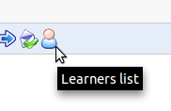Illustration 2: Icons label
There is also an online help facility on most pages which appears as a partially hidden lifebuoy ring on the top right side of your screen (see Illustration 3: Folded help) and clicking it will open a window explaining the feature you're in and how to use it (see Illustration 4, Unfolded help ).It remains in place when you scroll the screen so that it's constantly available and you can open and close it without affecting your current work. When you click the buoy, a small guide will open up, explaining the tool you're in and how to use it (see Illustration 5: Contextual help pop-up).

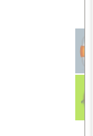Illustration 3: Folded help | 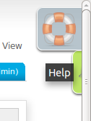Illustration 4: Unfolded help

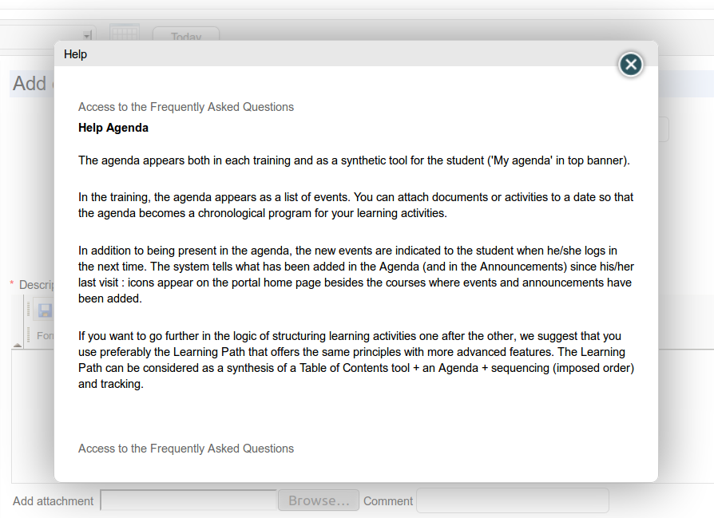Illustration 5: Contextual help pop-up

Terminology
At the time of writing, Chamilo is being used by more than 30,000 organizations around the world, in many different languages, including primary schools, colleges, higher education institutes, universities, NGOs, small, medium and large companies.
Obviously, all these bodies and institutions tend to use slightly differing terminologies. For example, some institutions will call their courses “Training sessions”, others will call them “Learning spaces” and others simply “Courses”. This presents challenges for the design of a “one-size-fits-all” e-learning platform (or even user guide), so we have sought the middle road, and employ a simple, universal terminology which we trust will make sense to all our users.

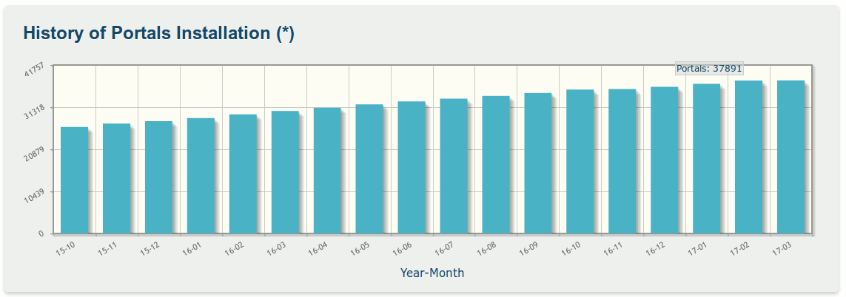Illustration 6: History of Chamilo installations around the world, 2015 to 2017
Of course, because we understand your organization may prefer a specific terminology, we have equipped Chamilo with a way to edit any interface term from within the platform administration. (this requires administration skills and is thus described in the Chamilo Administration Guide). Should you urgently require a customization, you can ask one of our official providers for a customized language pack to be imported into your platform.

In this guide, we have endeavored to employ a universal terminology so, for example, the common education term “student” has been replaced by more neutral terms like “learner” which applies equally well in the business world. When referring to all kinds of users collectively, we have decided to use the term “user”.

This manual is available in several formats, so you can always download it in editable format from our website and do a quick search & replace operation to make it fit your needs. Don't hesitate to send us the updated version back for sharing with others at info@chamilo.org. You'll be amazed at how this can benefit you in return, as other communities build up on your work to make things even better.

The somewhat ambivalent term “training” which had been employed in previous versions of the software has now been replaced by the more understandable term “course”, while the previously ousted term “learning path” has now been reinstated after a short and unpopular change to “course”. You will find all these terms defined and explained in the following guide. If in any doubt, make sure you check our Glossary on page 177 Don't forget: you can customize these terms with the help of your Chamilo administrator (if that's you, check the Chamilo Administration Guide, also available from our website).

Why Chamilo?
Chamilo is an e-learning and collaboration platform which comes bundled as open-source software (or as purists will note, rather Free Software) which can be adapted to educational or professional projects. It is distributed under the GNU/GPLv3+ license, which you are bound to accept when using it.

A teacher using Chamilo can access a series of useful tools allowing them to easily and efficiently create an effective learning environment. On creating/editing a course he (or she) can:
- import or create documents (audio, video, images) and publish them,
- build tests and exams with automated scores and feedback as required,
- build or import (SCORM and AICC) compliant courses,
- set and receive virtual assignments,
- describe the components of the course through description sections,
- communicate through forums or chat,
- publish announcements,
- add links,
- create work groups or laboratory groups,
- set up a virtual classroom (through the videoconference extension),
- manage scores through the assessments tool,
- create surveys,
- add a wiki to create documents collaboratively,
- use a glossary,
- use an agenda,
- manage a project (through the blog tool),
- enable tracking of learners in your courses,
- register attendances,
- elaborate a class diary (course progress).

The Chamilo platform is extremely flexible. All its tools can be customized according to the needs of each course. It provides a friendly and intuitive user interface which requires no special prior technical knowledge or skills.

Learning paradigm

Some learning management systems fall into the trap of attempting to support a specific learning/teaching methodology (e.g. social constructivism), perhaps in order to win some short-lived pedagogical credibility. While focusing on a single paradigm is appropriate, even desirable, on the part of individual teachers or organizations, Chamilo resists the temptation to limit the design of the platform to one specific approach in this way.

In our experience, the role of a Learning Management System is to provide a tool that can adapt to the needs and wishes of the user. Providing “the right tool for the job” may be fine for single-purpose tools (a hammer, a fork or a pencil). For a complex tool such as a LMS, however, it is a combination of the platform's wide range of flexible and adaptable features and the teacher's creative use of those features that will, in time, result in courses which reflect an appropriate specific learning methodology, be it social constructivism, instructionalism, behaviorism, radical constructivism, symbolic interactionism, etc. Chamilo acknowledges the role of the teacher in choosing their own teaching approach, and strives to ensure that all of these educational paradigms can all be effectively implemented using various combinations of the flexible tools provided on its platform.

Chamilo LMS enables you to develop a course using whatever paradigm/approach/method you as a teacher (or your institution/company) feel comfortable with and, as such, makes sure you have the right tools for the job.

Common interface elements

Because we know that common conventions make things easier for everybody to remember and manipulate, we use a set of common visual symbols throughout Chamilo. These symbols might stand alone representing an action, or be coupled with another symbol representing the object of the action.

Below are listed some of the most commonly used symbols on the platform:

          Icons | Features
 | The pencil tool allows the updating of a specific piece of information or content
 | The cross tool allows for the deletion of a specific piece of information or content
   | The eye tool allows you to change the visibility of a piece of information/ content
 | The yellow star marker on any icon symbolizes the creation of a new resource
 | A blue right arrow generally means move things or insert things into others
 | A blue left arrow generally means go back (like the back button in your browser).
 | A blue arrow pointing down generally means download some file or data.
 | A blue arrow pointing upwards generally means upload some file or data.

The Chamilo homepage
The homepage is the first visible page. It contains the login form and a few other important elements.
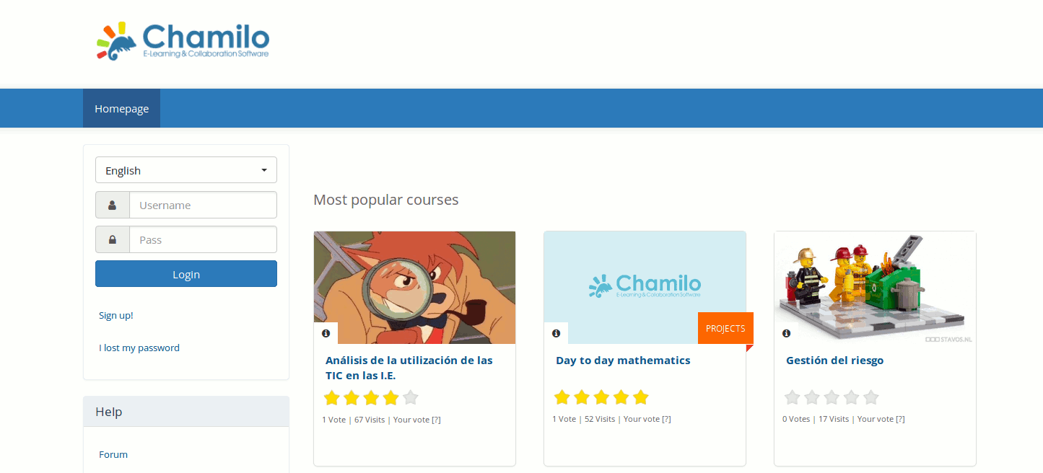Illustration 7: Homepage
Although your mileage may (and certainly will) vary, this is mostly what you should find on a Chamilo portal’s homepage:

- The logo of your organization will always appear on the top left corner of the page. This can later be changed (check the admin guide for more info).
- The blue bar (color may change depending on the stylesheet selected by your admin) contains the first elements of menu. This will change when you login or when the administrator ads new items to it.
- The login block allows you to login, a very straightforward process (the administrator assigns permissions to users depending on the platform configuration).
- It is possible to register on the platform using a simple form (Sign up! link).
- In case you lose your password, a new one can be generated easily (using the I lost my password link).
- Access to the Chamilo community's forum is provided through the Forum link in the Help box. This can be removed or edited by the administrator
- A block with the most popular courses appear. This will be empty at the beginning (when no courses exist on the platform) or can later be removed by the administrator, in case you don’t want the public to know about the courses available on the platform.

Note : To view the courses with restricted access, you must be registered on the platform and must be subscribed by the course teacher, through the course users list.

Registering on the platform
As for any web platform, users wishing to access the platform contents must register with their user name and password. This is simply done by following the Sign up! link on the homepage, or by an administrator pre-registering all users. Once registered, one can simply connect using your username and password.

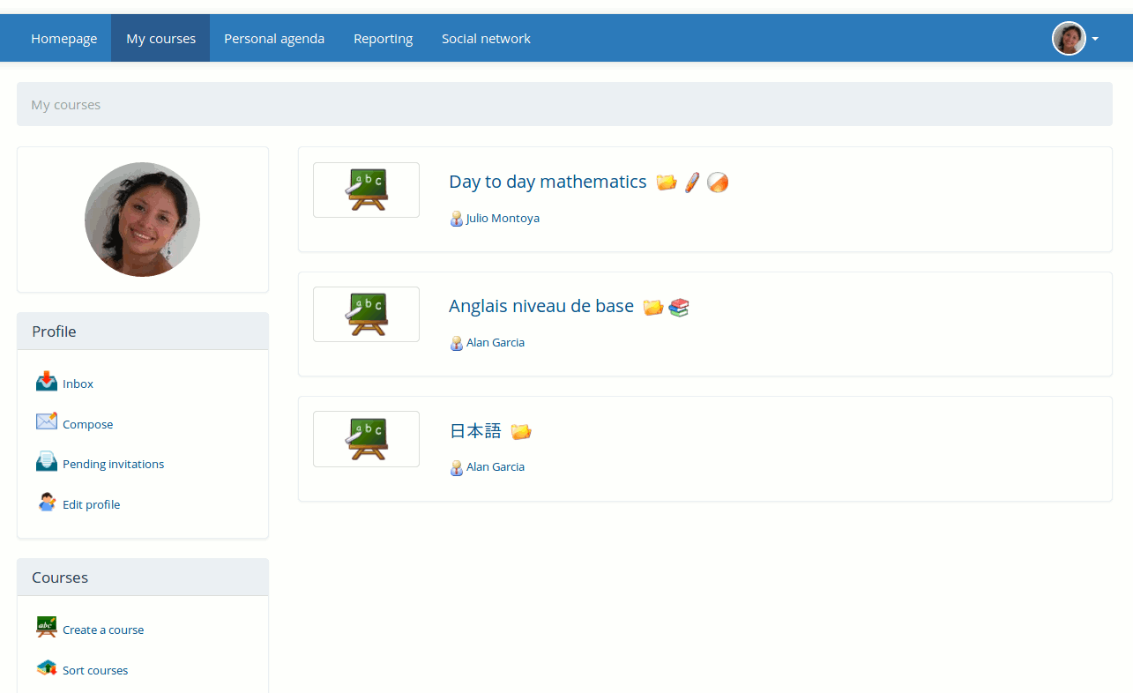Illustration 8: "My courses" page
Once connected, the teacher has access to any courses on which (s)he is registered:
- A list of courses to which the user is subscribed. A pencil will appear on the right of the courses boxes for which the current user is a teacher, allowing the teacher to directly go to the courses settings
- A link to the Social Network tool (which we will analyze in Social network on p. 164)
- A (non-admin) teacher can create a course
- Teachers and learners can subscribe to more existing courses through a “Course catalogue”
- Teachers and learners have access to the history of their sessions through the “Courses history”. Sessions are a vast concept detailed in the Admin Guide.

Note : Although the help feature link has been replaced (since version 1.8.8) by a more dynamic, JavaScript-based box, it remains fully accessible to people with impaired vision, which might be navigating the platform through a text-based browser. Version 1.9 and upwards also offer a font resize feature for people with slightly impaired vision.

Finding your way in Chamilo
Most pages are quickly accessible via the tabs at the top of the page:

Illustration 9: Chamilo header
The “tabs” provide access to the homepage, the courses list, your agenda, the reporting/tracking page, the social network and (if you are is lucky enough to be a portal administrator) to the dashboard and administration pages. The last tab shows the user's picture (so he can check he's not mistakenly using another user's account) and a drop-down menu lets the user go to his profile or log out at any time in just two clicks.

Browsing through a course offers the same kind of navigation elements you will find on any computer software. In Chamilo, the very important navigation bar is referred to as the breadcrumb navigation (in reference to a popular fairy tale, the Little Thumbling who saved the lives of his brothers by leaving a trail of stones, then breadcrumbs, in a dark forest so they could find their way home). This type of navigation allows the user to find its way back to his starting point.

The first “breadcrumb” link, on the left, displays the name of the course, and allows the user to return to the course homepage directly. The links to the right of this point directly to the elements of the course in which the user is currently located.
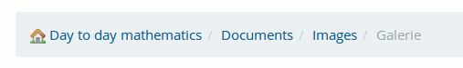Illustration 10: Breadcrumb Navigation

Within a course, Learner view allows the teacher to view the course as a learner. The link then changes to Teacher view. Just click the new link to get back to the normal “teacher” view:

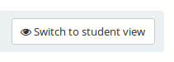Illustration 11: Switch to student view
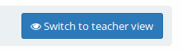Illustration 12: Switch to teacher view

Course creation
Creating a course is quick and easy, and can be done from the My courses page.
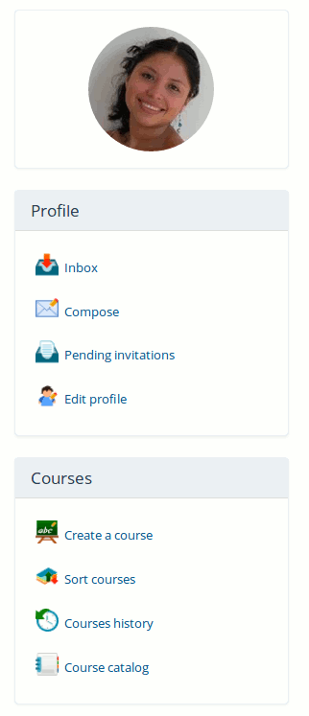Illustration 13: Personal menu blocks

Note : on some portals, teachers might not have permissions to create new courses and are simply assigned pre-created courses by the administrator.

Click on Create course in the side column. Fill the mandatory “Course name” field (see Illustration 14: Creating a course – short version) and click the button. That's it.

The course will be visible by the course creator and (later) by the users subscribed to it. By default, the person who creates the course is responsible for this course's administration. She is generally referred to as the Course owner or Course creator.

To create the course, you need only enter a single element, i.e. a clear and detailed title.

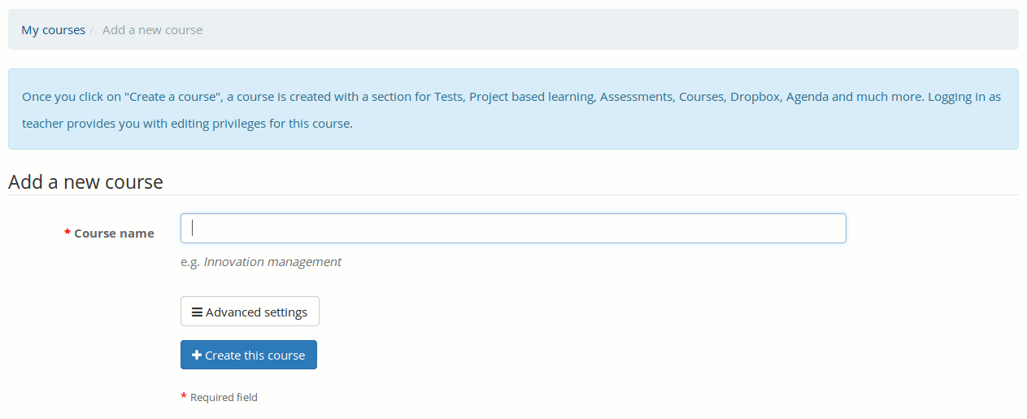Illustration 14: Creating a course – short version
Additional options (entirely optional) are available by clicking on the Advanced settings button:
- a category within the ones offered in the drop-down box (this is optional),
- a course code Pick a code that matches the course title associated with e.g. a numerical classification. (n.b. Even if entered in lowercase, the course code will be automatically uppercased and symbols like (-, _ and spaces will be removed from the code),
- the course admin this option is automatically filled with your name and cannot be updated,
- the language used to display the course environment (nothing stops you from using e.g. French even if the platform is installed in English). The language choice doesn't influence the course content, only the course interface
- the course can be filled with some demo content to indicate to the new course administrator the sort of thing s/he can create inside the course (typically an exercise, forums and an introduction section). Alternatively, this can be left completely empty.
- finally, the course can be created from a template course that you have access to (you must be a teacher in the template course to see it appear in your list)

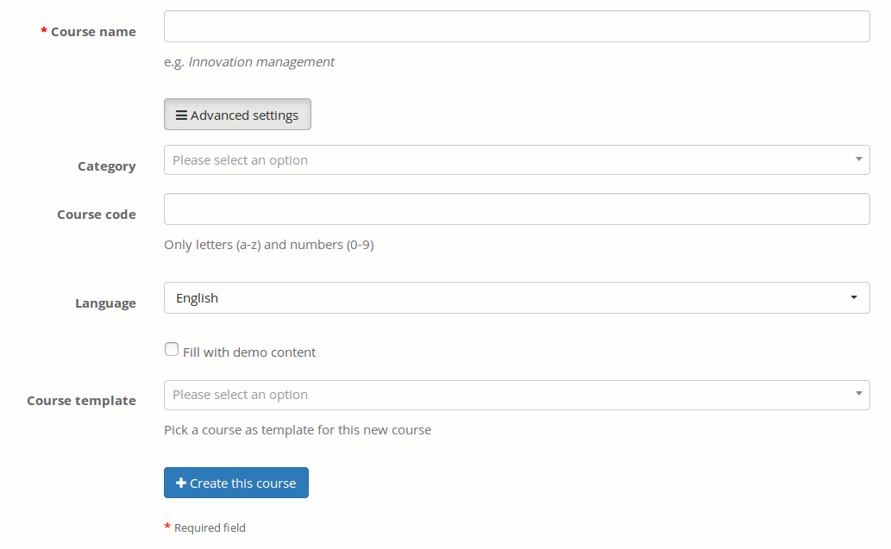Illustration 15: Create a course – extended version
In versions 1.9 and 1.10, a course creation follow-up page was displayed, which suggested:
- going straight to the newly created course (through a link on the course title),
- going directly, by clicking on the relevant icon, to one of the most common course configuration steps, as illustrated below.

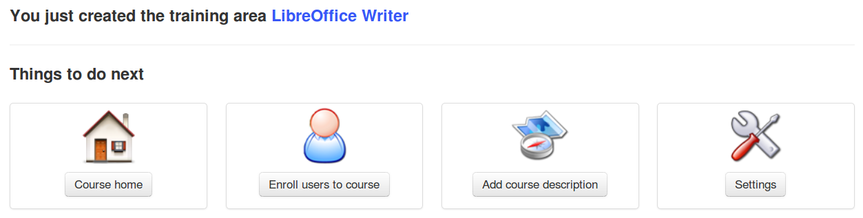Illustration 16: Course creation follow-up page
However, feedback has been relatively negative about this feature, so we decided to disable it by default in version 1.11 onward. Your administrator can still enable this if desired.

This empty course structure created, the next step is to enrich this course through the addition of text, multimedia documents, audio tracks, links etc. etc.....)

Control course access
During the creation of the course, it is recommended you don't allow learners access before it is ready so they don't see an incomplete course.

In order to do this, access has to be restricted by going to the course Settings tool:
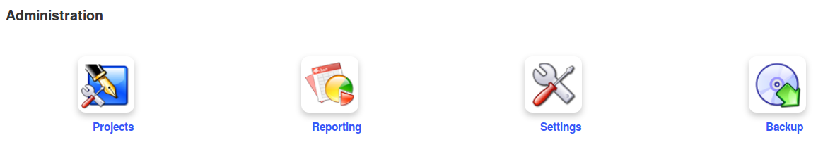Illustration 17: Course administration tools
A series of choices are available to the teacher.

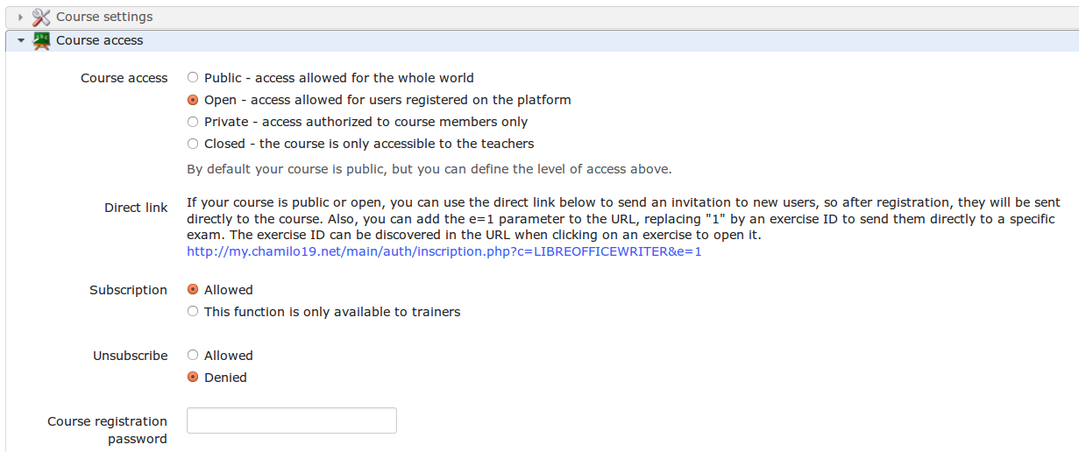Illustration 18: Course settings - Visibility
- Public : means it is accessible to any user, registered on this portal or not
- Open : means all users registered on the portal can access the course as long as they have previously subscribed to it (they can do this through the courses catalog). This is the default option
- Private : means the course is only available to students who have been subscribed to it by a teacher or administrator. Make sure the Subscription option is set to be only available to trainers, though, as otherwise students might be able to subscribe themselves.
- Closed : means the course is only available to its teacher or the administrator. Other users cannot access it, even if they have previously been subscribed to it. This last option is recommended during the building or maintenance periods of the course.

Organizing courses
With Chamilo, one can end up managing a large quantity of courses. In addition to general course categories, all course creators have an option to create personal categories, visible only to the user who created them, to help him organize his courses.

Note : This feature is not supported by the platform's developers anymore, and might be abandoned in the future. It can result in a conflict with the courses order on the My courses page when these are registered within sessions.

Personal categories
Go to My courses, option Sort courses in the menu, to get to the courses sorting tools page. Click on the Create a personal course category, and fill the name of the new personal category to be created. Finally, click the Add category icon.
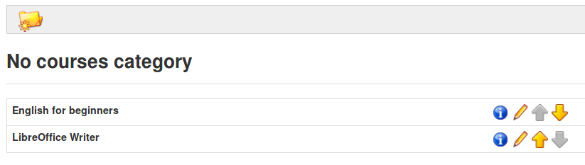Illustration 19: Sort my courses
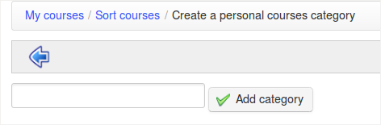Illustration 20: Personal category creation form
The new personal category appears in a list at the top of the page. It is possible to create several personal course categories.
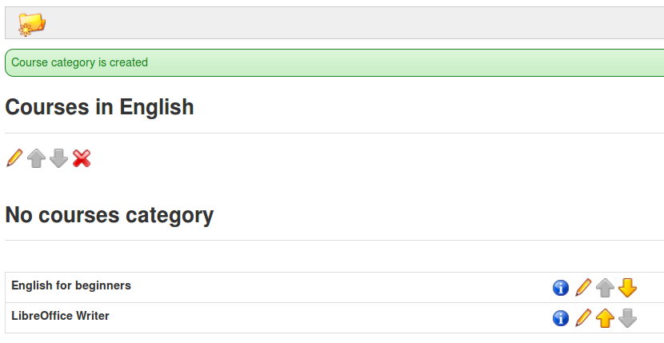Illustration 21: Personal courses category created

Click the pencil icon next to each course to set a category for it. In the drop-down list, select the personal category with which the course will be associated, then click the confirmation button. With courses sorted and linked to personal categories, the courses homepage is more readable. Courses not associated with any personal category are shown at the top of the page.
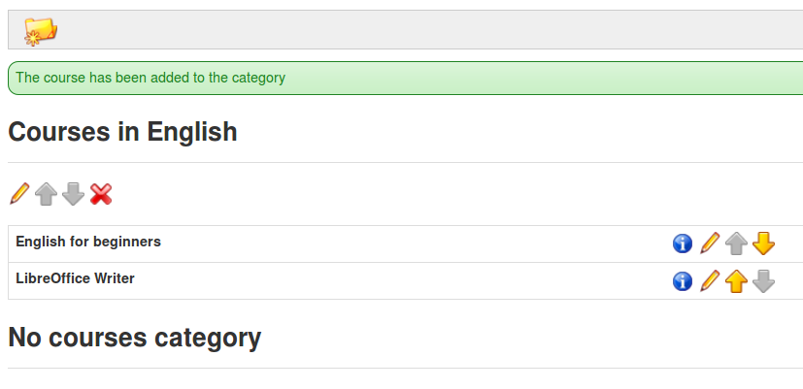Illustration 22: Personal courses categories
To remove a category, click the red cross and confirm.

Subscribing to other courses
Teachers and students can subscribe to courses. When a teacher subscribes to another course by himself, he is considered student in this course, and will thus not have access to the normal teacher tools. If you want to register to be registered to someone else's course as a teacher, you will have to ask the current teacher of that course or the administrator to register you, as a teacher, to that course.

Clicking on the Courses catalog link, and a list of courses will appear. You can look for the course in the suggested categories, or find it by searching for all or part of the course title via the search box on the top part of the page. If this portal uses sessions, a sessions catalog is also made available
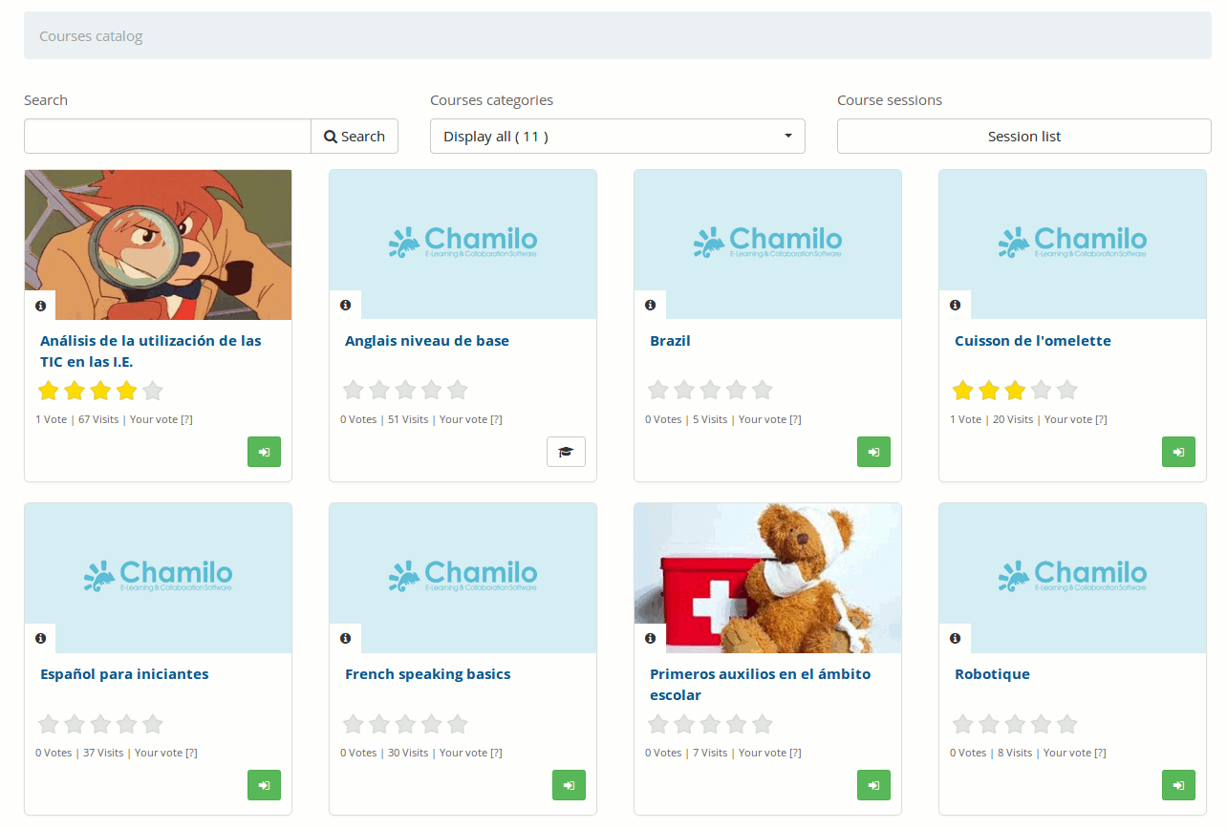Illustration 23: Courses catalog
Once you’ve found your the course, click on the green Subscribe icon to subscribe to it. The subscription gives the user subscribing learner status.

Courses management icons
In the courses management interface, you will see the following common icons and buttons.
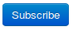
Icons | Features
 | Update/edit a course
 | Remove a course
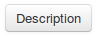 | Read the course description
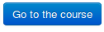 | Link to the course homepage (only available if public or open)
 | Register on the course

Course administration
The My courses tab the teacher to see a list of the courses which they can manage. (These display a pencil icon on the right side of the course's box, as opposed to courses on which they are subscribed as learners).

You just need to click on the course name to access its homepage. The various tools are arranged in three categories:
- Authoring : tools for creating course content,
- Interaction : tools for teacher-learner or learner-learner interaction within the course,
- Administration : tools for the management of course options.

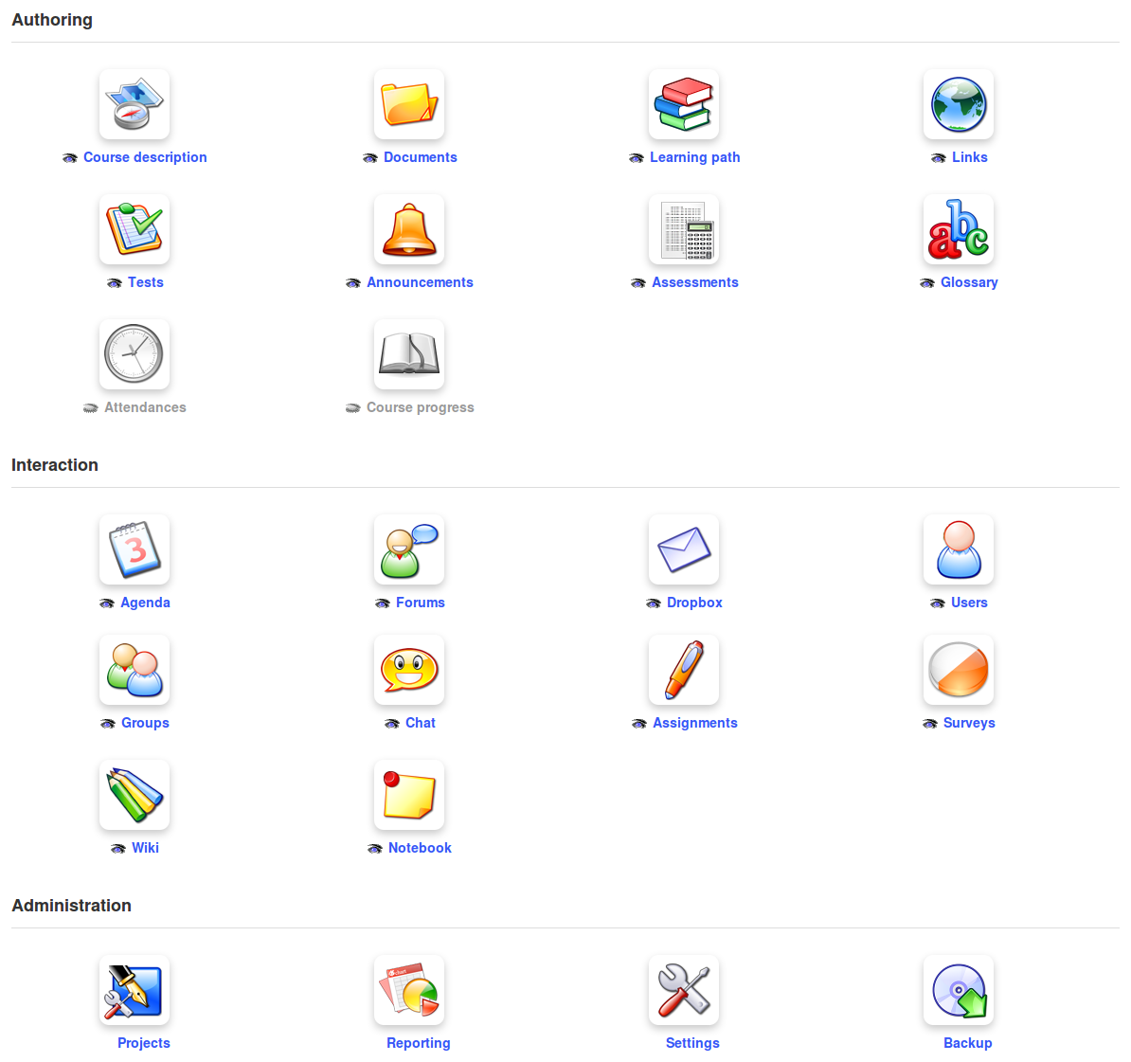Illustration 24: Course tools – Classical option
The teacher can choose to hide or show distinct tools using the eye icon under each tool, so that the course doesn't intimidate the new learner with too many options.

Note : In some cases the administrator may make tools unavailable to course teachers or enable tools which depend on specific extensions (like the full-text search or the video conference), so what you see entering the course might not be the same as described here.

Note : The course interface can be presented in different ways depending on what the administrator's chooses. He might, for example, enable a view that was popular in previous versions of Chamilo, as in this illustration. This view is called the 2-columns activity view.
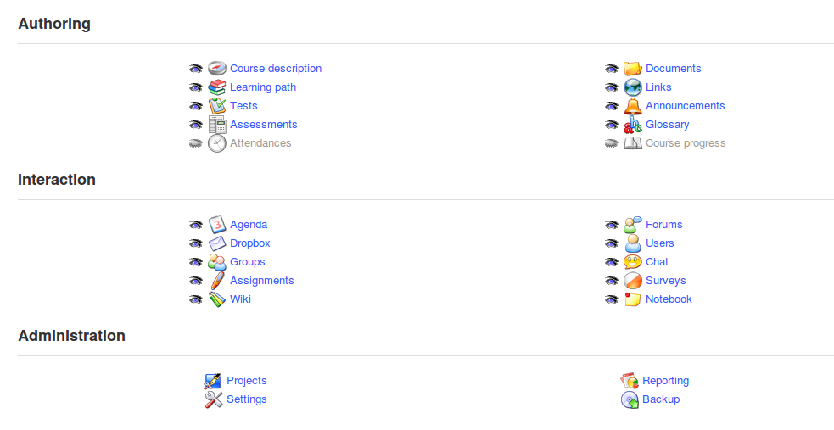Illustration 25: Authoring tools in ipad type view

Course homepage
In this chapter, we will present a brief overview of the various tools available. Each tool will be examined in more detail in later chapters.

Introductory text
Just before looking at any particular course tool, note that it is possible to present a welcome message to a course. Click on the Add an introduction text icon below the Learner View button. A text editor appears...
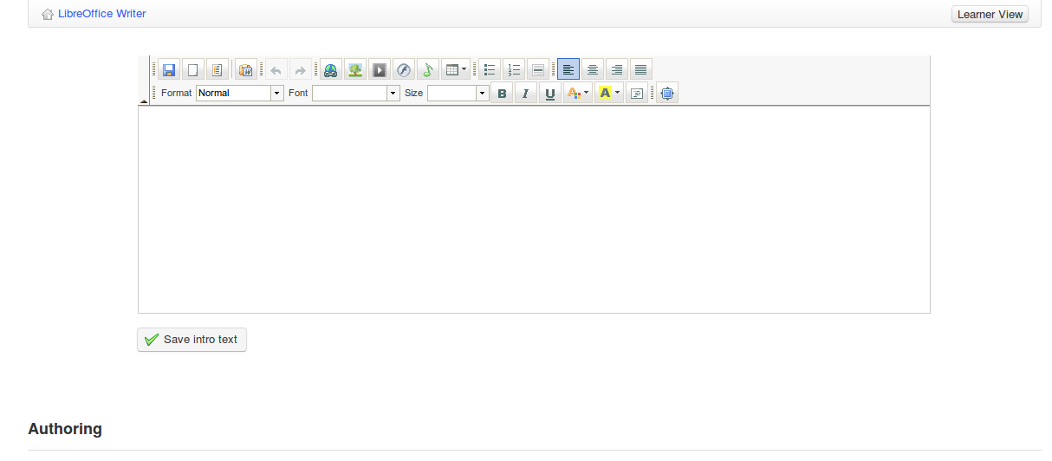Illustration 26: Course homepage – Introduction text
This feature, although very simple to use, is also very powerful: it can simply present a few words of introduction, but it also enables you to redesign the entire course homepage simply by hiding all the course tools and writing a large introduction text/page including icons with links to the course tools' internal pages.

To do this :
- hide all the tools (by clicking the eye, which must be closed and grayed)
- right-click on any tool to which the learners need access
- select Copy link location
- left-click on Add an introduction text
- place an introduction text (use the table tool , or an external HTML-editing tool if you wish, to position elements precisely) and a new icon/graphic representing the tool requiring access
- click an icon to select it then click the link creation tool
- « paste » the link that was saved a few steps before (CTRL-V should work just fine)
- click the save intro text button

You now have an entirely personalized course homepage! The only remaining other visual elements are the header and the footer.

Authoring tools

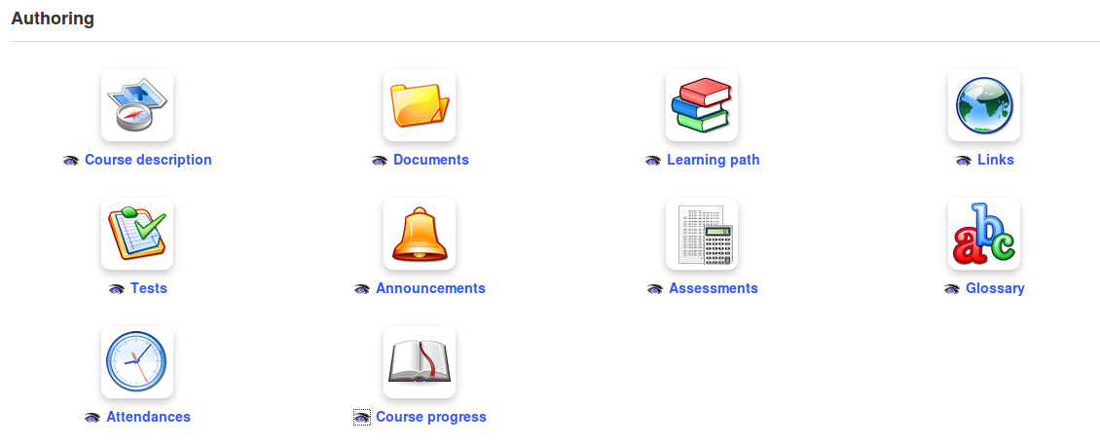Illustration 27: Authoring tools

Course description

The course description is not at all mandatory, but it allows you to present a global summary of the course and to offer potential subscribers a flavour of the course.

The description tool presents several sections which provide the course author with a simple suggested structure for their course description. (The teacher doesn't have to use these, of course; if the proposed sections do not match requirements, other sections can be created with the preferred titles). The sections include:
- « Course description »,
- « Objectives »,
- « Topics »,
- « Methodology » etc,
At any time, a section can be removed by clicking on the Delete icon , or updated using the update icon .

The description is available to learners inside the course, but can also be viewed in the course catalog (via the Description button). This button opens a pop-up window showing the description provided by the teacher.

Documents

This is used to add and organize the documents or files (text, images, audio, video, HTML files etc.) used in the course. You can create directories/folders within this tool as required.

Tests

The tests tool is used to create, update or import tests, quizzes and exams in the course. It includes facilities to automatically or manually score and feedback to learners and to track and export learners' results. The tests tool can be used to develop quite sophisticated automated exercises which might in themselves form the core of the course.

Learning Paths

This organizational tool allows you to generate or update learning paths to help guide your students through a specific sequence of learning objects/experiences. It can be configured in various ways e.g. to require students to undertake tasks in a given order, or to allow the repetition of certain activities.

Note: If you come from a Moodle background, this feature can be compared to the ordering of blocks on your course homepage.

Assessments

The assessments tool is very useful when a score has to be assigned for the whole course. It allows for the creation of a gradebook incorporating the results of on-line or in-class evaluations. It also allows for the automatic generation of certificates (although this might not prove as intuitive as the rest of the platform tools due to the many parameters involved).

Attendances

This provides a means for the registration of attendance by learners, taking this into account in the scoring of assessments.

Links

You can use this tool to add links to external websites from within the course which be be of value to students during the course of their study. These links can be incorporated into a learning path.

Announcements

Use this fully featured tool to make announcements related to the course, which will be flagged up to users when they log in to the course. They can be be personalized and configured to be sent via email to relevant users. It is also possible to attach documents to announcements.

Glossary

A course glossary can be an invaluable aid to students on some courses. This tool allows you add and view terms and definitions (including sound, graphics etc.) and to import and export text .csv lists or save the glossary as a .pdf file.

Course progress

This planning and record keeping tool helps you to create, import, export or save thematic sections which can serve as a “course diary” to include topics and plans and indicate class progress.

Note : The learning paths created inside the course can also be made visible in the « Authoring » section, which could generate redundancy. It is possible to show or hide them using the double square icon in the learning paths list (« Make visible to learners »)

Blogs

You may not see the Projects tool in the Authoring section, but if you create a project using the tool in the Administration section, it will show up in the Authoring tools, where you can hide it from the learners' view if you wish. This tool allows for collaborative work to be organized.

Search

The search tool can only be enabled on the platform by the administrator, as it requires the installation of specific and advanced modules external to Chamilo itself. If enabled, the tool allows for searching within the text of most documents on the whole platform, including texts imported or created inside Chamilo.

Interaction tools
The objective of the interaction section is to group tools which facilitate communication between learners as well as between learner and teacher. Unlike the Authoring tools which are primarily for teacher use, The Interaction tools are provided mainly for use by other users also, to support their learning.

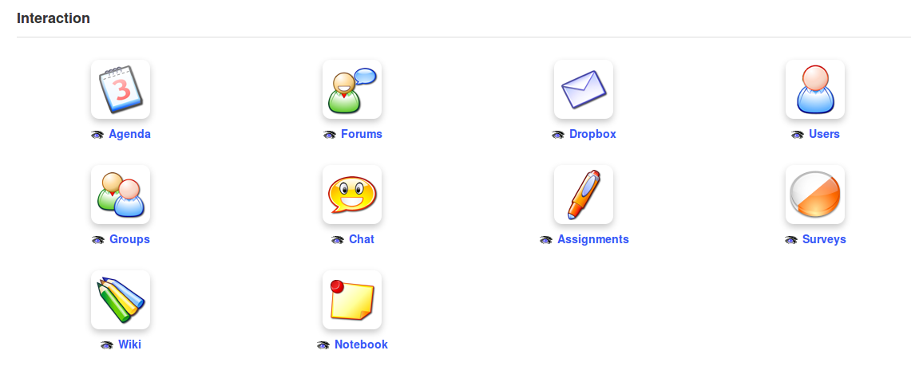Illustration 28: Interaction tools

Agenda

This tool provides users with a comprehensive diary/calendar tool to which they can add events etc.

Dropbox

Users can use the course dropbox to share their own documents with others on the course.

Groups

Use this to create groups within in the course and manage access to course tools.

Assignments

Create assignments for learners to complete within the Chamilo platform, or to complete externally and upload for evaluation by the teacher. The assignments tool integrates fully with the reporting and assessments tools and allows for quick and easy monitoring of assignment submissions and results.

Wiki

The Wiki provides a handy tool for collaboration between users, be they teachers or learners, through providing a clear and simple interface for the joint production of a class document.

Forum

The very fully featured forum tool allows for the creation and management of forums for use by course members, and includes the facility to quote student posts to teaching forums and edit, mark or annotate their work in whatever way the teacher judges will best support students' learning.

Users

This tool allows learners to view who else is subscribed to the course, and teachers to manage course users, subscribing teachers and users, and importing and exporting course lists as required. The users tool also integrates with the Groups tool.

Chat

Chamilo provides a simple text-chat facility allowing users to chat with other users on-line in the platform.

Surveys

The fully featured survey tool a powerful means of inviting users on the platform to quickly and easily offer comment and feedback for the evaluation and development of courses. The tool also supports the analysis of results collected from participants.

Notebook

Sometimes a learner or teacher just wants to keep personal notes relevant to his or coursework. The notebook tool provides a simple means for users to write and store and organize such notes within the platform for their own use, using the on-line editor. Notes created by this tool are private: no user has access to the notes of another user.

Video-conference

It is now relatively easy, using a local video-conference server, to install the video-conference tool within a Chamilo course, although it remains an external extension which is not always available in a classic portal. Chamilo 1.9 supports BigBlueButton 0.8, open-source conferencing software which supports recording of the white board and audio from a conference. The video sessions can later be made available within Chamilo itself as a video library inside the course. From a teacher's point of view, it's worth lobbying your administrator to set it up!

Administration tools
The administration section groups tools that the learner never needs access to – there is therefore no option to hide or show the tools, which are designed for teacher use only.

Illustration 29: Administration tools

Projects

This is where the teacher can create new blogs visible and available to learners in the Authoring section. A blog integrates tasks and users management via a calendar within the Blogs tool, supporting the effective management of collaborative projects.

Settings

Manage the course settings as a teacher. Settings are sorted in a few sections:

         | Course settings | Manage and update elements such as the course title, category, language, picture, etc.
 | Course access | Configure course access updates (visibility, subscription and other permissions)
 | E-mail notifications | Set the behaviour of for e-mails alerts
 | Users rights | Configure of the agenda, announcements or picture display inside the forum
 | Chat settings | Configure how the chat tool opens
 | Learning paths settings | Enable the graphical theme of the learning path, as well as various other learning path settings
 | Thematic advance configuration | Decide whether course progress information should be shown on course homepage

Reporting

This important teacher tool tracks learners' use of learning paths, tests, forums etc., as well as time spent on the course, progress, scores, assignments, numbers of messages and last connection date. It is a powerful monitoring tool which can save the teacher a huge amount of time and dreary record keeping work.

Backup

This is where you can (and regularly should!) back up your course by exporting a copy of the course. You can also use it to import previously backed up courses and to delete all or part of the course content and data. You can also use it simply to delete the course – be careful, though – there's no way back!

First Steps: Documents
The normal first step any teacher takes when needing content for a course is to go to the Documents tool and upload existing content (in the form of PDFs, PowerPoints, etc).

Chamilo allows for the import of all types of documents (HTML, MS-Word®, MS-PowerPoint® MS-Excel®, PDF, Flash, Quicktime®, OpenOffice.org, LibreOffice, MP3, OGG, AVI, etc.) and can first be used as a simple documents catalog while the teacher builds up a bank of materials (a few weeks, depending on the context).

You can rename documents at any time and arrange them in directories/folders. The only provision is that the user must, of course, have the requisite software installed on his computer to read the files at his disposal. We recommend the use of standard and open formats (see note below) to avoid the need for the learner to download or buy costly software which might be overly specific (i.e. with no other use) or prove difficult to maintain.

With regard to file storage, you do need to be sure to organize the Documents tool carefully to make it easy to find a document later on.

Note : The Chamilo community strives for a complete freedom in the distribution of (distance) learning material. From this perspective that a high priority is given to the support of open formats and applications, like LibreOffice® and its OASIS format rather than the Microsoft® Office® suite; OGG (and its variations) rather than MP3® or DivX®; etc. So we'd like to remind you that all features of Chamilo can be used with a simple, open spec. browser, the only exception to which is the video-conference and the hot spot exercises, which require the Flash® plug-in (which is free but not open). We are working on this last element to increase the availability of this type of exercise to devices that do not support Flash®.

Create a directory
To achieve a clearer storage structure, Chamilo lets you create directories (folders) and sub-directories by clicking on the folder icon with the yellow star symbol  .
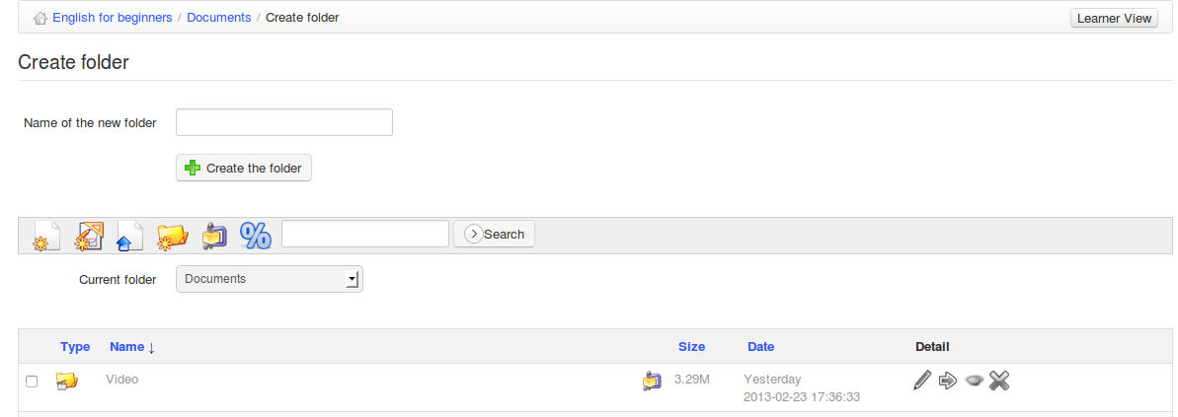Illustration 30: Documents – creating directories
To create a directory:

- click on the Create folder icon,
- enter the directory name,
- click on the Create the folder button,
- The new directory has been created and can be used right away to store new documents.

If you want to create a sub-directory, open the directory you want to create it in and follow the same procedure.

Quick-change of directory

When creating a new course with example content, the Documents tool contains several directories (audio, flash, images, etc) by default.
These directories are meant to provide additional help organizing resources inside the course. Once there are over twenty or so documents in the root directory, it becomes difficult to locate a document when needed, because you will have to scroll up and down to get to see all the files. Because of this, we recommend not having more than twenty files in a single directory - general good practice in file management anyway.

These directories are by default invisible to learners. It is up to the teacher to decide whether learners should see these directories' contents or not (by clicking on the eye icon ).

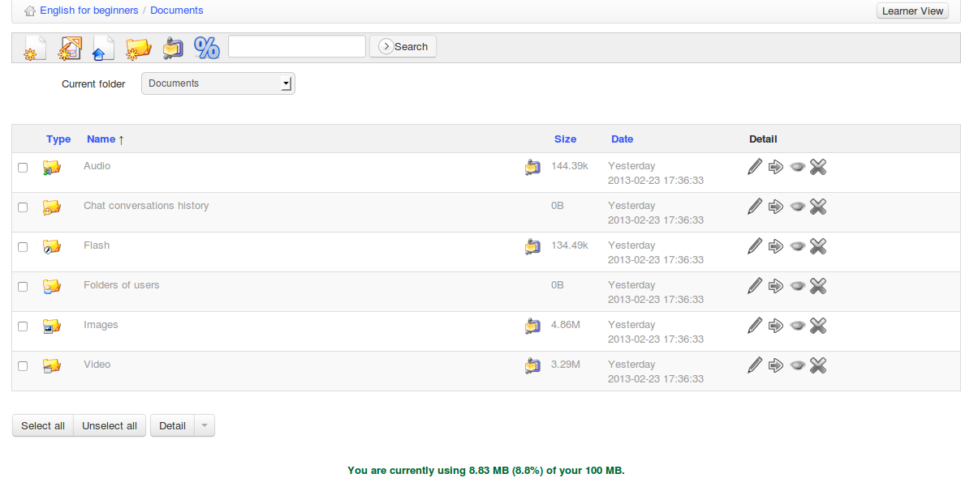Illustration 31: Documents – List of default directories
Of course, it is possible to create several other directories using the folder creation icon. In order to navigate swiftly within the directories tree, a drop-down list called Current folder is available on the top left of the screen allowing any level of documents-directory to be readily accessed.

Once inside a directory, the “up a level” icon  lets the teacher get back up one directory level.

Importing a document
Import a new document by going to the desired destination folder and clicking the Upload documents icon  .
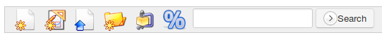Illustration 32: Documents - Icons - Upload
The following screen appears:

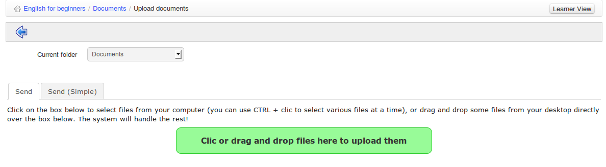Illustration 33: Documents – Documents upload
Click on the green area to explore the files on your disk and select one(s) to upload. Inside the pop-up window, click the confirmation button. The documents upload starts. If you send several files at the same time, you will see their upload progress, live, as in the following illustration.
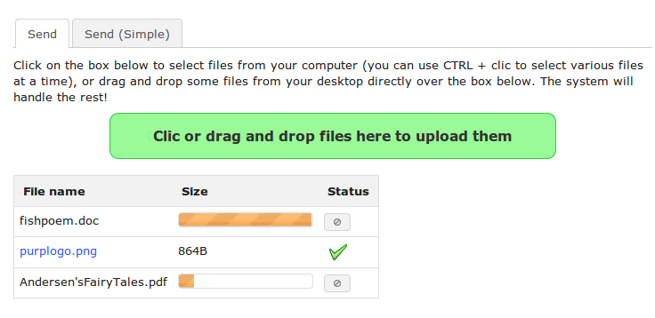Illustration 34: Documents – Documents upload in progress

Once the upload is finished, the following validation list appears.
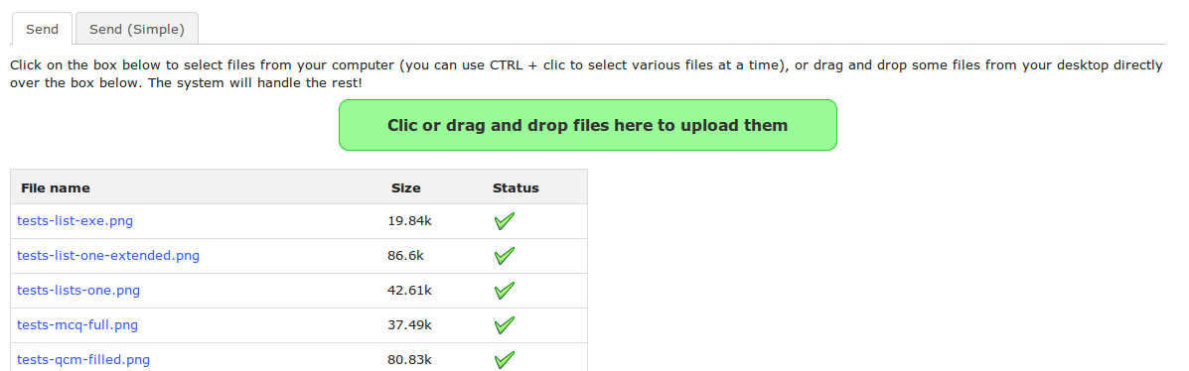
Illustration 35: Documents – Document upload finished
The green ticks indicate that the documents have been sent to the course successfully. Click on the blue arrow icon pointing left to get back to the documents list.

Note : The tab labeled Send (Simple) allows you to use the traditional “dialogue window” procedure to upload. We called it Simple because users are generally more used to this one, though it's really a bit more complicated to use! Document indexing options can only be found in the Simple form (in case your administrator has enabled the search feature) as well as an option to unzip a complete file hierarchy.

Authoring content in Chamilo
A major advantage of Chamilo over other Learning Management Systems is that it provides a wide range of inbuilt features supporting the effective authoring of course content. The toolbar at the top of the documents page displays a range of tools to support authoring:

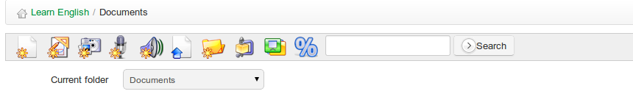Illustration 36: Documents - toolbar
The icons marked with an a yellow asterisk represent creation tools. First and foremost, the teacher can create new rich media documents directly via the documents tool, without any need for an external authoring system. Just click the create rich media page/activity icon  within the desired folder. A fully featured on-line editor appears.

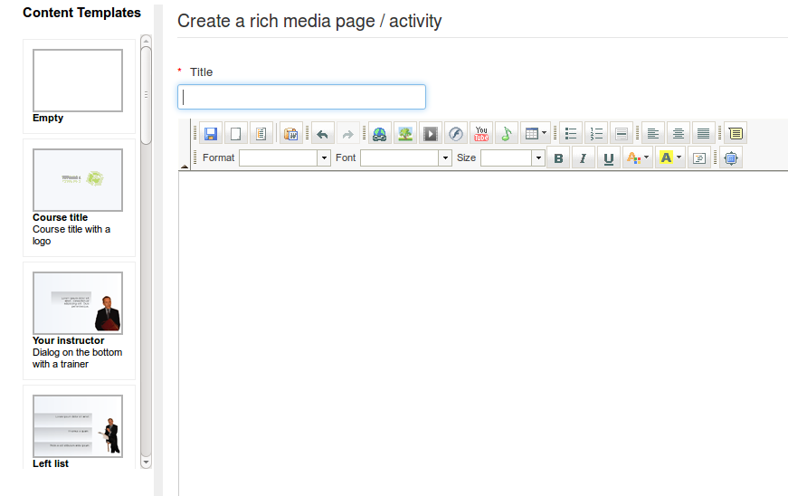Illustration 37: Documents – Creating a new document
After naming the document, it is possible to use all the options in the embedded rich text editor to format them. The editor supports a wide range of elements, including tables,images, audio, video, flash, etc. It includes an html editor which means that, for those with some knowledge of scripting the sky's the limit in terms of rich content!)

You can also use a series of document templates, (available in the left column), or create and save your own templates for designing further pages.

Once the document has been created/edited, save it by clicking on the Create document button.

Other types of documents can be created depending on your browser and the portal configuration (ask your administrator to enable these extra features if you don't see them in the toolbar).

Icon | Feature
 | The draw feature allows you to draw diagrams or schema in a vector format, which can be re-edited or exported to the bitmap format.
 | The photo retouching feature is very similar to the Photoshop® tool and allows for the editing, cutting, colouring etc. of pictures or other bitmap images.
 | The audio recording feature the recording of audio tracks right from your browser, using your microphone (on a laptop, the microphone is generally embedded). Flash® or Java® applet browser support is required for this one.
 | The text-based voice generation feature allows you to have the computer speak for you. Try it. You'll be surprised by the quality of the generated voices.
 | The web-cam clip feature allows you to record footage directly from your laptop's web-cam Flash® is required for this one.

Saving documents
Chamilo allows you to save all the documents, or a specific directory, simply by clicking on the Save (ZIP) icon in the toolbar at the top of the page.

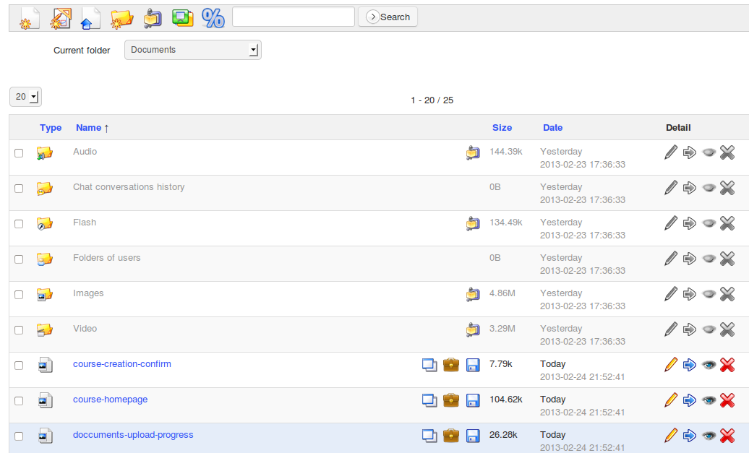Illustration 38: Documents – Download a copy
It is also possible to save a single file by clicking on the download icon to the right of the filename, or to download a specific directory by clicking on the Save (ZIP) icon to the right of the directory listing. The briefcase icon allows users to copy a shared file into their private file area in the social networks area (see chapter 35).

Deleting a file or a directory
To delete, update, hide or show a file or directory, use the options in the right hand column of the documents listing:

Illustration 39: Documents - Options
As you will realize yourself, the icons vary depending on the document type. HTML documents offer more possibilities.

The magic wand icon allows you to use the selected document as a template to create other documents. It thus becomes very easy to ensure a consistent visual style for all documents in the same course.

The PDF icon allows you to export the document in a PDF format. This can be particularly useful if you wish to read your course in the train or the plane, where you don't have access to your e-learning platform.

Watching course quotas
By default, a course quota of 100Mb is set, but it is also possible for your administrator to increase it. To check the space usage, look at the indication at the bottom of your documents list. I will indicate the percentage of your course that is being used.

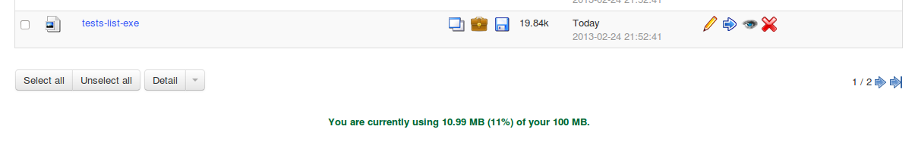Illustration 40: Documents - Quota
If you think you might reach the course limit in a few days, contact your administrator to ask him if it is possible to increase the available space. Only the platform administrator has the power to use this feature.

If you want to get a clearer view of what is occupying space in your documents directory, click the percent icon . You'll see a chart like the one in Illustration 41 below.

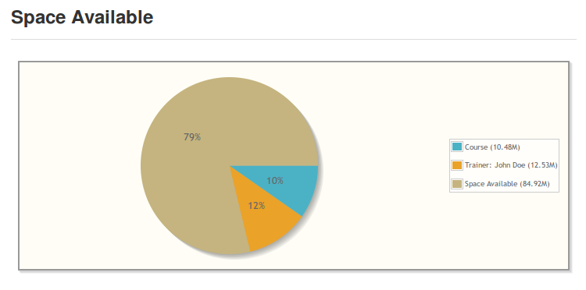Illustration 41: Documents quota chart

Note : the space available in a course is only limited, in Chamilo 1.9, to the use of the documents tool. Users will be allowed to send numerous assignments without worrying about the space limit.

Slideshow
If you have a lot of images uploaded in your folders and want to see them all at once, you can use the slideshow feature. Click on the slideshow icon  to go to the folder where your images are located.

You'll be presented with a type of “slideshow” view of the images in that folder. Each image is captioned with its name, dimensions and size on disk.
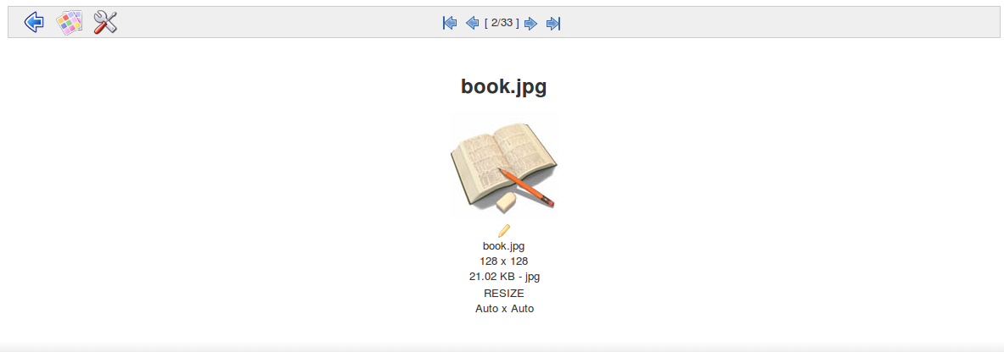Illustration 42: Image gallery - Slideshow view
It may be more practical to select the small show thumbnails icon  in the slideshow toolbar to let you view all images at once (as thumbnails), as illustrated below:

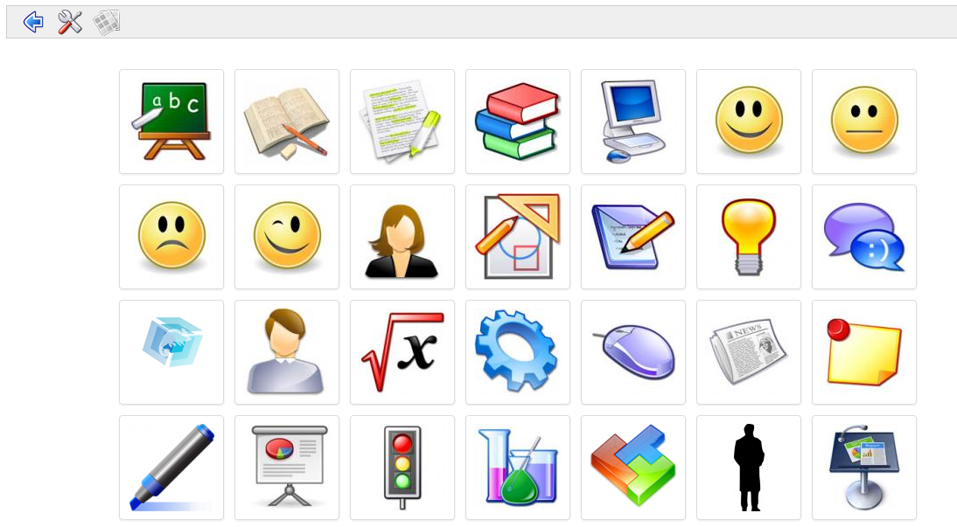Illustration 43: Thumbnails view
A settings option is available to further fine-tune the viewing of images.

Interactivity: Tests

Introduction
The Tests tool  is generally the next main focus for teachers exploring the world of e-learning.

The value of this tool is evident : automatic scoring and feedback of learners' answers means not only major time-savings for the teacher, they also allow the learner to self-test repeatedly (without feeling self-conscious) -for example when needing to learn language vocabulary, or master difficult mathematical algorithms. They can enjoy immediate automated feedback without depending on the presence or availability of the teacher. Test scores can be automatically integrated in each student's grade-book, and data such as dates, number of attempts etc. forwarded to the reporting tool to assist the teacher in tracking and monitoring students' progress.

A well designed test can prove an invaluable motivational tool for the learner. The teacher can build in extensive and meaningful feedback and suggestions and design stimulating questions and feedback which can involve not only text but graphics, audio video, etc.

The “Tests” tool could equally be termed the “Exercises” tool, inasmuch as its use is not restricted to simple “summative” quizzes at the end of a chapter or module. For example, some teachers use the test tool as the main vehicle for presenting new material (rather than simply displaying a series of documents) in order to present materials in a more interactive way (e.g. requiring the learner to complete a question or two at the end of each page.) Using the test tool in this way to create interactive exercises (involving formative rather than summative assessment approaches) keeps learners alert and enriches their learning experience. It is also enjoyable and rewarding for the teacher, challenging him/her to develop ever richer and more stimulating course content.

Of course, there are times when the teacher simply wants to set a formal, timed “Exam” for students, withholding feedback and scores for sharing at a later date. The tests tool can be configured in this way, too.

Because the tests tool is very fully featured, it takes a little time to learn how to use. The following sections explain in detail how to make full use of the Tests tool in Chamilo.

.

Creating a new test
Creating a new test is very easy. Click the create a test icon  on the left and give your test a title, then click on the proceed to questions button.

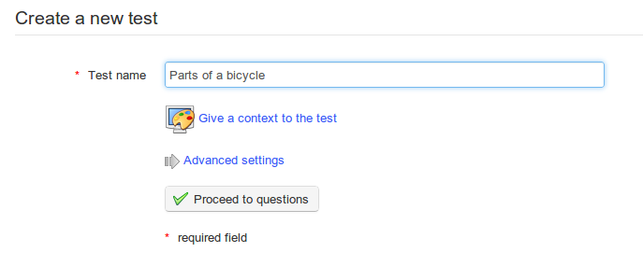

Illustration 44: Exercises – Create a new test
If you opt to give a context to the test  you can use the on-line editor to compose an explanatory section which will be visible to learners when they undertake the test.

The test will be displayed on the main page of the test tool, listed along with other tests created in the course:

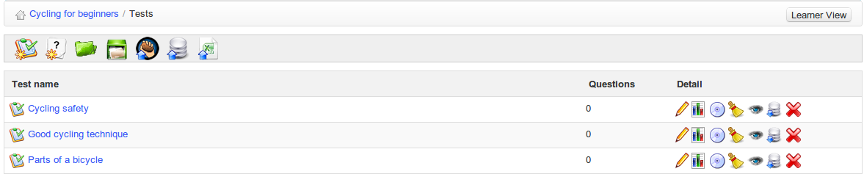Illustration 45: Exercises - List
Because there are so many different ways the test tool can be used, there is a good chance the default options are not entirely suitable your needs. Be careful, therefore to consider the extensive Advanced settings section available in the create/edit test page:

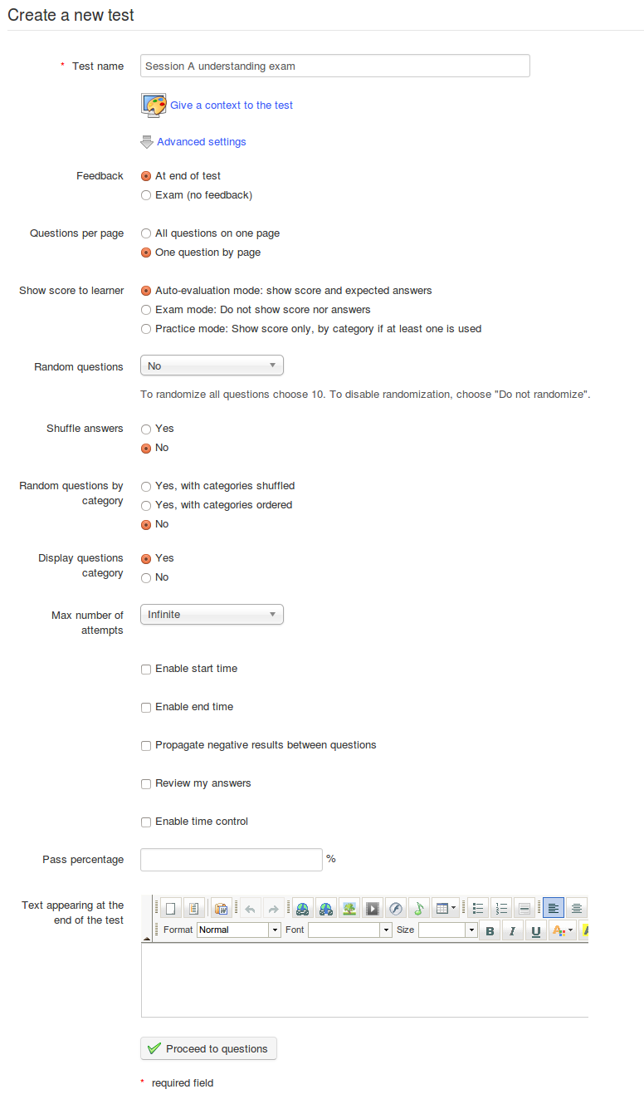Illustration 46: Exercises – Creating an exercise – Advanced options
The settings are fairly self evident:
- feedback can be provided either at the end of the test or withheld, e.g. for an exam
- questions can be presented either on a single page (e.g. for a brief text quiz) or on separate pages (e.g. when the question and answers are lengthy or incorporate media)
- scores and correct answers can be shown (e.g. for an interactive exercise) or hidden (e.g. for an exam).
- Questions and answers can follow a pre-determined sequence or be randomized and shuffled
- The relevant questions category can be displayed or hidden
- The number of attempts allowed can be limited to a given number - “infinite” attempts might suit a “practice” exercise
- Start and end times for the test can be set and the time allowed to complete the test can be limited; )a real-time counter will appear to the user)
- Negative scores can be “zeroed” or carried forward to the next question
- Students can review their answers before submitting the test
- A pass percentage can be set to indicate success or failure to the student
- A closing message to be viewed on completion can be composed.

Note : The platform administrator may enable an additional option in the “Feedback” section of the advanced settings: Self-evaluation (immediate feedback). This option, if checked, enables the “scenario” question types which allows teachers to devise quizzes based on multiple-choice or image mapping questions which, depending on the answer given, lead the learner to alternative subsequent questions. This is a powerful tool – however, be aware that once self-evaluation is checked, these advanced settings cannot be changed: you will instead have to create a new test not based on the Self-evaluation (immediate feedback) option.

Feedback, score and correct answers
This section describes some of the key educational concepts which have steered the design of the Tests feature in Chamilo. For teachers new to on-line teaching and learning, it is useful to consider some of the terminology Chamilo uses in relation to these concepts prior to developing the tests themselves.

Automated feedback
A major advantage in on-line learning is that it can offer the learner enormous flexibility in terms of where and when he/she chooses to study. A student can undertake a fully automated test if they wish anywhere and at any time and receive their score immediately. However, this freedom also means that there is no teacher to hand to explain why they have got a question wrong in a test or exercise, as there might be in a traditional classroom. In automated on-line tests, therefore, the teacher needs to pay particular attention to the provision of automated on-line feedback.

This means that as well as receiving a score, the student can receive a brief (pre-written) comment relating to their answer, whether it is right or wrong. Typically, if he gives the right answer, you might congratulate him: “Well done, I can see you have a good grasp of this concept!”. If he answers incorrectly, you can offer immediate feedback to encourage him to look beyond that demoralizing red “X”, and help make the error part of the learning process. This is the best time for him to learn where he went wrong and how to avoid the error next time. Use hints e.g : “Sorry, wrong answer! Have you read the Open Standards chapter deeply enough? A quick revision of Chapter 3 should help you out! Remember the example of OASIS and how it was designed?”. (This feedback could also contain a direct link to the “Chapter 3” example.)

Such feedback can “humanize” the test and is often really appreciated by students. It means a bit more work for the teacher when creating the test, but provides an important way of encouraging and correcting the learner during his auto-evaluation attempts.

Scoring tests
Assigning a score represents a “raw”, even crude way of evaluating a student's skills. Nevertheless, scores matter a lot to students even though they are of limited use in terms of formative assessment. You have a lot of flexibility in setting up scores, pass marks etc. in Chamilo, including assigning overall weightings to tests and the option to assign negative scores to individual answers. You should use these features with care, and avoid careless errors especially (a wrong score for a correct answer is incredibly frustrating for a student). If you give a automatically score to a learner, it can prove difficult to adjust it afterwards. Updating a score may be necessary under specific circumstances (e.g. where the test is complex), and this will require a manual revision by the teacher.

Displaying correct answers
The option to display correct answers is a simple and direct way of providing feedback by demonstrating to the learner what he should have answered. Sometimes displaying the answers in this way is desirable, but given that the learner may wish to re-take the test without being given the answer, or that you may well want to re-use the test on a future occasion, it is recommended you don't display the any answers, but instead use feedback to let the learner know how (rather than what) he should have answered and set him on the right course to get it right next time through his own efforts.

Test types
You will have gathered by now that the term Tests used for this tool is a generic term used to describe a range of on-line learning activities which, along with assignments and forums, can be used to generate evaluative information which can guide students' further learning. A key aspect of the Tests tool is that it can be used to provide instant automated responses to student input without the need to wait for the teacher to respond. How such automated responses are delivered and used however can vary widely in the course of the student's journey through the course. Below are some suggested broad categories of evaluative activity which can be effectively set up using the Tests tool.

- Exams refers to (generally time-controlled) exercises for which no immediate feedback, nor any answer, is given to the learner : he will obtain his results when the teacher considers it right. This type of summative assessment is often undertaken at the end of a course and may carry a high weighting in the overall assessment of the student. Because of its significance scoring and feedback are generally withheld until the teacher has had the chance to go through at students' results with a “fine-tooth comb”.

- Exercises allow the teacher to assess the learner throughout the course e.g. at the end of a lesson, unit or module. Less formal than an exam, such tests might allow students three or more attempts and represent a more formative approach to assessment, involving plenty supportive feedback. Some elements of these tests might not be fully automated, requiring some level of direct assessment by the teacher. Most scoring would be immediately supplied, but feedback would tend to fall short of displaying the correct answer directly, challenging students to apply themselves to study revision and reflection to work out the correct answer for themselves.

- Automated tests can generally be available to take an unlimited number of times. Their key purpose would be to allow the learner to “drill” himself, e.g. to learn vocabulary in a language course, rehearse a particular mathematical algorithm or memorize a safety procedure. Such tests would be free of any time constraints and would be fully automated displaying scoring, feedback and even correct answers to encourage improvements through practice.

- Scenarios represent a more advanced form of interactive exercise where the teacher can pre-determine alternative next steps in the test predicated on student's response to a question, leading the student through a particular path of questioning. This type of activity can be achieved using Chamilo's Tests tool and can provide students with a very effective interactive on-line learning experience, but of course is by its very nature quite complex and demanding to set up.

The above descriptions demonstrate how the Tests tool can function depending on how it is configured by the teacher. The tool is designed to be as flexible as possible while remaining relatively easy to use, so variations on all the above “models” can be achieved to meet requirements.

Adding questions to the test
On creating a test, click Proceed to questions you will be taken to the questions page:

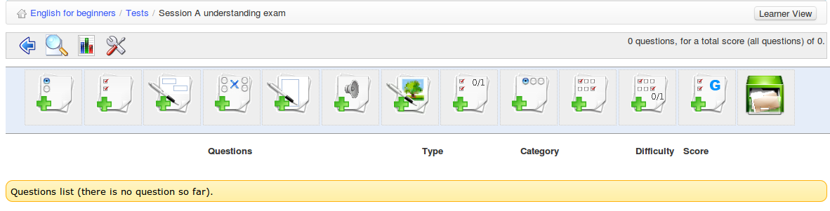Illustration 47: First view of the questions list

In addition to the toolbar the page displays an array of different types of question. (The same page can be accessed at a later time using the edit icon for any given test listed in the Tests page.) It offers a range of question types from which to choose, which are described in this section. Each test can contain a combination of question types – this can prove handy for ensuring tests don't become monotonous.

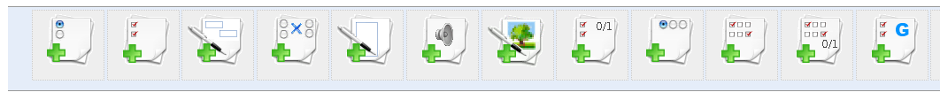
Illustration 48: Exercises – Question types
Fill banks/form
multiple choice
Open question
image zones
Unique answer + unknown
Combination T/F/ ?
multiple answer
matching
Oral expression
exact selection
Multiple answer T/F/ ?
Global multiple answer

Questions are created using an on-line form which differs according to the question type. The following subsections describe each form in detail. Completion of the forms is quite intuitive. The following general points regarding the completion of the on-line forms apply to all or most types of question:

- The “Comment” column will only be shown if you selected the show feedback option to in the advanced settings when you created the test (if you don't want to show any feedback, then there is little point in showing this column on the page.)
- Any fields marked with a red asterisk * must be completed.
- Every question has a title and an “enriched” description. We generally recommend putting a short title in the title box, and putting the real question in the enrich question box. This will allow you to present a much fuller, more meaning question, use images, and/or include audio or video.
- All answer and comment boxes have editing tools which are hidden by default but can be viewed by clicking the small black arrow on the top-left corner of the text box. This will allow you also add images, links and audio to your answers or feedback comments.
- Every question type involves the allocation of scores. In the case of questions requiring scoring later by a teacher, this will simply be a maximum score against which the teacher will mark the test. In the case of objective tests involving learners selecting an answer, the score for each right or wrong answer chosen can be set, and can include negative values. Teachers should give some thought, particularly in tests involving different question types, to what weighting within the overall test each question should carry.
- Teachers should also consider the number of options they wish to offer in the case of multiple choice type questions – this can be determined using the red and green remove/add answer option buttons at the foot of the form.
- If you have a lot of questions covering several topics, you may find it useful for organizational reasons to assign individual questions to categories in the advanced options – particularly if you plan to recycle questions. (You need to create the categories first of course, choosing the create category option  on the main test page. This allows to create a category with a description which will appear in a drop down list.) Using categories is optional but we would strongly advise you do so if you have any number of questions, for sake of future editing or recycling of questions.
- You can also assign a difficulty level for each question in the advanced options. This can be handy for later fine-tuning the evaluation of students' work, or reviewing the test overall. It can also be very useful when it comes to recycling questions, allowing you filter questions by difficulty.

Type 1 : Multiple choice – Single answer

The classic multiple choice question is one in which only one answer can be considered valid for scoring purposes. It is possible to make the test a little bit more challenging by assigning a negative score to a wrong answer. When this is highlighted (e.g. in the test introduction or the question itself), this encourages the learner to think more carefully before selecting an answer at random, and incurring a penalty.

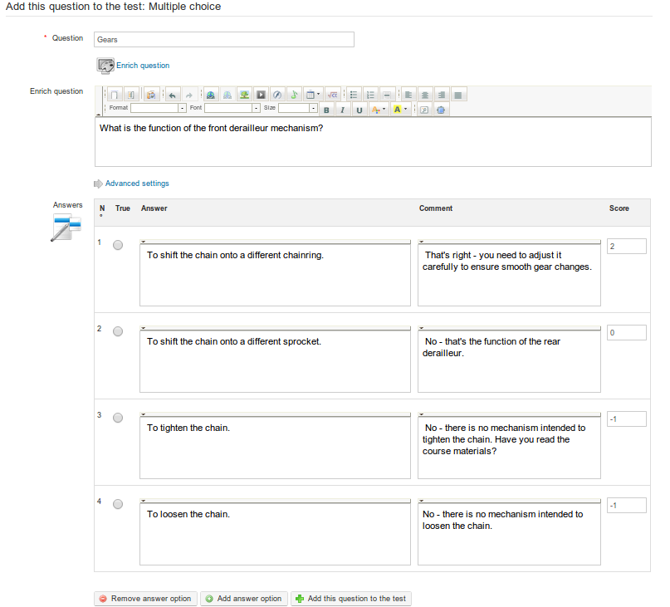
Illustration 49: Tests – Multiple choice, single answer

Type 2 : Multiple choice – multiple answer

This question type is a variation of the previous simple multiple choice question. It allows you to assign more than one valid answer. Again, positive and negative scores are possible. This type of question can prove more challenging to students (you may wish to indicate in the question that there are two answers – so as not to “trick” them!
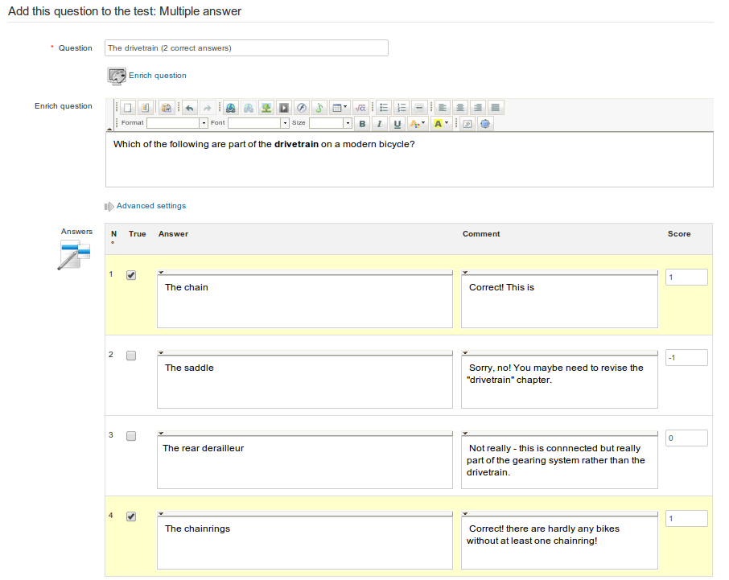
Illustration 50: Tests – Multiple answer question

Type 3 : Fill the blanks

This question type can be used to produce the classic “cloze passage” exercise favoured by language teachers, in which certain words in a written passage can be selected to be displayed as a blank field for students to fill in. First, the teacher simply needs to type the passage (or list of sentences) and then add square brackets around the words to be “blanked”. (These words will be displayed to the learner as empty text fields, which will be marked as correct if the student enters the correct answer matching the word typed by the teacher.) As soon as the square brackets are added, the form will display a “score” field for each word to be corrected. To make the test a little easier, the teacher may choose to list the words to be chose in the “enrich question” box. It's a handy test for checking key terminology or vocabulary.
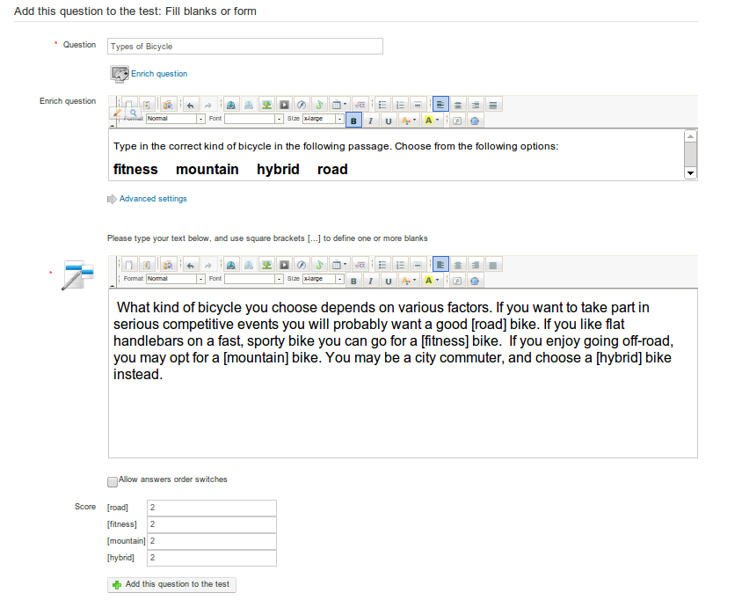
Illustration 51: Tests - Fill the blanks
The question will appear like this to the learner, who simply needs to type the correct word in to the blank fields:
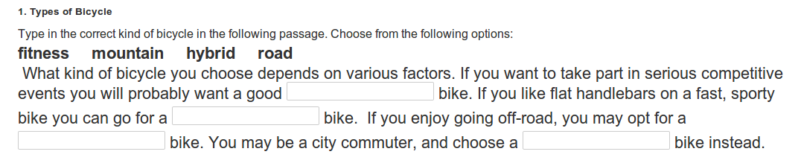

Type 4 : Matching

This type of question is designed to have the learner link together text elements from one list with text elements in another. An element might be a word, a sentence or part-sentence. It can also be used to ask a user to sort elements in a certain order.

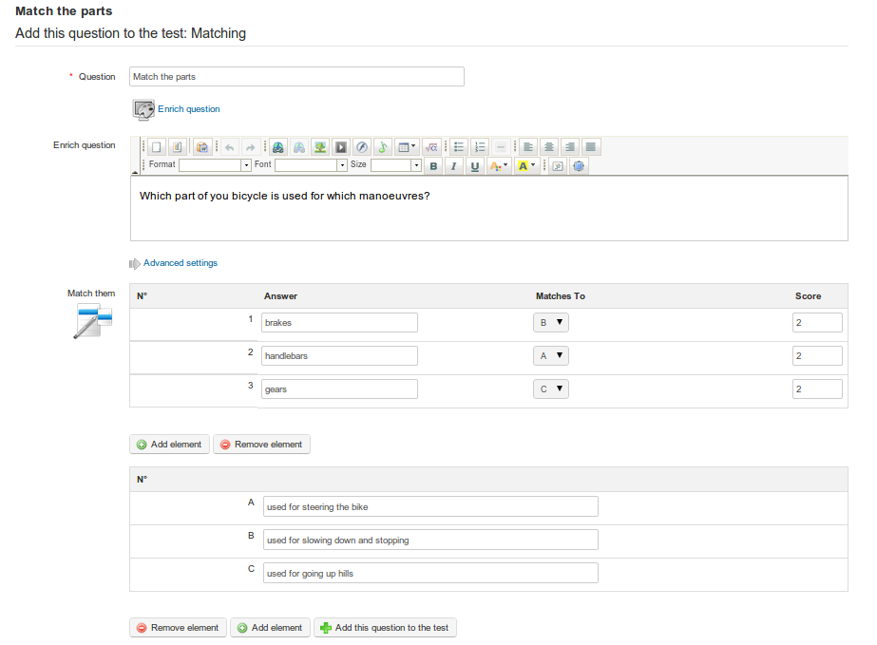
Illustration 52: Tests – Matching text elements

The learner will view the matching question like this:

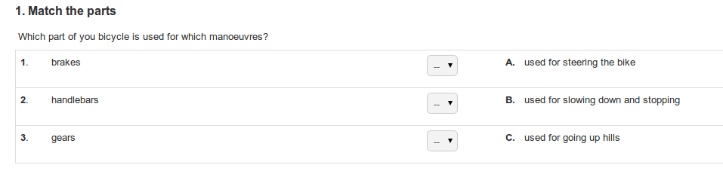
or, from 1.9.6, a draggable circle will make it a little more appealing to students.

Type 5 : Open question

The open question type allows the learner to write whatever they wish as an answer (a kind of “mini-assignment). As such an activity has no single give answer, it will not be automatically evaluated at the end of the test, but will have to be evaluated manually by the teacher before the final test result can be scored. As with assignment and marked forum posts, the teacher is able to do this via the Recording tool which will flag up open questions needing marked.
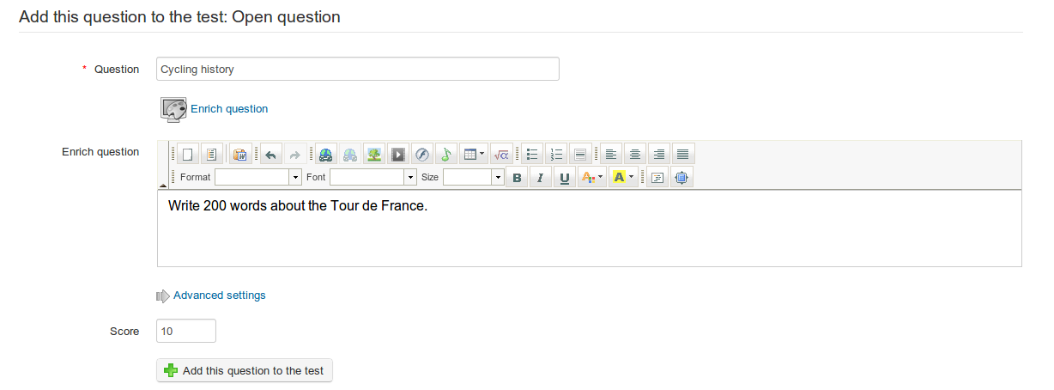
Illustration 53: Tests - Open questions
The learner will be presented with a text field in which to write. (He can use the small arrow on the left of the top border of the field to make use of a range of fields if he wishes to enrich his presentation. e.g. with heading or highlighted text.)

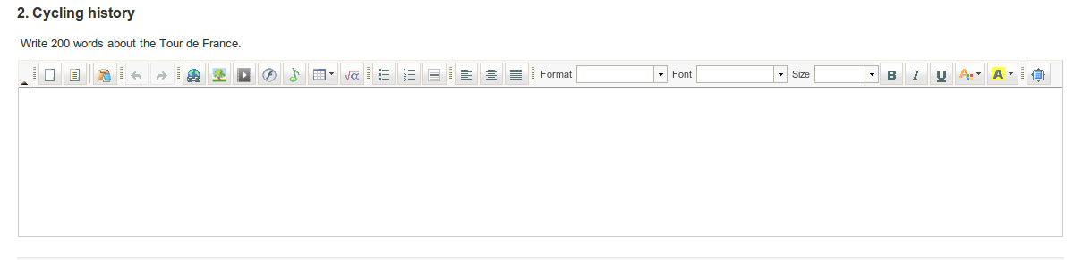

Type 6: Audio answer

This new question type, available with Chamilo 1.9, will only appear only if your administrator has enabled the Nanogong audio recording feature. The question can be compared to “open question” type described above, requiring manual marking by the teacher, but instead of asking the learner to write a text passage, you ask him to record an audio answer. This has obvious uses for language courses, of for learners with particular access needs, but can provide a useful alternative in many study fields – encouraging learners to develop their oral presentation skills.

(note: This question type requires the learner to have Java applets supported in his browser. If this is not the case, he will need to to record the audio separately and then upload it as an MP3 file to the server.)

Because of the additional requirements for this question type, you should make sure your learners are aware that the test will contain an audio question and that they have a more than one chance to try the test to check whether their browser supports it or not. (Bear in mind that taking a test is generally a stressful experience. You don't want to give your learners a nervous breakdown because they can't manage to record an audio answer!)
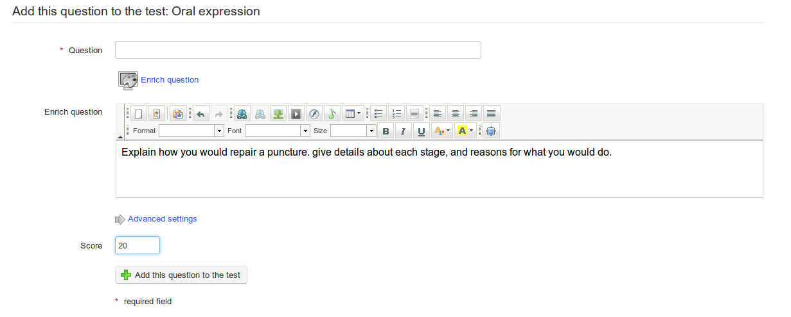
Illustration 54: Tests – Oral expression

The learner simply needs to press the Record answer when he is ready to talk, and follow the instructions for the on-screen Nanogong recorder, which will automatically send his recording to the teacher for marking and scoring.
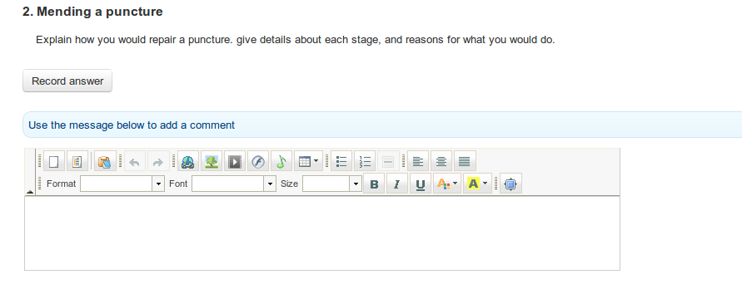
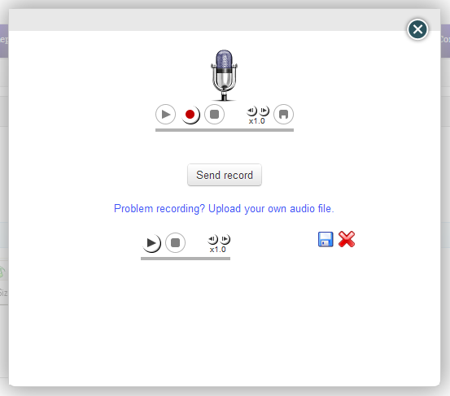

Type 7 : Hot spot, or image area

In this type of question, the learner will be asked to identify areas within an image by clicking on them. These areas have been previously defined by the teacher. Building one of these questions require slightly more work than other types.

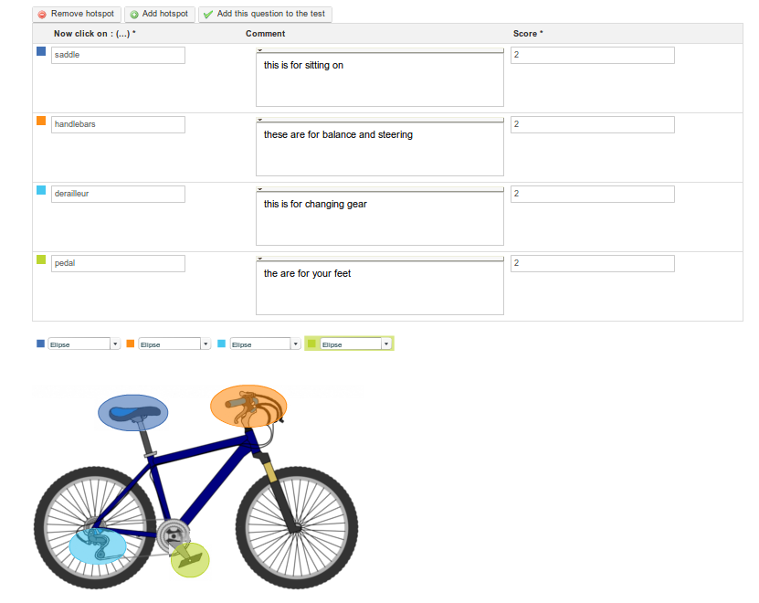Illustration 55: Exercises - Hot spot question creation

Having uploaded your image and named your question, you can add or remove hotspots, and define the area using an ellipse, a rectangle or a polygon shape. As with other question types, you can add comments for feedback purposes and determine a score for each correctly identified area.

The learner needs to click on the picture to identify the areas listed – the numbers will appear on top of the areas on which he clicks:

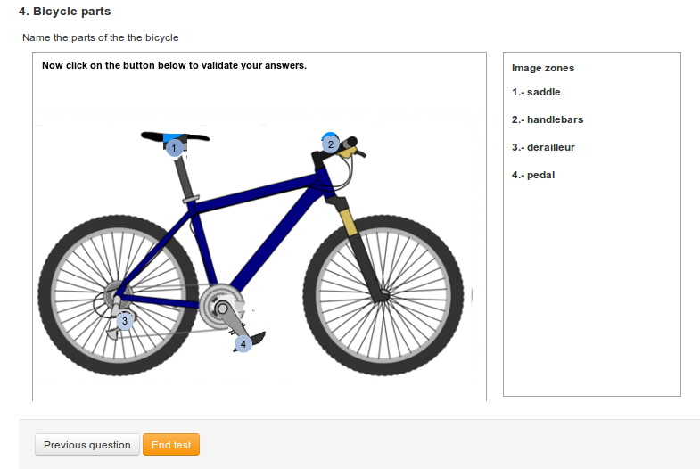

Illustration 56: Exercises - Hot spot learner view

Type 8 : Exact combination
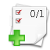
This is a variation of the multiple answer type test looked at above. The only difference is that no partially-correct combination will be accepted. This means that if, between options A-B-C-D, only B and D are correct, you will have to mark both B and D in order to be given the points assigned to this question. There is therefore only one overall score field shown on the form.

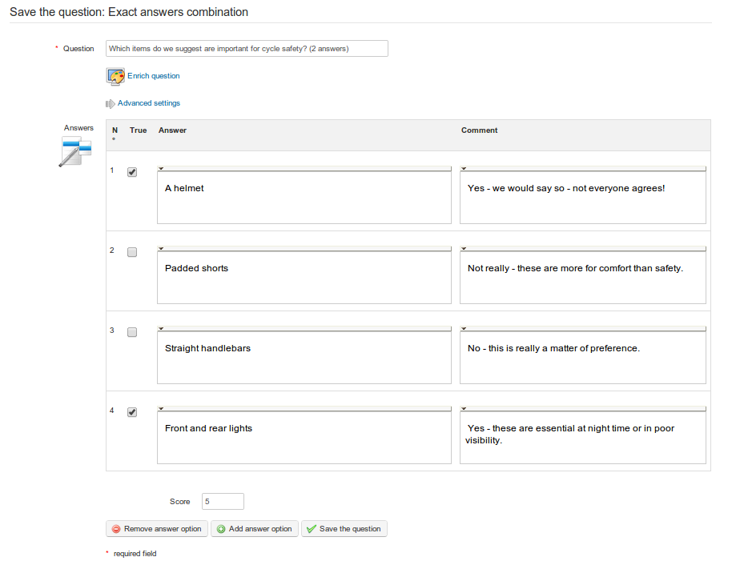
Illustration 57: Tests - Exact combination

Type 9 : Unique answer with unknown

Sometimes a teacher wants the student to indicate that they don't know the answer to a question, rather than just guess an answer. This question type is a single-answer multiple choice question, but reserves the last answer as a “Don't know” option, with an automatic score of zero. Students can be discouraged from guessing by penalizing a wrong answer with a negative score.

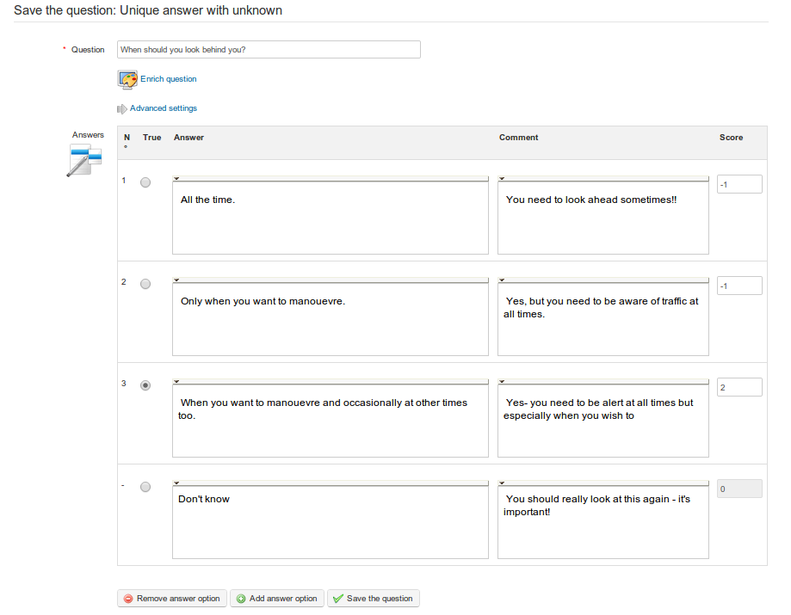
Illustration 58: Tests – unique answer with unknown

Type 10 : Multiple answer True/False/Don't know

This is a another combination format which includes a zero-scored “don't know” option as with the above question option, but using true/false answers rather than multiple choice. Again, negative scores can be assigned to discourage guessing, and admit “honest” ignorance!
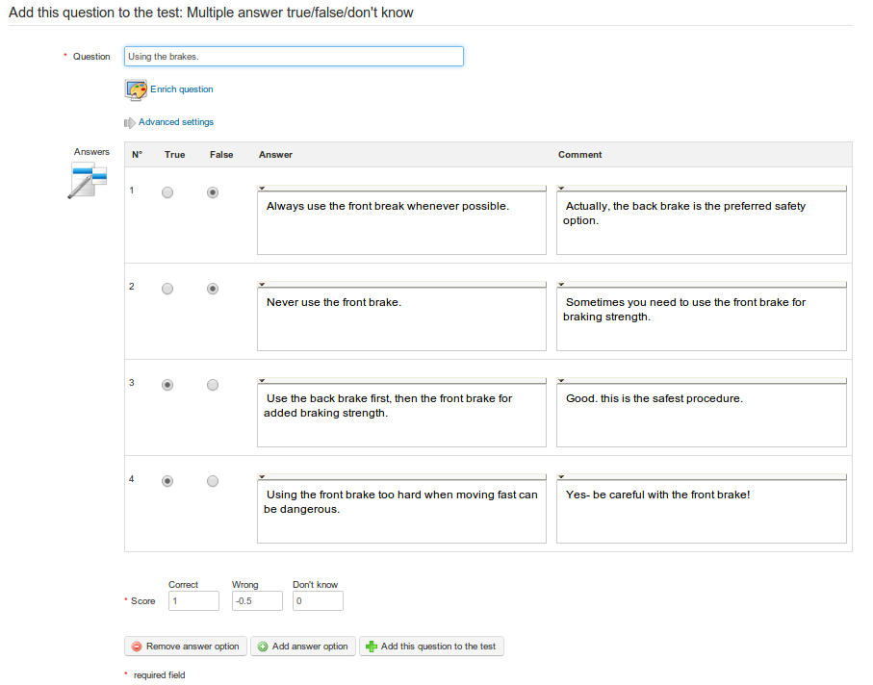
Illustration 59: Tests – Multiple answer true/false/don't know

Type 11 : Combination True/false/don't know
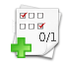
This option offers a single score covering one or more questions. The form looks similar to the “exact answer” form, but the test is displayed to the student differently, as illustrated below.
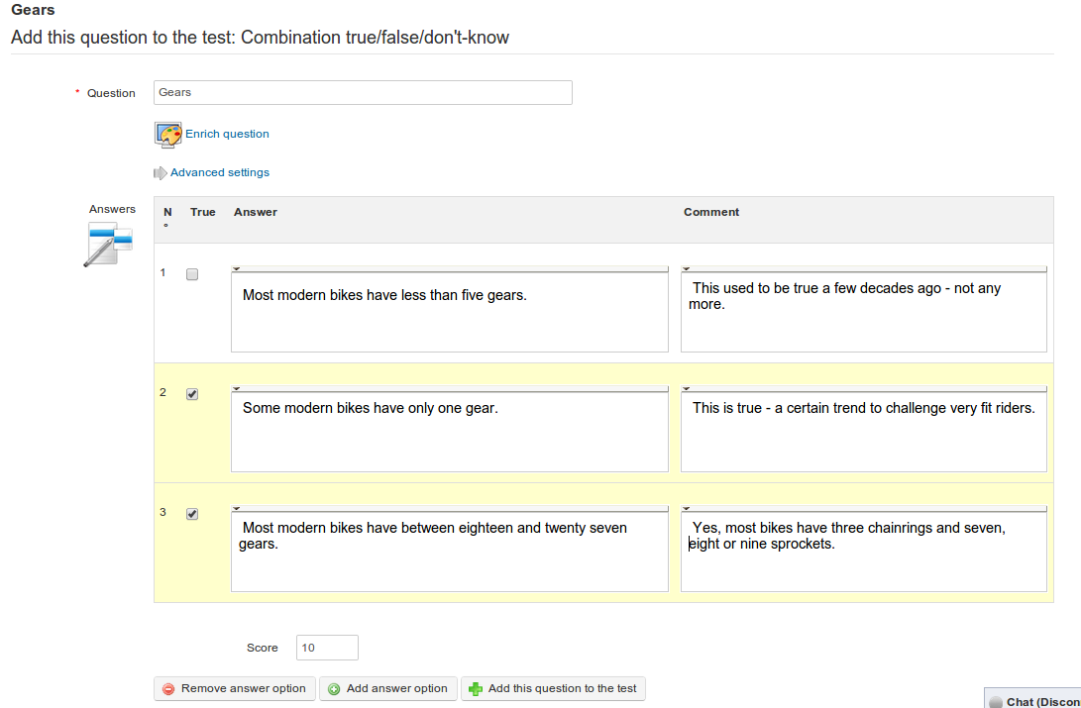
Illustration 60: Tests – Combination true/false/don't know
The learner will view the question(s) and use radio buttons like this:
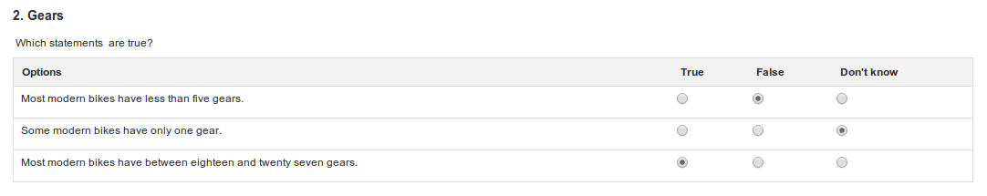
(Note: a “don't know” will generate a zero score, so this format might most fairly contain one or two questions – requiring prudent use from the teacher.)

Type 12 : Global multiple answer

This question format combines the multiple answer format with a single score , providing an option for ensuring that no negative score is accrued

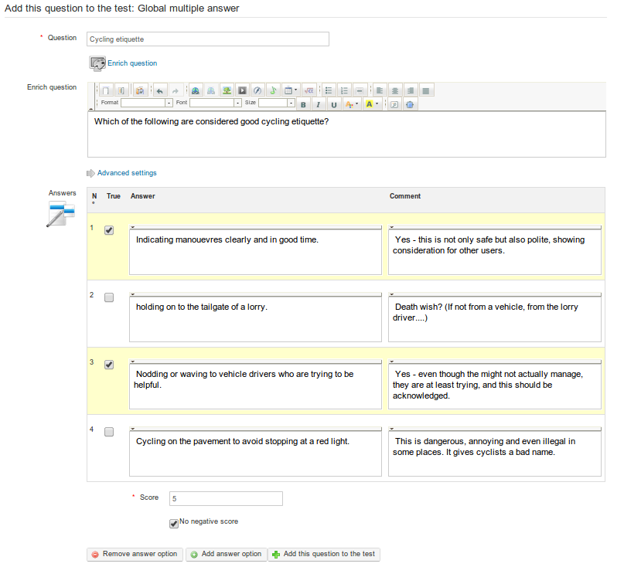

Illustration 61: Tests – Global multiple answer

Recycling existing questions

Any question created, independently of the test or course to which it has been attached, feeds the questions database. This base can be very useful for teachers wanting to re-use questions that are very general or, needing questions to serve as “fillers” when you're short of a few questions in a new test.

During test creation, the database shows questions from other tests, as well as orphan questions (i.e. those questions which have belonged to a test which has been removed).

When the question database shows, it presents a list of all existing questions inside the course. This is where assigning questions to categories and adding a difficulty to tests can prove very useful for identifying individual questions: use the Filter and Difficulty drop-down lists to filter the questions accordingly.

To access the database, click on the recycle existing questions icon  as it is listed on the Create a question page alongside the various question types:

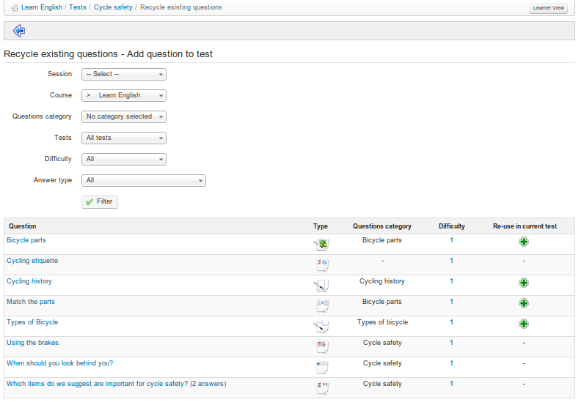
Illustration 62: Tests – Questions database
Click the Re-use in current test button to include these questions in the current test. What actually happens (in Chamilo 1.9) is that a copy of the old test is included in the current test, so that it can be edited if necessary for the new test without its content or configuration being altered within the test in which it was originally created.

Importing: HotPotatoes, IMS/QTI2, Excel
As well as allowing teachers to create their own tests as described above in sections 12.2 to 12.6, Chamilo enables teachers to easily upload and include tests created in external tools, in particular tests created using Hot Potatoes, Qti2 and Microsoft Excel. These are popular authoring tools which can produce tests in a standard format suitable for use in many, LMSes, including Chamilo. Details of how to use these software packages are obviously outwit h the scope of this guide, but experienced online educators may well be familiar with one or all of them, and may have produced tests with them which they wish to upload to Chamilo.
To do so, the teacher need simply click on the relevant icon in the toolbar on the main Tests page and follow the dialogue box to locate and import the relevant file.

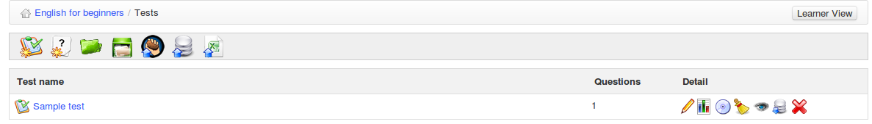Illustration 63: Tests – import external tests from Tests page
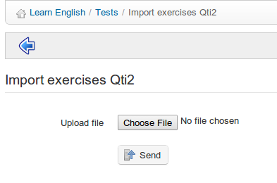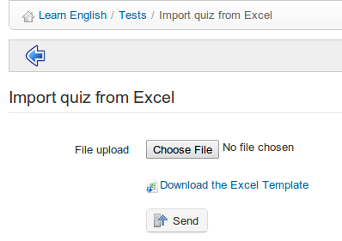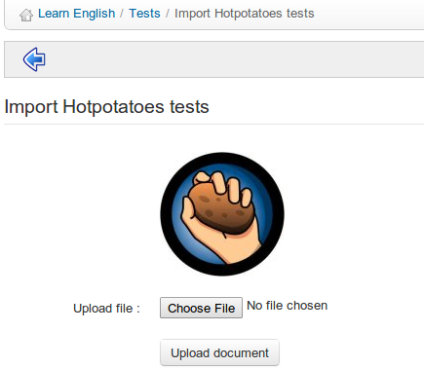

Illustration 64: Tests - Import HotPotatoes, Qti2 and Excel tests

Test results
Chamilo offers handy support for analyzing test results simply by clicking on the Results icon , displayed to the right of each test listed in the main Tests page.
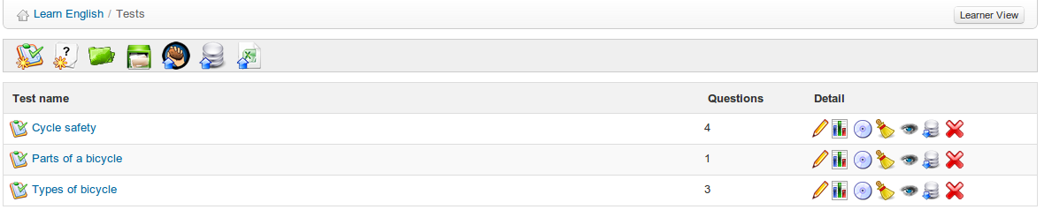Illustration 65: Exercises - List
This will display a page listing all the results for the relevant test.
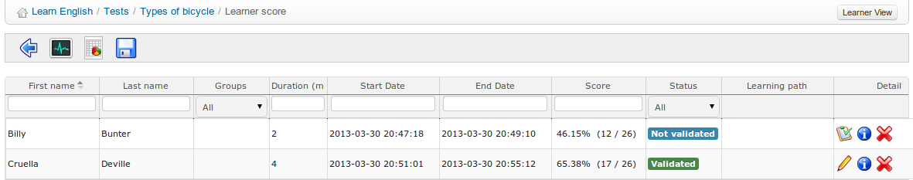
Illustration 66: Exercises – Results list
Here, the teacher can get an overview of learners' times and scores, and can score or edit open questions and offer feedback. He can also delete a test attempt to allow the learner to do the test again (if there is a valid reason to do so e.g. there was an error in the test).

The menu bar of this page allows the teacher to navigate back  to the test , export test results in CSV or XLS format  (e.g. to sort them and generate graphical evaluation statistics), view statistics  about test questions undertaken or even monitor students taking the test “live”  to know how they are performing “during” the exam (particularly useful to monitored exam centers).

Communication : Forums
Following on from the previous chapters you might be expecting to examine the learning paths tool at this juncture. However, we'll look at this later (see Structure: Learning paths on page 76). Instead, it actually makes more sense here to take a look at the next most commonly used tool on the platform.

The Forum tool allows you to organize the exchange of ideas, opinions and information relating to courses and the learning paths. The tool has been conceived so that learners with questions about their course can readily find answers to their questions without having to sift through a massive amount of information by themselves.

The forum is an asynchronous discussion tool, i.e. the people involved in a conversation do not have to be connected simultaneously to participate. Email is also an asynchronous tool. However, a major difference from e-mail is that the forum is a public or semi-public space, where several people can see information (even if they were not part of the discussion initially), boosting support for learning by providing ready access to really useful information, inasmuch as a group of students and teachers can exchange ideas together in their specialist field.
Forum management tools
category
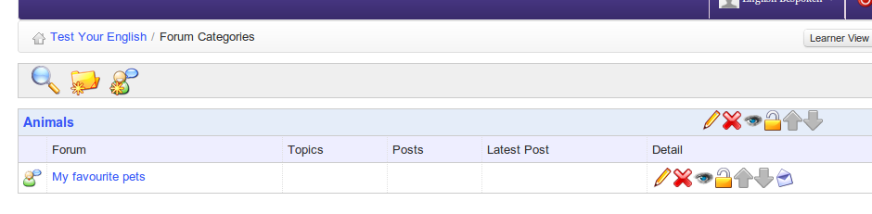Illustration 67: Forum – Global view
Name of forum

Exchanges are organized hierarchically, as follows:
*Forum category
→ Forum
→ → Discussion thread
→ → → message
→ → → → answer to the message
→ → → → answer to the message
→ → → message
→ → → → answer to the message
→ → → → → answer to the answer
and so forth...

Using forum views
Depending on the complexity of exchanges on the forums, several display modes can be used to simplify reading and answering discussion threads.

- List view : simply shows messages in chronological order,
- threaded view : shows only one answer thread at a time,
- nested view : uses the threaded view but displays a complete subject.
Illustration 68: Forum – Display modes

Add forum categories
In the Forum tool:
- click the New category link,
- give it a name,
- add a comment if needed,
- click Create category.
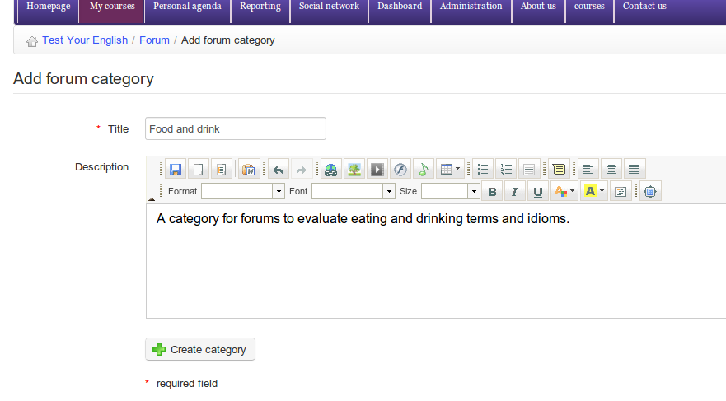Illustration 69: Forum – New category

Add forum
From the Forum page:
- Click New forum,
- give it a name,
- add a description if necessary,
- in the advanced settings, it is possible to:
  - authorize learners to modify their own answers,
  - authorize learners to create new discussion threads,
  - set the default view,
  - decide if the forum is the one of a group, if it is public or private,
- click the Create forum button.
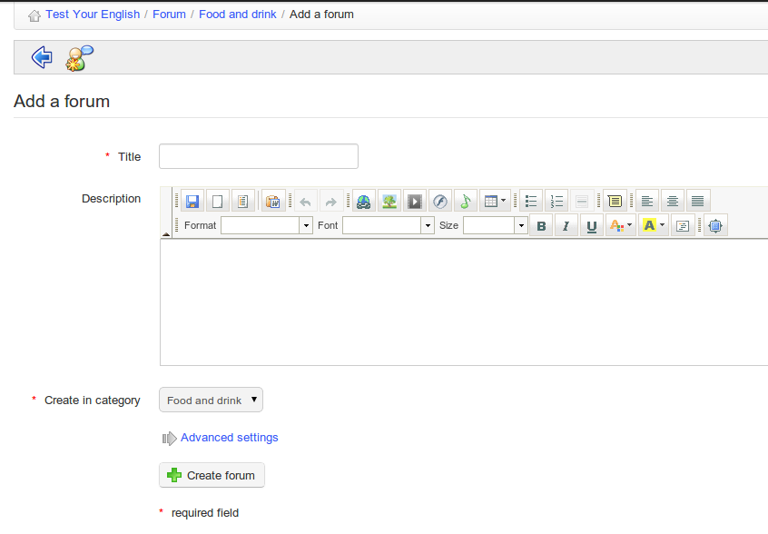Illustration 70: Forum – Forum creation form

Manage forum categories
Managing forum categories makes use of familiar icons:

Icons | Features
 | Update forum category settings
 | Delete the forum category and all its contents
 | Control visibility of a forum category
 | Lock / unlock a forum category to prevent editing
 | Re-organize forum categories

Manage forums
Managing forums makes use of familiar icons:

Icons | Features
 | Update forum settings
 | Delete the forum and all its contents
 | Control a forum's visibility
 | Lock / unlock a forum to prevent its edition (but previous articles can still be accessed)
 | Re-organize the forums position
 | Ask to be kept up to date by e-mail when a message is added to the forum

Start a new topic
When the content of a forum is shown:
- click on the New message link,
- complete the Name and Description fields,
- advanced settings allow us to
  - score a discussion thread as a teacher and give it a maximum score. To do this:
    - select the “Mark this thread” box
    - set a maximum score to reflect the learners participation in a discussion thread,
    - enter or update the title of the corresponding column for the assessments tool,
    - give a weight to the participation in the discussions thread in comparison to the other components of the assessment tool.
  - receive e-mail alerts if an answer is added to the discussion thread,
  - set a discussion thread to appear on top of the threads list,
  - add an attachment to any message, together with a comment,
- Click Create thread
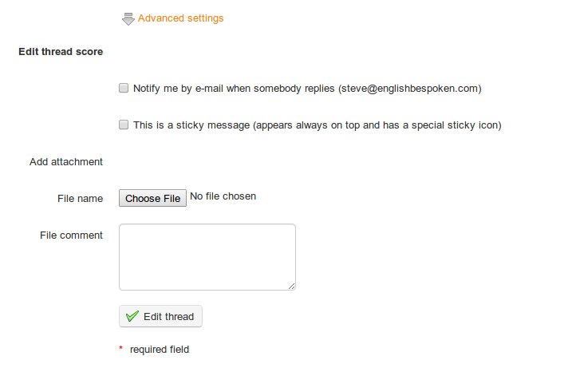Illustration 71: Forum – Discussion thread

Manage discussion threads
The day-to-day administration of topics (also referred to as “discussion threads”) is identical to that of categories or forums. You may, however, move a topic from one forum to another better suited,one.

Icons | Features
 | Change the settings (name, message and advanced settings: see previous page) of the topic
 | Delete (after approval) the topic and all the messages it contained
 | Control the visibility of a topic
 | Lock / unlock a topic to forbid its modification (but its reading will still be authorized)
 | Move a topic to another forum
 | Ask to be sent a notification by e-mail when a new answer is added
 | Visualize the topic's participants and score their contributions if the topic has been marked as scored

Moving a topic from one forum to another has to be done through a drop-down list. Select within that list the destination forum, then click on the “Move Thread” button to proceed. The effect is immediate.

Manage messages
A message is an answer within one of the discussion threads.

Icons | Features
 | Change the settings (name, text and advanced settings) of the message
 | Delete the message (after approval)
 | Control a message's visibility
 | Reply to the message
 | Move the message to another thread
 | Quote this message (and answer on the basis of the quoted message)

Give your learners a score
If you choose to score/grade a topic/discussion thread, you will first need to assign a maximum score to this thread. This needs to be done when the thread is created. Go to advanced settings in the create thread page and check the grade this thread box. An option to enter a maximum score will appear:
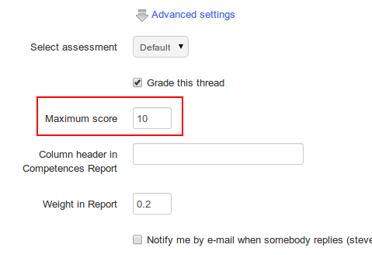Illustration 72: Assigning a maximum score to a discussion thread

To score a student's contribution to a thread:

- click on the Learners list icon
- scroll down to see the list of learners,
- click on the grade activity icon next to the learner's name
- on the new page, locate the list of all the contributions (messages) written by the learner scored as well as a statistical table based on these same contributions,
- enter the score you want to assign the learner: with the help of the list of contributions, choose a qualitative evaluation for these contributions. The statistical table allows a quantitative evaluation of the contributions,
- Click the Grade this thread button.
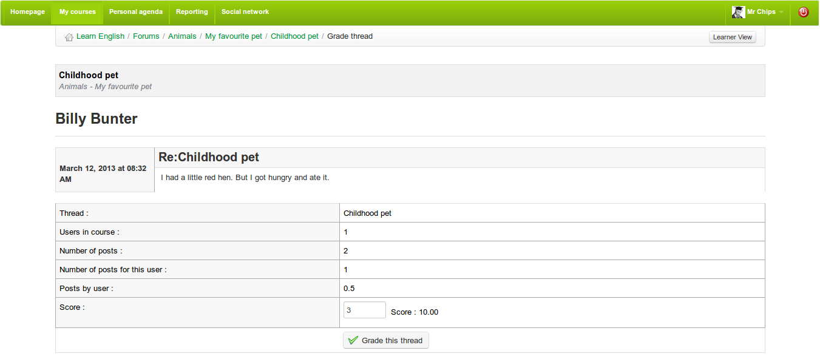Illustration 73: Forum – Marking a thread

Give a score from a message
- Click on the Grade activity icon under the user's picture,
- The new page gathers the list of all messages posted by the learner as well as a statistical table based on these messages,
- Click the Grade this thread button.

The score given to the learners will be shown in the assessment tool.

Add a message to a thread
In the list of tools for managing discussion threads, locate the Reply to this thread icon  . This allows you to add a message at the same hierarchical level as the starting message.
- clicking the icon will give you access to the on-line editor to write your message. An area allowing you to read the other messages of the thread appear at the bottom of the page,
- give a short topic to your message,
- enter your message,
- choose whether you want to be notified by e-mail in case anybody answers your message,
- attach a document (optional) and, if you do, add a small comment describing the document,
- click on the Reply to this thread button.

Reply to a specific message
The Reply to this message icon (), located below the message author's picture allows you to give an answer which will be linked to the chosen message and will be hierarchically dependent on that message.

The reply procedure is the same as the previous one, except the message topic includes the initial message, prefixing it with a « Re : » indicating the two messages are related.

Quote a previous message
Inside a thread, within a forum, it is often most practical to be able to quote a whole or part of a message. This is the aim of this operation, triggered by the double quote icon. The answer will be accompanied by the related message to which it is making reference (it will appear in another color in your answer). You can compose a comment etc. as well as edit the quoted text directly.

Reply or Reply to this topic
The main difference between those two options resides in the hierarchy of the different messages and their answers.
Reply creates new answers which will be deleted altogether when the initial message s removed, while Reply to this thread creates messages which will be kept, even if the starting message is removed.

Search a forum element
All the screens of the Forum tool include a search feature. The search can be executed in all the forums at once and you can combine search terms with the “+” sign. The results are sent in the form of a list indicating:
- the forum category,
- the forum title,
- the title of the thread in which the searched words have been found.

Structure: Learning paths

Introduction
A learning path in Chamilo is an organizational concept/tool which presents activities or learning objects from the course in an organized sequence to guide and support learning. It can be constructed in various ways appropriate to course content. At its simplest it constitutes a clear table of contents or, depending on the nature of the activities involved, it can provide the necessary agenda for the acquisition of a given area of knowledge, understanding or skill.

A learning path can be sequenced in a way which is suggestive (simply displaying sections one after another like a menu) or prescriptive (the learner is required to follow the sections in a given order). It is important to bear in mind that a learning path is more than just diced-up course content: it represents a pedagogical itinerary which might include tests, discussions, evaluations, experimentation etc. Structuring a path effectively to guide students through these learning experiences is a key factor in good course design.

On the course homepage, click on the Learning path link: 

Using the learning path tool, you can either import an existing AICC or SCORM course, create a new learning path within Chamilo or edit an existing learning path:

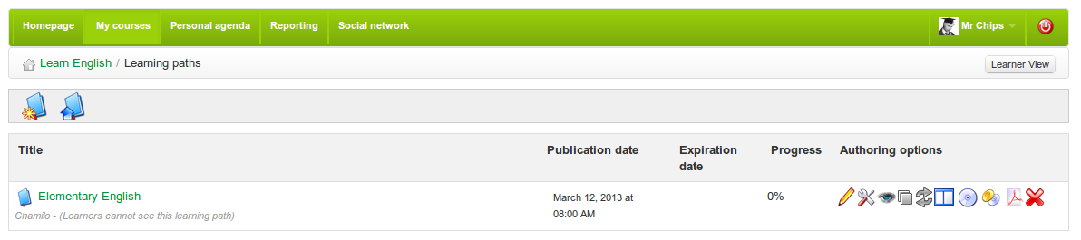Illustration 74: The learning path tool:

Create a learning path

Click on the create new course* icon: 

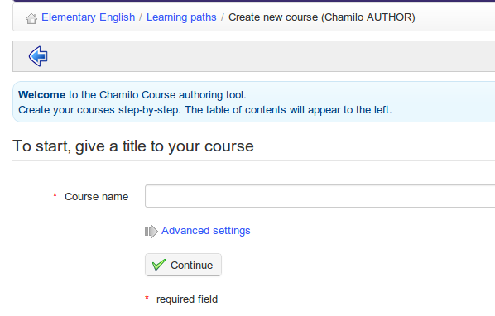Illustration 75: Learning paths - Creating a new learning path

Give a name to your learning path and click Continue. The learning path is created immediately (without content for the time being). It will appear in the learning paths list. Once the learning path is created, you get access to a series of tools to:

- update the learning path's settings
- add and order elements as you build the learning path 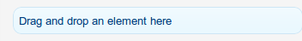
- add an activity / object / document 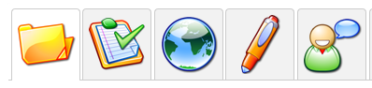
- add a new section 
- use a preview screen to check how it's going to look for learners 
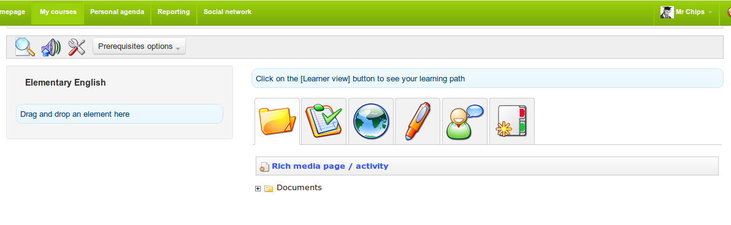Illustration 76: Learning paths – Learning paths – Adding a learning object or activity

Learning path's settings
Clicking on the settings icon will open the settings page. The example image on the right of the form represents what will be seen by the learner when using the learning path, depending on the options configured in the form.
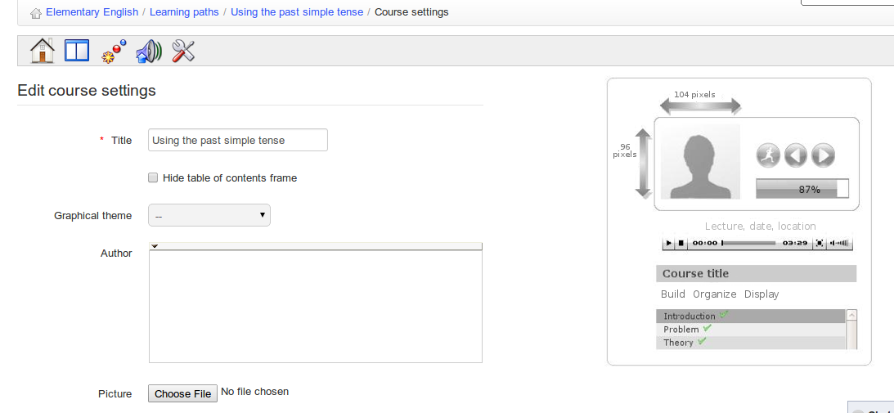Illustration 77: Learning paths – Settings

Add Learning Objects and Activities
As you build your learning path/course, you have the option to include existing learning objects or activities or to create your own using Chamilo.

Illustration 78: Adding a learning object or activity to a course

Create a new document
This option allows you to generate a document which will be automatically added to the learning path and saved in .html format in the learning path documents.

In essence, it is possible to use the rich text editor to edit styles, add images, videos, etc. You can toggle between html and the WYSIWYG editor to produce whatever content you wish. In other words, Chamilo provides you with a complete learning path creation tool.

To begin, click the Rich media page / activity icon to see the following page:
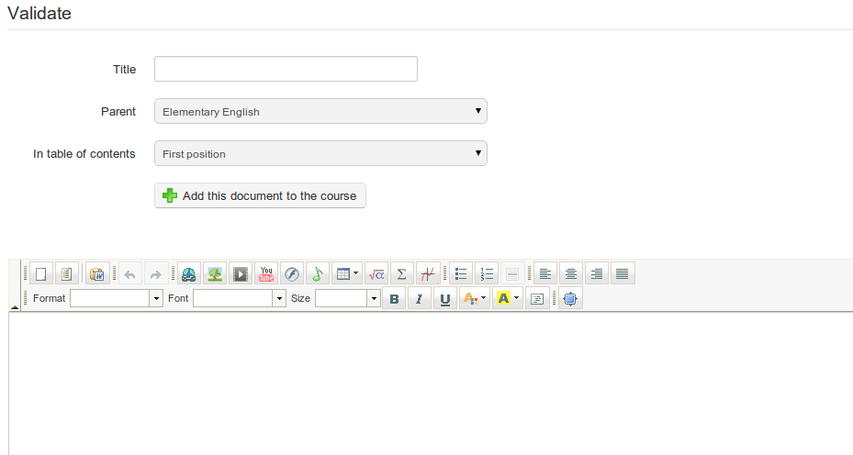Illustration 79: Learning paths – Rich media creation tool

Use existing resources
You can use any document you have previously imported or created in the documents tool of the course (e.g. a SCORM course, .html pages, videos, images, etc. - see Authoring content in Chamilo).

You can also add tests, links, assignments and forums by dragging them across to the learning paths list on the left of the page using the green “handle” . The chosen resource will appears in the wherever you choose in the learning path. Use the handle to re-order items, and the pencil and cross icons to edit/delete elements.

Links, tests, assignments and forums can be created prior to building the learning path in the Authoring or Interaction sections on your course's homepage, and then added from these sections into your learning path via the relevant tab on the learning path page. (Alternatively, they can be created directly from within the tabs themselves as you build the learning path:)
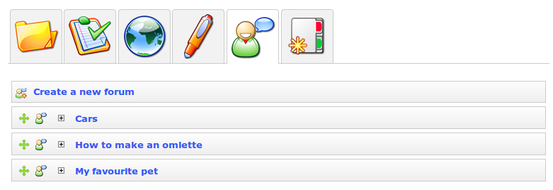Illustration 80: Learning paths – Importing existing resources

Add a new section
The Sections tool is a simple but effective tool allowing you to group activities in the the learning path under headings for clarity.
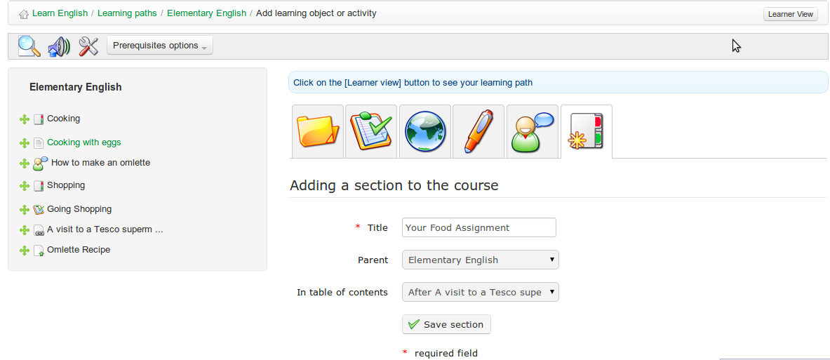Illustration 81: Learning paths – New sections

Display the learning path
Display the results of the learning path you just built:

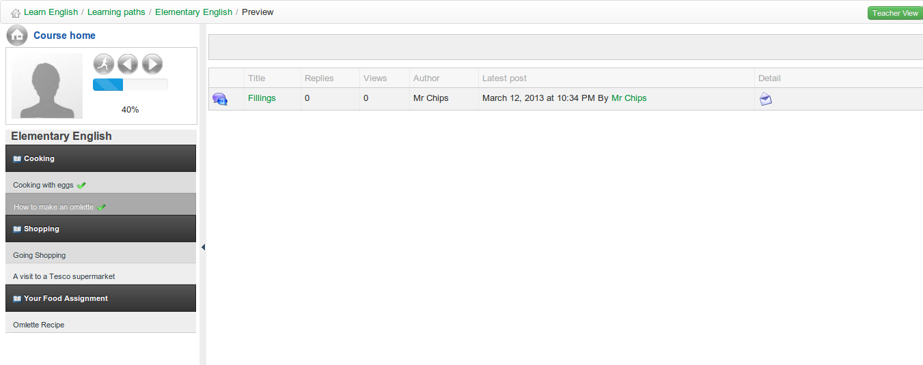Illustration 82: Learning paths – Learner's view

You can toggle between the above teacher and learner views by clicking the teacher/learner view button :

Import AICC and SCORM
Chamilo uses standards like SCORM and AICC for the exchange of contents. Importing such files couldn't be easier. Click the Learning Path icon  on the Learning paths page:
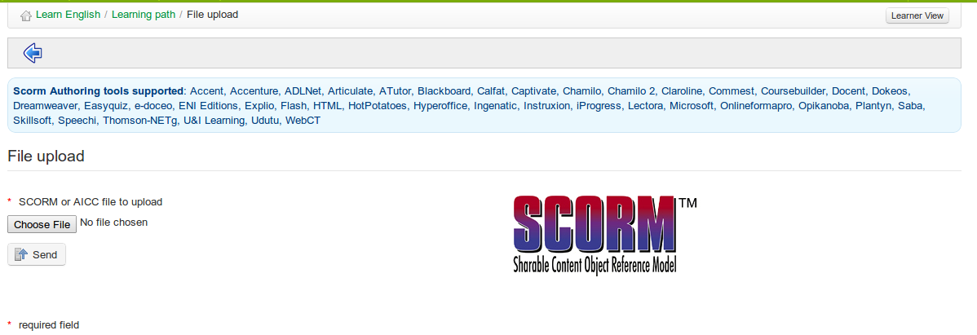Illustration 83: Learning paths - Import SCORM

Click choose file to select the relevant document on your hard disk and send to upload it. That's it. Your imported course is ready to use.

Note : Chamilo 1.8 and all its derivations (including D0keos) only support SCORM in version 1.2.

Managing learning paths
Go to My courses, pick a course and click the Learning paths icon :

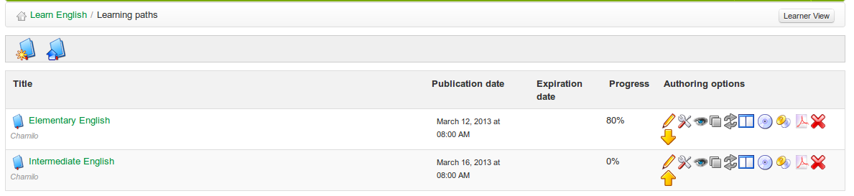Illustration 84: Learning paths – List

The right-side column, Authoring options includes tools to manage your learning paths:

Icons | Features
 | Update the learning path's settings
 | Delete the learning path
 | Edit the learning path
 | Show / hide the learning path to/from learners
 | Show / hide the learning page on the course homepage
 | Export the learning path in .zip format, to later use as SCORM content inside other tools
 | Allow / prevent multiple attempts by learners
 | Toggle between full-screen or normal (embedded) view
 | Re-order the learning paths
 | Export the complete learning path as a large multi-pages PDF document
 | Copy learning path

Prerequisites
If a learning path contains several elements, it is possible to establish the completion of tasks and targets expected of learners following the learning path using the prerequisites feature.
Click on the prerequisites button next to any element in the path (or in edit view):
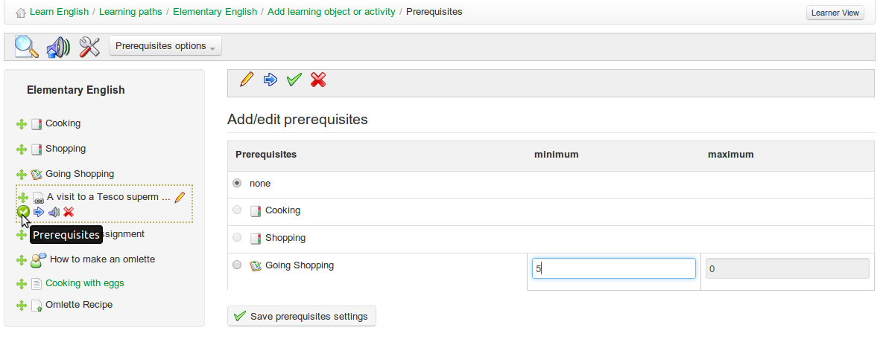Illustration 85: Learning paths – Prerequisites

This allows the teacher to require the learner to have completed another task in the learning path (e.g. the preceding task) before they can access this element, and also, e.g. in the case of a test or assessment, to have achieved a given minimum score.

Using the prerequisite options button in the toolbar, prerequisites to complete the preceding step can be set globally for all steps in the path, or alternatively all prerequisites can be cleared from the path.
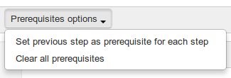Illustration 86: Learning paths – Prerequisites options

Generating certificates

You can readily create a certificate for students successfully completing the course. To do so, just make the last step in your course a certificate which students can view or print off. You can upload an existing pre-made certificate to the course documents area (e.g. an image or .pdf file). Alternatively, Chamilo offers a tool for creating certificate templates, which allows for the automatic generation of a certificate detailing relevant data for each learner in the course (see Chapter 18).

Reporting
Chamilo allows teachers to follow the progress of their learners using various tools, primarily via the Reporting tool  (accessed via the Administration tools section at the bottom of the course homepage) but also through the assignment of homework and tests/exercises during the course. The reporting tool allows teachers to monitor the activities and progress of individual learners, the overall progress of classes through courses, and the development of content and resources.

Tracking learners
By default, clicking on the Reporting icon will display summary details for a list of learners on the course. It includes summary information about test scores, time spent on-line, login details etc.

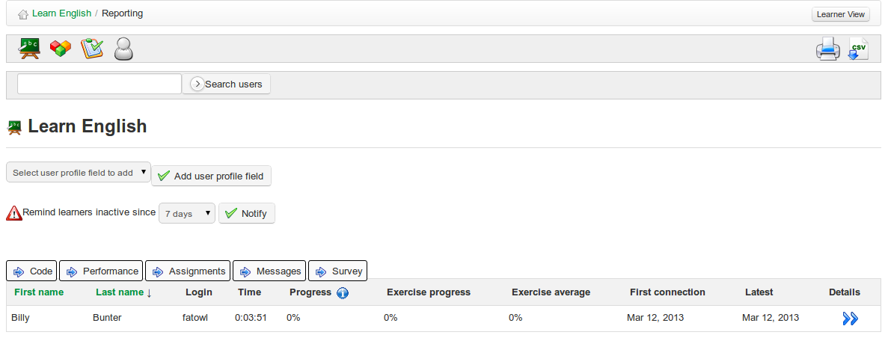Illustration 87: Reporting – Learners

On this page the teacher, as well as viewing a summary table of students' overall activity and progress, can easily add columns to the table drawing on students' profile information (country, date of birth) as well as data held elsewhere in the course (course code, performance data, assignments, messages, surveys). He/she can highlight learners absent from the course for a specified length of time and at one click notify learners with an appropriate announcement using a configurable announcement tool (see chapter 21) accessed by clicking the notify button 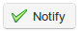 . The teacher can also print out the table or export it as a csv file .

Show individual learner's details

On the Reporting page, click the Details icon next to the name of the learner you want to check on. The new page shows the learner's details in summary, including profile information, photo, connection and summary progress details, but also detailed information about the student's progress through each learning path, results in tests, and potentially useful information about other activities such as assignments, messages sent, links visited, documents uploaded and chat.

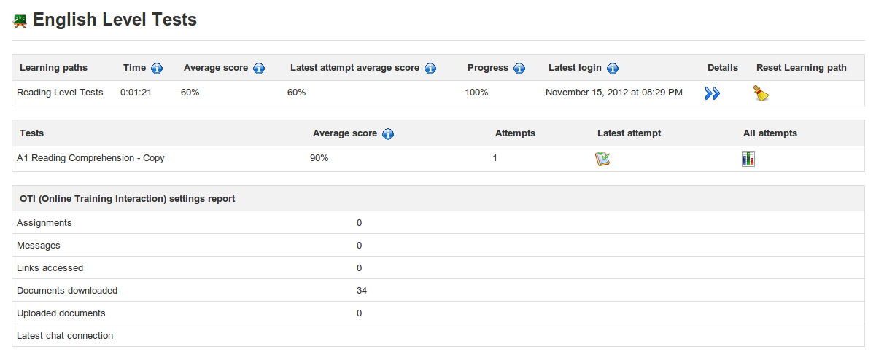Illustration 88: Reporting – individual student's details

The information can be printed , exported as a csv file or mailed by clicking on the relevant toolbar icon at the top of the page. Further details about test attempts and scores and progress through learning paths can be accessed by clicking on the various icons on the page.

Clicking on the Access Details icon in the toolbar allows the teacher to see the course (times and dates) . This general reporting screen gives a general idea of the participation of the learner, which is useful for judging of the involvement of the learner inside the course.
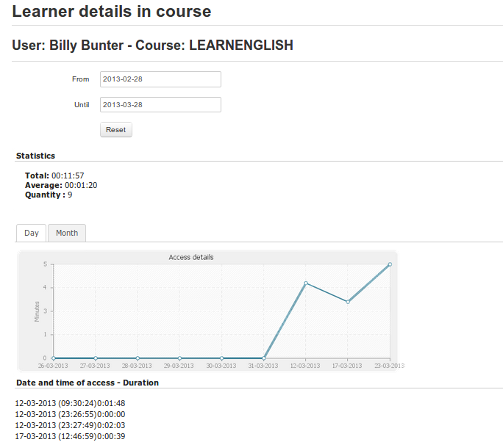Illustration 89: Users – Access details

Course reporting
Clicking on the course report icon  on the Reporting page provides global information about the
course as a whole that the teacher can use in evaluating or developing the course. This includes information such as general progress through learning paths, overall test scores, participation in forum and chats, tools used, documents downloaded and links visited. As with other reporting pages, information can be readily exported as csv files or printed by clicking the relevant tool bar icons.

Resource Reporting
To access details of resources used on the course, click on the Report on resource icon  on the main Reporting page. This will display a list of resources added and deleted to the course, including
resources added by students.

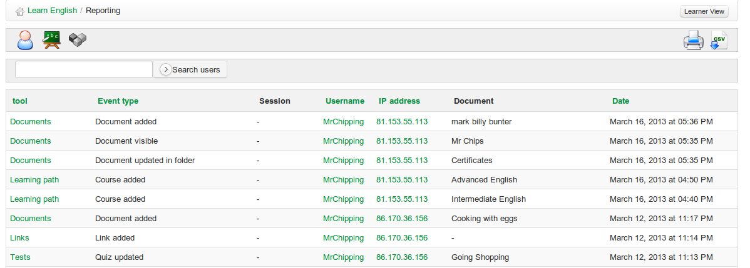Illustration 90: Report on resource

A search facility allows teachers to filter and find the resources they are interested in, and the links on the left allows him/her to navigate easily to the resource. There are also links to the user profile for the user adding each link, and even an IP address which can be used to indicate the location of users.

Test/exam Reporting
The exam tracking tool is useful for teachers wanting to focus on monitoring learners' performance in tests. By clicking on the exam tracking icon on the main reporting page, the teacher is provided with a list of tests and students' scores/percentages, including number of attempts. They can select individual tests and filter results by a given percentage e.g. to display a list of students passing a course, or excelling in their score. This data can be exported as a standard MS-Excel file®.

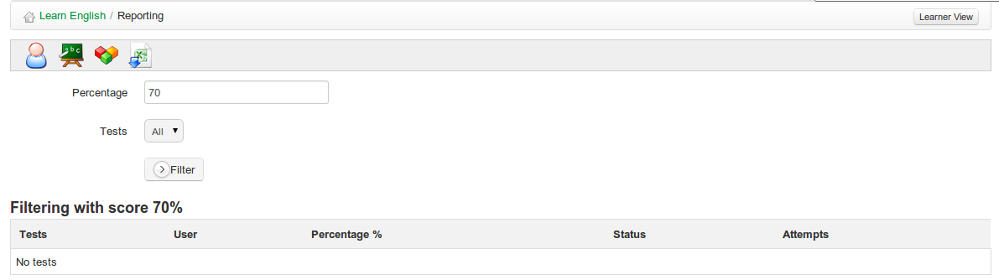Illustration 91: Exam tracking

Assignments
The assignments tool  (accessible from the home page) allows a learner or a group of learners to upload documents for the teacher to review. Assignments can be seen and downloaded by other learners unless configured as invisible ( ) by the teacher.

Assignment documents are usually homework exercises set by the teacher, but they could also be files of interest to others which a learner may wish to share. The assignments tool can therefore be used to receive individual or collective reports, to collect answers to open questions, or indeed any other form of document developed by learners.

The tool also allows the teacher to modify the default visibility of the assignments sent/posted by learners. This ensures students can sent files (exercises, reports, written production, …) in privacy to the course for evaluation by the teacher or course delegate. Click on Assignment settings on the Assignments page:

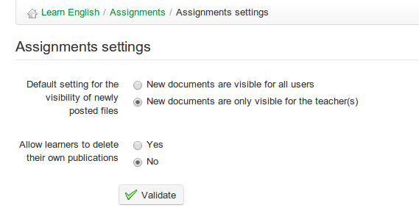Illustration 92: Assignment settings

Making assignments visible by default to all users enables learners to check one another's assignments. This can be a valuable learning technique, as pupils can learn a lot through sharing each other's work, but it has of course to be used carefully; not all learners are not ready to be given so much freedom! The choice between private (only visible to the teachers) or public assignments (all learners can see assignments from others) can be made by clicking the appropriate visibility settings. The teacher can make any post visible or invisible to other learners by checking the or icon next to the relevant entry in the list of learner posts shown for any given assignment.

Note: A significant improvement in 1.9 is that assignments can also now be written and submitted directly within the assignments tool, instead of requiring to be uploaded as documents.

Assignment creation

To create a new assignment:
- click on the Create assignment tool  in the Assignments page:
- give your new assignment a name,
- add a description (optional),
- click the Validate button.

Illustration 93: Create a new assignment
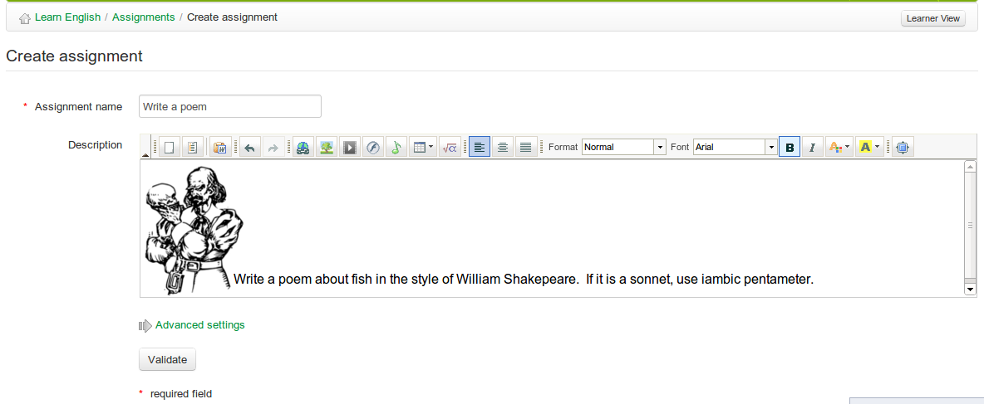
Advanced settings allow you to:
- Assign a maximum score for the assignment
- Include the assignment in the assessment/grade-book tool
- pick a deadline for the assignment to be completed and sent
- pick a final end date for the assignment (and hide it to students)
- Include the deadline in the course agenda/calendar.
- Allow students to hand in their assignment directly from the assignment editor

Completion of assignments by students

Students have the option either to do their assignment on-line or to upload a file or document they have chosen to complete outside of the Chamilo platform (n.b. to ensure students have this choice, the teacher will need to check the relevant box in the advanced settings options of the Create assignment page) The student simply needs to click on the assignment title and then the submit paper icon to be taken to a page where they can upload a file using the relevant tool and/or write their assignment using Chamilo's rich text editor.

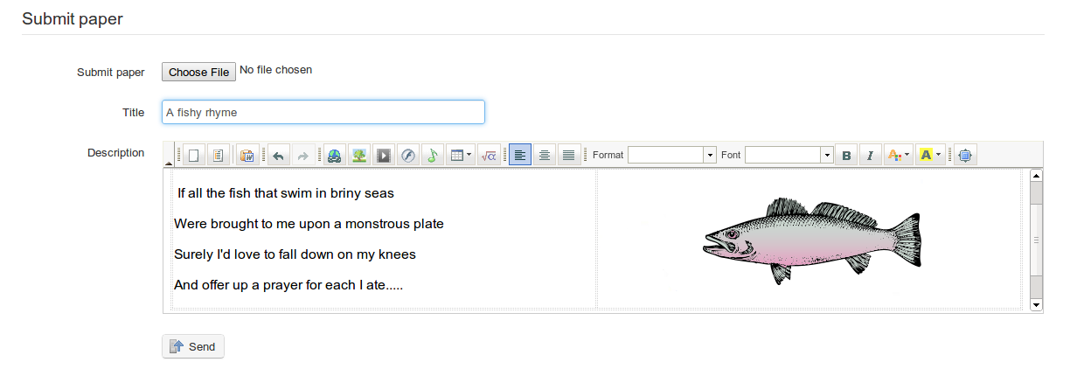Illustration 94: Student's assignment paper

Manage assignments
If the number of learners in your course is significant, there will be plenty of assignments to mark..!
Chamilo eases the burden a little by keeping an organized record of assignments set and student posts on the main page for each assignment set. It lists the assignments completed by learners as each is submitted, flags up clearly if they need to be marked, offers a record of dates , allows quick navigation to each assignment exercise for review and displays each learner's scores. Clicking on the column headings allows for the quick and easy re-ordering of entries e.g. according to date, students name, score etc. The toolbar includes listings  for “missing” submissions from students on the course (including an option to send a reminder), and the list can be downloaded as a .zip file.

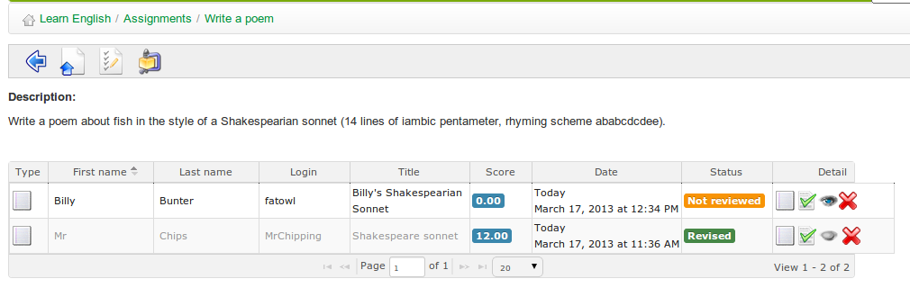Illustration 95: Main page for an assignment set by the teacher

Setting up the assignment evaluation
The teacher's evaluation of student assignments can be automatically included within the assessments tool. The marks assigned to corrected assignments will form part of the overall assessment, and a weighting assigned for each particular assignment.

To include assignments' evaluation in the assessments:

- click on the Advanced settings link in the Create/edit assignment page
- assign a Maximum score greater than 0
- check the Add to grade-book box
- choose the relevant assessment from the drop-down list
- assign a weighting within the assessment
- click on the Validate button.
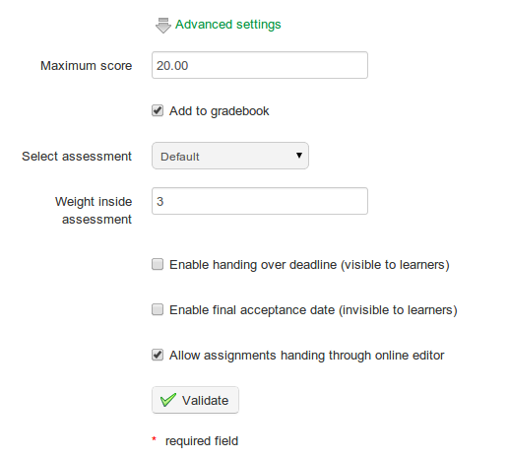Illustration 96: Assignments – Advanced settings

Assignment expiry dates
Chamilo offers two time-based options for the assignments:
- a “handing over” deadline: the date past which all assignments sent by the learners to the platform are marked as expired in red in the list of assignments. Past this date, assignments can still be sent, but they are marked to indicate late delivery.
- a “final acceptance” date: this is the date past which it becomes impossible for the learners to send an assignment . It is the definitive date after which the teacher will not consider any more work sent.

To configure these, check the relevant boxes in the advanced settings of the Create assignment page.
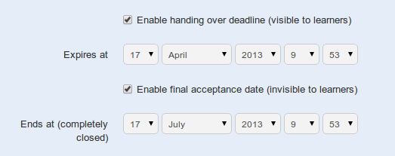

Illustration 97: Assignments – setting expiry dates

Marking assignments
To mark a document uploaded by a learner, go to the main page for the relevant assignment. In the right hand column headed Detail, click on the Save icon to download and view a file the student has submitted, then click the Correct and rate icon to add feedback/comments and a score. If the student has not uploaded a file, but submitted their assignment using the on-line editor, the save icon will not show – instead the student's assignment will be automatically shown in the editor to which the teacher can add feedback etc when scoring the work.
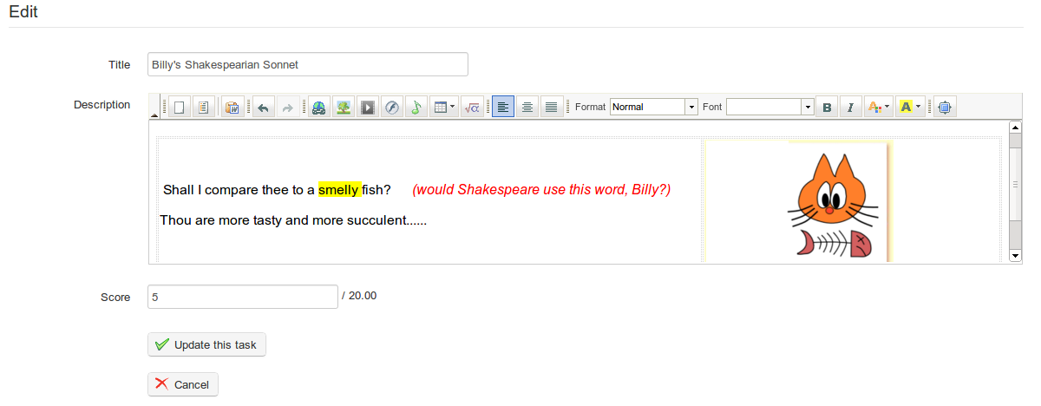Illustration 98: Marking students' assignments

To save the score/feedback, click the Update this task button.

Users
The Users tool  gathers all learners and teachers subscribed to the course. It allows you to manage a list of subscribed users, register new learners and assign specific roles and responsibilities. It also allows you to monitor the activities of all users subscribed to the course.

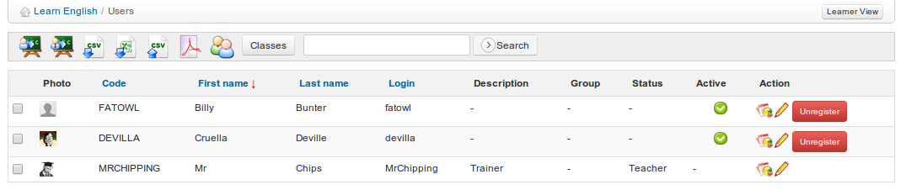Illustration 99: Users – Main screen

Subscribe users

Let's look first at how to subscribe new users as learners to the course. On the main Users page toolbar, click on the Enroll users to course icon . This will display a list of users registered on the platform not subscribed to the course:
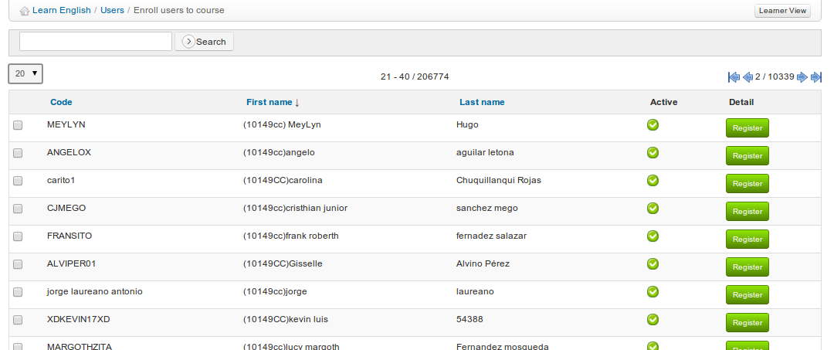
Illustration 100: Users – Action buttons
To subscribe a single learner, just click the Register link to the right of their listing.
To subscribe several learners at once, check the relevant boxes on the left hand side, then select the Register option in the drop-down list headed Detail at the bottom of the table (a confirmation window appears to ensure you want to subscribe them: once confirmed, a confirmation list appears indicating which learners have been subscribed.)

Add teachers
You can also subscribe another user as teacher in your course. Just click the second Enroll teacher icon  (he's wearing a tie!) and repeat the process as for learners. Users subscribed using this link will have the status of Teacher on the course.

Unsubscribe a user
You can unsubscribe users individually or as a group from a course.
To unsubscribe a single user, click the Unregister button next to the corresponding user and confirm your choice.
To unsubscribe a group of users, check the relevant boxes on the left side of the table and select Unregister in the drop-down list headed Detail at the bottom of the table, then click Unregister.

Note : As a teacher you cannot remove the main teacher of a course (by default described in the listing as Trainer) from this screen. Only the platform administrator can do that.

Add/update a user's description
- Click the Edit icon to the right of the relevant user's entry to view the user's basic details;
- Complete/update the Description field to inform other users of the role played by this user;
- Save changes.

The Assistant box (previously titled Tutor) allows the teacher to assign a special Course assistant role with its corresponding permissions. These permissions allow the assistant to view test and assignments results from other learners in the course, to help him assist the teacher in this role.

Search for a subscribed learner
If the teacher needs to find a specific learner in the list of users subscribed to the course, the search feature will allow him to find one or several users from all or part of his first name or last name.

Just fill in the search field with the relevant characters and click the Search button. A list of matching users will be displayed.

Export the list of subscribed users
You might want, (independently of the backup copies taken by your careful administrator!) to keep a separate copy of your users list. To do so, from the main Users page, click one of the export icons in the toolbar (CSV export Excel export  or .pdf export ) to download the list of users in the corresponding format.

Note: not all users details are exported through this feature (their passwords, for example, are confidential information not available to other users, not even to the teacher).

Display learners reporting
The teacher can directly access details from the main Users page about each learner's participation in the course by clicking on the Reporting icon next to the user's listing. This will link to the Learners details in course page, described more fully in chapter 15 above.

Assessments
The Assessments tool  is where you, as teacher, can establish success criteria for the course (i.e. the pass-mark, merit rankings etc.), involving the allocation of weightings to various activities, tests etc. You can also use the assessments tool to generate and issue certificates to learners on successful completion of the course. Click on the tool to display the main Assessments page which may (once set up for the course) look like this to the teacher.
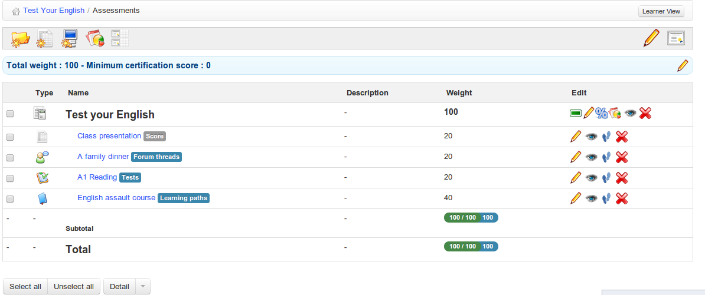
Illustration 101: Assessments – Example teacher view
It allows you to prepare an overview report compiling learners' achievements in the course overall, drawing on the results of activities undertaken in virtually every part of the online course, but also including “external” activities undertaken in your classroom, outside of the online course.
The learner can use the assessments tool as a “grade-book” to monitor his own progress, and will see a simpler, personalized view when he clicks on the Assessments tool which will look something like this:
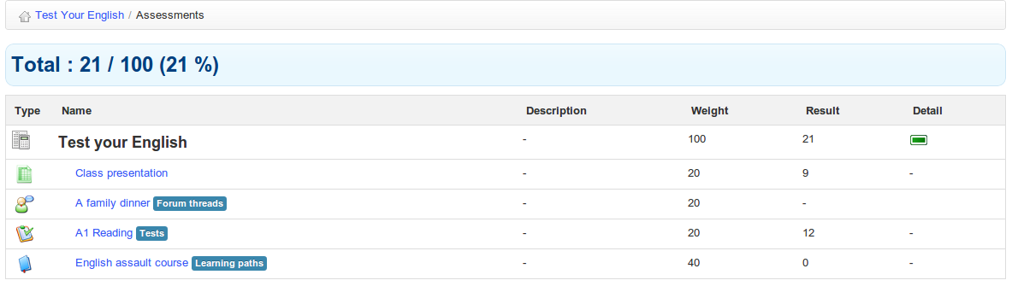Illustration 102: Assessments – Example learner view
(Note: Before looking further into the assessments tool, make sure you have at least one learner subscribed to your course. (This is why we cleverly put the Users chapter before this one!). In this chapter, it will be much easier to follow the examples if you already have learners subscribed and a series of activities created. Don't forget – until you choose to allow it, the user will not be able to see the course anyway, as long as is configured as closed.)

Assessments pre-configuration

The assessment tool (also called the gradebook tool by some of our users) requires several settings to be correctly configured to give you a useful result. The activities weighting, a minimum certification score (pass-mark), skills rankings and a certificate template are elements that can extend this tool if properly configured. If these are not set correctly, an orange alert will be displayed on the main Assessments page.

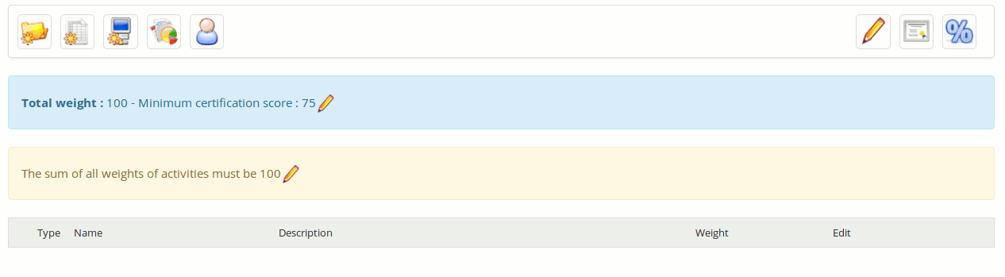
Illustration 103: An empty gradebook generates information messages
So let’s analyze each of these elements in more detail.

Total weight and minimum certification score
To view and edit this basic configuration , click on any of the edit icons ( ) of the page:

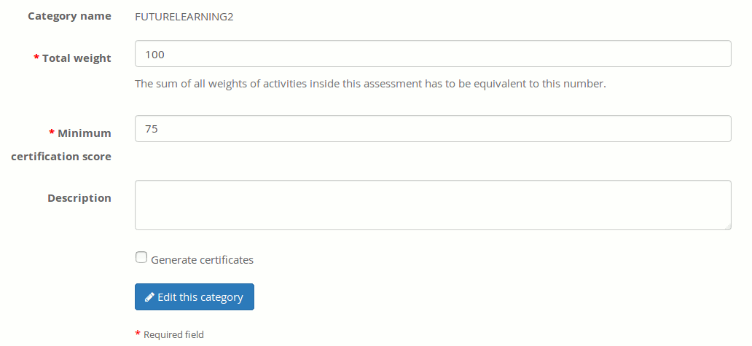
Illustration 104: Assessments – General settings
The Total weight of the course is important for assigning individual weights to activities. This will allow you to “spread” the importance of each activity in your course. If you only have a few activities, maybe a total weight of 10 is enough, but we consider 100 to be a common selection among teachers.
The Minimum certification score defines the pass-mark for the course. It is expressed as a percentage of the total score. This can be useful in several ways, but in the end, if a student has a grade/score that is superior to that percentage, he/she will “pass” the course and, if you configured certificates, he/she will also receive a certificate. If the score is below that percentage, no certificate will be generated, and we will consider the student didn’t acquire the corresponding skill or skills.

The description is really not used much. You can use this field to describe what is expected of the student to get a certificate or a passing score.

Finally, an option allows you to define whether you want to generate a certificate or not. In previous versions, the generation of a certificate was automatic if the student reached the minimum certification score. However, some teachers noted that they didn’t always have the time to configure certificates properly, and that they wanted to remain in control of when certificates should be generated when they used the assessments tool with students. Fair enough: we added the option so the certificate generation is optional (and is not enabled by default). We’ll come back to that option a bit later.

Sub-assessments
The assessments tool allows you to define several “sub-assessments” inside the assessments tool, or to just use the upper-level assessments tool to distribute your activities. We believe using sub-assessments is a bit more complex and we should avoid generating more confusion at this point, so let’s just keep it at that: if necessary, you can create a lower level of assessments inside the assessments tool, using the yellow folder creation icon ().

Adding classroom activities
A “classroom” activity refers to any component of the overall assessment not undertaken inside the Chamilo platform. Any assessed activity can be added a classroom activity and therefore become part of your overall course assessment. As such, you will of course need to add the relevant details manually to the Assessments. To do this, in the main assessment page, click on the Add classroom assessment icon  in the tool-bar.

The name, weighting and maximum score for the activity need to be entered, and the teacher can also choose whether to make the activity visible and whether to grade learners.
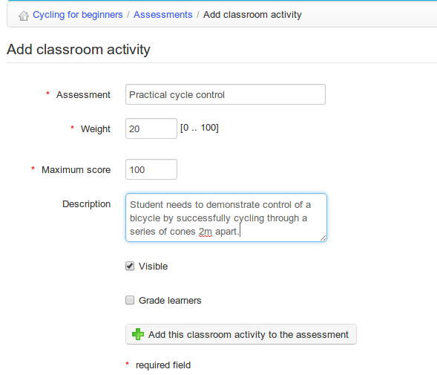
Illustration 105: Assessments – Classroom activity
You will only be able to add results for classroom activities for learners subscribed to your course. Scoring the Classroom activity is straightforward – click the relevant activity listed in the main Assessments page and then the edit icon either next to the learner's listing or (to score a list of learners) in the toolbar:

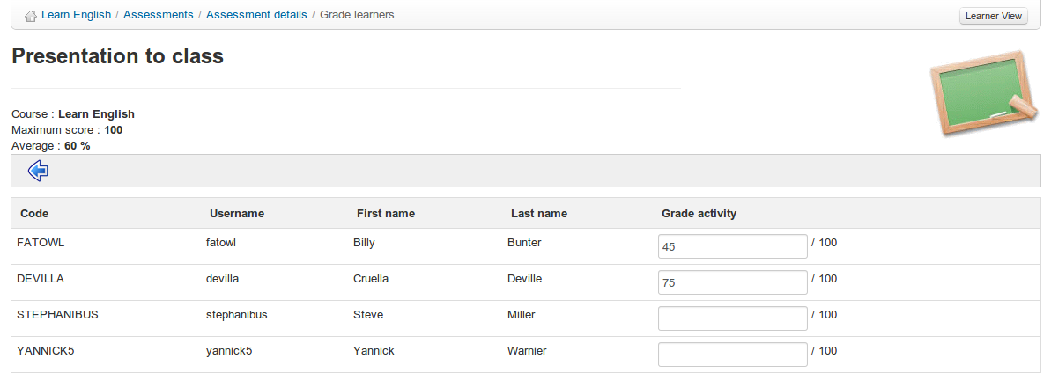Illustration 106: Assessments – Classroom activities – Filling in results
The scores will be added to the assessment data and included in each student's grade-book.

Adding online activities
Within the Chamilo course, not only tests but a whole range of activities can be scored and added to the Assessments tool for consideration in the overall grading of students. The Add online activity tool () allows you to create a link from the assessment to one of the following types of resources in your course (these resources already have scoring capabilities):
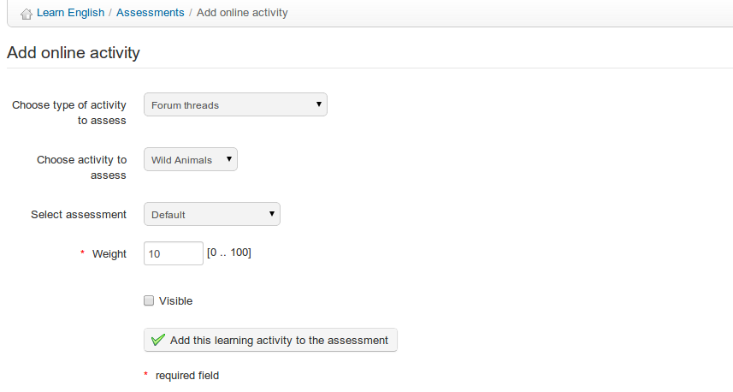
Illustration 107: Assessments – Add online activity
- Tests,
- Assignments,
- Learning paths,
- Forum threads,
- Attendances,
- Surveys

Walk down the drop-down lists to locate the activity visible in the list of activities for this assessment, and click to include the activity in the assessments so that it counts towards the learners' overall grade.

As you might expect, these “online” activities are automatically graded by Chamilo, so you don’t need to give students any score. That’s automatic. But the students will have to take the corresponding activities in order to get their grades.

Weights
The weights, accessed through a percentage-symbol icon () on the right side of the main assessments page, allow you to define the relative importance of each of the activities within the assessment. If you don't have any activity registered at this point, return to this section when you do.
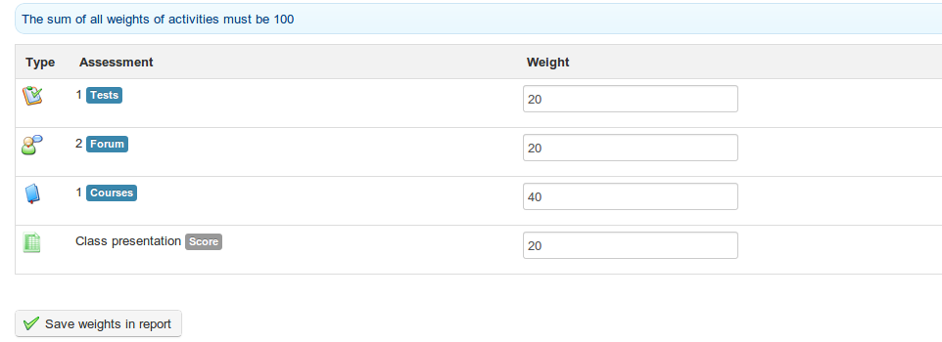
Illustration 108: Assessments - Weights
We suggest that you define a distribution of weights that make a total of 100 (or the equivalent total value for the course defined in the previous section), otherwise it becomes really complicated to understand all the possible relative scoring issues. Several messages will remind you to do just that.

Skills ranking
Skills ranking allow you to define ranks for the scores, so that they can be more easily represented literally and graphically. This option, however, must be enabled by your portal administrator. Otherwise you won’t see the following options.
Click on the podium icon on the right side of the main assessments page :

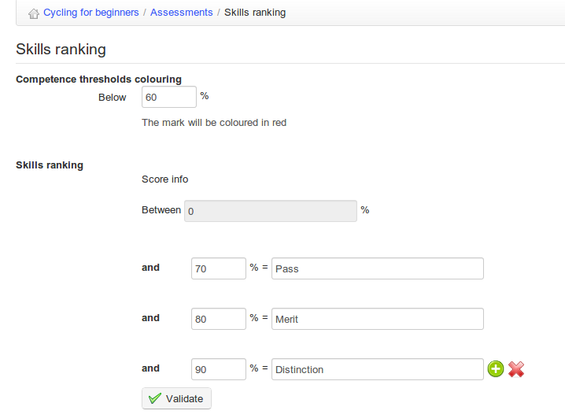

Illustration 109: Assessments – Skills ranking
As well as a pass-mark, you can add additional options: e.g. the names you want to give to any score range to make it faster to read generic reports.

Certificate template
Once you have configured the rest of the tools, you might get interested in setting up your own certificate template. But before we start, let’s get 3 concepts clear:
- Certificate templates are built in HTML, so you will probably need a web designer (or a lot of patience) to generate beautiful templates.
- Certificate templates are build in HTML (yes, again), so their export to PDF (a feature provided as a commodity in Chamilo) might not be ideal and you might need to work over that with your designer to make sure both results are fine.
- Certificates are only generated when the certificates option is selected (see Assessments pre-configuration on page 99), if students have a passing grade, and if the student actually enters the assessment tool (or, in 1.11, if you used the special certificate page in the learning path)

The assessments tool makes it possible to create a certificate generated automatically using the learner's data stored on the platform. To set this up, click the large certificate icon  on the right side of the main page. This will bring up a screen displaying a list of existing certificates, with tool-bar options to import  or create certificates. Chamilo provides one basic template certificate that you can update if you like. Click the Create certificate icon  to go to a document creation page, which allows you to design a certificate.

The page starts with a list of tags that you can use in the edition of your certificate:
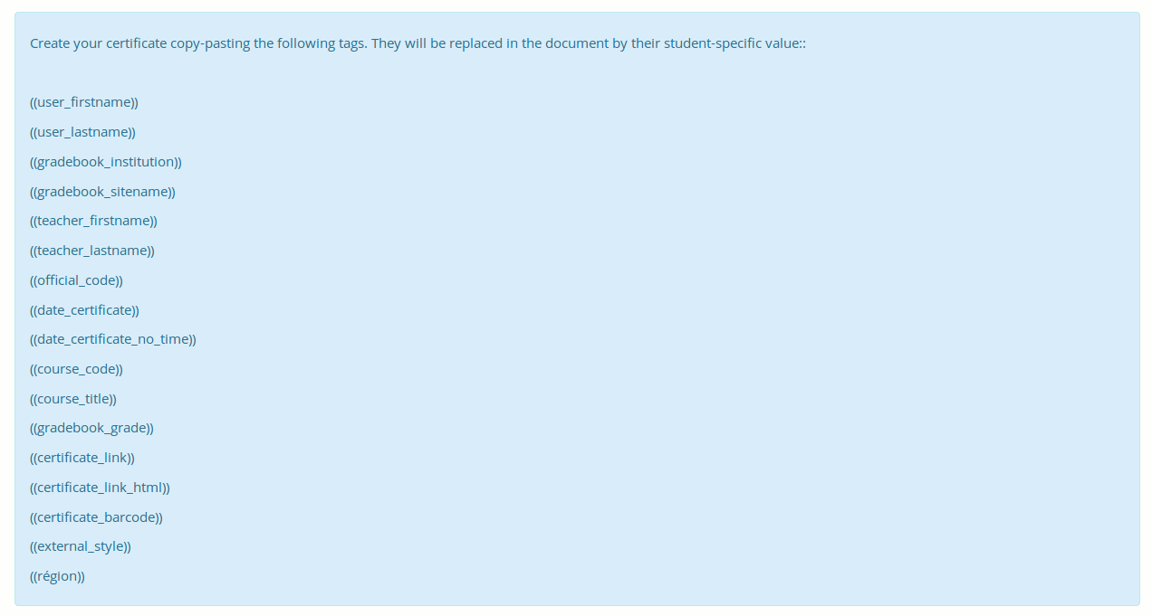
Illustration 110: Certificates edition tags
These tags are relatively self-explanatory, but for the sake of precision, let’s define them here:
- ((user_firstname)) will be replaced by the firstname of the user obtaining the certificate
- ((user_lastname)) same thing as above, with the lastname
- ((gradebook_institution)) this will be replaced by the name of your organization, defined by the administrator in the platform settings, and visible in the title bar of your browser
- ((gradebook_sitename)) will be replaced by the name of the platform, also defined by the administrator an visible in the title bar of your browser
- ((teacher_firstname)) will be replaced by the firstname of the teacher assigned to this course. A word of warning: this hasn’t been tested with multiple teachers or with sessions, so use with caution.
- ((teacher_lastname)) same as above, but lastname
- ((official_code)) if you use the users’ official code field, then the corresponding value will replace this tag when generating the certificate
- ((date_certificate)) will be replaced by the certificate date and time, in the date format that matches your language definition
- ((date_certificate_no_time)) same as above, without the hours and minutes
- ((course_code)) if you use a clear hierarchy of course codes, using the course code here might be useful
- ((course_title)) will be replaced by the course title
- ((gradebook_grade)) will be replaced by the score obtained (both absolute and percentage) by the student
- ((certificate_link)) will be replaced by the unique URL of the certificate. Chamilo keeps them well stored, so showing the link on a certificate that is going to be printed is a good idea to maintain the relationship with the digital original version
- ((certificate_link_html)) in case you will export the certificate as an HTML certificate or a PDF certificate to use in a digital format, this will put an HTML link directly on the certificate
- ((certificate_barcode)) will replace the tag with a QR code with information about the certificate (including the link to the original). This is a very nice feature if you like QR codes, but you have to think that the tag (a simple text on one line) will actually be replaced by a good-size QR code. So plan the free space around this text well.
- ((external_style)) and ((région)) are examples of extra profile fields defined on users. Extra fields will appear in this list depending on their availability, so that’s a great extension you can give to your certificates if your administrator is open to this type of usage.

Editing the certificate is then only a question of finding a good text and the right tags:
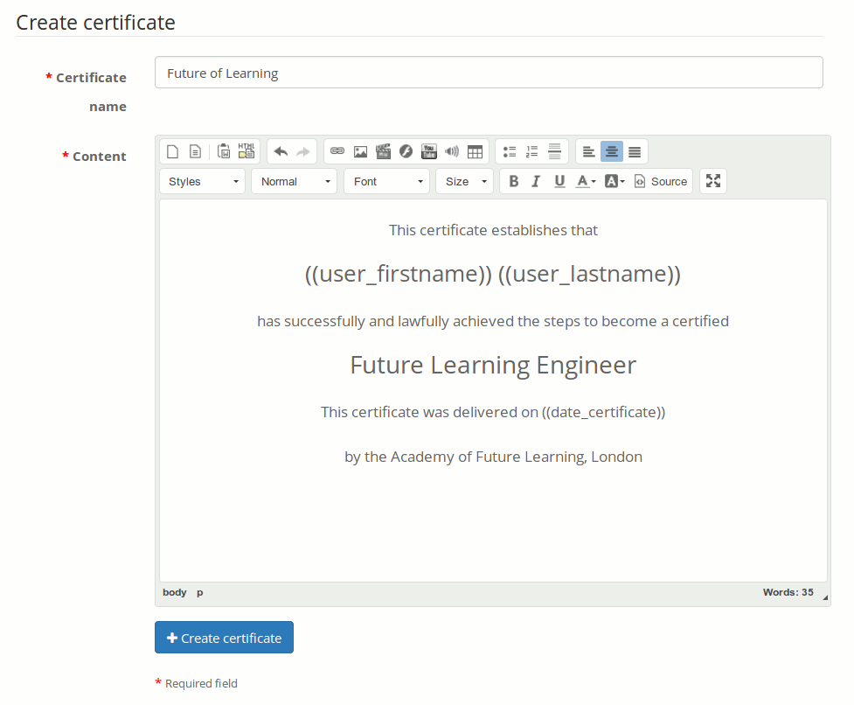
Illustration 111: Certificate creation area

Once you have created and saved your certificate, the main Certificate page lists the certificates that have been uploaded or created.

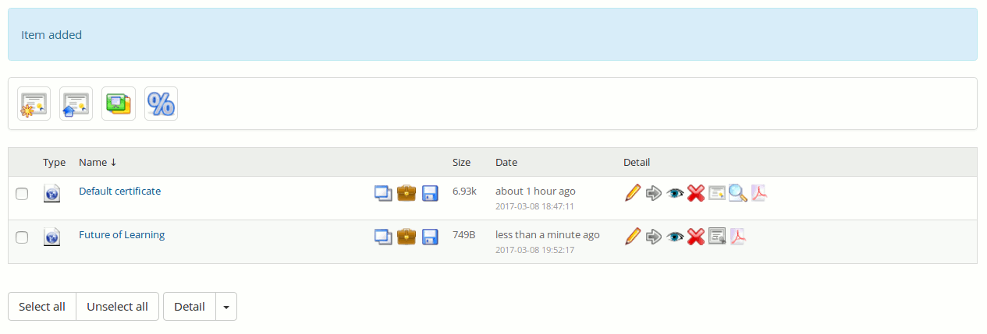
Illustration 112: Certificate templates list
You might note that the 5th icon on the right has a slightly different color for the first and the second line… That’s because the “Default certificate” in this example is still considered the… default certificate. To change that, you will have to click on the gray icon on the second line () to make your new certificate (“Future of Learning” in this example) the default certificate for all students.

Only one certificate can be selected in a course at any one time, so choose well.

Once this is done, the magnifier icon () will allow you to see a preview of the certificate with fake values. In our example, this gives something like this:

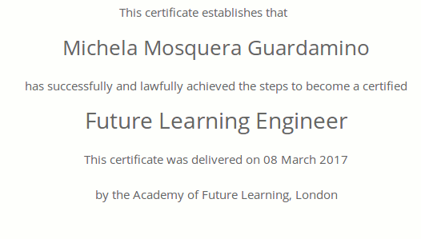
Illustration 113: Example certificate
Missing something? Clearly, some HTML design with a logo, the names of the people approving this certificate would have been a good addition. You will find these on the certificate available in every course in Chamilo by default, which would render like this.

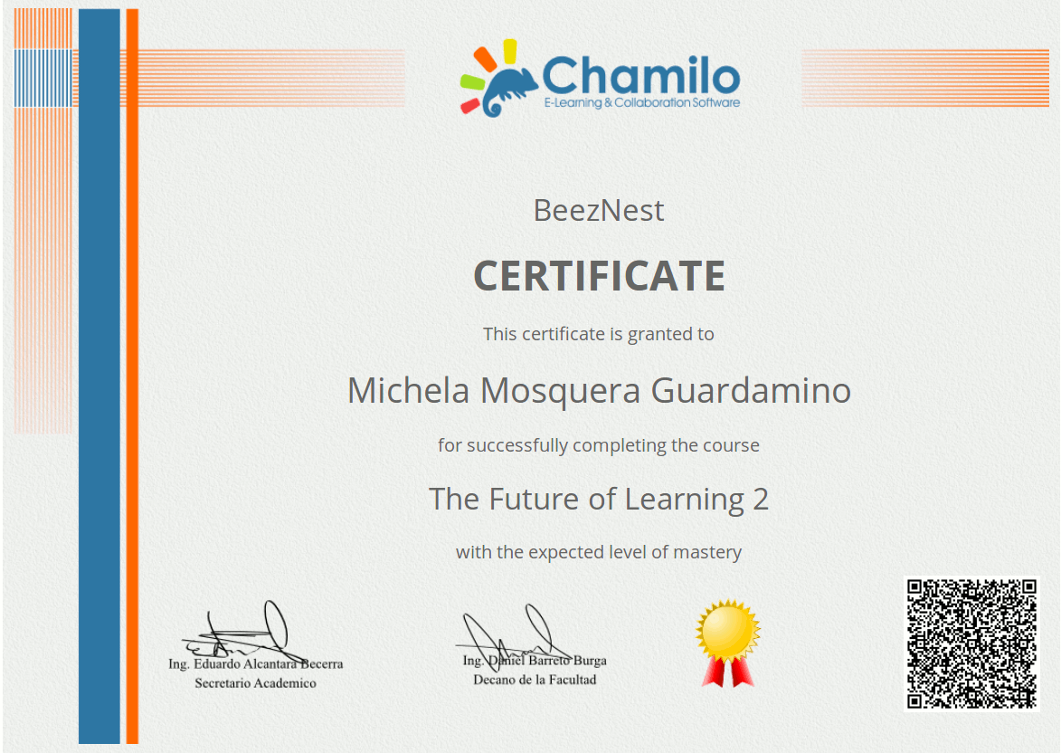
Illustration 114: Default certificate template available in Chamilo
As you can see, this template is much more developed than the quick template we built as an example for this guide. That’s because we intent to provide you with the best tools and templates to ensure you can generate a great impact with your course with minimal effort. You can edit the default template if you want and replace the logo by your institution’s logo. This is all up to you.

This certificate, however, sometimes shows a little defect when exporting to PDF, so test it first if you expect this to be your best feature...

You can return to the assessments screen through the breadcrumb navigation (click Assessments).

List view
The list view view in the Assessments tool allows you to list all learners and their results at any point through the course, as well as charts illustrating students' achievements overall for each assessment and a combined chart for all resources. (This resource is obviously more useful at the end of a course – when students have completed all the assessed activities). The view can be printed or exported in various formats (.xml, .doc, .pdf, .csv) using the relevant tool-bar icons.

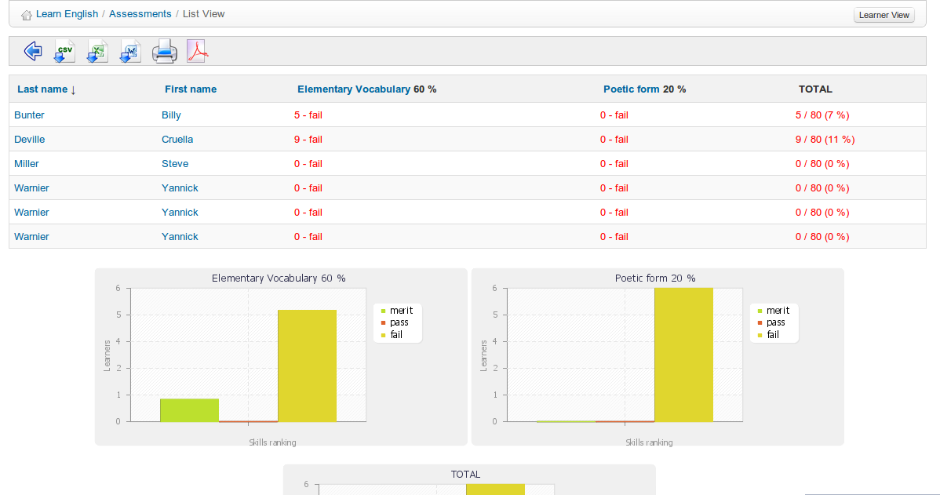Illustration 115: Assessments – List view
Note: This view only works if skills ranking rules have been fully defined.

How students generate certificates
Certainly one of the trickiest aspects of certificates is that students have to enter the assessments tool to generate their certificate. When a student enters the assessments tool and a default certificate is configured, and the student has reached the minimum grade to get the certificate, he will see a large certificate icon on the right side of the screen. This will send him directly to the certificate page.
The certificate page uses a unique URL, so the student can just copy the link and reuse it later on, as long as the link is public, which is an option the administrator has to enable, like this:
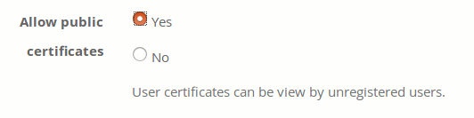
Illustration 116: Public certificates option
Once generated, a certificate cannot be canceled by the student. The teacher has to enter the certificates management tool to remove it and allow the student to re-generate it.

Students certificates management
Once students take the course and start getting higher scores that give them access to their certificate, you might have a few issues.
For example, certificates might get generated by students with a temporary score. Let’s take an example situation:
- You have configured your assessment to generate a certificate when students get 80% or more
- Your certificate template includes the score obtained by the student (on the certificate)
- You have configured 10 activities with equal weights (10% each)
- Your very good student Bilbo passes 9 of the 10 activities and already gets 85% (an almost perfect score)
- Before taking the last activity, Bilbo wants to check his global results on the assessments page. He enters the tool.

Because Bilbo’s score is above 80%, he satisfies the conditions to get a certificate, so Chamilo generates his certificate. Because the template includes the score, the certificate indicates “85%”. However, Bilbo hasn’t taken the last activity yet.
If Bilbo gets 10/10 on the last activity, his final total score will be 95%. However, his generated was already generated saying “85%”. In this case, Bilbo has no other option than to turn to you (the teacher) to help him out.

And you can! To access the certificates management, click the certificates icon (the 5th icon in the action bar).
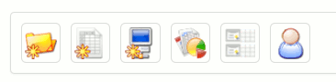
This leads you to the list of certificates, which shows all the certificates generated so far.
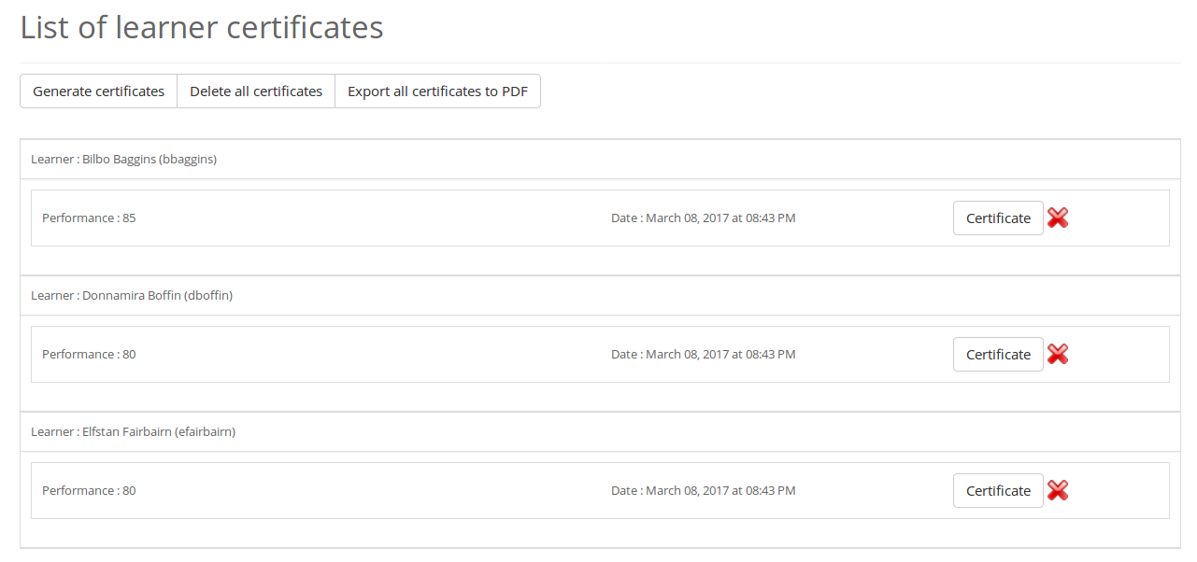
Illustration 117: Certificates management page
The page provides you with 5 options:
- Generate certificates: Lets you generate all student certificates in one single click. This is particularly useful if you configure the assessments tool but you don’t give your students access to the tool. This way, you can generate all certificates yourself, based on each student’s score.
- Delete all certificates: Allows you delete all the certificates of this assessment (usually, to re-generate those certificates after adding an activity to the overall evaluation, for example)
- Export all certificates to PDF: Allows you to download, in one single PDF, the whole list of certificates. This requires two things: that all students finish all activities, so you don’t have to generate this another time later, and that your certificate template works well in PDF export.
- Certificate: Gives you access to the certificate of this user, to check if everything is alright, mostly.
- Delete: Allows you to delete one specific certificate. This option is particularly useful for the use case described at the beginning of this section.

Linking assessments with skills
Since the latest versions 1.9.*, Chamilo allows you to link skills to assessments. In short, anything that would generate a certificate for a user can also be used to grant this student a skill.
This requires the administrator to have enabled and configured the skills available on the platform.
This usually requires you to discuss this specific topic with the organization authorities, as you cannot yourself create a skill.

Once skills are available, the administrator will have to come to your course and link the assessment that you have configured with a specific skill. This looks something like this (to the administrator):

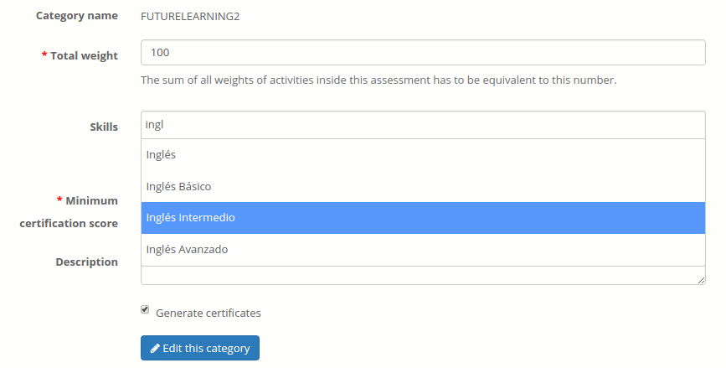
Illustration 118: Assign skill to assessment
We can see there (although the skills available are written in Spanish) that a new “Skills” field appears in the same edition form as we have for assessments.

Linking certificates with learning paths
Finally, version 1.11 has introduced a nice feature allowing you to generate a certificate (and assign a skill, if any) to students at the end of a learning path.
To do this, you will need to configure an assessment based only on this learning path, and make sure it generates a certificate.
Go to the learning path, create one, develop all its contents, then use the last content type icon to create the final page, like this.

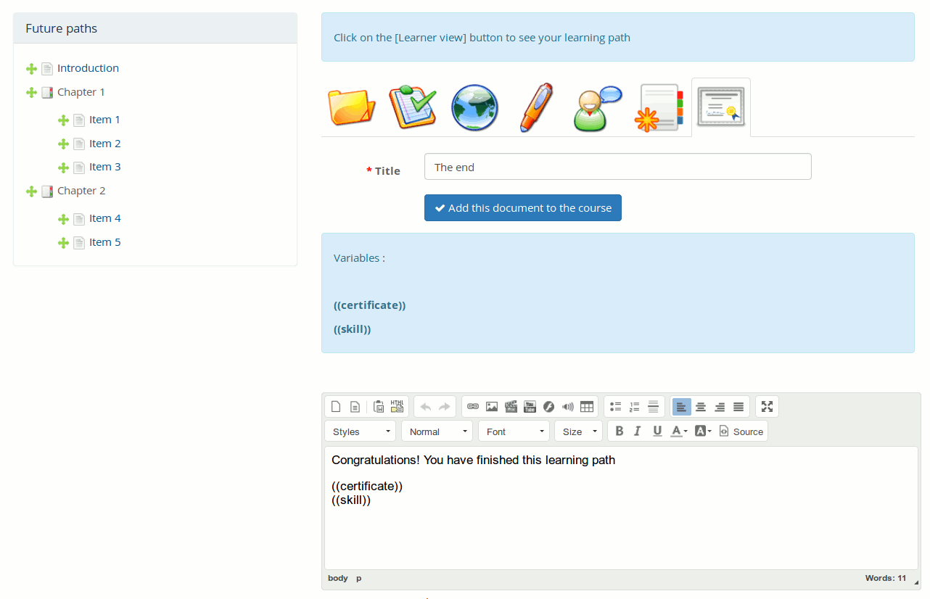
Illustration 119: Certificate to finish a learning path
There are many items on this page, so take your time to analyze all of them. The special certificate page will only ever appear as the last step of your learning path, out of any sub-folder.
It requires all steps of the learning path to be completed in order to appear.

Once this is configured, go to the assessment tool and make sure the whole assessment can only be obtained once the learning path is completed (it is possible to do otherwise but it might be a bit counter-productive).

When the student finished the learning path, he/she will automatically see a certificate and skill page. That is: the student will not have to go to the assessment page to generate the certificate anymore. Everything can be managed at the learning path level!

Wiki
The Wiki tool  is a collective or collaborative redaction tool. It allows users to work together on a single document, and to follow the history of modifications. It also allows you to save time and be more efficient during a group task. In many ways, it complements the forum tool.

A wiki page can contain many links to other pages, which may or may not (yet) have existing content. Wiki pages can be updated; each contributor sharing the same rights to write and edit content. Originally designed to support collaboration between learners, the wiki may, at the beginning of a course, consist only of a list of links inserted by the teacher, pointing to empty pages which each learner will have to build using one another's ideas, views and experiences.

Starting the wiki
The main page is the entry point of the wiki. It can initially be edited only by the teacher, who unlocks it through this initial action. Until he does this, learners cannot access it.

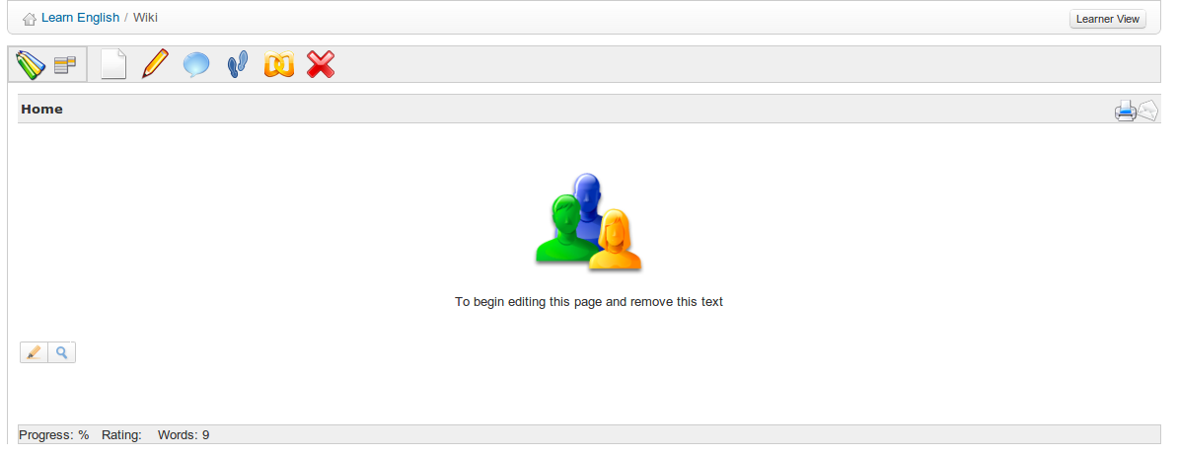Illustration 120: Wiki – Main page
- Click the Edit this page icon ,
- Remove the existing content and replace it by new content (for example, a list of links pointing to other pages of the wiki),
- Add a comment explaining your contribution,
- Click Save.

Add a new linked page
From the page you're going to add the link to:
- click the Edit this page icon,
- click the line you want to add the link on, then either:
- add the text between double square brackets [[link to the page to be created]]. Once saved, the text entered between brackets will be transformed into a link to a new empty page,
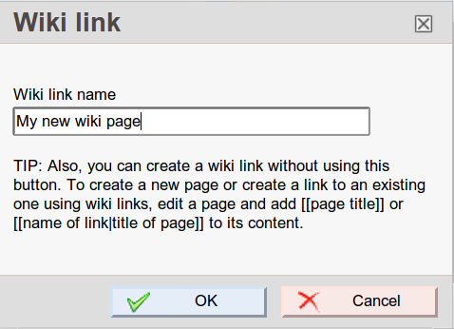
- or click the Insert/Edit Wiki Link icon in the editor to indicate the name of the new page to be created,
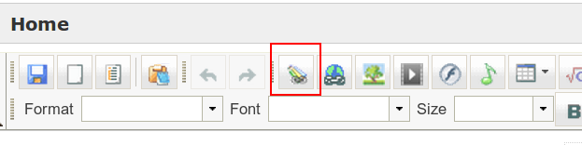

- click Save.

Add a new orphan page
By clicking the Add new page link inside the drop-down menu icon , you create a new page, unrelated to the rest of the wiki. This is one way of preparing a page which will temporarily not be visible to users (at least not in the usual way).
Note : Orphan pages can be listed from the All pages link in the drop-down menu.

Commenting a page
By clicking the Discuss this page icon , you get access to a form to add/see comments. This area is visible and can be updated by any user. Other actions which can be executed on wiki pages are:

Icons | Features
 | Check the history of changes of a page
 | Show a list of pages linked to the current page
 | Delete the current page
 | Export the page as an HTML document
 | Export the page as a PDF document
 | Get an e-mail notification of all changes made to this page
 | Make a page visible/invisible to learners
 | Lock / Unlock a page for edition by learners

Other wiki features

The menu located in the top left corner (drop-down menu) gives access to other wiki features, regardless of the current page:
- search titles or contents of pages,
- display a list of all the pages,
- list only the latest modifications,
- remove the whole wiki (be careful with this command!),
- see the most active users,
- see the most visited pages,
- see the most updated pages,
- see all orphan pages,
- see all empty pages (wanted pages) created as such in order to invite somebody else to add content on a given topic.

Links
The Links tool allows you to create a library of internal and external links which learners can use in a course as they work their way through the learning path.
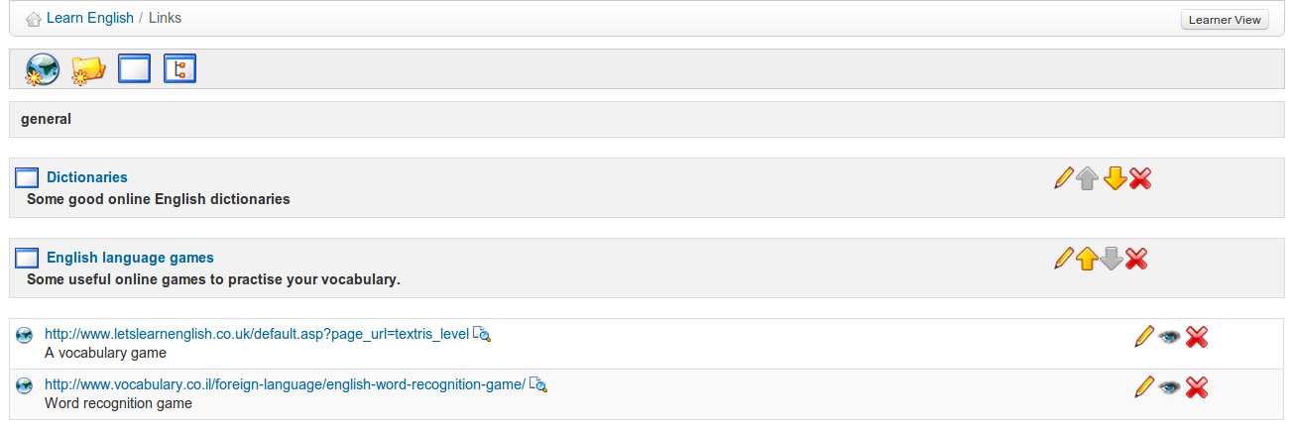
Illustration 121: The Links page

Links categories

You can create links categories in Chamilo, allowing for a better organizational structure when your library contains a lot of links.
- Click the Add a category icon ,
- Give a clear name to your category,
- Add a description if needed,
- Click the Add a category button.

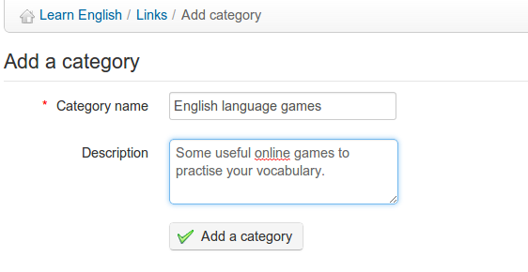
Illustration 122: Links - Add a category

Links
A link can be added in a category or at the root level:
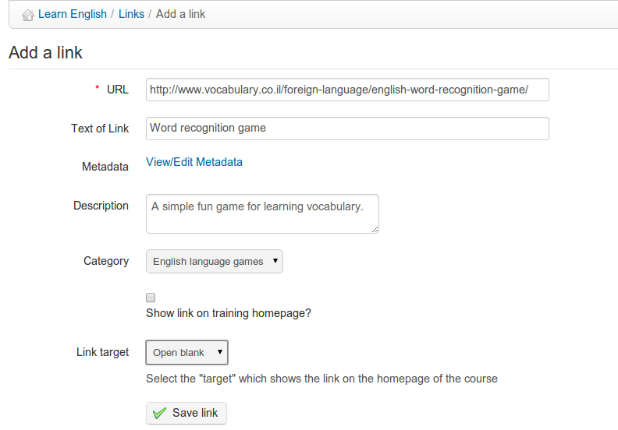
Illustration 123: Links - Add link
To add a link:
- Click the Add a link icon
- Add the link's URL,
- Give it a label,
- Add a description of what is on the other side of the link, if desired,
- Select a category if desired,
- Choose whether to show the link on the course homepage or not,
- Click the Save link button.

Manage links
Links management uses the usual action icons:

Icons | Features
 | Edit links or categories
 | Remove links or categories
 | Re-organize links and categories order
 | Show/Hide a link

Links checker
Since version 1.8.8.4, you can (manually) check whether a link is alive. To do this, click the small magnifier icon on the right side of the link as it is listed in the Links page. After a few seconds (or less), an icon appears. A green tick means the link is valid. A red sign means the link is broken.

Note: the links checker effectively tries to connect to the given link from the server. As such, a link that works for you might not work for the server, and vice-versa. This will require the server to be equipped with the CURL library. Check with your admin if this is the case.

Announcements
The Announcements tool lets you send a message by e-mail to your learners and/or publish an message directly to the course.

These announcements can be used, for example, to inform learners of the recent availability of a document, of the deadline for an assignment or any news or information related to the course.

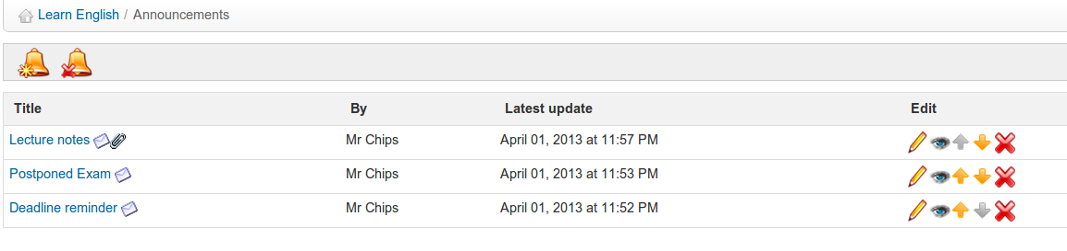Illustration 124: Announcements page

Add an announcement
From the main Announcement page:
- click the Add an announcement icon ,
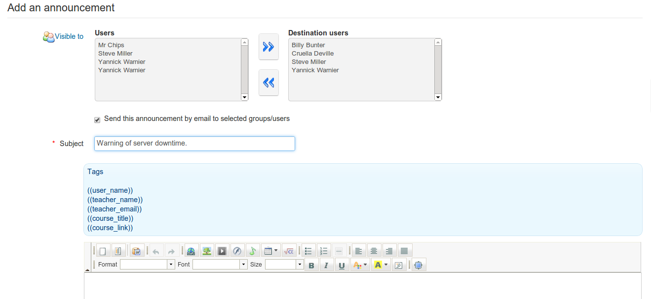
Illustration 125: Add an announcement
- by default, the announcement will be sent to all users, but it is possible to edit the list of recipients by clicking on the visible to link
- the announcement can be sent by e-mail to the course users (check the Send this announcement by email to selected groups/users box),
- add an announcement subject,
- write the main announcement using the editor,
- add an attachment if desired,
- click Send announcement.

Note: since version 1.8.8.4, you can use tags inside your announcements (just copy-paste them). These tags will be automatically replaced by the corresponding value when sent by e-mail or displayed on the platform to users.

Announcements will appear to recipients like this on the platform:
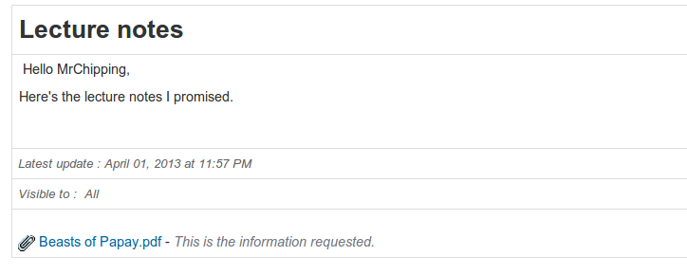
Illustration 126: Announcements – learner view

Announcements management
Announcements can be managed through the familiar action icons:
Icons | Features
 | Update the title, body or settings of the announcement
 | Re-order announcements position
 | Show / Hide announcement to learners
 | Indicates the announcement has been sent by e-mail
 | Indicates the announcement includes an attachment

Glossary
Chamilo integrates a glossary tool to allow the teacher to define terms or expressions in the same way as a dictionary. No term is defined by default - it is the teacher's responsibility to define important terms.

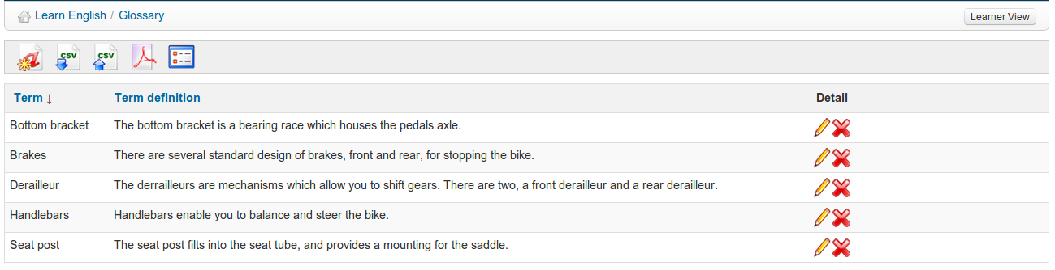Illustration 127: Glossary – Table view

New term
To add a new term:
- click on Add new glossary term ,
- enter the term in the first field,
- give the term's definition,
- click the Save term button.

A definition can be enriched by images and links:

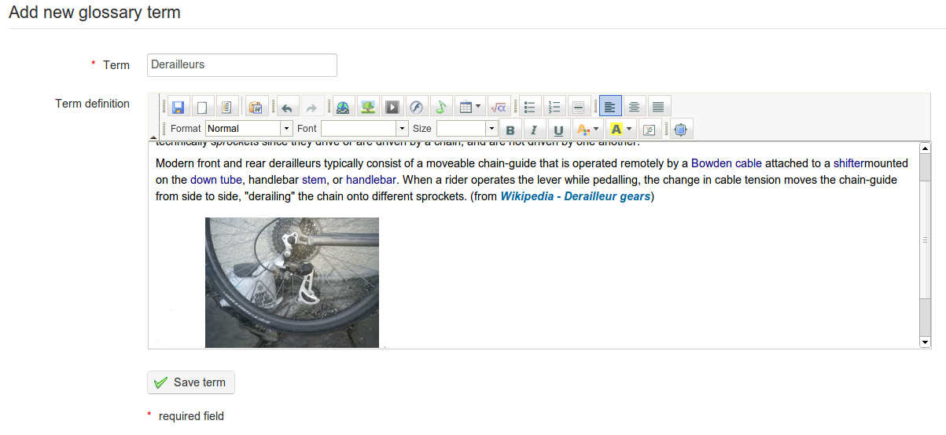
Illustration 128: Glossary – add a term

By default terms are displayed in Table view  – suitable for a large number of terms with a brief definition. For a smaller list of fuller definitions, both teacher and learner may wish to choose the more attractive List view  :
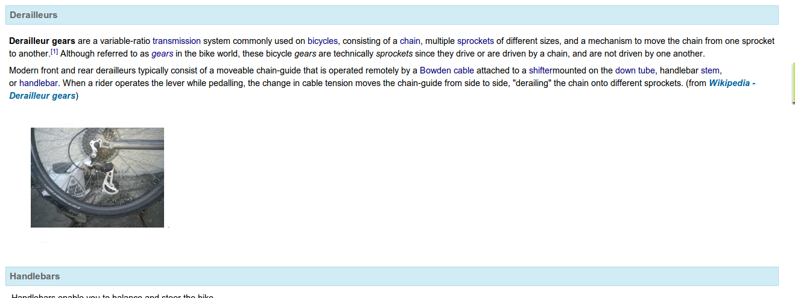
Illustration 129: Glossary – List view

Glossary terms management
Glossary terms management is done through the usual action icons:

Icons | Features
 | Edit term
 | Delete term
 | Show the list view
 | Show the table view
 | Export/import glossary as a .csv file
 | Export to .pdf

Attendances
In 2010, an academical institution co-financed the development of the Attendances tool  as well as the course progress tool (see next chapter) with a set of basic specifications. Over time it has evolved, thanks to the many suggestions from community users and the financial support of some customers. Today it's a more advanced tool, but it is still very young, which explains why its interface still leaves room for improvement.
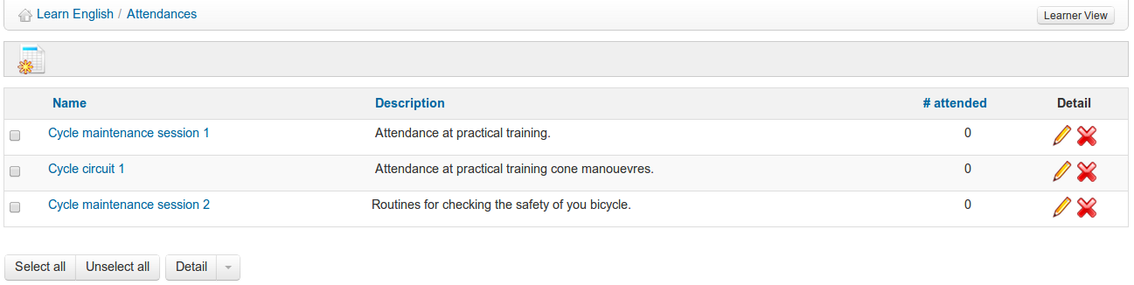Illustration 130: Attendances – main page
Before you go further with this chapter, do make sure you have learners subscribed to your course, otherwise your attempts to use it will not work. If need be, review the Users chapter on page 95. Without learners subscribed, it is practically impossible to make sense of the attendances tool.

Create an attendance sheet
To get started, click the Create a new attendance list icon :
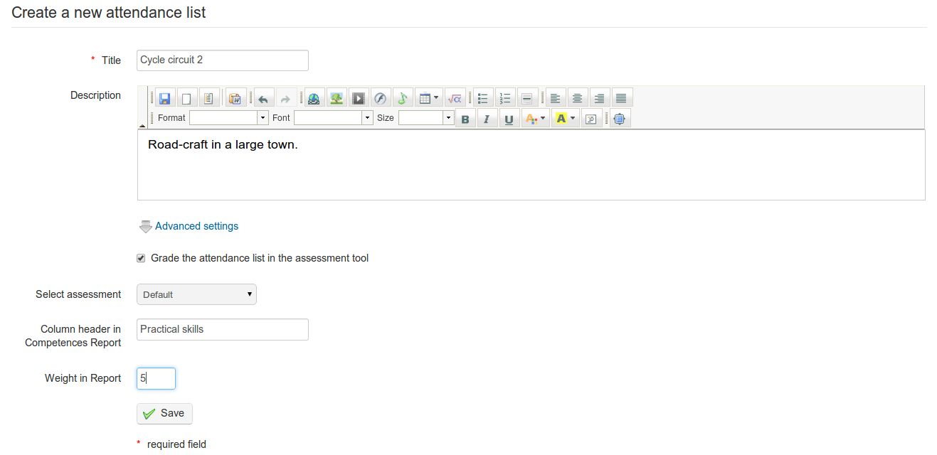
Illustration 131: Attendances – New attendances form

Fill in the main title/description fields and tick if you wish to grade the attendances. If you do so you can select an assessment to link attendances to, write a column header for the report and add a weighting to activities. Finally, click save and you will be prompted to add a time and date:
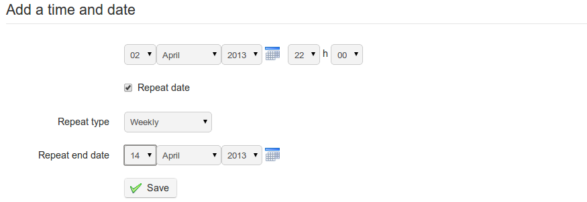

Illustration 132: Attendances – Intermediary step for dates creation

Selecting repeat date allows to you quickly generate a series dates and time for regular sessions e.g. weekly at 22.00 hrs. Click Save again to view a list of the dates chosen:
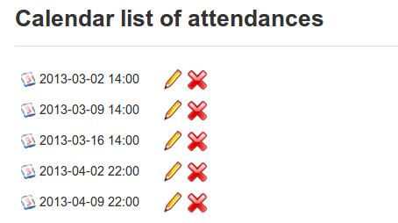Illustration 133: Attendances calendar

These are fully editable (e.g. if one week is a holiday, delete) and, equally, you can add to the dates/times using the add a date and time icon in the toolbar. You can also clear the entire list of dates and times using the clear the calendar of all lists icon . To view the attendance sheet for the relevant activity click the Attendance sheet icon

Recording attendances
Having set up your course sessions, you'll need to start recording your learners' attendances. You do this using the Attendances sheet, which you can access from the main Attendances page by clicking on the relevant listing. You'll see a list of learners' names in the first column, then one column for each attendance date. Generally, the default column enabled will be the first one that hasn't been modified yet.

The Attendance sheet displays a table with columns listing users, their attendance and dates/times. What dates you view is controlled by the Filter drop down menu in the toolbar (choose “all” and click filter to see them all). To enable editing of each date column, click the “padlock” in the column heading.
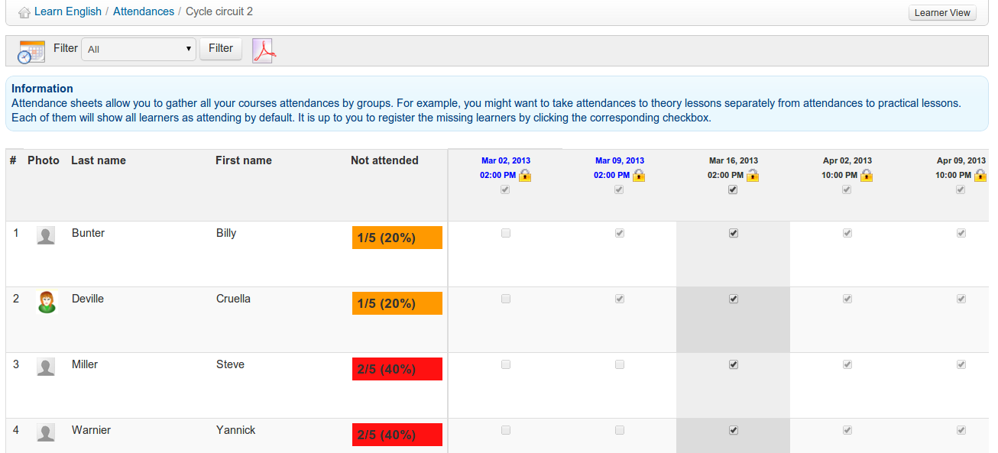
Illustration 134: Attendances sheet
By default, the system assumes all learners are attending the course session, so only take note of missing learners, by unchecking the learner's box to mark his absence.

A learner missing more than 10% of the total number of sessions will be marked by an orange background. A learner missing more than 25% of the sessions will be marked by a red background. (These colourings are fixed parameters which cannot, at this point in time, be modified inside the platform.)

An attendance sheet can be included in the assessments tool as a marked resource, to count towards a students overall grades for the course.

Course progress
The Course progress tool (or perhaps Course diary - the name of this tool is still under consideration) allows the teacher to build a course program to be shown (optionally) on the course homepage to include a progress status relative to the current teachers and learners' progress in the scheduled topic preparation.
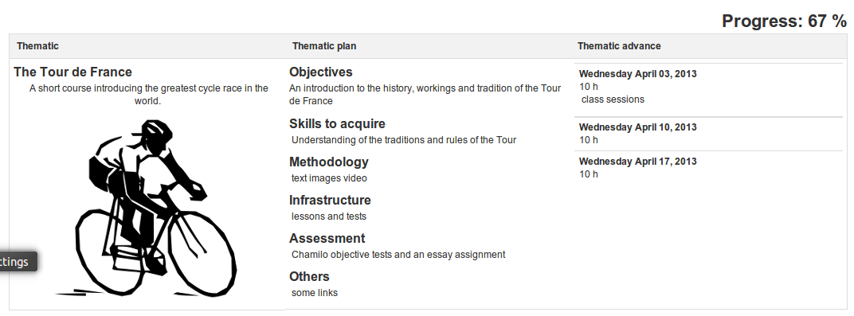Illustration 135: Course progress – Learner view
This tool is only useful in the case of “synchronous” courses, in which the teacher and the learners progress through the course concurrently. Configuring Course progress is quite easy, although quite a lengthy process.
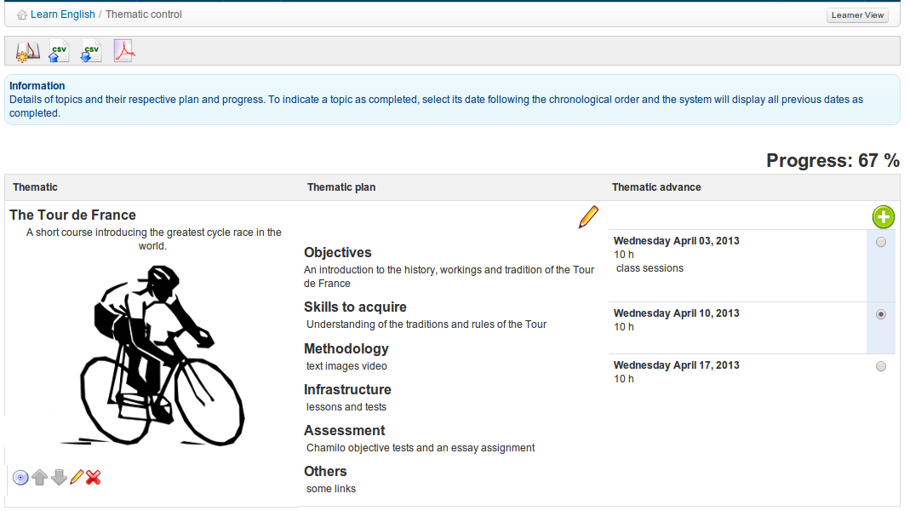Illustration 136: Course progress – Teacher view

Create a thematic section

The thematic sections represent the highest level in the course progress' structure. You need to create sections in order to be able to create other levels of the structure.

To create the first section, create the New thematic section icon  and complete the relevant fields using text, images etc.
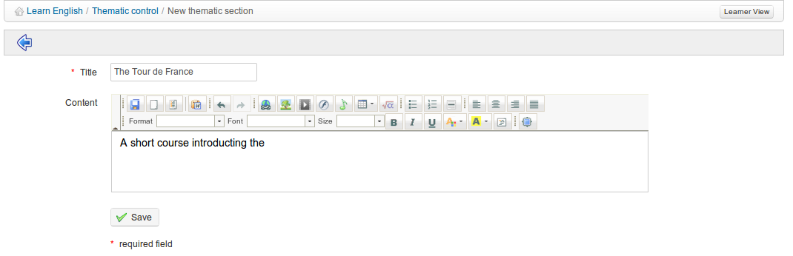Illustration 137: Course progress – invitation to create a thematic plan
On clicking Save you will be invited to create new thematic plan:
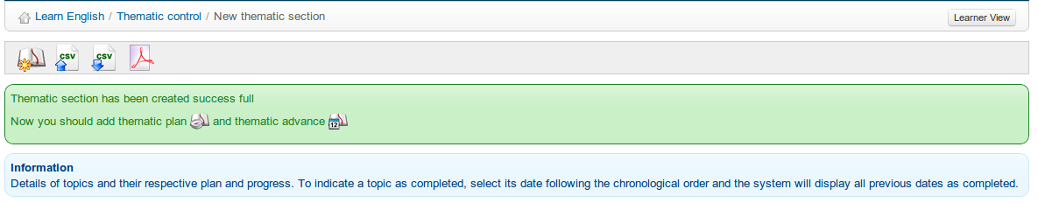Illustration 138: Course progress – invitation to create a thematic plan/advance

Define the thematic plan

Once the thematic section has been created, you can edit its entry in the Thematic plan column. The Thematic plan is the definition of the objectives, methodology and other details of the newly created thematic section. Click on the Thematic plan icon  to show a form containing several fields in each of which which you can enter a title and description which will be displayed on the main Course progress page. By default, the fields are titled: Objectives, skills to acquire, Methodology, Infrastructure, Assessment and Other, although these can be edited as appropriate. Fields with no description added will not be displayed.

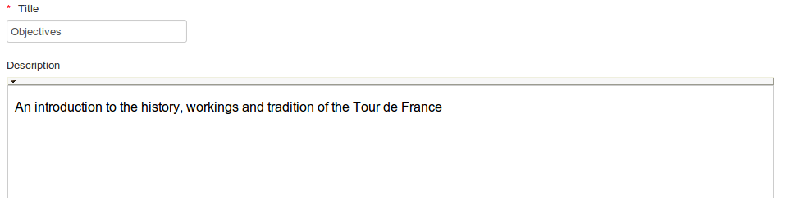Illustration 139: Course progress – example title and description fields

Create steps for the course progress
The steps (termed Thematic advance) are the dates on which you will teach the specific content of the relevant Thematic section. Having saved the thematic plan, return to the main course progress page using the breadcrumb navigation and click on the New thematic advance icon in the relevant section.
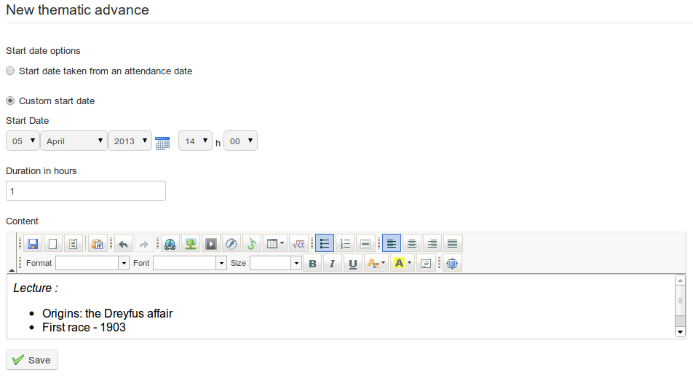
Illustration 140: Course progress – Steps creation
Here you can, enter the date for each teaching session and the contents of what is to be covered specifically in that session. You can either enter dates and times manually or link to dates previously defined in the attendance sheets (see Attendances-Attendances on page 122). Where the Course progress tool is used, progress through the course will be displayed on the main course page:
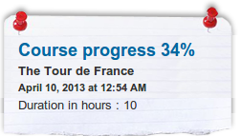

Agenda
The Agenda tool  allows the teacher to manage a course calendar/diary which integrates with the personal Agenda tool available to each individual user. In Chamilo 1.9 the user interface of the tool is very different (and more up-to-date) than in previous versions, though the underlying functionality remains essentially the same. Each course has it's own Agenda, while a “global” view (i.e. a view of events from all the courses to which the user is subscribed) is also available via the Personal Agenda tab. The Personal Agenda tab displays course events in green, and also allows users to add “personal” events, displayed in blue, which will not appear in other users' agendas. A teacher can view and edit course and personal events, while learners will have the same view, but will only be able to edit their own personal events.
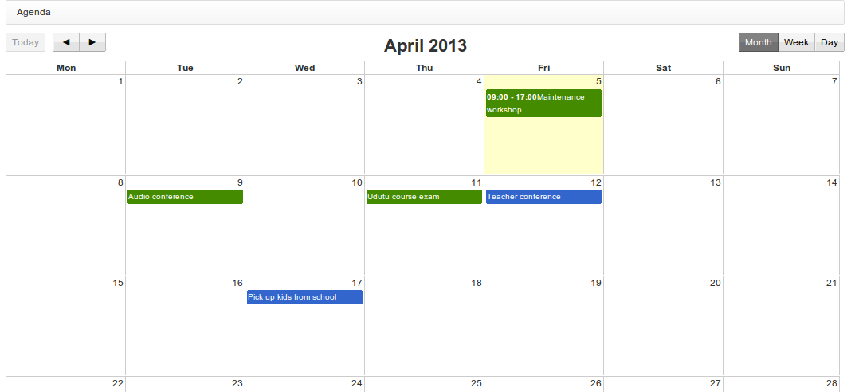Illustration 141: Personal Agenda
Viewing and navigating the course Agenda and Personal Agenda is straightforward and intuitive. The user can choose a month, week or day view using the buttons on the top right of the page, move forward and backwards through the months/weeks/days using the left and right arrows, and return to “today”'s view using the button on the left. Details of each event can be viewed simply by hovering over or clicking on the event title in the calendar.

Adding an event to the course agenda
Events can be added to the course Agenda in two ways. The simplest and quickest way is simply to click on the relevant date/day/time in the course Agenda (choose week or day view to select a specific time or timescale). You can select users who can see the event, add a title and a brief verbal description, and decide whether to also send the event as an announcement/email:

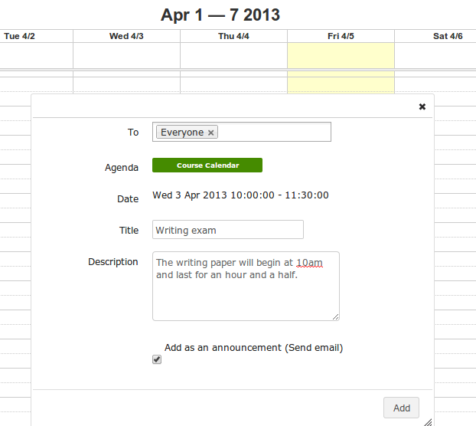

Illustration 142: Adding an event directly to the calendar
For a more fully configured event entry, however, click the Add event icon  in the tool-bar. This will open a dialogue page allowing entry of a title and the selection of users, but also a richer description (e.g. using graphics), automatic repeat configuration (daily, weekly, monthly, yearly) and the option to add an attachment (to accompany email announcements).

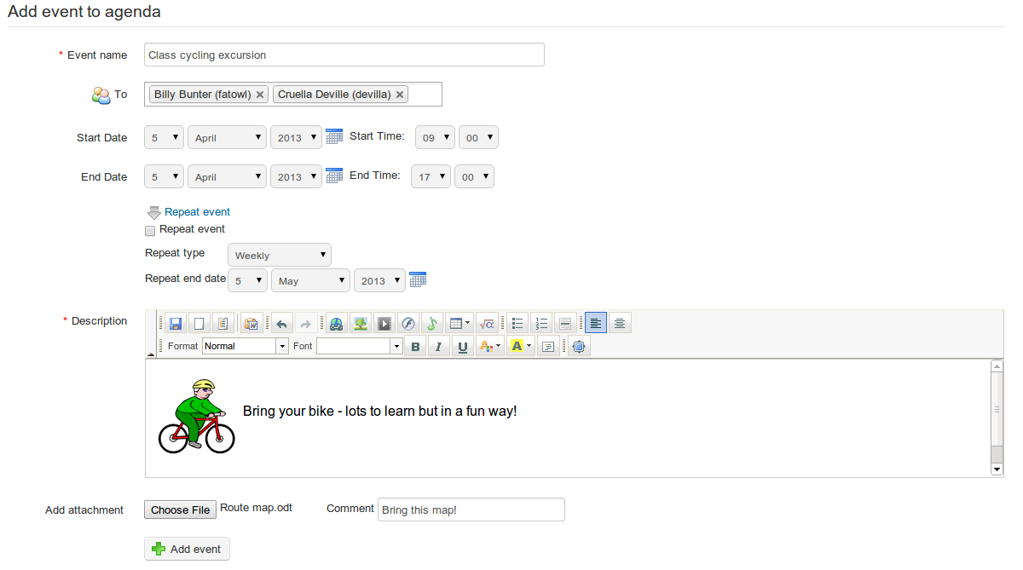Illustration 143: Adding an event using the Add event tool

Import and export events

The Chamilo Agenda tool supports the import and export of standard calendar files (Outlook, iCal). To import an Outlook file, click the Import Outlook icon  in the tool-bar in the course Agenda and upload the relevant file as prompted. Then return to the Agenda using the Agenda icon .

Users can export events as iCal from the pop-up window that appears when they click on an event to view details. They can select the appropriate iCal format (confidential, private, public) for the export at the bottom of the pop-up window, and teachers can edit or delete the event using the appropriate button in the pop-up window:

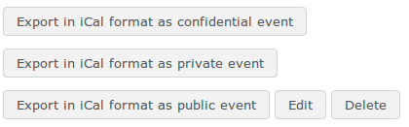

Illustration 144: Export, edit or delete an event
(Note: Teachers only have access to the delete/edit buttons via the course Agenda from the course homepage – not via the Personal Agenda tab, where, like learners, they can only view/export events).

Adding an event to the personal Agenda

The Personal Agenda, available at any point while navigating Chamilo via the relevant tab, works in exactly the same way as the course Agenda, except that options to create events are limited to the “direct” method (i.e. clicking/dragging on the relevant date/times to open a simple pop-up dialogue window (see above). Deleting, editing and exporting options for “personal” events can also be effected (as with the course Agenda) simply by clicking on an event to display a pop-up dialogue box. Teachers and learners need to bear in mind that the (blue) personal events cannot be viewed by anyone other than themselves.

Dropbox
The Dropbox (document-sharing) tool provide a place where users can leave files for each other, to be downloaded as convenient, avoiding heavy e-mail downloads. Files can be “dropped” there by the teacher for learners to collect, by a learner for other learners (if allowed by the platform administrator) or by a learner for the teacher (although it is not really intended for the delivery of homework or assignments, for which the Assignments tool should be used.)

While the basic concept of this tool is similar to popular tools such as Dropbox or Google Drive, it actually predates these modern tools and doesn't work in quite the same way. For example, when working collaboratively on one document, rather than open the “shared” file to view and edit it directly users simply download the shared file, work on it, and upload it again to the dropbox (e.g. with changes). By default, altered files won't over-write the original version even though the filename is the same, effectively making it easy to manage “versions” of a document differentiated by date/time of upload. All users have the option to add a comment within the dropbox window to a shared document, again a useful device for serious collaborative work. For example, it allows a teacher to make a brief note about each student's contribution.

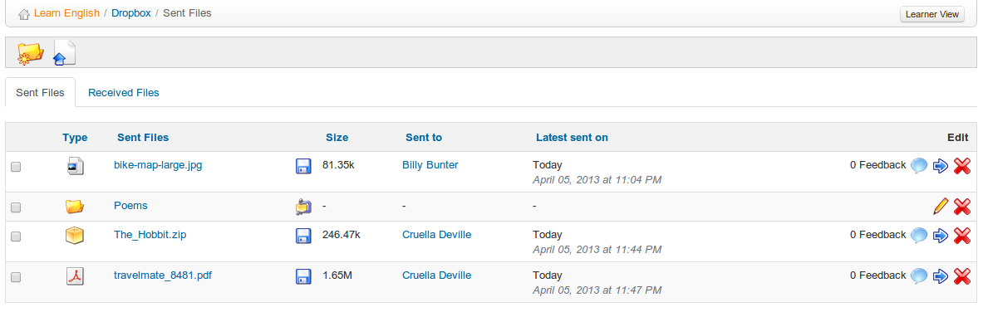Illustration 145: Dropbox – sent files

Folders
The teacher can add folders to categorize his files a bit more clearly. The shared folders (be they sent or received) are invisible to learners and are only there for organizational purposes.

To create a new folder, click on the Add a new folder icon , enter a name for it in the field that appears at the top of the screen and click the Create category button.

Send a file to specific users

- click the Share a new file icon
- click the choose file button and select the file on your computer,
- decide whether to overwrite other files with the same name
- in the Send to list, select the people to share the document with (groups can also be selected by holding the CTRL key pressed while clicking the names)
- click the Upload button.
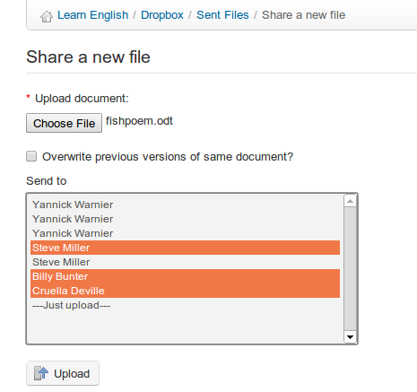
Illustration 146: Dropbox – Sending a file
Files will be listed under the “sent files” tab if they have been uploaded by the user, and under the “received file” tab if the file was uploaded by someone else all files can be instantly accessed by the recipient as well as the sender.

Managing dropbox files
As well as the familiar icons, the dropbox tool offers a series of new management icons:

Icons | Features
 | Edit the name of a folder
 | Delete a folder
 | Add a comment to the shared file
 | Shows next to the name of any new file
 | Move the file to another folder
 | Save on your computer a compressed archive of all the files in the folder
 | Save a copy of the corresponding file on your computer

Note : When a learner deletes a file sent to the system, this file is still available to the teacher

Read and add comments on a file

- click the Comment icon next to the file's name,
- read the existing comments,
- add a feedback comment in the text area available,
- click the Save feedback button.
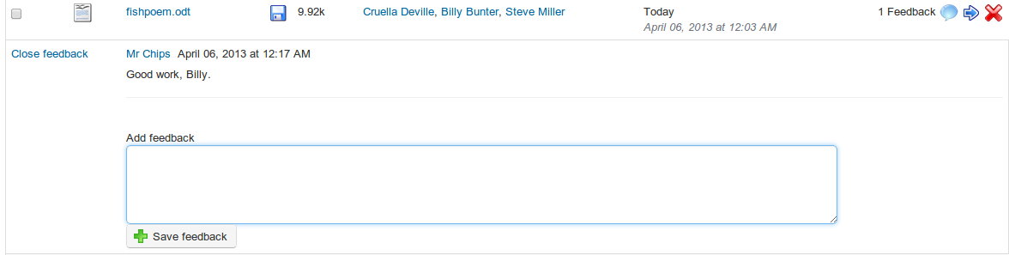
illustration 147: Dropbox - Comments

Groups
The Groups tool  allows a teacher to create and manage working groups of learners. This is a simple organizational tool allowing for the automatic or manual grouping of learners, yet from a pedagogical point of view this can be a very powerful tool for online learning. Group work encourages peer support and interaction, helping a student overcome that sense of isolation which is one of the main challenges he/she may face in online study. In conjunction with other tools, the use of the Groups tool can help to develop team-work skills, providing opportunities for task leadership and for mutual reflection and feedback between learners. As such , it can help students keep on task and enrich their online study experience considerably.

The Groups tool allows a teacher to assign a range of Chamilo tools (documents, agenda, assignments, announcements, forum, wiki and chat) to a group which can be configured as private to the group, effectively providing students with secure online workspaces which cannot be viewed by other learners or groups.

Create a group

On the main Groups page, click the Create new group(s) icon . You will be prompted to enter the number of groups to create (this will speed up the process if you want to create more than one group) and click the Proceed to create group(s) button:
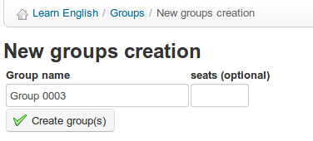
Illustration 148: Create a group
Give it a name, enter the number of empty seats you want in the group, and click Create group(s). The new group will appear in the listings in the main Groups page. It can be deleted using the usual Delete icon .

Groups settings
A teacher can access settings for the group from the toolbar in the main Groups page. Clicking the Edit settings icon takes you to a page which allows you to limit the number of groups an individual user can belong to, and to make default settings for all groups including maximum group size, self registration and access privileges for all the associated tools (documents, agenda, assignments, announcements, forum, wiki and chat):

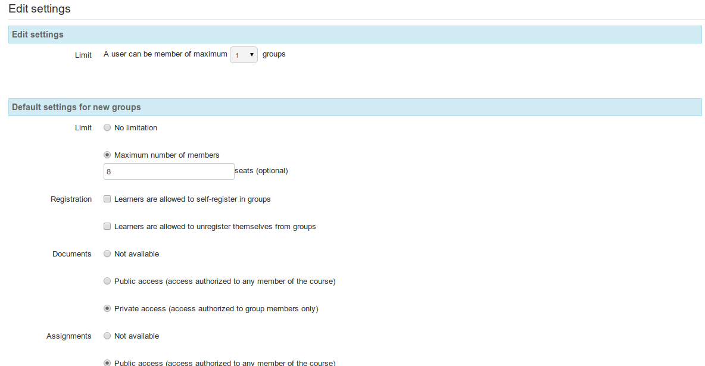
Illustration 149: Groups- settings
Remember to click the Save settings button at the bottom of the page. These default settings can be edited by the teacher for each group using the Edit this group icon to the right of each group listing in the main page.

Auto-filling a group
To quickly add course members to a group, click the Add users icon on the right of the group listing on the main Groups page. Use the batch processing (drop-down list at the bottom) to automatically fill several groups. You can't set parameters for filling groups (e.g. alphabetical, random etc), but you can always edit the group membership manually afterwards. You can clear all members from a group by clicking the Unsubscribe all users icon in the listing. If you have a long list of groups to manage, use the check boxes on the left and the batch processing option (i.e. the drop-down list at the bottom) to automatically fill several groups:

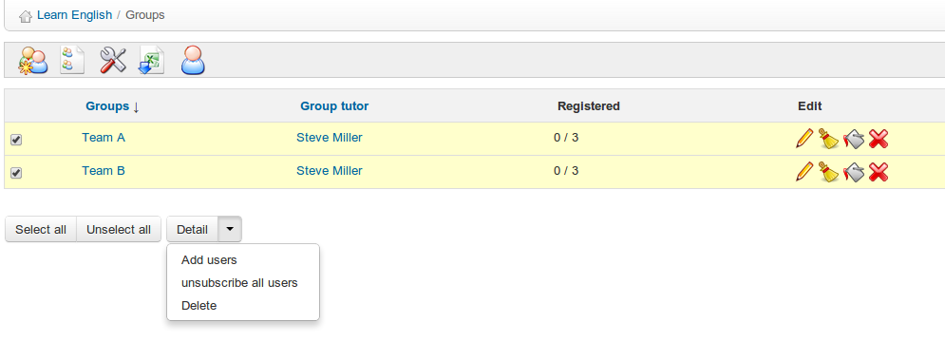Illustration 150: Groups – Auto-fill groups

Fill a group manually
For a variety of reasons, a teacher may want to select group members manually, i.e. choose which learners will work together, e.g. learners with similar interests or goal, or an experienced learner with a latecomer to the course. To do this, (whether or not the groups have already been auto-filled) click the Edit this group icon to add users manually:
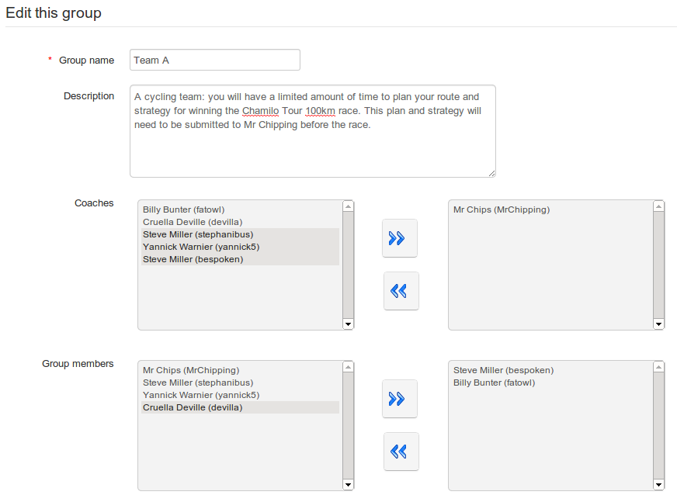Illustration 151: Groups – Filling a group manually
Select and add/remove users as required using the arrows. Any user can be added as a coach (i.e. group leader, tutor etc.) or as a Group member – this will be shown in the listing.

Getting into a group space

Group members can access the group's “workspace” simply by clicking the name of the relevant group in the listing on the main Groups page. The page will display the group description (e.g. a list of aims and objectives) and details of membership, as well as it's own “toolbar” of links to the group's various tools (Forums, Documents, Agenda, Assignments, Announcements, Wiki and chat) which link to the various (private) group workspaces:

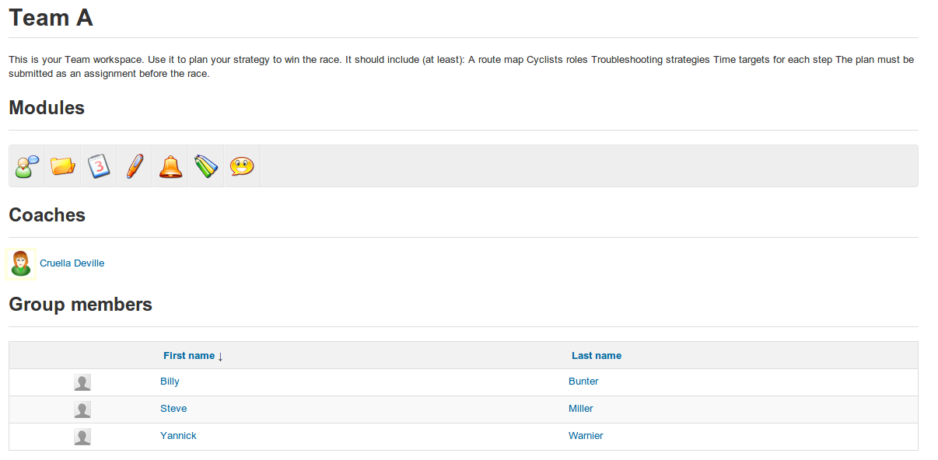
Illustration 152: Groups – Group space
From the group space, you can query a learner's information sheet by simply clicking on her name in the list of members in the lower part of the page.

Overview /Export of group members
A teacher can quickly view a list of group members by clicking on the Groups overview icon  on the main Groups page. From here, you can use the export feature, which is described more fully in the chapter dedicated to the Users tool. Just click on the Excel export icon  then open or save the file on your computer.

Groups management
A teacher can manage groups in two ways – using the icons on the right of each listing in the main Groups page (listed below) to manage individual groups, and using the “batch management” feature (tick boxes, buttons and drop-down lists) displayed on the same page, which allows the teacher to apply the same functions to several or all groups at once. Using these methods together can save the teacher a lot of time consuming organization.

  Icons | Features
 | Update a group's settings
 | Delete a group (confirmation pop-up) and all its contents
 | Fill a group with users automatically
 | Empty the group

Chat
The Chat tool is an instant messaging tool which allows users in a course to exchange ideas, questions and answers in “live”, written conversation.

While it may seem rather slow (three seconds per post) and limited in features to todays online users, the big advantage of this tool compared to e.g. Skype, Facebook chat tools is it works as part of the platform and, as such, does not require any external tool, being guaranteed to work on all computers with the capability to use Chamilo.
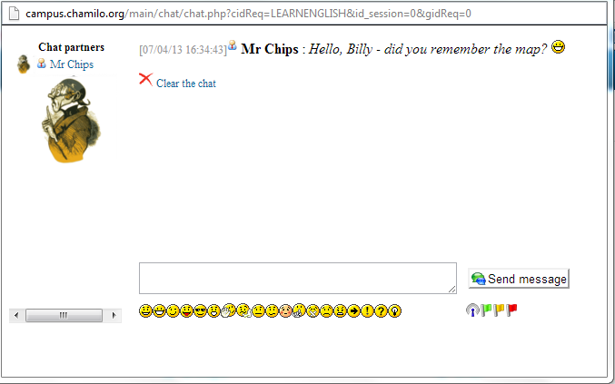

Illustration 153: The chat window

If users have configured their picture in the Social network (or Profile) tab, it will appear next to their name. It's up to the teacher to delete previous messages when he considers it necessary.

Send a message
Enter the text inside the field located at the bottom of the page, then click the Send message button. Inside the messages list, the messages from the teacher appear with a corresponding icon in front of the user's name.

Empty messages
You can disconnect from the platform and still have access to previous messages, providing your reconnect the same day.
To delete a conversation before starting a new one, click the Clear the chat link.

Note: Chat history logs are normally saved inside the documents tool, in a hidden folder called Chat history. Clearing the chat will also delete the history of the chat for this whole date.

Survey
The Survey tool  allows the teacher to collect information, views and opinions from course participants. It might typically be used during or at the end of a course as an aid to overall course evaluation, or it may be used at the beginning of a course to gather information about learners' interests, aspirations, previous achievements etc. in order to help the teacher tailor aspects of the course content to suit his learners.

Survey creation
To create a survey, click the Create survey icon  on the main Survey page:
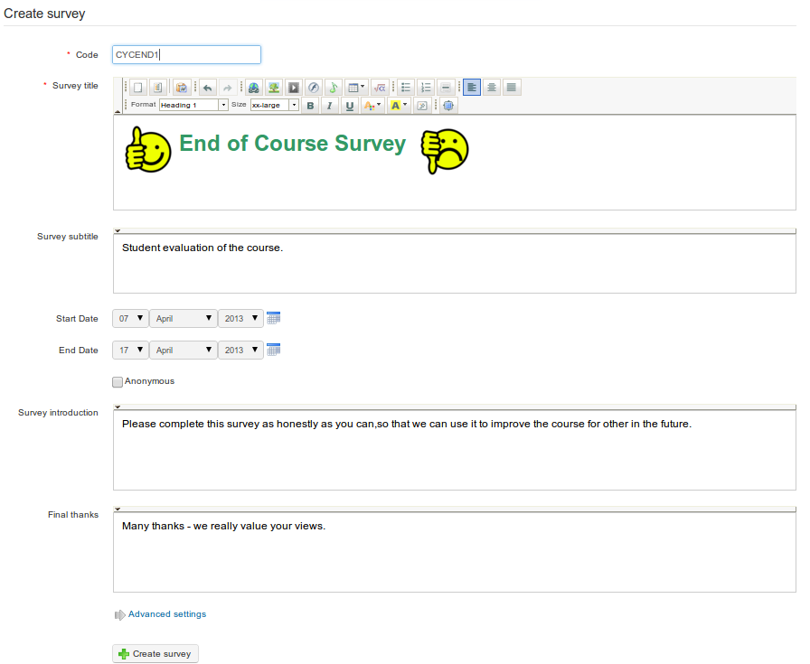
Illustration 154: Surveys – Creation form
Complete the fields, giving your survey a Code, a Title, and a Subtitle (description). Optionally, you can set a start and end date so the survey is only available for a limited time. You can choose whether your survey will be anonymous (users' answers will not be identifiable) by checking the relevant box. Finally, write a survey introduction (this is a text that will appear just before the user starts the survey) and a Final thanks message (this will appear when the users finish the survey, to thank them and maybe inform them of when the results will be compiled and used).

In the Advanced settings, you can choose whether you want this survey to be considered an essential element of the Assessments (Gradebook)stool , whether you want it to be attached to a parent survey (not documented in this guide yet), whether you want to have one question per page or whether you want to shuffle questions.

Remember to click the Create survey button.

Add survey questions
Once the shell of your survey has been created, you'll have to define a series of questions using a few pre-defined types (similar in many ways to the Tests tool): Yes/No, Multiple Choice, Multiple Answer, Open, Dropdown, Percentage, Performance, Comment.

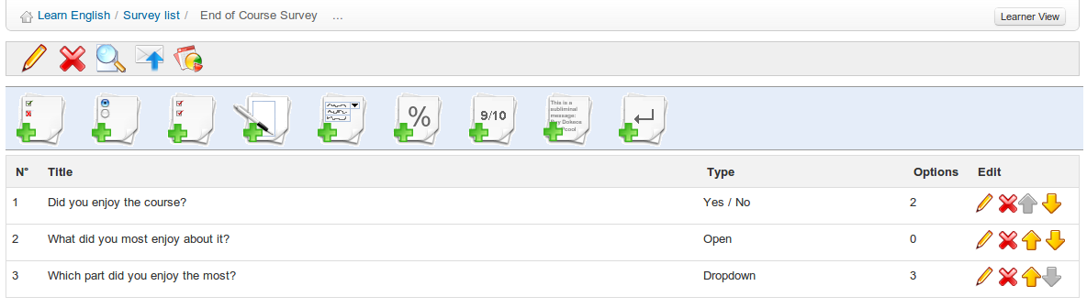Illustration 155: Surveys – Questions creation
To create questions, click the relevant icon and fill in the relevant fields as required.

Survey preview
Once the questions have been created, you can preview your survey before publishing it Click the Preview icon and the preview screen leads you through the questions as if you were a learner:

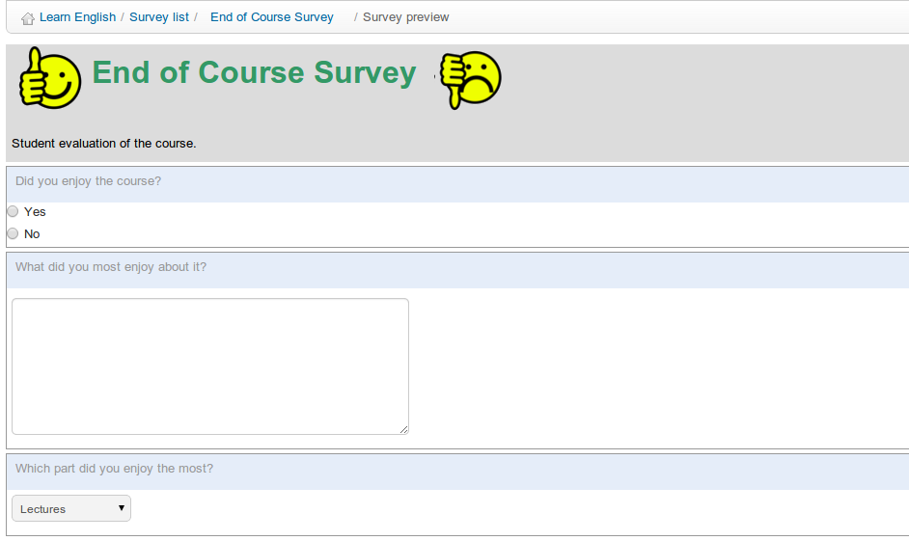Illustration 156: Surveys – Preview survey

Survey publication
If you are satisfied with the survey, you just need to publish it (make sure you don't contradict yourself with the start date, sending the invitation by e-mail for a survey which is not yet available!)

Click the Publish icon . Select the course users to send the survey invitation to:
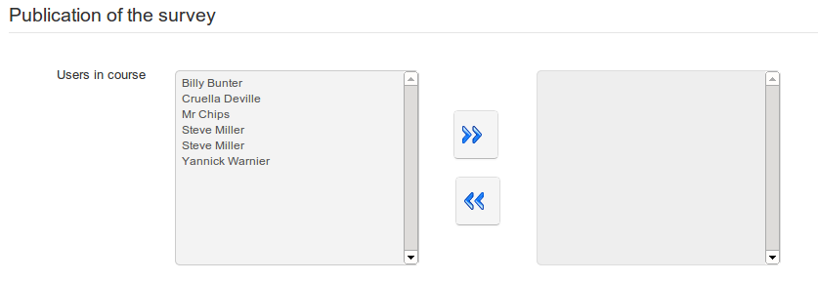
Illustration 157: Surveys – Publication: select course members
In addition/alternatively, send invitations using the same form directly by e-mail (separate email addresses using semi-colons). Invitations can be sent to people who are not registered users on the platform (e.g. you may wish to send the invitation to potential customers, or to parents of learners):
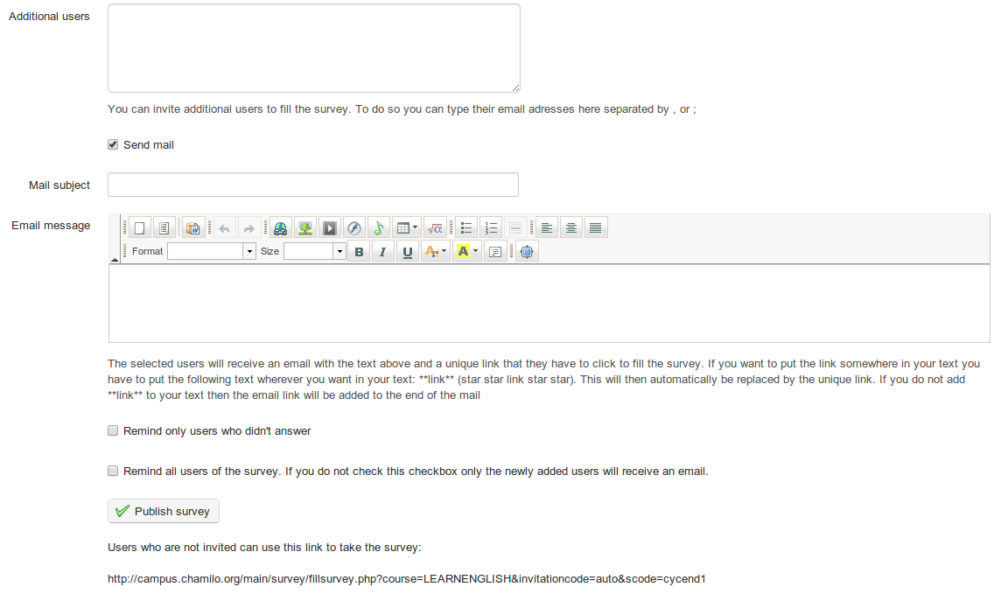
Illustration 158: Surveys – Publication: email additional recipients
Once you have completed the fields, remember to click the Publish survey button.

Note: you can also invite anonymous individuals without requiring an email address (e.g. visitors to a web page) using the Generate access link icon in the survey listings.

Results
Analyzing survey results can be an exhausting process. The tools provided in this section should be of great assistance. Click the Reporting icon to view a menu of automatically generated statistical and graphical reports, each of which will present a complete report which can be exported as a .csv or .xml file.
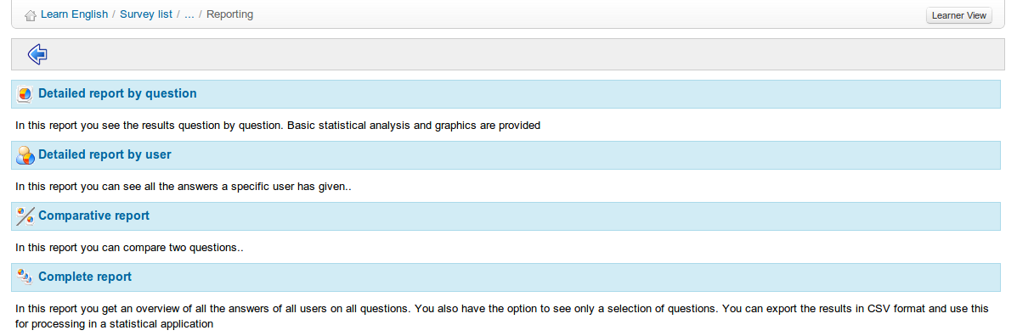
Illustration 159: Surveys - Results

Surveys management
A series of common icons are made available for the management of surveys, as well as a few specific icons.

Icons | Features
 | Edit survey settings
 | Delete surveys
 | Empty survey results
 | Survey preview
 | Publish survey
 | Generate survey access link
 | Access report features
 | Change the order of the questions inside the survey

Notebook
The Personal notes (or Notebook) tool  is a kind of notepad attached to each course. It allows the users to take note of things they would otherwise write on a piece of paper.
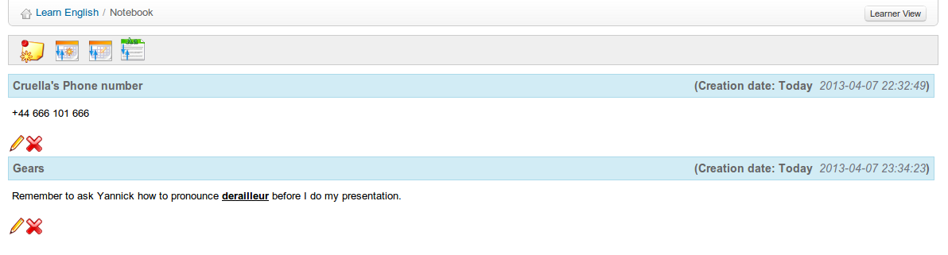Illustration 160: Notebook - List
Notes can be updated as needed and dates of creation and latest update are saved. Notes taken by a user are not visible by other users. In this sense, they are, indeed, personal.

Notes creation
- click on the Add new note in my personal notebook icon ,
- give your note a short title,
- write down your note,
- click Create note.
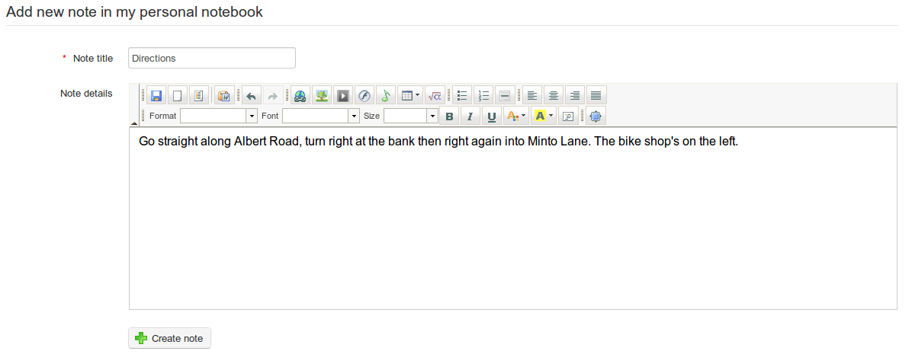Illustration 161: Notebook – Creation form

Sort notes

Using the tools in the toolbar on the Notes page, notes can be sorted by date created , date last modified  or by title .

Projects
The Projects or Blogs tool  was developed in 2006 at the request of a large Belgian telecoms company. The idea behind it was to implement a blog with lightweight project management features, which was tagged under the name of Smart blogs. Its philosophy is to allow for the assignment of tasks to the learners in order to write the contents of a story-telling type blog.

The teacher takes responsibility for choosing learners who will contribute to the blog, and defines the project and the assignment of tasks (or roles taken by the learners). The creation of articles is shared between the teacher and the learners.

The tool can, however, be used as a classic blog.

Note : When a new project is created, it appears in the list of course Authoring tools on the course homepage. Its visibility can be controlled like that of other tools. One main difference by comparison to other tools is that one can create several blogs in the same course. They will appear as multiple entries in the Authoring tools in much the same way as with links and learning paths.
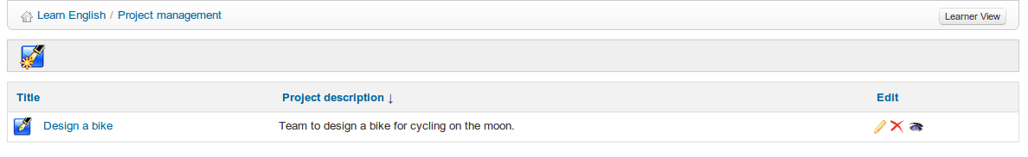Illustration 162: Projects - List

Project creation
From the projects homepage:
- click the Create a new project icon ,
- give your project a name and a short description,
- click Save blog.
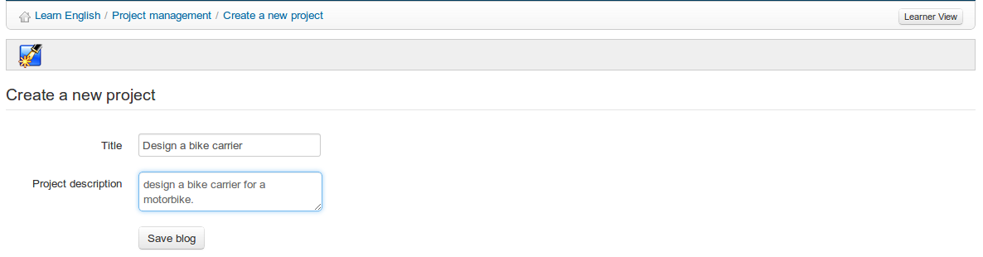Illustration 163: Blogs – Blog creation

Subscribe learners to a project
Your can manage several projects within the same course, and therefore select individual learners to contribute to each project.

To subscribe learners to a project from the homepage of this project:
- click the Users management icon ,
- check the boxes next to the learners you want to associate with this project,
- click the Validate button.
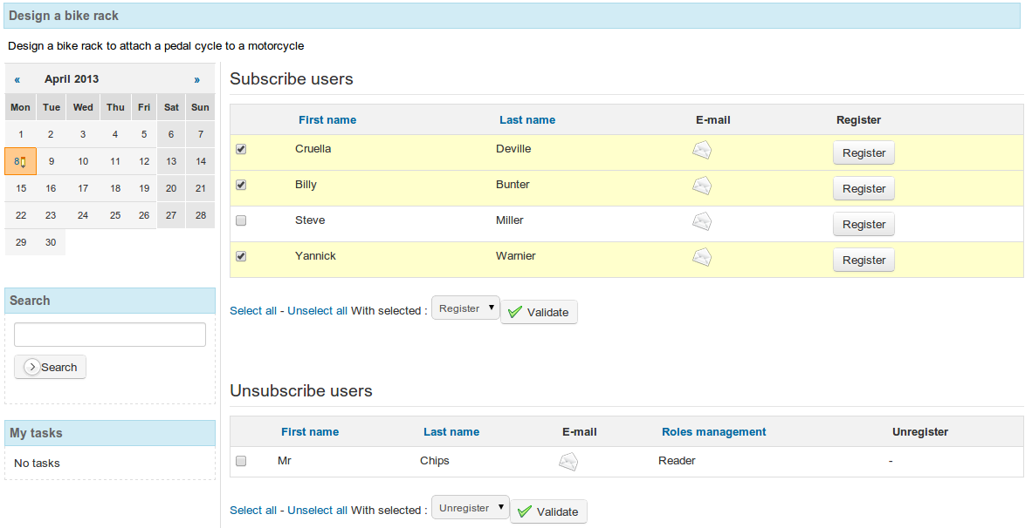
Illustration 164: Projects – Users management

New article/task
From the project's homepage:

- click the New task icon :
- give the article a name,
- write down the real article,
- attach a document (optional),
- click the Save button.
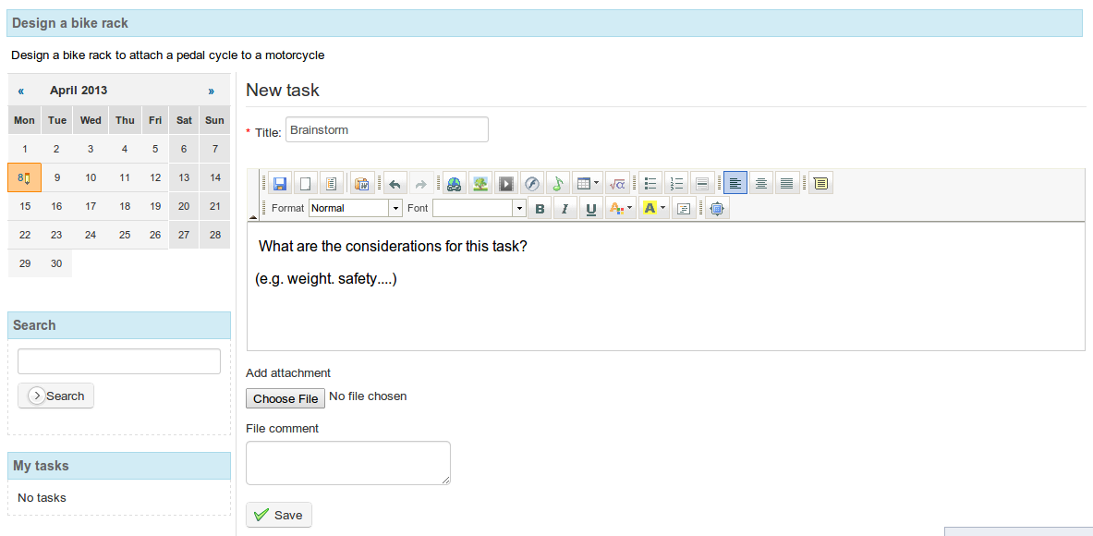
Illustration 165: Projects – New task

Roles management
The Roles management icon  displays a page listing the roles/tasks created and assigned to users:

Illustration 167: Projects – Roles management page
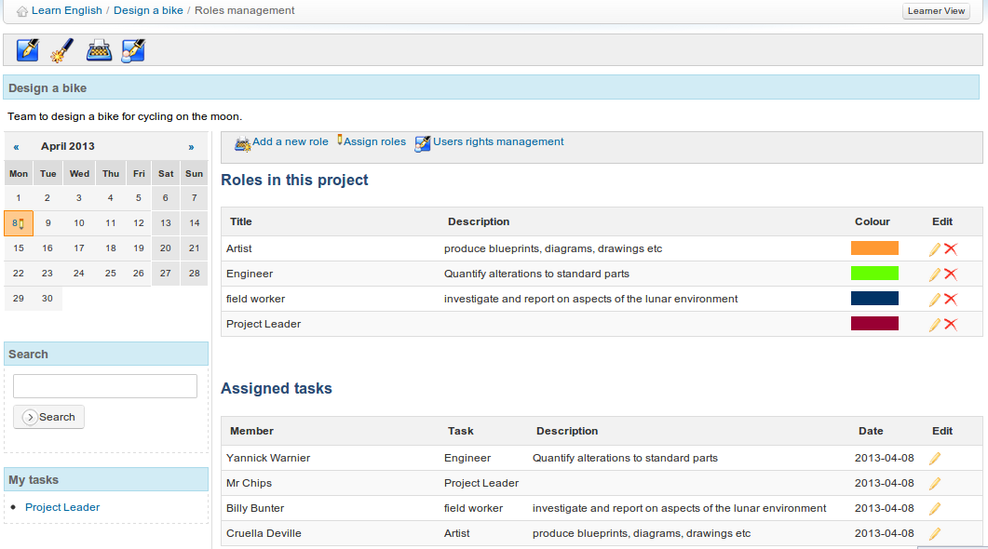Illustration 166: Projects - Roles management

From the Roles management page you can create detailed tasks of a project step or assign roles to the members of a project.
To create a new task/role:
- click the Add a new role icon ,
- give the role a title, description and assign permissions,
- choose a color using to the drop-down bar,
- click Save.
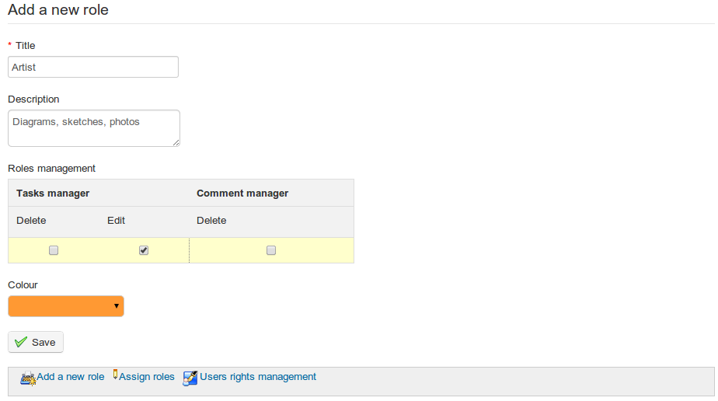Illustration 168: Projects – New role
→ The new role appears in the roles list.

Assign a role to a learner
Once the role has been created, you must assign it to a learner:
- click on the Assign roles link ,
- select a learner to assign the role to,
- select the task to be assigned,
- select a date to achieve the objective of the role,
- click the Validate button.
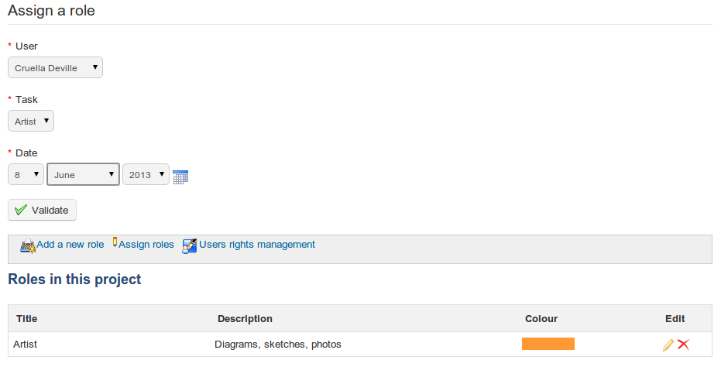
Illustration 169: Projects – Assign a role

Indicate the execution of a task
Whether for a teacher or a learner, tasks assigned to any user are shown at the bottom left of the projects page under section My tasks.

To indicate the successful execution of a task:
- click on an executed task,
- in the project steps list, select the article you want to attach the task to,
- in the resulting screen, fill the task name, a comment and optionally a document,
- click Save.

The execution report of the task appears as a comment to the article.
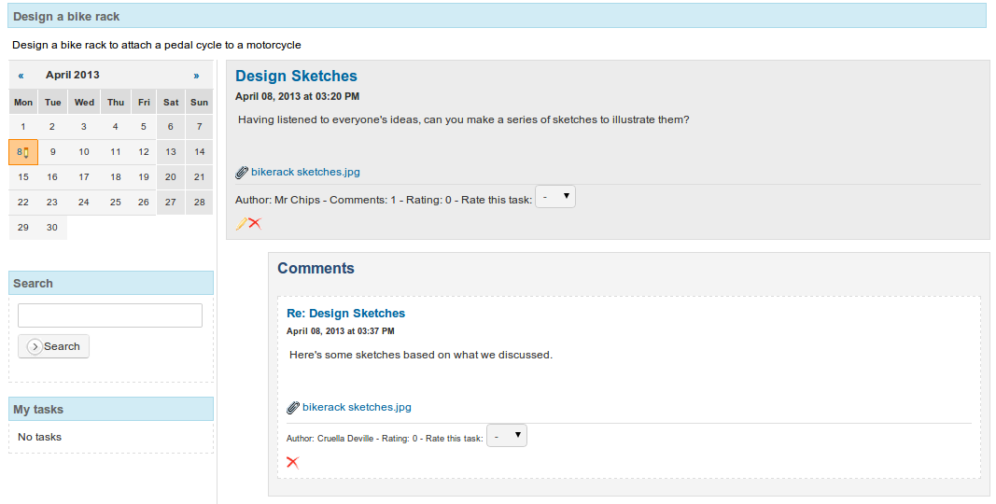
Illustration 170: Projects – Tasks comments

Learners' task management
By clicking the Users rights management icon in the roles management page, you get a table describing users rights within the project which can be edited as appropriate. Click on the red hasn't rights icons or the green has rights ticks to toggle between them.
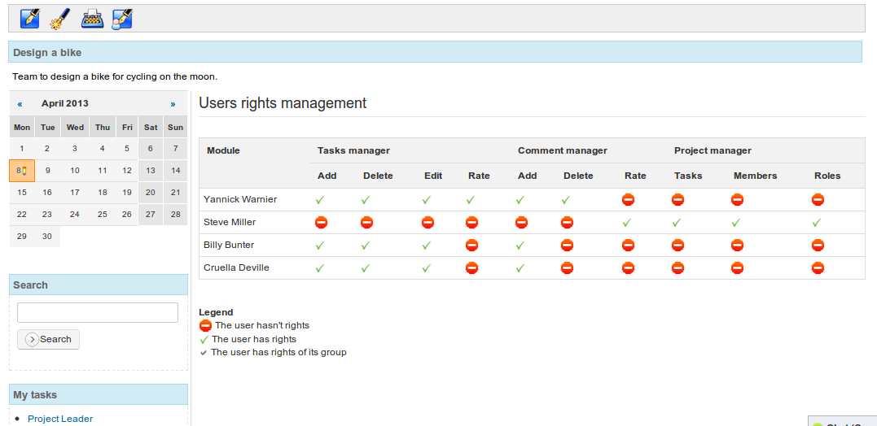
Illustration 171: Projects – Users management

Course settings
The Settings tool in the Administration section of the course homepage allows you to edit the overall behaviour of the course (most options will affect several tools). Although it is placed in a remote location at the bottom of the page (and at the end of this manual), it is generally a good idea to use it at the beginning of your course to manage subscription settings and course access (see later: Visibility and access Visibility and access section).

Note: Course tutors using the course inside the session will not have access to this tool as configuration changes might affect other sessions.

Update general course settings
By default, this page (a series of vertical tabs) displays the main Course settings where you can:
- enter or edit the course title,
- enter/edit the general category to which the course belongs,
- choose the language in which the course interface is set (this can be set to language other than that of the platform, - particularly useful for a “total immersion” language course).
- enter a Department name and/or web address
- add a picture to be displayed in the course catalogue (important for “marketing” your course)
- choose a stylesheet for this course from a drop down menu (by default that of the platform)

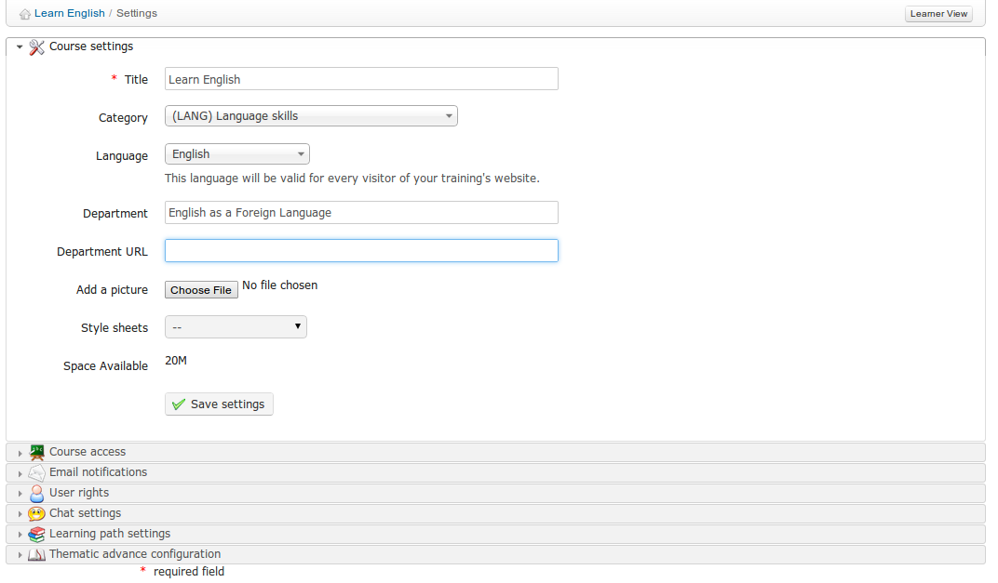Illustration 172: Course settings - General

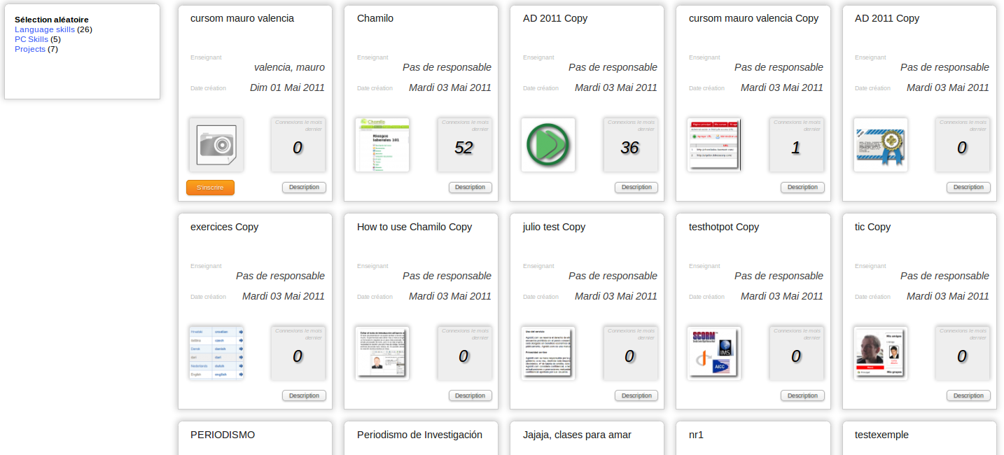
Illustration 173: Courses catalog – Example of courses illustrations
Note : the Department is a feature for which support has been dropped so far. Depending on visual styles, the department might appear as a link in the campus header (for old, deprecated styles). This is all a department will change. In more recent version of Chamilo 1.8, if you need to manage courses by departments inside a university, we recommend you use the multi-url feature, described in the administrator's guide, little brother of this guide.

Visibility and access
The Course access section allows you to define how open access to your course will be by selecting the Course visibility settings (already described in Control course access on page 20). These settings (public, open, private or closed) are fully defined on the page. On this page you can also:
- obtain a direct link to send e.g. via email or a web page to invite registration to this course
- allow self-subscription and unsubscription
- provide a registration password to allow access by unsubscribed users
- establish legal terms to be displayed on entry to the course

E-mail notifications

E-mail notifications are a effective way to ensure the teacher is aware, through immediate alerts, of key events in his course as they happen. The various settings are filly described on the section:
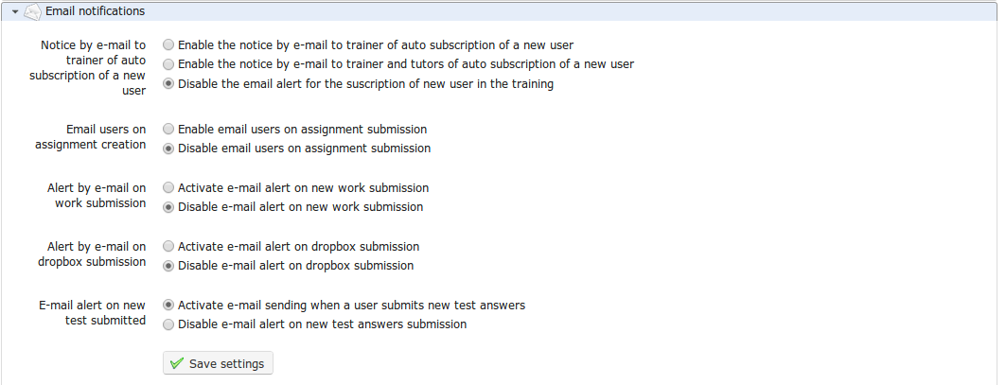
Illustration 174: Course settings – E-mail notifications
In this section, you can choose to receive an e-mail notification if:
- a user subscribed to your course (this feature has to be enabled by the platform admin),
- a new file is submitted in the Assignments or the Dropbox tools,
- a test is passed by a learner.
It is also possible to set an e-mail notification to all users when a new assignment is created.

User rights
The User rights section allows you to set particular permissions for users in this course, including the right to add events to the Agenda, to add Announcements. It also allows you to hide personal user pictures in the Forums, as well as decide whether users have access to the Users list.
(Note: This is independent of the visibility of the tool in the course homepage and is a real access change (the visibility of tools is only a homepage setting and does not prevent users entering the tool if they know the URL).
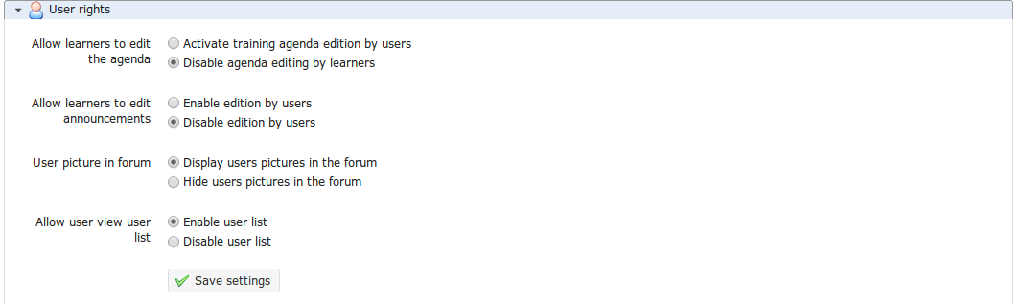
Illustration 175: Course settings – Users rights

Chat settings
In the Chat section , selecting the appropriate option allows you to choose whether the chat opens within in the page or in a new window:
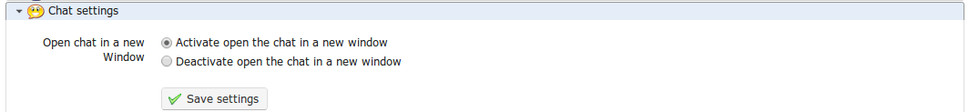Illustration 176: Course settings – Chat settings

Learning path settings
The Learning path section can be used to enable the auto-launch of learning paths and the style (or graphical theme) for the course.
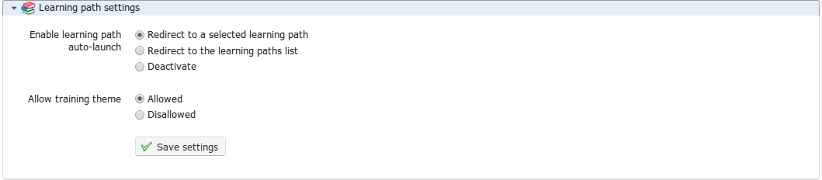Illustration 177: Course settings – Learning path settings
The auto-launch feature allows the teacher to select one specific learning path to auto-start when the user enters the course homepage. In order to use this feature, you'll need to enable the option in the course settings (remembering to save the changes) then go to the learning paths list and click on the rocket icon which represents the auto-launch of one of the learning paths:
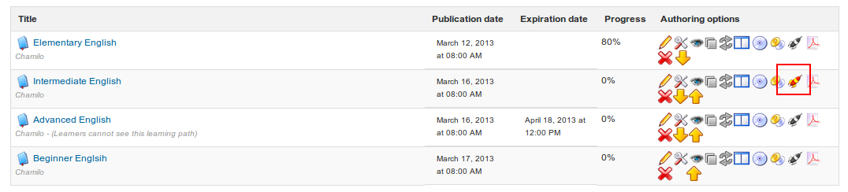Illustration 178: Learning paths - Auto-launch
Only one learning path can be set as auto-launch at a time, and it will start as soon as the learner enters the course homepage. Other learning paths show a gray rocket icon. To test this option, you'll have to connect as a learner as it has been disabled for teachers for practical reasons.

As long as the platform administrator has enabled this feature, the teacher can select the Allow training theme option to choose the graphical style of his course. It is also possible to select a separate theme for an individual Learning Path. This means that a learner might theoretically enter his Chamilo campus, see the platform in a particular visual style, (e.g. mostly blue), enter a course and see the style change to red, then enter a learning path and see the style mostly green... For visual comfort, it is recommended, however, to avoid style changes unless they are justified for real pedagogical reasons.

Note : a learner will be able to return to the course homepage from the left menu inside the learning path. The idea here is not to disable or hide the course homepage, but rather to speed access to the course content.

Thematic advance settings
This Thematic advance section allows you to choose which options for the Course progress will be visible on the course homepage (on the right-hand side of the introduction section).

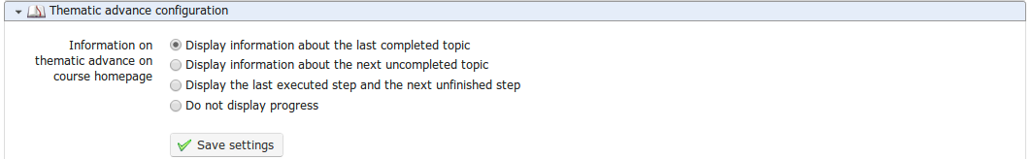Illustration 179: Courses settings - Course progress
These options require a proper understanding of the course progress tool. The results of the third option, for example, will be similar to the ones show in the illustration below).

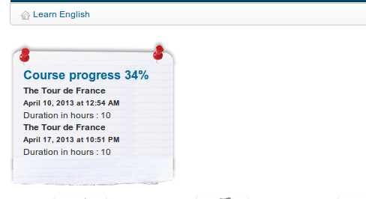
Illustration 180: Course progress – Display on course homepage

Backup
Chamilo makes a distinction between maintenance tools and course settings to simplify course maintenance and backup. Deleting, emptying, copying, saving or recovering the contents of a course (partly or completely) can be executed quickly and efficiently using the Backup tool :

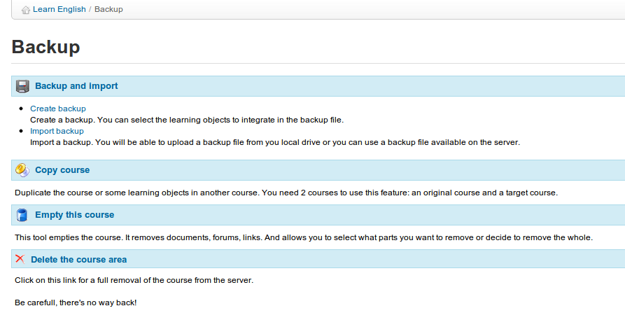
Illustration 181: Backup - General
Note : Features for saving, copying, recovering etc. have been developed with the intention of managing content. For this reason, interactions with or between users are not saved. To save them, you'll have to ask your platform administrator to do a full backup of the portal. If you are the administrator, this procedure is described in the admin guide.

Create a backup

For security and procedural reasons, it is recommended that you create a backup copy of the complete contents of your course. This procedure is automated. It allows you to create either a complete backup or a partial backup, based on your selection of what to save, using a few simple clicks. To begin backup:

- click on the Create backup link in the Backup and import section ,
- on the next page, select whether you want a full copy or just a selection of elements (in which case you will have to select them on the next page and click Validate),
- click the Create backup button to launch the procedure.
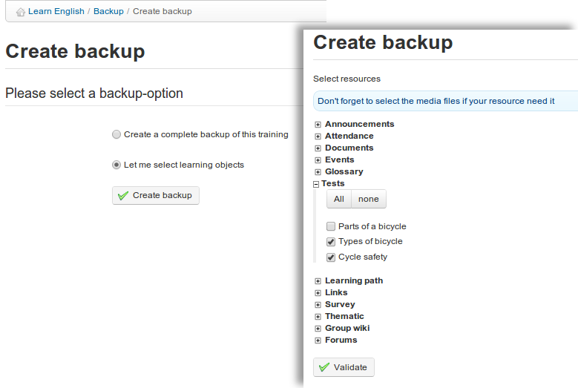

Illustration 182: Maintenance – Backup creation
The backup is made available in the form of a compressed file which you can download on your computer. It is also stored on the server for quick restoration if needed.

Import backup

Each backup is a compressed file (a Zip file) which is stored on the server (in the archive/ directory). It can also be downloaded to your computer.

Chamilo also allows you to import the contents of a backup copy inside a new empty course. This can be useful for a teacher creating a new course.

To start the import:
- click the Import backup link in the Backup and import section
- choose the source of backup: either a .zip file on your computer or one stored on the server,
- choose whether you want to import the whole course or only specific sections (to be selected in the next screen),
- decide whether to duplicate specific files during the importation operation or to replace them,
- click Import backup to start the import.
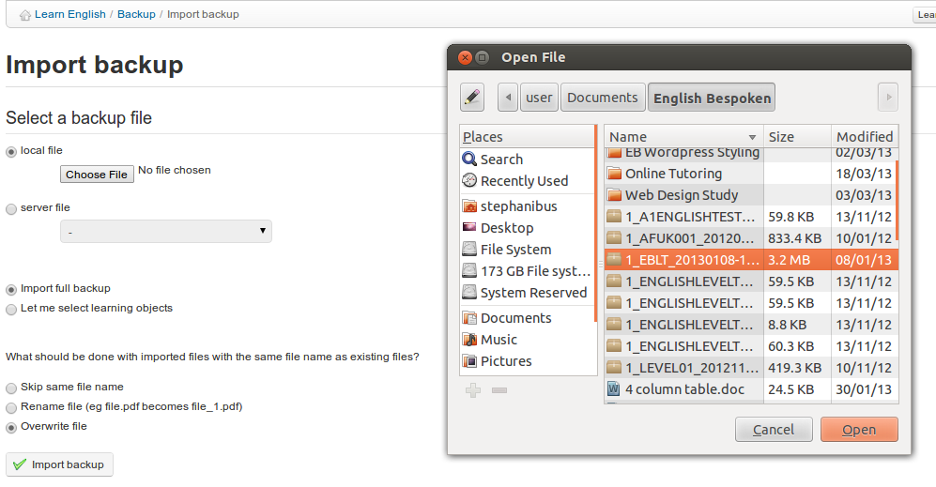
Illustration 183: Backup - Import

Note : A message will confirm the backup restoration executed successfully

Copy course
The Copy course feature allows you to copy all or part of a course to another (empty) course. To use it, you first need to have another course available to copy it to.

From the Backup page:
- click Copy course,
- select the destination course
- select the elements to copy (all or part of the origin course)
- select what to do when the files in the destination course already exist (rename or overwrite),
- click the Copy course button.

Note : A message will confirm if the course was successfully copied

Empty this course
The Empty this course feature empties (“recycles”) either the whole course or selected elements. It deletes documents, forums, links, etc. This procedure can be executed after a course has ended and when you want to start anew in the same space. Of course, it is generally recommended that you keep a history of these courses.

Warning: Before you empty the course, make sure you take a backup copy, just in case!

To empty a course:
- click on the Empty this course link,
- select whether you want to empty the whole course or just specific tools,
- click the Empty this course button to proceed.
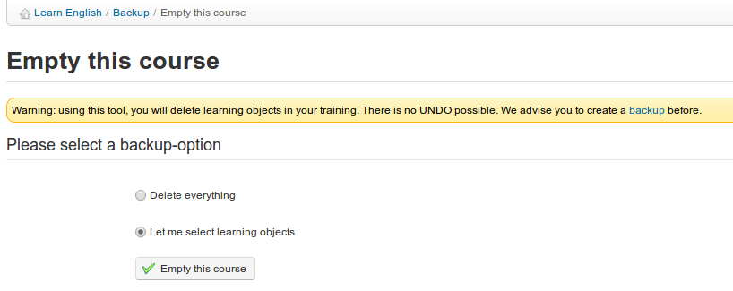
Illustration 184: Maintenance – Empty course

Delete the course area
Click the Delete the course area link to delete the course completely from the server.
Given the fact there's no way back from this, we highly recommend you consider this twice before confirming it.

Warning: This feature should be used with extreme caution!

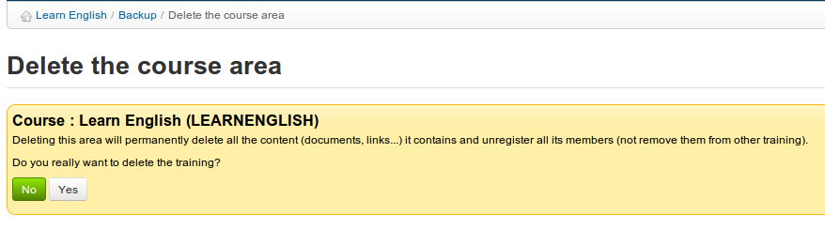Illustration 185: Maintenance – Course deleting

The Reporting tab
This chapter related to Reporting tab as opposed to the reporting tool discussed in earlier chapters which is accessed from the course home page and relates only to that specific course. The Reporting tab allows you to get an overview of what's happening inside all your courses or sessions. The Reporting link inside a course is essentially just a filtered version of the following and has been described in detail in chapter 15, so you can refer to that chapter as regards the details of the reporting pages.

Own courses and sessions reporting
The main page of the Reporting tab displays summary tables offering a general overview, some statistics relating to users on your courses (each entry shows some statistical data which allows you to track the progress and the results of all learners as an average value) , and a list of courses and sessions for which you are responsible:
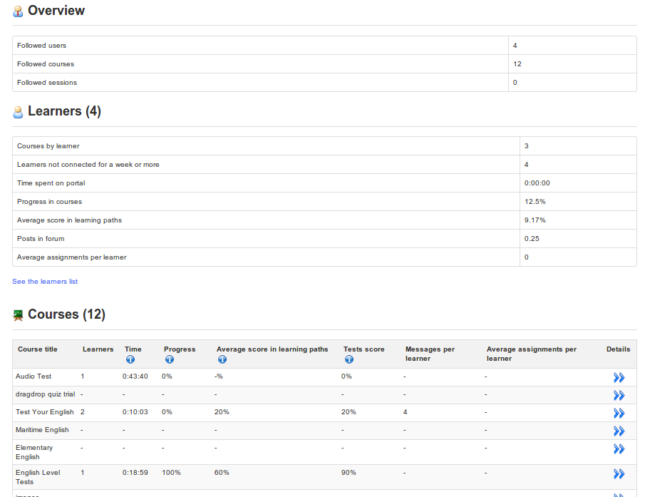
Illustration 186: Reporting tab – main page
Clicking the Details icon will show you a more detailed list for that specific course or session. Clicking on further Details icon in any of those screens will show you a deeper level of detail. There are about 4-5 levels of detail and this guide does not cover them all. We recommend you take some time to have a look through all the options and see which report best meets your needs.

Social network
Chamilo recognizes that effective online social interaction is an important element in successful online learning. The Social Network facility offered on the platform is designed to optimize support, within the platform, for teachers and learners wanting to make use of various social network features as an integral part of their online learning (and teaching) experience. These include simple profiling, an internal messaging system available to users and the facility to create interest groups. (Note that some of these features need to be enabled by the platform administrator.)

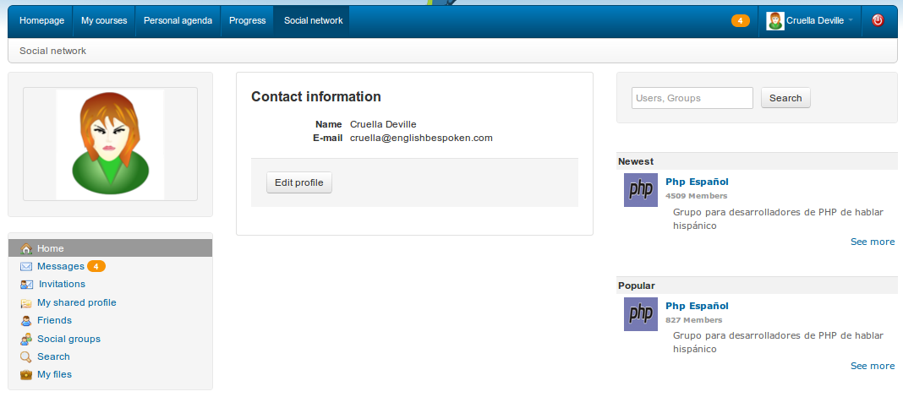Illustration 187: Social network - Home

Profile information
To enter/edit your personal details, go to the Social network tab:
- click the Edit profile link,
- update the fields,
- click Save settings.

Profile options allow you to edit your name, your Chamilo code, your email and you phone number, as well as a profile picture and preferred language. Other fields (if enabled by the administrator) allow you to choose a graphical theme and enter details of personal competences, diplomas (qualifications), and what you are able to teach. You can upload any relevant file using productions, and write any other relevant information in my personal open area. More recent versions of Chamilo also invite you to enter/edit your password, tags, rss feeds, timezone, email notifications, your Google calendar URL, your country, your birthday and even a range of personal social networking links:
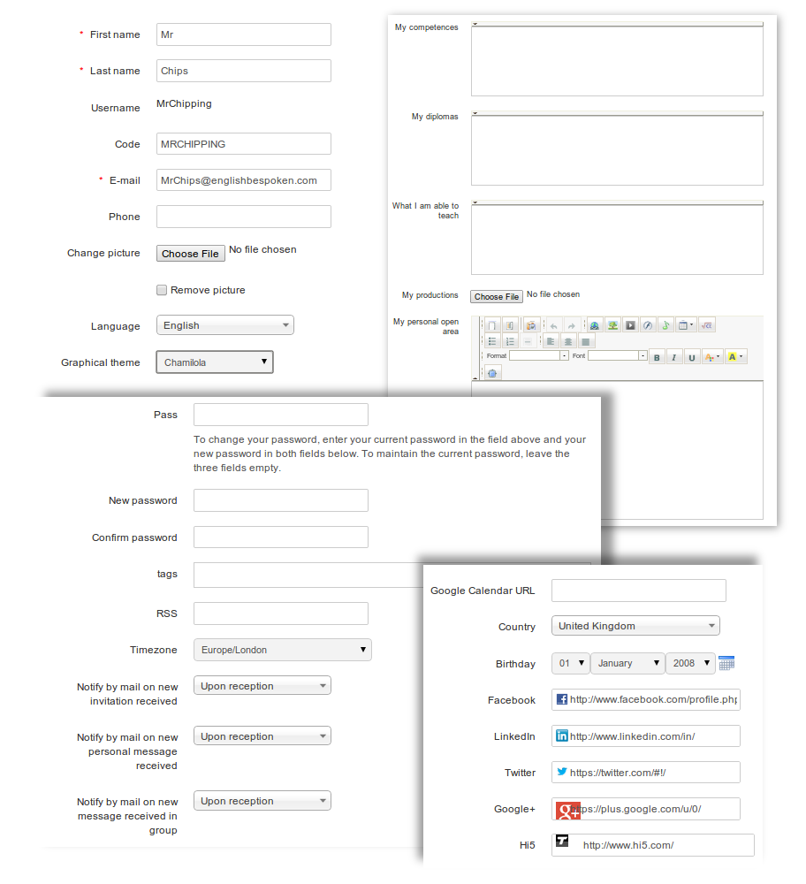
Illustration 188: Social network – Extended profile update
Remember to click the save button when you've completed entering/editing your profile details!

Internal messaging
From the Social network tab (left menu) the Messages entry allows you to send or receive messages. It is similar to most messaging tools.
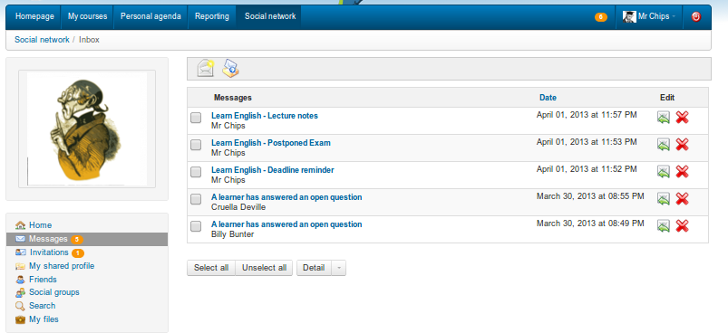
Illustration 189: Social network – Internal messaging - Inbox
To write a message to another user (or a friend) subscribed to the platform:
- click the Messages link below your picture,
- click the Compose message icon ,
- Chamilo will auto-complete the send-to field with known contacts,
- enter the subject and message (optionally you can add an attached file),
- click the Send message button.
If the recipient has entered their email in their profile, the message will also go automatically go to their email address.

Note: If the other user has chosen to, the message will also be sent to his e-mail as a notification of internal message. However, he will have to enter the platform to answer you.

“Friends”
In the Social network tab, you can make contacts and invite them as Friends (a rather free use of the term friend!). You can search for people by:

- clicking the Invitations link in the left menu ,
- click Search.

By simply entering a few characters of the user's first or last name, Chamilo will help by proposing a list of users matching these characters. The invitation can then be sent to the user, who can choose whether to accept or refuse it.

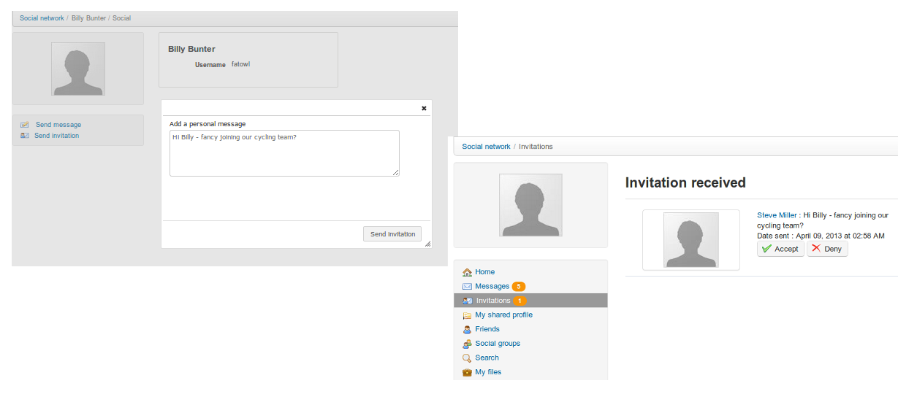
Illustration 190: Social network – send and receive invitations
The Friends link gathers all friends you have linked to on the platform. It allows you to see the shared profile of the user and send him a message with a click on his name.
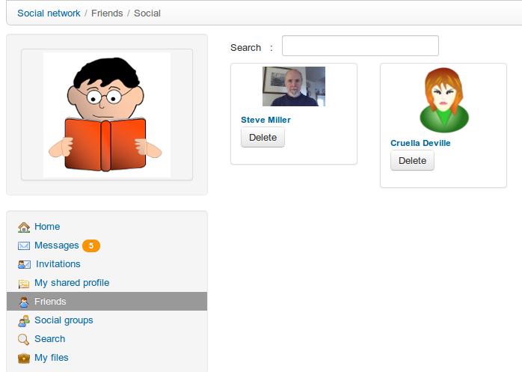
Illustration 191: Social network – Shared profile

Social groups
The Social groups link compiles together all groups that exist on the platform. These groups can only be created by administrators, unless they have enabled this option for all users.

There are two types of groups, depending on access:
- public (everybody can join)
- private (the group administrator must authorize the membership request)

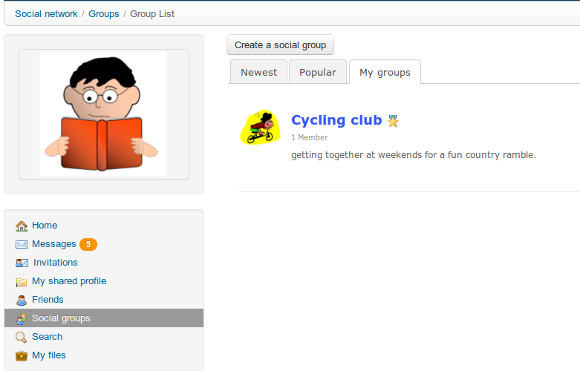
Illustration 192: Social network – Social groups
The My groups tab lists the groups of which you are a member. These groups work as a forum. The administrator (or moderator) creates discussion topics and users start contributing.
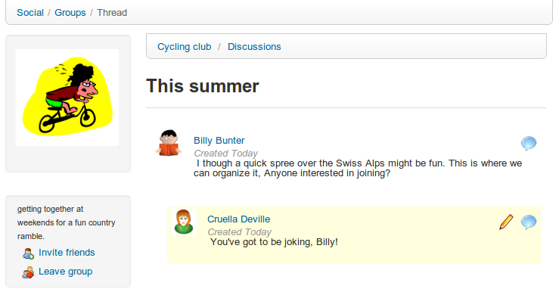
Illustration 193: Social network – Social groups interface

My files
A user can use the My files link in the social network to upload and store personal files (e.g. profile pictures, notes, assignment documents etc.). The link brings up an interface where the user can upload and organize files on the server:
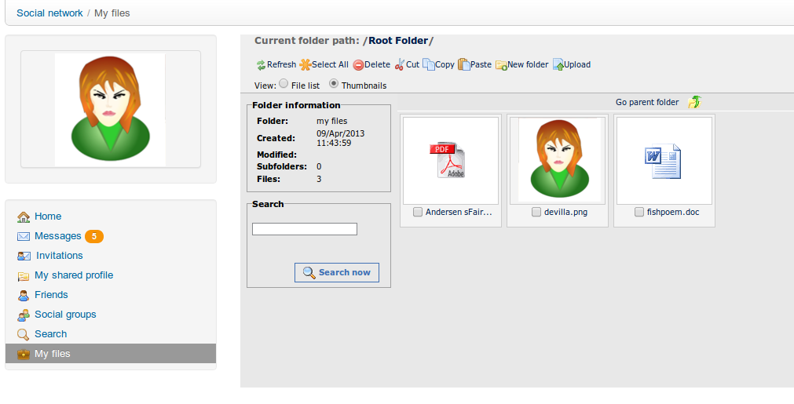
Illustration 194: Social network – My files
Files can be viewed or downloaded by clicking on them.

Session view
From Chamilo 1.8.8 platforms onwards, if your platform uses Course sessions a new view type has become available from the My courses tab. This is a special “sessions” view, which you will find is a very different way of presenting courses and tools (specifically learning paths and tests).
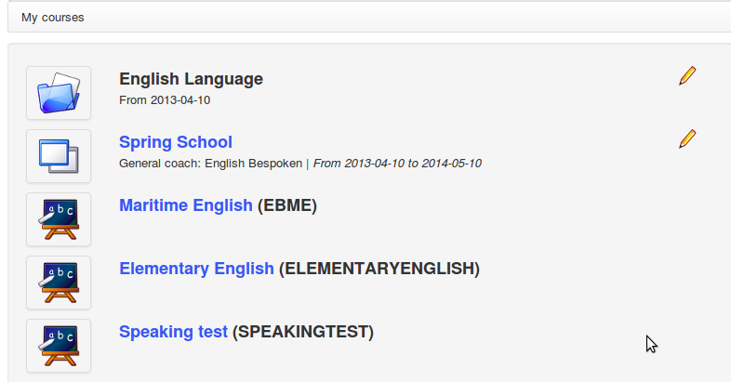
Illustration 195: My courses - Sessions
One main difference from previous versions of Chamilo is that the session title is now a link which leads directly to a page whose appearance differs in many ways from the rest of Chamilo. (This is a new format of presentation that we will be studying over the next few months, and we're counting on your help and feedback. Do let us know what you think on the Chamilo forum: http://www.chamilo.org/)

This new concept relies essentially on a new way of setting up tests and learning paths based on timescales. By making sure each exercise and learning path has a start and end date, the data shown in these screens make far more sense. (As such, it is not well suited to asynchronous teaching i.e. purely remote e-learning, with its relatively free timescales.)
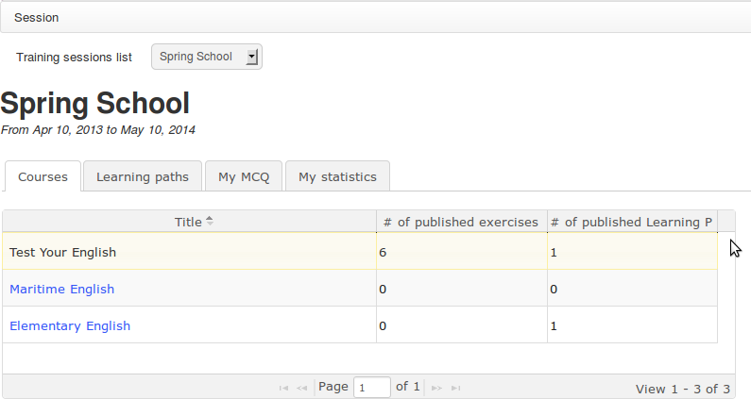

Illustration 196: Sessions – New session screen

Click on the relevant session icon  displayed in the My courses page The main screen displays four tabs: Courses, Learning paths, My MCQ (Multiple Choice Questions), and My statistics

Courses tab
The Courses tab shows a list of courses available inside the sessions. Click on one of these courses (the text will turn black) to filter the rest of the tabs to show only items from this course.

Clicking directly on one of the tabs will show a complete list of all corresponding resources in the session (if you don't click on one specific course in the first tab, the Learning paths tab will show all learning paths in the session, all courses mixed up).

Learning paths tab
The Learning paths tab shows a list of learning paths in the session, filtered according to course (as long as you clicked a course in the first tab).

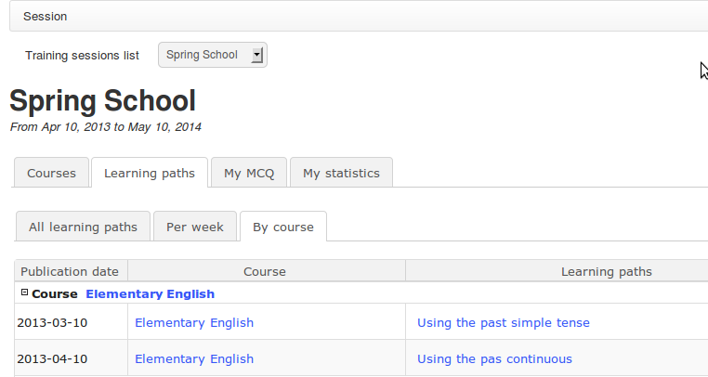
Illustration 197: Sessions – Learning paths
The publication date of each learning path gives you an idea of the chronological order of the learning paths. Where you have several simultaneous courses (which might be the case in a session) all offering several learning paths, organizing the right learning paths schedule will provide the learner with a clear indication of the order in which we expect him to follow them. The learner can enter a learning path directly from this screen, simply by clicking its name.

Note : there are three view types for learning paths: All, Per week, By course. They do not affect the way contents are ordered, so don't hesitate to try them out.

My MCQ tab
The My MCQ tab contains all tests pertaining to courses in the session, sorted by publication date. Because the display of these test is relative (comparing results to those of other learners) and is in a chronological order, it is doubly critical to establish publication dates for all your tests.

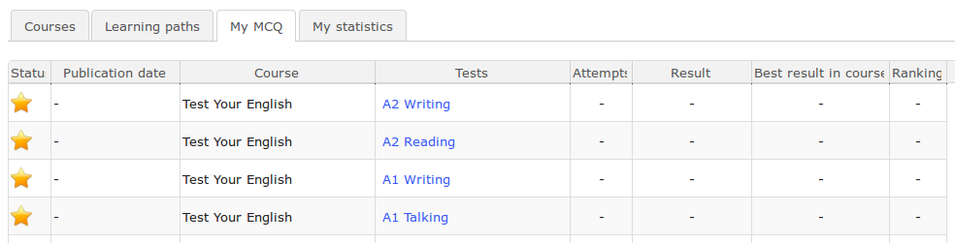
Illustration 198: Sessions – My QCM tab
Exercises which have not yet been attempted are indicated by a yellow star . The number of attempts is indicated as well as the exercise results, and also the highest scores obtained by any learner in the session. Finally, the position in the table reflects a learner's relative results within this session. By clicking the test title, the learner goes directly to the test or, once all attempts have been exhausted, directly to the test results screen.

My statistics tab
The My statistics tab offers teachers and learners an innovative set of features, provided publication dates have been established for exercises. Learners will then be able to see a visual result of their scores in comparison with those of other learners.

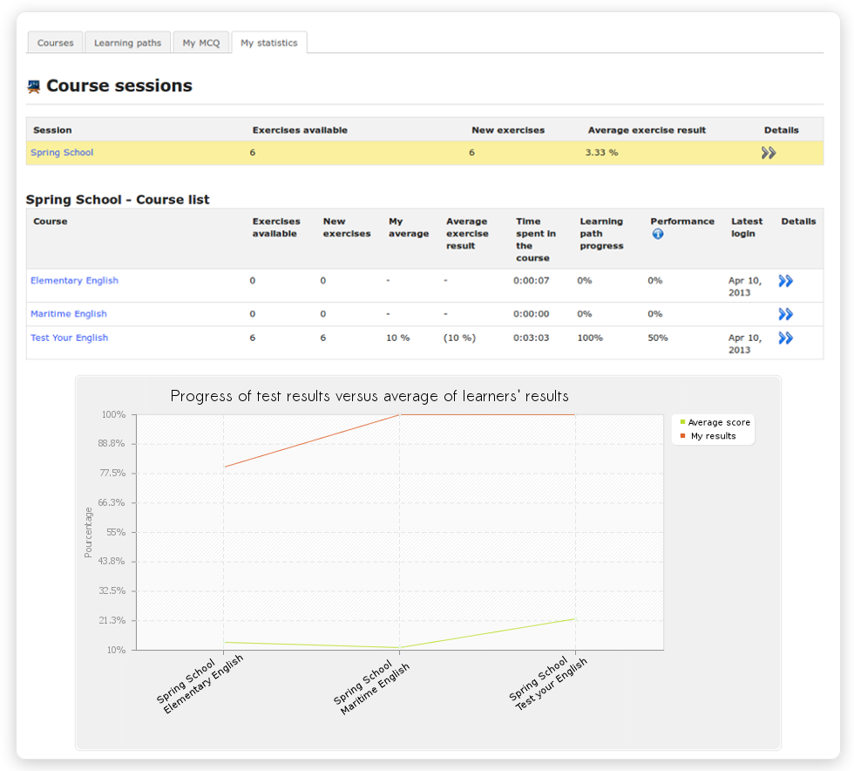
Illustration 199: Sessions – My statistics tab
By clicking the double blue arrow for any course, you'll be able to view a series of more detailed result information:

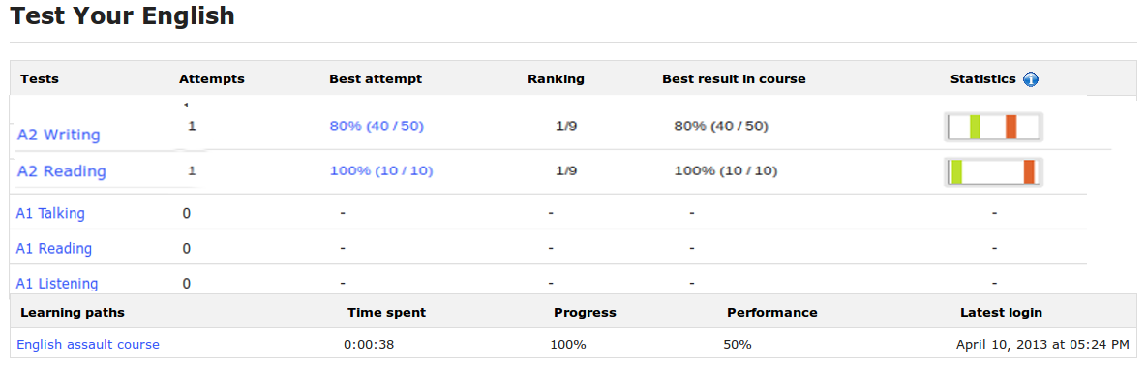Illustration 200: Sessions – Statistical details
This detailed view presents a graphical visualization of the scores repartition. Each bar represents a rank of results (0-20%, 21-40%, 41-60%, 61-80%, 81-100%). The global chart represents the repartition of all students' results for this exercise. The orange bar is the bar in which the current user's results are located. You can click the chart to get an exploded view.

Appendix

Glossary
- Administrator : The “master” user who controls and manages the Chamilo portal globally.
- Course administrator : See teacher
- Student : See learner
- Course assistant : a learner with additional rights limited to a specific course: he can track other learners' results, check their assignments and their test results
- Coach : a teacher of a course in the context of a Session
- Course : a course area, or course space, with its 20-odd tools
- Learner : A user who has the right, within a course, to access resources as the teacher prepared them
- Trainer : See teacher
- Training : See course. In versions 1.8.5 to 1.8.8 of Chamilo, the term Training replaced the term Course, resulting in an awful lot of confusion, not only in English, but also in other languages which depended on English for translations. The term can be of course be redefined on each portal depending on needs through the portal administration interface, but Course is the term used globally now.
- Teacher : The user who creates and/or controls a course (outwit h the Session context)
- Tutor : See Coach
- User : Any user who has an access to your Chamilo portal, regardless of his role

Frequently asked questions
This list of short questions and answers might help you sort out how to do specific things with Chamilo which are not explicitly explained in the previous chapters.

How can I set a survey as a requirement to complete a course?
The notion of “completing a course” can only be built upon the Assessments tool, by setting up a certificate that will only be generated when achieving a certain set of learning objectives (exercises, learning paths, assignments, etc). Surveys can then be configured as a “locking” mechanism where a student cannot get a certificate if he doesn't complete the survey.

To do this, go to the survey tool and create your survey. In the Advanced settings, check the Qualify in gradebook box and select a weight of 50 (yes, 50, that's usually quite large).

Now go to the Assessments tool and click the percentage icon (Weight in report). Whatever the total weight has been set to, ensure that the survey is worth half of it (if the total weight is 100, the survey must weight 50, but you can also set the total weight to 200 and make the survey weigh 100). The other objectives, combined, will be worth half the weight. This means that, even if the learner has the best results, he will only ever be able to achieve a 50% score, which shouldn't be enough to get the certificate. Because the survey is just a yes/no type of result (answered or not answered), there is no other easy way to make the survey be a required element.

Once the learner has completed the survey, his results will jump up to the sufficient result to get his certificate.

Just make sure that the availability dates for your survey do not prevent completely a user getting his certificate, just because he can't take the validation survey.

How can I create a crosswords-type question?
In any exercise, create a new Fill the blanks type question. In the question editing box (online media editor), click the Table icon and choose how many rows and columns you want your crosswords to be. Now fill the crosswords with letters. Once you're done, select the letters you want users to find out and replace them with the same letter with brackets around it. These letters will now disappear from the student view and they'll be able to complete the table that way.

Document license

All right reserved.

Rights given by the copyleft licenses are indicated below.

Copyright (c) 2007 2i2L Sarl. Permission is granted to copy, distribute and/or modify this document under the terms of the GNU Free Documentation License, Version 1.2 or any later version published by the Free Software Foundation ; with no Invariant Sections, no Front-Cover Texts, and no Back-Cover Texts. A copy of the license is included in the section entitled "GNU Free Documentation License".

The contents of this tutorial are available under a double copyleft license:

GNU FDL : http://www.gnu.org/licenses/fdl.txt
and
CC-BY-SA : http://creativecommons.org/licenses/by-sa/2.0/fr/

A small amount of illustrations have been borrowed from the OpenClipart library.

In the true spirit of software freedom, all fixes and updates to this tutorial are welcome at this e-mail address: info@chamilo.org

Illustrations index
Illustration 1: Right to use, study and modify, share and distribute the software 8
Illustration 2: Icons label 10
Illustration 3: Folded help 11
Illustration 4: Unfolded help 11
Illustration 5: Contextual help pop-up 11
Illustration 6: History of Chamilo installations around the world, 2015 to 2017 12
Illustration 7: Homepage 15
Illustration 8: "My courses" page 16
Illustration 9: Chamilo header 17
Illustration 10: Breadcrumb Navigation 17
Illustration 11: Switch to student view 17
Illustration 12: Switch to teacher view 17
Illustration 13: Personal menu blocks 18
Illustration 14: Creating a course – short version 18
Illustration 15: Create a course – extended version 19
Illustration 16: Course creation follow-up page 19
Illustration 17: Course administration tools 20
Illustration 18: Course settings - Visibility 20
Illustration 19: Sort my courses 21
Illustration 20: Personal category creation form 21
Illustration 21: Personal courses category created 22
Illustration 22: Personal courses categories 22
Illustration 23: Courses catalog 23
Illustration 24: Course tools – Classical option 24
Illustration 25: Authoring tools in ipad type view 25
Illustration 26: Course homepage – Introduction text 26
Illustration 27: Authoring tools 27
Illustration 28: Interaction tools 30
Illustration 29: Administration tools 32
Illustration 30: Documents – creating directories 34
Illustration 31: Documents – List of default directories 35
Illustration 32: Documents - Icons - Upload 36
Illustration 33: Documents – Documents upload 36
Illustration 34: Documents – Documents upload in progress 36
Illustration 35: Documents – Document upload finished 37
Illustration 36: Documents - toolbar 37
Illustration 37: Documents – Creating a new document 38
Illustration 38: Documents – Download a copy 40
Illustration 39: Documents - Options 40
Illustration 40: Documents - Quota 41
Illustration 41: Documents quota chart 41
Illustration 42: Image gallery - Slideshow view 42
Illustration 43: Thumbnails view 42
Illustration 44: Exercises – Create a new test 44
Illustration 45: Exercises - List 44
Illustration 46: Exercises – Creating an exercise – Advanced options 45
Illustration 47: First view of the questions list 49
Illustration 48: Exercises – Question types 49
Illustration 49: Tests – Multiple choice, single answer 51
Illustration 50: Tests – Multiple answer question 52
Illustration 51: Tests - Fill the blanks 53
Illustration 52: Tests – Matching text elements 54
Illustration 53: Tests - Open questions 55
Illustration 54: Tests – Oral expression 56
Illustration 55: Exercises - Hot spot question creation 58
Illustration 56: Exercises - Hot spot learner view 59
Illustration 57: Tests - Exact combination 60
Illustration 58: Tests – unique answer with unknown 61
Illustration 59: Tests – Multiple answer true/false/don't know 62
Illustration 60: Tests – Combination true/false/don't know 63
Illustration 61: Tests – Global multiple answer 64
Illustration 62: Tests – Questions database 65
Illustration 63: Tests – import external tests from Tests page 66
Illustration 64: Tests - Import HotPotatoes, Qti2 and Excel tests 66
Illustration 65: Exercises - List 67
Illustration 66: Exercises – Results list 67
Illustration 67: Forum – Global view 68
Illustration 68: Forum – Display modes 69
Illustration 69: Forum – New category 69
Illustration 70: Forum – Forum creation form 70
Illustration 71: Forum – Discussion thread 72
Illustration 72: Assigning a maximum score to a discussion thread 73
Illustration 73: Forum – Marking a thread 74
Illustration 74: The learning path tool: 76
Illustration 75: Learning paths - Creating a new learning path 77
Illustration 76: Learning paths – Learning paths – Adding a learning object or activity 78
Illustration 77: Learning paths – Settings 78
Illustration 78: Adding a learning object or activity to a course 79
Illustration 79: Learning paths – Rich media creation tool 79
Illustration 80: Learning paths – Importing existing resources 80
Illustration 81: Learning paths – New sections 80
Illustration 82: Learning paths – Learner's view 81
Illustration 83: Learning paths - Import SCORM 81
Illustration 84: Learning paths – List 82
Illustration 85: Learning paths – Prerequisites 83
Illustration 86: Learning paths – Prerequisites options 83
Illustration 87: Reporting – Learners 85
Illustration 88: Reporting – individual student's details 86
Illustration 89: Users – Access details 86
Illustration 90: Report on resource 87
Illustration 91: Exam tracking 88
Illustration 92: Assignment settings 89
Illustration 93: Create a new assignment 90
Illustration 94: Student's assignment paper 91
Illustration 95: Main page for an assignment set by the teacher 91
Illustration 96: Assignments – Advanced settings 92
Illustration 97: Assignments – setting expiry dates 93
Illustration 98: Marking students' assignments 94
Illustration 99: Users – Main screen 95
Illustration 100: Users – Action buttons 95
Illustration 101: Assessments – Example teacher view 98
Illustration 102: Assessments – Example learner view 98
Illustration 103: An empty gradebook generates information messages 99
Illustration 104: Assessments – General settings 99
Illustration 105: Assessments – Classroom activity 101
Illustration 106: Assessments – Classroom activities – Filling in results 101
Illustration 107: Assessments – Add online activity 102
Illustration 108: Assessments - Weights 102
Illustration 109: Assessments – Skills ranking 103
Illustration 110: Certificates edition tags 104
Illustration 111: Certificate creation area 105
Illustration 112: Certificate templates list 106
Illustration 113: Example certificate 106
Illustration 114: Default certificate template available in Chamilo 107
Illustration 115: Assessments – List view 108
Illustration 116: Assessments – creating categories 109
Illustration 117: Wiki – Main page 110
Illustration 118: The Links page 113
Illustration 119: Links - Add a category 113
Illustration 120: Links - Add link 114
Illustration 121: Announcements page 116
Illustration 122: Add an announcement 116
Illustration 123: Announcements – learner view 117
Illustration 124: Glossary – Table view 118
Illustration 125: Glossary – add a term 118
Illustration 126: Glossary – List view 119
Illustration 127: Attendances – main page 120
Illustration 128: Attendances – New attendances form 120
Illustration 129: Attendances – Intermediary step for dates creation 121
Illustration 130: Attendances calendar 121
Illustration 131: Attendances sheet 122
Illustration 132: Course progress – Learner view 123
Illustration 133: Course progress – Teacher view 123
Illustration 134: Course progress – invitation to create a thematic plan 124
Illustration 135: Course progress – invitation to create a thematic plan/advance 124
Illustration 136: Course progress – example title and description fields 125
Illustration 137: Course progress – Steps creation 125
Illustration 138: Personal Agenda 126
Illustration 139: Adding an event directly to the calendar 128
Illustration 140: Adding an event using the Add event tool 128
Illustration 141: Export, edit or delete an event 129
Illustration 142: Dropbox – sent files 130
Illustration 143: Dropbox – Sending a file 131
illustration 144: Dropbox - Comments 132
Illustration 145: Create a group 133
Illustration 146: Groups- settings 134
Illustration 147: Groups – Auto-fill groups 135
Illustration 148: Groups – Filling a group manually 136
Illustration 149: Groups – Group space 137
Illustration 150: The chat window 139
Illustration 151: Surveys – Creation form 140
Illustration 152: Surveys – Questions creation 141
Illustration 153: Surveys – Preview survey 142
Illustration 154: Surveys – Publication: select course members 142
Illustration 155: Surveys – Publication: email additional recipients 143
Illustration 156: Surveys - Results 143
Illustration 157: Notebook - List 145
Illustration 158: Notebook – Creation form 145
Illustration 159: Projects - List 146
Illustration 160: Blogs – Blog creation 146
Illustration 161: Projects – Users management 148
Illustration 162: Projects – New task 149
Illustration 163: Projects - Roles management 149
Illustration 164: Projects – Roles management page 149
Illustration 165: Projects – New role 150
Illustration 166: Projects – Assign a role 150
Illustration 167: Projects – Tasks comments 151
Illustration 168: Projects – Users management 152
Illustration 169: Course settings - General 153
Illustration 170: Courses catalog – Example of courses illustrations 154
Illustration 171: Course settings – E-mail notifications 155
Illustration 172: Course settings – Users rights 155
Illustration 173: Course settings – Chat settings 156
Illustration 174: Course settings – Learning path settings 156
Illustration 175: Learning paths - Auto-launch 156
Illustration 176: Courses settings - Course progress 157
Illustration 177: Course progress – Display on course homepage 157
Illustration 178: Backup - General 158
Illustration 179: Maintenance – Backup creation 159
Illustration 180: Backup - Import 160
Illustration 181: Maintenance – Empty course 161
Illustration 182: Maintenance – Course deleting 161
Illustration 183: Reporting tab – main page 162
Illustration 184: Social network - Home 163
Illustration 185: Social network – Extended profile update 166
Illustration 186: Social network – Internal messaging - Inbox 167
Illustration 187: Social network – send and receive invitations 168
Illustration 188: Social network – Shared profile 168
Illustration 189: Social network – Social groups 169
Illustration 190: Social network – Social groups interface 169
Illustration 191: Social network – My files 170
Illustration 192: My courses - Sessions 171
Illustration 193: Sessions – New session screen 171
Illustration 194: Sessions – Learning paths 172
Illustration 195: Sessions – My QCM tab 173
Illustration 196: Sessions – My statistics tab 174
Illustration 197: Sessions – Statistical details 175

Alphabetical index
activity view 25
AICC 76, 81
Audio answer 56
available space 41
AVI 34
certificates 84
certification score 100
Chat settings 32
Clear the chat 139
Course access 32
course admin 18
course catalog 27
course category 18
course code 18
course description 27
Course settings 32
Create assignment 90
Create folder 35
create forum thread 73
CURL 115
demo content 19
difficulty level 50
E-mail notifications 32
enrich question 49
Excel 66
feedback 49, 94
Fill the blanks 53
Flash 34
Forum creation 70
grade a topic 73
gradebook 28
Groups 133
Hot spot 58
HTML 34
image area 58
IMS/QTI 66
introduction text 26
IP address 87
language 18
Learner view 17
Learning paths settings 32
LibreOffice 34
maintenance 20
Matching answers 54
Moodle 28
MP3 34
MS-Excel® 34
MS-PowerPoint® 34
MS-Word 34
MS-Word® 34
multiple answer 52
Multiple answer 62
multiple choice 50
OGG 34
Open question 55
OpenOffice.org 34
opinions 140
PDF 34, 41
personal course category 21
Photoshop® 38
private assignments 89
public assignments 89
questions category 50
questions database 65
Quicktime® 34
Recycling questions 65
Report on resource 87
Reporting 87
score 46
SCORM 76, 81
Send message 139
show feedback 49
Single answer 51
Teacher view 17
template 40
Thematic advance 32
True/False/Don't know 62
Unique answer 61
Users permissions 32
working groups 133

Document history
Date | Collaborator | Contact | Updated
2010 | 2i2l.fr, Anaël Boulier | info@2i2l.fr | Rédaction du manuel pour Chamilo 1.8.7.
Avril 2011 | BeezNest Belgium SPRL, Yannick Warnier | info@beeznest.com | Mise à jour pour 1.8.8, correctifs, mise on page, ajouts de détails.
Juillet 2011 | BeezNest Belgium SPRL, Yannick Warnier | info@beeznest.com | Mise à jour pour 1.8.8.4 and réorganisation des chapitres ; réécriture de l'introduction, listing des options, ajout des nouvelles fonctionnalités, révision du texte. À revoir : outils Suivi and Réseau social.
August 2011 | BeezNest Belgium SPRL, Yannick Warnier | info@beeznest.com | Added FAQ, fixes and details.  Basic translation to English.
March 2013 | BeezNest Belgium SPRL, Yannick Warnier | info@beeznest.com | Updated to 1.9.6.
April 2013 | Steve Miller | stephanibus@gmail.com | Complete revision and update of English text and screenshots based on 1.9.4. Icons added inline to text for clarity. Some additional paragraphs on pedagogical use.
March 2017 | BeezNest Belgium SPRL, Yannick Warnier | info@beeznest.com | Basic review and partial update to 1.11

http://www.gnu.org/licenses/quick-guide-gplv3.html
http://www.chamilo.org/en/providers
http://www.chamilo.org/, documentation tab
If the administrator didn't disable this option
Or “Le petit Poucet” in French, see http://fr.wikipedia.org/wiki/Le_Petit_Poucet
Only the administrator can redefine global courses categories
To one exception: if the demo content is enabled, this content is created in the language of the course. Modifying the course language afterwards will have as minor consequence to have the interface in one language and the contents in another.
To select more than one file, use the CTRL key in combination with the left mouse button.
In all recent browsers except Internet Explorer 6, 7 and 8, where this feature is not implemented.
If the learner disconnects from the exercise, his time will continue counting down until it is completely expired, but he will be able to reconnect and continue his exercise right whee he left it. The time counter only works in one question per page mode.
*Note that Chamilo uses the simple term “course” here rather than “learning path”. Don't confuse this with the the term “course” as applied to the overall course (Learn English in the illustration)

