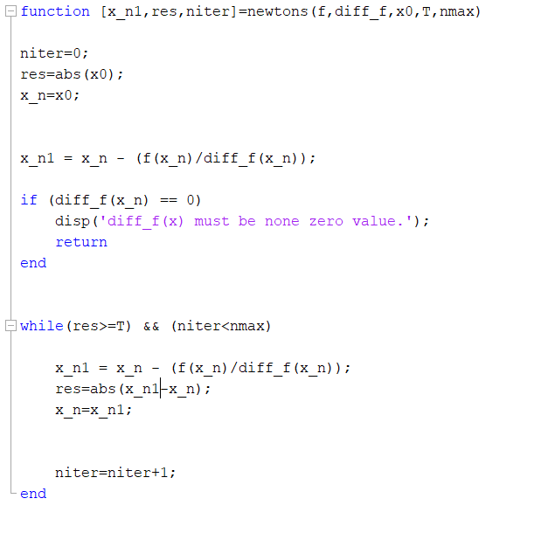4. (a) Newton’s Method (MATLAB code)

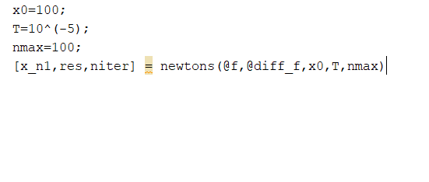testNewtons.m

f.m

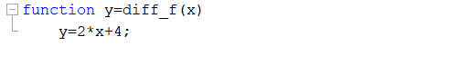diff_f.m

(b).

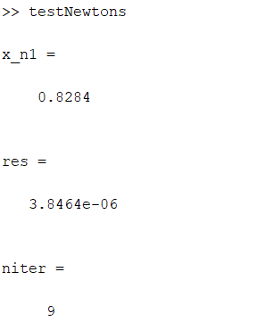Output

Expected solution is obtained and it is accurate up to 4 decimal places.

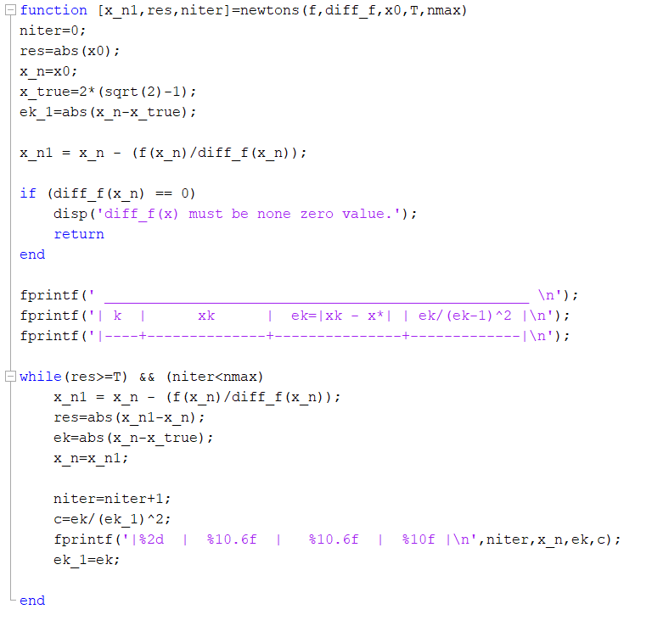(c).

Output when τ = 10-5

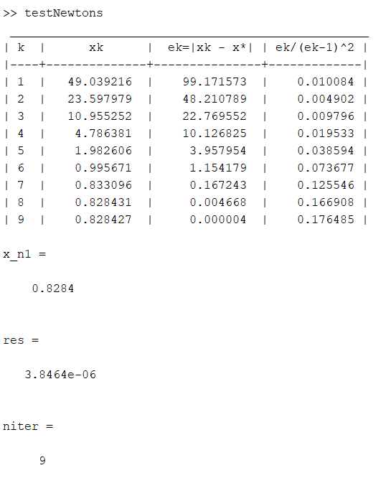

Quadratic convergence is not obtained. Value of the last column of the table does not converge to a constant.

(d).

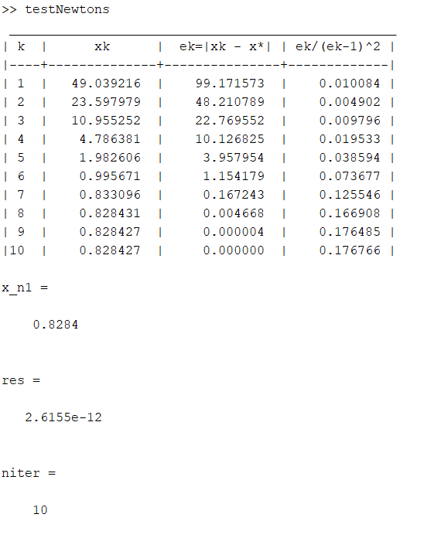Output when τ = 10-8

Here the value of the last column converges to some constant with an accuracy of 0.001. Therefore it can be concluded that quadratic convergence is obtained here.

(5). Kepler’s Equation

newtons.m

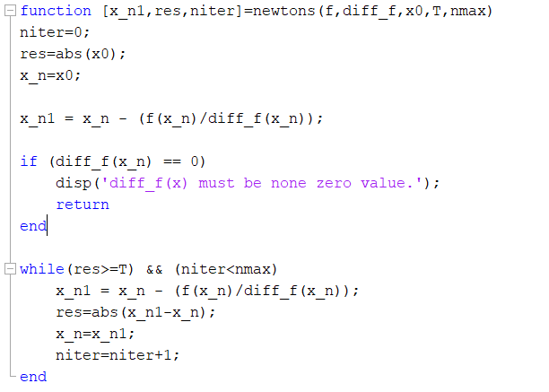

f.m

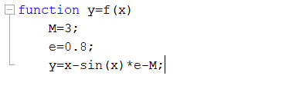

diff_f.m

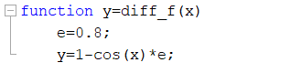

q5.m

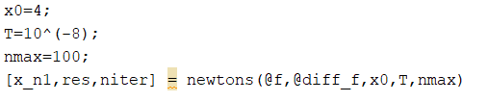

Output

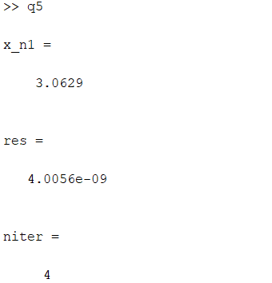

Hence, angle E = 3.0629 rad

(6). State Equation of a Gas

bisection.m

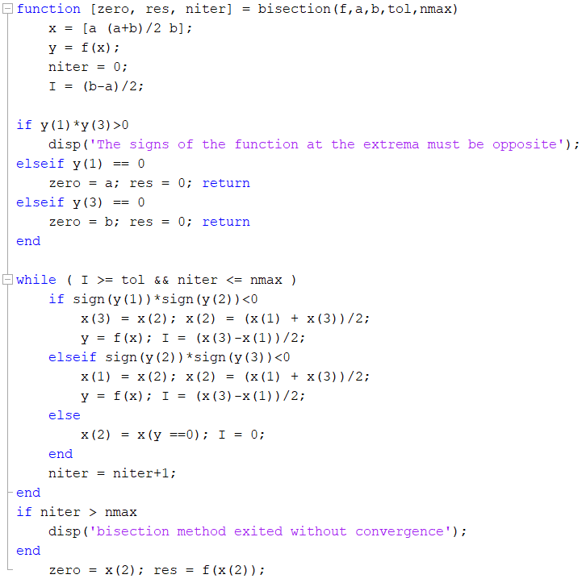

f.m

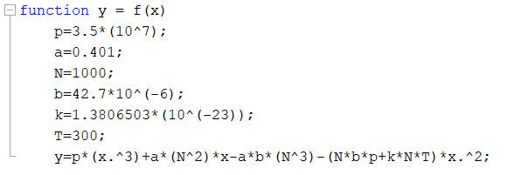

q6.m

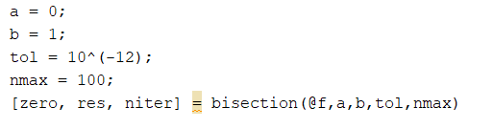

Output

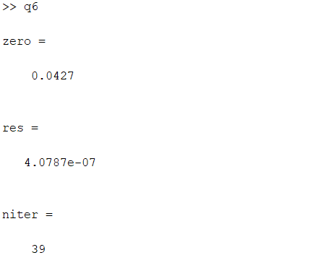

Therefore, volume = 0.0427 m3