IMPLEMENTATION

3. (a) LagrangeInterpolant.m

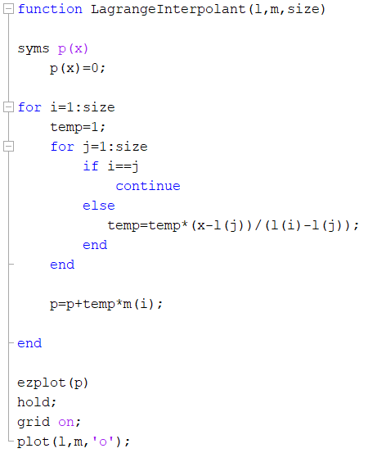

(b) q3.m

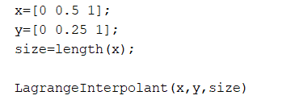

Output

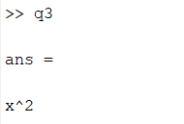

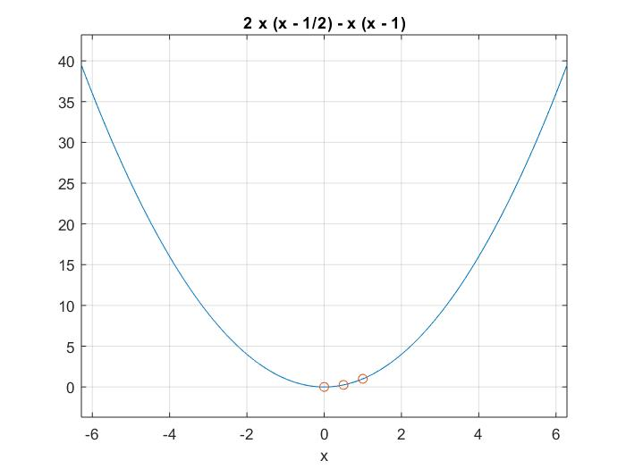

Expected answer is p(x)=x2

Therefore, expected answer is obtained.

APPLICATION

4. (a)

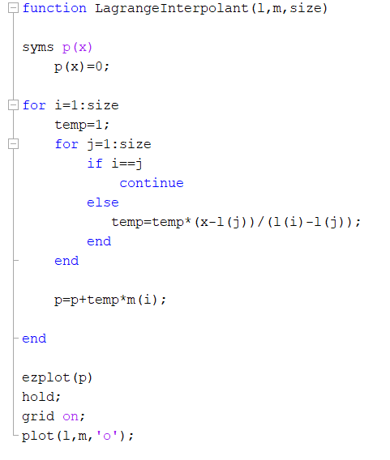

q4.m

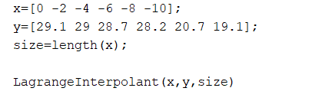

Output

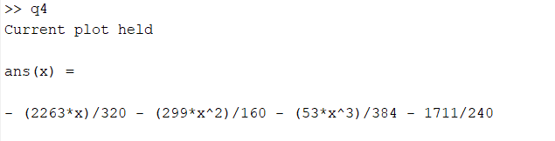

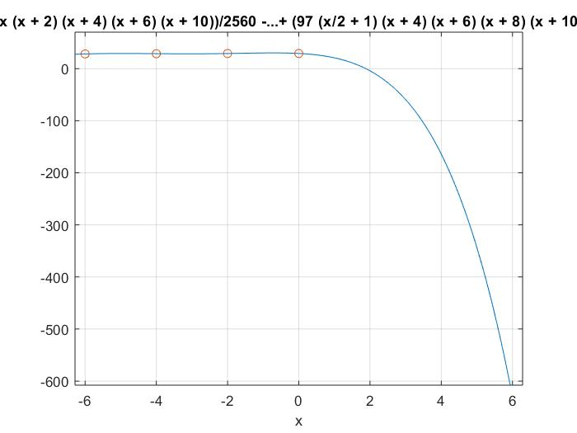

(b).

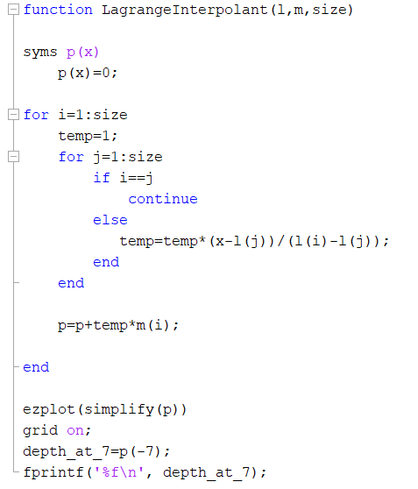

Output



According to the table value should be between 28.2 and 20.7

Therefore the answer is valid.

(c).

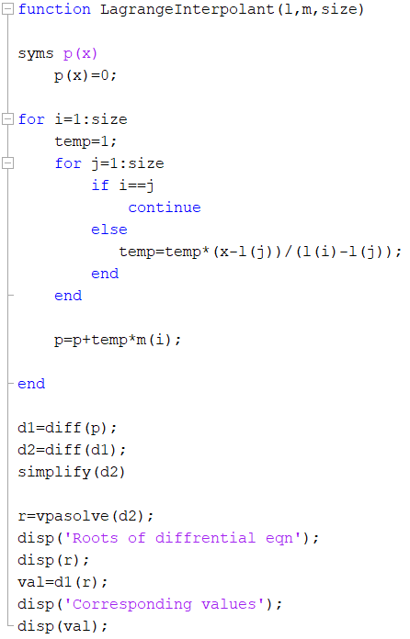

Output

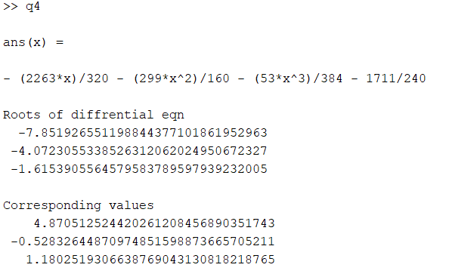

Maximizer of the T’(z) is at -7.85192… according to the output.

Hence, thermocline exists at 7.8519 m deep.