INT253 CA1

Name: Amit

Roll no.: 69

Reg. no.: 12114760

Output:

Views.py

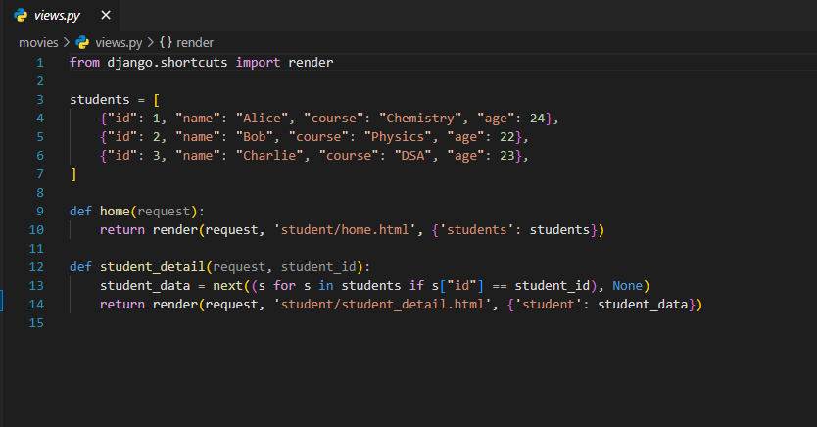

urls.py

Templates

* Home.html

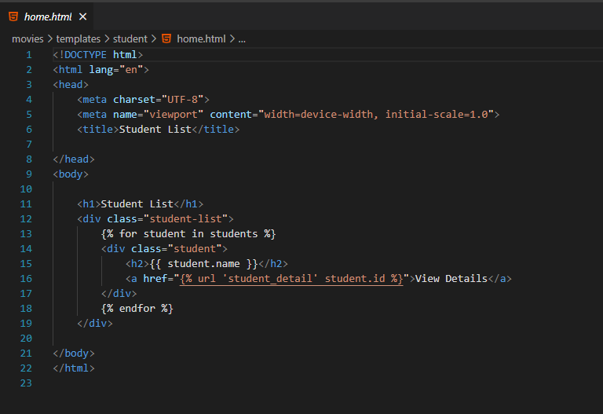

* Student_detail.html

