Lenovo

[Email address]

Abstract

[Draw your reader in with an engaging abstract. It is typically a short summary of the document.   
When you’re ready to add your content, just click here and start typing.]

CA

[Document subtitle]

**Introduction**

**Overview of Computer Network**

Computer Network is a collection of two or more computing devices which are interconnected for the purpose of sharing resources. ( hardware / software )

The Communication is based on an agreed set of rules. It means Protocol. Two or more computing devices are connected to one another by the linkages. We can sent information over these links through the Communication Protocols.

The ports are used to refer to the destination devices.

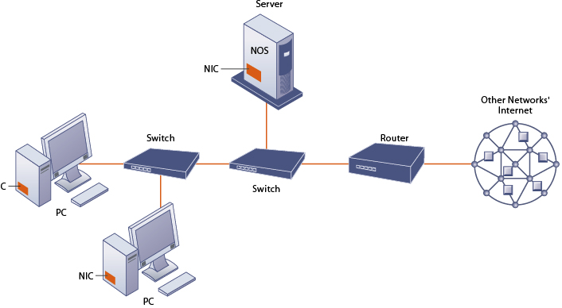

We can see two main devices categories in Computer Network.

1. Network Devices

These devices inter-connect other devices.

Eg : Router , Switch , Repeater , Hub , Bridge

1. End User Devices

This devices are used by the final user.

Eg: Pc , Laptop

We can categorize computer networks through a number of factors, network size, Topology and organization goals. Below have some network types.

PAN - Personal Area Network

LAN - Local Area Network

SAN - Storage Area Network

CAN - Campus Area Network

MAN - Metropolitan Area Network

WAN - Wide Area Network

Below Have Advantages & Disadvantages of Computer Network.

|  |  |
| --- | --- |
| Advantages | Disadvantages |
| * Reliability * Flexibility * Connectivity * Central storage of data * Faster problem solving * Security through Authorization | * Expensive * Virus * Less of information * System can be hack |

**Importance of network models**

Network Models are frameworks, predefined structured. This frameworks help in designing / analyzing the architecture and behavior of networks.

Network Model = Predefined structure + set of protocols and standards

Network Models are essential to understanding network architecture.

There are two major network models.

1. ISO/OSI Model
2. TCP/IP Model
3. Five Layer Model

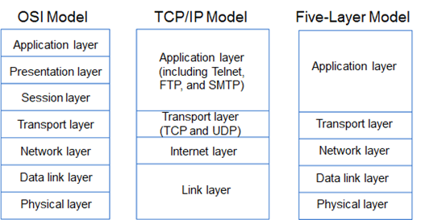

Below have some Importance of Network Models.

* We can abstract the key components of the networks through network models.so its helps to simplification and abstraction.
* Easy to analyzed network performance.
* Network Model provide a visual sketch of the network architecture. So that makes it easier to identify patterns and significant nodes and connections.
* Optimizing load balancing , routing protocols
* Scalability
* Can find security flaws and provide defenses against attacks.
* Understand complex dynamics and relationships in systems.

**Introduction to five layer model**

The Five layer Model is a simple conceptual framework. This is helpful to analyze, design, understand network architecture. This model divides five layers for communication process. Each layer have responsibility for specific data transmission. So following this five layer models developers can troubleshoot network applications more effectively. Each layer serving a specific purpose in the data transmission process.

Even when two devices are connected to separate networks , the data transmitted from one can be accurately received and understood by the other through the layers.

We can see five layer models.

* Application Layer
* Transport Layer
* Network Layer
* Data-Link Layer
* Physical Layer

**Five Layer Model**

**Application Layer**

This is the top layer of the five layer Model. Application Layer Communicates with end user apps / applications directly. It offers a range of protocols and network services that let app talk to each other across the network. Users and application processes can access network services through Application Layer.

The Main Purpose of this layer is to give user programs direct access to network resources and making it possible for users to perform tasks. Such as remote login , file transfers , web surfing. It supports end user operations.

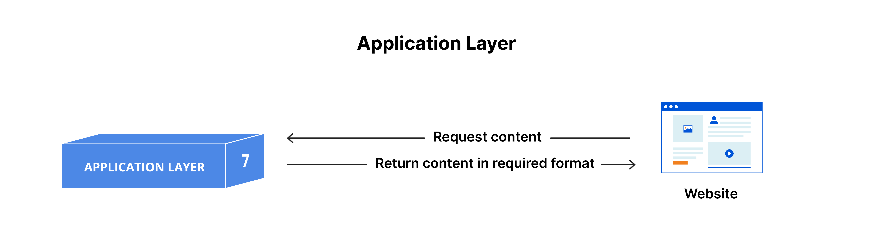

**Key functions**

* Make application level communication easier for services and protocols.(file transfers , email exchanges, web browsing)
* Allow access for share network resources , remote services
* Guarantees data protection during transmission and access to network resources to authorized users.
* Converts several data formats between the applications and networks.

Below Have Examples of protocols and technologies used.

|  |  |
| --- | --- |
| **Protocol** | **Technologies used** |
| HTTP | Transferring web pages |
| HTTPS | Secure data transmission using SSL/TLS encrypted |
| FTP | Files transfer between client and network |
| DNS | Translate human readable domain names into IP addresses |
| Telnet | Remote login capabilities to access and manage network devices and servers |
| SSH | Encrypted communication for remote login and other secure network services. |

**Transport Layer**

This Layer handled by Data transfer and end-to-end communication between devices. Helpful to data is sent without errors in the right order and without any duplications and losses. It offers dependable data transport services.

Main purpose of this layer is complete data transfer between source and destination.

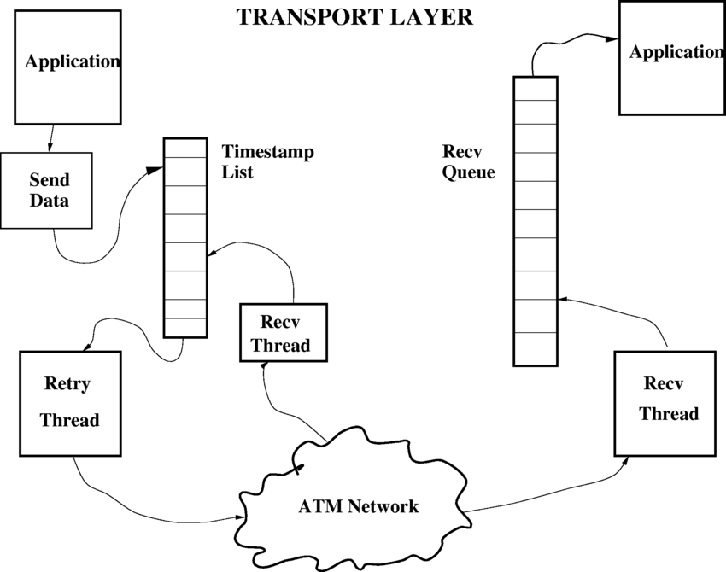

**Key Functions**

* Dependable communication session by establishing and breaking connections between devices.
* Breaking up big data files into small components for transmission.
* Data segmentation allows accurate rebuilding and efficient network transmission.
* Control the speed of data transfer
* Protect accuracy of data by identifying and fixing send data mistakes.

Below Have Examples of protocols and technologies used.

|  |  |
| --- | --- |
| **Protocols** | **Technologies Used** |
| TCP | Allows the safe helpful and error checked transfer of data between apps. |
| UDP | Provides a low overhead connectionless communications |

**Network Layer**

This Layer provides for data transfer across multiple networks. This layer manages logical route for data to take from the source to the destination. And also controls logical addressing.

The main purpose of this Layer is data is successfully route and delivered across linked networks. It provide a way for data to move across devices that are on different networks source device and the destination device.

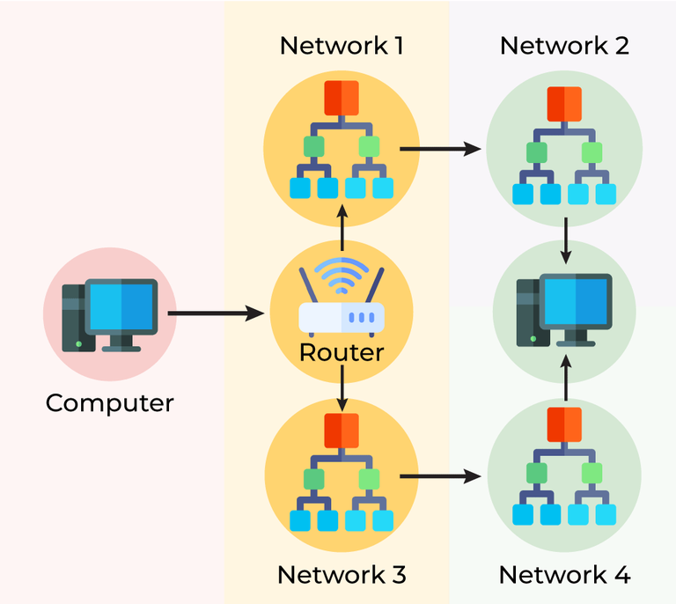

**Key Functions**

* Gives devices individual IP addresses. So that data may be directed to the right place.
* Uses a variety of routing protocols and techniques to determine the best route for data packets to take as they travelling across networks.
* Packet forwarding is a technique used to forward data packets from one network to another, guaranteeing that they reach their destination.
* Splits large data packets into more manageable chunks for delivery.

Below Have Examples of protocols and technologies used.

|  |  |
| --- | --- |
| **Protocol** | **Technologies Used** |
| IP | enables the routing and logical addressing of data packets across connected networks |
| ICMP | Used error messages as well as |
| ARP | connects mac addresses and IP addresses |
| OSRF | keep track of the topology of the network and employs a link-state routing algorithm. |
| BGP | oversees the data routing across the internet between independent systems. |

**Data Link Layer**

Data link layer handled Data transport from one node to another. It manages error detection and repair from the physical layer and offers a dependable link between two directly linked nodes.

The layer makes guarantee that information sent from one device's network layer can be correctly packaged and transferred to another device's network layer. This is a detailed explanation of the Data Link Layer, including all of its sublayers, roles, and protocols.

Main purpose of this layer is error-free communication between network devices on the same physical network section.

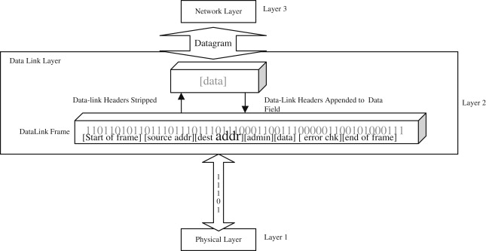

**Key Functions**

* Creates structured data packets for transmission by encapsulating raw bits into frames and adding headers and trailers The headers and trailers carry control information, which includes source and destination MAC addresses, frame time, and error detection codes.
* Errors detect and solve this errors in the transmitted data.
* Prevent receiving end overflow
* Manage data transmission rate
* Media access control
* Avoid collisions
* Make fair access

Below Have Examples of protocols and technologies used.

|  |  |
| --- | --- |
| **Protocols** | **Technologies used** |
| Ethernet | Collision detection and manage |
| Wi fi | Employ Carrier sense several access points |
| PPP | Straight links establishing two nodes |
| HDLC | Error detection capability |
| MAC Address | Data link layer devices identify |

**Physical Layer**

This layer is Foundation layer in five layer Model. Hardware components covered this layer. This layer transmitting raw data bits in communication medium. And also This layer useful for maintain electrical , mechanical , activating , deactivating physical link between network devices.

The main purpose of this layer is Transmitting raw bits over a physical between nodes.

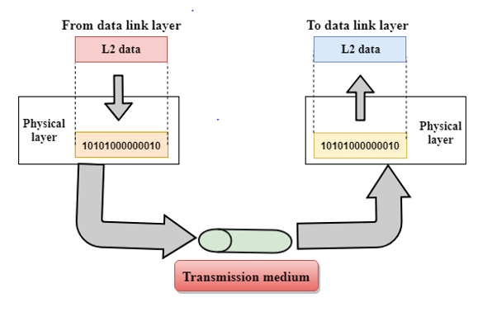

**Key Functions**

* Data convert to the signals
* Signal Encoding
* Medium transmission
* Topologies
* Bit level synchronized between sender and receiver

Below Have Examples of protocols and technologies used.

|  |  |
| --- | --- |
| **Protocols** | **Technologies Used** |
| Ethernet | local area networks |
| Wi Fi | Data Transmission |
| Bluetooth | Exchanging data |
| Fiber optic Cables | Transmit data high speed |
| Coaxial Cables | Broadband connections |

**Conclusion**

As Summery the Five layer Model provides structured way to comprehend and organized designed network systems. Each layer provides unique and crucial functions for the process of data communication. And also making network architecture is simple to analize and maintainability of network system.Each Layer based for specific set of functions. It making easier for manage , troubleshoot , develop network protocols.

And also this five layer model used different protocols. It helps to communicate different devices , applications from various cohesive networking environment .When we followed five layer model helpful for flexibility in network architecture. Because of the layered structure resolving network issues and ease of troubleshooting. And also network administrators can isolate problems.

Important thing is when we followed multiple layers useful for enhanced security high. Encryption can be applied transport and application layers when we access control mechanism.

**References**

Mailsamy, K. (2020). *5-LAYER NETWORK MODEL MADE SIMPLIFIED!* [online] Medium. Available at: <https://medium.com/@karthikayanmailsamy/5-layer-network-model-made-simplified-e813da0913ba>.

www.parthshandilya.com. (n.d.). *The TCP/IP Five-layer Network Model*. [online] Available at: <https://www.parthshandilya.com/networking-tcp-ip-model/>.

GeeksforGeeks. (2017). *TCP/IP Model*. [online] Available at: <https://www.geeksforgeeks.org/tcp-ip-model/?ref=header_search>.

Spiceworks. (n.d.). *What Is a Computer Network? Definition, Objectives, Components, Types, and Best Practices*. [online] Available at: <https://www.spiceworks.com/tech/networking/articles/what-is-a-computer-network/#_002>.‌

omerros (2022). *What is the Five Layers Model? The Framework of the Internet Explained*. [online] freeCodeCamp.org. Available at: https://www.freecodecamp.org/news/the-five-layers-model-explained/#:~:text=The%20physical%20layer%20is%20responsible [Accessed 9 Jun. 2024].