Picture 1

Sam-camera.jpg

Sam.jpg

Results

Database

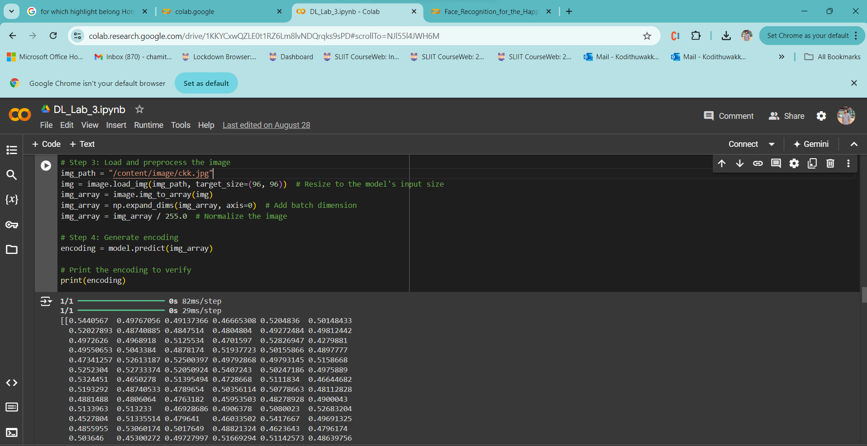

-verify()

-who_is_it() / output 2

