**DL Lab 8**

IT21156960

C.K.Kodithuwakku

**Question 1**

Code Snippet Edit

**Markov_Decision_Process File**

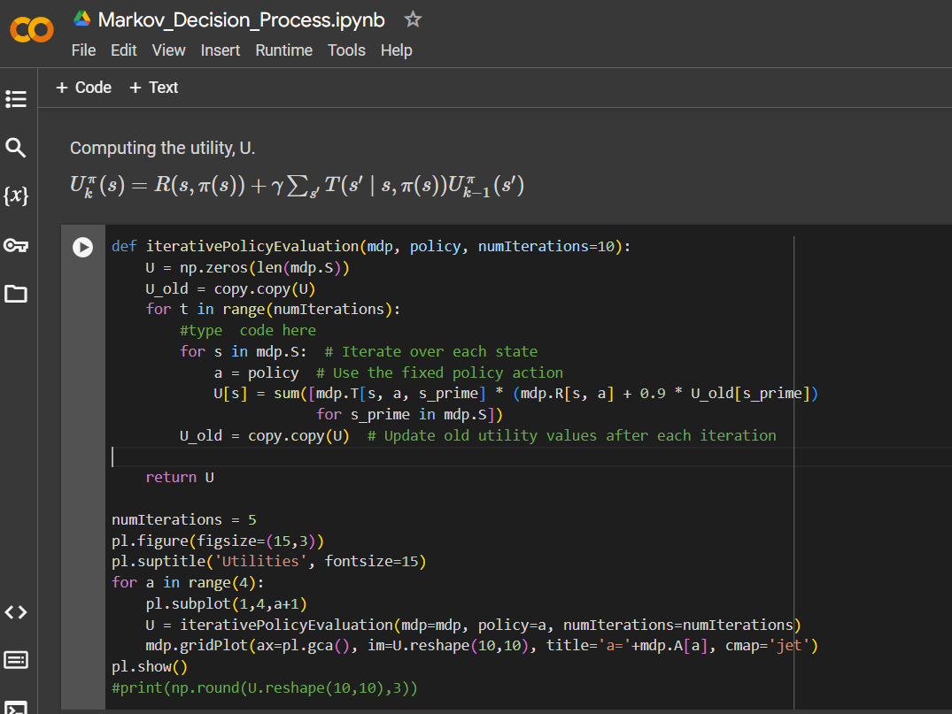

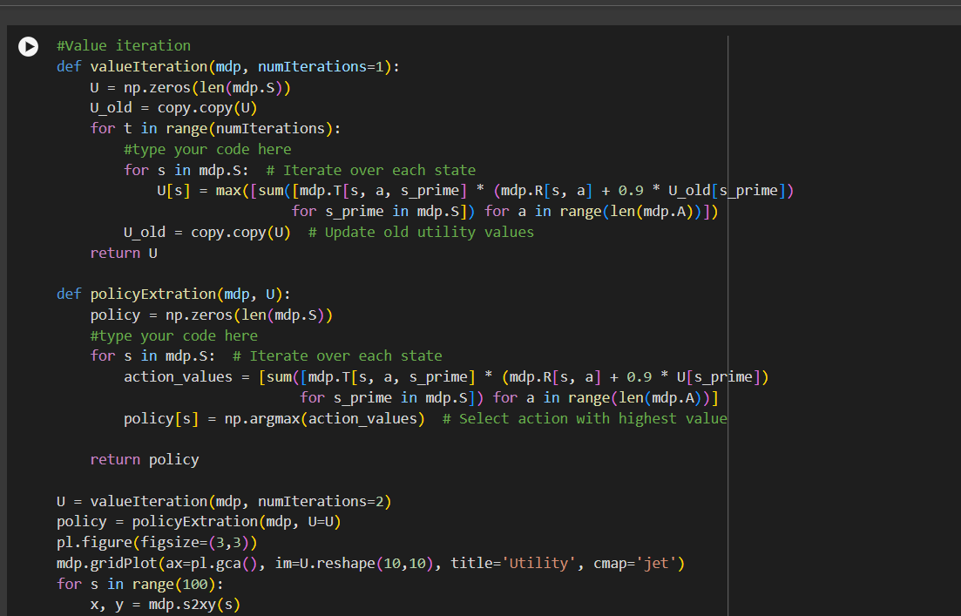

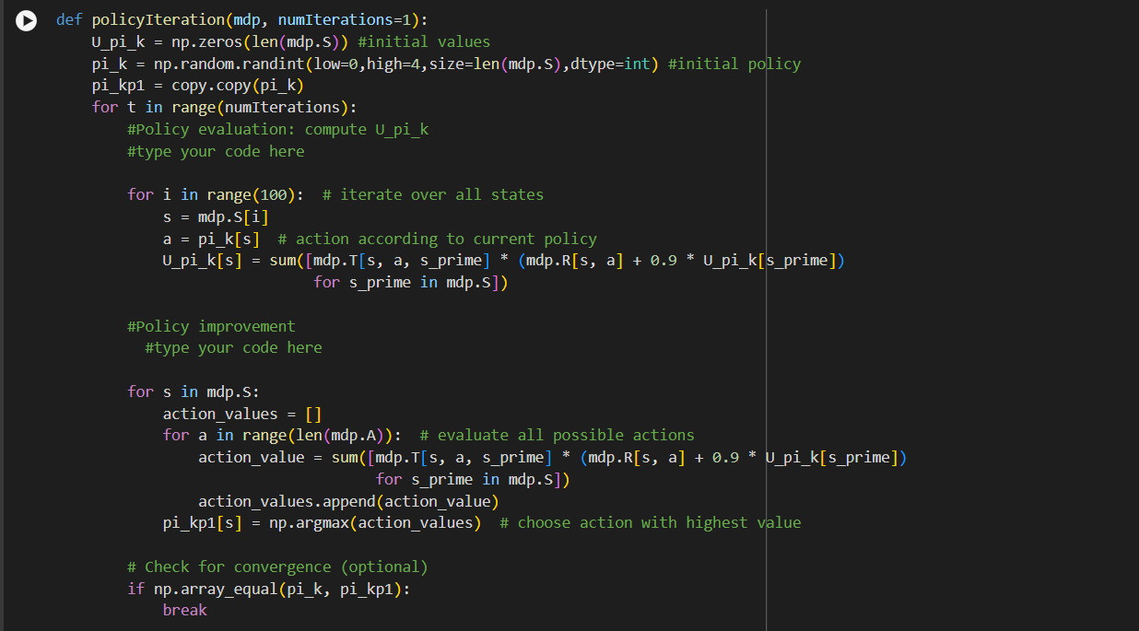

**Gridworld File**

